|  |  |
| --- | --- |
|  | **FPT ACADEMY INTERNATIONAL**  **FPT – APTECH COMPUTER EDUCATION** |

**Centre Name: ACE-THUDUC-1-FPT.**

**Address: 391A Nam Ky Khoi Nghia Str, Vo Thi Sau Ward, District 3, Ho Chi Minh City, Viet Nam.**

FUN ZONE

|  |  |  |
| --- | --- | --- |
| **Supervisor.** | Mr. Nguyen Phat Tai | |
| **Batch.** | T3.2307.E1 | |
| **Group.** | Group 2 | |
| **Serial No.** | **Enrollment Number** | **Student Name** |
| 1. | Student1491478 | Nguyễn Tiến Đan |
| 2. | Student1492259 | Vũ Trần Việt Hải |
| 3. | Student1492040 | Nguyễn Thiện Nhân |
| 4. | Student1496443 | Trần Quang Đạt |

Nov-14-2023

**This is to certify that**

**Mr.:**

Nguyễn Tiến Đan

Vũ Trần Việt Hải

Nguyễn Thiện Nhân

Trần Quang Đạt

**has successfully designed & developed**

eProject: Fun Zone website

**Submitted by: Vũ Trần Việt Hải**

**Date of issue:** 14-Nov-2023 ___________________

**Authorized Signature: Hai**

**TABLE OF CONTENTS**

ACKNOWLEDGEMENT 3

SYNOPSIS 3

PROBLEM DEFINITION 3

CUSTOMER'S REQUIREMENTS SPECIFICATIONS (CRS) 4

Business/Project Objective: 4

Hardware/ Software Requirements: 4,5

SCOPE OF THE WORK (IN BRIEF) 6

Architecture and design of the system 7

Diagram of the website 8

TASK SHEET REVIEW 1 9

SITE MAP 9

MOCK OF THE WEBSITE 10

**1.** **HOMEPAGE** 11

**2.** **PRODUCTS** 12

**3.** **BRANDS** 13

**4.** **COMPARE** 14

**5.** **CONTACT US** 15

**6.** **ABOUT US** 16

TASK SHEET REVIEW 2 19

**WEBSITE DESCRIPTION 20**

**1. HOME PAGE: 20**

**2. MENUDROPDOWN01: 21**

**3. MENUDROPDOWN02 24**

**4. PRODUCT PAGE: 27**

**5. BRANDS PAGE 28**

**6. PRODUCT DETAIL: 29**

**7. ABOUT US PAGE: 30**

**8. CONTACT PAGE: 31**

**TASK SHEET REVIEW 3 36**

# ACKNOWLEDGEMENT

On behalf of all members of Team 2, I would like to thank all of you for your hard work and support to successfully complete this eProject. Especially Mr. Nguyen Phat Tai, our teacher, has helped us a lot since the day we started studying at FPT Aptech. With this eProject, the Teacher guided us very enthusiastically and heavily. Thanks to his guidance, we were able to complete this project. Additionally, I would like to thank all team 2 members, each team member worked continuously for 4 weeks to complete this project. Last but not least, we would like to thank our family for always supporting and creating the best conditions for us to focus on the project and believe in the dreams we pursue.

# SYNOPSIS

The ‘FUN ZONE’ Most Entertaining Theme Park, is one of the best ideas executed in the amusement & entertainment industry. It caters to everyone, be it a child who seeks entertainment or an adult who wishes for a pleasant evening. This initiative is aimed towards providing its visitors with ample elements to spend a quality day. It promises fun and frolic packed with adventurous and elegant ambience.

# PROBLEM DEFINITION

The Web site is to be created based on the following requirements.

1. The Home Page should be created with sections, graphics and with a suitable logo.

2) The site should display a menu with following categories:

• EXPERIENCE

• LEISURE & DINNING

• PARKS CHARACTERS

• WHATS UP

• PARK INFORMATION

• BUSINESS OPPORTUNITIES

1. ‘EXPERIENCE’ menu option should provide an overview of the entire park with proper maps and brief information on the sections in park.
2. ‘LEISURE & DINNING’ menu option should provide information on food section with outlet details. It can also be organized brand wise. When a user selects any particular brand, a list of products for that brand will be displayed
3. ‘PARKS CHARACTERS’ menu option should provide details about the characters in the parks and a small story should be associated to them.
4. ‘WHATS UP’ should provide details of past and upcoming events.

7) There should be a “Contact Us” page which will have the Address of the Company which is as follows and the mail address which when clicked will invoke the local mail client from where they can send an email.

# CUSTOMER'S REQUIREMENTS SPECIFICATIONS (CRS)

**Client: Fun zone**

### Business/Project Objective:

The Objective of this program is to give a sample project to work on real life projects. These applications help you build a larger more robust application.

The objective is not to teach you JavaScript/Dreamweaver but to provide you with a real life scenario and help you create basic applications using the tools.

You can revise the chapters before you start with the project.

This project is meant for students who have completed the module of ***HTML5.*** These programs should be done in the Lab sessions with assistance of the faculty if required.

It is very essential that a student has a clear understanding of the subject. Students should go through the project and solve the assignments as per requirements given.

Kindly get back @ [eprojects@aptech.ac.in](mailto:eprojects@aptech.ac.in) in case of any doubts regarding the application or its objectives.

**Input to the system:**

* ‘FUN ZONE’ is looking to have it’s own website to provide information and also connect with prospective clients.

**Output from the system:**

1. The Home Page should be created with sections, graphics and with a suitable logo
2. The site should display a menu with following categories:

* EXPERIENCE
* LEISURE & DINNING
* PARKS CHARACTERS
* WHATS UP
* PARK INFORMATION
* BUSINESS OPPORTUNITIES

1. ‘EXPERIENCE’ menu option should provide an overview of the entire park with proper maps and brief information on the sections in park.
2. ‘LEISURE & DINNING’ menu option should provide information on food section with outlet details. It can also be organized brand wise. When a user selects any particular brand, a list of products for that brand will be displayed
3. ‘PARKS CHARACTERS’ menu option should provide details about the characters in the parks and a small story should be associated to them.
4. ‘WHATS UP’ should provide details of past and upcoming events.
5. There should be a “Contact Us” page which will have the Address of the Company which is as follows and the mail address which when clicked will invoke the local mail client from where they can send an email.

**Expected delivery date:** 14-Nov-2023.

**List of deliverables:**

* + - * Document Word.
      * User Guide.
      * Source code.

### Hardware/ Software Requirements:

**Hardware**

* + A minimum computer system that will help you access all the tools in the courses is a Pentium 166 or better.
  + 64 Megabytes of RAM or better.

**Software**

* + Notepad/HTML editor.
  + Dreamweaver, VisualStudioCode.
  + IE 5.0/ Netscape 6.0.

# SCOPE OF THE WORK (IN BRIEF)

**The team has discussed and has agreed about the website layout as shown briefly below:**

1. **‘THE HOME PAGE’:** sections, graphics and with a suitable logo.
2. **‘CATEGORIES’:**

* EXPERIENCE
* LEISURE & DINNING
* PARKS CHARACTERS
* WHATS UP
* PARK INFORMATION
* BUSINESS OPPORTUNITIES

1. **‘EXPERIENCE’**: an overview of the entire park with proper maps and brief information on the sections in park.
2. **‘LEISURE & DINNING’:** information on food section with outlet details. It can also be organized brand wise. When a user selects any particular, a list of products for that brand will be displayed.
3. ‘**PARKS CHARACTERS’:** provide details about the characters in the parks and a small story should be associated to them.
4. **‘WHATS UP’**: provide details of past and upcoming events.
5. **‘Contact Us’**: the Address of the Company which is as follows and the mail address which when clicked will invoke the local mail client from where they can send an email.

# 

# Architecture and design of the system

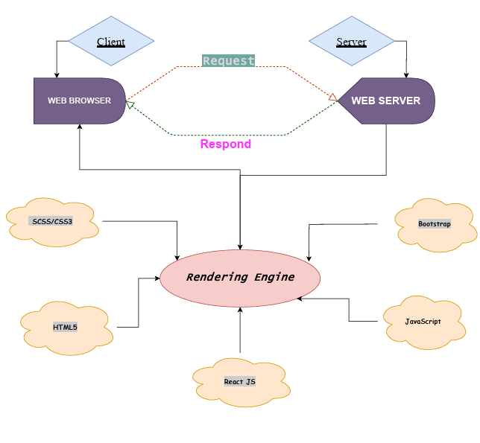

# Diagram of the website

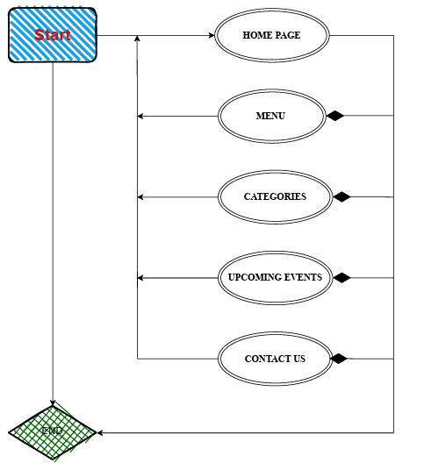



TASK SHEET REVIEW 1

|  |  |  |  |  |  |  |  |
| --- | --- | --- | --- | --- | --- | --- | --- |
| **Project Ref. No.:**  **eP/Advertisement Portal Management**  **System/01** | | **Project Title:** | **Activity Plan Prepared By:** | **Date of Preparation of Activity Plan:** | | | |
| **Sr.**  **No.** | **Task** | **Actual**  **Start Date** | **Actual Days** | **Team**  **Mate Names** | **Status** |
| 1 | Problem Statement | FUN ZONE | Hai | 14-Oct-2023 | 1 | Dan, Hai,  Nhan, | Completed |
| 2 | Analysis of the requirements about the website | 14-Oct-2023 | 1 | Dan, Hai,  Nhan, | Completed |
| 3 | The scope of the work (in brief) | 14-Oct-2023 | 1 | Dan, Hai,  Nhan, | Completed |
| 4 | Architecture and design of the system | 14-Oct-2023 | 1 | Dan, Hai,  Nhan, | Completed |
| 5 | Diagram of the website | 14-Oct-2023 | 1 | Dan, Hai,  Nhan, | Completed |
| 6 | Task Sheet | 14-Oct-2023 | 1 | Dan, Hai,  Nhan, | Completed |

|  |  |
| --- | --- |
| **Date: 19/10/2023** | |
| Signature of Instructor:  **Mr. Nguyen Phat Tai** | Signature of Team Leader:    **Mr.Vu Tran Viet Hai** |

# SITE MAP

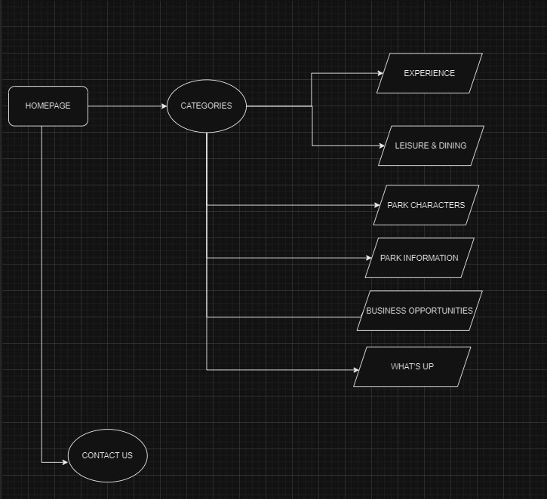

# MOCK OF THE WEBSITE

1. **HOMEPAGE**

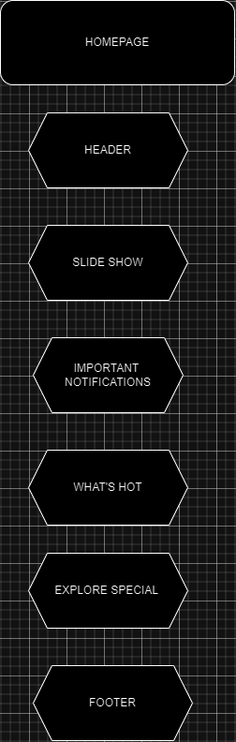

# CATEGORIES:

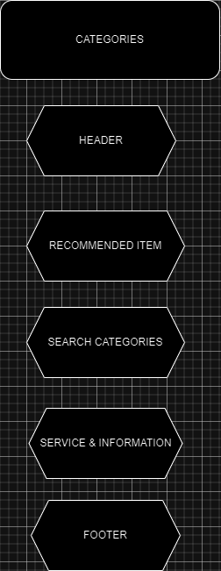

1. **EXPERIENCE:**

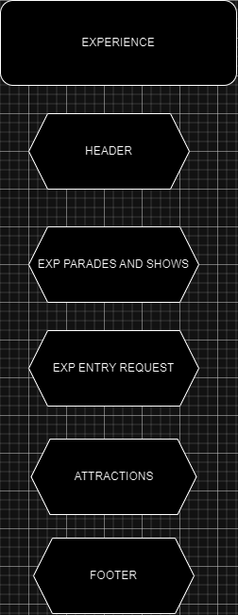

1. **LEISURE & DINING:**

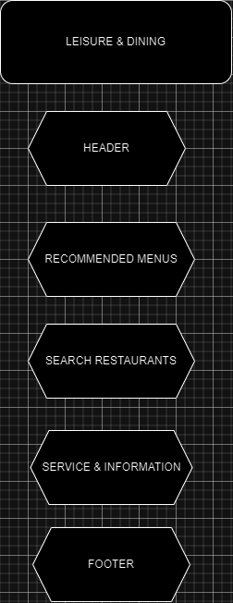

# PARK AND CHARACTER:

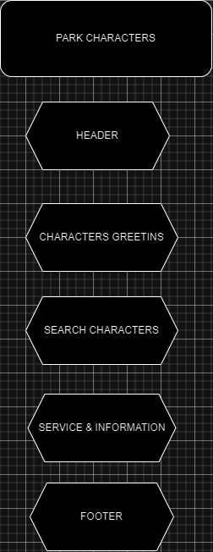

**6. WHAT UP:**

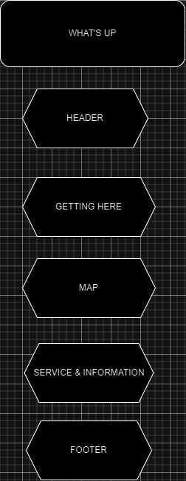

**7. CONTACT US**

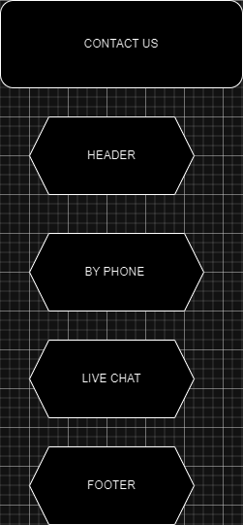

# TASK SHEET REVIEW 2

|  |  |  |  |  |  |  |  |
| --- | --- | --- | --- | --- | --- | --- | --- |
| **Project Ref. No.:**  **eP/Advertisement**  **Portal Management System/01** | | **Project Title:** | **Activity Plan Prepared By:** | **Date of Preparation of Activity Plan:** | | | |
| **Sr.**  **No.** | **Task** | **Actual**  **Start Date** | **Actual Days** | **Team**  **Mate Names** | **Status** |
| 1 | Site map | Fun Zone | Hai | 26-Oct-2023 | 1 | Dan, Hai, Nhan | Completed |
| 2 | Mock of the website | 26-Oct-2023 | 1 | Dan, Hai, Nhan | Completed |
| 3 | Task Sheet | 26-Oct-2023 | 1 | Dan, Hai, Nhan | Completed |

|  |  |
| --- | --- |
| **Date: 26/10/2023** | |
| Signature of Instructor:  **Mr. Nguyen Phat Tai** | Signature of Team Leader:  **Mr.Vu Tran Viet Hai** |

# WEBSITE DESCRIPTION

1. **HOME PAGE:**

# 

**Figure 1.1:** Homepage slideshow

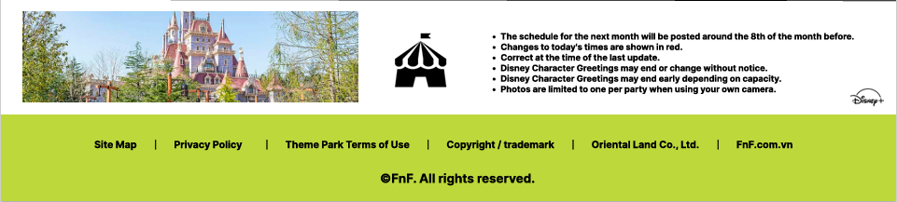

**Figure 1.2:** Footer

1. **Liesure & dining:**

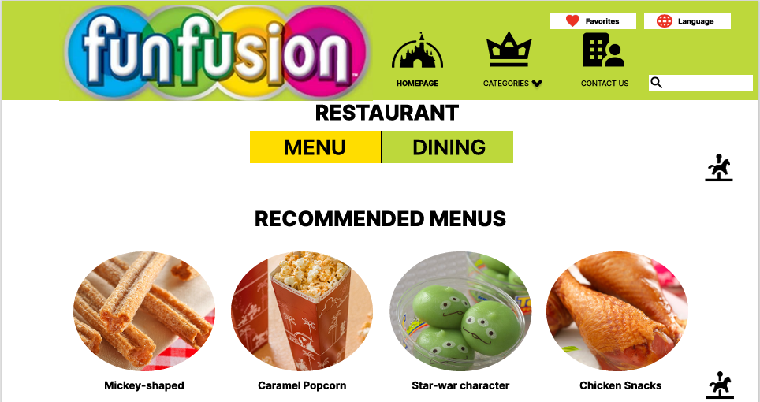

**Figure 1.3:** Dining

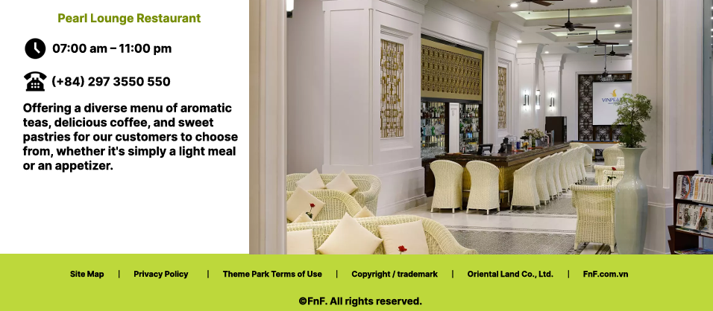

**Figure 1.3:** Leisure

1. **What’s hot:**

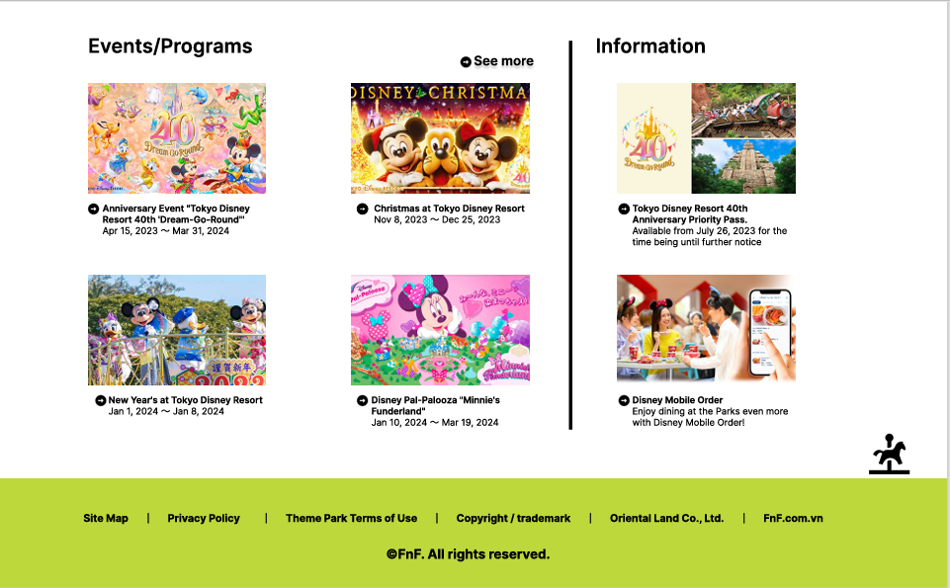

1. **Character:**

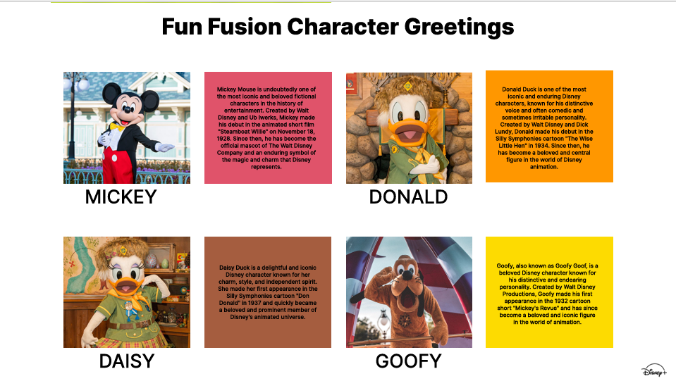

1. **Contact us:**

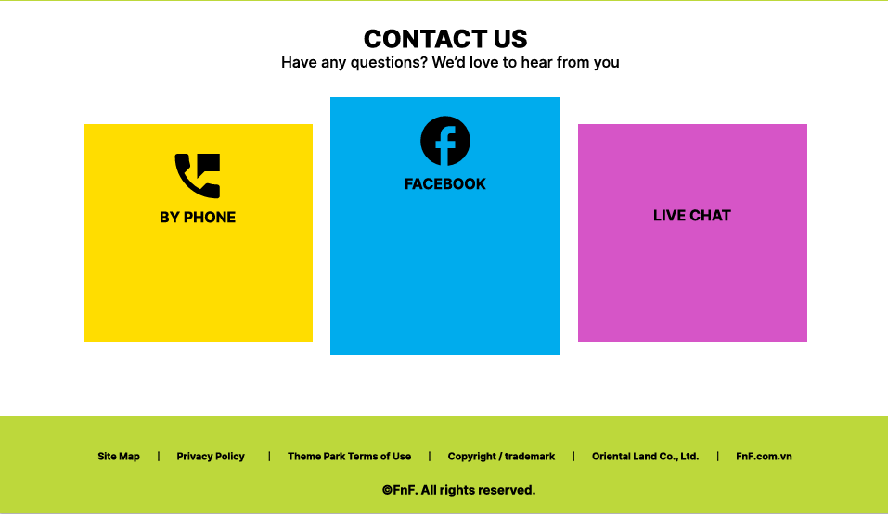

**SOURCE CODE**

**HomePage**

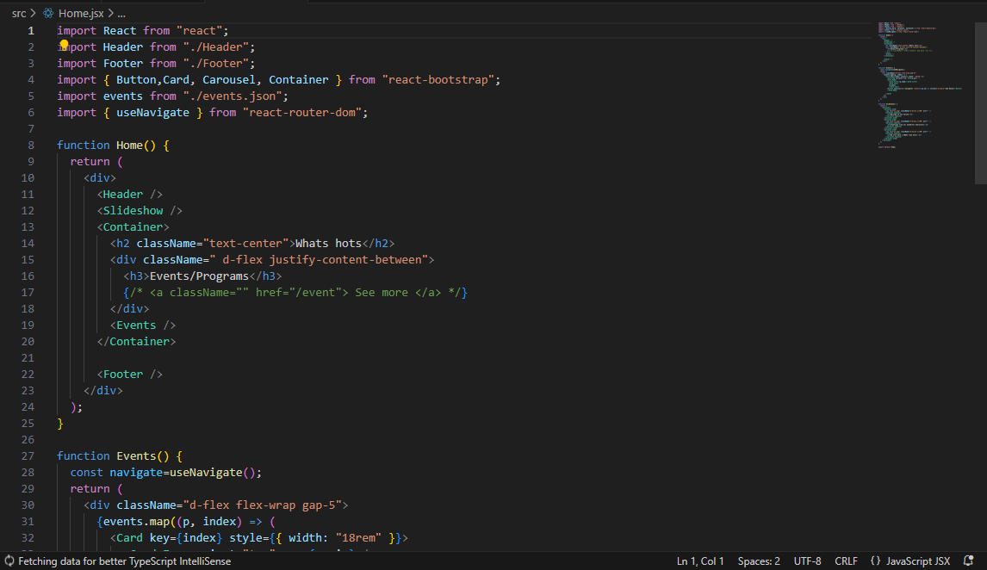

**Liesure & dining:**

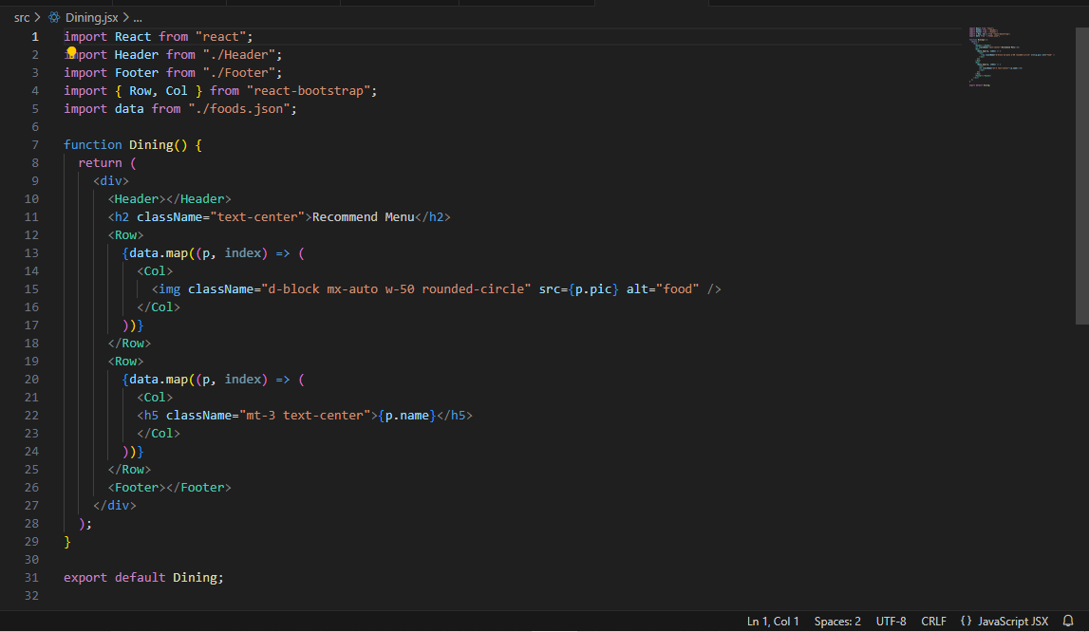

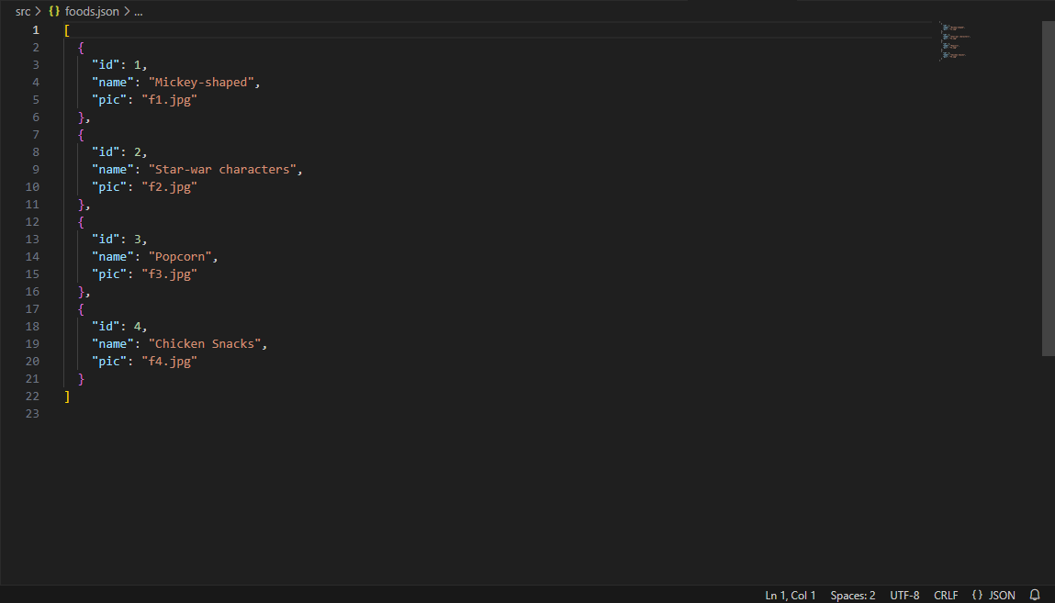

**What’s hot:**

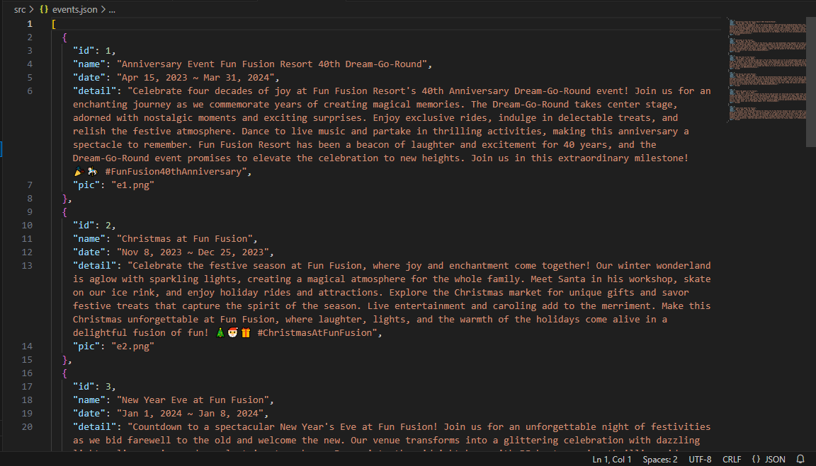

**Character**

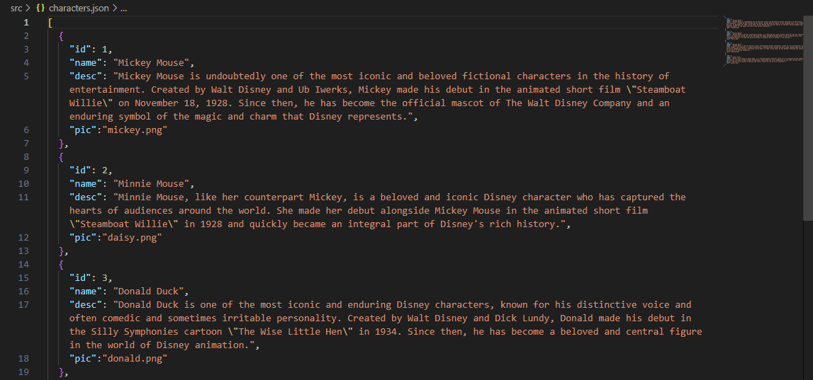

**Contact us:**

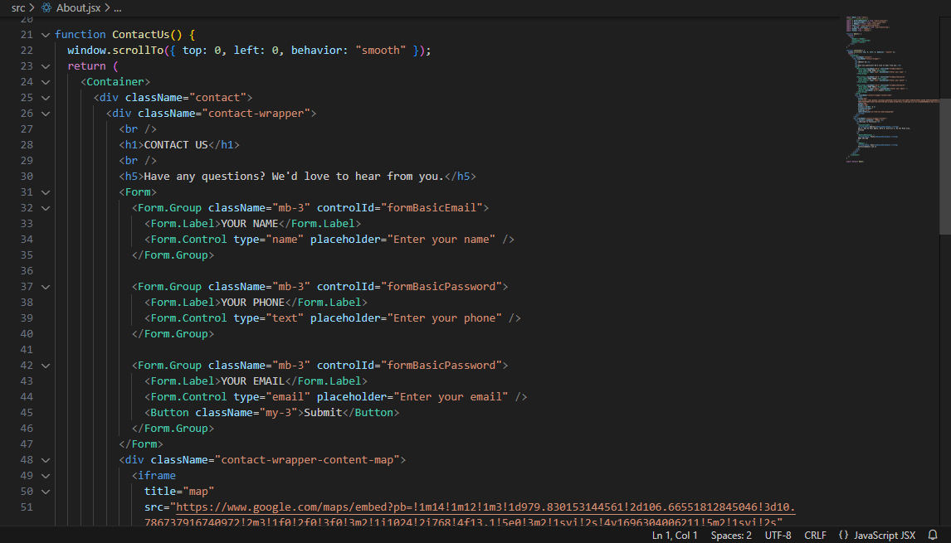

# TASK SHEET REVIEW 3

|  |  |  |  |  |  |  |  |
| --- | --- | --- | --- | --- | --- | --- | --- |
| **Project Ref. No.:**  **eP/Advertisement**  **Portal Management System/01** | | **Project Title:** | **Activity Plan Prepared By:** | **Date of Preparation of Activity Plan:** | | | |
| **Sr.**  **No.** | **Task** | **Actual**  **Start Date** | **Actual Days** | **Team**  **Mate Names** | **Status** |
| 1 | Home page | FUN ZONE | Hai | 04-Nov-2023 | 1 | Hai, Doan, Nhan | Completed |
| 2 | MenuDropdown01 | 04-Nov-2023 | 1 | Hai, Doan, Nhan | Completed |
| 3 | MenuDropdown02 | 04-Nov-2023 | 1 | Hai, Doan, Nhan | Completed |
| 4 | ProductsPage | 04-Nov-2023 | 1 | Hai, Doan, Nhan | Completed |
| 5 | BrandsPage | 04-Nov-2023 | 1 | Hai, Doan, Nhan | Completed |
| 6 | ProductDetail | 04-Nov-2023 | 1 | Hai, Doan, Nhan | Completed |
| 7 | AboutUsPage | 04-Nov-2023 | 1 | Hai, Doan, Nhan | Completed |
| 8 | ContactPage | 04-Nov-2023 | 1 | Hai, Doan, Nhan | Completed |

|  |  |
| --- | --- |
| **Date: 04/11/2023** | |
| Signature of Instructor:  **Mr. Nguyen Phat Tai** | Signature of Team Leader:  **Mr. Vu Tran Viet Hai** |