A3EM Acoustic Recorder
LED Field Guide
How to read the indicator lights when activating, testing and deploying a device

The device has exactly two indicator lights, RED and GREEN. Everything it needs to tell you in the field is expressed by which light is on, how fast it blinks, and how many times. This guide shows each pattern as a timing diagram: a colored block means that light is ON.
The single most important habit: when a light is blinking a COUNT, count the SHORT blinks between the LONG pulses. That count is a fault code.

1. Activating or deactivating a device
Touch the magnet to the marked spot on the housing. The moment the device senses it, one light comes on solid and tells you what the magnet is about to do:
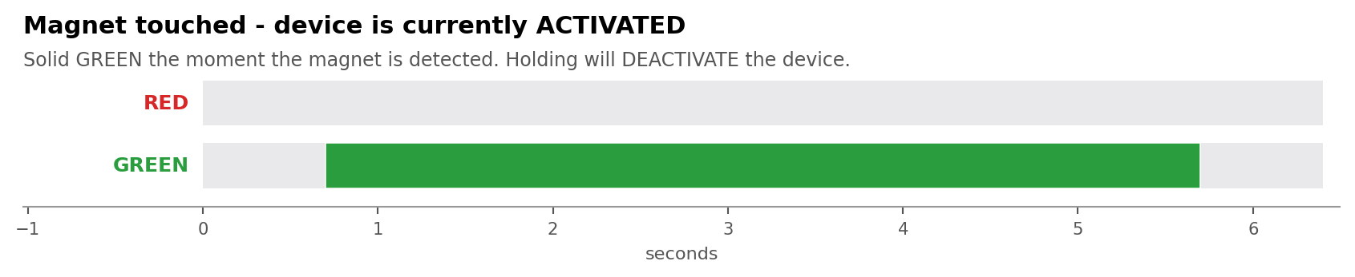
GREEN solid — the device is currently ACTIVE and recording. Holding the magnet will SHUT IT DOWN.
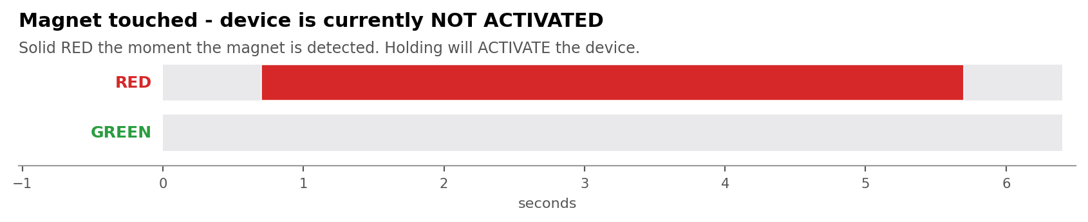
RED solid — the device is currently ASLEEP. Holding the magnet will START the deployment.
If neither light comes on when you touch the magnet, the device is not seeing it. Reposition the magnet and try again before assuming a fault.

The hold-and-release sequence
To prevent accidental activation, the device asks you to confirm with a deliberate pattern: hold the magnet on for five seconds, take it away for five seconds, and repeat until you have held it three times in total. Both lights blink together at every changeover, which is your cue to switch.
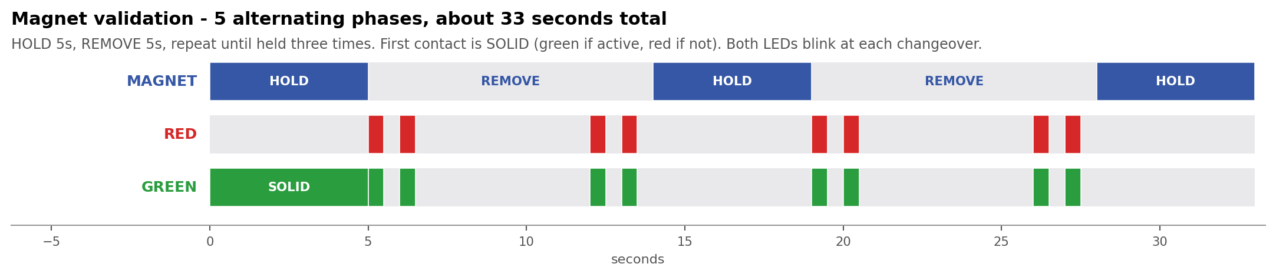
The whole sequence takes about 33 seconds. Do not rush it and do not let the magnet drift away mid-hold.

What you get at the end
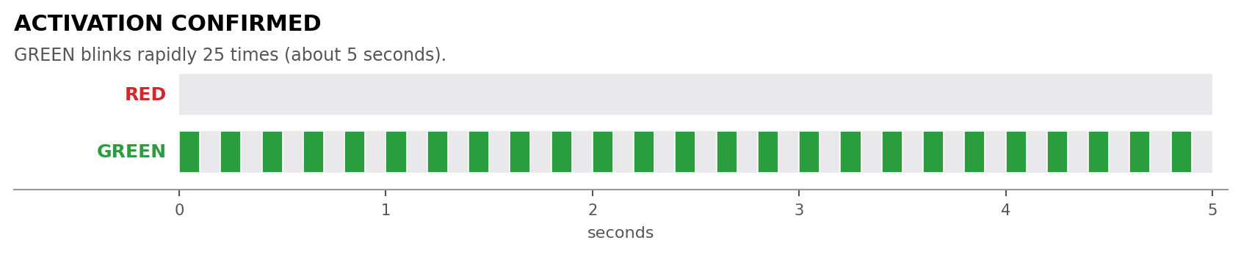
GREEN blinking fast, 25 times — the device is now ACTIVE.
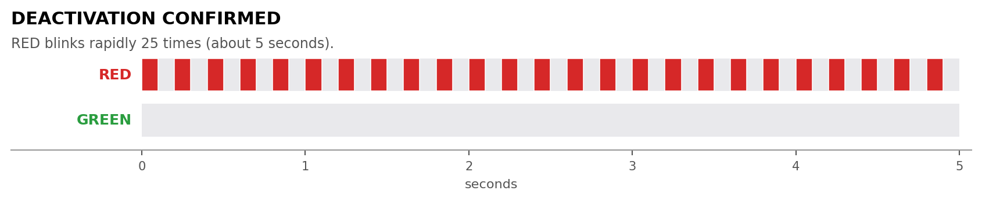
RED blinking fast, 25 times — the device is now ASLEEP. Safe to remove the card.
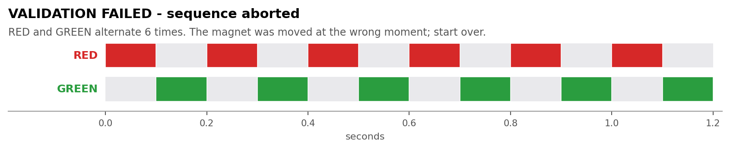
RED and GREEN alternating 6 times — the sequence was broken and nothing changed. The magnet moved at the wrong moment. Start again from the beginning.

2. The self test (runs right after you activate)
After a successful activation the device restarts and then checks its own hardware once. This takes about half a minute. You should stay with the device and watch it, because this is your only chance to confirm the microphone is working before you walk away.

Step 1 — the listening window opens
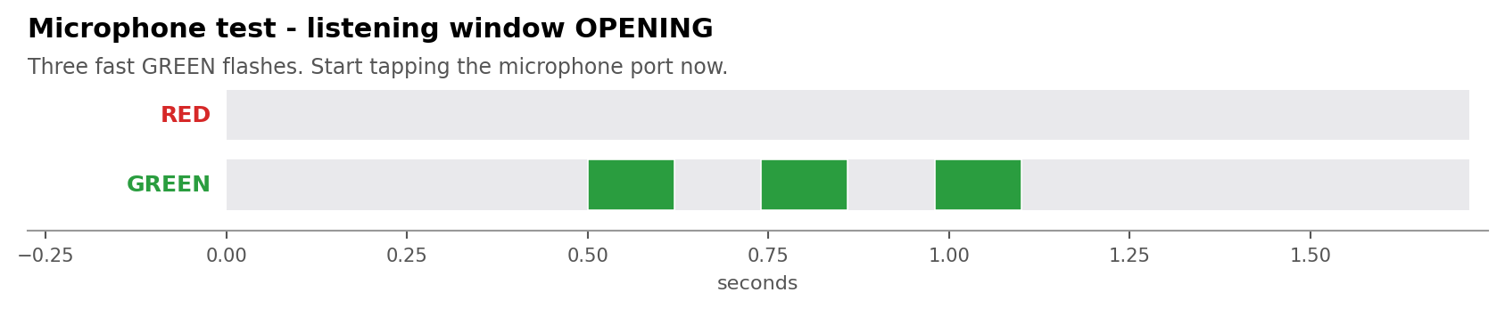
Three fast GREEN flashes. Start tapping the microphone port now.

Step 2 — tap the microphone
For the next 20 seconds the GREEN light follows the sound the microphone is hearing. Tap firmly next to the microphone port with a fingernail. The light should come on within about a tenth of a second of each tap and stay on briefly.
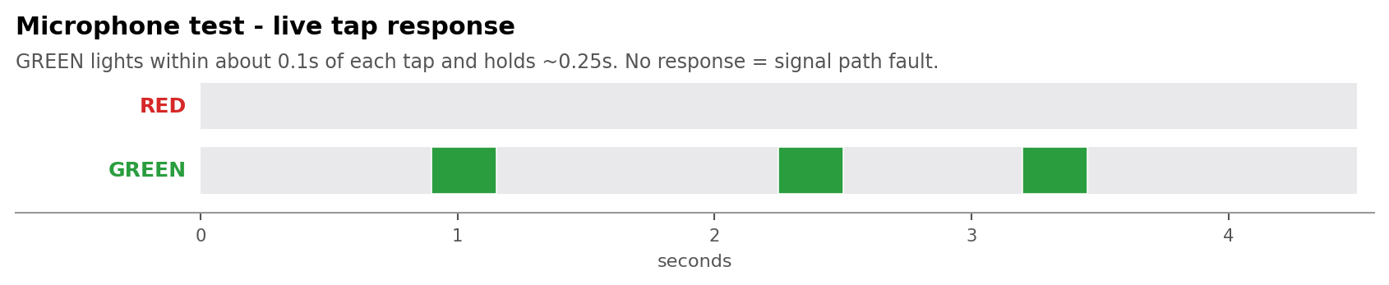
GREEN responds to each tap — the microphone is working.
If GREEN never lights, or if it is on solid the whole time regardless of what you do, the microphone signal path is faulty. Do not deploy the device; note the serial number and report it.

Step 3 — the listening window closes
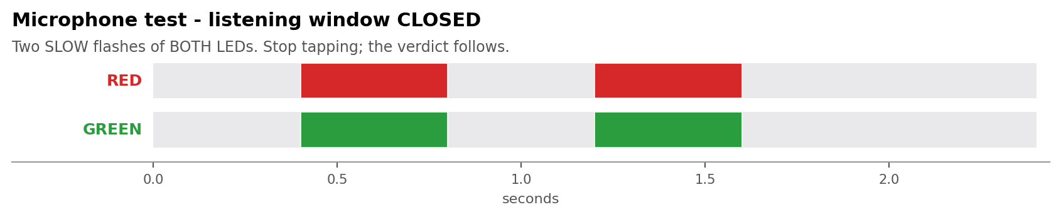
Two SLOW flashes of BOTH lights. Stop tapping. The verdict comes next.

Step 4 — the verdict
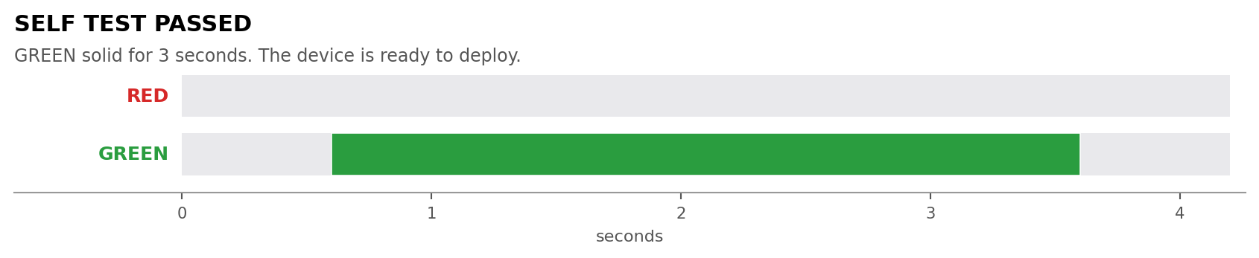
GREEN solid for 3 seconds — everything passed. The device is ready to deploy.
If anything failed you get a RED fault code instead. Read the next section carefully.

3. Reading a self-test fault code
A fault code is a LONG RED pulse, then a few SHORT RED blinks, then a pause. It repeats three times so you can check your count. The number of SHORT blinks is the fault code.
Count the short blinks, not the long pulse, and not the number of repeats.
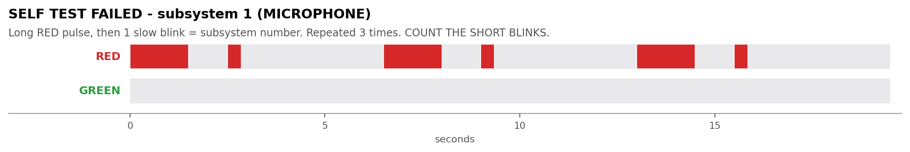
One short blink after each long pulse = fault code 1, MICROPHONE.
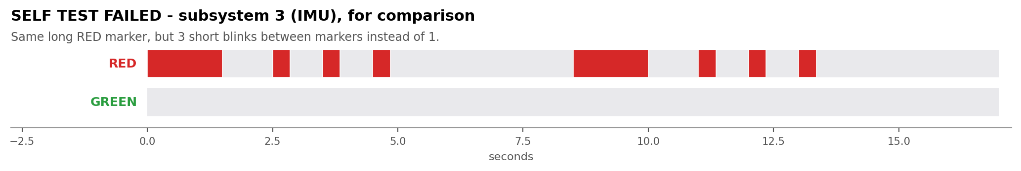
Three short blinks after each long pulse = fault code 3, IMU. Compare the two diagrams above — the long pulses are identical, only the short blinks differ.
Blinks | Subsystem | What it means | What to do
1 | Microphone | The microphone is not producing usable audio | Do not deploy. Report the unit.
2 | SD card | The card could not be written and read back reliably | Reseat or replace the card, then re-activate.
3 | Motion sensor | The accelerometer is not reporting gravity correctly | Set the device on a flat surface and re-activate. If it repeats, report the unit.
4 | Power or clock | Battery voltage, temperature or clock is out of range | Check the battery and replace if low, then re-activate.

A device that fails its self test will still go on to record, but it is telling you that something is wrong. Treat any fault code as a reason not to leave that unit in the field.

4. Normal operation during a deployment
Once recording begins, the device settles into a repeating pattern. If the lights have been enabled in the configuration, each audio clip starts with three quick GREEN flashes, after which GREEN toggles slowly while audio is being written to the card.
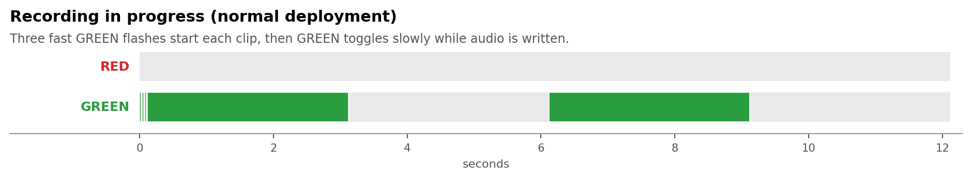
This is the pattern you should see on a healthy, actively recording device.
Note: lights are usually configured to switch off after the first hour of a deployment to save battery. A device that is dark after that point is not necessarily faulty.

Deactivating while it is recording
You can apply the magnet at any time during recording. The recording indications are suspended for as long as the magnet sequence is running, so the activation lights will not be interrupted by the clip flashes. Follow the hold-and-release sequence in section 1.

5. Fault indications at power-up
These appear when the device is first powered or restarts, before any recording starts.
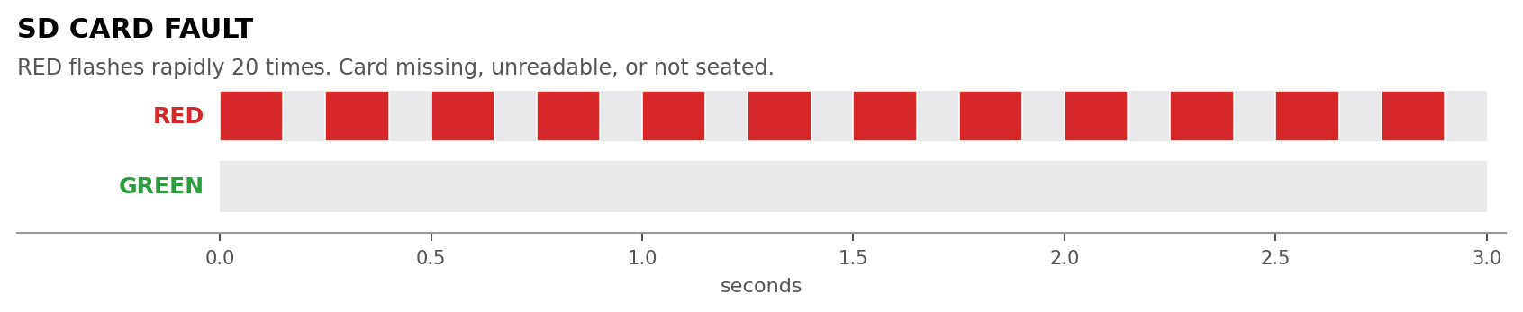
RED flashing rapidly about 20 times — SD CARD FAULT. The card is missing, not seated, or unreadable. Power the device down, reseat or replace the card, and power it back up.
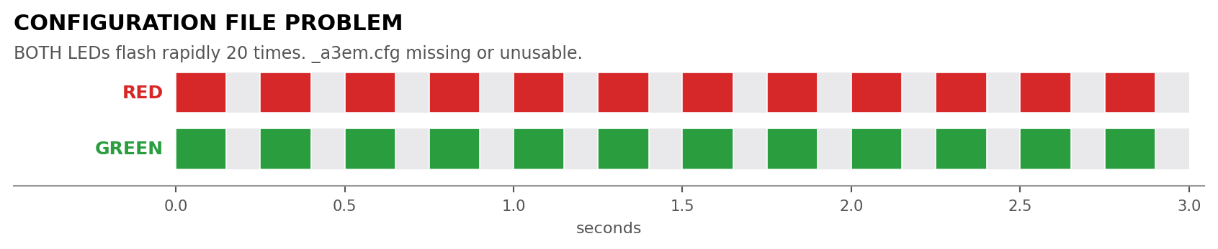
BOTH lights flashing rapidly about 20 times — CONFIGURATION PROBLEM. The card is readable but the deployment configuration file on it is missing or unusable. Re-write the card from the configurator and try again.

6. Quick reference
What you see | What it means
GREEN solid when magnet touched | Device is ACTIVE — holding will shut it down
RED solid when magnet touched | Device is ASLEEP — holding will start it
Both lights blink together | Changeover point — switch the magnet on or off now
GREEN fast blink x25 | Activation confirmed
RED fast blink x25 | Deactivation confirmed
RED / GREEN alternating x6 | Magnet sequence failed — start over
3 fast GREEN flashes | Microphone listening window opening — start tapping
GREEN following your taps | Microphone is working
2 slow flashes of both | Listening window closed
GREEN solid 3 seconds | Self test PASSED — ready to deploy
Long RED, then N short RED | Self test FAILED — N is the fault code (see section 3)
3 quick GREEN then slow toggle | Recording normally
RED fast x20 at power-up | SD card fault
Both fast x20 at power-up | Configuration file problem

Before you walk away from a device
- You saw the activation confirmation (GREEN fast blink x25).
- You tapped the microphone and saw GREEN respond to your taps.
- You saw GREEN solid for 3 seconds at the end of the self test.
- You did NOT see any RED fault code.
If any of those four is missing, the device is not confirmed good. Note the serial number and deal with it before leaving the site.

