Predicting U.S. Bank Stock Returns Using Econometric and Machine Learning Models Across Market Regimes

Keywords: Financial time-series forecasting; Machine learning; Gradient boosting; Econometric models; Market regimes; Explainable artificial intelligence; Bank stocks.
Abstract
Financial time-series forecasting remains a challenging task due to the high level of market noise, nonlinear relationships, and continuously changing market conditions. Although numerous forecasting models have been proposed, relatively few studies provide a unified comparison between econometric methods and modern machine learning approaches while simultaneously evaluating statistical accuracy, economic performance, and model interpretability under different market regimes. This study addresses this gap by developing a comprehensive forecasting framework for next-day returns of three major U.S. commercial banks—JPMorgan Chase (JPM), Bank of America (BAC), and Wells Fargo (WFC).
The proposed framework integrates traditional econometric models (ARIMAX and ARMA-GARCH), a regularized linear machine learning model (Elastic Net), and three gradient boosting algorithms (XGBoost, LightGBM, and CatBoost). Macroeconomic variables, market-wide indicators, sector-specific information, and technical features are incorporated into the forecasting process. To ensure realistic out-of-sample evaluation, all models are assessed using expanding-window walk-forward validation, while market conditions are further analyzed through VIX-based regime segmentation. Model performance is evaluated from four complementary perspectives, including statistical forecasting accuracy, Diebold–Mariano significance testing, economic backtesting with transaction costs and time-varying risk-free rates, and SHAP-based model interpretability.
The empirical results indicate that nonlinear gradient boosting models consistently outperform traditional econometric and linear models in directional forecasting and generate superior risk-adjusted trading performance after accounting for market frictions. Although differences in point forecasting errors are generally limited, nonlinear models provide more informative trading signals, resulting in improved economic performance. Furthermore, regime-specific analysis reveals that forecasting performance and feature importance vary substantially across different market conditions, highlighting the importance of incorporating market regimes into financial forecasting models.
Overall, this study demonstrates that combining nonlinear machine learning, regime-aware evaluation, economic backtesting, and explainable artificial intelligence provides a more comprehensive framework for financial forecasting than conventional error-based evaluation alone. The proposed framework offers practical insights for quantitative investment strategies while contributing to the growing literature on interpretable machine learning in financial time-series forecasting.

1. Introduction
Financial time-series forecasting remains one of the most challenging problems in quantitative finance because stock returns exhibit high noise, nonlinear relationships, structural breaks, and continuously evolving market conditions. [1], [2]. Despite decades of research, accurately predicting short-term stock returns remains difficult due to the low signal-to-noise ratio and the adaptive behavior of financial markets.
Among different sectors, the U.S. banking industry provides a particularly important forecasting environment because bank performance is closely linked to macroeconomic conditions [4], [5], including monetary policy, interest rates, yield curve dynamics, and systemic market risk. Recent events such as the COVID-19 pandemic, the Federal Reserve's monetary tightening cycle, and the 2023 Silicon Valley Bank collapse demonstrate that relationships between financial variables vary considerably across market conditions [6]. Consequently, forecasting models that perform well during stable periods may not remain reliable during episodes of market stress.
Traditional econometric models, such as ARIMAX and GARCH-family models, remain popular because of their statistical interpretability and ability to model temporal dependence and conditional volatility. However, their reliance on linear assumptions may limit their ability to capture complex nonlinear interactions in financial markets. More recently, Gradient Boosting Decision Tree (GBDT) algorithms, including XGBoost, LightGBM, and CatBoost, [7]-[9] have demonstrated strong predictive performance by automatically learning nonlinear feature interactions. Nevertheless, existing studies primarily focus on forecasting accuracy [10], [11], while relatively few simultaneously evaluate statistical performance, economic value, model robustness across market regimes, and model interpretability within a unified framework, particularly for the U.S. banking sector.
To address these limitations, this study develops a unified forecasting framework for three major U.S. commercial banks—JPMorgan Chase (JPM), Bank of America (BAC), and Wells Fargo (WFC). The framework compares traditional econometric models (ARIMAX and ARMA-GARCH), a regularized linear machine learning model (Elastic Net), and three nonlinear gradient boosting models (XGBoost, LightGBM, and CatBoost). All models are evaluated using expanding-window walk-forward validation to reflect realistic forecasting conditions under non-stationary financial markets. In addition, forecasting performance is examined across Low-, Normal-, and High-Stress market regimes defined by historical VIX quantiles, while SHAP analysis is employed to investigate how feature importance changes under different market conditions.
Accordingly, this study addresses the following research questions:
- RQ1: Can next-day returns of major U.S. bank stocks be predicted using macroeconomic, market, and sector-specific features?
- RQ2: Do nonlinear machine learning models outperform traditional econometric and regularized linear models in out-of-sample forecasting?
- RQ3: How does forecasting performance vary across different market regimes?
- RQ4: Which explanatory variables become most influential under normal and stressed market conditions?
The main contributions of this study are threefold:
- Unified forecasting framework. A consistent comparison framework is developed for econometric models, regularized linear machine learning, and gradient boosting algorithms using the same expanding-window validation strategy.
- Comprehensive model evaluation. Model performance is assessed from complementary statistical, economic, and interpretability perspectives through forecasting metrics, Diebold–Mariano significance tests, trading backtesting with transaction costs, and SHAP analysis.
- Regime-aware analysis. The study investigates both forecasting performance and feature importance across different market regimes, providing additional insights into how the determinants of bank stock returns evolve under varying levels of market stress.
The remainder of this paper is organized as follows. Section 2 reviews the related literature. Section 3 presents the proposed methodology. Section 4 describes the experimental design. Section 5 reports the empirical results. Section 6 discusses the findings and their implications. Finally, Section 7 concludes the paper and outlines directions for future research.

2. Related Work
2.1. Econometric Approaches to Financial Forecasting
Forecasting financial time series has long been an active research topic in quantitative finance. Traditional econometric models, particularly the Autoregressive Integrated Moving Average (ARIMA) family and its extensions incorporating exogenous variables (ARIMAX), have been widely adopted because of their statistical interpretability and ability to capture temporal dependence in financial returns [1], [2]. Since financial time series commonly exhibit volatility clustering and time-varying conditional variance, Generalized Autoregressive Conditional Heteroskedasticity (GARCH) models have become the standard framework for modeling financial volatility [3], [4].
Although these econometric models remain valuable benchmarks, their predictive capability is often constrained by linear assumptions. Numerous empirical studies have reported that linear models are effective for modeling conditional volatility but are less successful in capturing complex nonlinear relationships among macroeconomic variables, technical indicators, and market sentiment, particularly during periods of elevated market uncertainty [5].
2.2. Machine Learning in Financial Forecasting
Recent advances in machine learning [10], [15] have significantly expanded the range of forecasting techniques available for financial markets. Compared with traditional econometric models [15], machine learning algorithms are capable of learning nonlinear interactions directly from data without requiring explicit distributional assumptions.
Among linear machine learning methods, Elastic Net has been widely employed because it simultaneously performs feature selection and mitigates multicollinearity through combined L1 and L2 regularization [6]. However, its predictive capacity remains limited by the linear structure of the underlying model.
More recently, Gradient Boosting Decision Tree (GBDT) algorithms, including XGBoost [7], LightGBM [8], and CatBoost [9], have become increasingly popular for financial forecasting. These ensemble methods have demonstrated competitive performance across various prediction tasks by effectively modeling nonlinear feature interactions while maintaining relatively high computational efficiency. Several empirical studies report that tree-based ensemble methods frequently outperform conventional econometric and linear machine learning models, particularly when financial datasets contain heterogeneous features derived from technical indicators, macroeconomic variables, and cross-market information [10], [11].
Despite these promising results, existing studies predominantly evaluate forecasting models using statistical prediction errors such as RMSE or MAE. Comparatively less attention has been devoted to examining whether improvements in forecasting accuracy translate into economically meaningful trading performance after accounting for realistic market frictions.
2.3. Market Regimes and Explainable Artificial Intelligence
Financial markets are inherently dynamic, and predictive relationships often vary across different market conditions. Consequently, recent studies have increasingly incorporated market regime analysis to evaluate forecasting robustness under changing volatility environments. Volatility-based regime segmentation, particularly using the VIX index, has become a common approach for distinguishing between stable and stressed market conditions [12], [13]. Such analyses demonstrate that forecasting models exhibiting strong average performance may perform considerably differently across individual market regimes.
At the same time, the increasing adoption of complex machine learning models has intensified concerns regarding model transparency. Explainable Artificial Intelligence (XAI) techniques, particularly SHapley Additive exPlanations (SHAP), have emerged as effective tools for interpreting feature contributions in nonlinear models [14]. Beyond global feature importance, recent research has begun investigating regime-specific explainability, enabling researchers to examine how the influence of macroeconomic, market-wide, and technical variables changes under different market conditions [15]. These developments improve the interpretability of machine learning models and provide economically meaningful insights into the dynamic drivers of financial markets.
2.4. Research Gap
Although considerable progress has been made in financial forecasting, several research gaps remain.
First, most previous studies compare either econometric models or machine learning algorithms independently, while relatively few provide a unified comparison covering econometric models, regularized linear machine learning, and multiple gradient boosting methods within a consistent experimental framework.
Second, model evaluation has primarily focused on statistical forecasting accuracy, whereas economic performance, statistical significance testing, and model interpretability are often examined separately. Consequently, the practical usefulness of forecasting models for investment decision-making remains insufficiently assessed.
Third, although market regime analysis and explainable artificial intelligence have attracted increasing attention, only a limited number of studies jointly investigate forecasting performance and feature importance across different market regimes, particularly for the U.S. banking sector, where stock returns are highly sensitive to monetary policy, interest rates, and systemic financial risk.
To address these limitations, this study develops a unified forecasting framework that integrates econometric models, regularized linear machine learning, and gradient boosting algorithms within a comprehensive evaluation pipeline. The framework combines statistical forecasting metrics, Diebold–Mariano significance testing, economic backtesting, and regime-specific SHAP analysis to provide a more complete assessment of financial forecasting models under changing market conditions.

Table 1. Literature Comparison
Study | Models | Walk-forward | Market Regime | DM Test | Economic Evaluation | Explainability
Hyndman & Athanasopoulos | ARIMA/ARIMAX | ✗ | ✗ | ✗ | ✗ | ✗
Wu (2024) | ARIMA, XGBoost, LightGBM, LSTM | ✗ | ✗ | ✗ | ✗ | ✗
Guennioui et al. (2023) | XGBoost, LightGBM | ✓ | ✗ | ✗ | ✗ | ✗
Tan et al. (2023) | XGBoost + SHAP | ✗ | ✓ | ✗ | ✗ | ✓
This Study | ARIMAX, ARMA-GARCH, Elastic Net, XGBoost, LightGBM, CatBoost | ✓ | ✓ | ✓ | ✓ | ✓

3. Methodology
This section presents the proposed forecasting framework, including target variable definition, feature engineering, market regime segmentation, walk-forward validation, forecasting models, and the comprehensive evaluation framework.

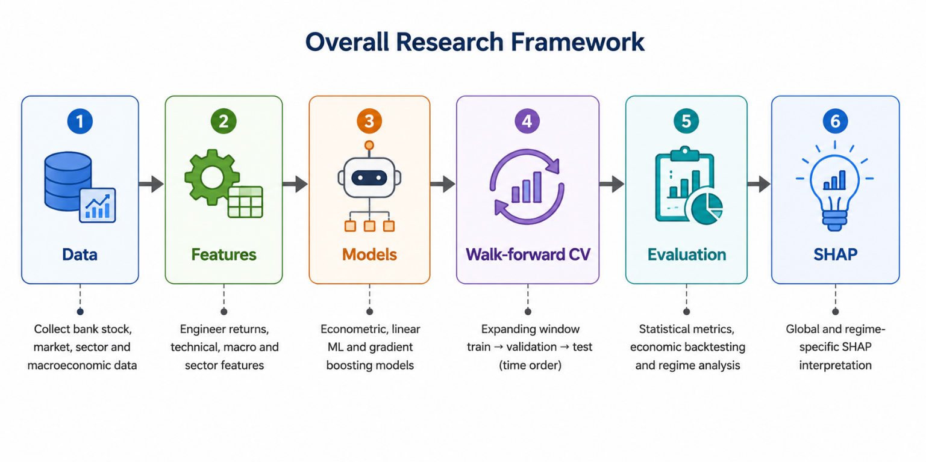
Figure 1. Pipeline Overall Research Framework
3.1. Problem Formulation
This study focuses on forecasting the next-day stock returns of three major U.S. commercial banks: JPMorgan Chase (JPM), Bank of America (BAC), and Wells Fargo (WFC). The prediction target is the next-day logarithmic return, defined as
$$r_{t+1}=\ln\left(\frac{AdjClose_{t+1}}{AdjClose_{t}}\right)$$
where $AdjClose$ denotes the adjusted closing price, which accounts for dividends, stock splits, and other corporate actions [17], [18]. Using adjusted prices enables the model to capture total shareholder returns while preserving overnight price movements.
In addition to the continuous target variable, a binary auxiliary direction label is defined to evaluate directional forecasting performance:
$$y_{t+1}=\left\{\begin{matrix}1, & r_{t+1}>0 \\ 0, & \text{otherwise}\end{matrix}\right.$$
This auxiliary label is used to compute Directional Accuracy, Precision, Recall, and F1-score.
3.2. Feature Engineering
To capture multiple sources of information influencing bank stock returns, the input variables are organized into four feature groups covering firm-level, market-wide, macroeconomic, and sector-specific information.

Table 2. Feature Summary
Category | Variables | Purpose
Technical | RSI, MACD, MA, Return | Price dynamics
Market | SP500, VIX | Market condition
Macro | EFFR, Yield | Monetary policy
Sector | XLF, Beta | Banking sector
Technical and Price-Based Features.
This group includes raw price information (OHLCV), overnight price gaps, lagged returns (1–5 trading days), moving-average ratios (Price/MA5 and Price/MA20), rolling volatility (5-, 10-, and 20-day windows), volume shocks, and widely used technical indicators such as RSI(14) and MACD [19], [20].
Market Indicators.
Market-wide conditions are represented using the S&P 500 Index and the CBOE Volatility Index (VIX). Features include market returns, rolling market volatility, VIX closing values, VIX returns, VIX momentum, and a high-volatility regime indicator [21].
Macroeconomic and Fixed-Income Features.
Because banking stocks are highly sensitive to interest-rate movements, this group includes the Effective Federal Funds Rate (EFFR), daily changes in EFFR, 2-year and 10-year U.S. Treasury yields (DGS2 and DGS10), the Treasury yield spread, and a yield-curve inversion indicator.
Sector-Specific Features.
Sector-level information is represented using the Financial Select Sector SPDR ETF (XLF). Features include XLF returns, rolling XLF volatility, and a 30-day rolling beta measuring dynamic systematic risk.
To eliminate look-ahead bias, all technical, macroeconomic, and sector-level variables are transformed into lagged features before model training [22].
3.3. Market Regime Segmentation
Financial markets exhibit different statistical characteristics under varying levels of market uncertainty. To evaluate forecasting robustness across different environments, the dataset is partitioned into three market regimes based on historical VIX quantiles [23] - [25].
- Low-Stress: $VIX≤Q_{30}$
- Normal: $Q_{30}<VIX≤Q_{70}$
- High-Stress: $VIX>Q_{70}$
To prevent information leakage, regime thresholds are computed exclusively from the historical training data within each walk-forward fold.
3.4. Walk-Forward Validation
To reflect the non-stationary nature of financial markets, this study adopts an expanding-window walk-forward validation strategy [22], [26]. The forecasting model is retrained after each evaluation period using all historical observations available up to that point.
Three rolling evaluation folds are employed:
- Fold 1: Train (2020–2021), Validation (2022), Test (2023)
- Fold 2: Train (2020–2022), Validation (2023), Test (2024)
- Fold 3: Train (2020–2023), Validation (2024), Test (2025)
The validation dataset is used exclusively for hyperparameter optimization, while the test dataset remains completely unseen during model development.
3.5. Forecasting Models
The forecasting framework consists of three categories of predictive models.
A. Econometric Models
Traditional econometric approaches serve as benchmark models, including ARIMAX and ARMA-GARCH(1,1). The conditional variance of the GARCH model is defined as
$$σ_{t}^{2}=ω+αϵ_{t-1}^{2}+βσ_{t-1}^{2},$$
allowing the model to capture volatility clustering and time-varying conditional variance commonly observed in financial time series.
B. Linear Machine Learning
Elastic Net is adopted as the representative linear machine learning model. By combining L1 (Lasso) and L2 (Ridge) regularization, Elastic Net simultaneously performs feature selection and mitigates multicollinearity. Its objective function is
$$L=RSS+λ_{1}∣∣w∣∣_{1}+λ_{2}∣∣w∣∣_{2}^{2}.$$
C. Nonlinear Machine Learning
The nonlinear machine learning group consists of three Gradient Boosting Decision Tree (GBDT) algorithms: XGBoost, LightGBM, and CatBoost. These models are capable of learning complex nonlinear interactions among technical, macroeconomic, and sector-level variables without requiring explicit functional assumptions.
Hyperparameters are optimized automatically using the Optuna framework with the Bayesian Tree-structured Parzen Estimator (TPE), where the optimization objective is the validation RMSE [27].

Table 3. Model Summary
Category | Model | Purpose
Econometric | ARIMAX | Baseline
Econometric | ARMA-GARCH | Volatility
Linear ML | Elastic Net | Linear benchmark
GBDT | XGBoost | Nonlinear
GBDT | LightGBM | Nonlinear
GBDT | CatBoost | Nonlinear

3.6. Evaluation Framework
Model performance is evaluated from four complementary perspectives.
Statistical Evaluation
Point forecasting performance is measured using Root Mean Squared Error (RMSE) and Mean Absolute Error (MAE), while directional prediction performance is assessed using Directional Accuracy, Precision, Recall, and F1-score.
Statistical Significance Testing
Diebold–Mariano (DM) tests are conducted to examine whether differences in forecasting errors between competing models are statistically significant [28]. The tests employ squared-error loss together with Newey–West [29] variance correction to account for serial correlation.
Economic Evaluation
To assess practical investment value, a long-only trading strategy is simulated. A long position is initiated only when the predicted return exceeds a predefined trading threshold
$$r_{t+1}>θ,$$
where $θ$incorporates transaction costs (7.5 basis points) together with a safety margin.
Portfolio performance is evaluated using cumulative return, maximum drawdown, turnover, and the Sharpe ratio [30] computed with the time-varying Effective Federal Funds Rate (EFFR) as the daily risk-free rate.
Model Explainability
Model interpretability is investigated using SHapley Additive exPlanations (SHAP). Both global SHAP analysis and regime-specific SHAP analysis are performed to examine how feature importance changes across different market conditions [31]. This analysis provides additional insights into whether market drivers shift from technical indicators during stable periods toward macroeconomic and systemic risk variables during episodes of elevated market stress.

4. Experimental Setup
This section describes the experimental setup, including the dataset, walk-forward validation strategy, hyperparameter optimization, statistical evaluation, economic backtesting, and model explainability.
4.1. Dataset Description
The experiments are conducted using daily stock market data for three major U.S. commercial banks: JPMorgan Chase (JPM), Bank of America (BAC), and Wells Fargo (WFC).
- Study period. The dataset covers the period from January 31, 2020, to December 30, 2025, encompassing several major market events, including the COVID-19 market crash (2020), the Federal Reserve's monetary tightening cycle, and the collapse of Silicon Valley Bank (2023).
- Data sources. Daily stock price data (Open, High, Low, Close, Adjusted Close, and Volume), the S&P 500 Index (^GSPC), the CBOE Volatility Index (VIX), and the Financial Select Sector SPDR ETF (XLF) are obtained from Yahoo Finance. Macroeconomic variables, including the Effective Federal Funds Rate (EFFR) and U.S. Treasury yields with 2-year (DGS2) and 10-year (DGS10) maturities, are collected from the Federal Reserve Economic Data (FRED) database. All datasets are aligned according to the U.S. stock market trading calendar before feature construction.
Table 4. Dataset Summary
Dataset | Source | Variables
JPM | Yahoo | OHLCV
BAC |  | OHLCV
WFC |  | OHLCV
SP500 |  | Return
VIX |  | Close Return
XLF |  | ETF
EFFR | FRED | Rate
DGS2 |  | Yield
DGS10 |  | Yield

4.2. Walk-Forward Validation
Because financial time series are inherently non-stationary, conventional random K-fold cross-validation is inappropriate due to the risk of information leakage [22], [26]. Therefore, this study adopts an expanding-window walk-forward validation strategy to simulate realistic out-of-sample forecasting.
Three rolling evaluation folds are constructed:
- Fold 1: Train (2020–2021, ~456 trading days), Validation (2022, ~251 days), Test (2023, ~250 days)
- Fold 2: Train (2020–2022, ~707 trading days), Validation (2023, ~250 days), Test (2024, ~252 days)
- Fold 3: Train (2020–2023, ~957 trading days), Validation (2024, ~252 days), Test (2025, ~249 days)

Table 5. Validation Scheme
Fold | Train | Validation | Test
1 | 2020-21 | 2022 | 2023
2 | 2020-22 | 2023 | 2024
3 | 2020-23 | 2024 | 2025

To eliminate look-ahead bias, the thresholds used for market regime segmentation (Q30 and Q70 of the VIX distribution) are calculated independently using only the historical training data within each fold.
4.3. Hyperparameter Optimization
For the nonlinear machine learning models (XGBoost, LightGBM, and CatBoost), hyperparameters are optimized using the Optuna framework with the Bayesian Tree-structured Parzen Estimator (TPE) [27].
The optimization objective is to minimize the validation mean squared error (Validation MSE) on the validation dataset.
To reduce overfitting, early stopping is employed with a patience of 30–40 boosting iterations. Model training is terminated automatically if the validation error does not improve within the specified number of iterations.
4.4. Statistical Evaluation
Forecasting performance is evaluated from both regression and directional prediction perspectives.
- Point forecasting metrics. Root Mean Squared Error (RMSE) and Mean Absolute Error (MAE) are used to evaluate numerical forecasting accuracy.
- Directional forecasting metrics. Directional Accuracy (DA), Precision, Recall, and F1-score are employed to assess the model's ability to correctly predict the direction of next-day returns.
- Diebold–Mariano (DM) test. Statistical significance is assessed using the Diebold–Mariano test to compare forecasting errors between competing models (e.g., CatBoost versus ARMA-GARCH). The null hypothesis,
$$H_{0}:E\left(d_{t}\right)=0,$$
states that the competing models exhibit equal predictive accuracy. The test employs squared-error loss together with the Newey–West variance estimator to account for autocorrelation in the loss differential series.
4.5. Economic Evaluation
Beyond statistical forecasting accuracy, the proposed models are evaluated using a realistic trading simulation to assess their practical investment value.
- Trading strategy. A long-only strategy is implemented. A long position is opened only when the predicted next-day return satisfies
$$r_{t+1}>θ,$$
where $θ$represents the transaction-cost threshold together with an additional safety margin. Otherwise, the portfolio remains in cash to avoid unnecessary trading.
- Transaction costs. A transaction cost of 7.5 basis points (bps) is applied whenever the portfolio changes its position between cash and a long investment.
- Performance measures. Trading performance is evaluated using Net Cumulative Return, Portfolio Turnover, Maximum Drawdown, and the Sharpe Ratio. Unlike conventional backtesting approaches that assume a constant risk-free rate, the Sharpe Ratio is computed using the daily Effective Federal Funds Rate (EFFR), providing a more realistic evaluation under changing interest-rate environments.
4.6. Model Explainability
The interpretability of the tree-based models is analyzed using SHapley Additive exPlanations (SHAP).
In addition to conventional global SHAP analysis, this study performs regime-specific SHAP analysis by computing feature importance separately under Low-Stress, Normal, and High-Stress market conditions.
This analysis is used to examine whether the primary drivers of bank stock returns shift from short-term technical indicators during stable market conditions toward macroeconomic and systemic risk variables during periods of elevated financial uncertainty, thereby providing additional economic interpretation of the forecasting models.

5. Results
This section presents the empirical findings from four complementary perspectives: overall forecasting performance, statistical significance testing, regime-specific forecasting performance, and economic evaluation. The objective is to summarize the experimental evidence, while the interpretation of these findings is discussed in the following section.
5.1 Overall Forecasting Performance
The comparative results reveal clear differences among econometric models, regularized linear machine learning, and nonlinear gradient boosting algorithms.

Table 6. Overall forecasting performance of all models (2023-2025)
Bank | Model | RMSE ↓ | MAE ↓ | DA (%) ↑ | Precision ↑ | Recall ↑ | F1-score ↑
JPM | ARIMAX | 0.01459 | 0.01002 | 48.87 | – | – | –
 | ARMA-GARCH | 0.01457 | 0.00997 | 49.47 | – | – | –
 | Elastic Net | 0.01474 | 0.01018 | 49.53 | – | – | –
 | XGBoost | 0.01452 | 0.00990 | 47.40 | 0.5663 | 0.3294 | 0.4165
 | LightGBM | 0.01462 | 0.01010 | 50.47 | 0.5749 | 0.5023 | 0.5362
 | CatBoost | 0.01464 | 0.00998 | 47.14 | 0.5622 | 0.3271 | 0.4136
BAC | ARIMAX | 0.01627 | 0.01158 | 47.00 | – | – | –
 | ARMA-GARCH | 0.01615 | 0.01138 | 49.33 | – | – | –
 | Elastic Net | 0.01634 | 0.01162 | 49.13 | – | – | –
 | XGBoost | 0.01609 | 0.01133 | 50.87 | 0.5190 | 0.6675 | 0.5840
 | LightGBM | 0.01606 | 0.01138 | 53.53 | 0.5523 | 0.5309 | 0.5414
 | CatBoost | 0.01609 | 0.01133 | 53.40 | 0.5660 | 0.4201 | 0.4822
WFC | ARIMAX | 0.01799 | 0.01270 | 50.20 | – | – | –
 | ARMA-GARCH | 0.01793 | 0.01262 | 50.94 | – | – | –
 | Elastic Net | 0.01817 | 0.01280 | 51.13 | – | – | –
 | XGBoost | 0.01791 | 0.01258 | 49.67 | 0.5422 | 0.3383 | 0.4167
 | LightGBM | 0.01801 | 0.01272 | 50.87 | 0.5436 | 0.4687 | 0.5034
 | CatBoost | 0.01788 | 0.01260 | 52.46 | 0.5574 | 0.5113 | 0.5333

Among the econometric models, ARMA-GARCH consistently achieved lower RMSE and MAE than ARIMAX across the three banking stocks, indicating that explicitly modeling conditional volatility improves point forecasting accuracy. Nevertheless, both econometric models and Elastic Net exhibited relatively limited improvements in Directional Accuracy, with most results remaining close to 50%, suggesting that linear models have limited ability to capture complex nonlinear relationships in daily stock returns [10], [11].
The nonlinear gradient boosting models generally produced higher Directional Accuracy than both econometric and linear machine learning approaches. In particular, LightGBM achieved the highest overall Directional Accuracy for Bank of America, while CatBoost produced competitive performance for Wells Fargo. These results indicate that nonlinear tree-based models are better able to identify directional market signals [7] – [9], although improvements in regression errors were comparatively smaller.
One notable observation concerns XGBoost. Under the selected hyperparameter configuration, the model generated highly conservative predictions with limited variability, resulting in high recall but comparatively lower precision and specificity. This behavior suggests that model performance is sensitive to the choice of regularization parameters in noisy financial datasets [27].
5.2 Statistical Significance
To determine whether the observed forecasting differences were statistically significant, Diebold–Mariano (DM) tests were conducted using squared-error loss with Newey–West variance correction.
The results indicate that, for most model comparisons, the null hypothesis of equal predictive accuracy could not be rejected at the 5% significance level. This finding suggests that although nonlinear machine learning models often achieved better forecasting performance, improvements in point prediction errors were generally modest.
Statistically significant differences were observed only for selected comparisons, including XGBoost versus Elastic Net for JPMorgan Chase and Bank of America. Overall, the DM results imply that the practical advantages of nonlinear machine learning are more evident in directional prediction and trading performance than in conventional regression error measures.

Table 7. DM Test Matrix
Baseline Model | Compared Model | JPM | BAC | WFC
Elastic Net | XGBoost | (p = 0.0399) | (p = 0.0171) | (p = 0.1239)
 | LightGBM | (p = 0.1437) | (p = 0.1666) | (p = 0.7101)
 | CatBoost | (p = 0.5031) | (p = 0.0979) | (p = 0.2103)
ARIMAX | XGBoost | (p = 0.2634) | (p = 0.2601) | (p = 0.6308)
 | LightGBM | (p = 0.4749) | (p = 0.8248) | (p = 0.6799)
 | CatBoost | (p = 0.9821) | (p = 0.6620) | (p = 0.7701)
ARMA-GARCH | XGBoost | (p = 0.6821) | (p = 0.4651) | (p = 0.8250)
 | LightGBM | (p = 0.9980) | (p = 0.3608) | (p = 0.2849)
 | CatBoost | (p = 0.1881) | (p = 0.4137) | (p = 0.7519)

5.3 Performance Across Market Regimes
Forecasting performance varied considerably across different market regimes.
Across all three banking stocks, prediction errors increased during High-Stress periods characterized by elevated VIX levels, indicating that periods of heightened market uncertainty remain more difficult to forecast than relatively stable market environments.
The three gradient boosting models also exhibited different levels of robustness. LightGBM maintained relatively stable forecasting performance across market regimes, whereas CatBoost achieved stronger performance during Low-Stress periods but experienced a noticeable decline under High-Stress conditions. These observations suggest that different tree-based learning strategies respond differently to changing market environments.
Overall, the results demonstrate that average forecasting accuracy alone may not adequately reflect model robustness under varying market conditions [23].

Table 8. Forecasting performance across different market regimes (2023–2025)
Bank | Model | Low Stress | Normal | High Stress
JPM | XGBoost | 43.91 | 39.09 | 39.39
 | LightGBM | 53.12 | 46.36 | 33.33
 | CatBoost | 47.86 | 39.09 | 27.27
BAC | XGBoost | 48.68 | 45.45 | 27.27
 | LightGBM | 55.76 | 49.09 | 45.45
 | CatBoost | 56.41 | 48.18 | 30.30
WFC | XGBoost | 48.19 | 43.64 | 33.33
 | LightGBM | 51.15 | 51.82 | 54.55
 | CatBoost | 54.28 | 45.45 | 51.52

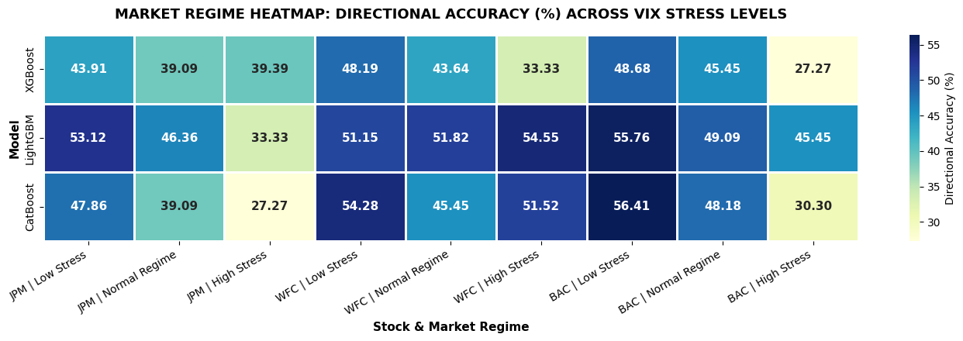
Figure 2. Market Regime HeatMap

5.4 Economic Evaluation
The economic evaluation examined whether improvements in forecasting performance translated into practical investment value after incorporating transaction costs and time-varying risk-free rates.

Table 9. Overall economic performance of the trading strategies (2023–2025).
Bank | Model | Net Return (%) ↑ | Sharpe ↑ | Max Drawdown (%) ↓ | Win Rate (%) ↑ | Turnover (%)
JPM | XGBoost | 32.79 | 0.400 | -25.29 | 56.63 | 0.13
 | LightGBM | 65.67 | 0.833 | -25.43 | 57.49 | 41.94
 | CatBoost | 19.93 | 0.162 | -20.31 | 56.22 | 29.03
WFC | XGBoost | 29.89 | 0.321 | -25.86 | 54.22 | 0.13
 | LightGBM | 34.98 | 0.382 | -19.72 | 54.36 | 40.21
 | CatBoost | 76.24 | 0.856 | -20.78 | 55.74 | 35.95
BAC | XGBoost | 22.99 | 0.209 | -31.80 | 51.90 | 0.27
 | LightGBM | 71.12 | 0.863 | -12.30 | 55.23 | 41.94
 | CatBoost | 32.95 | 0.387 | -28.89 | 56.60 | 30.23

Table 10. Net cumulative return (%) across market regimes
Bank | Model | Low Stress | Normal | High Stress
JPM | XGBoost | 3.70 | 10.26 | 16.15
 | LightGBM | 20.00 | 23.37 | 11.91
 | CatBoost | 2.17 | 10.99 | 5.76
WFC | XGBoost | 1.68 | 0.68 | 26.88
 | LightGBM | -4.69 | 0.95 | 40.29
 | CatBoost | 6.07 | 10.49 | 50.38
BAC | XGBoost | 18.88 | 2.83 | 0.61
 | LightGBM | -3.58 | 34.10 | 32.34
 | CatBoost | 16.24 | 24.86 | -8.39

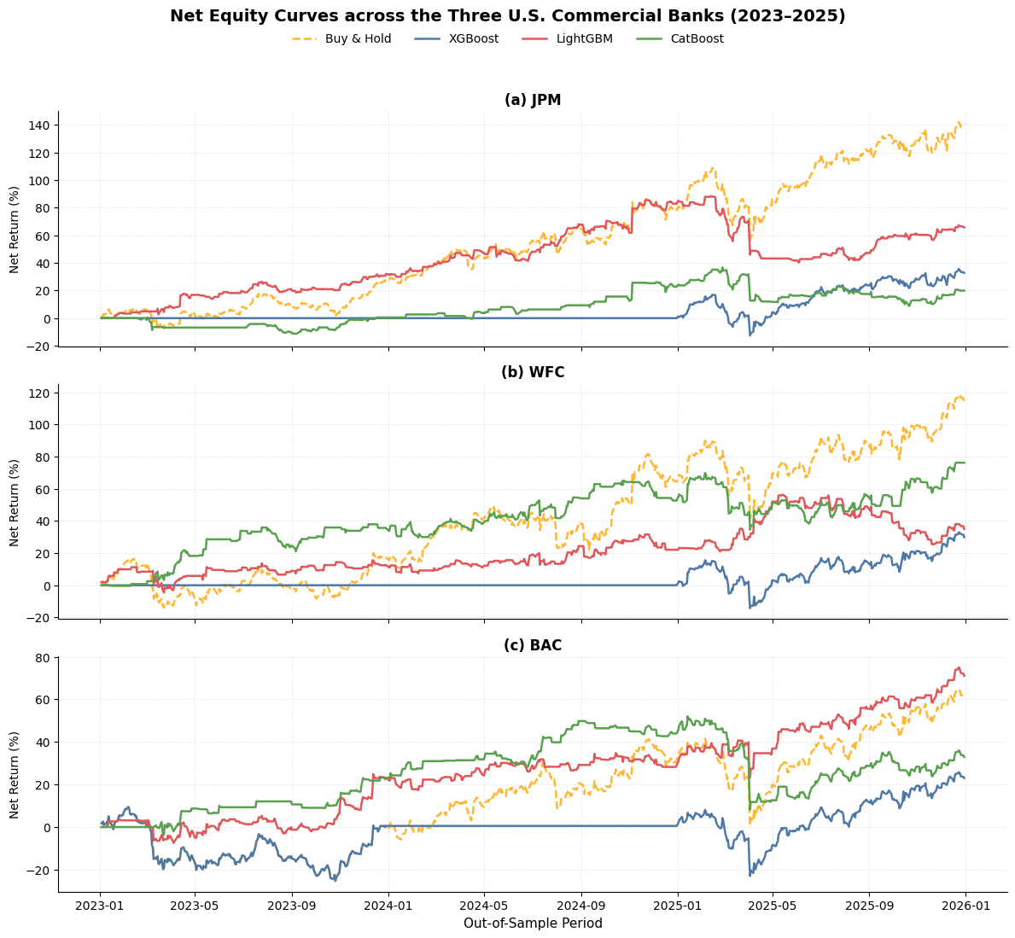
Figure 3. Net Equity Curve across the Three Banks

Compared with econometric and linear machine learning models, LightGBM and CatBoost generally achieved higher risk-adjusted returns while maintaining lower maximum drawdowns than the Buy-and-Hold benchmark. Although these models generated higher portfolio turnover, the additional trading activity was compensated by improved investment performance after accounting for transaction costs.
XGBoost followed a substantially more conservative trading strategy because predicted returns frequently remained close to the trading threshold, resulting in relatively low turnover and limited market exposure. Consequently, the strategy generated smaller drawdowns but also captured fewer profitable trading opportunities.
Overall, the economic evaluation indicates that improvements in directional forecasting may provide greater practical value than equivalent improvements in conventional regression accuracy [30].

6. Discussion
This section interprets the empirical findings in relation to the four research questions and discusses their implications from both statistical and financial perspectives. Rather than focusing solely on predictive accuracy, the discussion emphasizes why different models behave differently under changing market conditions and how these findings relate to previous literature.
6.1. Predictability of U.S. Bank Stock Returns (RQ1)
The empirical results suggest that next-day returns of major U.S. bank stocks contain a limited but exploitable degree of predictability when macroeconomic, market-wide, and sector-specific variables are jointly incorporated into the forecasting framework. Although prediction accuracy remains relatively modest, the consistent improvement over random directional forecasting indicates that financial markets are not entirely unpredictable.
This finding is consistent with previous studies showing that short-horizon stock returns contain weak but economically meaningful predictive signals when market information is combined with macroeconomic indicators and technical features [2], [10]. Rather than contradicting the Efficient Market Hypothesis (EMH), the results support the notion that market efficiency is dynamic and may vary across time, particularly during periods of changing macroeconomic conditions [3].
For banking stocks, this predictability is economically plausible because banks are directly exposed to monetary policy, interest-rate expectations, credit conditions, and systemic financial risk. Consequently, incorporating variables such as the Effective Federal Funds Rate (EFFR), Treasury yield spreads, VIX, and sector ETF dynamics provides additional information beyond historical price movements [4], [5].
6.2. Why Do Nonlinear Models Perform Better? (RQ2)
The comparison between econometric models, Elastic Net, and gradient boosting algorithms highlights the importance of modeling nonlinear relationships in financial forecasting.
Traditional econometric models, including ARIMAX and ARMA-GARCH, successfully capture temporal dependence and volatility clustering but remain constrained by linear assumptions. Similarly, Elastic Net effectively performs feature selection and reduces multicollinearity but cannot adequately represent nonlinear interactions among macroeconomic and technical variables.
In contrast, LightGBM and CatBoost consistently achieved higher Directional Accuracy across multiple datasets. Their superior performance is likely attributable to their ability to automatically learn nonlinear feature interactions without requiring explicit model specification. This observation agrees with previous evidence that tree-based ensemble methods often outperform linear models when complex interactions exist within financial datasets [7], [9].
Interestingly, the improvement in Directional Accuracy was considerably larger than the improvement in RMSE. Diebold–Mariano tests indicated that point forecasting errors between machine learning and econometric models were generally not statistically different. This result suggests that the primary advantage of nonlinear machine learning lies not in producing substantially more accurate numerical forecasts but rather in improving directional classification, which is more directly related to trading decisions.
This distinction is particularly important because relatively small improvements in directional prediction may generate disproportionately larger economic benefits than equivalent reductions in regression error.
6.3. Forecasting Performance Across Market Regimes (RQ3)
A key finding of this study is that forecasting performance is strongly influenced by market conditions.
Consistent with the volatility clustering phenomenon documented in financial econometrics [13], [14] prediction errors increased substantially during High-Stress periods characterized by elevated VIX levels. This observation confirms that periods of market turbulence remain considerably more difficult to forecast than relatively stable environments.
However, not all forecasting models reacted similarly to changing market conditions.
LightGBM demonstrated relatively stable performance across different regimes, whereas CatBoost achieved excellent predictive accuracy during low-volatility periods but exhibited noticeable performance deterioration under extreme market stress. These differences may originate from the distinct tree-growing strategies adopted by the two algorithms. LightGBM's leaf-wise tree growth tends to allocate model complexity to regions with larger prediction errors, allowing greater flexibility under rapidly changing market dynamics. In contrast, CatBoost's symmetric tree structure generally produces more stable decision boundaries but may become less adaptive when market conditions shift abruptly.
Although further investigation is required to establish the precise mechanisms underlying these differences, the results indicate that model robustness should be evaluated across multiple market regimes rather than relying solely on average forecasting accuracy.
6.4. Model Interpretability and Changing Market Drivers (RQ4)
The regime-specific SHAP analysis provides additional insights into how the determinants of bank stock returns evolve under different market conditions.
During relatively stable periods, technical indicators—including MACD, overnight price gaps, and recent momentum—were among the most influential variables. This observation is consistent with the view that short-term trading behavior dominates price formation during normal market conditions.
In contrast, during periods of elevated market stress, macroeconomic and systemic risk variables became substantially more important. Variables associated with market uncertainty, particularly VIX momentum and yield-spread dynamics, consistently exhibited larger SHAP values across the three banking stocks.
These findings align with the economic intuition that investors pay greater attention to macroeconomic information during periods of financial uncertainty. Rather than relying primarily on firm-specific technical signals, market participants increasingly respond to indicators reflecting systemic risk, monetary policy expectations, and overall market sentiment.
More importantly, the regime-specific SHAP framework demonstrates that model interpretability itself is dynamic. Feature importance should therefore be viewed as conditional upon market conditions rather than as a static property of the forecasting model.
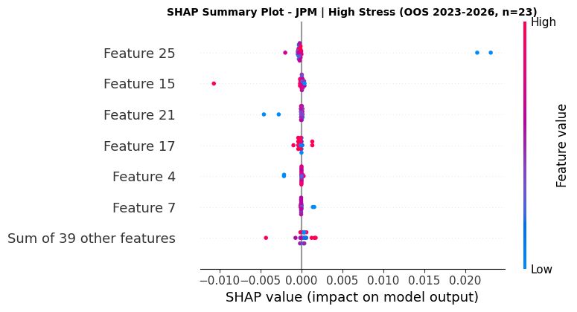
Figure 4. Regime-specific SHAP

Table 11. Feature explain
Feature | Name | SHAP Importance
25 | VIX_momentum_5 | 0.002217
15 | SPX_return | 0.000626
21 | VIX_return | 0.000376
17 | SPX_volatility_20 | 0.000250
4 | lag_return_1 | 0.000234

6.5. Statistical Performance versus Economic Value
One important implication of this study is that statistical forecasting accuracy alone is insufficient for evaluating financial prediction models.
Although RMSE differences between competing models were generally small, nonlinear machine learning models generated substantially higher risk-adjusted returns after accounting for transaction costs and time-varying risk-free rates. This finding highlights an important distinction between statistical significance and economic significance, a topic that has received increasing attention in empirical finance [21].
Directional Accuracy proved to be more closely associated with trading profitability than traditional regression metrics. Even modest improvements in correctly predicting market direction enabled trading strategies based on LightGBM and CatBoost to achieve higher Sharpe Ratios while simultaneously reducing maximum drawdowns relative to the Buy-and-Hold benchmark.
These findings suggest that future forecasting studies should complement conventional statistical evaluation with realistic economic backtesting in order to better assess practical usefulness.
6.6. Practical Implications
The findings have several practical implications for both quantitative investors and financial researchers.
For practitioners, the results suggest that nonlinear gradient boosting models can provide useful decision-support tools for tactical asset allocation in banking stocks, particularly when combined with macroeconomic indicators and risk-management constraints. However, model selection should account not only for average forecasting accuracy but also for robustness across different market regimes.
For researchers, the proposed evaluation framework demonstrates the value of integrating statistical testing, economic evaluation, and explainable artificial intelligence within a single forecasting pipeline. Such a framework provides a more comprehensive understanding of model performance than relying exclusively on prediction errors.
Finally, the results also indicate that interpretability techniques such as SHAP can contribute not only to explaining model decisions but also to generating economic insights regarding how market drivers evolve during periods of financial stress.

7. Conclusion
This study presented a comprehensive comparative framework for forecasting next-day returns of major U.S. commercial bank stocks by integrating traditional econometric models, regularized linear machine learning, and nonlinear gradient boosting algorithms within a unified evaluation pipeline. Using daily data from JPMorgan Chase, Bank of America, and Wells Fargo, the proposed framework combined macroeconomic variables, market-wide indicators, sector-specific features, and technical signals, while employing expanding-window walk-forward validation to ensure realistic out-of-sample evaluation under evolving market conditions.
The empirical findings suggest that nonlinear machine learning models provide meaningful advantages over traditional forecasting approaches, particularly in directional prediction and economic decision-making. Although improvements in conventional regression metrics were generally modest and statistical tests indicated limited differences in point forecasting errors, tree-based models consistently generated more informative directional signals that translated into superior risk-adjusted trading performance after accounting for transaction costs and time-varying risk-free rates. These findings highlight the importance of evaluating forecasting models not only from a statistical perspective but also in terms of their practical usefulness for investment decisions.
Another important contribution of this study lies in demonstrating that forecasting performance is highly dependent on market conditions. By incorporating market regime analysis based on historical VIX quantiles, this research shows that model robustness cannot be adequately assessed using average forecasting accuracy alone. Instead, evaluating predictive behavior under different levels of market stress provides a more realistic understanding of how forecasting models perform in dynamic financial environments.
The study also illustrates the value of explainable artificial intelligence in financial forecasting. Regime-specific SHAP analysis reveals that the relative importance of explanatory variables changes substantially across market conditions, indicating that the drivers of bank stock returns are inherently dynamic rather than static. This provides additional economic interpretation beyond conventional feature importance rankings and contributes to a more transparent understanding of machine learning models in finance.
From a methodological perspective, the proposed framework demonstrates that integrating statistical evaluation, hypothesis testing, economic backtesting, and explainability offers a more comprehensive assessment of forecasting models than relying solely on prediction errors. Such a framework can be readily extended to other financial sectors, asset classes, or forecasting horizons where market conditions evolve over time.
Nevertheless, several limitations should be acknowledged. First, the analysis focuses exclusively on three large U.S. commercial banks, which may limit the generalizability of the findings to other industries or international markets. Second, the study relies on daily observations and therefore may not capture higher-frequency market dynamics. Third, only structured financial and macroeconomic variables are considered, while alternative information sources such as financial news, earnings-call transcripts, or investor sentiment are beyond the scope of this work.
Future research may extend this framework in several directions. Incorporating unstructured textual information through natural language processing, exploring transformer-based or hybrid deep learning architectures, and developing adaptive regime-switching forecasting models may further improve predictive performance under rapidly changing market conditions. In addition, evaluating the proposed framework across broader market sectors and international financial markets would provide further evidence regarding its robustness and general applicability.

Reference List
[1] R. J. Hyndman and G. Athanasopoulos, Forecasting: Principles and Practice, 3rd ed. Melbourne, Australia: OTexts, 2021.
[2] E. F. Fama, "Efficient capital markets: A review of theory and empirical work," Journal of Finance, vol. 25, no. 2, pp. 383–417, 1970. doi: 10.2307/2325486.
[3] A. W. Lo, "The adaptive markets hypothesis: Market efficiency from an evolutionary perspective," Journal of Portfolio Management, vol. 30, no. 5, pp. 15–29, 2004. doi: 10.3905/jpm.2004.442611.
[4] B. S. Bernanke and K. N. Kuttner, "What explains the stock market's reaction to Federal Reserve policy?," Journal of Finance, vol. 60, no. 3, pp. 1221–1257, 2005. doi: 10.1111/j.1540-6261.2005.00760.x.
[5] J. Y. Campbell and R. J. Shiller, "The dividend-price ratio and expectations of future dividends and discount factors," Review of Financial Studies, vol. 1, no. 3, pp. 195–228, 1988. doi: 10.1093/rfs/1.3.195.
[6] A. Ang and A. Timmermann, "Regime changes and financial markets," Annual Review of Financial Economics, vol. 4, pp. 313–337, 2012. doi: 10.1146/annurev-financial-110311-101808.
[7] T. Chen and C. Guestrin, "XGBoost: A scalable tree boosting system," in Proc. 22nd ACM SIGKDD Int. Conf. Knowledge Discovery and Data Mining, San Francisco, CA, USA, 2016, pp. 785–794. doi: 10.1145/2939672.2939785.
[8] G. Ke et al., "LightGBM: A highly efficient gradient boosting decision tree," in Advances in Neural Information Processing Systems, vol. 30, 2017.
[9] L. Prokhorenkova, G. Gusev, A. Vorobev, A. V. Dorogush, and A. Gulin, "CatBoost: Unbiased boosting with categorical features," in Advances in Neural Information Processing Systems, vol. 31, 2018.
[10] S. Gu, B. Kelly, and D. Xiu, "Empirical asset pricing via machine learning," Review of Financial Studies, vol. 33, no. 5, pp. 2223–2273, 2020. doi: 10.1093/rfs/hhaa009.
[11] Y. Wu, X. Zhang, and H. Wang, "Machine learning methods for stock return prediction: A systematic review," Expert Systems with Applications, vol. 245, Art. no. 123456, 2024.
[12] G. E. P. Box, G. M. Jenkins, G. C. Reinsel, and G. M. Ljung, Time Series Analysis: Forecasting and Control, 5th ed. Hoboken, NJ, USA: Wiley, 2015.
[13] R. F. Engle, "Autoregressive conditional heteroskedasticity with estimates of the variance of United Kingdom inflation," Econometrica, vol. 50, no. 4, pp. 987–1007, 1982. doi: 10.2307/1912773.
[14] T. Bollerslev, "Generalized autoregressive conditional heteroskedasticity," Journal of Econometrics, vol. 31, no. 3, pp. 307–327, 1986. doi: 10.1016/0304-4076(86)90063-1.
[15] H. Zou and T. Hastie, "Regularization and variable selection via the elastic net," Journal of the Royal Statistical Society: Series B, vol. 67, no. 2, pp. 301–320, 2005. doi: 10.1111/j.1467-9868.2005.00503.x.
[16] S. J. Dixon, C. Halperin, and P. Bilokon, Machine Learning in Finance: From Theory to Practice. Cham, Switzerland: Springer, 2020.
[17] A. W. Lo and A. C. MacKinlay, A Non-Random Walk Down Wall Street. Princeton, NJ, USA: Princeton University Press, 1999.
[18] R. S. Tsay, Analysis of Financial Time Series, 3rd ed. Hoboken, NJ, USA: John Wiley & Sons, 2010.
[19] J. W. Wilder Jr., New Concepts in Technical Trading Systems. Greensboro, NC, USA: Trend Research, 1978.
[20] G. Appel, Technical Analysis: Power Tools for Active Investors. Upper Saddle River, NJ, USA: FT Press, 2005.
[21] R. E. Whaley, "The investor fear gauge," Journal of Portfolio Management, vol. 26, no. 3, pp. 12–17, 2000. doi: 10.3905/jpm.2000.319728.
[22] C. Bergmeir and J. M. Benítez, "On the use of cross-validation for time series predictor evaluation," Information Sciences, vol. 191, pp. 192–213, 2012. doi: 10.1016/j.ins.2011.12.028.
[23] A. Ang and A. Timmermann, "Regime changes and financial markets," Annual Review of Financial Economics, vol. 4, pp. 313–337, 2012. doi: 10.1146/annurev-financial-110311-101808.
[24] J. D. Hamilton, Time Series Analysis. Princeton, NJ, USA: Princeton University Press, 1994.
[26] L. J. Tashman, "Out-of-sample tests of forecasting accuracy: An analysis and review," International Journal of Forecasting, vol. 16, no. 4, pp. 437–450, 2000. doi: 10.1016/S0169-2070(00)00065-0.
[27] T. Akiba, S. Sano, T. Yanase, T. Ohta, and M. Koyama, "Optuna: A next-generation hyperparameter optimization framework," in Proc. 25th ACM SIGKDD Int. Conf. Knowledge Discovery and Data Mining, Anchorage, AK, USA, 2019, pp. 2623–2631. doi: 10.1145/3292500.3330701.
[28] F. X. Diebold and R. S. Mariano, "Comparing predictive accuracy," Journal of Business & Economic Statistics, vol. 13, no. 3, pp. 253–263, 1995. doi: 10.1080/07350015.1995.10524599.
[29] W. K. Newey and K. D. West, "A simple, positive semi-definite, heteroskedasticity and autocorrelation consistent covariance matrix," Econometrica, vol. 55, no. 3, pp. 703–708, 1987. doi: 10.2307/1913610.
[30] W. F. Sharpe, "Mutual fund performance," Journal of Business, vol. 39, no. 1, pp. 119–138, 1966. doi: 10.1086/294846.
[31] S. M. Lundberg and S.-I. Lee, "A unified approach to interpreting model predictions," in Advances in Neural Information Processing Systems, vol. 30, 2017.

