A FIELD PROJECT REPORT ON

BLOOD DONATION MANAGEMENT SYSTEM
Submitted
in partial fulfilment of the requirements for the award of the degree

BACHELOR OF TECHNOLOGY
In
COMPUTER SCIENCE AND ENGINEERING

By

Pranith | 241FA04307
Kowsar | 241FA04361
Sravan | 241FA04553
Karthikeya | 241FA04943

Under the Guidance of
Ms. Prashanthi


Department of Computer Science and Engineering
School of Computing and Informatics
Vignan’s Foundation for Science, Technology and Research (Deemed to be University) Vadlamudi, Guntur, Andhra Pradesh-522213, India.
April – 2026



CERTIFICATE

This is to certify that the field project entitled “ BLOOD DONATION MANAGEMENT SYSTEM” is being submitted Pranith (241FA04307), Kowsar (241FA04361), Sravan (241FA04553),Karthikeya (241FA049) in partial fulfilment of the requirements for the degree of Bachelor of Technology (B.Tech) in Computer Science and Engineering at Vignan’s Foundation For Science Technology & Research (Deemed to be University), Vadlamudi, Guntur District, Andhra Pradesh, India.
This is a bonafide work carried out by the aforementioned students under my guidance and supervision.

Guide

Project Review Committee | Head of the Department



DECLARATION
Date: 29-04-2026
We hereby declare that the work presented in the field project titled “ BLOOD DONATION MANAGEMENT SYSTEM”, is the result of our own efforts and investigation. This project is being submitted under the supervision Ms. V. Nandini, CSE, in partial fulfilment of the requirements for the Bachelor of Technology (B.Tech) degree in Computer Science and Engineering at Vignan’s Foundation for Science, Technology and Research (Deemed to be University), Vadlamudi, Guntur, Andhra Pradesh.

Pranith | (241FA04307) | Signature
Kowsar | (241FA04361) | Signature
Sravan | (241FA04553) | Signature
Karthikeya | (241FA04943) | Signature

 |  |  | 
 |  |  | 5
5
5
 |  |  | 6
 |  |  | 6 - 7
 |  |  | 7
 |  |  | 8
 |  |  | 8
 |  |  | 8 - 9
 |  |  | 9 - 10
 |  |  | 10
 |  |  | 11
 |  |  | 11 - 12
 |  |  | 12 - 27
 |  |  | 27
 |  |  | 28
 |  |  | 28 - 29
 |  |  | 29
33
30
1.INTRODUCTION

The Blood Donor Management System is a web-based application designed to simplify and organize the process of collecting, storing, and retrieving information about blood donors. In emergency situations, finding the right blood group at the right time is critical, and manual methods often lead to delays and inefficiencies. This system provides a centralized platform where donor details such as name, contact information, blood group, and location can be stored and accessed quickly, helping to save valuable time and lives.
Traditionally, blood donation records have been maintained manually or through disconnected systems, making it difficult to search and manage data efficiently. The proposed system addresses these challenges by digitizing the entire process and enabling users to easily register as donors and search for available donors based on specific requirements. By leveraging web technologies, the system ensures accessibility from anywhere, making it a practical solution for hospitals, blood banks, and individuals in need.
Furthermore, the Blood Donor Management System enhances communication between donors and recipients by providing a user-friendly interface and quick search functionality. It reduces dependency on intermediaries and increases the chances of finding suitable donors in critical situations. With future enhancements such as real-time notifications and location-based services, the system can become an even more powerful tool in supporting healthcare services and promoting voluntary blood donation

  - PROBLEM STATEMENT

In many emergency medical situations, the timely availability of the required blood group is a critical factor in saving lives. However, the current system for managing blood donor information is often manual, unorganized, and inefficient. Hospitals and blood banks frequently face difficulties in maintaining accurate and up-to-date records of donors, which leads to delays in identifying suitable donors during urgent situations. This lack of a centralized and easily accessible system creates confusion and can result in life-threatening delays.
Additionally, there is no efficient mechanism for individuals in need to quickly search for donors based on specific criteria such as blood group and location. Existing methods rely heavily on personal contacts, phone calls, or social media, which are unreliable and time-consuming. The absence of a proper digital platform limits communication between donors and recipients, reducing the chances of timely blood donation.
Therefore, there is a need for a web-based Blood Donor Management System that can store, manage, and retrieve donor information efficiently. The system should provide a user-friendly interface for donor registration and enable quick searching of donors based on requirements. By addressing these issues, the proposed system aims to improve response time, enhance accessibility, and ultimately help in saving lives.

1.2 EXISTING SYSTEM

The existing system for managing blood donor information is largely based on manual methods and basic record-keeping techniques. In many hospitals and blood banks, donor details are stored in physical registers or simple spreadsheets. These methods are prone to errors, data loss, and difficulty in updating records. Searching for a specific donor or blood group in such systems is time-consuming and inefficient, especially during emergency situations where quick access is crucial.
In addition to manual records, people often rely on informal communication channels such as phone calls, personal contacts, and social media platforms to find blood donors. While these methods can sometimes be helpful, they are not reliable or systematic. There is no guarantee of accuracy, availability, or timely response from donors. This lack of a structured system creates confusion and delays in critical moments.
Furthermore, the existing system does not provide centralized access to donor information, making it difficult to share and manage data across different locations. There is also no proper mechanism for real-time updates or filtering donors based on specific criteria like location or availability. Due to these limitations, the current system fails to meet the growing demand for efficient and quick blood donor management, highlighting the need for a more advanced and automated solution.

1.3 PROPOSED SYSTEM

The proposed system is a web-based Blood Donor Management System designed to overcome the limitations of the existing manual and unorganized methods. This system provides a centralized platform where donor information can be securely stored, updated, and accessed in real time. Users can easily register as blood donors by entering their details such as name, contact number, blood group, and location. The system ensures that all data is maintained in a structured format, reducing errors and improving efficiency.
One of the key features of the proposed system is its fast and flexible search functionality. Users can quickly find suitable donors by filtering based on blood group and location, which is especially useful during emergencies. The system also provides a user-friendly interface, making it easy for both technical and non-technical users to operate. By automating the process of data storage and retrieval, the system significantly reduces the time required to locate donors and improves overall response time.
In addition, the proposed system can be further enhanced with advanced features such as login authentication, real-time notifications, and integration with hospital or blood bank databases. It can also support mobile access, allowing users to search for donors anytime and anywhere. Overall, the proposed system aims to create an efficient, reliable, and accessible solution that improves blood donation management and helps save lives.

1.4 LITERATURE REVIEW
Several research studies have been conducted to improve the efficiency of blood donation and management systems. A study on blood donation system management highlights that blood is a limited and critical healthcare resource, requiring efficient handling across stages such as collection, storage, and distribution. Researchers emphasize the importance of optimization techniques in managing blood supply chains, including donor allocation and transportation, to ensure adequate availability and minimize wastage.
Recent works focus on the development of web-based platforms for blood donor management. A 2025 study proposes a centralized web system that connects donors, patients, and administrators, enabling donor registration, data storage, and quick search functionality based on blood group and location. Such systems improve accessibility and reduce delays during emergencies by providing real-time information and better communication between users.
Another research project titled “Donor Dreams” highlights the challenges of traditional methods, where finding suitable donors is time-consuming and fragmented. The study proposes a web application that integrates blood banks and donors into a single platform, helping users track blood availability and locate donors efficiently. This approach significantly enhances the speed and reliability of the blood donation process.
In addition, studies on blood bank management systems show the importance of maintaining accurate donor records, tracking blood inventory, and ensuring proper database management. These systems use technologies such as DBMS and web frameworks to automate operations, reduce human errors, and improve overall efficiency in managing blood-related data.
Furthermore, research on mobile applications for blood donation reveals that digital platforms can play a crucial role in attracting and retaining donors. Mobile apps and online systems help increase awareness, provide notifications, and encourage voluntary participation, especially among younger populations.
Overall, the literature indicates that transitioning from manual systems to web-based and mobile-enabled solutions significantly improves the effectiveness of blood donor management. However, challenges such as data accuracy, donor availability, and system scalability still exist, highlighting the need for continuous improvement and innovation in this field.

2.SYSTEM REQUIREMENTS
The system requirements define the hardware and software specifications needed to develop and run the Blood Donor Management System.

  - HARDWARE REQUIREMENTS& SOFTWARE REQUIREMENTS

Hardware Requirements:
- Computer/Laptop
- Minimum 4GB RAM
- Processor: Intel i3 or above

Software Requirements:
- Operating System: Windows/Linux
- Python (3.x)
- Flask Framework
- Web Browser (Chrome/Edge)
- Visual Studio Code

  - SOFTWARE REQUIREMENTS SPECIFICATION

The Software Requirements Specification (SRS) describes the functional and non-functional requirements of the Blood Donor Management System. It provides a detailed description of the system’s features, constraints, and overall behavior
Functional Requirements:
Functional requirements define the core operations of the system.
- The system shall provide a donor registration module to allow users to enter their personal details such as name, contact number, blood group, and location.
- The system shall allow administrators to add, update, and delete donor records.
- The system shall enable users to search for donors based on blood group and location.
- The system shall allow users to view the list of available donors.
- The system shall provide secure data handling and basic validation for user inputs.
- The system shall allow data to be stored and retrieved from the database efficiently.

Non-Functional Requirements:
Non-functional requirements define the quality attributes of the system.
- Performance: The system should respond quickly to user requests and search queries.
- Security: Donor information should be protected from unauthorized access.
- Usability: The system should have a user-friendly and easy-to-navigate interface.
- Reliability: The system should function without failure under normal conditions.
- Scalability: The system should support an increasing number of donor records and users.

System Constraints:
- Uses SQLite (limited for large-scale data)
- Works on local system (not cloud-based)
- Requires Python environment installed
- No advanced security features

Assumptions:
- Users have basic knowledge of computer systems.
- The system will be accessed through a web browser.
- The database server is properly configured and maintained

3.SYSTEM DESIGN
System design defines the overall architecture and structure of the Student Academic Portal. It explains how different components of the system interact with each other to achieve the desired functionality.

Architecture Design
- Presentation Layer: HTML, CSS, Bootstrap
- Application Layer: Python(Flask)
- Database Layer: SQLite

Modules
- Donor Registration Module
- Search Module
- Admin Module
- Database Module

User Interface
- Simple form-based UI
- Search dropdown
- Table display
3.1 MODULES OF THE SYSTEM
The Blood Donor Management System is divided into several modules to ensure efficient functioning and easy management of donor information. Each module performs a specific task within the system.
The donor registration module is responsible for collecting and storing donor details such as name, contact number, blood group, and location. It allows users to register themselves as donors through a simple form interface. The module ensures that all required fields are filled correctly and stores the data in the database for future use.
The search module enables users to find suitable blood donors quickly based on specific criteria such as blood group and location. It retrieves relevant data from the database and displays it in an organized manner. This module plays a crucial role during emergency situations by reducing the time required to locate donors.
The admin module provides complete control over donor data management. Administrators can add new donor records, update existing details, and delete records when necessary. This module ensures that the database remains accurate, up-to-date, and free from duplicate or incorrect information.
The database module is responsible for storing and managing all the data used in the system. It handles operations such as data insertion, updating, deletion, and retrieval. This module ensures that the data is organized, secure, and easily accessible whenever required, acting as the backbone of the entire system.
The user interface module provides a simple and user-friendly interface that allows users to interact with the system easily. It includes forms for registration, search options, and display tables for viewing donor details. The interface is designed to ensure smooth navigation and better user experience

  - UML DIAGRAMS
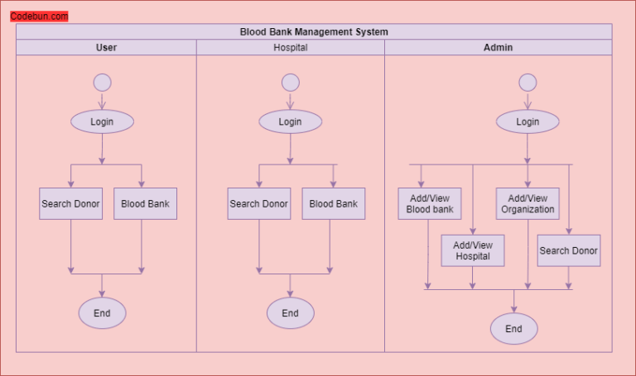
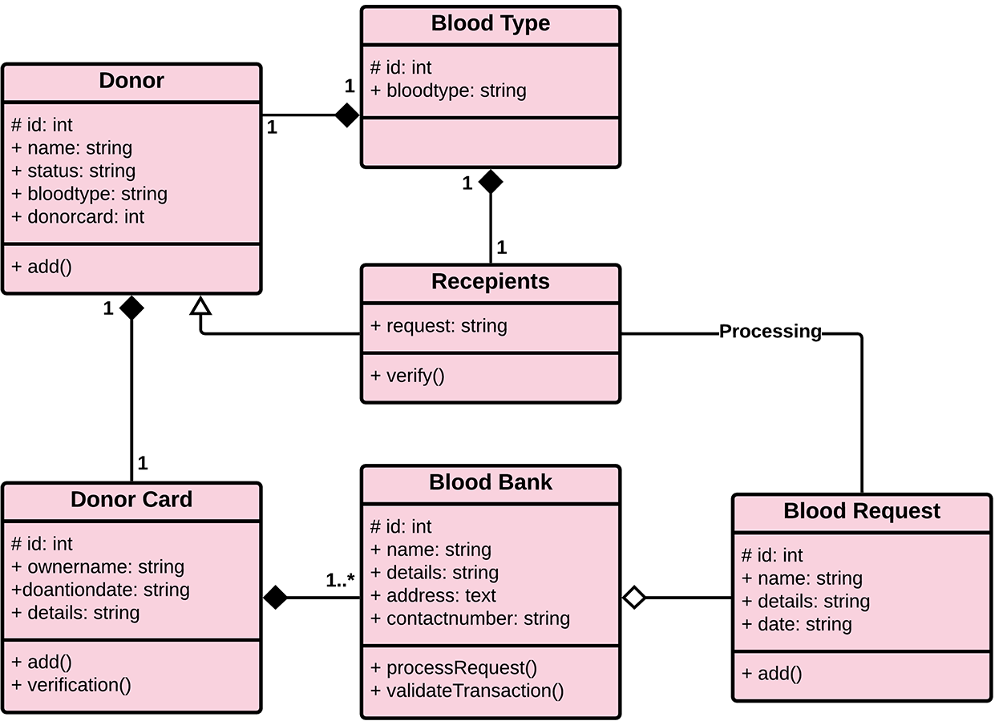

4.IMPLEMENTATION
The Blood Donor Management System is implemented as a web-based application using Python and the Flask framework for backend development. The application is designed following a modular approach where different functionalities such as donor registration, viewing donor records, searching donors, and managing data are handled through separate routes defined in the Flask application. Each route corresponds to a specific function that processes user requests and returns appropriate responses.
The frontend of the system is developed using HTML, CSS, and Bootstrap to create a responsive and user-friendly interface. Forms are used to collect donor details such as name, age, blood group, and contact information. These forms send data to the backend using HTTP POST requests. The system ensures proper data handling by capturing user inputs through form fields and passing them to the server-side logic.
The backend logic is implemented in the Flask application (app.py), where database operations are performed using SQLite. When a user submits the registration form, the application establishes a connection with the SQLite database and inserts the donor details into the donors table. Similarly, when users request to view donors, the application retrieves all records from the database and displays them dynamically using HTML templates.
The search functionality is implemented by allowing users to select a blood group and submit a request. The application then queries the database using SQL statements to filter donors based on the selected blood group and displays the matching results. This ensures quick and efficient access to relevant donor information during emergencies.
The system also includes update and delete functionalities to manage donor records effectively. The delete operation removes a specific donor record from the database based on a unique identifier, while the update functionality allows modification of existing donor details through an edit form. These operations are handled through specific Flask routes and SQL queries.
Overall, the implementation ensures smooth interaction between the user interface, application logic, and database. The use of Flask simplifies backend development, while SQLite provides a lightweight and efficient database solution. This integration results in a functional, reliable, and easy-to-use system for managing blood donor information.

  - SAMPLE CODE

- index.html

<!DOCTYPE html>
<html>
<head>
<title>Blood Donor System</title>

<link href="https://cdn.jsdelivr.net/npm/bootstrap@5.3.0/dist/css/bootstrap.min.css" rel="stylesheet">

<style>
body { background: #f4f6f9; }

.navbar {
background: linear-gradient(to right, #c31432, #240b36);
}

.navbar a { color: white !important; }

.hero {
background: white;
padding: 40px;
border-radius: 10px;
text-align: center;
margin-top: 30px;
}

.btn-custom {
margin: 10px;
padding: 10px 20px;
}
</style>
</head>

<body>

<nav class="navbar p-3">
<span class="text-white fw-bold">🩸 Blood Donor System</span>
</nav>

<div class="container">
<div class="hero">
<h1 class="text-danger">Donate Blood, Save Lives ❤️</h1>
<p>Simple blood donor management system</p>

<a href="/register" class="btn btn-danger btn-custom">Register Donor</a>
<a href="/donors" class="btn btn-success btn-custom">View Donors</a>
<a href="/request" class="btn btn-primary btn-custom">Request Blood</a>
</div>
</div>

</body>
</html>
- register.html

<!DOCTYPE html>
<html>
<head>
<title>Register Donor</title>

<!-- Bootstrap -->
<link href="https://cdn.jsdelivr.net/npm/bootstrap@5.3.0/dist/css/bootstrap.min.css" rel="stylesheet">

<!-- Icons -->
<link rel="stylesheet" href="https://cdnjs.cloudflare.com/ajax/libs/font-awesome/6.0.0/css/all.min.css">

<style>
body {
background: #f4f6f9;
}

.navbar {
background: linear-gradient(to right, #c31432, #240b36);
}

.navbar a {
color: white !important;
font-weight: 500;
}

.card {
border-radius: 15px;
box-shadow: 0px 5px 20px rgba(0,0,0,0.1);
}

.btn-danger {
background: linear-gradient(to right, #ff416c, #ff4b2b);
border: none;
}

.hero {
padding: 30px;
background: white;
border-radius: 10px;
margin-bottom: 20px;
}

.right-box {
background: #fff5f5;
padding: 20px;
border-radius: 10px;
}

.footer {
background: #c31432;
color: white;
padding: 15px;
text-align: center;
margin-top: 30px;
}
</style>
</head>

<body>

<!-- 🔴 Navbar -->
<nav class="navbar navbar-expand-lg px-4">
<a class="navbar-brand text-white fw-bold" href="#">🩸 Blood Donor</a>

<div class="ms-auto">
<a href="/" class="mx-3">Home</a>
<a href="/register" class="mx-3">Register</a>
<a href="/donors" class="mx-3">View</a>
<a href="/request" class="mx-3">Request</a>
</div>
</nav>

<div class="container mt-4">

<!-- 🔴 Header -->
<div class="hero">
<h2 class="fw-bold">Register as a Donor</h2>
<p>Your donation can save many lives.</p>
</div>

<div class="row">

<!-- LEFT FORM -->
<div class="col-md-8">
<div class="card p-4">

<h5 class="text-danger mb-3"><i class="fa fa-user"></i> Donor Information</h5>

<form method="POST">

<div class="row">
<div class="col-md-6 mb-3">
<label>Full Name</label>
<input type="text" name="name" class="form-control" placeholder="Enter name" required>
</div>

<div class="col-md-6 mb-3">
<label>Age</label>
<input type="number" name="age" class="form-control" placeholder="Enter age" required>
</div>
</div>

<div class="row">
<div class="col-md-6 mb-3">
<label>Blood Group</label>
<select name="blood" class="form-control">
<option>A+</option><option>B+</option>
<option>O+</option><option>AB+</option>
<option>A-</option><option>B-</option>
<option>O-</option><option>AB-</option>
</select>
</div>

<div class="col-md-6 mb-3">
<label>Contact</label>
<input type="text" name="contact" class="form-control" placeholder="Phone number" required>
</div>
</div>

<button class="btn btn-danger px-4">Register Donor</button>

</form>
</div>
</div>

<!-- RIGHT SIDE INFO -->
<div class="col-md-4">
<div class="right-box">

<h5 class="text-danger">❤️ Why Donate Blood?</h5>

<p><b>✔ Save Lives</b><br>One donation can save 3 lives.</p>

<p><b>✔ Stay Healthy</b><br>Improves heart health.</p>

<p><b>✔ Help Others</b><br>Be a hero in your community.</p>

</div>
</div>

</div>
</div>

<!-- 🔴 Footer -->
<div class="footer">
© 2026 Blood Donor Management System
</div>

</body>
</html>
- donors.html

<!DOCTYPE html>
<html>
<head>
<title>All Donors</title>

<!-- Bootstrap -->
<link href="https://cdn.jsdelivr.net/npm/bootstrap@5.3.0/dist/css/bootstrap.min.css" rel="stylesheet">

<style>
body {
background: #f4f6f9;
}

.navbar {
background: linear-gradient(to right, #c31432, #240b36);
}

.navbar a {
color: white !important;
font-weight: 500;
}

.card {
border-radius: 15px;
box-shadow: 0px 5px 20px rgba(0,0,0,0.1);
}

.table th {
background-color: #c31432;
color: white;
}

.btn-danger {
background: linear-gradient(to right, #ff416c, #ff4b2b);
border: none;
}
</style>
</head>

<body>

<!-- 🔴 Navbar -->
<nav class="navbar navbar-expand-lg px-4">
<a class="navbar-brand text-white fw-bold" href="/">🩸 Blood Donor</a>

<div class="ms-auto">
<a href="/" class="mx-3">Home</a>
<a href="/register" class="mx-3">Register</a>
<a href="/donors" class="mx-3">View Donors</a>
<a href="/request" class="mx-3">Request Blood</a>
</div>
</nav>

<div class="container mt-4">

<!-- 🔴 Page Title -->
<h2 class="text-danger mb-4">All Registered Donors</h2>

<!-- 🔴 Card -->
<div class="card p-4">

<table class="table table-hover text-center">
<thead>
<tr>
<th>ID</th>
<th>Name</th>
<th>Age</th>
<th>Blood Group</th>
<th>Contact</th>
<th>Action</th>
</tr>
</thead>

<tbody>
{% for d in donors %}
<tr>
<td>{{d[0]}}</td>
<td>{{d[1]}}</td>
<td>{{d[2]}}</td>
<td>{{d[3]}}</td>
<td>{{d[4]}}</td>
<td>
<a href="/delete/{{d[0]}}"
class="btn btn-danger btn-sm"
onclick="return confirm('Are you sure you want to delete this donor?')">
Delete
</a>
</td>
</tr>
{% endfor %}
</tbody>

</table>

</div>

</div>

</body>
</html>
- request.html
<!DOCTYPE html>
<html>
<head>
<title>Request Blood</title>

<link href="https://cdn.jsdelivr.net/npm/bootstrap@5.3.0/dist/css/bootstrap.min.css" rel="stylesheet">

<style>
body { background: #f4f6f9; }
.navbar { background: #c31432; }
.navbar a { color: white !important; }
</style>
</head>

<body>

<nav class="navbar p-3">
<a href="/" class="text-white">🏠 Home</a>
</nav>

<div class="container mt-4">

<div class="card p-4">
<h3 class="text-danger">Search Blood Donors</h3>

<form method="POST" class="mt-3">
<select name="blood" class="form-control mb-3">
<option>A+</option><option>B+</option>
<option>O+</option><option>AB+</option>
<option>A-</option><option>B-</option>
<option>O-</option><option>AB-</option>
</select>

<button class="btn btn-danger">Search</button>
</form>
</div>

<div class="card p-4 mt-4">
<h4>Available Donors</h4>

<table class="table">
<tr>
<th>Name</th>
<th>Age</th>
<th>Contact</th>
</tr>

{% for d in donors %}
<tr>
<td>{{d[1]}}</td>
<td>{{d[2]}}</td>
<td>{{d[4]}}</td>
</tr>
{% endfor %}

</table>
</div>

</div>

</body>
</html>

2. Sylye.css:

body {
font-family: Arial;
margin: 20px;
background-color: #f5f5f5;
}
h1, h2 {
color: red;
}
table {
background: white;
}

3. app.py (database.db):
from flask import Flask, render_template, request, redirect
import sqlite3

app = Flask(__name__)

# Create DB
def init_db():
conn = sqlite3.connect('database.db')
conn.execute('''CREATE TABLE IF NOT EXISTS donors (
id INTEGER PRIMARY KEY AUTOINCREMENT,
name TEXT,
age INTEGER,
blood_group TEXT,
contact TEXT)''')
conn.commit()
conn.close()

init_db()

# Home
@app.route('/')
def index():
return render_template('index.html')

# Register donor
@app.route('/register', methods=['GET', 'POST'])
def register():
if request.method == 'POST':
name = request.form['name']
age = request.form['age']
blood = request.form['blood']
contact = request.form['contact']

conn = sqlite3.connect('database.db')
conn.execute("INSERT INTO donors (name, age, blood_group, contact) VALUES (?, ?, ?, ?)",
(name, age, blood, contact))
conn.commit()
conn.close()
return redirect('/donors')

return render_template('register.html')

# View donors
@app.route('/donors')
def donors():
conn = sqlite3.connect('database.db')
data = conn.execute("SELECT * FROM donors").fetchall()
conn.close()
return render_template('donors.html', donors=data)

# Search blood
@app.route('/request', methods=['GET', 'POST'])
def request_blood():
donors = []
if request.method == 'POST':
blood = request.form['blood']
conn = sqlite3.connect('database.db')
donors = conn.execute("SELECT * FROM donors WHERE blood_group=?", (blood,)).fetchall()
conn.close()

return render_template('request.html', donors=donors)
@app.route('/delete/<int:id>')
def delete(id):
conn = sqlite3.connect('database.db')
conn.execute("DELETE FROM donors WHERE id=?", (id,))
conn.commit()
conn.close()
return redirect('/donors')

if __name__ == '__main__':
app.run(debug=True)

  - TEST CASES

Test cases are used to verify that the system functions correctly and meets the specified requirements. The following test cases are designed for Blood Donor management system.

Test ID | Test Description | Input | Expected Output | Result
TC01 | Register Donor | Ravi, 25, A+, 9876543210 | Stored in DB | Pass
TC02 | Invalid Age | Age: -5 | Reject input | Pass
TC03 | View Donors | Click View | Display all donors | Pass
TC04 | Search Blood | B+ | Show B+ donors | Pass
TC05 | No Data Search | AB- | Show no donors | Pass
TC06 | Delete Donor | ID 1 | Deleted from DB | Pass
TC07 | Edit Donor | Update data | Saved successfully | Pass
TC08 | Empty Form | No input | Show error | Pass

5.RESULTS
The Blood Donor Management System was successfully developed and tested, and it produced accurate and reliable results for all the implemented functionalities. The system allows users to register donor details, which are stored correctly in the database without any data loss. The donor information can be retrieved efficiently, and all registered donors are displayed in a well-structured format.
The search functionality works effectively by filtering donors based on the selected blood group, providing quick access to relevant donor information. The system also supports update and delete operations, enabling users to modify or remove donor records as needed. These operations were tested and performed accurately without affecting other data in the database.
The user interface is responsive and easy to use, allowing users to navigate between different modules smoothly. The integration between the frontend, backend, and database ensures seamless data flow and consistent performance. Overall, the system meets its objectives by providing a simple, efficient, and reliable solution for managing blood donor information.

5.1 OUTPUT SCREENS

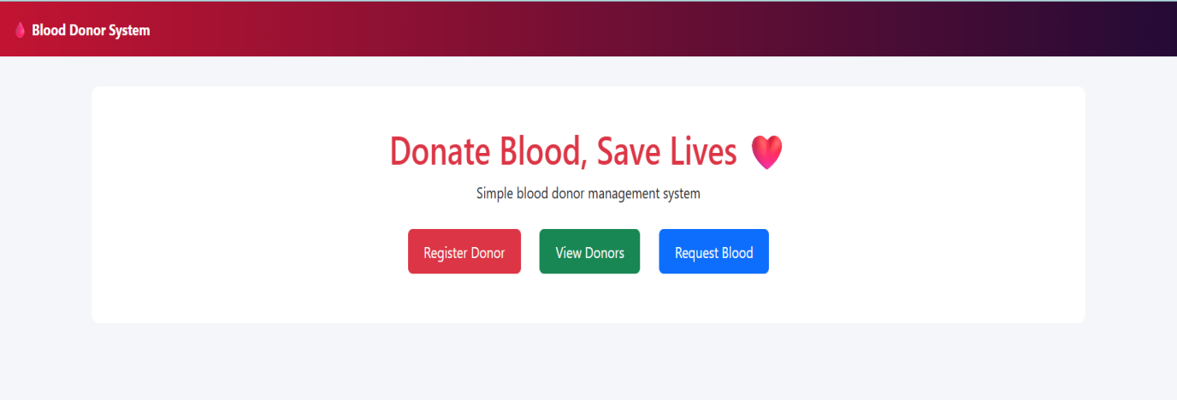

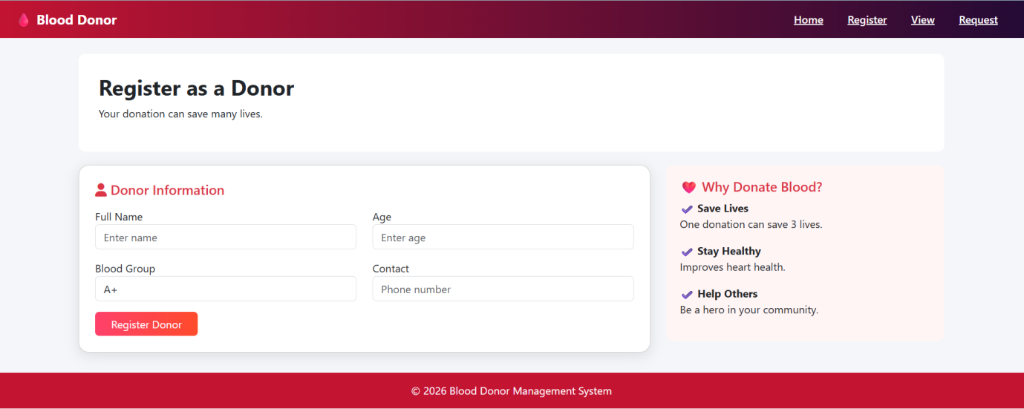

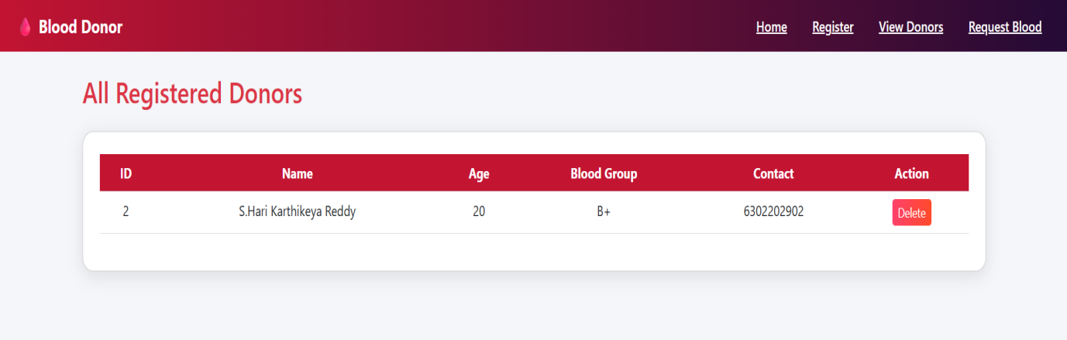

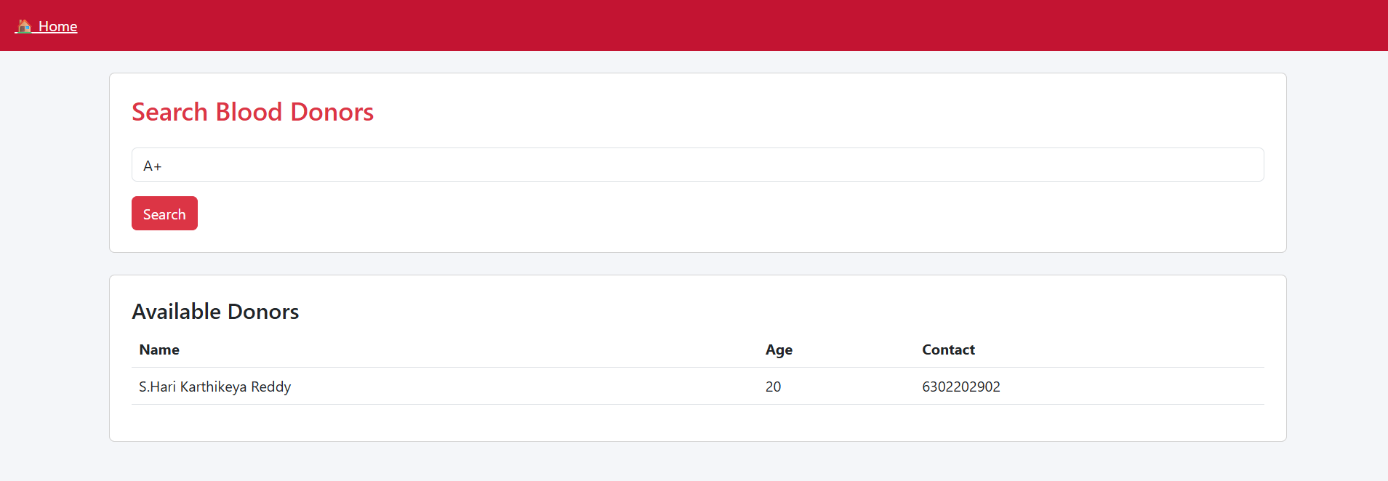

6.CONCLUSION
The Blood Donor Management System was successfully designed and implemented as a web-based application to manage donor information efficiently. The system provides essential functionalities such as donor registration, viewing donor details, searching donors by blood group, and managing records through update and delete operations.
The application replaces traditional manual methods with a digital solution, thereby reducing errors, improving data accessibility, and saving time during critical situations. The use of technologies like Python (Flask), HTML, CSS, and SQLite ensures that the system is lightweight, easy to use, and suitable for small-scale environments.
The project achieves its primary objective of providing a simple and effective platform for managing blood donor information. It demonstrates how web technologies can be used to solve real-world problems in healthcare. With further enhancements such as online deployment, user authentication, and integration with larger databases, the system can be extended into a more robust and scalable solution.

REFERENCES:
- Flask Documentation –https://flask.palletsprojects.com/
(Official guide for building web applications using Flask)
- Python Official Documentation –https://docs.python.org/3/
(Reference for Python programming concepts)
- SQLite Documentation –https://www.sqlite.org/docs.html
(Used for database design and queries)
- Bootstrap Documentation –https://getbootstrap.com/docs/
(Used for designing responsive UI)
- Grinberg, M. Flask Web Development: Developing Web Applications with Python, O’Reilly Media, 2018.
- Silberschatz, A., Korth, H. F., & Sudarshan, S.
Database System Concepts, McGraw-Hill Education.
- Pressman, R. S.
Software Engineering: A Practitioner’s Approach, McGraw-Hill.
- W3Schools –https://www.w3schools.com/
(Reference for HTML, CSS, and basic web development)
- Mozilla Developer Network (MDN) –https://developer.mozilla.org/
(Web technologies reference)
- TutorialsPoint –https://www.tutorialspoint.com/
(General programming and database concepts)

GITHUB PROJECT LINK: https://github.com/vu241fa04943-max/blood-donor-system.git

