Predicting Amazon Top 50 Bestselling Book Ratings Using Machine Learning: A Comparative Regression Study
Register Number: 241FA18191
ACSE Department
Vignan's Foundation for Science, Technology & Research
Abstract—Online bestseller rankings such as Amazon's Top 50 list are widely used as a proxy for book popularity, yet the relationship between a book's observable metadata and the rating readers ultimately assign to it is rarely quantified. This study presents an end-to-end machine learning pipeline for predicting the User Rating of a book using the publicly available Amazon Top 50 Bestselling Books dataset (2009-2019), containing 550 records with seven original columns: Name, Author, User Rating, Reviews, Price, Year, and Genre. The workflow includes data-quality checks, engineered features (Book Age, Author Book Count, Review Category, Price Category, Name Length, and Author Frequency) for exploratory purposes, categorical encoding, and the training of three supervised regression models: Linear Regression, Decision Tree, and Random Forest, using Reviews, Price, Year, and one-hot encoded Genre as the modeling features. Model performance was evaluated using Mean Absolute Error (MAE), Root Mean Squared Error (RMSE), and R-squared (R2) on an 80/20 train-test split. Random Forest achieved the best overall performance (R2 = 0.2543, MAE = 0.1390, RMSE = 0.2068), outperforming Linear Regression (R2 = 0.0815) and Decision Tree, which produced a negative R2 (-0.1789), indicating it generalized worse than a mean-value baseline. Although Random Forest was the strongest of the three models, the modest R2 values overall indicate that Reviews, Price, Year, and Genre alone explain only a limited portion of the variance in User Rating, which clusters tightly in a narrow high range across the dataset. The selected Random Forest model was used to generate predicted ratings for all 550 books, which were then ranked to identify the top 50 and top 10 predicted bestsellers.
Index Terms—Amazon bestsellers, book rating prediction, decision tree, feature engineering, machine learning, random forest, regression

I. Introduction
Bestseller lists such as Amazon's Top 50 Bestselling Books are compiled from sales volume, but the User Rating attached to each title reflects a separate, reader-driven judgment of quality and satisfaction. Publishers, authors, and platform recommendation systems have a shared interest in understanding whether readily observable book metadata, such as price, review volume, publication year, and genre, can explain or predict this rating.
The increasing availability of structured bestseller datasets makes it possible to apply machine learning (ML) regression techniques to this question. This project applies a systematic ML workflow, comprising data understanding, feature engineering, model development, and evaluation, to the Amazon Top 50 Bestselling Books dataset in order to predict User Rating from a book's available metadata and to rank titles by their predicted rating.

II. Problem Statement
The central problem addressed in this research is: can machine learning models predict a book's User Rating from its Reviews, Price, Year, and Genre, and how much of the variation in rating can these features realistically explain? The dataset presents several characteristics relevant to this problem:
- Small-to-moderate, clean dataset: 550 records with no missing values or duplicate rows.
- Narrow target range: User Rating values are concentrated in a high, narrow band, limiting the variance available for a regression model to explain.
- Mixed feature types: Reviews, Price, and Year are numerical, while Genre is categorical and requires encoding.
- Repeated titles: several books (e.g., annual bestsellers) appear in the dataset across multiple years, which affects features such as Author Book Count and Author Frequency.
Solving this problem has practical value: a model that reliably links observable book attributes to reader ratings could support catalog curation and highlight which factors, if any, are associated with higher-rated titles.

III. Research Objectives
- Perform data-quality checks for missing values and duplicate records in the dataset.
- Engineer descriptive features (Book Age, Author Book Count, Review Category, Price Category, Name Length, Author Frequency) to support exploratory analysis.
- Encode categorical variables and prepare a modeling feature set from Reviews, Price, Year, and Genre.
- Develop and train multiple supervised regression models to predict User Rating.
- Evaluate and compare model performance using MAE, RMSE, and R2 on a held-out test set.
- Identify and justify the best-performing model for User Rating prediction.
- Apply the selected model to rank all books by predicted rating and identify the top 50 and top 10 titles.

IV. Research Questions
- How well can Reviews, Price, Year, and Genre predict a book's User Rating?
- Does a non-linear model (Decision Tree or Random Forest) outperform Linear Regression on this dataset?
- Among Linear Regression, Decision Tree, and Random Forest, which model achieves the best generalization performance on the test set?
- Is a single, unconstrained Decision Tree prone to overfitting on this dataset relative to an ensemble method?
- How does the selected model rank books when applied to the full dataset, and how closely do the resulting top predicted titles align with actual high-rated books?

V. Literature Review / Related Work
A. Linear Regression Approaches
James et al. [1] describe linear regression as an interpretable baseline for continuous-target prediction problems, useful for establishing whether a target variable is approximately linearly related to its predictors before more complex models are considered.
B. Decision Trees
Quinlan [2] introduced recursive partitioning approaches that underlie modern decision tree regressors, which split the feature space into regions of relatively homogeneous target values. Unconstrained decision trees are known to fit training data closely but can generalize poorly on small or noisy datasets.
C. Ensemble Methods
Breiman [3] introduced Random Forests, a bagging ensemble of decision trees that averages predictions across many trees trained on bootstrapped samples and random feature subsets, reducing the variance and overfitting associated with a single tree.
D. Tooling
Pedregosa et al. [4] describe scikit-learn, the machine learning library used for model training and evaluation in this study; McKinney [5] describes pandas, used for data handling; and Hunter [6] and Waskom [7] describe Matplotlib and Seaborn, used for visualization.

VI. Research Gap
- Many treatments of bestseller datasets focus on descriptive analysis (e.g., genre or year distributions) without a systematic, multi-model regression comparison for rating prediction.
- Few analyses explicitly test whether engineered descriptive features versus the raw core features (Reviews, Price, Year, Genre) change model performance.
- The practical ceiling on predictability imposed by a narrow, high-clustered rating distribution is rarely reported quantitatively alongside model results.
This research addresses these gaps by presenting a reproducible pipeline comparing three regression model families and reporting model performance transparently, including cases where a model underperforms a naive baseline.

VII. Dataset Description
The dataset used is the Amazon Top 50 Bestselling Books dataset (2009-2019) [8], containing 550 records and seven original columns, with no missing values and no duplicate rows.
Feature | Type | Role
Name | Text | Identifier
Author | Text | Identifier
User Rating | Continuous | Target
Reviews | Discrete | Predictor
Price | Discrete | Predictor
Year | Discrete | Predictor
Genre | Categorical | Predictor
TABLE I: Original Dataset Feature Description

VIII. Methodology
This research follows a standard supervised regression workflow: data understanding, data preparation, exploratory analysis, model development, evaluation, and final selection. Since User Rating is continuous, regression was selected as the task type. Linear, tree-based, and ensemble tree-based models were compared to assess whether non-linear methods offer an advantage over a linear baseline on this dataset.

IX. System / ML Workflow
- Data Collection: Load the raw CSV dataset and perform initial inspection.
- Data Quality Checks: Verify absence of missing values and duplicate rows.
- Feature Engineering: Derive Book Age, Author Book Count, Review Category, Price Category, Name Length, and Author Frequency for exploratory analysis.
- Exploratory Data Analysis: Visualize genre distribution, publication-year distribution, and rating trends over time.
- Feature Preparation: Drop text identifiers (Name, Author) and one-hot encode Genre for the modeling feature set.
- Train/Test Split: 80/20 split of the data (random_state = 42).
- Model Training: Train Linear Regression, Decision Tree, and Random Forest on Reviews, Price, Year, and encoded Genre.
- Evaluation: Evaluate all models on the held-out test set using MAE, RMSE, and R2.
- Model Selection: Select the best-performing model based on test-set R2.
- Full-Dataset Prediction: Apply the selected model to all 550 books and rank them by predicted rating.

X. Data Preprocessing
A. Handling Missing Values and Duplicates
The dataset was checked using isnull().sum() and duplicated().sum(). No missing values and no duplicate rows were found, so no imputation or deduplication was required.
B. Categorical Encoding
The Genre column (Fiction / Non Fiction) was converted into numerical form using one-hot encoding (pd.get_dummies) so it could be used by the regression models.
C. Final Modeling Feature Set
While several descriptive features were engineered for exploratory purposes (Section XII), the final feature set used to train and evaluate the regression models consisted of Reviews, Price, Year, and the one-hot encoded Genre columns, after dropping the text-based Name and Author identifiers. No additional feature scaling was applied prior to model training, since all three models used (Linear Regression, Decision Tree, and Random Forest) do not strictly require standardized inputs to fit.

XI. Exploratory Data Analysis
A. Genre Distribution
The dataset was examined for the balance between Fiction and Non Fiction titles among the bestsellers.
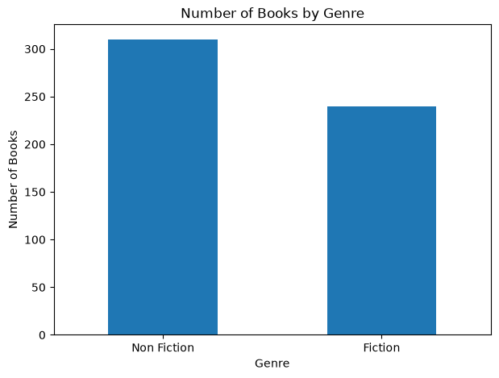
Fig. 1. Number of Books by Genre
B. Distribution by Year
The number of bestselling titles listed in each year from 2009 to 2019 was examined to check for consistency in list size across years.
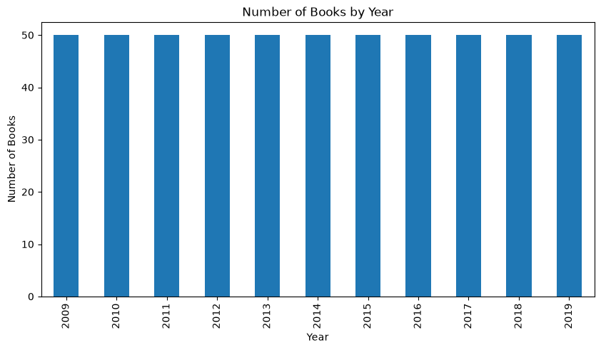
Fig. 2. Number of Books by Year
C. Rating Trend Over Time
The average User Rating for each year was computed to check whether reader ratings of bestsellers have trended upward, downward, or remained stable over the eleven-year period.
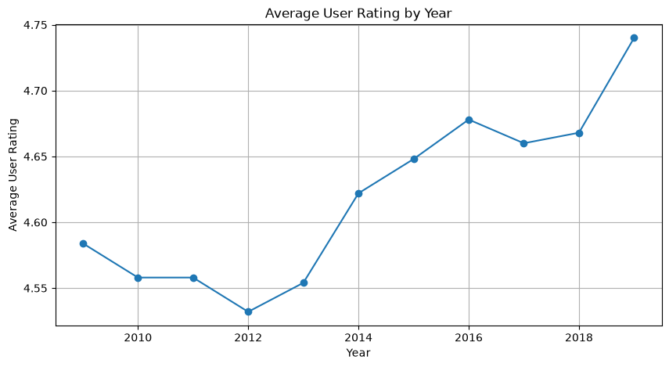
Fig. 3. Average User Rating by Year

XII. Feature Engineering / Feature Selection
Six descriptive features were engineered from the original columns to support exploratory understanding of the dataset:
- Book_Age: computed as 2026 minus Year, representing how old each bestseller is.
- Author_Book_Count: the number of times each author appears in the dataset, as a proxy for prolificacy.
- Review_Category: Reviews divided into Low, Medium, and High tertiles.
- Price_Category: Price grouped into Budget, Medium, and Expensive bands.
- Name_Length: the character length of the book title.
- Author_Frequency: a count-based encoding of how often each author appears in the bestseller list.
These engineered features were retained for exploratory purposes but were not included in the final modeling feature set, which used only Reviews, Price, Year, and encoded Genre, consistent with the feature preparation described in Section X-C.

XIII. Model Development
Three regression models were developed for comparison (Table II), all trained on the same 80/20 train-test split of Reviews, Price, Year, and encoded Genre.
Model | Family | Key Parameters
Linear Regression | Linear | Default (OLS)
Decision Tree | Tree-based | random_state=42
Random Forest | Ensemble (Bagging) | n_estimators=100, random_state=42
TABLE II: Machine Learning Models and Key Parameters
A. Linear Regression
Linear Regression models User Rating as a linear combination of Reviews, Price, Year, and Genre. It serves as the interpretable baseline model.
B. Decision Tree
The Decision Tree Regressor recursively partitions the feature space to fit User Rating, capable of capturing non-linear relationships, but prone to overfitting when grown without depth constraints, as in this study.
C. Random Forest
Random Forest is a bagging ensemble of 100 decision trees, each trained on a bootstrapped sample with predictions averaged across trees, intended to reduce the variance and overfitting risk of a single tree.

XIV. Experimental Setup
Configuration | Details
Environment | Jupyter Notebook, Python 3.13
Key Libraries | scikit-learn, pandas, numpy, matplotlib, seaborn
Train/Test Split | 80% training / 20% testing
Random Seed | random_state = 42 (all models and split)
Modeling Features | Reviews, Price, Year, Genre (one-hot encoded)
Evaluation Strategy | Hold-out test set (110 records)
TABLE III: Experimental Setup

XV. Model Validation
Model validation was performed using an 80/20 hold-out split, with 440 records used for training and 110 records reserved for testing. Each model's predictions on the test set were compared against actual User Rating values using MAE, RMSE, and R2.

XVI. Model Evaluation
Three evaluation metrics were computed for each model on the test set:
- R-squared (R2): the proportion of variance in User Rating explained by the model; the primary selection metric.
- RMSE: root mean squared error, penalizing larger errors more heavily, reported in rating-point units.
- MAE: mean absolute error, a directly interpretable average error magnitude in rating points.

XVII. Model Comparison
Table IV summarizes the performance of all three models on the held-out test set.
Model | MAE | RMSE | R2
Linear Regression | 0.1648 | 0.2296 | 0.0815
Decision Tree | 0.1582 | 0.2601 | -0.1789
Random Forest | 0.1390 | 0.2068 | 0.2543
TABLE IV: Model Performance Comparison
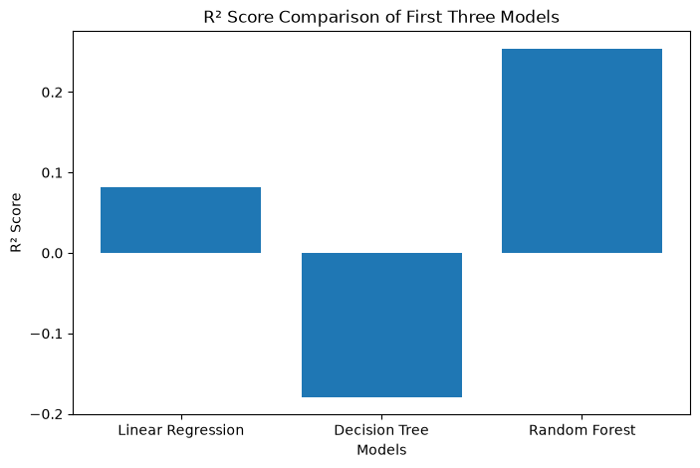
Fig. 4. R2 Score Comparison of the Three Models
Random Forest achieved the highest R2 (0.2543) and the lowest MAE and RMSE among the three models, making it the best-performing model overall. Linear Regression achieved a positive but modest R2 (0.0815). The Decision Tree produced a negative R2 (-0.1789), meaning its test-set predictions were less accurate than simply predicting the mean User Rating for every book, an indication of overfitting from an unconstrained single tree on a small, high-cardinality feature (Year, Price, Reviews) dataset.

XVIII. Final Model Selection
Random Forest was selected as the final model based on the following justification: it achieved the highest test R2 (0.2543) and the lowest test MAE (0.1390) and RMSE (0.2068) among the three candidates; its ensemble averaging across 100 trees reduced the overfitting seen in the single Decision Tree; and it was the only tree-based model to outperform the linear baseline, suggesting it captured some non-linear structure in the relationship between Reviews, Price, Year, Genre, and User Rating without overfitting as severely as the single tree.

XIX. Full-Dataset Prediction and Book Ranking
The selected Random Forest model was evaluated once more on the test set for confirmation (MAE = 0.1390, RMSE = 0.2068, R2 = 0.2543), matching Table IV. The predicted-versus-actual relationship on the test set is shown in Fig. 5.
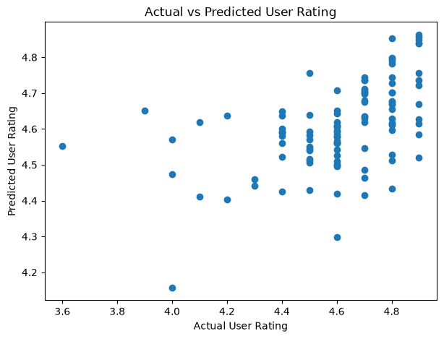
Fig. 5. Actual vs Predicted User Rating (Test Set)
The tuned Random Forest model was then applied to predict User Rating for all 550 books in the dataset. Books were sorted by predicted rating to obtain the top 50 predicted titles, and the top 10 of these are shown in Fig. 6. The highest-ranked titles included repeated high-review, high-rating entries such as "Oh, the Places You'll Go!", the "Jesus Calling" devotional, "The Wonderful Things You Will Be", and "The Very Hungry Caterpillar", each of which appears multiple times in the source dataset across different years.
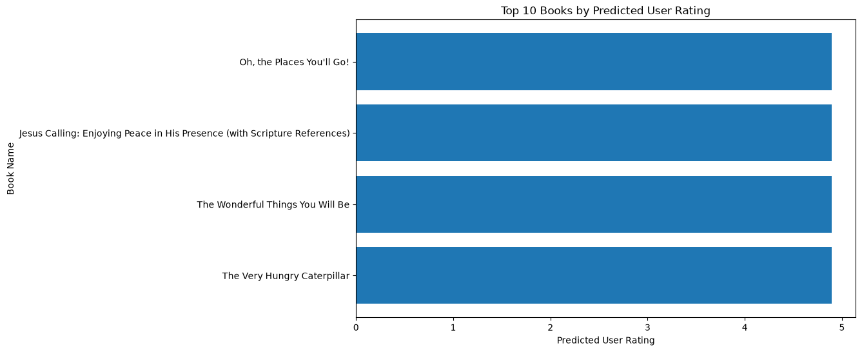
Fig. 6. Top 10 Books by Predicted User Rating

XX. Results
- The dataset contained 550 records with no missing values or duplicate rows.
- Six descriptive features (Book Age, Author Book Count, Review Category, Price Category, Name Length, Author Frequency) were engineered for exploratory analysis.
- The final modeling feature set used Reviews, Price, Year, and one-hot encoded Genre.
- Random Forest achieved the best test performance: R2 = 0.2543, MAE = 0.1390, RMSE = 0.2068.
- Linear Regression achieved a modest positive R2 (0.0815); the single Decision Tree achieved a negative R2 (-0.1789), underperforming a mean-value baseline.
- The final Random Forest model was used to rank all 550 books, producing a top 50 and top 10 list of predicted bestsellers.

XXI. Discussion
The comparatively low R2 values across all three models, even for the best-performing Random Forest, indicate that Reviews, Price, Year, and Genre alone explain only a limited share of the variance in User Rating. This is consistent with the nature of the dataset: User Rating values for Amazon bestsellers are tightly clustered in a high range (typically above 4.0), leaving relatively little variance for any model to explain, regardless of model family.
The negative R2 for the single Decision Tree illustrates a classic overfitting failure mode: an unconstrained tree can memorize training-set patterns, including noise, and generalize poorly to unseen data, especially with a small dataset and only a handful of numerical and categorical predictors. Random Forest's bagging approach, which averages over 100 differently-sampled trees, substantially reduced this overfitting and was the only model to meaningfully outperform the linear baseline, suggesting a small but real non-linear or interaction effect among Reviews, Price, Year, and Genre that a purely additive linear model could not fully capture.

XXII. Limitations
- Narrow target range: User Rating values are tightly clustered, which caps the achievable R2 for any model built on this feature set.
- Limited predictor set: the final models used only Reviews, Price, Year, and Genre; richer signals such as review text sentiment or sub-genre were not available.
- No hyperparameter tuning: models were trained with default or fixed parameters (e.g., n_estimators = 100 for Random Forest) rather than tuned via grid or random search.
- Repeated titles across years: the same book title can appear multiple times in the dataset, which may inflate the apparent consistency of predictions for those titles.

XXIII. Conclusion
This research developed and evaluated an end-to-end machine learning pipeline for predicting the User Rating of Amazon Top 50 Bestselling Books from Reviews, Price, Year, and Genre. Three regression models were compared, and Random Forest was selected as the best-performing model (R2 = 0.2543, MAE = 0.1390, RMSE = 0.2068), outperforming both Linear Regression and a single Decision Tree, the latter of which overfit the training data. The key finding is that a book's User Rating is only weakly explained by its price, review volume, publication year, and genre, most likely because bestseller ratings are already concentrated in a narrow, high range. The selected model was nonetheless used to rank all 550 books by predicted rating, producing a reproducible baseline for bestseller-rating prediction that can be extended with richer features.

XXIV. Future Scope
- Incorporate the engineered descriptive features (Book Age, Author Book Count, Review Category, Price Category, Name Length, Author Frequency) directly into the modeling feature set and measure their effect on R2.
- Apply hyperparameter tuning (e.g., GridSearchCV) to the Decision Tree and Random Forest models to reduce overfitting and improve generalization.
- Incorporate additional data sources, such as review text sentiment or sub-genre tags, to capture signal beyond price, review count, year, and top-level genre.
- Extend the analysis to a larger, multi-platform bestseller dataset to test whether the same feature-rating relationship holds outside Amazon's Top 50 list.
ACKNOWLEDGMENT
The author would like to thank their institution and course instructors for their guidance and support throughout this research project.
REFERENCES
[1] G. James, D. Witten, T. Hastie, and R. Tibshirani, An Introduction to Statistical Learning, 2nd ed. New York, NY, USA: Springer, 2021.
[2] J. R. Quinlan, "Induction of decision trees," Mach. Learn., vol. 1, no. 1, pp. 81-106, 1986.
[3] L. Breiman, "Random forests," Mach. Learn., vol. 45, no. 1, pp. 5-32, 2001.
[4] F. Pedregosa et al., "Scikit-learn: Machine learning in Python," J. Mach. Learn. Res., vol. 12, pp. 2825-2830, 2011.
[5] W. McKinney, "Data structures for statistical computing in Python," in Proc. 9th Python in Science Conf., Austin, TX, USA, 2010, pp. 56-61.
[6] J. D. Hunter, "Matplotlib: A 2D graphics environment," Comput. Sci. Eng., vol. 9, no. 3, pp. 90-95, 2007.
[7] M. Waskom, "Seaborn: Statistical data visualization," J. Open Source Softw., vol. 6, no. 60, p. 3021, 2021.
[8] Amazon Top 50 Bestselling Books 2009-2019 dataset, Kaggle. [Online]. Available: https://www.kaggle.com/datasets/sootersaalu/amazon-top-50-bestselling-books-2009-2019

