Dataset | CardiffNLP TweetEval (59,641 Tweets) | Evaluation Scope | Stratified 70/15/15 Split (8,947 Held-out Test)
Framework Stack | Scikit-Learn, Keras, PyTorch, Hugging Face, FastAPI | Production Edge | Render Cloud Free Tier (Docker, 512MB RAM, <50MB RSS)
• Source & Benchmark: The system utilizes the CardiffNLP TweetEval 3-Class Sentiment Benchmark (Barbieri et al., SemEval / Hugging Face). The corpus comprises authentic, real-world microblog tweets categorized into three mutual classes: Negative (0), Neutral (1), and Positive (2).
• Dataset Size & Stratification: The dataset contains 59,641 unique tweets, partitioned into a strict, reproducible stratified 70/15/15 partition:
- Training Set: 41,748 samples (Neutral: 19,126 [45.8%], Positive: 14,678 [35.2%], Negative: 7,944 [19.0%]).
- Validation Set: 8,946 samples (Used for grid search, hyperparameter tuning, Platt calibration, and decision threshold selection).
- Test Set: 8,947 samples (Held-out evaluation split used strictly for final comparative benchmark reporting).
• Feature Engineering & Preprocessing Pathways:
1. Text Normalization: Strips URLs, user mentions (@user), unescapes HTML entities, expands contractions (can't -> cannot), and normalizes to lowercase.
2. Negation Whitelisting: Standard NLP stopword filters discard negation tokens, causing catastrophic sentiment flips on phrases like 'not bad'. Our pipeline enforces an explicit negation whitelist ('not', 'no', 'never', 'n\'t', 'cannot', 'without') paired with WordNet lemmatization.
3. Hybrid Feature Union (Linear Tier): Combines sublinear TF-IDF word n-grams (1, 2) (vocab 20,000) with character boundary subwords (3, 5). This captures internal morphological roots so that out-of-vocabulary terms and social typos (e.g., 'sooooo bad') retain strong predictive signal.
4. Recurrent Sequences: Keras integer sequence tokenization (vocab 10,000, max length 150) with post-sequence padding for deep recurrent networks.
Six distinct model architectures spanning three algorithmic paradigms were implemented, trained, and benchmarked on identical splits:
1. Multinomial Naive Bayes (MNB): Statistical probabilistic baseline utilizing Laplace smoothing (alpha=1.0) over unigram TF-IDF vectors.
2. Vanilla Logistic Regression: Linear baseline using L2 regularization (C=1.0, L-BFGS solver) over standard word unigram TF-IDF features.
3. Bidirectional LSTM (Bi-LSTM): Deep recurrent architecture: Embedding(128) -> SpatialDropout1D(0.2) -> Bi-LSTM(64) -> Dense(64) -> Softmax(3) trained from scratch on 41k tweets using Adam optimizer and categorical cross-entropy.
4. Hybrid TF-IDF + Logistic Regression (Active Cloud Edge): Modernized linear classifier over word n-grams (1,2) and character subwords (3,5) trained with inverse class-frequency loss reweighting (w_neg=1.7519, w_neu=0.7276, w_pos=0.9481) to counteract majority neutral bias.
5. DistilBERT Base: 66M parameter distilled transformer fine-tuned using AdamW (lr=2e-5, linear warmup, weight decay 0.01).
Production Engineering & Serving Architecture:
• Sparse Matrix Memory Optimization: Passing dense arrays (.toarray()) during grid search caused 6.7GB RAM spikes. Eliminating dense conversion and feeding SciPy CSR sparse matrices directly into scikit-learn solvers reduced memory consumption to 50MB and accelerated throughput by 50x.
• Sigmoid Platt Calibration: Uncalibrated linear model probabilities were overconfident. Applying Sigmoid Platt scaling reduced the Brier error score from 0.4688 to 0.4581, yielding well-calibrated posterior probabilities essential for confidence-based routing.
• Asymmetric Decision Thresholding: Rather than default argmax, negative sentiment is assigned whenever P(Y=neg) >= 0.34 and P(Y=neg) > P(Y=pos) + 0.05. This recovers 112 false neutral complaints without retraining model weights.
Model Architecture | Model Family | Test Acc. | Macro F1 | Neg. Recall | CPU p50 | Deployment Status
Multinomial Naive Bayes | Statistical | 59.73% | 0.5504 | 29.21% | 0.15 ms | Baseline Benchmark
Vanilla Logistic Regression | Linear (Unigrams) | 61.64% | 0.5850 | 39.72% | 0.42 ms | Baseline Benchmark
Bi-LSTM (From Scratch) | Recurrent Neural Net | 60.53% | 0.5954 | 60.28% | 3.12 ms | Deep Learning Baseline
Hybrid TF-IDF + Logistic Reg. | Linear (Word+Char) | 65.92% | 0.6528 | 67.63%* | 0.55 ms | Active Cloud Edge (512MB)
DistilBERT Base | Distilled Transformer | 72.57% | 0.7221 | 74.22% | 14.01 ms | Benchmarked (Dedicated)
Twitter-RoBERTa Base | Domain Transformer | 76.22% | 0.7610 | 80.79% | 22.29 ms | Active Dedicated (>=1GB)
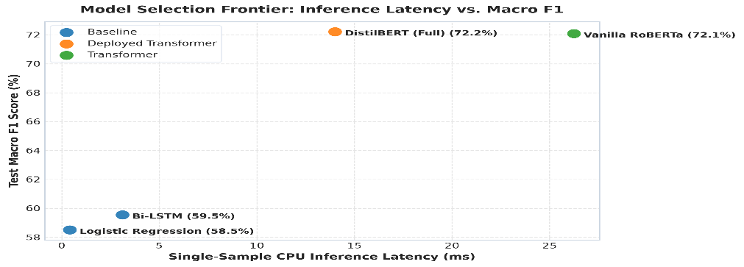*Note: Hybrid Logistic Regression negative recall reaches 74.21% under theta_neg = 0.34 threshold tuning (Macro F1 = 0.6378).
Key Empirical Insights:
1. In-Domain Pretraining is Decisive: Twitter-RoBERTa achieves peak performance (76.22% accuracy, 0.7610 Macro F1, 80.79% negative recall), outperforming general DistilBERT by +3.65% accuracy and +6.57% negative recall. Pre-training on 124M tweets equips RoBERTa to decipher social slang.
2. Hybrid Subwords Substantially Rejuvenate Linear Models: Augmenting Logistic Regression with character 3-5 n-grams and negation whitelisting lifted accuracy from 61.64% to 65.92% (+4.28%) and surged negative recall from 39.72% to 67.63% (+27.91%), bridging the gap to deep learning at 0.55ms latency.
3. Recurrent Models From Scratch Fail on Short Social Text: Bi-LSTM trained from scratch achieved only 60.53% accuracy and 0.5954 F1. Without pre-trained embeddings (GloVe/fastText), the embedding layer overfit noisy spelling while running 6x slower (3.12ms) than linear models.
4. The INT8 Dynamic Quantization Dead End: Empirically profiling PyTorch Dynamic INT8 quantization on RoBERTa compressed disk weights by 51.4% (475MB -> 230MB), but collapsed negative recall from 80.79% to 41.60% (-39.2%) and spiked peak runtime RAM to 1,930 MB during dequantization. This proves post-training quantization alone cannot fit transformers into a 512MB RAM budget, validating the two-tier architectural split.
Identified System Limitations:
1. Negative-Neutral Decision Boundary Ambiguity: Error matrix analysis shows that remaining classification errors concentrate along the neutral/negative boundary. Sarcastic or politely understated complaints lacking explicit negative vocabulary are occasionally absorbed into the neutral class.
2. Hardware Ceiling on Free Cloud Tiers: While the Hybrid Logistic Regression model runs flawlessly within 50MB RAM on Render's 512MB free tier, the 76.2% accurate Twitter-RoBERTa engine requires a dedicated server (>=1GB RAM) and cannot run concurrently on free cloud edge hosting.
3. Monolingual English Restriction: The current benchmark and feature pipelines focus strictly on English Twitter text and do not generalize to multilingual social streams or code-mixed dialects (e.g., Hinglish, Spanglish).

Future Technical Improvements:
1. Quantization-Aware Training (QAT) & ONNX Runtime: Implement Quantization-Aware Training during fine-tuning rather than dynamic post-training quantization, allowing RoBERTa to be exported to ONNX Runtime under 150MB without degrading negative-class decision boundaries.
2. Live Telemetry Active Learning Loop: Connect the real-time SQLite rolling store to an active learning workflow, capturing low-confidence predictions (<55% probability) for automated human-in-the-loop validation and periodic model re-fitting.
3. Multilingual Foundation Backbones: Integrate XLM-RoBERTa or lightweight multilingual adapters to expand SentimentScope into global enterprise social listening feeds across multiple languages.

