Value range for Questions 5 7d and 8 are the same. But within an attempt they should all be distinct.

***RFRA005A please check attached ppt too***

*Minimum - 3*

*Maximum – 4*

**FLOWCHART**

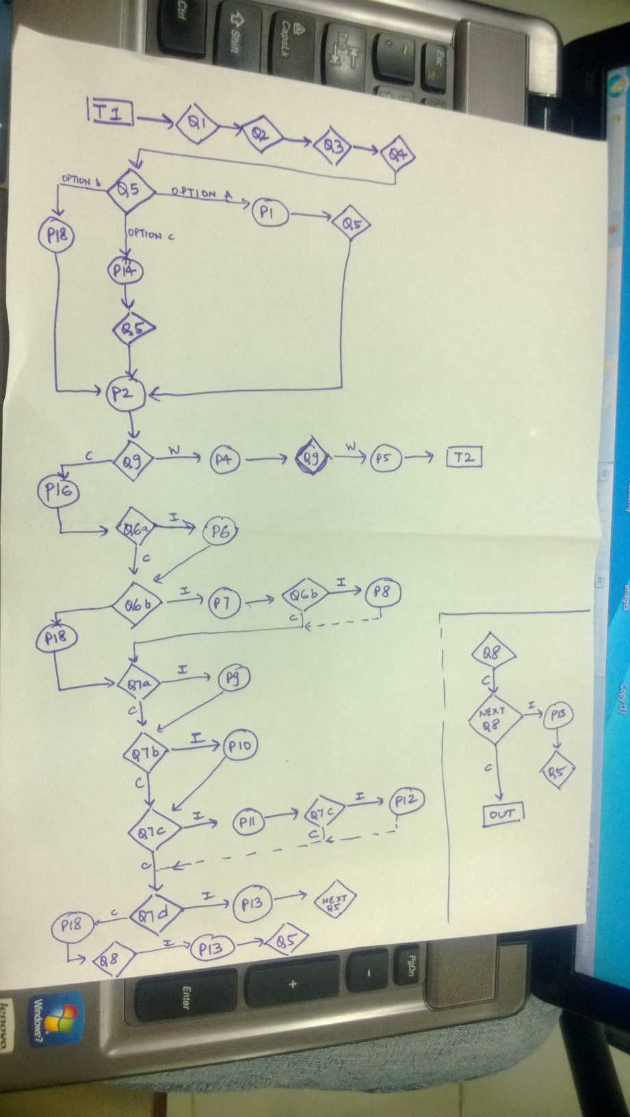

*Key: w – wrong*

*C- correct*

**TEXT**

T1) Hi! Welcome to the CHOCO-WORLD!

Here, small pieces of chocolates are given by experts for tasting.

You and your friends are the experts today.

T2)

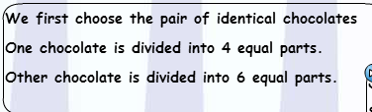

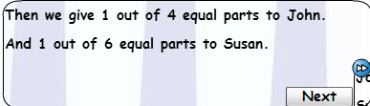

**QUESTION**  
Q1) Pick your avatar.

Q2) *Write your name here <John>. (comes within the blank)*

Q3) Pick your friend’s avatar.

Q4) *Write your friend’s name here <Susan>. (comes within the blank)*

Q5) John wants to have ¼ of a chocolate.

Susan wants to have 1/6 of an identical chocolate.

Which pair of chocolates will you choose for distribution?

{value range (2/4, 2/5), (2/3,2/7), (1/2, 1/6), (1/4, 1/6), (2/5, 2/6), (1/3,1/7), (2/4,2/6), (2/4,2/7),(2/5,2/7), (1/5, 1/6), (1/3,1/5), (2/7, 2/6) }

1. *(Un-identical chocolates broken into 4 and 6 equal parts)*

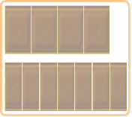

1. identical chocolates broken into 4 and 6 equal parts

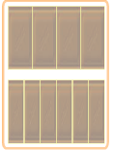

1. Identical chocolates broken into 4 and 6 un-equal parts.

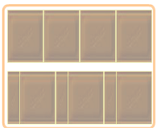

Q9)

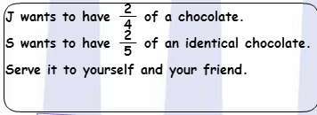

Q6a) John wants to have ¼ of a chocolate.

Susan wants to have 1/6 of an identical chocolate.

(*correct amount of chocolate is served in John and Susan’s tray’s*)

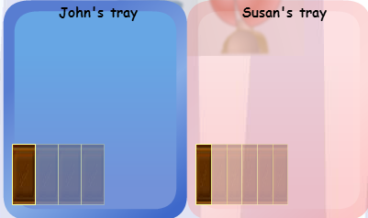

Who ate more chocolate? {Drop: John, Susan}

Q6b) Choose the correct sign:

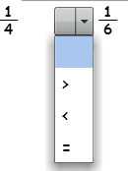

Q7a) (*Q6a nad Q6b with correct answers are projected on a new screen.*)

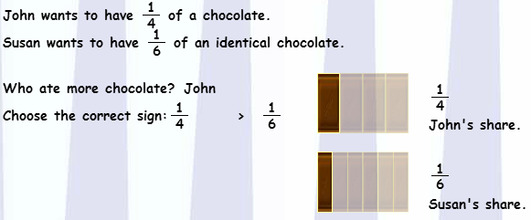

Whose chocolate is divided into smaller pieces?

{drop: John, Susan}

Q7b) Whose chocolate s divided into more number of pieces?

{drop: John, Susan}

Q7c)

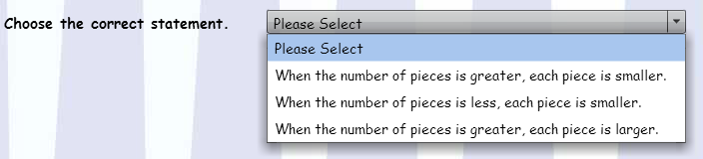

Q7d) Value range (same as Q5)



Q8) Now compare these two fractions:

Value range (same as Q5)

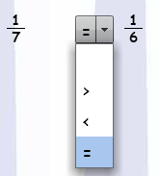

**PROMPTS**  
P1) The two chocolates are not of the same size.

You have to choose identical chocolates.

P2) (*highlighting the correct response*) This pair has 2 identical chocolates.

One Is divided into 4 equal parts and the other is divided into 6 equal parts.

Use this to serve John and Susan.

P3) Click on the highlighted chocolate piece to serve!

P4)

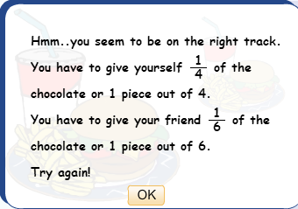

P5) Oops! Let me serve you!

P6)

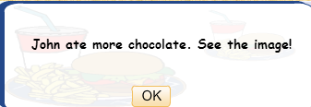

P7)

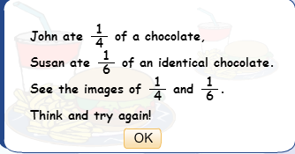

P8)

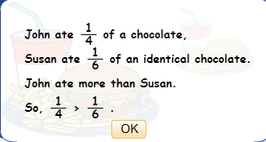

P9)

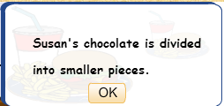

P10)

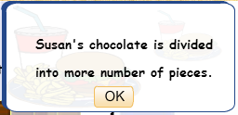

P11)

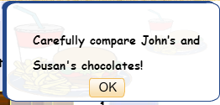

P12)

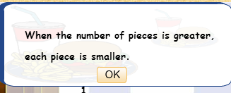

P13)

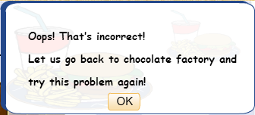

P14)

One chocolate is not divided into equal parts in this pair. You will not be able to give Susan 1/6 if you choose this pair.

Try again!

P15)

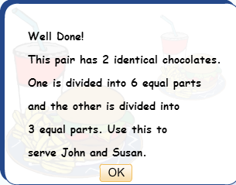

P16)

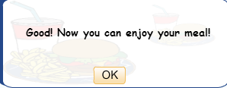

P17)

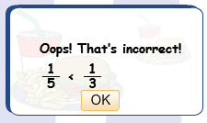

P18) Well done!