Advanced Voting System to Tackle Cross Voting
Design Dcument

Abstract

Once again an election season is coming in few days.One of the main problems which would affect
the whole election procedure is cross voting.In the present pandemic system all are advised wear mask for
their protection So there is more possibility for cross voting. Here we have system which tackles the cross
voting.In this system like the ordinary voting machine it has two blocks the voting unit and the control unit.
The voting unit is somewhat similar to the ordinary voting unit .But in the control unit we have a camera
which interfaced to it which is situvated near the voting unit.Once the poling officer enables the voting unit
by entering the voters list number the camera become active and it takes the image of the voter and sends it
to a telegram bot associated with the poling staion.After that the voting system will be active and the
recorded vote is send to control unit via mqtt through wifi.

High Level Design

Block Diagram
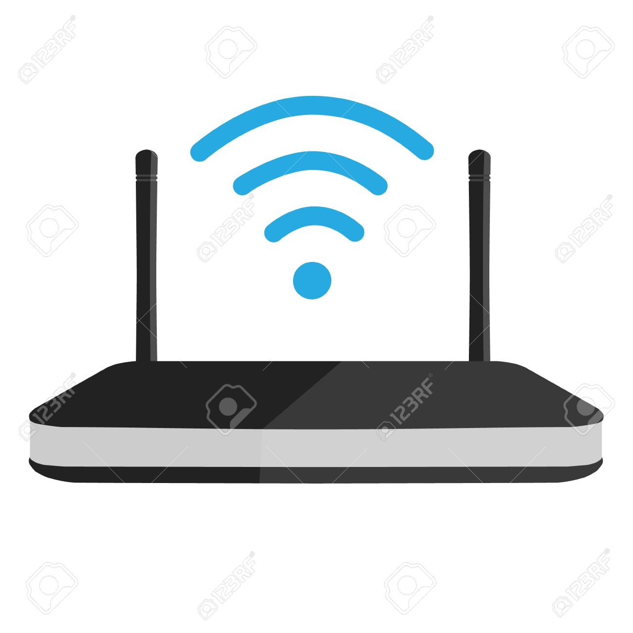

Ballet Unit
Control Unit
4x4 k/b
Sound
O/p
Camera
I/P
Mqtt over wifi

WAN

O/p

Ballet Unit Control Unit
Nodemcu Raspberry Pi3
Push Buttons 4x4 matrix keyboard
Mini Buzzer c270 camera
Mini Buzzer

Control Unit is connected to wireless router in public network.

Schematic

Ballet Unit
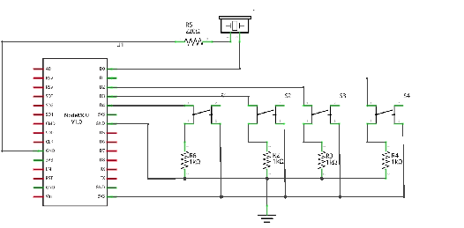

Control Unit

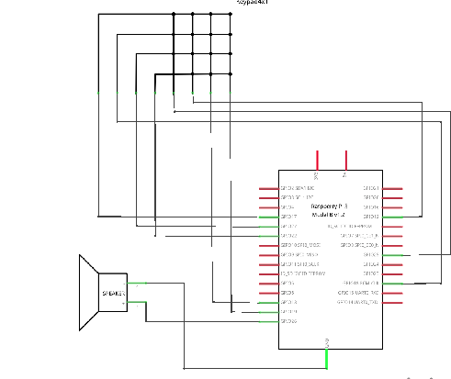

Project Schedule

Project Schedule Phase 1
Si NO | Task | Start Date | End Date
1 | Purchase of components | 11/03/21 | 11/03/21
2 | Literature Survey | 08/03/21 | 12/03/21
3 | Set up mqtt b/w nodemcu and Rp1 | 13/03/21 | 14/03/21
4 | Set up of ballet unit and control unit | 14/03/21 | 16/03/21
5 | System Testing | 16/03/21 | 18/03/21
Phase 2
6 | Camera and telegram integration on Raspberry Pi | 18/03/21 | 21/03/21
7 | System Testing of Phase 2 | 21/03/21 | 23/03/21
Phase 3
8 | Final Integration | 24/03/21 | 25/03/21
8 | System Testing for final integration | 26/03/21 | 28/03/21

Version Control And Tracking.

Version Control.

A git repository is created for proper version control and for collaborative working.All project related stuffs will be uploaded to created git repo.
https://github.com/vu2swz/Advanced-Voting-System-to-Tackle-Cross-Voting

Project Tracking
For project tracking a jira account is created. Individual tasks are alloted via jira so that we can easily track the status of the work.
https://vu2swz.atlassian.net/secure/BrowseProjects.jspa
A Google sheet is mainted online to add the weekly Status of the work
https://docs.google.com/spreadsheets/d/15y8IqyVAe3e9kO8HYBn5R3zeuBPukgr9fXfNyfvK9_k/edit?usp=sharing

