Task 1:
You should spend about 20 minutes on this task

The chart below illustrates the amount of waste collected by a recycling centre between 2011 and 2015.
Provide an overview of the information by identifying and describing the key details, and include comparisons where appropriate.

Write at least 150 words

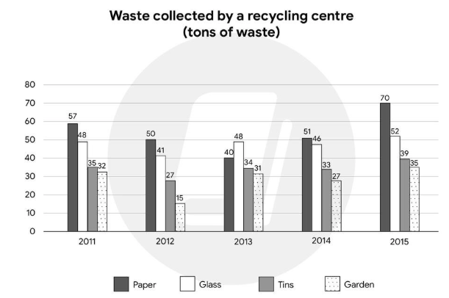

Task 2:
You should spend about 20 minutes on this task

Too much emphasis is placed on education for young people. Some people believe that governments should spend more money on leisure activities for the youth instead.

To what extent do you agree or disagree with this belief?

Give reasons for your answer and include any relevant examples from your knowledge or experience.

Write at least 250 words

