Task 1:
You should spend about 20 minutes on this task

The diagram below shows the process for producing olive oil.

Provide an overview of the information by identifying and describing the key details, and include comparisons where appropriate.

Write at least 150 words

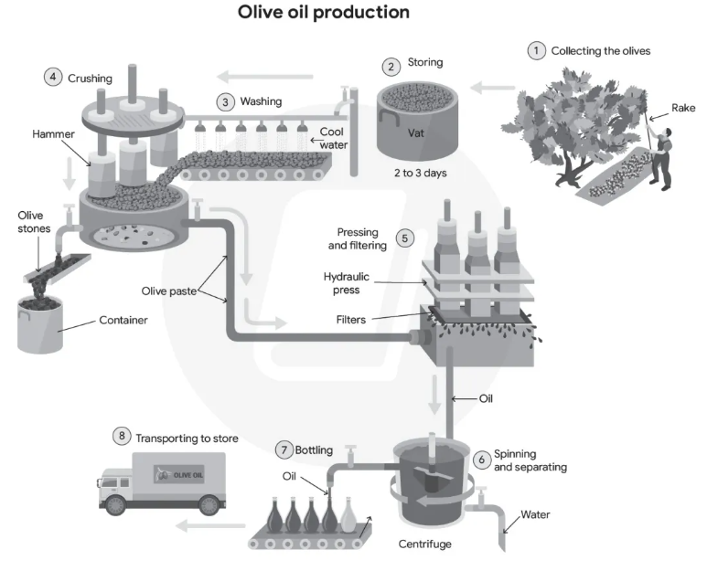

Task 2:
You should spend about 20 minutes on this task

Some people believe that detailed reporting of crimes in newspapers and on TV can lead to harmful consequences and should therefore be limited.

To what extent do you agree or disagree with this belief?

Give reasons for your answer and include any relevant examples from your knowledge or experience.

Write at least 250 words

