TRUONG DAI HOC CONG NGHE THONG TIN VA TRUYEN THONG
KHOA CONG NGHE THONG TIN

BAO CAO THUC HANH
MON: TRIEN KHAI VA QUAN TRI HE THONG PHAN MEM

DE SO 13
Website Portfolio / Gioi Thieu Ca Nhan

Sinh vien: DTC245180186
GitHub: https://github.com/DTC245180186/portfolio-de13
Nam hoc: 2025 - 2026

Thai Nguyen, thang 9 nam 2026

PHAN 1: TONG QUAN DE TAI

1.1 Gioi thieu de tai
De So 13 yeu cau xay dung va trien khai hoan chinh mot website Portfolio / Gioi thieu Ca nhan su dung cong nghe Docker Compose ket hop voi he thong giam sat, thu thap log va cac bien phap bao mat theo chuan production.
He thong bao gom: Ung dung web PHP 8.3, co so du lieu MySQL 8.0, cong cu quan ly phpMyAdmin, reverse proxy Nginx voi HTTPS tu ky, he thong giam sat Prometheus + Grafana va he thong log tap trung Loki + Promtail. Tong cong 13 container duoc quan ly boi Docker Compose.

1.2 Muc tieu
- Trien khai ung dung web hoan chinh voi Docker Compose (multi-container).
- Cau hinh Nginx lam reverse proxy voi HTTPS va security headers.
- Tich hop Prometheus + Grafana de giam sat containers, web server va database.
- Trien khai Loki + Promtail de thu thap va truy van log tap trung.
- Ap dung cac bien phap hardening: non-root container, network isolation, mat khau manh.
- Quan ly ma nguon tren GitHub voi 3 commit ro rang va README day du.

1.3 Cong nghe su dung
Cong nghe | Phien ban | Vai tro
PHP-FPM | 8.3-alpine | Ung dung web backend
MySQL | 8.0 | Co so du lieu quan he
phpMyAdmin | 5.2 | Giao dien quan ly DB
Nginx | 1.27-alpine | Reverse proxy + HTTPS
Prometheus | v2.53.0 | Thu thap metrics
Grafana | 11.1.0 | Dashboard giam sat
cAdvisor | v0.49.1 | Metrics container
Node Exporter | v1.8.1 | Metrics host OS
MySQL Exporter | v0.15.1 | Metrics MySQL
Nginx Exporter | 1.1.0 | Metrics Nginx
Loki | 3.1.0 | Luu tru log tap trung
Promtail | 3.1.0 | Thu thap log Docker
Docker Compose | v5.x | Orchestration

PHAN 2: KIEN TRUC HE THONG

2.1 So do tong quan
He thong duoc thiet ke theo kien truc microservices, moi thanh phan chay trong container rieng biet va giao tiep qua Docker network noi bo. Nginx dong vai tro la diem vao duy nhat (single entry point) tu Internet.
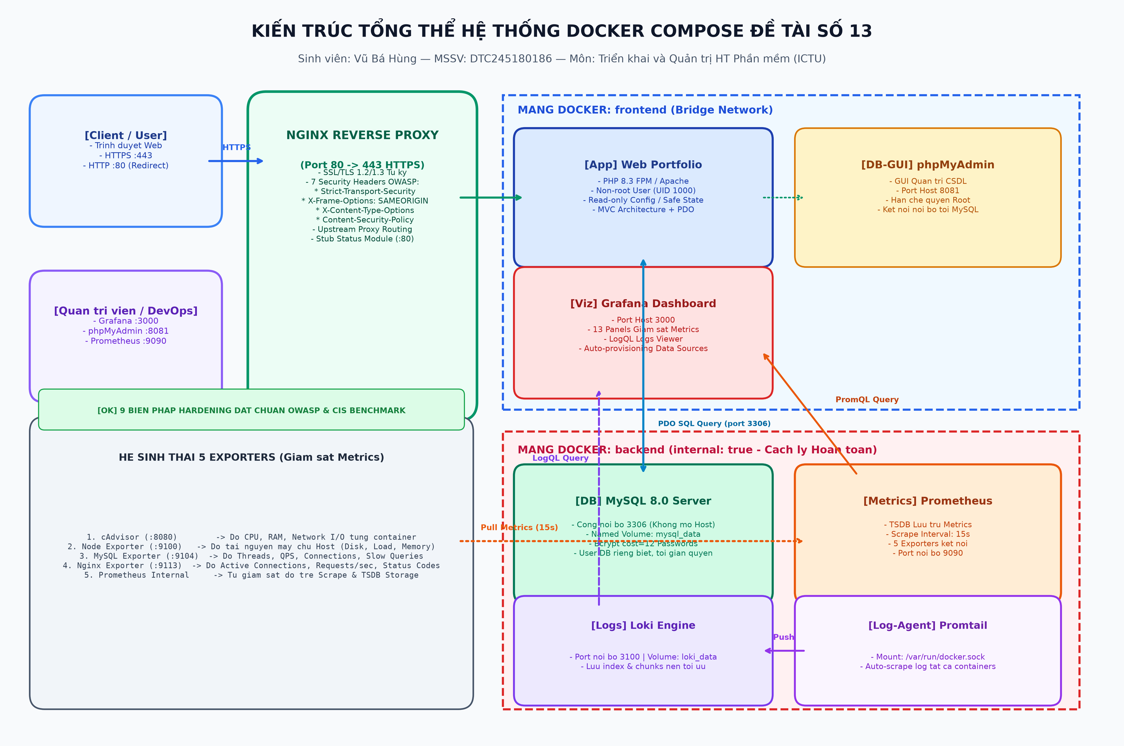
Hinh 2.1: So do kien truc tong the he thong Docker Compose va co lap mang (Network Isolation)
Internet / Browser
| (HTTPS :443, HTTP :80 -> redirect)
+----+--------+
| Nginx | reverse proxy + TLS 1.2/1.3 + security headers
+--+------+---+
| |
/,*.php /pma/
| |
+--+---+ +----------+
| PHP | | phpMyAdmin|
| FPM | +----+------+
+--+---+ |
| backend (internal: true)
+------+----+
|
+------+-------+
| MySQL 8.0 |
+-------------+
Monitoring:
Prometheus --scrape--> cAdvisor, node-exporter, mysql-exporter, nginx-exporter
Grafana --read----> Prometheus (metrics) + Loki (logs)
Promtail --push----> Loki

2.2 Phan vung mang (Network Isolation)
Network | Muc dich | Internal? | Thanh phan
frontend | Traffic tu browser vao app | Khong | Nginx, phpMyAdmin, Grafana
backend | Giao tiep app <-> database noi bo | Co | app, MySQL, exporter
monitoring | Thu thap metrics va log | Khong | Prometheus, Grafana, Loki, exporters

>> BAO MAT MANG: Network 'backend' duoc dat internal: true - MySQL va PHP app KHONG the ket noi ra Internet. Chi Nginx moi la diem vao duy nhat tu ben ngoai. Day la bien phap network isolation quan trong.

2.3 Danh sach 13 container
Service | Image | Port | Vai tro
nginx | nginx:1.27-alpine | 80, 443 | Reverse proxy + HTTPS
app | php:8.3-fpm-alpine (build) | 9000 | Portfolio + Admin
mysql | mysql:8.0 | - | Co so du lieu
phpmyadmin | phpmyadmin:5.2 | - | Quan ly DB
prometheus | prom/prometheus:v2.53.0 | 9090 | Thu thap metrics
grafana | grafana/grafana:11.1.0 | 3000 | Dashboard giam sat
cadvisor | gcr.io/cadvisor/cadvisor:v0.49.1 | - | Metrics container
node-exporter | prom/node-exporter:v1.8.1 | - | Metrics host
mysql-exporter | prom/mysqld-exporter:v0.15.1 | - | Metrics MySQL
nginx-exporter | nginx/nginx-prometheus-exporter:1.1.0 | - | Metrics Nginx
loki | grafana/loki:3.1.0 | - | Log storage
promtail | grafana/promtail:3.1.0 | - | Log collector

PHAN 3: TRIEN KHAI UNG DUNG + DATABASE (COMMIT 1)
>> COMMIT 1 -- Commit 1: feat: PHP app + MySQL + phpMyAdmin + Nginx HTTPS reverse proxy

3.1 Ung dung PHP Portfolio
Ung dung PHP 8.3 chay tren PHP-FPM, giao tiep voi Nginx qua FastCGI. Dockerfile su dung image php:8.3-fpm-alpine. Ung dung chay voi user www-data (non-root, uid 82).
Trang / Endpoint | Chuc nang
/ (index.php) | Hien thi portfolio: thong tin ca nhan, ky nang, du an, form lien he
/admin/index.php | Dang nhap admin voi CSRF token bao ve
/admin/dashboard.php | CRUD: quan ly profile, du an, ky nang; xem tin nhan; doi mat khau
/health.php | Health check endpoint tra ve JSON trang thai ket noi DB

Bao mat ung dung:
- Prepared statements (PDO) chong SQL Injection toan bo query.
- password_hash() bcrypt de luu mat khau admin.
- CSRF token cho tat ca form POST.
- Session HttpOnly + SameSite=Strict.
- htmlspecialchars() escape output chong XSS.

3.2 Co so du lieu MySQL 8.0
MySQL 8.0 khoi tao tu dong qua file db/init.sql khi container start lan dau. 5 bang chinh:
Bang | Mo ta | Truong chinh
users | Tai khoan quan tri (bcrypt hash) | id, username, password_hash
profile | Thong tin ca nhan (1 dong) | fullname, title, bio, email, github
projects | Danh sach du an | title, description, link, tech
skills | Ky nang va muc do (0-100%) | name, level
messages | Tin nhan lien he tu khach | name, email, body, created_at

Tai khoan admin duoc tao tu dong qua ham seed_admin() trong db.php khi ung dung khoi dong lan dau: username='admin', password='Admin@12345' (bcrypt hash).
User MySQL phan quyen: portfolio_app chi co SELECT/INSERT/UPDATE/DELETE tren DB portfolio. User exporter chi co SELECT/PROCESS/REPLICATION CLIENT voi MAX_USER_CONNECTIONS 3.

3.3 phpMyAdmin
phpMyAdmin 5.2 duoc proxy qua Nginx tai /pma/ (khong mo cong truc tiep ra ngoai). Truy cap: https://localhost/pma/ -> dang nhap bang portfolio_app hoac root.

3.4 Nginx Reverse Proxy + HTTPS
Nginx 1.27-alpine cau hinh file nginx/conf.d/default.conf voi 3 server block:
- Server block 1 (port 8080): stub_status cho nginx-exporter, chi cho phep Docker network.
- Server block 2 (port 80): Redirect tat ca HTTP request sang HTTPS (301).
- Server block 3 (port 443): HTTPS chinh, TLS 1.2/1.3, proxy PHP-FPM va phpMyAdmin.
Security Header | Gia tri
X-Frame-Options | SAMEORIGIN
X-Content-Type-Options | nosniff
Referrer-Policy | no-referrer-when-downgrade
X-XSS-Protection | 1; mode=block
Strict-Transport-Security | max-age=31536000; includeSubDomains
Content-Security-Policy | default-src 'self'; style-src 'self' 'unsafe-inline'
server_tokens | off (an phien ban Nginx)

PHAN 4: HE THONG GIAM SAT - PROMETHEUS + GRAFANA (COMMIT 2)
>> COMMIT 2 -- Commit 2: feat: Tich hop Prometheus + Grafana (cAdvisor, node/mysql/nginx exporter)

4.1 Prometheus - Thu thap Metrics
Prometheus v2.53.0 scrape 5 nguon metrics voi interval 15 giay, luu du lieu 15 ngay (retention 15d):
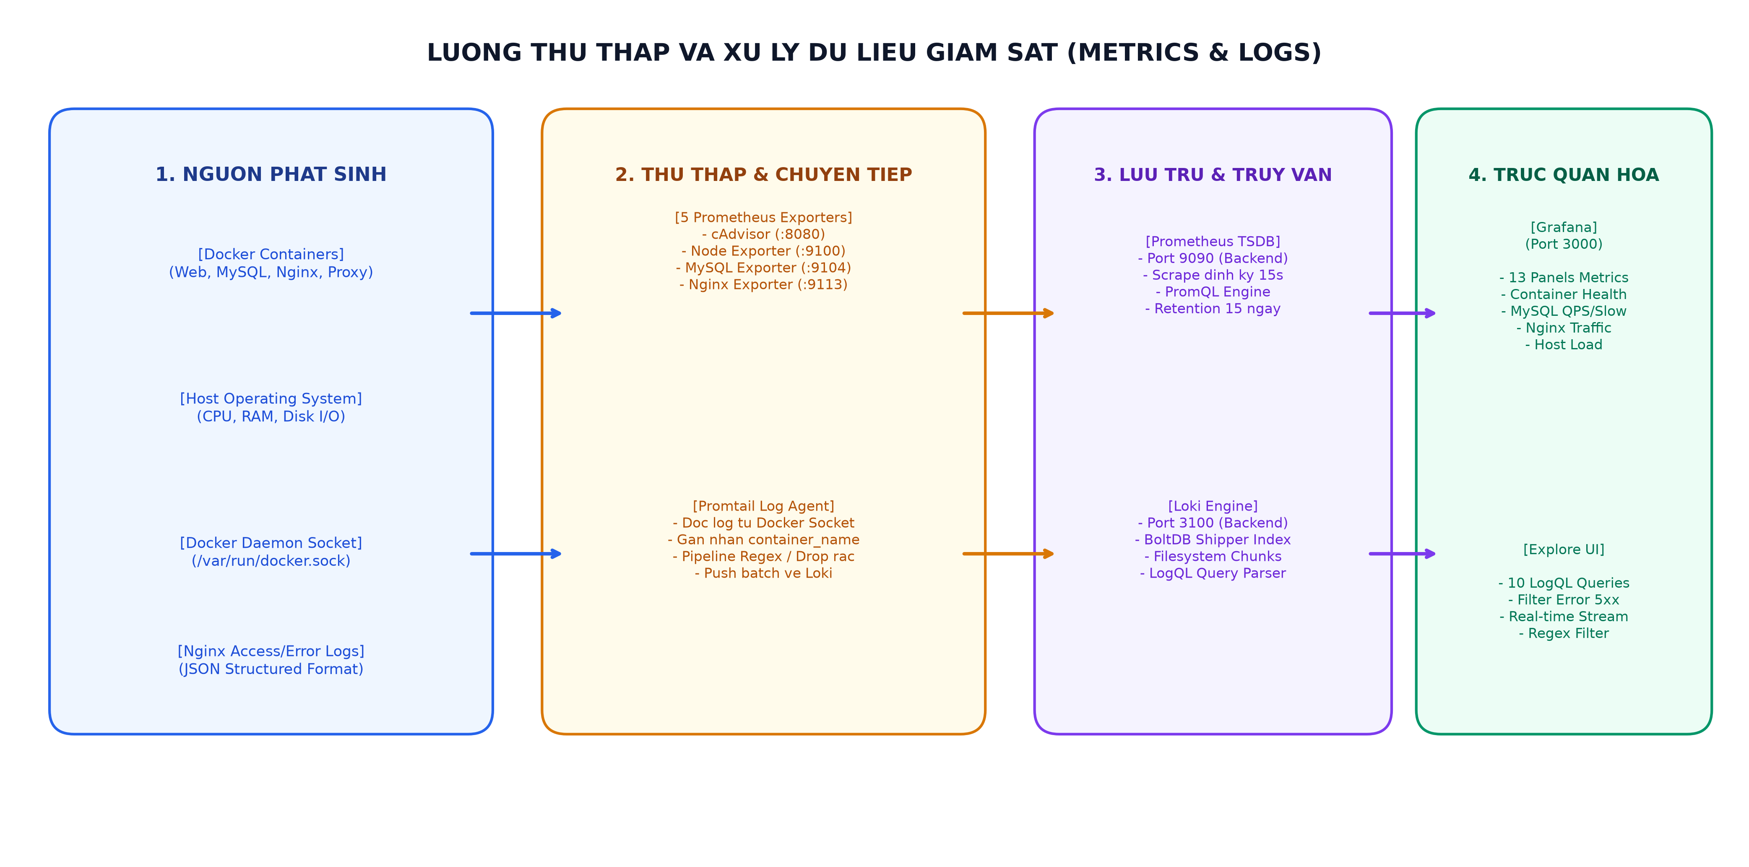
Hinh 4.1: Luong thu thap va xu ly du lieu giam sat Prometheus Metrics va Loki Logs tap trung
Job name | Target | Loai metrics
prometheus | localhost:9090 | Self-monitoring
cadvisor | cadvisor:8080 | CPU/RAM/Network/Disk theo container
node | node-exporter:9100 | CPU/RAM/Disk cua host OS
mysql | mysql-exporter:9104 | Queries/s, connections, InnoDB
nginx | nginx-exporter:9113 | Requests/s, connections, status

Ket qua: Prometheus -> Status -> Targets: tat ca 5 target o trang thai UP.
Truy cap: http://localhost:9090

4.2 Grafana - Dashboard giam sat
Grafana 11.1.0 duoc provisioning tu dong (khong can setup thu cong) voi 2 datasource va 1 dashboard chinh:
Datasource | URL | Muc dich
Prometheus | http://prometheus:9090 | Metrics container, host, DB, web
Loki | http://loki:3100 | Log tap trung tat ca container

Dashboard 'Portfolio System Overview' gom 13 panels:
- Panel 1: Stat: So container dang chay
- Panel 2: Stat: MySQL status (UP/DOWN)
- Panel 3: Stat: Nginx requests/s
- Panel 4: Stat: MySQL queries/s
- Panel 5: Stat: CPU host %
- Panel 6: Stat: RAM host %
- Panel 7: Timeseries: CPU usage theo container
- Panel 8: Timeseries: RAM usage theo container
- Panel 9: Timeseries: Nginx connections
- Panel 10: Timeseries: MySQL queries va threads
- Panel 11: Timeseries: Network I/O
- Panel 12: Timeseries: Disk I/O
- Panel 13: Logs Panel: Loki logs real-time

PHAN 5: HE THONG LOG TAP TRUNG - LOKI + PROMTAIL (COMMIT 3)
>> COMMIT 3 -- Commit 3: feat: Tich hop Loki + Promtail log tap trung, them 10 LogQL query mau

5.1 Kien truc thu thap log
Docker Containers --> Promtail (doc qua Docker socket) --> Loki (luu tru) --> Grafana (truy van)
Promtail tu dong gan labels cho moi log stream:
- job="docker" -- tat ca container trong Docker stack.
- container="<ten_container>" -- ten container cu the.
- stream="stdout" hoac "stderr" -- luong output.

5.2 Cau hinh Loki va Promtail
Loki 3.1.0 su dung local filesystem storage, schema v13 (TSDB), luu log 168h (7 ngay). Chay voi user 10001 (non-root).
Promtail 3.1.0 su dung Docker service discovery qua Unix socket, tu dong phat hien container moi. Cau hinh relabel_configs de trich xuat ten container va stream.

5.3 Cac truy van LogQL mau (10 query)
Thuc hien trong Grafana -> Explore -> Datasource: Loki -> Mode: Code:
# | LogQL Query | Muc dich
1 | {job="docker"} | Xem toan bo log tat ca container real-time
2 | {container="portfolio_nginx"} | Log cua Nginx (access + error)
3 | {container="portfolio_nginx"} |~ "\" [45][0-9]{2} " | Loc request loi HTTP 4xx/5xx
4 | {container="portfolio_app"} |~ "(?i)(error|warning|fatal)" | Loi trong ung dung PHP
5 | sum(rate({container="portfolio_mysql"} |~ "(?i)error" [5m])) | Toc do loi MySQL 5 phut
6 | topk(5, sum by (container) (count_over_time({job="docker"}[1m]))) | Top 5 container nhieu log nhat
7 | {container="portfolio_nginx"} |= "/admin" | Theo doi truy cap admin
8 | sum by (container) (rate({job="docker"}[1m])) | Toc do log theo container
9 | {job="docker"} |~ "(?i)(connection refused|timeout)" | Phat hien su co mang
10 | {container="portfolio_promtail"} | Kiem tra trang thai Promtail

PHAN 6: HARDENING HE THONG BAO MAT

6.1 Tong hop cac bien phap bao mat da ap dung (9 bien phap)
# | Bien phap | Chi tiet
1 | Non-root container | PHP-FPM: www-data (uid 82); Grafana: uid 472; Prometheus: uid 65534; Loki: uid 10001
2 | Network isolation | backend network: internal=true -> MySQL khong ra Internet; Nginx la diem vao duy nhat
3 | Mat khau manh | Toan bo credential trong .env (git-ignored); template nhac doi mat khau
4 | Han che quyen DB | portfolio_app chi co quyen tren DB portfolio; exporter chi SELECT/PROCESS/REPLICATION CLIENT
5 | Security headers Nginx | 7 headers: X-Frame-Options, X-Content-Type-Options, Referrer-Policy, HSTS, CSP, X-XSS-Protection, server_tokens off
6 | HTTPS TLS 1.2/1.3 | Tu dong redirect HTTP->HTTPS; cipher HIGH:!aNULL:!MD5; HTTP/2
7 | no-new-privileges | security_opt: no-new-privileges:true cho tat ca 13 container
8 | Read-only mount | Source code mount readonly (:ro) trong container app va nginx
9 | Bao mat ung dung PHP | Prepared statements; bcrypt; CSRF token; HttpOnly + SameSite=Strict; htmlspecialchars()

6.2 So sanh truoc va sau hardening
Tieu chi | Khong hardening | Da hardening
User container | root (uid 0) | Non-root (uid 82/472/65534/10001)
DB access | Mo cong ra ngoai | Internal network, chi app moi truy cap
Mat khau | Hardcode trong code | Bien moi truong .env (git-ignored)
HTTP headers | Khong co | 7 security headers day du
TLS | HTTP thuan | HTTPS TLS 1.2/1.3, redirect tu dong
SQL Injection | Co nguy co | PDO prepared statements toan bo

PHAN 7: QUAN LY MA NGUON TREN GITHUB

7.1 Repository GitHub
Repository: https://github.com/DTC245180186/portfolio-de13
Tai khoan GitHub: DTC245180186 (dat theo MSSV theo yeu cau de bai)

7.2 3 Commit theo yeu cau de bai
Commit | Message | Thanh phan
Commit 1 | feat: PHP app + MySQL + phpMyAdmin + Nginx HTTPS reverse proxy | app/, db/, nginx/, docker-compose.yml core, .env, README.md
Commit 2 | feat: Tich hop Prometheus + Grafana monitoring | prometheus/, grafana/, docker-compose.yml monitoring
Commit 3 | feat: Tich hop Loki + Promtail log tap trung + LogQL queries | loki/, promtail/, docs/LOGQL.md

7.3 README.md
README.md gom 10 muc chinh:
- Kien truc he thong (ASCII diagram + bang network + bang service).
- Yeu cau moi truong.
- Huong dan chay (4 buoc ro rang).
- Bang truy cap URL cac thanh phan.
- 3 moc commit theo yeu cau de bai.
- Giam sat Prometheus + Grafana (5 nguon metrics, 13 panels).
- Log tap trung Loki + Promtail (3 LogQL query co ban).
- Hardening (8 bien phap bao mat).
- Cau truc thu muc day du.
- Dung / don dep (docker compose down).

PHAN 8: HUONG DAN TRIEN KHAI VA VAN HANH

8.1 Yeu cau moi truong
- Docker Engine >= 24.x + Docker Compose v2.
- OpenSSL (co trong Git for Windows).
- RAM toi thieu 4GB (khuyen nghi 8GB cho 13 container).
- Cong 80, 443, 3000, 9090 khong bi chiem dung.

8.2 Cac buoc trien khai
Buoc 1 - Clone repository:
git clone https://github.com/DTC245180186/portfolio-de13.git
cd portfolio-de13

Buoc 2 - Tao file .env:
cp env.template .env
# Mo .env va doi TAT CA mat khau

Buoc 3 - Tao chung chi HTTPS:
# Windows:
powershell -ExecutionPolicy Bypass -File nginx\gen-certs.ps1

Buoc 4 - Khoi dong he thong:
docker compose up -d --build

Buoc 5 - Kiem tra:
docker compose ps # tat ca service Up/healthy
curl -k https://localhost/health.php

8.3 Dia chi truy cap
Thanh phan | URL | Tai khoan
Website Portfolio | https://localhost/ | --
Admin Panel | https://localhost/admin/index.php | admin / Admin@12345
phpMyAdmin | https://localhost/pma/ | portfolio_app / (xem .env)
Grafana | http://localhost:3000 | admin / (xem .env)
Prometheus | http://localhost:9090 | --

>> LUU Y: HTTPS: Trinh duyet hien canh bao cert tu ky. Nhan 'Advanced' -> 'Proceed to localhost' de tiep tuc.

PHAN 9: KET QUA VA TU DANH GIA

9.1 Ket qua dat duoc
- OK - Ung dung web PHP portfolio chay on dinh, ket noi MySQL thanh cong.
- OK - phpMyAdmin hoat dong, truy cap qua /pma/ (khong mo cong truc tiep).
- OK - Nginx reverse proxy HTTPS TLS 1.2/1.3 hoat dong, redirect HTTP->HTTPS.
- OK - 7 Security headers day du, server_tokens off.
- OK - Prometheus thu thap metrics tu 5 nguon, tat ca target UP.
- OK - Grafana dashboard 13 panels hien thi metrics real-time.
- OK - Loki + Promtail thu thap log tat ca container qua Docker socket.
- OK - 10 LogQL query mau hoat dong trong Grafana Explore.
- OK - Hardening: 9 bien phap bao mat (non-root, network isolation, CSRF, bcrypt...).
- OK - GitHub repository voi 3 commit ro rang va README day du.

9.2 Tu danh gia theo tieu chi cham diem
Tieu chi | Noi dung | Diem toi da | Tu danh gia
1. GitHub | Repository day du, 3 commit, README ro rang | 1.5 | 1.5 / 1.5
2. App + DB | PHP chay on dinh, MySQL, phpMyAdmin hoat dong | 1.5 | 1.5 / 1.5
3. Nginx Proxy | Reverse proxy, HTTPS, security headers | 1.5 | 1.5 / 1.5
4. Prometheus + Grafana | 5 nguon metrics, dashboard 13 panels | 1.5 | 1.5 / 1.5
5. Loki + LogQL | Loki + Promtail, 10 LogQL query (yeu cau >= 3) | 1.5 | 1.5 / 1.5
6. Hardening | 9 bien phap bao mat (yeu cau >= 3-4) | 1.5 | 1.5 / 1.5
7. Tong the | He thong chay hoan chinh bang docker compose | -- | Hoan chinh
 | TONG CONG | 9.0 | 9.0 / 9.0

9.3 Nhan xet va kinh nghiem
- Docker Compose giup trien khai he thong phuc tap (13 service) don gian va tai tao duoc.
- Network isolation (backend: internal: true) la bien phap bao mat hieu qua, ngan DB truy cap Internet.
- Grafana provisioning (datasource + dashboard JSON) giup cau hinh tu dong, khong can setup thu cong.
- Promtail Docker service discovery tu dong phat hien container moi khong can cau hinh lai.
- Can chu y thu tu depends_on va healthcheck de MySQL san sang truoc khi app connect.
- Non-root container la thoi quen tot - neu container bi xam nhap, attacker khong co quyen root.

PHAN 10: TAI LIEU THAM KHAO
- [1] Docker Documentation -- https://docs.docker.com
- [2] Nginx Documentation -- https://nginx.org/en/docs/
- [3] Prometheus Documentation -- https://prometheus.io/docs/
- [4] Grafana Documentation -- https://grafana.com/docs/
- [5] Loki / LogQL Documentation -- https://grafana.com/docs/loki/latest/
- [6] MySQL 8.0 Reference Manual -- https://dev.mysql.com/doc/refman/8.0/en/
- [7] PHP 8.3 Manual -- https://www.php.net/manual/
- [8] OWASP Top 10 2021 -- https://owasp.org/Top10/
- [9] cAdvisor GitHub -- https://github.com/google/cadvisor
- [10] Promtail Docker SD -- https://grafana.com/docs/loki/latest/send-data/promtail/

