How to set up Vanderbilt University Dual ID account.

As a VUMC employee to use Vanderbilt University ACCRE account, you must first create a VU Dual ID. Here are the steps to create a VU Dual ID:
Step1. Submit a Pegasus - Submit Request to obtain a VU ID.
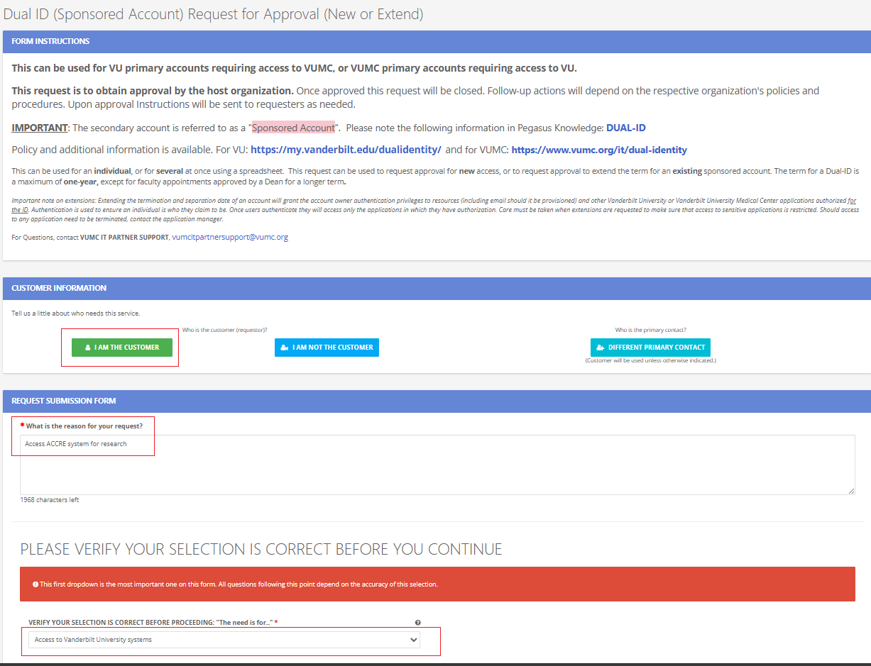
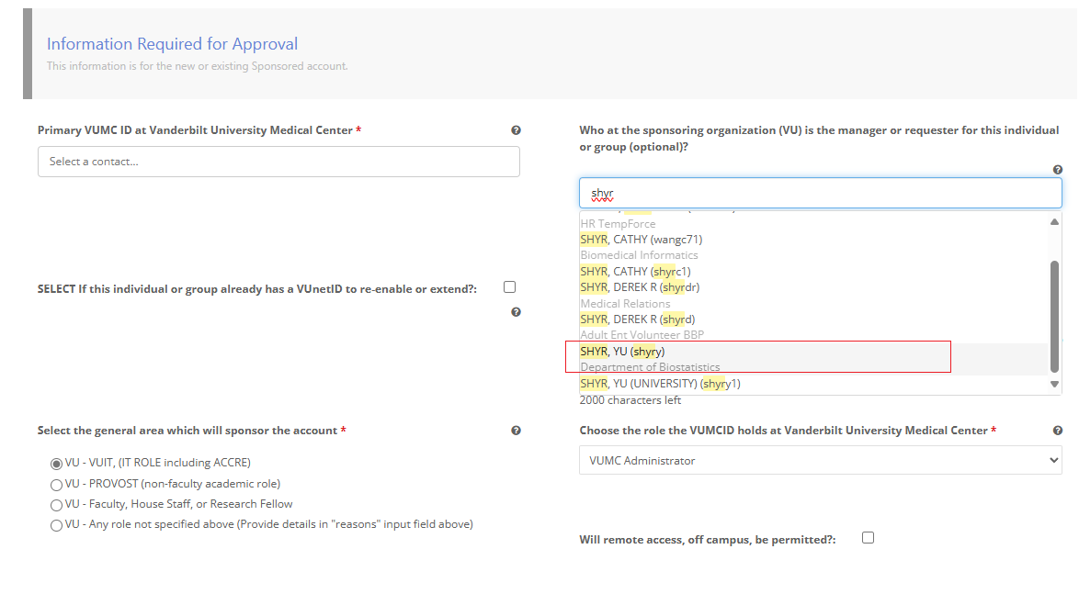
Follow through the questions carefully.
Important! Although the question “Who at the sponsoring organization (VU) is the manager or requester for this individual or group (optional)?” states it is optional, if you leave it blank, your application will be denied. For Biostatistics Department users, please select Dr. Shyr as your sponsor.
After submitting your Dual ID application, you will receive an email notification. In this email, it won’t explicitly state whether your application is approved or not; it only confirms that your request has been fulfilled. To check the actual status of your request, you must click the “View in Pegasus” button.
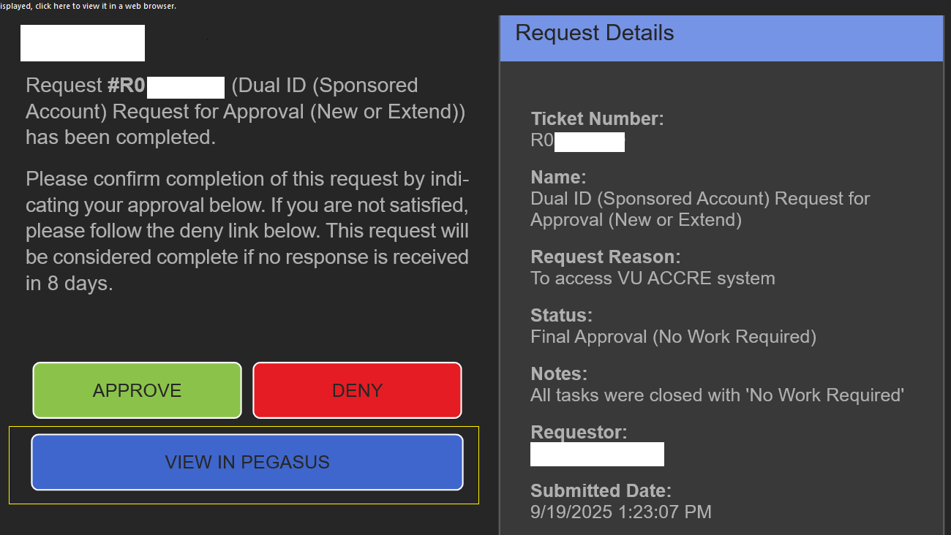
By following this link and reading through their notes, you will find your newly assigned VU account ID. You will also be instructed to call VUIT Tech Hub at 615-343-9999 to proceed to the next step.

Step2. Call VUIT Tech Hub at 615-343-9999 to activate your account.
You will be asked to go to http://vu.edu/claim. Scroll down to the section titled “Resolution or Procedure Steps,” then click “here” as shown in the following picture.

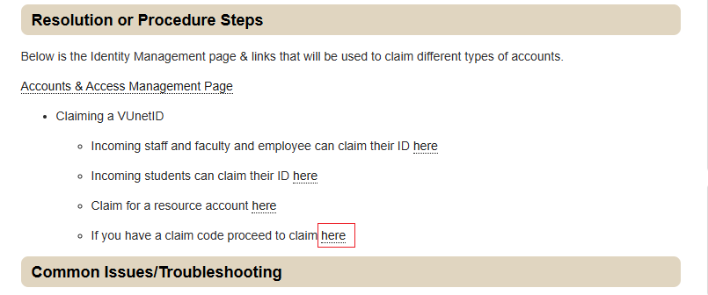
You will be prompted to enter your new VUNetID. The call helper should provide you with your claim number. Enter this claim number into the system. Your VU ID should be activated, but it may take several hours before your VU ID becomes fully operational. Meanwhile, ask the call helper for your full email address.

To access your email address:
1) Download Okta Verify from the App/Play Store on your mobile device
2) On a computer, navigate to https://onevu.vanderbilt.edu and login using your full Vanderbilt email address (your_vu_email@vanderbilt.edu) and click Next
3) Type in your VUnetID password and click Next
4) You should be given an option to set-up Okta Verify click Setup
5) On your mobile device, open the Okta Verify app and follow the prompts until you reach the point to scan a QR code (Add account, Organization for the account type, Skip adding from another device and Yes, ready to scan to scan the QR code)
6) Point your phone camera to the qr code that's on the computer screen
7) (Optional) Enable FaceID/Passcode on the phone
8) (Optional) Add a security key and secondary email address (can skip if needed)
Accessing Your Vanderbilt Mailbox
Once your setup is complete, you can access your Vanderbilt mailbox by navigating to https://outlook.office.com/vanderbilt.edu. Enter your email address (your_vu_email@vanderbilt.edu) and the password you created to log in.

