**Topics: Descriptive Statistics and Probability**

1. Look at the data given below. Plot the data, find the outliers and find out $μ, σ, σ^{2}$

|  |  |
| --- | --- |
| **Name of company** | **Measure X** |
| Allied Signal | 24.23% |
| Bankers Trust | 25.53% |
| General Mills | 25.41% |
| ITT Industries | 24.14% |
| J.P.Morgan & Co. | 29.62% |
| Lehman Brothers | 28.25% |
| Marriott | 25.81% |
| MCI | 24.39% |
| Merrill Lynch | 40.26% |
| Microsoft | 32.95% |
| Morgan Stanley | 91.36% |
| Sun Microsystems | 25.99% |
| Travelers | 39.42% |
| US Airways | 26.71% |
| Warner-Lambert | 35.00% |

Ans)

Mean=33.2713

Std=16.9454

Var=287.1466

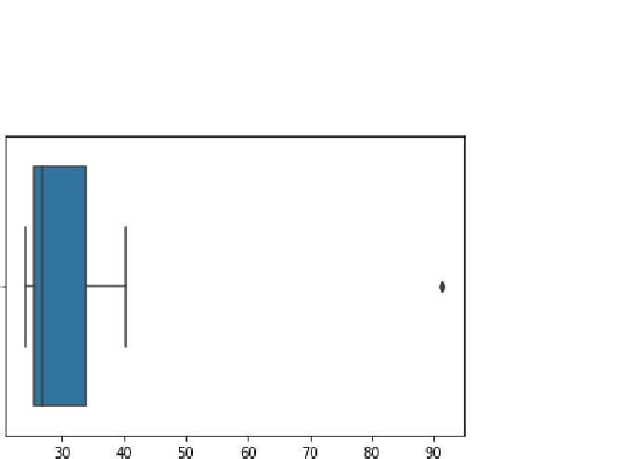

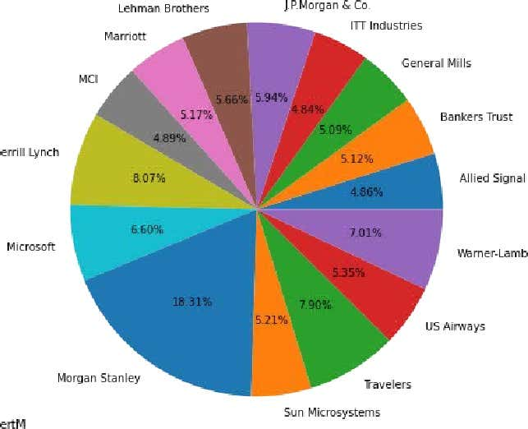



Answer the following three questions based on the box-plot above.

1. What is inter-quartile range of this dataset? (please approximate the numbers) In one line, explain what this value implies.

Ans) here clearly 25 is the outlier.

Median=7

1st quartile=5

2nd quartile=12

IQR=(12-5)=7

1. What can we say about the skewness of this dataset?

Positively skewed.

1. If it was found that the data point with the value 25 is actually 2.5, how would the new box-plot be affected?

In that case there would have been no outliers,and it might have affected in the values of mean and median alightly.the boxplot might have moved towards right slightly.



Answer the following three questions based on the histogram above.

1. Where would the mode of this dataset lie?

ANS) between 5-8(most frequent data)

1. Comment on the skewness of the dataset.

Ans) it is positively skewed.

1. Suppose that the above histogram and the box-plot in question 2 are plotted for the same dataset. Explain how these graphs complement each other in providing information about any dataset.

Ans) by comparing both of them it is very clear that the data would be positively skewd.also,would like help us finding mean,mode value.

1. AT&T was running commercials in 1990 aimed at luring back customers who had switched to one of the other long-distance phone service providers. One such commercial shows a businessman trying to reach Phoenix and mistakenly getting Fiji, where a half-naked native on a beach responds incomprehensibly in Polynesian. When asked about this advertisement, AT&T admitted that the portrayed incident did not actually take place but added that this was an enactment of something that “could happen.” Suppose that one in 200 long-distance telephone calls is misdirected. What is the probability that at least one in five attempted telephone calls reaches the wrong number? (Assume independence of attempts.)

Ans)

*p* = probability of a call being misdirected = 1/200

*q* = probability of a call not being misdirected = 1 - *p*

We want to find the probability that none of the five attempted calls is misdirected, then subtract that probability from 1 to get the probability that at least one call is misdirected.

Probability of none of the five calls being misdirected:

*P*(none misdirected)=*q*5

Probability of at least one call being misdirected: *P*(at least one misdirected)=1−*P*(none misdirected)

Substituting the values:

*P*(at least one misdirected)=1−(1−2001​)5

Calculating:

*P*(at least one misdirected)=1−(1−0.005)5 *P*(at least one misdirected)=1−(0.995)5

*P*(at least one misdirected)=1−0.97515

*P*(at least one misdirected)≈0.02485

So, the probability that at least one in five attempted telephone calls reaches the wrong number is approximately 0.02485.

1. Returns on a certain business venture, to the nearest $1,000, are known to follow the following probability distribution

|  |  |
| --- | --- |
| x | P(x) |
| -2,000 | 0.1 |
| -1,000 | 0.1 |
| 0 | 0.2 |
| 1000 | 0.2 |
| 2000 | 0.3 |
| 3000 | 0.1 |

1. What is the most likely monetary outcome of the business venture?

Ans) the most likely monetary outcome of the business ventures x=2,000 with the highest probability of 0.3

1. Is the venture likely to be successful? Explain

Ans) the venture likely successfully because (x=1,000)+(x=2,000)+p(x=3,000)=0.2+0.3+0.1=0.6

1. What is the long-term average earning of business ventures of this kind? Explain

=(0.1)(-2000)+(0.1)(-1000)+(0.2)(0)+(0.2)(1000)+(0.3)(1000)+(0.1)(3000)=800

1. What is the good measure of the risk involved in a venture of this kind? Compute this measure

Standered deviation=0.08164