

Software Requirement Specification
Smart Cafe Management System
Project Code: SCMS
Document Code: version 03

– Hanoi, September 2026 –

Contents
I. Record of Changes 3
II. Software Requirement Specification 4
1. Product Overview 4
1.1 Business Context 4
1.2 Current Problems 4
1.3 Solution and Value Proposition 4
1.4 Key Differentiators 5
1.5 System Scope and Actors 5
2. User Requirements 6
2.1 Actors 6
2.2 Use Cases 7
2.2.1 Diagrams 7
2.2.2 Descriptions 10
3. Software Features 15
3.1 Functional Overview 15
3.1.1 Screens Flow 15
3.1.2 Screen Descriptions 16
3.1.3 Screen Authorization 20
3.1.4 Entity Relationship Diagram 21
3.1.5 Entity Details 22
3.2 Authentication, Navigation & Attendance 29
3.3 Point of Sale (POS) & Checkout 38
3.4 Order & Cash Drawer Management 49
3.5 Branch Operations 57
3.6 Chain Management & Master Data 75
3.7 Reports & Analytics 90
3.8 System Configuration & Security 98
4. Non-Functional Requirements 101
5. Requirement Appendix 103
5.1 Business Rules 103
5.2 Common Requirements 106
5.3 Application Messages List 108
6. Business Process 109
6.1. Order process 110
6.2. Chain set up process 110
6.3. Cash shift handover 112
6.4. Attendance to payroll 113

I. Record of Changes
Date | A, M, D | In charge | Change Description
25/09 | A | VuNL | Context diagram
25/09 | A | TamDHM | Usecase list, product overview
25/09 | A | KhanhPG | Screen flow, screen description, Non-function requirment
25/09 | A | AnhTV | Usecase list, Entity Class Diagram
25/9 | A | VanNT | Usecase diagram, product overview
28/9 | M | KhanhPG, VuNL, AnhVT | Context diagram, description
30/9 | M | TamDHM, VanNT | Usecase diagram, usecase description
1/10 | M | VuNL | Entity Class diagram
1/10 | M | AnhVT | Context diagram
2/10 | M | VanNT, TamDHM | Usecase list
2/10 | M | KhanhPG | Screen flow
2/10 | A | KhanhPG, AnhVT, TamHDM | Screen mockup
3/10 | M | VanNT, VuNL | Screen description
*A - Added M - Modified D - Deleted

II. Software Requirement Specification

1. Product Overview

1.1 Business Context
The Smart Cafe Management System (SCMS) targets expanding mid-sized cafe and F&B chains. This segment has outgrown the single owner-operated store model but is not yet large enough to build its own proprietary management system like Highlands Coffee or The Coffee House. A reference business in this segment operates around 6 to 10 branches. Over a 2-year period, the enterprise might open one additional branch, or possibly none, with daily operating hours from 06:00 to 23:00.
Each branch employs about 12 to 15 staff members divided into 2 to 3 shifts, consisting of Branch Managers, Cashiers, and Baristas. The COO centrally synchronizes menus, pricing, and promotions, and tracks financial data across the entire chain. Each branch serves approximately 300 to 500 orders daily, generating a monthly revenue of around 400 to 600 million VND. Cash flows include physical cash in the registers at each branch and digital transfers via QR code directly into the chain's central bank account.

1.2 Current Problems
Each branch operates almost independently, while the COO requires centralized control. When using disjointed POS systems combined with manual ledgers and Excel, the business faces three groups of problems:
First, inconsistent configuration. Every time prices change, new items are introduced, or promotions are launched, the COO must manually update each branch, leading to omissions and discrepancies between stores. Revenue and Cost of Goods Sold (COGS) reports must also be consolidated from multiple sources, causing reporting delays.
Second, losses at the counter and in inventory. Cashiers verify bank transfers by opening banking apps or checking transaction screenshots provided by customers, which is slow during peak hours and carries the risk of forged images. The cash drawer lacks a strict shift opening and closing process, and there are no approval thresholds for order cancellations and refunds. Inventory is manually recorded and not linked to the standard recipe/ingredients of each item, making shrinkage difficult to detect.
Third, high costs and dependency. Third-party POS software often charges per store, meaning costs scale up with the number of branches, and it is difficult to customize the software to specific proprietary workflows. Manual paper-based timesheets are also prone to errors in calculating working hours.

1.3 Solution and Value Proposition
SCMS is an independent web-based application that runs on browsers using the store's existing hardware. The system integrates multiple modules: POS order taking, printing preparation tickets to the bar, time attendance, cash drawer management, bulk-packaging inventory management, and automated bank transfer reconciliation via SePay. The COO configures settings once and synchronizes them across all branches with a single action, views consolidated financial reports, and controls ingredient shrinkage. Branch Managers schedule shifts, reconcile cash, manage inventory, and view branch-level reports. Cashiers take orders quickly and accept auto-verified QR payments. Staff clock in/out using RFID cards or PINs in less than 0.5 seconds. A standard order is completed in under 5 clicks, the VietQR code is generated in a maximum of 1 second, the order status shifts to "paid" within 1 second after the Webhook triggers, and the system guarantees a minimum availability/uptime of 99.5% during operating hours.

1.4 Key Differentiators
SCMS stands out in four key areas. First, auto-reconciled QR payments: the system matches the order code, amount, and authentication signature from SePay, then automatically updates the order to "paid"; orders with amount discrepancies are held with warnings. Second, cash drawer control by shift lifecycle: shift opening, cash-in/cash-out with required reasons, shift closing via actual physical counts, and mandatory explanations for any discrepancies. Third, centralized management with strict role-based access control (RBAC): Branch Managers only see data for their own branch, managers cannot approve their own actions, paid orders are frozen, and all sensitive actions are recorded in an audit log. Fourth, low cost and ownership autonomy: the system runs on commodity hardware, ESC/POS standard K80 printers, and driverless USB card readers; the enterprise owns the system instead of paying per-store subscription fees.
Version 1.0 focuses on core operations. Out of scope: multi-channel/FoodApp integrations, Kitchen Display Systems (KDS), CRM/loyalty programs, electronic invoicing and S1a/S2a accounting, WebOrder, splitting/merging tables, card/e-wallet payments, offline mode, social insurance (BHXH) and personal income tax (PIT) calculations, and biometrics.

1.5 System Scope and Actors
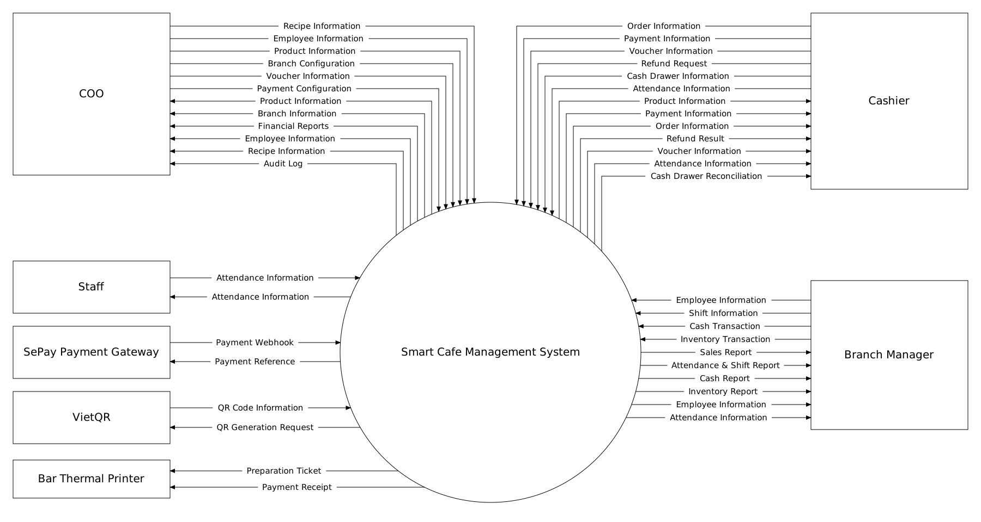

2. User Requirements

2.1 Actors
# | Actor | Description
1 | COO | The highest-level user with chain-wide scope. Focuses on configuration and monitoring; does not perform sales operations or handle cash. Manages branch and Branch Manager accounts. Centrally manages the master menu, pricing, promotions, standard recipes/portions, and ingredient catalogs, then synchronizes them across all branches with a single action. Configures the SePay receiving bank account and approval thresholds. Approves actions directly related to Branch Managers (timesheets, bonuses/deductions, payroll) and refund requests exceeding standard thresholds. Views consolidated financial reports, monitors chain-wide performance, controls ingredient shrinkage, views the system-wide audit log, and handles data recovery.
2 | Branch Manager | The direct manager of a specific branch, restricted to accessing data only for their assigned branch. Organizes shift schedules, reviews shift opening/closing reports, and reconciles cash at the start and end of shifts. Confirms inventory receipts. Manages HR records for Cashiers and Staff, and prepares branch payroll. Views branch-level reports. Strictly prohibited from self-approving their own operational requests.
3 | Cashier | Operates the Point of Sale (POS) at the counter of the assigned branch, with access to the orders of the current business day. Creates orders, customizes item options (size, sugar, ice, toppings), collects cash or starts QR payments, and prints preparation slips and customer receipts. Initiates requests for order cancellations (for unpaid orders) and refunds. Performs physical cash drawer counts to finalize shift closures. Records attendance at the Kiosk like every other employee.
4 | Staff | Staff represents general store personnel (baristas, servers). Staff have no SCMS account and cannot log in. They only record attendance at the Attendance Kiosk (SCR-02) by tapping an RFID card or by selecting their name and entering a personal 4-digit PIN. Cashiers and Branch Managers record attendance the same way, in addition to their login accounts.
5 | Payment Gateway - SePay | An external intermediary payment gateway service that operates automatically via a Webhook mechanism. When a customer transfers funds using a Dynamic VietQR code, SePay detects the bank balance fluctuation and pushes an HTTP POST payload (containing the order code and transaction amount) to the SCMS, allowing the software to automatically update the order status to paid.
6 | VietQR | A third-party system providing an API/tool to generate payment QR codes compliant with the NAPAS national standard. The SCMS sends invoice details (transaction amount, transfer memo, and bank account number) to VietQR, which returns a dynamic QR code image for the customer to scan and pay at the counter.

2.2 Use Cases

2.2.1 Diagrams
- COO
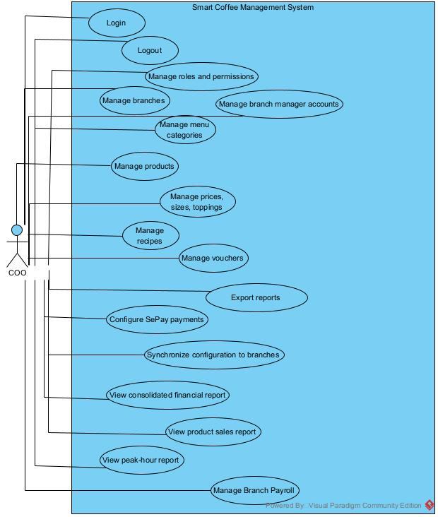

- Branch Manager
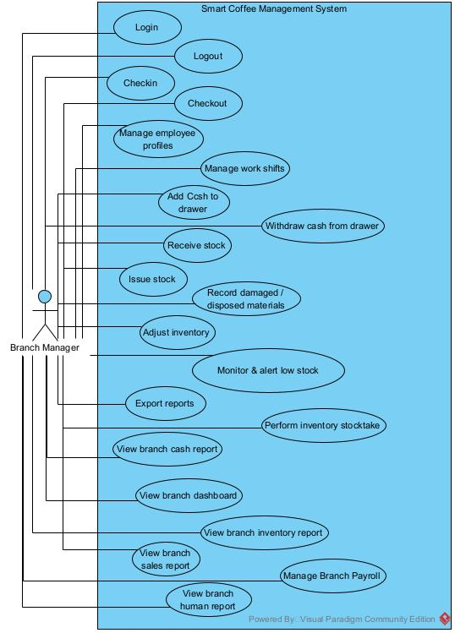

- Cashier
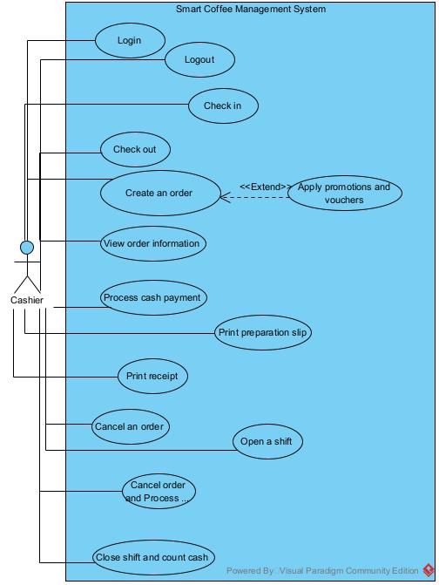
- Staff, Sepay, VietQR, Printer
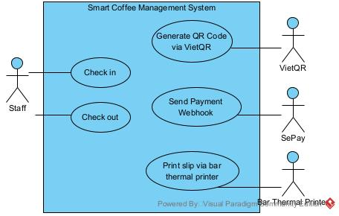

2.2.2 Descriptions
ID | Group Function | Use Case | Actors | Use Case Description
UC01 | Authentication & Access Control | Login / Logout | COO, Branch Manager | The user enters login credentials. The system validates the credentials, identifies the user's role, determines the data access scope, and initiates a session.
UC02 | Manage Role | Manage Roles & Permissions | COO | The COO reviews the list of roles and assigns them to individual employees. The system validates these role-based assignments and then saves the access permissions for each employee.
UC03 | Attendance Management | Check In | Staff, Cashier | The user enters a PIN to authenticate. The system verifies the working shift status, records the check-in time, and returns a successful result.
UC04 | Attendance Management | Check Out | Staff, Cashier | The user requests to end the shift. The system verifies that the shift is active, records the check-out time, and returns a successful result.
UC05 | Branch Management | Manage Branches | COO | The COO creates, views, edits, or deactivates branch information. The system receives and saves the changes to the database.
UC06 | Branch Manager Account Management | Manage Branch Manager Accounts | COO | The COO creates or updates an account, assigns the account to a specific branch, and configures its permissions. The system stores the account configuration.
UC07 | Human Resource Management | Manage Employee Profiles | Branch Manager | The Branch Manager views the employee list and creates, updates, or deactivates employee profiles. The system updates the corresponding information.
UC08 | Shift Management | Manage Work Shifts | Branch Manager | The Branch Manager creates shifts, sets working time frames, and assigns employees. The system checks for schedule conflicts, issues warnings if any, and saves the schedule.
UC09 | Menu Management | Manage Menu Categories | COO | The COO creates, modifies, or deactivates menus and assigns products to each menu. The system saves the standard menu configuration.
UC10 | Product Management | Manage Products | COO | The COO creates new products, updates product details, or deactivates products. The system saves the information in the product catalog.
UC11 | Pricing Management | Manage Prices, Sizes & Toppings | COO | The COO sets or updates selling prices for each product based on size and toppings. The system validates the information and saves the pricing configuration.
UC12 | Recipe Management | Manage Recipes | COO | The COO selects a product and defines the required quantities of raw materials for its preparation.
UC13 | Promotion Management | Manage Vouchers | COO | The COO creates or updates vouchers and configures usage conditions such as validity period, order value, and applicable products. The system validates and saves the voucher information.
UC14 | Chain Management | Synchronize Configuration to Branches | COO | The COO selects configuration data and target branches. The system synchronizes the selected data to the branches and records the synchronization results.
UC15 | Payment Management | Configure SePay Payment | COO | The COO configures the receiving account, Payment Reference, and Webhook. The system validates the information and saves the connection configuration.
UC16 | POS Order Management | Create New Order | Cashier | The Cashier selects products, enters quantities, chooses sizes/toppings, customizes sugar/ice levels, and adds notes. The system consolidates the information and creates the order.
UC17 | Promotion & Voucher Application | Apply Promotion / Voucher | Cashier | The Cashier enters or selects a promotion code. The system verifies the applicable conditions, calculates the discount, and updates the total payment amount.
UC18 | Order Management | View Order Information | Cashier | The Cashier selects an order. The system displays the order number, item list, quantities, discount amount, total amount, and current status.
UC19 | Cash Payment | Process Cash Payment | Cashier | The Cashier selects the Cash payment method and enters the amount received from the customer. The system calculates the change, the Cashier confirms the payment, and the system updates the order status.
UC20 | QR Payment | Confirm QR Payment | SePay | The system receives a Webhook from SePay and automatically reconciles the Payment Reference and payment amount. If the information matches, the system confirms the payment and updates the order status.
UC21 | Order Fulfillment | Print Preparation Slip | Cashier, Bar Thermal Printer | Immediately after the order is paid, the system automatically sends the preparation slip to the printer at the bar. The printer prints the slip and returns the printing result.
UC22 | Receipt Printing | Print Payment Receipt | Cashier, Bar Thermal Printer | When the transaction is successful, the system automatically generates a receipt and sends a print command to the thermal printer. The printer prints the receipt and returns the printing status.
UC23 | Special Order Processing | Process Refund for PAID Order | Cashier | The Cashier selects the paid order to be refunded and enters a mandatory reason. The system verifies the order status and Branch Manager PIN authorization (BR-32), processes the refund, and deducts the refunded cash amount from the cash drawer.
UC24 | Cash Drawer Management | Open Shift | Cashier | The Cashier selects a working shift and declares the opening cash amount. The system validates the information and saves the shift opening configuration.
UC25 | Cash Drawer Management | Add Cash to Drawer | Branch Manager, COO | The Branch Manager or COO enters the cash amount and reason. The system records the cash-in transaction and automatically adds the amount to the cash drawer balance.
UC26 | Cash Drawer Management | Withdraw Cash from Drawer | Branch Manager, COO | The Branch Manager or COO enters the cash-out amount and reason. The system records the cash-out transaction and automatically deducts the amount from the cash drawer balance.
UC27 | Cash Drawer Management | Close Shift & Count Cash | Cashier | The Cashier requests to close the shift and enters the actual counted cash amount. The system calculates the expected cash amount, reconciles the variance, records the closing report, and locks the shift.
UC28 | Branch Inventory Management | Receive Stock | Branch Manager | The Branch Manager creates a goods receipt, selects raw materials, and enters quantities and costs. The system validates the information and increases the corresponding inventory quantities.
UC29 | Branch Inventory Management | Issue Stock | Branch Manager | The Branch Manager creates an issue document, selects raw materials, and enters the quantities to be issued. The system checks the current inventory balance and deducts the issued quantities.
UC30 | Branch Inventory Management | Record Damaged / Disposed Materials | Branch Manager | The Branch Manager declares the quantity of damaged or disposed raw materials and provides a reason. The system validates the information and deducts the corresponding quantity from inventory.
UC31 | Branch Inventory Management | Perform Inventory Stocktake | Branch Manager | The Branch Manager creates an inventory stocktake session and enters the actual counted quantities. The system compares the physical count with the system records and records the variance.
UC32 | Branch Inventory Management | Adjust Inventory | Branch Manager | Based on the stocktake variance, the Branch Manager enters an adjustment transaction with a reason. The system validates the information and updates the actual inventory balance.
UC33 | Branch Inventory Management | Monitor & Alert Low Stock | Branch Manager | The system continuously compares inventory levels with the minimum stock threshold. If the quantity falls below the threshold, the system automatically displays an alert to the Branch Manager.
UC34 | Reporting & Statistics | View Branch Dashboard | Branch Manager, COO | The Branch Manager or COO accesses the dashboard. The system aggregates and visually displays key indicators related to revenue, cash flow, inventory, and employee performance.
UC35 | Reporting & Statistics | View Branch Sales Report | Branch Manager, COO | The Branch Manager or COO selects a time period. The system retrieves, aggregates, and displays the sales report for the selected branch.
UC36 | Reporting & Statistics | Export Reports | Branch Manager, COO | The Branch Manager or COO exports reports as Excel files.
UC37 | Reporting & Statistics | View Branch Cash Flow Report | Branch Manager, COO | The Branch Manager or COO requests the report. The system aggregates the opening cash, cash-in/cash-out transactions, revenue, actual cash balance, and displays the cash flow variance.
UC38 | Reporting & Statistics | View Branch Inventory Report | Branch Manager, COO | The Branch Manager or COO requests the inventory report. The system aggregates receiving, issuing, disposal, and stocktake data and displays the inventory status and variance.
UC39 | Reporting & Statistics | View Branch HR & Shifts Report | Branch Manager | The Branch Manager requests the report. The system aggregates and displays attendance, work shift, and employee productivity data.
UC40 | Reporting & Statistics | View Consolidated Financial Report | COO | The COO requests the consolidated report. The system retrieves data from all branches and generates a consolidated report of revenue, cost of goods sold, and gross profit for the entire chain.
UC41 | Reporting & Statistics | View Product Sales Report | COO | The COO requests the report. The system analyzes sales quantities to identify and display the best-selling products.
UC42 | Reporting & Statistics | View Peak Hours Report | COO, Branch Manager | The COO or Branch Manager requests the report. The system analyzes order volumes by time period, identifies peak sales hours, and displays the results to optimize shift scheduling and operational planning.
UC43 | External System Integration | Generate VietQR Dynamic QR Code | VietQR | The software system sends a request to generate a QR code for an order. VietQR generates the QR code and returns the QR code image together with the payment information.
UC44 | External System Integration | Send Payment Webhook via SePay | SePay | SePay records a successful customer bank transfer and sends a Webhook containing the transaction reference, payment amount, and payment status to the software system.
UC45 | Human Resource & Payroll Management | Manage Branch Payroll | Branch Manager, COO | The Branch Manager organizes branch pay periods, reviews employee attendance hours, adjusts bonuses and deductions, and submits payroll to the COO. The COO reviews and approves or rejects the payroll. Once approved, official payroll disbursement reports are exported.

3. Software Features

3.1 Functional Overview

3.1.1 Screens Flow
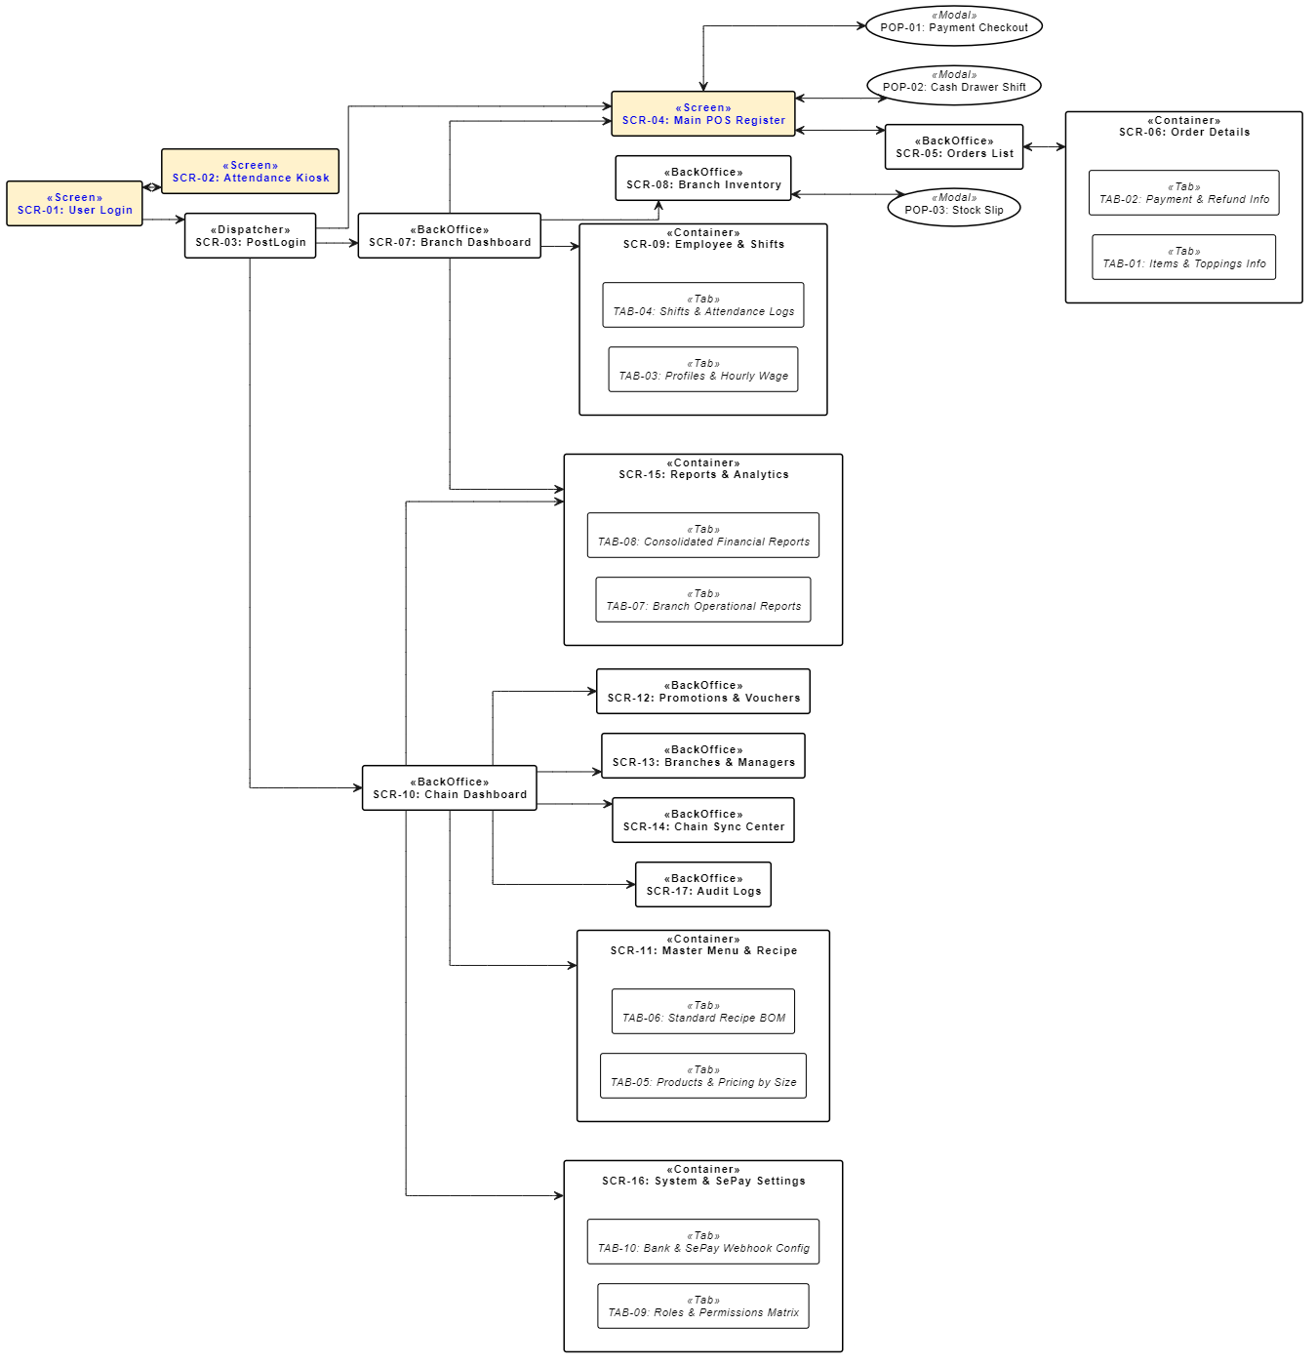

3.1.2 Screen Descriptions

# | Feature | Screen | Description
SCR-01 | Authentication & Timekeeping | User Login | System login screen via Username and Password. Supports quick toggle to the Attendance Kiosk screen (SCR-02). Automatically locks account temporarily after 5 consecutive failed attempts to prevent brute-force attacks. After successful authentication, routes through the System Router (SCR-03).
SCR-02 | Authentication & Timekeeping | Attendance Kiosk | Dedicated timekeeping screen placed at counter/store for shift staff. Supports scanning personal QR code or entering Employee ID/PIN to perform shift Check-in / Check-out. Records actual time, cross-checks with assigned shift roster, and saves log to system. Provides return button to login screen (SCR-01).
SCR-03 | System Navigation | PostLogin | Intermediate component handling post-login logic (navigation/routing splash screen). Checks account Role, current work shift, and permissions to automatically route workflow: Cashier/Staff straight to POS (SCR-04), Branch Manager to Branch Dashboard (SCR-07), COO to Chain Dashboard (SCR-10).
SCR-04 | Point of Sale (POS) | Main POS Register | Primary cashier interface optimized for touchscreens: displays item categories in grid/image card layout, category filters, quick search; current shopping cart area (select size, sugar level, ice level, toppings with extra fee); applies discount codes; displays auto-calculated total including tax/promotions. Allows holding bills temporarily, opening item customization popup (POP-01), payment checkout popup (POP-02), and cash drawer shift management popup (POP-03).
POP-01 | Point of Sale (POS) | Item Options & Apply Promotion (Modal) | Item customization popup: cup size (S/M/L), sugar/ice levels, toppings, and discount voucher application.
POP-02 | Point of Sale (POS) | Payment Checkout (Modal) | Bill payment popup window: selects payment method (Cash, VietQR/SePay Bank Transfer). Integrates dynamic VietQR code generation, Webhook confirmation, change calculation, and receipt printing.
SCR-05 | Order Management | Orders List | Branch order list screen. Supports advanced filters by time, status (Pending Payment, Paid, Partially Refunded, Refunded, Cancelled), assigned cashier, and payment method. Displays daily revenue summary and allows clicking to view detailed order information (SCR-06).
SCR-06 | Order Management | Order Details | Detailed view of a specific order, structured as a Container containing 2 functional tabs (TAB-01 and TAB-02). Provides administrative actions: Reprint Receipt, Reprint Prep Label, Cancel Order (requires Branch Manager role or higher), and Refund.
TAB-01 | Order Management | Items & Toppings Info (Tab) | Sub-tab of SCR-06: Displays detailed list of items in the order, cup size, custom measurements (sugar, ice), attached topping list,unit price, quantity, and customer brewing notes.
TAB-02 | Order Management | Payment & Refund Info (Tab) | Sub-tab of SCR-06: Displays payment transaction history: SePay transaction ID, account number, bank, actual payment time, Webhook reconciliation log. Refund processing area: allows partial or full refund, records reason, and updates inventory/bill status.
POP-03 | Order & Cash Drawer Management | Cash Drawer Shift (Modal) | Cash drawer opening and closing workflow popup window: declares opening cash balance (initial float/change), records mid-shift emergency receipts/disbursements (with reason), and conducts end-of-shift cash reconciliation (theoretical total cash revenue vs. actual cash in drawer). Allows printing shift handover reports.
SCR-07 | Branch Operations | Branch Dashboard | Central dashboard for Branch Manager: monitors real-time revenue, hourly order count chart, low-stock inventory status with red alert thresholds, daily staff shift fulfillment rate. Features quick links to POS (SCR-04), Inventory Management (SCR-08), Shift Staff (SCR-09), and Reports (SCR-15).
SCR-08 | Branch Operations | Branch Inventory | Branch inventory management screen: displays actual on-hand quantity of each raw material (coffee beans, milk, syrup, cups, straws, etc.), minimum safety thresholds, stock shortage alert status. Supports search, category filter, and triggers stock voucher creation via popup (POP-04).
POP-04 | Branch Operations | Stock Slip (Modal) | Popup window to create and process stock vouchers: Inbound Stock Voucher (from central warehouse or external supplier), Disposal Voucher (due to damage or expiration), Stock Count Voucher (enters actual quantity to balance book discrepancies). Requires Branch Manager confirmation signature.
SCR-09 | Branch Operations | Employee & Shifts | Branch-level staff and shift management screen, structured as a Container with 2 functional tabs (TAB-03 and TAB-04). Manages branch employee directory, schedules weekly shift rosters, and tracks attendance.
TAB-03 | Branch Operations | Profiles & Hourly Wage (Tab) | Sub-tab of SCR-09: Manages branch employee profiles (full name, phone number, role, employment status), configures hourly pay rates (UC45), attendance PIN codes, and real-time cumulative working hours tracking. Supports generating and exporting the official branch payroll report (.xlsx) with automated period reset.
TAB-04 | Branch Operations | Shifts & Attendance Logs (Tab) | Sub-tab of SCR-09: Weekly/monthly shift scheduling (Morning Shift, Afternoon Shift, Evening Shift); detailed attendance log table retrieved from Kiosk (SCR-02): actual check-in/check-out time, minutes late/early departure, cumulative working hours for payroll calculation. Allows Branch Manager to approve attendance time adjustments during exceptions.
SCR-10 | Chain Management | Chain Dashboard | Comprehensive dashboard for COO: consolidates daily/monthly revenue across all 6–10 branches, ranks branch sales performance, top-selling items system-wide, abnormal warnings regarding order cancellation costs or inventory discrepancies. Navigates to all centralized administrative modules.
SCR-11 | Chain Management | Master Menu & Recipe | System-wide master menu and recipe management screen, structured as a Container containing 2 tabs (TAB-05 and TAB-06). Allows creating item categories, pricing by size, and managing Bill of Materials (BOM) formulas applied synchronously across branches.
TAB-05 | Chain Management | Products & Pricing by Size (Tab) | Sub-tab of SCR-11: Configures item details (name, image, category, description), sales pricing policy by size (S, M, L), allowed topping options, and topping unit prices. Supports enabling/disabling items system-wide or allowing individual branches to temporarily pause items when out of stock.
TAB-06 | Chain Management | Standard Recipe BOM (Tab) | Sub-tab of SCR-11: Defines raw material consumption standards (Bill of Materials - BOM) per item per size. The system uses this data to calculate theoretical COGS and theoretical ingredient consumption. It does not deduct branch stock per order (BR-41)
SCR-12 | Chain Management | Promotions & Vouchers | System-wide promotional campaign management screen: creates discount voucher codes (percentage or fixed amount), usage conditions (minimum order value, happy hour frames, designated branch applications), usage limits, and validity period. Tracks usage count in real time.
SCR-13 | Chain Management | Branches & Managers | Branch list management screen: adds new branches, updates branch profile (name, address, hotline, opening hours), assigns responsible Branch Manager account, sets operational status (Open, Temporarily Closed, Maintenance).
SCR-14 | Chain Management | Chain Sync Center | Master data publishing hub: publishes a numbered version of menu and prices, standard recipes and promotions to selected branches, shows the publish result per branch and the history of publish versions. It applies new configurations centrally and they are available instantly.
SCR-15 | Reports & Analytics | Reports & Analytics | Financial & operational data analysis screen, structured as a Container consisting of 2 in-depth report tabs (TAB-07 and TAB-08). Allows exporting reports to Excel, PDF, CSV formats for accounting purposes.
TAB-07 | Reports & Analytics | Branch Operational Reports (Tab) | Sub-tab of SCR-15: Detailed branch-level operational reports: daily/weekly revenue, payment method breakdowns (Cash vs. VietQR SePay), order refund/cancellation rates, inventory movement & material loss reports, and shift staff labor costs.
TAB-08 | Reports & Analytics | Consolidated Financial Reports (Tab) | Sub-tab of SCR-15: System-wide consolidated financial reports: P&L (Profit & Loss) comparisons across branches, item profit margins, total cash flow through bank/SePay payment gateways, quarterly/annual revenue growth trend analysis.
SCR-16 | Configuration & Security | System & SePay Settings | System & payment gateway configuration screen, structured as a Container with 2 tabs (TAB-09 and TAB-10). Dedicated to COO for configuring security parameters, bank settings, and access control permissions.
TAB-09 | Configuration & Security | Roles & Permissions Matrix (Tab) | Sub-tab of SCR-16: Granular permission matrix for 4 roles in the system (Staff, Cashier, Branch Manager, COO). Allows toggling view, add, edit, delete, approve order, cancel order, refund, and access permissions for each screen/feature.
TAB-10 | Configuration & Security | Bank & SePay Webhook Config (Tab) | Sub-tab of SCR-16: Configures beneficiary bank accounts, transfer syntax templates for dynamic VietQR generation, SePay API Key, Webhook URL, and security Secret Key. Provides connectivity test tools (Test Ping Webhook) and monitors response packet logs from SePay.
SCR-17 | Audit Logs | Audit Logs | System audit log screen: records details of all critical and sensitive operations (Login, Item Price Edit, BOM Standard Edit, Invoice Cancellation, Refund, Manual Inventory Adjustment, Permission Assignment). Displays operator, timestamp, IP address, branch, and data payload details before/after changes (Diff payload).
Table 3b: Master Use Case to Screen Mapping (Traceability Matrix of 45 Use Cases to Screens)

UC ID | Use Case Name | Primary Actor(s) | Screen Code | Screen / Component Name | Section
UC01 | Login / Logout | COO, Branch Manager | SCR-01, SCR-03 | User Login, PostLogin Router | 3.2.1
UC02 | Manage Roles & Permissions | COO | SCR-16 (TAB-09) | System & SePay Settings (Roles & Permissions) | 3.8.1
UC03 | Check In | Staff, Cashier | SCR-02 | Attendance Kiosk | 3.2.2
UC04 | Check Out | Staff, Cashier | SCR-02 | Attendance Kiosk | 3.2.2
UC05 | Manage Branches | COO | SCR-13 | Branches & Managers | 3.6.4
UC06 | Manage Branch Manager Accounts | COO | SCR-13 | Branches & Managers | 3.6.4
UC07 | Manage Employee Profiles | Branch Manager | SCR-09 (TAB-03) | Employee & Shifts (Profiles & Hourly Wage) | 3.5.3
UC08 | Manage Work Shifts | Branch Manager | SCR-09 (TAB-04) | Employee & Shifts (Shifts & Attendance Logs) | 3.5.3
UC09 | Manage Menu Categories | COO | SCR-11 (TAB-05) | Master Menu & Recipe (Products & Pricing) | 3.6.2
UC10 | Manage Products | COO | SCR-11 (TAB-05) | Master Menu & Recipe (Products & Pricing) | 3.6.2
UC11 | Manage Prices, Sizes & Toppings | COO | SCR-11 (TAB-05) | Master Menu & Recipe (Products & Pricing) | 3.6.2
UC12 | Manage Recipes | COO | SCR-11 (TAB-06) | Master Menu & Recipe (Standard Recipe BOM) | 3.6.2
UC13 | Manage Vouchers | COO | SCR-12 | Promotions & Vouchers | 3.6.3
UC14 | Synchronize Configuration to Branches | COO | SCR-14 | Chain Sync Center | 3.6.5
UC15 | Configure SePay Payment | COO | SCR-16 (TAB-10) | System & SePay Settings (Bank & SePay Webhook) | 3.8.1
UC16 | Create New Order | Cashier | SCR-04 | Main POS Register | 3.3.1
UC17 | Apply Promotion / Voucher | Cashier | SCR-04, POP-01 | Main POS Register, Item Options & Voucher Modal | 3.3.2
UC18 | View Order Information | Cashier | SCR-05, SCR-06 (TAB-01) | Orders List, Order Details (Items & Toppings) | 3.4.1
UC19 | Process Cash Payment | Cashier | POP-02 | Payment Checkout (Modal) | 3.3.3
UC20 | Confirm QR Payment | SePay | POP-02 | Payment Checkout (Modal) | 3.3.3
UC21 | Print Preparation Slip | Cashier, Bar Thermal Printer | POP-02 | Payment Checkout (Modal) | 3.3.3
UC22 | Print Payment Receipt | Cashier, Bar Thermal Printer | POP-02 | Payment Checkout (Modal) | 3.3.3
UC23 | Process Refund for PAID Order | Cashier | SCR-06 (TAB-02) | Order Details (Payment & Refund Info) | 3.4.1
UC24 | Open Shift | Cashier | POP-03 | Cash Drawer Shift (Modal) | 3.4.2
UC25 | Add Cash to Drawer | Branch Manager, COO | POP-03 | Cash Drawer Shift (Modal) | 3.4.2
UC26 | Withdraw Cash from Drawer | Branch Manager, COO | POP-03 | Cash Drawer Shift (Modal) | 3.4.2
UC27 | Close Shift & Count Cash | Cashier | POP-03 | Cash Drawer Shift (Modal) | 3.4.2
UC28 | Receive Stock | Branch Manager | SCR-08, POP-04 | Branch Inventory, Stock Slip (Modal) | 3.5.2
UC29 | Issue Stock | Branch Manager | SCR-08, POP-04 | Branch Inventory, Stock Slip (Modal) | 3.5.2
UC30 | Record Damaged / Disposed Materials | Branch Manager | SCR-08, POP-04 | Branch Inventory, Stock Slip (Modal) | 3.5.2
UC31 | Perform Inventory Stocktake | Branch Manager | SCR-08, POP-04 | Branch Inventory, Stock Slip (Modal) | 3.5.2
UC32 | Adjust Inventory | Branch Manager | SCR-08, POP-04 | Branch Inventory, Stock Slip (Modal) | 3.5.2
UC33 | Monitor & Alert Low Stock | Branch Manager | SCR-08 | Branch Inventory | 3.5.2
UC34 | View Branch Dashboard | Branch Manager, COO | SCR-07 | Branch Dashboard | 3.5.1
UC35 | View Branch Sales Report | Branch Manager, COO | SCR-15 (TAB-07) | Reports & Analytics (Branch Operational Reports) | 3.7.1
UC36 | Export Reports | Branch Manager, COO | SCR-15 (TAB-07, TAB-08) | Reports & Analytics | 3.7.1
UC37 | View Branch Cash Flow Report | Branch Manager, COO | SCR-15 (TAB-07) | Reports & Analytics (Branch Operational Reports) | 3.7.1
UC38 | View Branch Inventory Report | Branch Manager, COO | SCR-15 (TAB-07) | Reports & Analytics (Branch Operational Reports) | 3.7.1
UC39 | View Branch HR & Shifts Report | Branch Manager | SCR-15 (TAB-07) | Reports & Analytics (Branch Operational Reports) | 3.7.1
UC40 | View Consolidated Financial Report | COO | SCR-10, SCR-15 (TAB-08) | Chain Dashboard, Consolidated Financial Reports | 3.6.1
UC41 | View Product Sales Report | COO | SCR-10, SCR-15 (TAB-08) | Chain Dashboard, Consolidated Financial Reports | 3.6.1
UC42 | View Peak Hours Report | COO, Branch Manager | SCR-10, SCR-15 | Chain Dashboard, Reports & Analytics | 3.6.1
UC43 | Generate VietQR Dynamic QR Code | VietQR | POP-02 | Payment Checkout (Modal) | 3.3.3
UC44 | Send Payment Webhook via SePay | SePay | SCR-16 (TAB-10), System API | System & SePay Settings (Webhook Gateway) | 3.8.1
UC45 | Manage Branch Payroll | Branch Manager, COO | SCR-09 (TAB-03), SCR-07 | Employee & Shifts (TAB-03: Pay Periods & Wage, TAB-04: Attendance Unlocking), Chain Review (SCR-16) | 3.5.3

3.1.3 Screen Authorization

# | Screen | Staff | Cashier | Branch Manager | COO
SCR-01 | User Login |  |  | x | x
SCR-02 | Attendance Kiosk | x | x
SCR-03 | Role Dispatcher |  | x | x | x
SCR-04 | Main POS Register |  | x | x
POP-01 | Item Options |  | x | x
POP-02 | Payment Checkout |  | x | x
POP-03 | Cash Drawer Shift |  | x | x | x
SCR-05 | Orders List |  | x | x | x
SCR-06 | Order Details |  | x | x | x
TAB-01 | Items & Toppings Info |  | x | x | x
TAB-02 | Payment & Refund Info |  | x | x | x
SCR-07 | Branch Dashboard |  |  | x | x
SCR-08 | Branch Inventory |  |  | x | x
POP-04 | Stock Slip |  |  | x | x
SCR-09 | Employee & Shifts |  |  | x | x
TAB-03 | Profiles & Hourly Wage |  |  | x | x
TAB-04 | Shifts & Attendance Logs |  | x | x | x
SCR-10 | Chain Dashboard |  |  |  | x
SCR-11 | Master Menu & Recipe |  |  | x | x
TAB-05 | Products & Pricing by Size |  |  | x | x
TAB-06 | Standard Recipe BOM |  |  | x | x
SCR-12 | Promotions & Vouchers |  |  | x | x
SCR-13 | Branches & Managers |  |  |  | x
SCR-14 | Chain Sync Center |  |  | x | x
SCR-15 | Reports & Analytics |  |  | x | x
TAB-07 | Branch Operational Reports |  |  | x | x
TAB-08 | Consolidated Financial Reports |  |  |  | x
SCR-16 | System & SePay Settings |  |  |  | x
TAB-09 | Roles & Permissions Matrix |  |  |  | x
TAB-10 | Bank & SePay Webhook Config |  |  |  | x
SCR-17 | Audit Logs |  |  |  | x

3.1.4 Entity Relationship Diagram
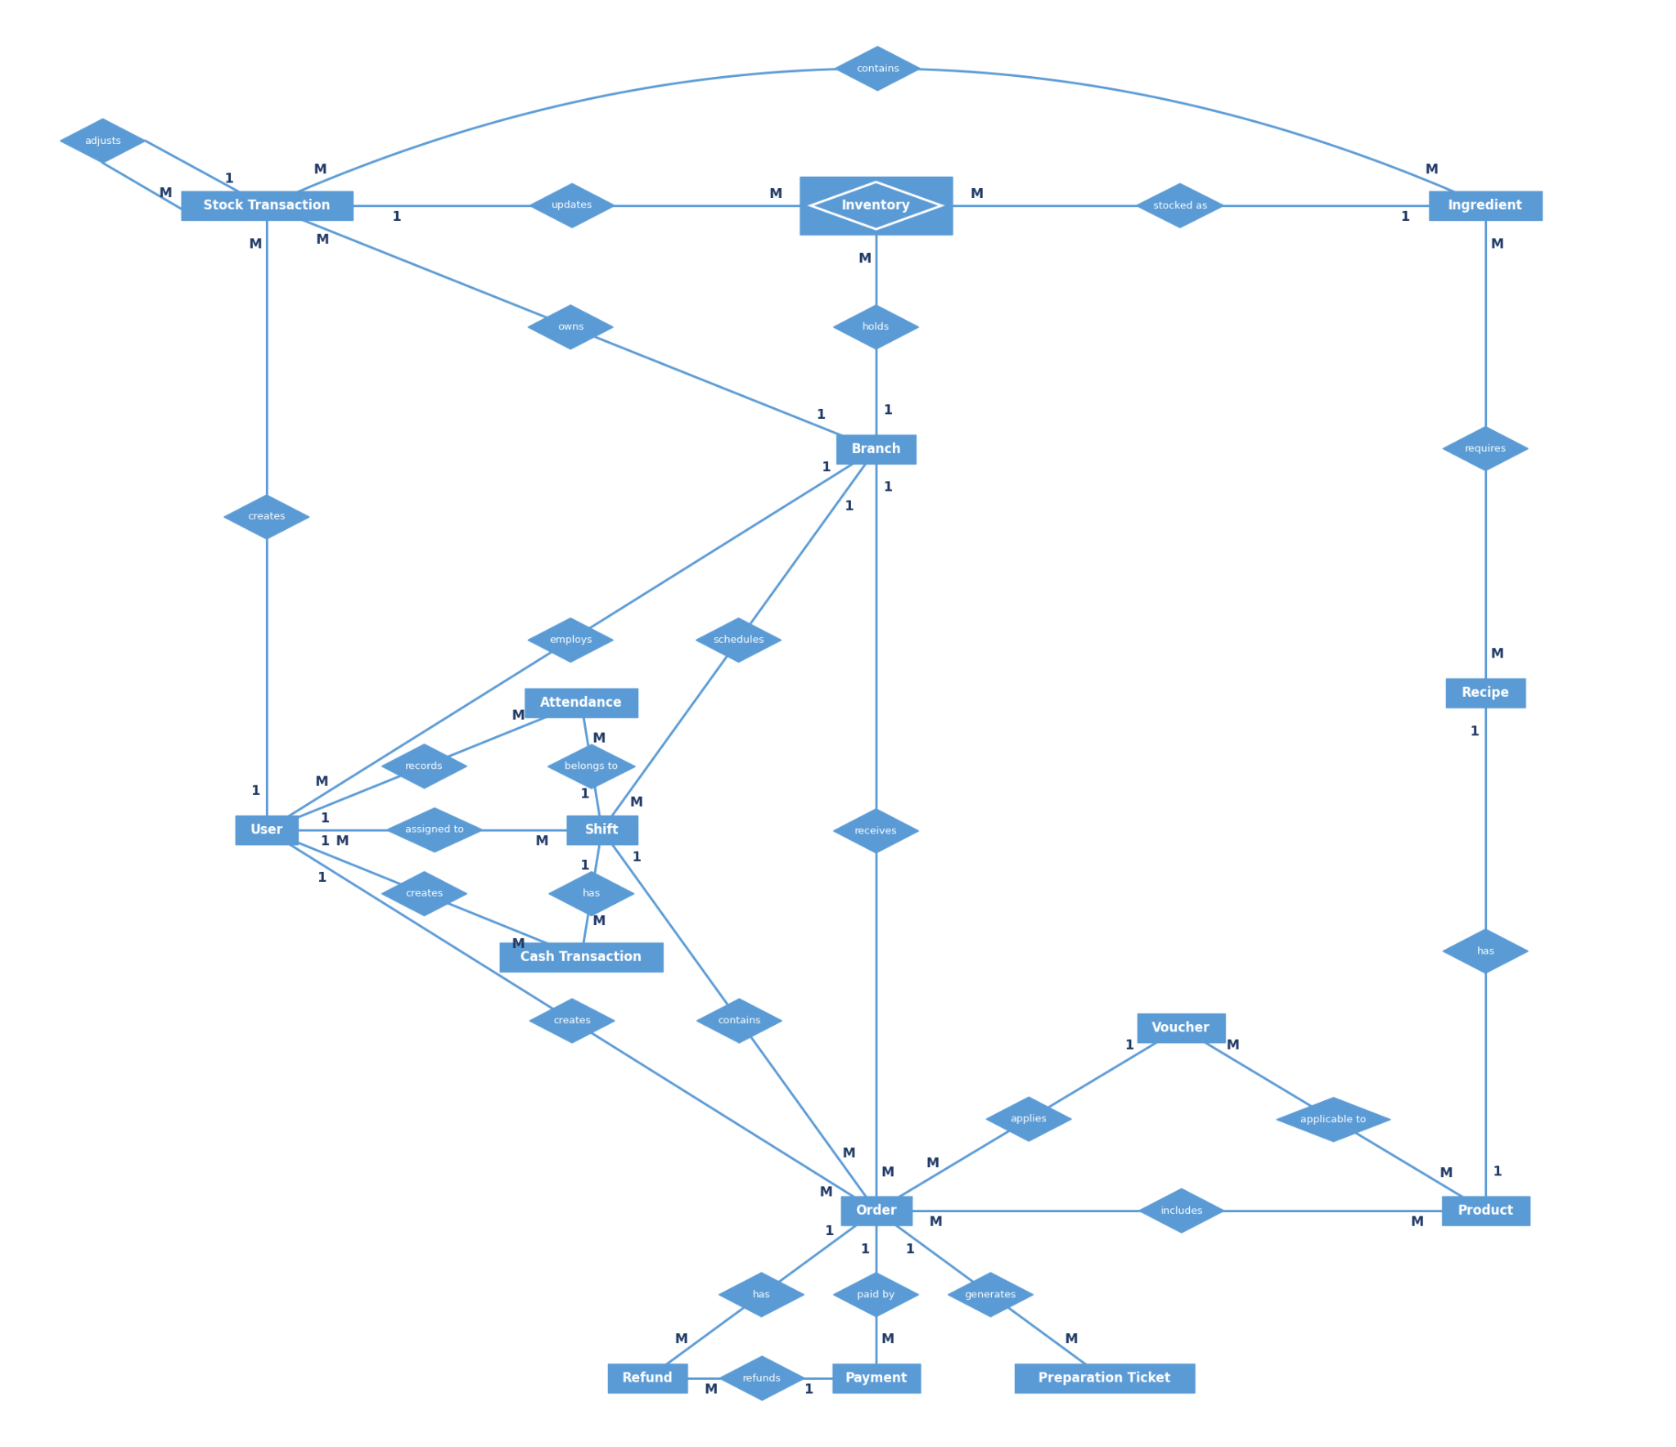
Entities Description
# | Entity | Description
1 | Branch | A cafe branch within the chain. Stores branch information and operating settings (opening hours, tables, printers, etc.).
2 | User | An user of the chain, including personal information, the assigned branch, and the assigned role.
3 | Attendance | An employee's attendance record (check-in and check-out time) for a work shift.
4 | Shift | A work shift at a branch, opened and closed by an employee. It is the unit for reconciling cash and revenue.
5 | Cash Transaction | A cash movement during a shift (cash in, cash out, opening and closing the cash drawer), used for cash reports.
6 | Product | A product sold at the cafe (beverage or food), including name, price, and selling status.
7 | Recipe | The recipe of a product, defining which ingredients and what quantities are used for each product.
8 | Ingredient | A raw material used to prepare products, including its unit of measure and current stock level.
9 | Stock Transaction | A stock-in, stock-out, or adjustment record for ingredients, used to track inventory and generate inventory reports.
10 | Order | A customer order created by a cashier, including total amount, status, and creation time.
11 | Inventory | Current stock balance of raw material ingredients stored at a specific branch, updated upon stock transactions and POS usage deductions.
12 | Voucher | A discount or promotion code applied to an order, including its conditions, value, and validity period.
13 | Payment | The payment of an order (cash or bank transfer), storing the method, amount, status, and the QR code information generated by VietQR.
14 | Refund | A refund request for a payment, including the reason, amount, and processing result.
15 | Preparation Ticket | A ticket printed on the bar thermal printer for each item that needs to be prepared.
16 | PayPeriod | A payroll cycle for a branch (e.g. bi-weekly or monthly). Records start/end dates, approval lifecycle (Draft, Submitted, Approved, Rejected, Paid), total working hours, total payroll disbursement amount, and COO approval metadata.
17 | PayrollItem | An individual employee's payroll statement for a specific pay period (Period x Employee relation). Captures regular hours worked, snapshot hourly wage rate, bonuses, deductions, and net salary payable.

3.1.5 Entity Details
- Branch
# | Attribute name | PK | Type | Mandatory | Description
1 | Branch Number | x | String | Yes | Unique identifier of the branch.
2 | Name |  | String | Yes | Name of the branch.
3 | Address |  | String | Yes | Physical address of the branch.
4 | Phone |  | String | No | Contact phone number of the branch.
5 | Opening Time |  | Time | Yes | Opening time of the branch.
6 | Closing Time |  | Time | Yes | Closing time of the branch.
7 | Table Count |  | Number | No | Total number of tables at the branch.
8 | Status |  | String | Yes | Operating status of the branch.
9 | Created At |  | DateTime | Yes | Timestamp when the branch was created.
10 | Bank Name |  | String | No | Bank of the SePay receiving account
11 | Account Number |  | String | No | Receiving account number for QR payments
12 | Account Holder |  | String | No | Name of the receiving account holder

- User
# | Attribute name | PK | Type | Mandatory | Description
1 | User Number | x | String | Yes | Unique identifier of the User.
2 | Full Name |  | String | Yes | Full name of the User .
3 | Phone |  | String | Yes | Contact phone number.
4 | Username |  | String | No | System login username (applicable for users with system accounts).
5 | Password |  | String | No | System login password (applicable for users with system accounts).
6 | PIN |  | String | No | 4-digit PIN code used for kiosk time tracking/check-in.
7 | Card Code |  | String | No | User RFID card code used for time tracking.
8 | Status |  | String | Yes | User status of the User .
9 | Created At |  | DateTime | Yes | Timestamp when the User profile was created.
10 | Update At |  | DateTime | No | Timestamp when the User profile was updated.
11 | Role |  | String | Yes | Role of User in System
12 | Hourly Rate |  | Number | No | Hourly wage rate based on the role policy at the employee's branch.
13 | Base Salary |  | Number | No | Base salary.

- Attendance
# | Attribute name | PK | Type | Mandatory | Description
1 | Attendance Number | x | String | Yes | Unique identifier of the attendance record.
2 | Work Date |  | Date | Yes | Working date.
3 | Check In Time |  | DateTime | Yes | Timestamp when the employee checks in to start the shift.
4 | Check Out Time |  | DateTime | No | Check-out timestamp when ending the shift (empty if not yet checked out).
5 | Method |  | String | Yes | Way the employee checked in (PIN code or employee card).
6 | Status |  | String | Yes | Attendance results compared with the assigned working hours (e.g., on time, late, early departure, missing check-out).
7 | Shift type |  | String | Yes | Title of shift like Morning, evening.

- Recipe
# | Attribute name | PK | Type | Mandatory | Description
1 | Recipe Number | x | String | Yes | Unique identifier of the recipe line item.
2 | Quantity |  | Number | Yes | Standard quantity of ingredient required for one unit of product.
3 | Unit |  | String | Yes | Unit of measurement for the ingredient quantity.

- Shift
# | Attribute name | PK | Type | Mandatory | Description
1 | Shift Number | x | String | Yes | Unique identifier of the work shift.
2 | Shift Date |  | Date | Yes | Date of the shift
3 | Shift Type |  | String | Yes | Morning / Evening / Night
4 | Start Time |  | Time | Yes | Planned start time
5 | End Time |  | Time | Yes | Planned end time
6 | Opened At |  | DateTime | Yes | Timestamp when the shift was opened.
7 | Closed At |  | DateTime | No | Timestamp when the shift was closed.
8 | Opening Cash |  | Number | Yes | Initial cash amount in the cash drawer when opening the shift.
9 | Cash revenue |  | Number | Yes | Total cash payments received during the shift
10 | Transfer revenue |  | Number | Yes | Total QR payments received during the shift
11 | Expected Cash |  | Number | Yes | Opening Cash + Cash Revenue + cash-in − cash-out − cash refunds
12 | Counted Cash |  | Number | Yes | Actual physical cash amount counted when closing the shift.
13 | Cash Variance |  | Number | Yes | Counted Cash − Expected Cash (positive = overage, negative = shortage).
14 | Discrepancy Reason |  | String | Conditional | Required when Cash Variance is not zero
15 | Status |  | String | Yes | Shift status (open, closed).

- Cash Transaction
# | Attribute name | PK | Type | Mandatory | Description
1 | Transaction Number | x | String | Yes | Unique identifier of the cash transaction
2 | Type |  | String | Yes | Cash-in / Cash-out
3 | Amount |  | Number | No | Amount added to or withdrawn from the drawer
4 | Reason |  | String | No | Reason entered by the Branch Manager
5 | Created At |  | DateTime | No | Time the transaction was recorded

- Product
# | Attribute name | PK | Type | Mandatory | Description
1 | Product Number | x | String | Yes | Unique identifier of the product.
2 | Name |  | String | Yes | Product name.
3 | Topping |  | String | No | Topping included with the product
4 | Size |  | String | No | Size of product.
5 | Image |  | String | No | Product photos.
6 | Description |  | String | No | Product description.
7 | Category |  | String | Yes | which category does the product belong to
8 | Price |  | Number | Yes | Selling price of the product.
9 | Status |  | String | Yes | Business status of the product.

- Ingredient
# | Attribute name | PK | Type | Mandatory | Description
1 | Ingredient Number | x | String | Yes | Unique identifier of the ingredient.
2 | Name |  | String | Yes | Ingredient name.
3 | Base Unit |  | String | Yes | Dispensing unit of measurement used in preparation/recipes.
4 | Pack Unit |  | String | No | Bulk packaging unit used for inventory receiving.
5 | Conversion Ratio |  | Number | No | Number of base units contained in one bulk packaging unit.
6 | Min Stock Level |  | Number | No | Minimum safe stock threshold for low-stock alerts.
7 | Unit Cost |  | Number | Yes | Cost price per base unit.

- Order
# | Attribute name | PK | Type | Mandatory | Description
1 | Order Number | x | String | Yes | Unique identifier of the order.
2 | Status |  | String | Yes | Order status (Pending Payment, Paid, Partially Refunded, Refunded, Cancelled)
3 | Note |  | String | No | Order notes or customer special requests.
4 | Created At |  | DateTime | Yes | Timestamp when the order was created.
5 | Paid At |  | DateTime | No | Timestamp when the order was successfully paid.
6 | Total Amount |  | Number | Yes | Order total of order
7 | Discount Amount |  | Number | Yes | Discount amount of order
8 | Final Amount |  | Number | Yes | Accounts receivable of order
9 | Receipt Number |  | Number | Yes | Unique receipt code, incrementing by day/shift
10 | Receipt Printed At |  | Time | Yes | Time when the receipt was issued

- Voucher
# | Attribute name | PK | Type | Mandatory | Description
1 | Voucher Number | x | String | Yes | Unique identifier of the voucher.
2 | Code |  | String | Yes | Voucher promotional code entered by customer or cashier.
3 | Discount Type |  | String | Yes | Discount type (percentage or fixed amount).
4 | Discount Value |  | Number | Yes | Discount value.
5 | Min Order Amount |  | Number | No | Minimum order total required to apply the voucher.
6 | Start Date |  | Date | Yes | Effective start date of the voucher.
7 | End Date |  | Date | Yes | Expiration date of the voucher.
8 | Usage Limit |  | Number | No | Maximum allowed number of total usages.
9 | Status |  | String | Yes | Voucher status (e.g., active, expired, disabled).

- Payment
# | Attribute name | PK | Type | Mandatory | Description
1 | Payment Number | x | String | Yes | Unique identifier of the payment record.
2 | Method |  | String | Yes | Payment method (cash or QR transfer).
3 | Amount |  | Number | Yes | Amount that has to be paid by this payment.
4 | Status |  | String | Yes | Payment status (pending, completed, failed, amount mismatch).
5 | QR Content |  | String | No | VietQR raw payload string (applicable for QR payment).
6 | QR Expired At |  | DateTime | No | Expiration timestamp of the generated QR code.
7 | Reference Code |  | String | No | Reconciliation reference code provided by SePay.
8 | Received Amount |  | Number | No | Amount reported as received by the payment gateway (QR payments only).
9 | Created At |  | DateTime | Yes | Timestamp when the payment record was created.
10 | Paid At |  | DateTime | No | Timestamp when the payment was confirmed as received.

- Refund
# | Attribute name | PK | Type | Mandatory | Description
1 | Refund Number | x | String | Yes | Unique identifier of the refund request.
2 | Amount |  | Number | Yes | Amount to be refunded to the customer. It cannot exceed the amount paid.
3 | Reason |  | String | Yes | Reason for requesting refund.
4 | Status |  | String | Yes | Refund status (pending approval, approved, rejected, completed).
5 | Requested At |  | DateTime | Yes | Timestamp when the refund was requested.
6 | Processed At |  | DateTime | No | Timestamp when the refund was approved or rejected.

- Inventory
# | Attribute name | PK | Type | Mandatory | Description
1 | Inventory Number | x | String | Yes | Unique identifier of the branch inventory balance record.
2 | Current Quantity |  | Number | Yes | Actual on-hand stock quantity in base pour unit, updated upon stock movements and sales order deductions.
3 | Safety Stock Level |  | Number | Yes | Minimum safe stock threshold for low-stock alerts, set per branch.
4 | Last Updated |  | DateTime | Yes | Timestamp when the inventory balance was last modified.
5 | Low-Stock Alert Flag |  | Boolean | Yes | True when Current Quantity < Safety Stock Level

- Stock Transaction
# | Attribute name | PK | Type | Mandatory | Description
1 | Stock Transaction Number | x | String | Yes | Unique identifier of the stock transaction.
2 | Type |  | String | Yes | Transaction type: Receive, Issue, Damaged/Disposed, Stocktake, or Adjustment.
3 | Reason |  | String | Yes | Reason for the transaction. Required for Damaged/Disposed and Adjustment, empty for other types.
4 | Created Date |  | DateTime | Yes | Timestamp when the stock transaction was recorded.
5 | Evidence Image |  | String | No | Photo evidence. Required for Damaged/Disposed, optional for other types.
6 | Quantity |  | Number | Yes | Quantity received, issued, written off or adjusted, in packages. For stocktake it is the counted quantity
7 | Converted Pour Unit Quantity |  | Number | Yes | Quantity converted to the pour unit (derived from Quantity and the ingredient’s Conversion Ratio).
8 | Purchase Price |  | Number | Conditional | Price per package, required only for Receive
9 | Line Total |  | Number | Conditional | Package quantity × purchase price, only for Receive
10 | Book Quantity |  | Number | Conditional | System stock at the time of counting, only for Stocktake
11 | Variance |  | Number | Conditional | Counted quantity − book quantity, only for Stocktake

- Preparation Ticket
# | Attribute name | PK | Type | Mandatory | Description
1 | Ticket Number | x | String | Yes | Unique identifier of the kitchen/bar preparation ticket.
2 | Print Status |  | String | Yes | Ticket printing status (printed, error).
3 | Printed At |  | DateTime | No | Timestamp when the ticket was successfully printed.
4 | Description |  | String | Yes | Describe the task to be done
PayPeriod
# | Attribute name | PK | Type | Mandatory | Description
1 | period_id | PK | BIGINT | No | Primary key identifying the branch pay period.
2 | branch_id | FK | INT | No | Foreign key referencing Branch (Target branch).
3 | period_name | - | VARCHAR(100) | No | Descriptive name (e.g., 'October 2026 - Cycle 1').
4 | start_date | - | DATE | No | Start date of the attendance & payroll period.
5 | end_date | - | DATE | No | End date of the attendance & payroll period.
6 | status | - | VARCHAR(20) | No | Period status: DRAFT, SUBMITTED, APPROVED, REJECTED, PAID.
7 | total_hours | - | DECIMAL(10,2) | No | Total aggregate valid staff working hours.
8 | total_amount | - | DECIMAL(15,2) | No | Total aggregate payroll disbursement amount (VND).
9 | created_by | FK | INT | No | Foreign key referencing User (Branch Manager creator).
10 | approved_by | FK | INT | Yes | Foreign key referencing User (COO approver).
11 | approved_at | - | TIMESTAMP | Yes | Timestamp when COO approved the pay period.
12 | rejection_reason | - | VARCHAR(255) | Yes | Reason provided by COO if rejected.
13 | created_at | - | TIMESTAMP | No | Timestamp when the pay period record was created.
14 | updated_at | - | TIMESTAMP | No | Timestamp when the record was last modified.
PayrollItem
# | Attribute name | PK | Type | Mandatory | Description
1 | payroll_id | PK | BIGINT | No | Primary key identifying employee payroll line item.
2 | period_id | FK | BIGINT | No | Foreign key referencing PayPeriod (Parent period).
3 | user_id | FK | INT | No | Foreign key referencing User (Staff recipient).
4 | hourly_rate | - | DECIMAL(10,2) | No | Snapshot hourly wage rate applied (BR-14).
5 | regular_hours | - | DECIMAL(8,2) | No | Total verified attendance working hours in period.
6 | base_salary | - | DECIMAL(12,2) | No | Computed base wage: regular_hours x hourly_rate.
7 | bonus_amount | - | DECIMAL(12,2) | No | Performance/attendance bonus proposed by BM.
8 | bonus_reason | - | VARCHAR(255) | Yes | Justification for added bonus amount.
9 | deduction_amount | - | DECIMAL(12,2) | No | Penalty/deduction amount (breakage, tardiness).
10 | deduction_reason | - | VARCHAR(255) | Yes | Justification for penalty deduction.
11 | net_salary | - | DECIMAL(12,2) | No | Net payable: base_salary + bonus - deduction.
12 | status | - | VARCHAR(20) | No | Line item status: PENDING, APPROVED, PAID.
13 | note | - | VARCHAR(255) | Yes | General remarks and notes.

3.2 Authentication, Navigation & Attendance

3.2.1 User Login

3.2.1.1 Screen Mock-up
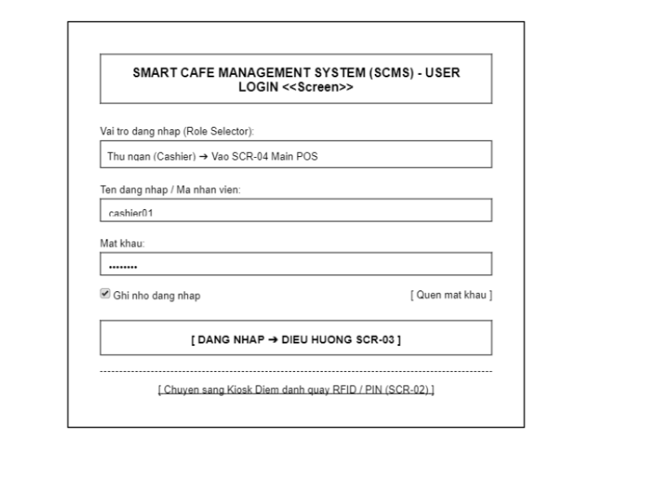

Screen Definition
# | Field Name | Type | Mandatory | Max Length | Description
1 | Role Selector | Dropdown | Yes | - | Select the intended working role/module (Cashier, Branch Manager, COO, Staff). Default: Cashier.
2 | User Name | Text | Yes | 30 | Enter the username or employee ID (e.g., cashier01, manager_d1).
3 | Password | Password | Yes | 32 | Enter the password. Displays hidden characters (*) instead of actual text. Minimum 6 characters.
4 | Remember Me | Checkbox | No | - | Option to save the active working session on the device's browser. Default: Checked.
5 | Forgot Password | Link | - | - | Opens instructions to contact the Branch Manager or COO for a password reset.
6 | Login | Button | - | - | Submits the authentication request. Upon successful login, redirects to SCR-03: Role Dispatcher.
7 | Switch to Kiosk | Link / Button | - | - | Quick switch to the counter attendance screen (SCR-02: Attendance Kiosk).

3.2.1.2 Use Case Description
UC01 – Login / Logout
Use Case ID |  | UC01 | Use Case Name |  | Login / Logout
Author |  | TamDHM | Version | 1.0 | Date | 04/10/2026
Actor |  | COO, Branch Manager
Description |  | The user enters login credentials (username/phone number and password) into the SCMS. The system validates the credentials, identifies the user's role and data access scope, creates an active session, and redirects the user to the appropriate landing dashboard.
Precondition |  | PRE-01: The user has an active account provisioned in the SCMS database.  PRE-02: The system is connected to the authentication service and database.
Trigger |  | TRG-01: The user accesses the SCMS login page and submits their credentials.
Post-Condition |  | POS-01: An active login session is created with a valid authentication token.  POS-02: The user is logged into the system with permissions and data access corresponding to their assigned role.
Main flows
Step | Actor | Action
1 | User | Navigate to the SCMS login screen (SCR-01) and enter login credentials (username/phone number and password).
2 | User | Click the "Login" button.
3 | SCMS | Validate the input fields to ensure required data is provided.
4 | SCMS | Authenticate credentials against the database and check the user account status (e.g., Active).
5 | SCMS | Identify the user's role (COO, Branch Manager, Cashier, Staff) and determine the corresponding data access scope and branch context.
6 | SCMS | Create an active session, generate an access token, and redirect the user to their designated default screen/dashboard.

Alternative flows
AT1 | Invalid credentials or inactive account (At step 4 in the main flows)
Sub step | Actor | Action
2.1 | SCMS | Detect invalid username/password or find that the account is deactivated/locked.
2.2 | SCMS | Display an error message notifying the user of incorrect credentials or inactive account status.
2.3 | SCMS | Keep the user on the login screen and allow re-entry of credentials.

3.2.2 Attendance Kiosk

3.2.2.1 Screen Mock-up
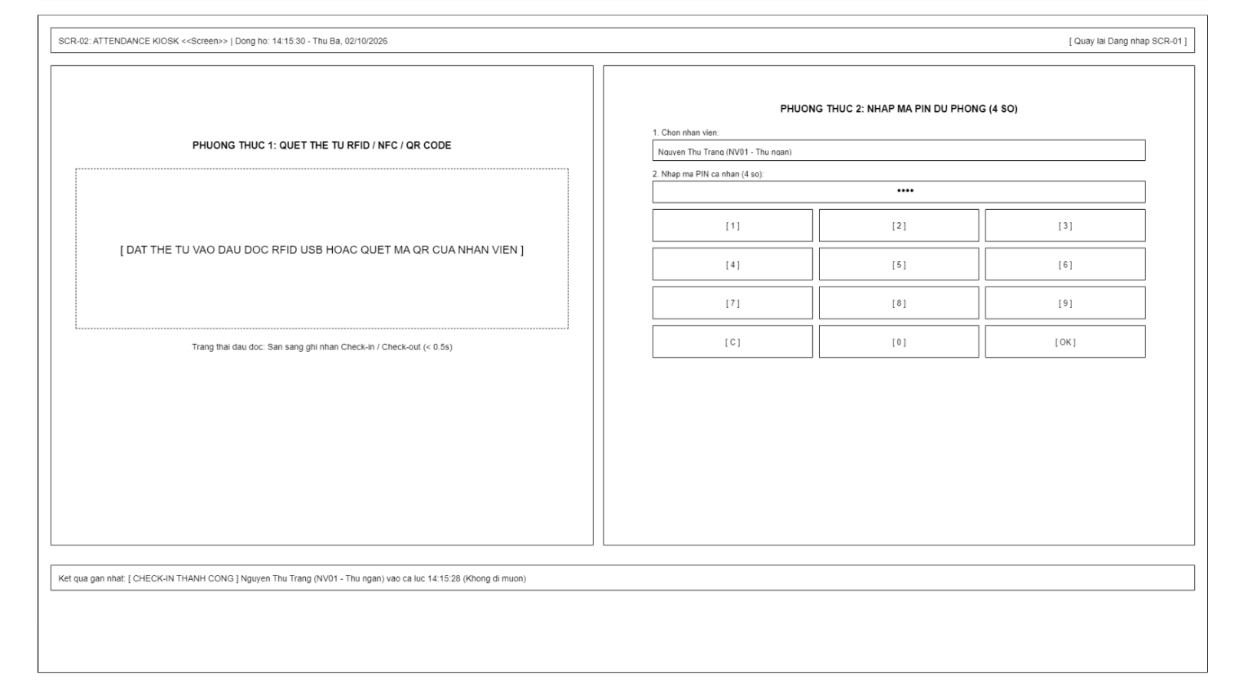

Screen Definition
# | Field Name | Type | Mandatory | Max Length | Description
1 | System Clock | Label | - | - | Displays a real-time clock (Hours:Minutes:Seconds - Day of the week, Date/Month/Year) synchronized with the server to reconcile clock-in/out times.
2 | Back to Login | Button | - | - | Click to return to the user login screen (SCR-01: User Login).
3 | RFID / QR Scan Area | Component | - | - | Receives the card code from the USB RFID reader. A valid card immediately records check-in or check-out (BR-06).
4 | Reader Status | Label | - | 50 | Displays peripheral device connection status (e.g., "Ready for check-in/out" or "Card reader disconnected").
5 | Employee Selector | Dropdown | Yes | - | List to select shift-assigned employees (Full Name + Employee ID) used as a backup PIN method when a card is forgotten.
6 | PIN Display | Password | Yes | 4 | Shows masked digits. Exactly 4 digits.
7 | Numpad (0 - 9) | Button Grid | - | - | Grid of 10 large touch number keys from 0 to 9 for staff to operate directly on the counter screen.
8 | Clear (C) | Button | - | - | Key to clear all recently entered PIN digits in the display field.
9 | Submit (OK) | Button | - | - | Submits the PIN code for time tracking authentication reconciled against assigned shifts.
10 | Result Banner | Label / Box | - | 150 | Notification box displaying the latest time tracking result (Full Name, Employee ID, Check-in / Check-out status, actual timestamp, and notes on punctuality/tardiness).

3.2.2.2 Use Case Description
UC03 – Check In
Use Case ID |  | UC03 | Use Case Name |  | Check In
Author |  | TamDHM | Version | 1.0 | Date | 04/10/2026
Actor |  | Staff, Cashier
Description |  | The user (Staff or Cashier) enters a personal PIN or scans an RFID card on the branch terminal to authenticate. The system checks shift roster status, records check-in timestamp, and updates attendance logs.
Precondition |  | PRE-01: The user is assigned to the current branch and scheduled for a shift.  PRE-02: The POS/Attendance terminal is on the "Check-In" screen (SCR-03).
Trigger |  | TRG-01: The user initiates a check-in request at the beginning of their shift.
Post-Condition |  | POS-01: A check-in record containing the exact timestamp, user ID, and shift ID is recorded.  POS-02: The user's status for the scheduled shift is marked as "Checked-In".
Main flows
Step | Actor | Action
1 | User | Select their name or enter their Employee ID on the attendance terminal.
2 | User | Enter their security PIN and press the "Check In" button.
3 | SCMS | Validate the PIN against user security credentials.
4 | SCMS | Verify current time against scheduled shifts for the employee to associate the check-in with the correct shift.
5 | SCMS | Record the check-in time, calculate status (e.g., On Time, Late), and update attendance records.
6 | SCMS | Display a success message confirming the check-in time.

Alternative flows
AT1 | Incorrect PIN entered (At step 3 in the main flows)
Sub step | Actor | Action
1.1 | SCMS | Detect that the entered PIN does not match the employee record.
1.2 | SCMS | Display an error message "Incorrect PIN. Please try again."
1.3 | SCMS | Prompt the user to re-enter their PIN.
AT2 | No scheduled shift found (At step 4 in the main flows)
Sub step | Actor | Action
2.1 | SCMS | Detect that no active or upcoming schedule exists for the employee on the current date.
2.2 | SCMS | Log an unscheduled attendance record or alert the user.
2.3 | SCMS | Display a warning message "No scheduled shift found for today" and request manager override or log as an unscheduled check-in.

UC04 – Check Out
Use Case ID |  | UC04 | Use Case Name |  | Check Out
Author |  | TamDHM | Version | 1.0 | Date | 04/10/2026
Actor |  | Staff, Cashier
Description |  | The user (Staff or Cashier) requests to complete their working shift by authenticating via PIN or RFID card. The system verifies active check-in session, records check-out timestamp, calculates shift hours, and closes attendance record.
Precondition |  | PRE-01: The user has previously completed a successful check-in (UC03) for the current active shift.  PRE-02: The POS/Attendance terminal is on the "Check-Out" screen (SCR-04).
Trigger |  | TRG-01: The user initiates a check-out request upon ending their work shift.
Post-Condition |  | POS-01: The check-out timestamp is recorded for the active attendance log.  POS-02: Total working hours for the shift are calculated and saved in attendance records.
Main flows
Step | Actor | Action
1 | User | Select their name/Employee ID on the attendance terminal and enter their security PIN.
2 | User | Click the "Check Out" button.
3 | SCMS | Validate the security PIN against user credentials.
4 | SCMS | Verify that an open check-in record exists for the employee.
5 | SCMS | Record the check-out timestamp and calculate total working time for the shift.
6 | SCMS | Display a confirmation message displaying the check-out time and total shift hours worked.

Alternative flows
AT1 | No active check-in record found (At step 4 in the main flows)
Sub step | Actor | Action
2.1 | SCMS | Detect that no open check-in session exists for the user on the current day.
2.2 | SCMS | Display an error message "No open check-in record found for this user."
2.3 | SCMS | Prompt the user to contact the Branch Manager for manual attendance adjustment.

3.2.3 Role Dispatcher

3.2.3.1 Screen Mock-up
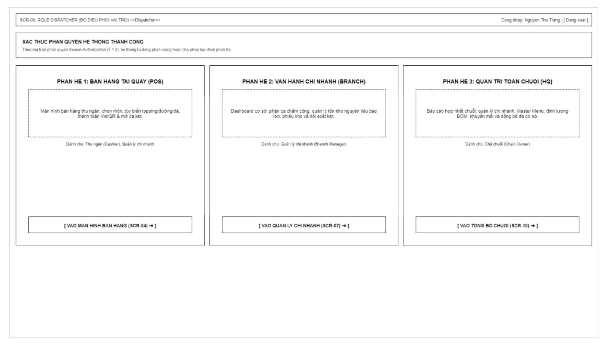
Screen Definition
# | Field Name | Type | Mandatory | Max Length | Description
1 | Current User Info | Label | - | 80 | Displays the name and assigned role of the currently logged-in employee/user (e.g., "Logged in: Nguyen Thu Trang (Cashier - Branch 01)").
2 | Logout | Button / Link | - | - | Logs out the current session, clears session/token, and redirects back to the Login screen (SCR-01).
3 | Authorization Notice | Label | - | 200 | Displays a system permission status message and provides instructions for the user to select the appropriate module corresponding to their role.
4 | POS Section Card | Container | - | - | Displays information block for Point of Sale (POS) module: item selection, custom sugar/ice/topping adjustments, cash collection, Dynamic VietQR, and cash drawer shift management.
5 | Enter POS | Button | - | - | Click to navigate to the main cash register screen (SCR-04: Main POS Register). Visible/active only for Cashier and Branch Manager roles.
6 | Branch Section Card | Container | - | - | Displays information block for Branch Management module: monitoring branch revenue, timekeeping, managing bulk raw material inventory, and issuing stock vouchers.
7 | Enter Branch Portal | Button | - | - | Click to navigate to the branch dashboard (SCR-07: Branch Dashboard). Active only for Branch Manager and COO roles.
8 | HQ Section Card | Container | - | - | Displays information block for Chain HQ Management module: consolidated financial reporting across 6–10 branches, Master Menu setup, BOM formulas, promotions, and data synchronization.
9 | Enter HQ Portal | Button | - | - | Click to navigate to the headquarters central dashboard (SCR-10: Chain Dashboard). Visible/active exclusively for the COO role.

3.3 Point of Sale (POS) & Checkout

3.3.1 Main POS Register

3.3.1.1 Screen Mock-up
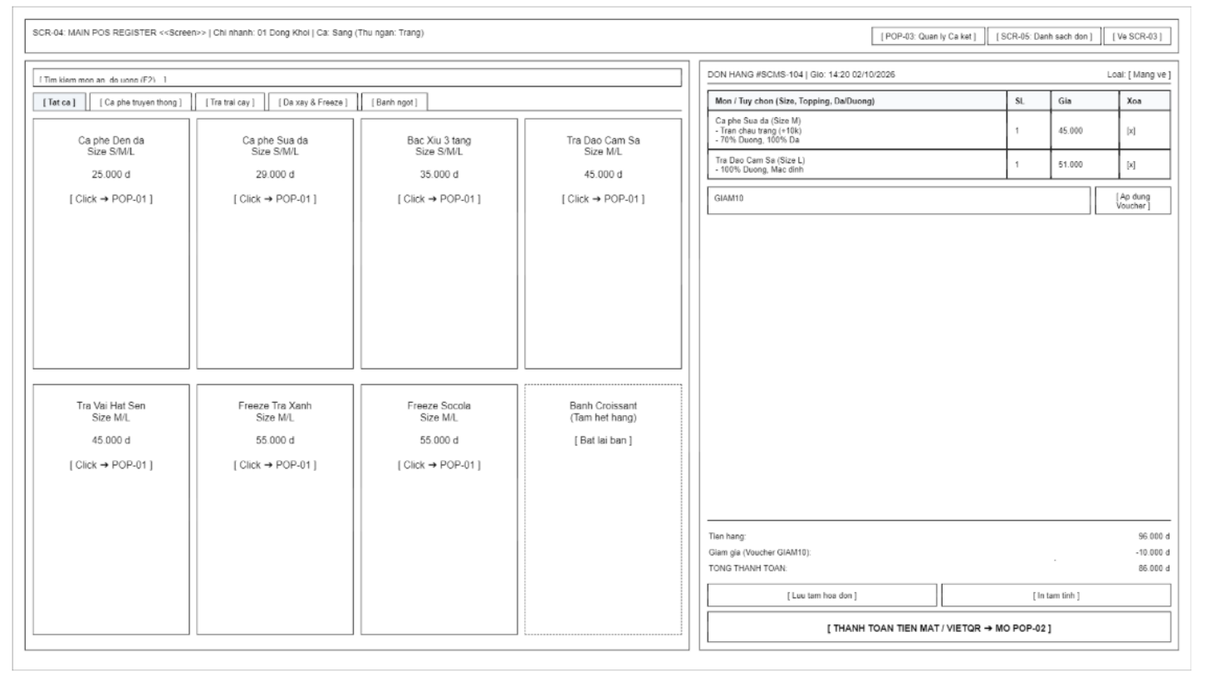
Screen Definition
# | Field Name | Type | Mandatory | Max Length | Description
1 | Shift & Branch Info | Label | - | 60 | Displays current branch name, work shift, and cashier.
2 | Cash Drawer Shift | Button | - | - | Opens shift and cash drawer management popup (POP-03).
3 | Orders List Nav | Button | - | - | Navigates to the order list screen (SCR-05).
4 | Back to Dispatcher | Button | - | - | Returns to the role allocation / module selection screen (SCR-03).
5 | Product Search | Text | No | 50 | Quick search items by name or item code.
6 | Category Tabs | Tabs | - | - | Filters items by category: Coffee, Tea, Blended, Pastries.
7 | Product Item Card | Component | - | - | Item display card (name, price). Click to open the item customization popup (POP-01).
8 | Order Type | Dropdown | Yes | - | Select service type: Takeaway or Dine-in.
9 | Cart Table | Table | - | - | Selected item list (Item Name, Size, Topping, Qty, Price).
10 | Remove Item | Button | - | - | Removes an item line from the cart.
11 | Voucher Code | Text | No | 20 | Inputs promo code/voucher.
12 | Apply Voucher | Button | - | - | Validates and applies a discount to the order.
13 | Subtotal Amount | Label | - | 15 | Displays subtotal (total amount before discount).
14 | Discount Amount | Label | - | 15 | Displays discount amount.
15 | Total Amount | Label | - | 15 | Displays grand total (final amount payable by customer).
16 | Hold Order | Button | - | - | Holds current bill temporarily to serve the next customer.
17 | Checkout | Button | - | - | Opens payment popup (POP-02).

3.3.1.2 Use Case Description
UC16 – Create New Order
Use Case ID |  | UC16 | Use Case Name |  | Create New Order
Author |  | VanNT | Version | 1.0 | Date | 04/10/2026
Actor |  | Cashier
Description |  | The Cashier selects products, enters quantities, chooses sizes/toppings, customizes sugar/ice levels, and adds notes. The system consolidates the information and creates the order.
Precondition |  | PRE-01: The Cashier has completed shift check-in (UC03) and opened an active cash drawer shift (UC24).  PRE-02: The Cashier is on the "Main POS Register" screen (SCR-04).
Trigger |  | TRG-01: A customer places an order at the counter and the Cashier selects items on the POS screen.
Post-Condition |  | POS-01: A new order is created in Pending Payment status with complete item details, customizations, and calculated total amount.
Main flows
Step | Actor | Action
1 | Cashier | Select order service type (Dine-in or Takeaway) and click on a product card on the Main POS Register (SCR-04).
2 | SCMS | Open the "Item Options" modal (POP-01) displaying available sizes (S/M/L), sugar levels, ice levels, and toppings.
3 | Cashier | Select desired cup size, sugar/ice preferences, add-on toppings, enter preparation notes (if any), and click "Add to Cart".
4 | SCMS | Calculate item unit price including size and topping surcharges, add the line item to the current shopping cart, and update the order subtotal and total payable amount.
5 | Cashier | Repeat steps 1–4 for additional items, then click "Hold Order" or proceed to payment checkout (POP-02).
6 | SCMS | Validate the cart items and save the order record in Pending Payment status.
Alternative flows
AT1 | Selected product is out of stock / unavailable (At step 1)
Sub step | Actor | Action
1.1 | SCMS | Disable selection of products marked as "Unavailable" on the POS interface (BR-17).
1.2 | Cashier | Inform the customer and suggest an alternative item.

3.3.2 Item Options & Apply Promotion

3.3.2.1 Screen Mock-up
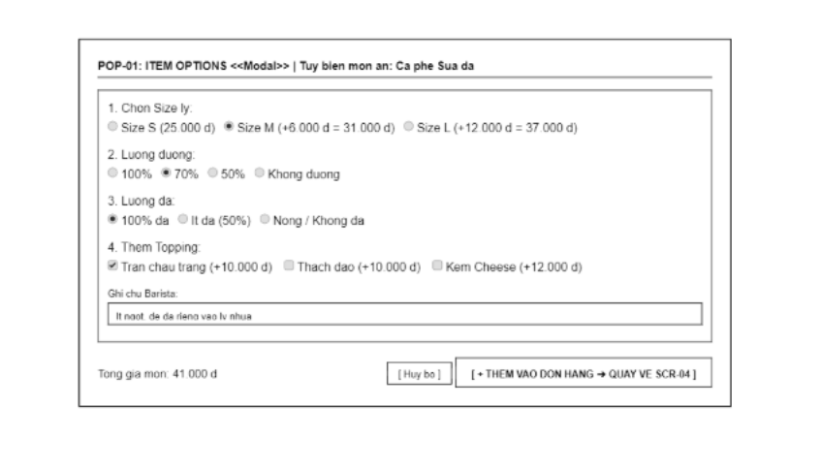
Screen Definition
# | Field Name | Type | Mandatory | Max Length | Description
1 | Modal Header | Label | - | 50 | Displays popup title and the name of the item being customized.
2 | Size Option | Radio | Yes | - | Select cup size: Size S, Size M (+extra fee), Size L (+extra fee). Default: Size M.
3 | Sugar Level | Radio | Yes | - | Select sugar level: 100%, 70%, 50%, No Sugar. Default: 70%.
4 | Ice Level | Radio | Yes | - | Select ice level: 100% Ice, Less Ice (50%), Hot/No Ice. Default: 100% Ice.
5 | Topping List | Checkbox | No | - | Select add-on toppings (White Boba, Peach Jelly, Cheese Foam, etc., with surcharges).
6 | Barista Note | Text | No | 100 | Inputs custom brewing/preparation notes from customer (e.g., "Less sweet, ice on the side").
7 | Item Total Price | Label | - | 15 | Displays item total price after adding size and topping adjustments.
8 | Cancel | Button | - | - | Closes popup and cancels item selection.
9 | Add to Cart | Button | - | - | Adds item with customized options to cart (SCR-04) and closes popup.

3.3.2.2 Use Case Description

UC17 – Apply Promotion / Voucher
Use Case ID |  | UC17 | Use Case Name |  | Apply Promotion / Voucher
Author |  | VanNT | Version | 1.0 | Date | 04/10/2026
Actor |  | Cashier
Description |  | The Cashier enters or selects a promotion code. The system verifies the applicable conditions, calculates the discount, and updates the total payment amount.
Precondition |  | PRE-01: The Cashier is completed shift check-in (UC03) and is currently operating the "Main POS Register" screen (SCR-04).  PRE-02: There is an active, unpaid order currently being processed (Business Rule BR-01 states promotions cannot be applied to PAID orders).
Trigger |  | TRG-01: The Cashier inputs a promotion code or selects an available voucher to apply to the customer's current order.
Post-Condition |  | POS-01: The system successfully calculates the discount and updates the total payment amount, ensuring the total payable amount is not less than VND 0 (BR-05).
Main flows
Step | Actor | Action
1 | Cashier | Enter the voucher code or select an applicable promotion on the POS interface.
2 | SCMS | Verify the voucher's validity by checking its Status, Start Date, End Date, Min Order Amount, and Usage Limit against the current order details.
3 | SCMS | Verify that no other discount or promotion has already been applied to this order, enforcing the limit of one discount per order (BR-05).
4 | SCMS | Calculate the discount amount based on the voucher's Discount Type (percentage or fixed amount) and Discount Value.
5 | SCMS | Apply the discount, update the order's total payment amount (ensuring it is ≥ VND 0), and display the new total on the POS screen.
Alternative flows
AT1 | Order is already PAID (At step 2 in the main flows)
Sub step | Actor | Action
1.1 | SCMS | Detect that the current order has already been changed to PAID status.
1.2 | SCMS | Display system error message and return to Orders List.
AT2 | Voucher conditions are not met (At step 2 in the main flows)
Sub step | Actor | Action
2.1 | SCMS | Detect that the voucher is invalid (e.g., expired End Date, order value is below Min Order Amount, or Usage Limit exceeded).
2.2 | SCMS | Reject the voucher application, do not apply any discount, and display a warning message indicating why the voucher is invalid.
AT3 | A promotion is already applied (At step 3 in the main flows)
Sub step | Actor | Action
3.1 | SCMS | Detect that the order already has an existing discount or voucher applied.
3.2 | SCMS | Reject the new voucher to enforce the rule that each order may have a maximum of one discount/promotion applied (BR-05). Display a warning message to the Cashier.

3.3.3 Payment Checkout

3.3.3.1 Screen Mock-up
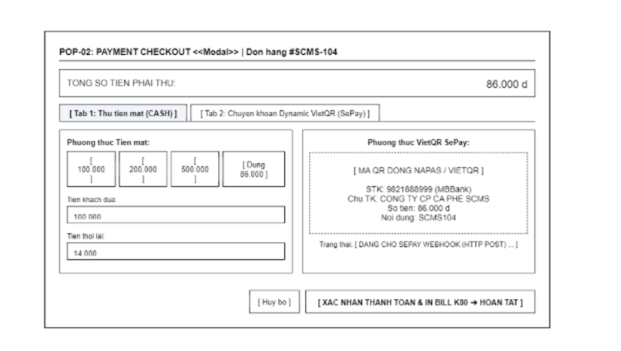
Screen Definition
# | Field Name | Type | Mandatory | Max Length | Description
1 | Modal Header | Label | - | 50 | Displays popup title and order code currently being paid.
2 | Total Amount Due | Label | - | 15 | Displays total amount payable by the customer.
3 | Payment Method Tabs | Tabs | - | - | Toggles between two payment methods: Cash and VietQR Transfer.
4 | Quick Cash Buttons | Button Grid | - | - | Quick-select options for cash tendered (100k, 200k, 500k, Exact Amount).
5 | Cash Received | Text | Yes | 15 | Amount tendered by customer (manual input or quick-select option).
6 | Change Return | Label | - | 15 | Displays change due to customer (automatically calculated).
7 | Dynamic VietQR Display | Component | - | - | Displays dynamic VietQR code containing exact order amount and transaction reference code.
8 | Webhook Status | Label | - | 50 | Displays payment status received via SePay integration (Pending / Paid).
9 | Cancel | Button | - | - | Closes popup and returns to the sales register screen (SCR-04).
10 | Confirm & Print Bill | Button | - | - | Confirms payment completion and triggers 80mm receipt printing.

3.3.3.2 Use Case Description
UC19 – Process Cash Payment
Use Case ID |  | UC19 | Use Case Name |  | Process Cash Payment
Author |  | KhanhPG | Version | 1.0 | Date | 04/10/2026
Actor |  | Cashier
Description |  | The Cashier processes a cash payment for an active order on the Payment Checkout modal (POP-02). The Cashier enters the cash amount received from the customer or selects a quick-cash shortcut. The system validates the amount, calculates the change return, updates order status to PAID, freezes order data (BR-26), records cash into the current shift's cash drawer balance (BR-27, BR-39), and triggers automatic printing of receipts and bar slips (UC21, UC22, BR-31).
Precondition |  | PRE-01: The Cashier has completed shift check-in (UC03) and has an active sales shift (UC24, BR-36).  PRE-02: The Cashier is on the "Main POS Register" screen (SCR-04) with an active order in PENDING status.  PRE-03: The "Payment Checkout" modal (POP-02) is open displaying the order Total Amount Due.
Trigger |  | TRG-01: The Cashier selects the "Cash" payment tab on modal POP-02, enters cash received, and clicks "Confirm & Print Bill".
Post-Condition |  | POS-01: Order status transitions to PAID and order details are permanently frozen against modifications (BR-26).  POS-02: The cash amount is recorded into sales revenue and added to the active shift's cash drawer balance (BR-27, BR-39).  POS-03: Change return amount is accurately calculated and displayed.  POS-04: Print commands are sent to print Bar Preparation Slip (UC21) and Payment Receipt (UC22) (BR-31).  POS-05: Modal POP-02 closes and POS register (SCR-04) resets for the next order.
Main flows
Step | Actor | Action
1 | Cashier | On the "Payment Checkout" modal (POP-02), verify Total Amount Due and select the "Cash" payment tab (default active).
2 | SCMS | Display cash payment UI with Total Amount Due, quick-cash shortcut buttons (100k, 200k, 500k, Exact), Cash Received input, and Change Return field.
3 | Cashier | Input the amount of cash received from customer into "Cash Received" field or click a quick-cash button.
4 | SCMS | Validate that cash received is >= Total Amount Due, calculate change return amount (Change Return = Cash Received - Total Amount Due), and display it in real time.
5 | Cashier | Verify the displayed change return, collect cash, return change if applicable, and click "Confirm & Print Bill".
6 | SCMS | Save payment with method CASH, transition order to PAID, freeze order data (BR-26), add cash to shift drawer balance (BR-27, BR-39), trigger printing of preparation slip (UC21) and customer receipt (UC22) (BR-31), close modal POP-02, and reset POS register.
Alternative flows
AT1 | Cash received is less than total amount due (At step 4 in the main flows)
Sub step | Actor | Action
1.1 | SCMS | Detect that Cash Received is less than Total Amount Due.
1.2 | SCMS | Display an inline error message notifying that cash received is insufficient and disable "Confirm & Print Bill".
1.3 | SCMS | Keep the Cashier on modal POP-02 to re-enter an adequate cash amount.
Alternative flows
AT2 | Cashier cancels cash payment (At step 1, 3, or 5 in the main flows)
Sub step | Actor | Action
2.1 | Cashier | Click the "Cancel" button on modal POP-02.
2.2 | SCMS | Close modal POP-02 without creating any payment record or modifying order status (order remains PENDING).
2.3 | SCMS | Return Cashier to Main POS Register (SCR-04) with current order cart preserved.

UC20 – Confirm QR Payment
Use Case ID |  | UC20 | Use Case Name |  | Confirm QR Payment
Author |  | KhanhPG | Version | 1.0 | Date | 04/10/2026
Actor |  | SePay
Description |  | The system receives an automated payment Webhook from SePay after the customer completes a bank transfer via dynamic VietQR. The system validates the Webhook signature and reconciles the Order ID and payment amount (BR-29). Upon a match, the system transitions order status to PAID, freezes order data (BR-26), notifies POS in real time, and triggers automatic printing of receipts and bar tickets (BR-31).
Precondition |  | PRE-01: Cashier opened Payment Checkout modal (POP-02) and selected "Dynamic VietQR" tab (Tab 2).  PRE-02: System generated and displayed a dynamic VietQR code with chain account, order amount, and reference prefix CAFE (BR-24, BR-28, UC43).  PRE-03: Customer completed bank transfer via mobile banking app.
Trigger |  | TRG-01: SePay payment gateway sends an HTTP POST Webhook payload containing transaction details to the SCMS webhook endpoint (UC44).
Post-Condition |  | POS-01: Webhook authentication signature and transaction details are successfully verified (BR-29).  POS-02: Order status updates from PENDING to PAID and is frozen against edits (BR-26, BR-29).  POS-03: Payment record is saved with method VIETQR, referencing SePay transaction ID.  POS-04: Modal POP-02 displays payment success, triggers receipt printing (UC21, UC22, BR-31), and resets POS cart.
Main flows
Step | Actor | Action
1 | SePay | Send an HTTP POST Webhook payload to SCMS containing Transaction ID, Order Reference, Transfer Amount, and Authentication Signature.
2 | SCMS | Verify the Webhook authentication signature against the configured SePay API Secret Key (BR-29, SCR-16 TAB-10).
3 | SCMS | Reconcile Order ID and verify that the transferred amount exactly equals the order Total Amount Due (BR-29).
4 | SCMS | Save payment transaction with method VIETQR, update order status to PAID, and freeze order data (BR-26).
5 | SCMS | Push real-time notification via WebSocket to POS register (SCR-04 / POP-02) indicating payment success.
6 | SCMS | Trigger automatic printing of Bar Preparation Slip (UC21) and Payment Receipt (UC22) (BR-31), close modal POP-02, and reset POS register for next order.
Alternative flows
AT1 | Transferred amount does not match total amount due (At step 3 in the main flows)
Sub step | Actor | Action
1.1 | SCMS | Detect that transferred amount does not match order total amount due.
1.2 | SCMS | Retain order in PENDING status, log discrepancy, and push reconciliation alert to POS screen (BR-30).
1.3 | SCMS | Require Cashier / Branch Manager to verify bank transaction details manually.

AT2 | Invalid signature or unauthorized webhook (At step 2 in the main flows)
Sub step | Actor | Action
2.1 | SCMS | Detect invalid authentication signature in Webhook payload.
2.2 | SCMS | Reject Webhook with HTTP 401/403 status and log unauthorized security event.
2.3 | SCMS | Keep order in PENDING status without updating.

UC21 – Print Preparation Slip
Use Case ID |  | UC21 | Use Case Name |  | Print Preparation Slip
Author |  | KhanhPG | Version | 1.0 | Date | 04/10/2026
Actor |  | Cashier, Bar Thermal Printer
Description |  | The system formats and transmits a drink preparation ticket to the Bar thermal printer immediately after an order transitions to PAID status (BR-31), or upon a manual reprint request by the Cashier from Order Details (SCR-06). The slip contains order number, items, cup sizes, sugar/ice levels, toppings, and barista notes.
Precondition |  | PRE-01: An order has successfully transitioned to PAID status (BR-31) via Cash (UC19) or QR (UC20), OR Cashier requests a reprint from Order Details (SCR-06).  PRE-02: Bar thermal printer is connected via network/USB and configured in system settings.
Trigger |  | TRG-01: Order payment is confirmed and status becomes PAID (BR-31), OR Cashier clicks "Reprint Bar Label" on SCR-06.
Post-Condition |  | POS-01: Preparation slip data is formatted and transmitted to the Bar thermal printer.  POS-02: Bar thermal printer outputs the preparation ticket / cup labels.  POS-03: Print job status is logged in the order audit history.
Main flows
Step | Actor | Action
1 | SCMS | Detect that order status has transitioned to PAID (BR-31) or receive manual reprint command from Cashier.
2 | SCMS | Retrieve order item specifications: product names, sizes, sugar %, ice %, toppings, and barista preparation notes.
3 | SCMS | Format preparation ticket payload with Order Number, Timestamp, Items, and Notes into standard ESC/POS format.
4 | SCMS | Transmit print command to the designated Bar thermal printer over local network/USB.
5 | Bar Thermal Printer | Receive print command, print the preparation ticket / cup stickers, and return completion status.
6 | SCMS | Confirm successful print execution and log print timestamp into order history.
Alternative flows
AT1 | Bar printer offline or out of paper (At step 5 in the main flows)
Sub step | Actor | Action
1.1 | SCMS | Detect printer connection timeout or hardware error signal (paper out/jam).
1.2 | SCMS | Display warning toast notification on POS: "Bar printer offline or out of paper. Print job queued."
1.3 | SCMS | Save print command to retry queue and allow Cashier to reprint from Order Details (SCR-06).

UC22 – Print Payment Receipt
Use Case ID |  | UC22 | Use Case Name |  | Print Payment Receipt
Author |  | KhanhPG | Version | 1.0 | Date | 04/10/2026
Actor |  | Cashier, Bar Thermal Printer
Description |  | The system automatically generates a standard K80 customer receipt and sends a print command to the counter thermal printer once an order is PAID (BR-31), or when Cashier clicks "Reprint Receipt" on Order Details (SCR-06). The receipt displays branch info, order number, items, unit prices, discounts, payment method, and cashier name.
Precondition |  | PRE-01: Order has transitioned to PAID status (BR-31), OR Cashier requests a reprint from Order Details (SCR-06).  PRE-02: Counter thermal receipt printer is connected and online.
Trigger |  | TRG-01: Order transitions to PAID status following cash/QR confirmation, OR Cashier clicks "Reprint Receipt" button on SCR-06.
Post-Condition |  | POS-01: Customer payment receipt is printed and handed to the customer.  POS-02: Print execution and reprint counter are recorded in system logs.
Main flows
Step | Actor | Action
1 | SCMS | Receive print trigger following payment confirmation or manual reprint request on SCR-06.
2 | SCMS | Aggregate receipt details: Branch Name & Address, Order Number, Date/Time, Cashier, Item List, Subtotal, Discount, Total Due, Payment Method, and Change.
3 | SCMS | Format printable receipt layout adhering to standard K80 80mm thermal roll specifications.
4 | SCMS | Send print command directly to counter thermal receipt printer.
5 | Bar Thermal Printer | Print the paper receipt, perform auto-cut, and return execution status to SCMS.
6 | SCMS | Record print completion timestamp in order audit log.
Alternative flows
AT1 | Receipt printer paper out or cover open (At step 5 in the main flows)
Sub step | Actor | Action
1.1 | Bar Thermal Printer | Send error status signal (paper out / cover open) back to SCMS.
1.2 | SCMS | Display alert on POS screen: "Receipt printer out of paper. Please reload paper roll."
1.3 | Cashier | Reload paper roll and click retry or reprint from Order Details (SCR-06).

UC43 – Generate VietQR Dynamic QR Code
Use Case ID |  | UC43 | Use Case Name |  | Generate VietQR Dynamic QR Code
Author |  | VuNL | Version | 1.0 | Date | 04/10/2026
Actor |  | VietQR
Description |  | SCMS submits a QR generation request for an order. VietQR generates a dynamic QR code and returns the QR image along with payment transfer details.
Precondition |  | PRE-01: Order is in pending payment status with total payable amount greater than 0.  PRE-02: COO has configured the recipient bank account.  PRE-03: Connection to VietQR service is operational.
Trigger |  | TRG-01: Cashier selects QR payment method for the order.
Post-Condition |  | POS-01: QR code information is stored in the order payment record.  POS-02: QR code is rendered for Cashier and customer to scan.
Main flows
Step | Actor | Action
1 | SCMS | Sends QR generation request to VietQR including payment amount, transfer narration (containing order code), and recipient account number.
2 | VietQR | Validates payload and generates dynamic QR code according to NAPAS standards.
3 | VietQR | Returns QR code image and payment details to SCMS.
4 | SCMS | Saves QR information into order payment record and displays QR code on Cashier screen.
Alternative flows
AT1 | At step 2 or 3, if VietQR does not respond or returns an error:
Sub step | Actor | Action
2.1 | SCMS | Notifies Cashier of QR generation failure, allowing retry or switching to cash payment.
2.2 | SCMS | Preserves current order state without modification.
AT2 | At step 2, if VietQR rejects due to missing or invalid recipient account configuration:
Sub step | Actor | Action
2.1 | SCMS | Displays receiving account configuration error and advises contacting COO.
Business Rules
# | Rule Description
BR-01 | Amount encoded in QR code equals the exact order payable amount and cannot be edited (BR-24).
BR-02 | Transfer narration must contain the unique order code for reconciliation when SCMS receives SePay webhook (UC44) (BR-28).
BR-03 | Beneficiary bank account is configured exclusively by COO (BR-28).
BR-04 | QR code has an expiration duration. Once expired, a new QR code must be generated (BR-28).
BR-05 | QR code must be displayed within a maximum of 3 seconds.

3.4 Order & Cash Drawer Management

3.4.1 Order Details & Refund

3.4.1.1 Screen Mock-up
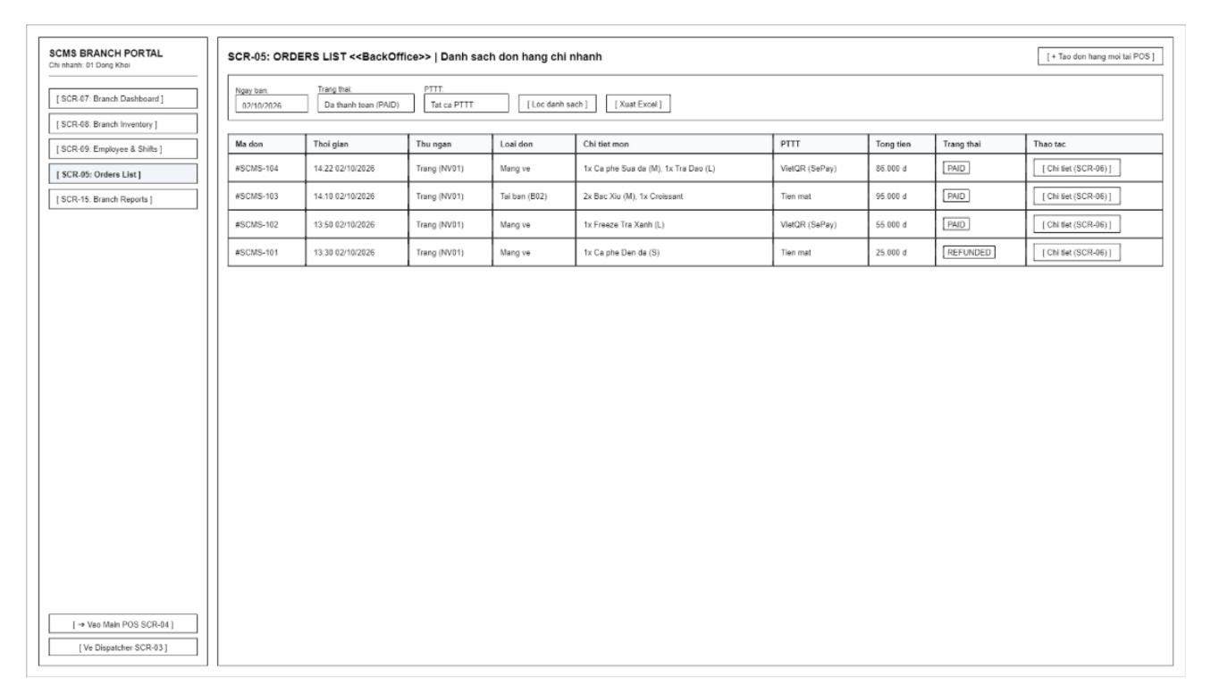
Screen Definition
# | Field Name | Type | Mandatory | Max Length | Description
1 | Order Date Filter | Text / Date | No | 10 | Filter orders by sales date (Default: Current date).
2 | Status Filter | Dropdown | No | - | Filter by order status: All, Pending Payment, Paid, Partially Refunded, Refunded, Cancelled.
3 | Payment Method Filter | Dropdown | No | - | Filter by payment method: All, Cash, VietQR.
4 | Filter Action | Button | - | - | Apply filters and reload the order list.
5 | Export Excel | Button | - | - | Export the order list to an Excel file.
6 | Orders Table | Table | - | - | List of orders (Order Code, Time, Cashier, Item Details, Payment Method, Total Amount, Status).
7 | View Order Details | Button | - | - | Navigate to the order details screen (SCR-06).
8 | Nav to POS | Button | - | - | Return to the POS/sales screen (SCR-04).

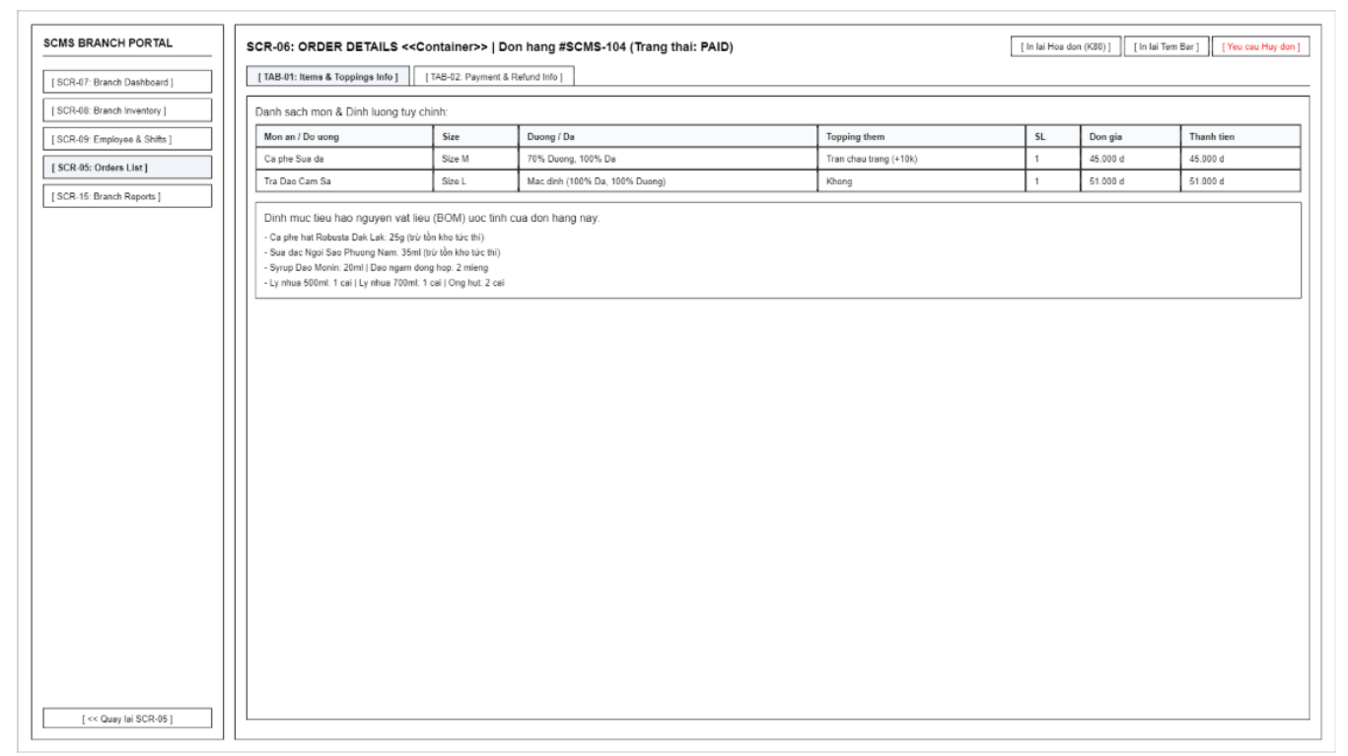
Screen Definition
# | Field Name | Type | Mandatory | Max Length | Description
1 | Order Header Info | Label | - | 80 | Display order code, creation time, and order status.
2 | Sub-Tab Switcher | Tabs | - | - | Switch between TAB-01 (Items & Toppings) and TAB-02 (Payment & Refund).
3 | Reprint Receipt | Button | - | - | Send command to reprint the K80 receipt.
4 | Reprint Bar Label | Button | - | - | Send command to reprint cup labels for the bar/preparation counter.
5 | Cancel Order / Refund Order | Button | - | - | Contextual Action Button: If Order Status is PENDING (unpaid), button displays 'Cancel Order' allowing Cashier to cancel unpaid order with mandatory reason and audit log (BR-26b). If Order Status is PAID, button displays 'Refund Order' requiring Branch Manager PIN approval to issue cash refund (UC23, BR-32). Direct cancellation of PAID orders is strictly prohibited (BR-26).
6 | Back to Orders List | Button | - | - | Return to the orders list screen (SCR-05).
7 | (TAB-01) Order Items Table | Table | - | - | Table listing items, size, sugar, ice, toppings, quantity, and total amount.
8 | (TAB-01) BOM Usage Box | Box / Label | - | 200 | Display estimated raw material consumption quota based on the order's recipe.
9 | (TAB-02) Transaction Details | Table | - | - | Payment details: SePay transaction ID, account number, bank, and Webhook matching time.
10 | (TAB-02) Refund Reason | Dropdown | Yes | - | Select refund reason (Customer changed mind, Wrong item, Quality issue).

3.4.1.2 Use Case Description
UC18 – View Order Information
Use Case ID |  | UC18 | Use Case Name |  | View Order Information
Author |  | VanNT | Version | 1.0 | Date | 04/10/2026
Actor |  | Cashier
Description |  | The Cashier selects an order. The system displays the order number, item list, quantities, discount amount, total amount, and current status.
Precondition |  | PRE-01: The Cashier has completed shift check-in (UC03). PRE-02: The Cashier is currently on the "Main POS Register" screen (SCR-04).  PRE-03: A sales shift is currently active (BR-09).
Trigger |  | TRG-01: The Cashier selects a specific order from the list/queue on the POS interface to view its details.
Post-Condition |  | POS-01: The system successfully retrieves and displays all detailed information related to the selected order on the screen.
Main flows
Step | Actor | Action
1 | Cashier | Select an order from the active or historical order list on the POS screen.
2 | SCMS | Retrieve the order record from the database, including data from the Order entity (Order Number, Status), Order Item entity (Quantity, Unit Price, Sugar/Ice Levels, Note), and any applied Voucher or Payment records.
3 | SCMS | Aggregate the data to calculate the total amount and any applicable discount amount.
4 | SCMS | Display the detailed order information to the Cashier, including: order number, item list, quantities, discount amount, total amount, and current status.
Alternative flows
AT1 | System fails to retrieve order details (At step 2 in the main flows)
Sub step | Actor | Action
1.1 | SCMS | Attempt to retrieve the order data but encounter an error (e.g., network timeout or order was deleted/not found).
1.2 | SCMS | Strictly prohibit applying the promotion (BR-01) and display an error message to the Cashier.
1.3 | SCMS | Return the Cashier to the main order list view.

UC23 – Process Refund for PAID Order
Use Case ID |  | UC23 | Use Case Name |  | Process Refund for PAID Order
Author |  | KhanhPG | Version | 1.0 | Date | 04/10/2026
Actor |  | Cashier, Branch Manager
Description |  | Allows processing a cash refund for a paid order on Order Details (SCR-06 TAB-02). Cashiers cannot arbitrarily refund orders; refunds require Branch Manager approval and an explicit reason (BR-32). All refunds are paid in cash from the drawer regardless of initial payment method (BR-33), deducted from current shift balance (BR-34), and logged in Audit Log (BR-51).
Precondition |  | PRE-01: Cashier or Branch Manager is logged in and viewing a PAID order on Order Details (SCR-06 TAB-02).  PRE-02: Order belongs to the current branch and was created during an active sales shift.
Trigger |  | TRG-01: Cashier selects refund reason, inputs refund amount, and requests Branch Manager approval (or Branch Manager clicks "Approve Refund").
Post-Condition |  | POS-01: Order status remains firmly as PAID (BR-26). A separate Refund record is created and linked to the order.  POS-02: Refund amount is deducted in cash from the current shift's cash drawer balance (BR-33, BR-34, BR-39).  POS-03: Cancellation reason, manager approval, and refund details are recorded in Audit Log (BR-51).
Main flows
Step | Actor | Action
1 | Cashier | On Order Details screen (SCR-06), select "Payment & Refund Info" tab (TAB-02) and click "Refund".
2 | SCMS | Display refund dialog requesting: Refund Reason (dropdown), Refund Amount, and Branch Manager PIN authorization (BR-32).
3 | Cashier | Select refund reason (Customer Changed Mind, Wrong Item, Quality Issue, Other), enter refund amount (maximum: paid amount - already refunded), and request manager approval.
4 | Branch Manager | Verify order circumstances, inspect reason, and enter manager credentials/PIN (SCR-06 TAB-02) to approve the refund (BR-32).
5 | SCMS | Validate manager authorization. Update order status to Partially Refunded or Refunded (original order remains PAID). Create Refund record with status Completed. Deduct refund amount from shift cash drawer balance (BR-33, BR-34), and record in Audit Log (BR-51).
6 | Cashier | Refund reason, manager approval, and refund details are recorded in Audit Log (BR-51).
Alternative flows
AT1 | Refund amount exceeds Branch Manager approval threshold (At step 4 in the main flows)
Sub step | Actor | Action
1.1 | SCMS | Detect that refund amount exceeds Branch Manager approval threshold limit (BR-35).
1.2 | SCMS | Require COO approval code or reject operation.
1.3 | Branch Manager | Contact COO for override code or reject customer refund request.

AT2 | Insufficient cash in drawer for refund (At step 5 in the main flows)
Sub step | Actor | Action
2.1 | SCMS | Detect that current cash in drawer is less than required refund amount.
2.2 | SCMS | Display alert indicating drawer cash is insufficient and requires Cash In deposit (UC25, BR-37).
2.3 | Branch Manager | Perform Cash In transaction (UC25) to supply funds before retrying refund.

3.4.2 Cash Drawer Shift

3.4.2.1 Screen Mock-up
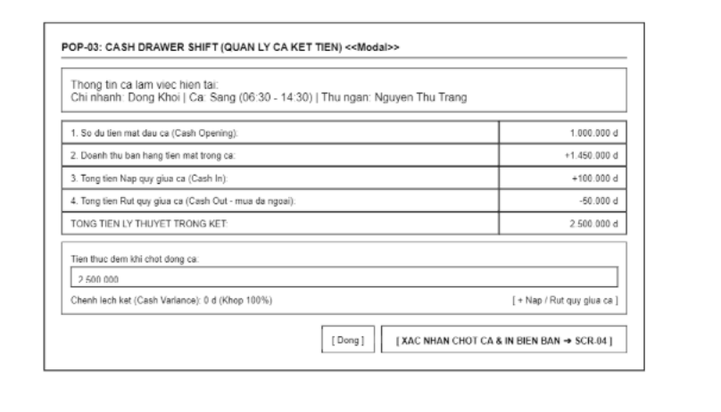
Screen Definition
# | Field Name | Type | Mandatory | Max Length | Description
1 | Shift Header | Label | - | 60 | Displays branch information, work shift, and assigned cashier.
2 | Opening Cash | Label | - | 15 | Displays opening cash balance handed over at the start of the shift.
3 | Cash Sales | Label | - | 15 | Displays total cash sales revenue generated during the shift.
4 | Cash In Total | Label | - | 15 | Displays total mid-shift cash top-ups added to the cash drawer.
5 | Cash Out Total | Label | - | 15 | Displays total emergency cash withdrawals made from the cash drawer during the shift.
6 | Theoretical Cash | Label | - | 15 | Displays calculated theoretical cash balance that should be in the drawer.
7 | Actual Cash Counted | Text | Yes | 15 | Inputs actual cash counted upon shift closure.
8 | Cash Variance | Label | - | 30 | Displays variance between actual and theoretical cash balance (Balanced / Surplus / Shortage).
9 | Cash Adjustment Action | Button | - | - | Opens form to record emergency mid-shift cash top-ups or withdrawals along with reason.
10 | Close Modal | Button | - | - | Closes popup and returns to the POS screen.
11 | Confirm Shift Close | Button | - | - | Confirms shift closing, locks cash drawer, and prints handover report.

3.4.2.2 Use Case Description
UC24 – Open Shift
Use Case ID |  | UC24 | Use Case Name |  | Open Shift
Author |  | KhanhPG | Version | 1.0 | Date | 04/10/2026
Actor |  | Cashier
Description |  | The Cashier selects a working shift and declares the opening cash amount. The system validates the information and saves the shift opening configuration.
Precondition |  | PRE-01: The Cashier has checked in at the Attendance Kiosk (UC03).  PRE-02: No other active sales shift is currently open on the register.
Trigger |  | TRG-01: The Cashier opens the "Cash Drawer Shift" modal (POP-03) to start a new sales shift.
Post-Condition |  | POS-01: A new Shift record is created in Open status with the declared Opening Cash amount (BR-36).  POS-02: The POS register is unlocked and ready to process customer orders.
Main flows
Step | Actor | Action
1 | Cashier | Open the "Cash Drawer Shift" modal (POP-03) and select the current working shift.
2 | Cashier | Count the initial physical cash float in the drawer, enter the "Opening Cash" amount, and click "Confirm Open Shift".
3 | SCMS | Validate that the entered opening cash amount is a valid non-negative number (>= 0).
4 | SCMS | Create a new Shift record with status Open, record the initial cash transaction, log the action in the Audit Log (BR-51), and enable POS sales functions.
Alternative flows
AT1 | Invalid opening cash input (At step 3)
Sub step | Actor | Action
3.1 | SCMS | Detect empty or negative input and display an inline validation error (MSG02).

UC25 – Add Cash to Drawer
Use Case ID |  | UC25 | Use Case Name |  | Add Cash to Drawer
Author |  | KhanhPG | Version | 1.0 | Date | 04/10/2026
Actor |  | Branch Manager, COO
Description |  | The Branch Manager or COO enters the cash amount and reason. The system records the cash-in transaction and automatically adds the amount to the cash drawer balance.
Precondition |  | PRE-01: A sales shift is currently Open at the branch (UC24).
Trigger |  | TRG-01: The counter requires additional change/float mid-shift and the user selects the Cash-In action on modal POP-03.
Post-Condition |  | POS-01: A Cash-In transaction is saved with a mandatory reason.  POS-02: The theoretical cash balance of the active shift is increased by the added amount (BR-37, BR-39).
Main flows
Step | Actor | Action
1 | Branch Manager / COO | On the "Cash Drawer Shift" modal (POP-03), click the "Cash In / Out" button and select transaction type Cash In.
2 | Branch Manager / COO | Enter the cash-in amount, input a mandatory business reason (e.g., adding change float), and confirm.
3 | SCMS | Validate that the amount is > 0 and the reason field is not empty (BR-37).
4 | SCMS | Record the Cash Transaction, add the amount to the active shift's theoretical cash balance, and write an entry to the Audit Log (BR-51).
Alternative flows
AT1 | Missing reason or invalid amount (At step 3)
Sub step | Actor | Action
3.1 | SCMS | Highlight the empty reason or invalid amount field and block submission until corrected.

UC26 – Withdraw Cash from Drawer
Use Case ID |  | UC26 | Use Case Name |  | Withdraw Cash from Drawer
Author |  | KhanhPG | Version | 1.0 | Date | 04/10/2026
Actor |  | Branch Manager, COO
Description |  | The Branch Manager or COO enters the cash-out amount and reason. The system records the cash-out transaction and automatically deducts the amount from the cash drawer balance.
Precondition |  | PRE-01: A sales shift is currently Open at the branch (UC24) and has sufficient cash balance.
Trigger |  | TRG-01: Emergency cash disbursement is needed mid-shift (e.g., buying ice) or safe drop, and the user selects Cash-Out on modal POP-03.
Post-Condition |  | POS-01: A Cash-Out transaction is recorded with a mandatory reason.  POS-02: The theoretical cash balance of the active shift is decreased by the withdrawn amount (BR-37, BR-39).
Main flows
Step | Actor | Action
1 | Branch Manager / COO | On the "Cash Drawer Shift" modal (POP-03), click the "Cash In / Out" button and select transaction type Cash Out.
2 | Branch Manager / COO | Enter the withdrawal amount, provide a mandatory reason, and confirm.
3 | SCMS | Validate that the amount is > 0, does not exceed current drawer cash balance, and includes a valid reason (BR-37).
4 | SCMS | Save the Cash Transaction, deduct the amount from the shift's theoretical cash balance, and log the action in the Audit Log (BR-51).
Alternative flows
AT1 | Withdrawal amount exceeds current drawer balance (At step 3)
Sub step | Actor | Action
3.1 | SCMS | Display an error message indicating insufficient cash in the drawer and reject the transaction.

UC27 – Close Shift & Count Cash
Use Case ID |  | UC27 | Use Case Name |  | Close Shift & Count Cash
Author |  | KhanhPG | Version | 1.0 | Date | 04/10/2026
Actor |  | Cashier
Description |  | The Cashier requests to close the shift and enters the actual counted cash amount. The system calculates the expected cash amount, reconciles the variance, records the closing report, and locks the shift.
Precondition |  | PRE-01: The current sales shift is in Open status (UC24).  PRE-02: No orders are left in Pending Payment status for the current shift.
Trigger |  | TRG-01: At the end of the shift, the Cashier opens modal POP-03 to perform physical cash counting and shift closure.
Post-Condition |  | POS-01: Shift status transitions to Closed and is permanently locked.  POS-02: Expected cash, actual counted cash, variance, and explanation reason (if any) are saved and the handover slip is printed (BR-38, BR-39).
Main flows
Step | Actor | Action
1 | Cashier | Open the "Cash Drawer Shift" modal (POP-03) at the end of the working shift.
2 | SCMS | Calculate and display the Theoretical Cash balance using formula: Opening Cash + Cash Sales + Cash In - Cash Out - Cash Refunds (BR-39).
3 | Cashier | Count the actual physical cash in the drawer and enter the value into the "Actual Cash Counted" field.
4 | SCMS | Calculate the Cash Variance (Actual Cash Counted - Theoretical Cash) and display the reconciliation status.
5 | Cashier | Click "Confirm Shift Close".
6 | SCMS | Update shift status to Closed, lock the shift, log the event in the Audit Log (BR-51), and print the shift handover report.
Alternative flows
AT1 | Cash variance exists (Variance != 0) (At step 4)
Sub step | Actor | Action
4.1 | SCMS | Require the Cashier to enter a mandatory "Difference Reason" before allowing shift closure (BR-38) and require Branch Manager PIN approval if the variance exceeds tolerance (BR-32).

3.5 Branch Operations

3.5.1 Branch Dashboard

3.5.1.1 Screen Mock-up
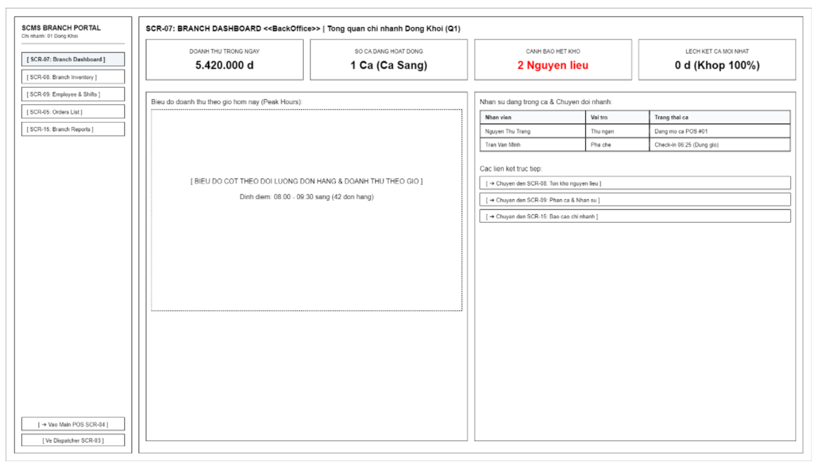
Screen Definition
# | Field Name | Type | Mandatory | Max Length | Description
1 | Branch Sidebar Menu | Menu | - | - | Navigation bar for internal branch modules (Dashboard, Inventory, HR, Orders, Reports).
2 | Daily Revenue KPI | Card | - | 20 | Displays accumulated total sales revenue for the day.
3 | Active Shift KPI | Card | - | 20 | Displays the number of active sales shifts at the counter.
4 | Low Stock Alert KPI | Card | - | 20 | Displays the number of raw materials reaching critical low-stock alert thresholds.
5 | Cash Variance KPI | Card | - | 20 | Displays cash variance from the most recent shift.
6 | Peak Hours Chart | Chart | - | - | Bar chart depicting order count and revenue by hourly time slots.
7 | Active Staff List | Table | - | - | List of staff members currently on shift along with their check-in status.
8 | Quick Nav to POS | Button | - | - | Quick access to the sales register screen (SCR-04).
9 | Quick Nav to Inventory | Button | - | - | Quick access to the inventory management screen (SCR-08).
10 | Quick Nav to Staff | Button | - | - | Quick access to the staff shift roster management screen (SCR-09).

3.5.1.2 Use Case Description
UC34 – View Branch Dashboard
Use Case ID |  | UC34 | Use Case Name |  | View Branch Dashboard
Author |  | AnhTV | Version | 1.0 | Date | 04/10/2026
Actor |  | Branch Manager, COO
Description |  | The Branch Manager or COO accesses the dashboard. The system aggregates and visually displays key indicators related to revenue, cash flow, inventory, and employee performance.
Precondition |  | PRE-01: Successfully logged in with Branch Manager or COO role.
Trigger |  | TRG-01: Branch Manager or COO accesses home page or clicks "Dashboard" menu.
Post-Condition |  | POS-01: Overview charts and key performance indicators (KPIs) of the assigned branch are displayed completely and accurately.
Main flows
Step | Actor | Action
1 | Branch Manager / COO | Selects the Branch Dashboard function from the navigation menu.
2 | SCMS | Verifies assigned branch scope and retrieves real-time aggregated data: sales revenue, order counts, cash drawer flow (opening cash, cash in/out, refunds), and low stock alerts.
3 | SCMS | Displays information as visual charts, KPI indicator cards, and action alert lists.
4 | Branch Manager | Views overview metrics or clicks widgets to drill down into corresponding detailed modules.
Alternative flows
AT1 | At step 2 of the main flow, system fails to retrieve aggregation data due to connection issues:
Sub step | Actor | Action
2.1 | SCMS | Displays empty state widgets with message: "Failed to load dashboard data. Please refresh."
2.2 | SCMS | Provides a "Retry" button for the user.
Business Rules
# | Rule Description
BR-01 | Operational data must be strictly isolated by branch: Branch Managers are only allowed to view Dashboard metrics of their assigned branch (Rule BR-04).
BR-02 | The system must provide a Dashboard and detailed Sales Reports over time for the Branch Manager to track revenue and order volumes (Rule BR-46).
BR-03 | The system must provide in-depth branch-level tracking: Cash Drawer Flow (over/short reconciliation) and Inventory In-Out-Balance status (Rule BR-47).

3.5.2 Branch Inventory & Stock Slip

3.5.2.1 Screen Mock-up
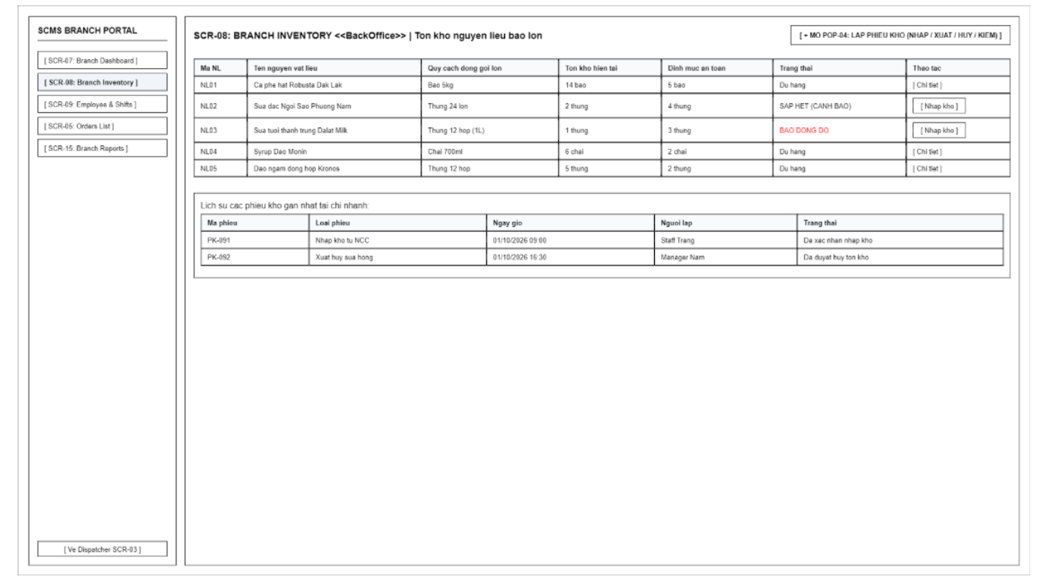
Screen Definition
# | Field Name | Type | Mandatory | Max Length | Description
1 | Open Stock Slip | Button | - | - | Opens the popup to create a new stock voucher (POP-04).
2 | Inventory Table | Table | - | - | Table listing bulk inventory items (Code, Name, Packaging Specification, On-hand Stock, Threshold, Status).
3 | Stock Item Detail | Button | - | - | Views the inbound/outbound transaction history of a specific raw material.
4 | Quick Restock Button | Button | - | - | Quickly opens an inbound stock voucher for raw materials currently triggering low-stock alerts.
5 | Recent Stock Slips | Table | - | - | Table displaying the list of most recently created stock vouchers at the branch.

3.5.2.2 Use Case Description
UC28 – Receive Stock
Use Case ID |  | UC28 | Use Case Name |  | Receive Stock
Author |  | AnhTV | Version | 1.0 | Date | 04/10/2026
Actor |  | Branch Manager
Description |  | The Branch Manager creates a goods receipt, selects raw materials, and enters quantities and costs. The system validates the information and increases the corresponding inventory quantities.
Precondition |  | PRE-01: Branch Manager has successfully logged into the system.  PRE-02: Raw materials catalog and standard packaging units have been configured in the system.
Trigger |  | TRG-01: Branch Manager needs to import additional raw materials into branch stock.
Post-Condition |  | POS-01: The system records and stores a new inventory import receipt.  POS-02: Inventory quantity in the branch warehouse is updated and added successfully.
Main flows
Step | Actor | Action
1 | Branch Manager | Selects the "Create inventory import receipt" feature.
2 | SCMS | Displays the import receipt creation screen with fields: Raw Material, Quantity, Import Price, Packaging Unit, Notes, and a "Confirm" button.
3 | Branch Manager | Selects raw material, enters quantity and price, and clicks "Confirm".
4 | SCMS | Validates information (quantity > 0, price >= 0, valid packaging unit).
5 | SCMS | Saves the import receipt, adds quantity to branch inventory stock, and logs the operation in the audit trail.
6 | SCMS | Displays a success notification.
Alternative flows
AT1 | At step 4 of the main flow, if entered information is missing or incorrectly formatted:
Sub step | Actor | Action
4.1 | SCMS | Highlights empty mandatory fields and displays message: "The * field is required and must be a valid positive number."
4.2 | SCMS | Halts the save operation and remains on the import receipt screen.
AT2 | At step 4 of the main flow, if the selected unit is not a standard large packaging unit:
Sub step | Actor | Action
4.1 | SCMS | Displays error message: "Goods received must be managed by large packaging units (cartons, bags, boxes, kg)."
4.2 | SCMS | Prompts user to select a valid packaging unit before proceeding.
Business Rules
# | Rule Description
BR-01 | Branch Managers are only allowed to create import receipts and manage inventory data belonging to their assigned branch (Rule BR-04).
BR-02 | Goods received at the branch must be managed by large packaging units (cartons, bags, boxes, kg) and fully record the quantity and import cost to increase inventory (Rule BR-40).
BR-03 | All sensitive inventory import operations must be automatically recorded in the Audit Log and cannot be modified or deleted (Rule BR-51).

UC29 – Issue Stock
Use Case ID |  | UC29 | Use Case Name |  | Issue Stock
Author |  | AnhTV | Version | 1.0 | Date | 04/10/2026
Actor |  | Branch Manager
Description |  | The Branch Manager creates an issue document, selects raw materials, and enters the quantities to be issued. The system checks the current inventory balance and deducts the issued quantities.
Precondition |  | PRE-01: Branch Manager has successfully logged into the system.  PRE-02: Branch warehouse contains raw materials with available stock balance > 0.
Trigger |  | TRG-01: Need to retrieve raw materials from inventory for Bar counter usage or transfer.
Post-Condition |  | POS-01: Inventory export receipt is created and stored in the system.  POS-02: Corresponding inventory quantity is deducted from the branch warehouse.
Main flows
Step | Actor | Action
1 | Branch Manager | Selects the "Create inventory export receipt" feature.
2 | SCMS | Displays export receipt creation screen with raw materials list, available balance, export quantity, and purpose.
3 | Branch Manager | Selects raw materials to export, enters quantity in intact packaging units, and clicks "Confirm".
4 | SCMS | Checks available inventory balance and validates packaging specifications.
5 | SCMS | Saves export receipt, deducts quantity from branch inventory stock, and logs the operation in the audit trail.
6 | SCMS | Displays success notification.
Alternative flows
AT1 | At step 4 of the main flow, if exported quantity exceeds current inventory stock balance:
Sub step | Actor | Action
4.1 | SCMS | Displays error message: "Export quantity exceeds available stock balance."
4.2 | SCMS | Halts the save operation and remains on the export receipt creation page.
AT2 | At step 4 of the main flow, if quantity is not in intact large packaging units:
Sub step | Actor | Action
4.1 | SCMS | Displays warning: "Raw materials are only deducted from branch inventory when issued to the Bar counter in intact large packaging units."
4.2 | SCMS | Requires user to adjust the quantity to match standard packaging units.
Business Rules
# | Rule Description
BR-01 | Operational data must be strictly isolated by branch: Branch Managers are only allowed to issue stock belonging to their assigned branch (Rule BR-04).
BR-02 | Raw materials are only deducted from branch inventory when issued to the Bar counter in intact large packaging units. The system does not deduct branch inventory in fractional amounts per cup sold (Rule BR-41).
BR-03 | The quantity of raw materials issued to the bar must not exceed the currently available inventory quantity in the branch warehouse (Rule BR-42).
BR-04 | All stock issue transactions must be automatically recorded in the Audit Log and cannot be modified or deleted (Rule BR-51).

UC30 – Record Damaged / Disposed Materials
Use Case ID |  | UC30 | Use Case Name |  | Record Damaged / Disposed Materials
Author |  | AnhTV | Version | 1.0 | Date | 04/10/2026
Actor |  | Branch Manager
Description |  | The Branch Manager declares the quantity of damaged or disposed raw materials and provides a reason. The system validates the information and deducts the corresponding quantity from inventory.
Precondition |  | PRE-01: Branch Manager has successfully logged into the system.  PRE-02: Materials to be disposed of exist in the branch inventory with positive available stock.
Trigger |  | TRG-01: Discovered damaged, expired, or broken raw materials requiring disposal in warehouse or bar.
Post-Condition |  | POS-01: Disposal receipt is recorded and stored with attached explanation reason.  POS-02: Branch inventory stock is reduced accordingly.
Main flows
Step | Actor | Action
1 | Branch Manager | Selects the "Record material disposal" feature.
2 | SCMS | Displays material disposal declaration form (Raw Material, Quantity, Reason for Disposal, Photo evidence).
3 | Branch Manager | Selects material, enters quantity, enters complete disposal reason, and clicks "Confirm Disposal".
4 | SCMS | Validates data: disposal quantity <= available stock, reason is mandatory.
5 | SCMS | Validates value against Branch Manager inventory adjustment limit. If below limit, saves data, deducts stock and logs in audit trail. If above limit, saves request in 'Pending' status awaiting COO approval before deducting stock (BR-51).
6 | SCMS | Displays success notification.
Alternative flows
AT1 | At step 4 of the main flow, if Reason for Disposal is left empty:
Sub step | Actor | Action
4.1 | SCMS | Highlights the reason field and displays message: "Reason for disposal is mandatory."
4.2 | SCMS | Halts the save operation until a valid reason is provided.
AT2 | At step 4 of the main flow, if disposal quantity exceeds current stock balance:
Sub step | Actor | Action
4.1 | SCMS | Displays error message: "Disposal quantity cannot exceed currently available inventory quantity."
4.2 | SCMS | Keeps the form for user adjustment.
AT3 | At step 2 in the main flow, an internal system error occurs:
Sub step | Actor | Action
2.1 | SCMS | Displays "Error" page with message: "Internal System Error, please contact administrator."
Business Rules
# | Rule Description
BR-01 | Branch Managers are only authorized to declare disposal for materials belonging to their assigned branch (Rule BR-04).
BR-02 | The quantity of raw materials declared for disposal must not exceed the currently available inventory quantity in the branch warehouse (Rule BR-42).
BR-03 | All disposal transactions for damaged, expired, or broken raw materials must include a specific disposal reason (Rule BR-43).
BR-04 | All disposal transactions that reduce inventory must be automatically recorded in the Audit Log and cannot be modified or deleted (Rule BR-51).

UC31 – Perform Inventory Stocktake
Use Case ID |  | UC31 | Use Case Name |  | Perform Inventory Stocktake
Author |  | AnhTV | Version | 1.0 | Date | 04/10/2026
Actor |  | Branch Manager
Description |  | The Branch Manager creates an inventory stocktake session and enters the actual counted quantities. The system compares the physical count with the system records and records the variance.
Precondition |  | PRE-01: Branch Manager has successfully logged into the system.  PRE-02: Branch raw materials catalog has book inventory data in the system.
Trigger |  | TRG-01: Periodic inventory count period reached (end-of-day/week/month) or urgent stock check needed.
Post-Condition |  | POS-01: Audit session is saved with system book balance, physical count, and actual variance data.  POS-02: Variance reconciliation report is generated, ready for the adjustment phase.
Main flows
Step | Actor | Action
1 | Branch Manager | Selects "Create inventory audit session" feature.
2 | SCMS | Generates audit session ID and displays list of raw materials with current system book levels, "Actual Quantity" input fields, and "Complete Count" button.
3 | Branch Manager | Conducts physical count, enters counted quantities for items, and clicks "Complete Count".
4 | SCMS | Validates entered quantities (must be non-negative numbers).
5 | SCMS | Automatically calculates variance (Actual - Book), displays variance report, and saves audit session in "Pending Adjustment" status.
6 | SCMS | Displays audit session completion notification.
Alternative flows
AT1 | At step 4 of the main flow, if an entered count value is non-numeric or negative:
Sub step | Actor | Action
4.1 | SCMS | Displays error message: "Quantity must be a non-negative number (>= 0)."
4.2 | SCMS | Highlights invalid input cell and prevents completing the audit session.
AT2 | At step 3 of the main flow, if some items have not been counted:
Sub step | Actor | Action
3.1 | SCMS | Displays warning prompt: "Some raw materials have not had their actual count entered."
3.2 | Branch Manager | Either fills in missing counts or confirms uncounted items have 0 actual quantity.
Business Rules
# | Rule Description
BR-01 | Inventory stocktake operations are strictly isolated by branch; Branch Managers can only audit their assigned branch (Rule BR-04).
BR-02 | After completing a periodic inventory count, the system must log the inventory discrepancy record showing book balance, physical count, and variances (Rule BR-44).
BR-03 | All completed audit session records must be automatically captured in the Audit Log for transparency and verification (Rule BR-51).

UC32 – Adjust Inventory
Use Case ID |  | UC32 | Use Case Name |  | Adjust Inventory
Author |  | AnhTV | Version | 1.0 | Date | 04/10/2026
Actor |  | Branch Manager
Description |  | Based on the stocktake variance, the Branch Manager enters an adjustment transaction with a reason. The system validates the information and updates the actual inventory balance.
Precondition |  | PRE-01: An audit session with variances has been completed (UC31) and is in pending adjustment status.
Trigger |  | TRG-01: Branch Manager needs to synchronize system stock quantity with actual count post-audit.
Post-Condition |  | POS-01: System book inventory quantity is adjusted to match physical count.  POS-02: Inventory adjustment voucher is stored with mandatory reason and the audit session is closed.
Main flows
Step | Actor | Action
1 | Branch Manager | Opens completed audit session and selects "Adjust Inventory".
2 | SCMS | Displays adjustment entry form showing discrepancy items, adjustment quantities, mandatory "Reason for Adjustment" field, and "Confirm Adjustment" button.
3 | Branch Manager | Enters specific justification reason and clicks "Confirm Adjustment".
4 | SCMS | Validates reason field (mandatory, cannot be blank).
5 | SCMS | Validates value against Branch Manager inventory adjustment limit. If below limit, updates branch inventory balance according to actual audit session quantities. If above limit, saves adjustment request in 'Pending' status awaiting COO approval before updating stock (BR-51).
6 | SCMS | Closes audit session, logs operation in Audit Log, and displays success notification.
Alternative flows
AT1 | At step 4 of the main flow, if Reason for Adjustment is left empty:
Sub step | Actor | Action
4.1 | SCMS | Highlights the reason field and displays message: "Reason for adjustment is mandatory."
4.2 | SCMS | Remains on the form and blocks confirmation until a valid reason is provided.
AT2 | At step 1 of the main flow, if all items in the audit session have zero variance:
Sub step | Actor | Action
1.1 | SCMS | Displays notification: "All physical counts match system book records; no adjustment is required."
1.2 | SCMS | Allows closing the audit session directly without creating an adjustment voucher.
Business Rules
# | Rule Description
BR-01 | Branch Managers are only authorized to adjust inventory for their assigned branch (Rule BR-04).
BR-02 | After completing a periodic inventory count, the system must automatically update the book inventory balance according to the physical count and log the inventory discrepancy record (Rule BR-44).
BR-03 | All sensitive business operations, including inventory adjustments, must be automatically recorded in the Audit Log and cannot be modified or deleted (Rule BR-51).

UC33 – Monitor & Alert Low Stock
Use Case ID |  | UC33 | Use Case Name |  | Monitor & Alert Low Stock
Author |  | AnhTV | Version | 1.0 | Date | 04/10/2026
Actor |  | Branch Manager, SCMS
Description |  | The system continuously compares inventory levels with the minimum stock threshold. If the quantity falls below the threshold, the system automatically displays an alert to the Branch Manager.
Precondition |  | PRE-01: Minimum inventory stock / Safety Stock thresholds have been configured for raw materials at the branch.
Trigger |  | TRG-01: Export, disposal, or adjustment transaction causes stock quantity to drop to or below minimum threshold.
Post-Condition |  | POS-01: Low stock alert is generated and displayed to Branch Manager via notification bell and Dashboard widgets.
Main flows
Step | Actor | Action
1 | SCMS | Continuously tracks stock quantities of all items after every inventory transaction (export, disposal, adjustment).
2 | SCMS | Detects items with quantity <= minimum Safety Stock threshold.
3 | SCMS | Sends and displays "Low stock" alert via notification bell and Dashboard widgets to the assigned Branch Manager.
4 | Branch Manager | Clicks on alert to view details of nearly depleted materials (current balance, safety stock, recommended order quantity).
Alternative flows
AT1 | At step 2 of the main flow, if stock quantity drops to 0 (completely depleted):
Sub step | Actor | Action
2.1 | SCMS | Upgrades alert level to "Critical / Out of Stock" (highlighted in red) on Dashboard.
2.2 | SCMS | Prompts a quick action button to create an import receipt (Receive Stock).
AT2 | If real-time notification service is temporarily disconnected:
Sub step | Actor | Action
3.1 | SCMS | Queues the alert and delivers it immediately once the Branch Manager opens or refreshes Dashboard.
Business Rules
# | Rule Description
BR-01 | Stock alerts are strictly partitioned by branch; alerts are only sent to the Branch Manager of the affected branch (Rule BR-04).
BR-02 | When the inventory quantity of a raw material drops to or below the Safety Stock level, the system must automatically issue an out-of-stock alert to the Branch Manager (Rule BR-45).

3.5.3 Employee & Shifts

3.5.3.1 Screen Mock-up
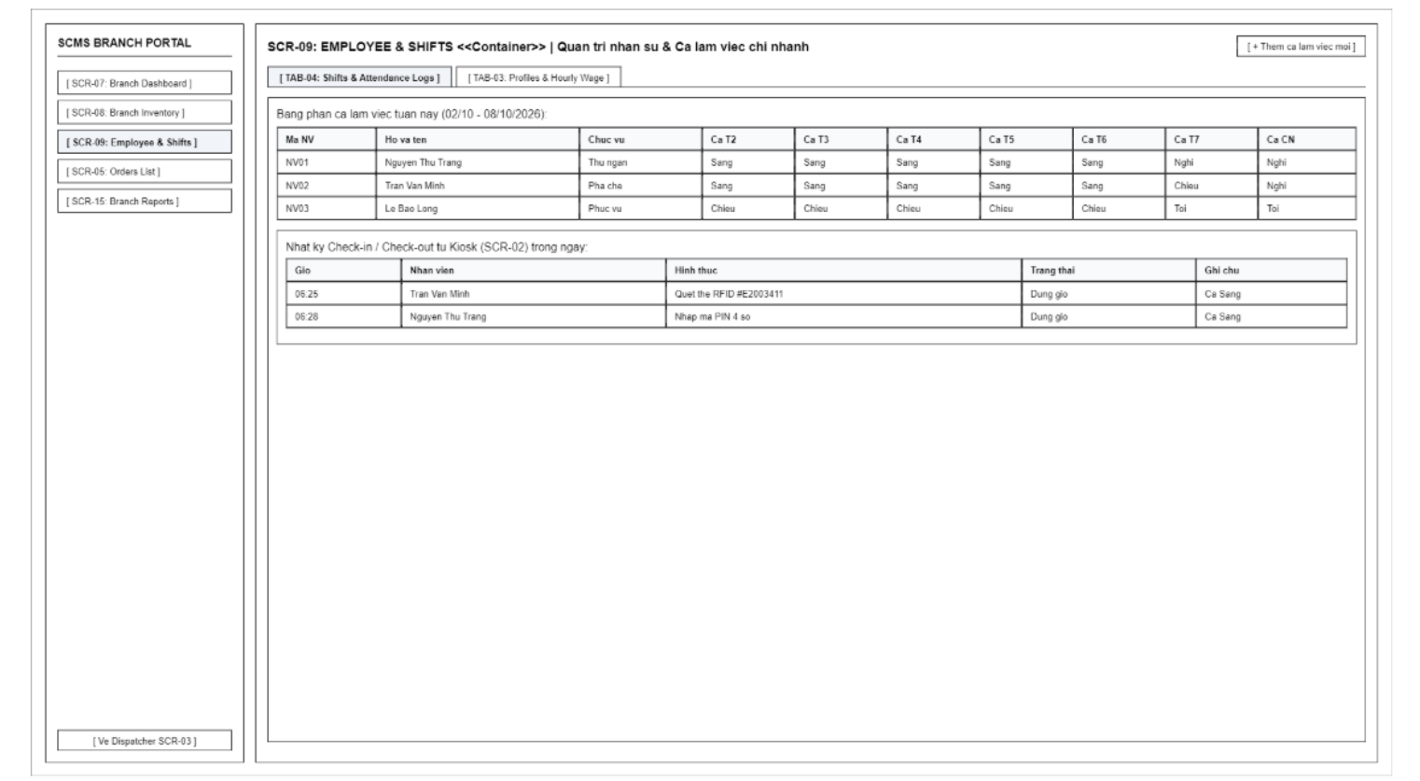
Screen Definition
# | Field Name | Type | Mandatory | Max Length | Description
1 | Add Shift / Staff | Button | - | - | Opens form to schedule a new shift or add a employee profile.
2 | Sub-Tab Switcher | Tabs | - | - | Toggles between TAB-04 (Shift Roster & Timekeeping) and TAB-03 (Profiles & Hourly Wage).
3 | (TAB-04) Weekly Schedule | Table | - | - | Shift assignment matrix for branch staff from Monday to Sunday.
4 | (TAB-04) Kiosk Logs Table | Table | - | - | Actual Check-in / Check-out time logs recorded from Kiosk (SCR-02).
5 | (TAB-04) Adjust Attendance | Button | - | - | Manages approvals for employee attendance time adjustments during system/issue exceptions.
6 | (TAB-03) Profiles Table | Table | - | - | Employee directory table (Employee ID, Full Name, Phone Number, Position, Employment Status).
7 | (TAB-03) Hourly Wage Rate | Text | Yes | 10 | Configures base hourly wage rates for employees.
8 | (TAB-03) RFID / PIN Config | Text | Yes | 15 | Configures RFID card ID or 4-digit timekeeping PIN code for employees.
9 | (TAB-03) Edit Profile | Button | - | - | Opens window to edit employee profile information.

3.5.3.2 Use Case Description

UC07 – Manage Employee Profiles
Use Case ID |  | UC07 | Use Case Name |  | Manage Employee Profiles
Author |  | TamDHM | Version | 1.0 | Date | 04/10/2026
Actor |  | Branch Manager
Description |  | The Branch Manager manages store staff profiles within their assigned branch, including creating, updating employee details (e.g., full name, role, phone, PIN code), or deactivating profiles upon termination.
Precondition |  | PRE-01: The Branch Manager has successfully logged into the SCMS (UC01).  PRE-02: The Branch Manager has navigated to the "Employee Profiles" screen (SCR-07).
Trigger |  | TRG-01: The Branch Manager chooses to add a new employee, edit employee details, or change an employee's employment status.
Post-Condition |  | POS-01: Employee records for the specific branch are updated in the central database.  POS-02: Updated employee details and PIN codes are immediately applicable for attendance and operations.
Main flows
Step | Actor | Action
1 | Branch Manager | View the employee list for the managed branch and select "Add Employee" or choose an existing employee to edit/deactivate.
2 | Branch Manager | Fill in or update employee profile data (Full Name, Phone, Role/Position, Attendance PIN, Status).
3 | Branch Manager | Click the "Save" button.
4 | SCMS | Validate employee profile inputs (e.g., required fields, unique attendance PIN within the branch).
5 | SCMS | Save the employee record associated with the current branch context.
6 | SCMS | Display a success confirmation message and update the employee directory display.

Alternative flows
AT1 | Duplicate PIN code within the same branch (At step 4 in the main flows)
Sub step | Actor | Action
2.1 | SCMS | Detect that the entered PIN code is already assigned to another employee in the branch.
2.2 | SCMS | Display a validation error message "PIN code already in use by another staff member."
2.3 | SCMS | Prompt the Branch Manager to provide a unique PIN code.

UC08 – Manage Work Shifts
Use Case ID |  | UC08 | Use Case Name |  | Manage Work Shifts
Author |  | TamDHM | Version | 1.0 | Date | 04/10/2026
Actor |  | Branch Manager
Description |  | The Branch Manager defines work shift timeframes, creates shift schedules for upcoming periods, and assigns employees to specific shifts. The system checks for scheduling conflicts and saves the work schedule.
Precondition |  | PRE-01: The Branch Manager has successfully logged into the SCMS (UC01).  PRE-02: Active employees exist in the branch directory (UC07).  PRE-03: The Branch Manager has navigated to the "Shift Management" screen (SCR-08).
Trigger |  | TRG-01: The Branch Manager creates a new shift schedule or assigns employees to working shifts for a calendar period.
Post-Condition |  | POS-01: Work shift schedules and employee shift assignments are persisted in the database.  POS-02: The shift schedule becomes active and is available for employee check-in verification (UC03)
Main flows
Step | Actor | Action
1 | Branch Manager | Select shift configuration (e.g., Morning Shift, Evening Shift) or pick a date on the shift schedule calendar.
2 | Branch Manager | Define/adjust shift time frames (Start Time, End Time) and select target employees to assign to the shift.
3 | Branch Manager | Click the "Save Schedule" button.
4 | SCMS | Validate shift configurations and check for schedule conflicts (e.g., employee assigned to overlapping shifts on the same day).
5 | SCMS | Save shift schedules and employee assignment data to the database.
6 | SCMS | Display a confirmation message and refresh the schedule view.

Alternative flows
AT1 | Schedule conflict detected (At step 4 in the main flows)
Sub step | Actor | Action
2.1 | SCMS | Detect that one or more assigned employees are already scheduled for an overlapping shift time.
2.2 | SCMS | Display a warning message detailing the conflicting employees and shift times.
2.3 | SCMS | Highlight conflicting assignments and allow the Branch Manager to resolve or reassign staff.

UC45 – Manage Branch Payroll
Use Case ID |  | UC45 | Use Case Name |  | Manage Branch Payroll
Author |  | TamDHM | Version | 1.0 | Date | 04/10/2026
Actor |  | Branch Manager (Primary - Manage, Calculate, Submit, Export), COO (Secondary - Review, Approve, Reject)
Description |  | The Branch Manager defines branch pay periods, verifies staff attendance hours, resolves forgot check-out flags (BR-09), enters bonuses and deductions, and calculates net wages = (Hours x Rate) + Bonus - Deduction. The Branch Manager submits the payroll to the COO for approval. The COO reviews and either Approves or Rejects the payroll with feedback. Once approved, the official payroll disbursement report (.xlsx) is exported.
Precondition |  | PRE-01: User is authenticated with Branch Manager or COO role (UC01).  PRE-02: Target branch context is selected.  PRE-03: Active employees and attendance records exist in the branch directory (UC03, UC04, UC07).
Trigger |  | TRG-01: Branch Manager or COO navigates to the Payroll view on SCR-09 (TAB-03) or Branch Dashboard (SCR-07).
Post-Condition |  | POS-01: A PayPeriod and linked PayrollItem records are created and saved in the database.  POS-02: Unlocked attendance records are frozen into the closed pay period.  POS-03: When approved by COO, payroll report (.xlsx) is exported and status transitions to APPROVED/PAID.
Main flows
Step | Actor | Action
1 | Branch Manager | Navigate to SCR-09 (TAB-03: Pay Periods & Wage) or Branch Dashboard (SCR-07).
2 | Branch Manager | Click 'Create New Pay Period', specify period name, start date, and end date, then click 'Generate Payroll Draft'.
3 | SCMS | Aggregate all approved attendance records (UC03, UC04) within the date range. If any shift has 'Forgot Check-out' (BR-09), alert manager to resolve via Attendance Logs (SCR-09 TAB-04).
4 | SCMS | Populate employee payroll items: Staff Name, Hourly Wage Rate (BR-14), Total Verified Hours, and Base Wage (Hours x Rate).
5 | Branch Manager | Input performance/attendance bonuses and deduction penalties with mandatory explanatory reasons, then review Net Salary calculations.
6 | Branch Manager | Click 'Submit Payroll to COO'. Period status transitions to SUBMITTED and branch edits are locked.
7 | COO | Review submitted payroll on SCR-16 / SCR-10. Upon COO Approval, status updates to APPROVED. Branch Manager clicks 'Export Official Payroll Report' (.xlsx) for disbursement.

Alternative flows
AT1 | Unresolved attendance logs or missing check-outs detected (At step 3 in the main flows)
Sub step | Actor | Action
3.1 | SCMS | Detect that one or more employee shifts within the pay period date range have missing check-out flags (BR-09).
3.2 | SCMS | Display an alert notification prompting the Branch Manager to resolve or adjust the attendance hours via Attendance Logs (SCR-09 TAB-04).
3.3 | Branch Manager | Adjust the shifts or approve unlocked records, then regenerate the draft payroll.

AT2 | COO rejects the submitted payroll (At step 7 in the main flows)
Sub step | Actor | Action
7.1 | COO | Review the payroll on SCR-16 / SCR-10, identify discrepancy or issue, enter rejection feedback reason, and click 'Reject'.
7.2 | SCMS | Update period status to REJECTED, notify the Branch Manager, and unlock the period for branch corrections.
7.3 | Branch Manager | Adjust the bonuses, deductions, or attendance calculations and re-submit the payroll to COO.

Business Rules
# | Rule Description
BR-01 | Cumulative working hours and payroll calculations are tracked and closed per pay period (PayPeriod).
BR-02 | Only the assigned Branch Manager can create and submit payroll for their branch; COO has chain-wide review and final approval authority.
BR-03 | Hourly wage rate modifications only apply to future work shifts and do not retroactively alter closed pay periods (BR-14).
BR-04 | All payroll creation, adjustment, bonus/deduction justification, and export actions are permanently logged in the system Audit Log (BR-51).

3.6 Chain Management & Master Data

3.6.1 Chain Dashboard

3.6.1.1 Screen Mock-up

Screen Definition
# | Field Name | Type | Mandatory | Max Length | Description
1 | HQ Sidebar Menu | Menu | - | - | Navigation bar for high-level management modules of the Chain Headquarters.
2 | Chain Total Revenue | Card | - | 25 | Display the total daily revenue of all 6-10 branches.
3 | Active Branches KPI | Card | - | 15 | Display the number of open and operating branches.
4 | Top 1 Best Seller | Card | - | 50 | Display the name of the food/beverage item with the highest consumption across the chain.
5 | Peak Hours KPI | Card | - | 30 | Display the peak hour timeframe with the highest number of orders across the chain.
6 | Branch Performance Table | Table | - | - | Table comparing revenue, COGS (Cost of Goods Sold), gross profit, and cash drawer discrepancy status of each facility.

3.6.1.2 Use Case Description
UC40 – View Consolidated Financial Report
Use Case ID |  | UC40 | Use Case Name |  | View Consolidated Financial Report
Author |  | VuNL | Version | 1.0 | Date | 04/10/2026
Actor |  | COO
Description |  | COO requests consolidated reporting. The system retrieves data from all branches to compute and display total Revenue, Cost of Goods Sold (COGS), and Gross Profit across the entire chain.
Precondition |  | PRE-01: COO is logged in.  PRE-02: The chain has at least one branch that has processed orders.
Trigger |  | TRG-01: COO selects the "Consolidated Financial Report" function.
Post-Condition |  | POS-01: Revenue, COGS, and Gross Profit reports across the chain and per branch are displayed.
Main flows
Step | Actor | Action
1 | COO | Selects the consolidated financial report function.
2 | SCMS | Displays time range filter and branch selection list (defaults to all branches).
3 | COO | Selects filter parameters and requests to view report.
4 | SCMS | Retrieves paid order data from all selected branches to calculate revenue.
5 | SCMS | Calculates COGS based on recipe ingredient quantities, sales volumes, and ingredient unit costs.
6 | SCMS | Calculates gross profit.
7 | SCMS | Displays consolidated chain-wide figures and detailed breakdown per branch.
Alternative flows
AT1 | At step 4, if a branch has not generated any orders during the period:
Sub step | Actor | Action
4.1 | SCMS | Displays zero values for that branch and still includes it in the consolidated report.
AT2 | At step 5, if products lack recipes or ingredients lack unit cost prices:
Sub step | Actor | Action
5.1 | SCMS | Displays an incomplete cost data warning while still presenting available calculated figures.
Business Rules
# | Rule Description
BR-01 | Only COO is permitted to view the chain-wide consolidated report (BR-02, BR-04).
BR-02 | Revenue only accounts for paid orders, excluding cancelled or refunded orders (BR-26, BR-48).
BR-03 | COGS = Σ (recipe ingredient quantity × product sales volume × ingredient unit cost) (BR-19, BR-48).
BR-04 | Gross Profit = Revenue − COGS (BR-48).

UC41 – View Product Sales Report
Use Case ID |  | UC41 | Use Case Name |  | View Product Sales Report
Author |  | VuNL | Version | 1.0 | Date | 04/10/2026
Actor |  | COO
Description |  | COO requests product sales report. The system calculates sales volumes, ranks top-selling products in descending order, and displays sales revenue per product.
Precondition |  | PRE-01: COO is logged in.  PRE-02: Paid orders exist within the selected viewing period.
Trigger |  | TRG-01: COO selects the "Sales Report by Product" function.
Post-Condition |  | POS-01: List of top-selling products is displayed in descending order.
Main flows
Step | Actor | Action
1 | COO | Selects the sales report by product function.
2 | SCMS | Displays time range filter and scope selection (chain-wide or specific branch).
3 | COO | Selects filter parameters and requests to view report.
4 | SCMS | Aggregates sales quantity for each product from paid orders.
5 | SCMS | Sorts products in descending order by quantity sold.
6 | SCMS | Displays list of best-selling products along with quantities sold and generated revenue.
Alternative flows
AT1 | At step 4, if no paid orders exist within the selected time range:
Sub step | Actor | Action
4.1 | SCMS | Displays a message indicating no sales data available.
Business Rules
# | Rule Description
BR-01 | Only paid orders are counted; cancelled orders are excluded (BR-26).
BR-02 | Products are ranked by sales volume (quantity sold), not by revenue (BR-49).
BR-03 | The list defaults to displaying the top 10 products (BR-49).

UC42 – View Peak Hours Report
Use Case ID |  | UC42 | Use Case Name |  | View Peak Hours Report
Author |  | VuNL | Version | 1.0 | Date | 04/10/2026
Actor |  | COO, Branch Manager
Description |  | The COO or Branch Manager requests peak hours reporting. The system analyzes order volume by hourly time slots, identifies peak sales periods, and displays traffic distribution to optimize shift scheduling and operational planning.
Precondition |  | PRE-01: COO or Branch Manager is logged in. PRE-02: Orders exist within the selected viewing period.
Trigger |  | TRG-01: COO or Branch Manager selects the "Peak Hours Report" function.
Post-Condition |  | POS-01: Order volume by hourly slot and identified peak hours are displayed.
Main flows
Step | Actor | Action
1 | COO / Branch Manager | Selects the Peak Hours Report function from the navigation menu.
2 | SCMS | Displays time range filter and scope selection (chain-wide or specific branch).
3 | COO / Branch Manager | Selects filter criteria (date range, branch) and clicks "Search" / "View Report".
4 | SCMS | Groups paid orders by hourly slots within store operating hours.
5 | SCMS | Identifies time slots with the highest order volume.
6 | SCMS | Displays traffic volume by hourly slot and highlights peak hours.
Alternative flows
AT1 | At step 4, if no orders exist within the selected time range:
Sub step | Actor | Action
4.1 | SCMS | Displays a message indicating no data available for analysis.
Business Rules
# | Rule Description
BR-01 | Time slots fall within chain operating hours (06:00 to 23:00) (BR-49).
BR-02 | Each time slot has a duration of 1 hour (BR-49).
BR-03 | Orders are grouped into time slots based on order creation timestamp (BR-25, BR-49).
BR-04 | Peak hours are defined as slots with order counts belonging to the highest tier during the period (BR-49).

3.6.2 Master Menu & Recipe

3.6.2.1 Screen Mock-up

# | Field Name | Type | Mandatory | Max Length | Description
1 | Add New Product | Button | - | - | Open the form to create a new item in the chain menu.
2 | Sub-Tab Switcher | Tabs | - | - | Switch between TAB-05 (Products & Prices) and TAB-06 (BOM Recipe).
3 | (TAB-05) Products Table | Table | - | - | List of items, categories, selling price table by S/M/L sizes, and applicable toppings.
4 | (TAB-05) Active Status | Toggle | - | - | Enable/Disable the active business status of the item across the entire chain system.
5 | (TAB-06) Recipe BOM Table | Table | - | - | Detailed raw material consumption quota table for each item by size.
6 | (TAB-06) Estimated COGS | Label | - | 15 | Display the theoretical cost of goods sold (COGS) automatically calculated from the BOM formula.
7 | (TAB-06) Edit BOM Formula | Button | - | - | Open the form to edit the ingredient quantities for the item.

3.6.2.2 Use Case Description
UC09 – Manage Menu Categories
Use Case ID |  | UC09 | Use Case Name |  | Manage Menu Categories
Author |  | TamDHM | Version | 1.0 | Date | 04/10/2026
Actor |  | COO
Description |  | The COO creates, modifies, or deactivates standard menu categories and master menus, assigning products to each menu structure. The system records the standardized menu configuration centrally.
Precondition |  | PRE-01: The COO has successfully logged into the SCMS (UC01).  PRE-02: The COO has navigated to the "Menu Management" screen (SCR-09).
Trigger |  | TRG-01: The COO initiates creation or modification of master menu categories or item groupings.
Post-Condition |  | POS-01: Master menu structures and category-product mappings are updated in the database.  POS-02: The updated menu hierarchy becomes available for store synchronization (UC14).
Main flows
Step | Actor | Action
1 | COO | Select "Create Category" or choose an existing menu category to edit/deactivate.
2 | COO | Enter/update category details (Category Name, Display Sequence, Description, Active Status).
3 | COO | Assign/reorder products associated with the menu category.
4 | COO | Click the "Save Menu Category" button.
5 | SCMS | Validate category inputs and verify structural integrity (e.g., mandatory names, valid display order).
6 | SCMS | Save standard menu structure to the central database and display a success notification.

Alternative flows
AT1 | Category contains assigned products upon deletion request (At step 1 in the main flows)
Sub step | Actor | Action
2.1 | COO | Attempt to delete/deactivate a menu category that currently contains active products.
2.2 | SCMS | Detect linked products within the target category.
2.3 | SCMS | Display a warning message "Category contains active products. Please reassign or remove products before deleting."
2.4 | SCMS | Abort deletion and maintain current category status.

UC10 – Manage Products
Use Case ID |  | UC10 | Use Case Name |  | Manage Products
Author |  | VanNT | Version | 1.0 | Date | 04/10/2026
Actor |  | COO
Description |  | The function allows the COO to create new products, update product details, or deactivate products. The system saves the information in the product catalog.
Precondition |  | PRE-01: The COO has successfully logged into the SCMS (UC01).  PRE-02: The COO has navigated to the "Master Menu & Recipe" screen (SCR-11).
Trigger |  | TRG-01: The COO clicks on the "Add Product" button or selects an existing product from the list to view/edit details.
Post-Condition |  | POS-01: The product information is successfully created or updated in the system database.  POS-02: If a product is deactivated, its status is changed to "Unavailable" and it is disabled on the POS interface (BR-04).
Main flows
Step | Actor | Action
1 | COO | Click the "Add Product" button on the Master Menu & Recipe screen.
2 | SCMS | Display the Product Information form with the following fields:  - Name (Required)  - Description  - Price (Required)  - Status (Active/Unavailable)
3 | COO | Enter the required product details and click the "Save" button.
4 | SCMS | Validate the entered data (check for empty required fields and data types).
5 | SCMS | Save the new product into the database and display a success toast message.
Alternative flows
AT1 | At step 1 in the main flows, update an existing product
Sub step | Actor | Action
1.1 | COO | Select an existing product from the list and click the "Edit" icon.
1.2 | SCMS | Display the Product Information form pre-filled with the current data.
1.3 | COO | Modify the product details (e.g., Name, Description) and click the "Save" button.
1.4 | SCMS | Validate, update the information in the database, and display a success toast message.
AT2 | At step 1 in the main flows: Deactivate a product.
Sub step | Actor | Action
2.1 | COO | Select an existing product, change its Status field to "Unavailable", and click "Save".
2.2 | SCMS | Update the status in the database. Apply Business Rule BR-04: The system strictly disables this item on the POS interface so it cannot be added to any new order.

UC11 – Manage Prices, Sizes & Toppings
Use Case ID |  | UC11 | Use Case Name |  | Manage Prices, Sizes & Toppings
Author |  | VanNT | Version | 1.0 | Date | 04/10/2026
Actor |  | COO
Description |  | The function allows the COO to set or update selling prices for each product based on size and toppings. The system validates the information and saves the pricing configuration.
Precondition |  | PRE-01: The COO has successfully logged into the SCMS (UC01).  PRE-02: The COO has navigated to the "Master Menu & Recipe" screen (SCR-11) and accessed the "Products & Pricing by Size" sub-tab.
Trigger |  | TRG-01: The COO selects a product to configure its size options and topping prices.
Post-Condition |  | POS-01: The pricing configuration (sizes and toppings) is successfully saved in the database and applied to the product.
Main flows
Step | Actor | Action
1 | COO | Select a product from the catalog and click the "Configure Price/Size" button.
2 | SCMS | Display the Pricing Configuration form, showing available sizes (Small/Medium/Large) and applicable toppings.
3 | COO | Input or update the numeric selling prices for each active size and topping, then click "Save".
4 | SCMS | Validate the entered data (ensure price fields are filled and contain valid non-negative numbers).
5 | SCMS | Save the pricing configuration into the database and display a success toast message (e.g., MSG03).
Alternative flows
AT1 | At step 1 in the main flows, update an existing product
Sub step | Actor | Action
1.1 | SCMS | Detects that a required price field is left blank.
1.2 | SCMS | Highlight the empty mandatory field(s) and display message MSG02: "The * field is required." in red under the text box
1.3 | SCMS | The system halts the save operation and remains on the configuration form page.

UC12 – Manage Recipes
Use Case ID |  | UC12 | Use Case Name |  | Manage Recipes
Author |  | VanNT | Version | 1.0 | Date | 04/10/2026
Actor |  | COO
Description |  | The COO selects a product and defines the required quantities of raw materials (Bill of Materials - BOM) for its preparation.
Precondition |  | PRE-01: The COO is logged in (UC01) and on the "Master Menu & Recipe" screen (SCR-11 - TAB-06: Standard Recipe BOM).  PRE-02: Products (UC10) and Raw Material Ingredients already exist in the catalog.
Trigger |  | TRG-01: The COO selects a product and size to create or update its standard recipe formula.
Post-Condition |  | POS-01: The standard recipe (BOM) and theoretical COGS for the product are saved in the master database and ready for branch synchronization (UC14, BR-19).
Main flows
Step | Actor | Action
1 | COO | Navigate to TAB-06 (Standard Recipe BOM) on SCR-11 and select a target Product and Cup Size (S, M, or L).
2 | SCMS | Display the current list of ingredients and quantities configured for the selected product size.
3 | COO | Add or remove raw materials, enter the standard consumption quantity (in dispensing base units) for each ingredient, and click "Save".
4 | SCMS | Validate that all ingredient quantities are positive numbers (> 0) and calculate the estimated Cost of Goods Sold (COGS).
5 | SCMS | Save the recipe BOM configuration, log the change in the Audit Log (BR-51), and display a success notification.
Alternative flows
AT1 | Invalid or zero ingredient quantity (At step 4)
Sub step | Actor | Action
4.1 | SCMS | Highlight invalid quantity fields and display an error message requiring a positive numeric value.

3.6.3 Promotions & Vouchers

3.6.3.1 Screen Mock-up

Screen Definition
# | Field Name | Type | Mandatory | Max Length | Description
1 | Create Promotion | Button | - | - | Open the form to create a new promotion campaign or voucher code.
2 | Promotion Code | Text | Yes | 15 | Voucher code applied during POS checkout (e.g., GIAM10).
3 | Discount Type & Value | Dropdown / Text | Yes | 15 | Set the discount type (Percentage discount or Fixed amount discount).
4 | Min Order Value | Text | No | 15 | Minimum order value condition to apply the code.
5 | Usage Limit / Count | Label | - | 20 | Display the number of times used over the maximum issued limit.
6 | Validity Period | Text / Date | Yes | 25 | Start and end validity period of the program.
7 | Status Toggle | Toggle | - | - | Activate or suspend the validity of the promotion.

3.6.3.2 Use Case Description
UC13 – Manage Vouchers
Use Case ID |  | UC13 | Use Case Name |  | Manage Vouchers
Author |  | VanNT | Version | 1.0 | Date | 04/10/2026
Actor |  | COO
Description |  | The COO creates or updates vouchers and configures usage conditions such as validity period, order value, and applicable products. The system validates and saves the voucher information.
Precondition |  | PRE-01: The COO has logged into SCMS (UC01) and navigated to the "Promotions & Vouchers" screen (SCR-12).
Trigger |  | TRG-01: The COO clicks "Create Promotion" or selects an existing voucher to update/deactivate.
Post-Condition |  | POS-01: The voucher configuration is saved in the database and ready to be published to branches via Chain Sync Center (UC14, BR-20, BR-23).
Main flows
Step | Actor | Action
1 | COO | Click "Create Promotion" or select an existing voucher to edit on screen SCR-12.
2 | SCMS | Display the Voucher Configuration form (Voucher Code, Discount Type, Discount Value, Min Order Amount, Start Date, End Date, Usage Limit, Status).
3 | COO | Enter or modify the voucher parameters and click "Save".
4 | SCMS | Validate inputs: unique Voucher Code, Discount Value > 0 (if percentage, <= 100%), and Start Date <= End Date.
5 | SCMS | Save the voucher record in the central database, record the operation in the Audit Log (BR-51), and display a success message.
Alternative flows
AT1 | Duplicate Voucher Code or invalid validity dates (At step 4)
Sub step | Actor | Action
4.1 | SCMS | Detect duplicate code or End Date < Start Date, display an error message, and keep the form open for correction.

3.6.4 Branches & Managers

3.6.4.1 Screen Mock-up

Screen Definition
# | Field Name | Type | Mandatory | Max Length | Description
1 | Add Branch | Button | - | - | Open the form to add a new branch to the chain system.
2 | Branches Table | Table | - | - | Branch information table (Branch Code, Name, Address, Phone Number, Assigned Manager).
3 | Assigned Manager | Dropdown | Yes | - | Assign the Branch Manager account in charge of the facility.
4 | POS Connection Status | Label | - | 20 | Display the network connection status of the POS system at the branch (Online/Offline).
5 | Edit Branch Action | Button | - | - | Open the form to edit information or temporarily close the branch.

3.6.4.2 Use Case Description
UC05 – Manage Branches
Use Case ID |  | UC05 | Use Case Name |  | Manage Branches
Author |  | TamDHM | Version | 1.0 | Date | 04/10/2026
Actor |  | COO
Description |  | The COO creates, views, edits, or deactivates store branch profiles (including address, contact details, operating status, and tax info). The system validates and saves the branch configuration in the central database.
Precondition |  | PRE-01: The COO has successfully logged into the SCMS (UC01).  PRE-02: The COO has navigated to the "Branch Management" screen (SCR-05).
Trigger |  | TRG-01: The COO chooses to add a new branch, update existing branch info, or change a branch operational status.
Post-Condition |  | POS-01: Branch information is updated or created in the central system database.  POS-02: Updated branch profile data becomes available across chain-wide modules.
Main flows
Step | Actor | Action
1 | COO | Select an action: "Create New Branch" or choose an existing branch from the list to "Edit" or "Deactivate".
2 | COO | Input or modify branch details (Branch Name, Code, Address, Phone Number, Operating Hours, Status).
3 | COO | Click the "Save" button.
4 | SCMS | Validate the entered information (e.g., check for unique Branch Code and required fields).
5 | SCMS | Save the branch record to the system database.
6 | SCMS | Display a success message and update the branch list table on screen.

Alternative flows
AT1 | Duplicate branch code or missing required fields (At step 4 in the main flows)
Sub step | Actor | Action
1.1 | SCMS | Detect missing mandatory fields or a duplicate Branch Code in the database.
1.2 | SCMS | Highlight the erroneous input fields and display appropriate validation error messages.
1.3 | SCMS | Allow the COO to correct the information and re-submit.

UC06 – Manage Branch Manager Accounts
Use Case ID |  | UC06 | Use Case Name |  | Manage Branch Manager Accounts
Author |  | TamDHM | Version | 1.0 | Date | 04/10/2026
Actor |  | COO
Description |  | The COO creates or updates Branch Manager user accounts, assigns specific branch ownership/data scopes, and sets login credentials and permissions. The system updates the manager account database.
Precondition |  | PRE-01: The COO has successfully logged into the SCMS (UC01).  PRE-02: Target branches exist within the system (UC05).  PRE-03: The COO has navigated to the "Branch Manager Account Management" screen (SCR-06).
Trigger |  | TRG-01: The COO selects the option to create a new Branch Manager account or modify an existing manager's assigned branch/credentials.
Post-Condition |  | POS-01: Branch Manager account details, assigned branch scope, and credentials are saved in the system.  POS-02: The assigned Branch Manager can log into the system with target branch permissions.
Main flows
Step | Actor | Action
1 | COO | Select "Create Manager Account" or select an existing Branch Manager account to edit.
2 | COO | Enter/modify manager details (Full Name, Phone Number, Email, Username, Password) and select the target branch to assign.
3 | COO | Click the "Save Account" button.
4 | SCMS | Validate account details (e.g., unique username/email, strong password, valid branch assignment).
5 | SCMS | Store account details and bind the manager profile to the specified branch scope.
6 | SCMS | Display a success message confirming account setup/update.

Alternative flows
AT1 | Username or email already exists (At step 4 in the main flows)
Sub step | Actor | Action
1.1 | SCMS | Detect that the username or email is already registered to another account.
1.2 | SCMS | Display an error message "Username/Email already exists in the system."
1.3 | SCMS | Retain the form data and allow the COO to enter unique credentials.

3.6.5 Chain Sync Center

3.6.5.1 Screen Mock-up
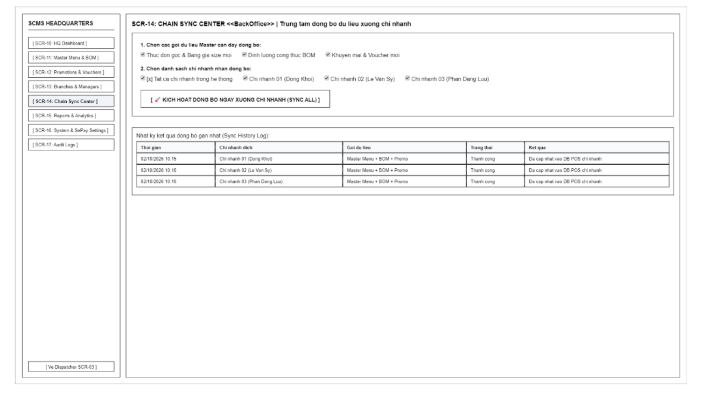
Screen Definition
# | Field Name | Type | Mandatory | Max Length | Description
1 | Data Packages Select | Checkbox Group | Yes | - | Select data packages to synchronize (Menu & Prices, BOM Recipes, Promotions).
2 | Target Branches Select | Checkbox Group | Yes | - | Select the list of branches to receive the synchronization (All or specific branches).
3 | Trigger Sync Button | Button | - | - | Trigger the process of instantly pushing Master data to the POS DB of the branches.
4 | Sync History Table | Table | - | - | Table tracking the results of synchronization batches (Time, Target Branch, Data Package, Status).

3.6.5.2 Use Case Description
UC14 – Synchronize Configuration to Branches
Use Case ID |  | UC14 | Use Case Name |  | Synchronize Configuration to Branches
Author |  | VanNT | Version | 1.0 | Date | 04/10/2026
Actor |  | COO
Description |  | The COO selects configuration data and target branches. The system synchronizes the selected data to the branches and records the synchronization results.
Precondition |  | PRE-01: The COO has successfully logged into the SCMS (UC01).  PRE-02: The COO has navigated to the "Chain Sync Center" screen (SCR-14).
Trigger |  | TRG-01: The COO initiates the synchronization process to push updated master data down to the branch level.
Post-Condition |  | POS-01: Configuration data (including master menu items, pricing tiers, BOM recipes, and active promotions) is successfully updated in the selected branches' databases.  POS-02: The system records the synchronization log/results.
Main flows
Step | Actor | Action
1 | COO | Review the configuration data packages available for syncing, which encompass master menu items, pricing tiers, BOM recipes, and active promotions.
2 | COO | Select the specific target branches to receive the update.
3 | COO | Click the synchronization button to trigger the one-click sync process.
4 | SCMS | Validate the selected data packages and establish a connection to the target branches' databases.
5 | SCMS | Push and synchronize the selected configuration data to the databases of the chosen branches.
6 | SCMS | Record the synchronization results and display a success message confirming the operation is complete.
Alternative flows
AT1 | Synchronization fails for one or more branches (At step 4 in the main flows)
Sub step | Actor | Action
1.1 | SCMS | Attempt to connect to the target branch's database.
1.2 | SCMS | Detect a connection failure (e.g., the branch network is offline).
1.3 | SCMS | Log the synchronization failure for the specific unreachable branch, flag it in the synchronization results, and proceed to sync the remaining available branches.
1.4 | SCMS | Display a warning message summarizing which branches succeeded and which failed.

3.7 Reports & Analytics

3.7.1 Reports & Analytics

3.7.1.1 Screen Mock-up
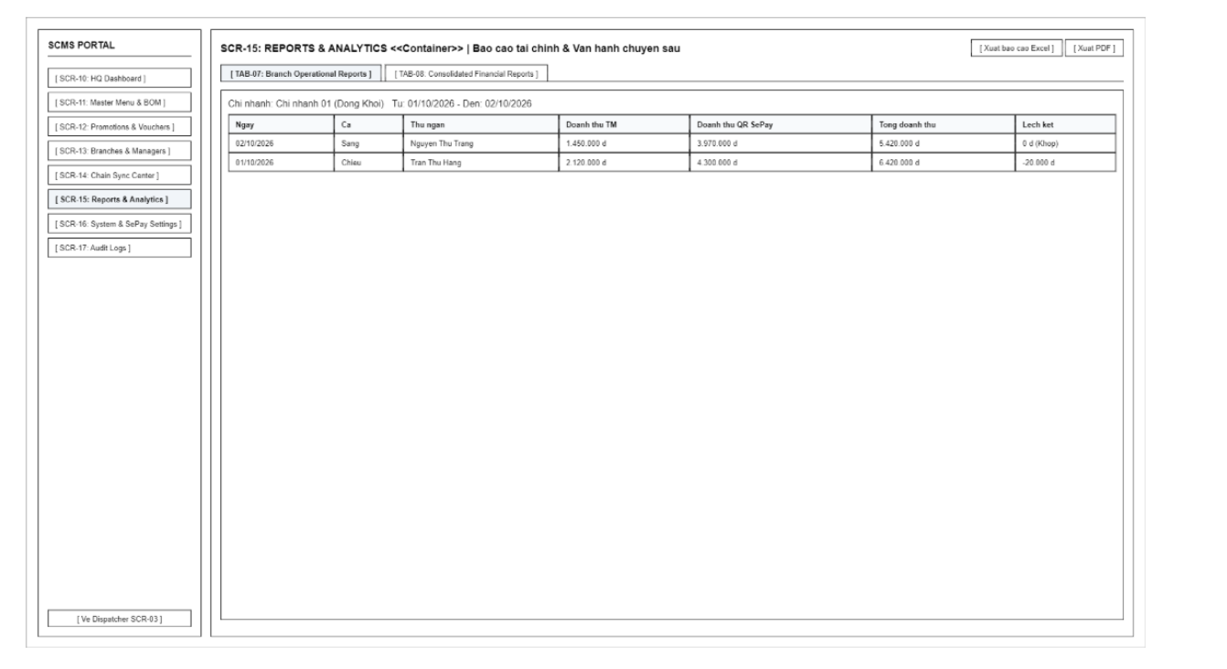

Screen Definition
# | Field Name | Type | Mandatory | Max Length | Description
1 | Date Range Filter | Text / Date | Yes | 25 | Select the time range to view the report (From date - To date).
2 | Export Excel | Button | - | - | Export the entire current report table to an Excel file.
3 | Export PDF | Button | - | - | Export the report in PDF format for printing and archiving.
4 | Sub-Tab Switcher | Tabs | - | - | Switch between TAB-07 (Branch Report) and TAB-08 (Chain Consolidated Report).
5 | (TAB-07) Payment Mix Table | Table | - | - | Statistics on revenue proportion between Cash and SePay QR Transfer by shift.
6 | (TAB-07) Cash Variance Log | Table | - | - | Detailed log of cash overage/shortage reconciliation in the cash register for work shifts.
7 | (TAB-08) Chain P&L Table | Table | - | - | Consolidated report of net revenue, COGS (Cost of Goods Sold), and gross profit for the entire system.
8 | (TAB-08) Gross Margin KPI | Label | - | 15 | Display the average gross profit margin of the entire chain.

3.7.1.2 Use Case Description
UC35 – View Branch Sales Report
Use Case ID |  | UC35 | Use Case Name |  | View Branch Sales Report
Author |  | AnhTV | Version | 1.0 | Date | 04/10/2026
Actor |  | Branch Manager, COO
Description |  | The Branch Manager or COO selects a time period. The system retrieves, aggregates, and displays the sales report for the selected branch.
Precondition |  | PRE-01: Successfully logged in with Branch Manager or COO role.
Trigger |  | TRG-01: Branch Manager or COO requests to view sales figures for a specific timeframe.
Post-Condition |  | POS-01: Sales report is displayed matching applied filters in table and chart formats.
Main flows
Step | Actor | Action
1 | Branch Manager / COO | Selects the Branch Sales Report function from the navigation menu.
2 | SCMS | Displays filter options: From date - To date, Shift, Payment method (Cash / VietQR), and "Search" button.
3 | Branch Manager / COO | Selects filter criteria (date range, branch) and clicks "Search" / "View Report".
4 | SCMS | Validates date range (From date <= To date).
5 | SCMS | Retrieves and aggregates sales data from orders with PAID status within selected timeframe.
6 | SCMS | Presents results in visual charts, revenue summary cards, and itemized order/product sales tables.
Alternative flows
AT1 | At step 3 of the main flow, user selects 'From date' that is greater than 'To date':
Sub step | Actor | Action
3.1 | SCMS | Displays error message: "'From date' cannot be greater than 'To date'."
3.2 | SCMS | Halts query execution and keeps previous report view.
AT2 | At step 5 of the main flow, if no sales transactions exist in the selected period:
Sub step | Actor | Action
5.1 | SCMS | Displays empty state notification: "No sales data available within the selected timeframe."
Business Rules
# | Rule Description
BR-01 | Branch Managers are only allowed to access and view sales report data belonging to their assigned branch (Rule BR-04).
BR-02 | Sales revenue is only recognized from orders in PAID status; cash collected is booked into the respective cashier shift (Rule BR-26, BR-27).
BR-03 | The system must provide detailed Sales Reports over time for the Branch Manager to track revenue and order volumes (Rule BR-46).
BR-04 | All sales report views must support exporting data to Excel format (.xlsx) (Rule BR-50).

UC36 – Export Reports
Use Case ID |  | UC36 | Use Case Name |  | Export Reports
Author |  | AnhTV | Version | 1.0 | Date | 04/10/2026
Actor |  | Branch Manager, COO
Description |  | The Branch Manager or COO exports reports as Excel files.
Precondition |  | PRE-01: User is authenticated with Branch Manager or COO role.  PRE-02: Selected report contains data within the specified timeframe.
Trigger |  | TRG-01: User clicks "Export Excel" button on current report screen.
Post-Condition |  | POS-01: An Excel file (.xlsx) containing report data is generated and downloaded to user's computer.  POS-02: Export operation is recorded in the system audit log (*).
Main flows
Step | Actor | Action
1 | User | Selects report type to export (Sales, Inventory In-Out-Balance, Cash Drawer Flow, Employee Hours).
2 | SCMS | Displays filter options based on role: date range, and branch selector (COO only).
3 | User | Selects filters and clicks "Export Excel".
4 | SCMS | Verifies data access permissions according to user role and branch scope.
5 | SCMS | Aggregates data according to filters and generates formatted Excel file (.xlsx).
6 | SCMS | Returns file for browser download and records operation in Audit Log.
Alternative flows
AT1 | At step 4, if Branch Manager selects a branch outside their assigned scope:
Sub step | Actor | Action
4.1 | SCMS | Rejects operation and displays message: 'Access denied: You do not have permission to access data outside your assigned branch.'
AT2 | At step 5, if the current report dataset is completely empty:
Sub step | Actor | Action
5.1 | SCMS | Displays toast message: 'No data available to export.' and aborts file generation.
AT3 | At step 5, if an error occurs during file generation:
Sub step | Actor | Action
5.1 | SCMS | Displays error message: 'File generation failed. Please try again.'
Business Rules
# | Rule Description
BR-01 | Branch Manager can only export data belonging to their assigned branch (Rule BR-04).
BR-02 | Excel file contents must strictly match the report data displayed on screen under the same filter criteria (Rule BR-50).
BR-03 | File export format must be Excel (.xlsx) (Rule BR-50).
BR-04 | All report export actions must be automatically recorded in the system Audit Log (*) (Rule BR-51).

UC37 – View Branch Cash Flow Report
Use Case ID |  | UC37 | Use Case Name |  | View Branch Cash Flow Report
Author |  | VuNL | Version | 1.0 | Date | 04/10/2026
Actor |  | Branch Manager, COO
Description |  | The Branch Manager or COO views the cash flow report of the branch. The system aggregates shift cash, sales revenue, cash-in/cash-out, and calculates expected cash versus counted cash to report drawer discrepancies.
Precondition |  | PRE-01: Branch Manager or COO is logged in. PRE-02: The branch has opened work shifts and sales transactions.
Trigger |  | TRG-01: Branch Manager or COO selects the "Cash Flow Report" function.
Post-Condition |  | POS-01: Cash flow report and cash drawer discrepancy details are displayed.
Main flows
Step | Actor | Action
1 | Branch Manager / COO | Selects the Branch Cash Flow Report function from the navigation menu.
2 | SCMS | Displays filters by date or shift (defaults to current date).
3 | Branch Manager / COO | Selects filter criteria (date range, branch) and clicks "Search" / "View Report".
4 | SCMS | Aggregates data for each shift at the branch: opening cash, cash-in/cash-out with reasons, cash sales revenue, cash refunds.
5 | SCMS | Calculates expected cash, reconciles with counted cash upon shift closing, and computes discrepancy.
6 | SCMS | Displays summary and shift breakdown report with discrepancy explanations, highlighting shifts with variances.
Alternative flows
AT1 | At step 4, if no shifts exist within the selected time range:
Sub step | Actor | Action
4.1 | SCMS | Displays a message indicating no cash flow data available.
AT2 | At step 5, if shift is not yet closed and physical count has not occurred:
Sub step | Actor | Action
5.1 | SCMS | Displays "Unreconciled" status for that shift and does not calculate discrepancy.
Business Rules
# | Rule Description
BR-01 | Branch Manager can only view data of their assigned branch.(BR-04)
BR-02 | Expected Cash = Opening Cash + Cash Sales Revenue + Cash In − Cash Out − Cash Refunds (BR-39).
BR-03 | Discrepancy = Counted Cash − Expected Cash. Shifts with discrepancies must provide an explanation (BR-38).
BR-04 | Revenue in cash flow report only includes orders paid in cash (BR-27).

UC38 – View Branch Inventory Report
Use Case ID |  | UC38 | Use Case Name |  | View Branch Inventory Report
Author |  | VuNL | Version | 1.0 | Date | 04/10/2026
Actor |  | Branch Manager, COO
Description |  | The Branch Manager or COO views the inventory report for the branch. The system aggregates stock receipts, issues, disposals, physical counts, and displays inventory status along with discrepancies.
Precondition |  | PRE-01: Branch Manager or COO is logged in. PRE-02: The branch has an active ingredient catalog.
Trigger |  | TRG-01: Branch Manager or COO selects the "Inventory Report" function.
Post-Condition |  | POS-01: Inventory report, stock status, and stock discrepancies are displayed.
Main flows
Step | Actor | Action
1 | Branch Manager / COO | Selects the Branch Inventory Report function from the navigation menu.
2 | SCMS | Displays time range filter.
3 | Branch Manager / COO | Selects filter criteria (date range, branch) and clicks "Search" / "View Report".
4 | SCMS | Aggregates stock transactions in the period: stock receipts, consumption, disposals, physical inventory counts.
5 | SCMS | Calculates opening inventory, closing inventory, and compares system stock against physical count to determine variance.
6 | SCMS | Determines stock status for each ingredient and displays report, highlighting items with discrepancies.
Alternative flows
AT1 | At step 4, if no stock transactions occurred during the period:
Sub step | Actor | Action
4.1 | SCMS | Displays current stock on hand for each ingredient with a notification that no transactions occurred during the period.
AT2 | At step 5, if an ingredient has never been physically counted:
Sub step | Actor | Action
5.1 | SCMS | Displays discrepancy status as "Uncounted" for that ingredient.
Business Rules
# | Rule Description
BR-01 | Branch Manager can only view inventory data of their assigned branch (BR-04).
BR-02 | Discrepancy = Physical Count Quantity − System Inventory at the time of count (BR-44).
BR-03 | Ingredients with stock less than or equal to minimum stock level are flagged as "Low Stock" (BR-45).
BR-04 | Quantities are displayed in bulk packaging units along with conversion to dispensing units used in recipes (BR-40, BR-41).

UC39 – View Branch HR & Shifts Report
Use Case ID |  | UC39 | Use Case Name |  | View Branch HR & Shifts Report
Author |  | VuNL | Version | 1.0 | Date | 04/10/2026
Actor |  | Branch Manager
Description |  | Branch Manager views the human resources and shift report of their branch. The system aggregates and displays attendance data, work shifts, and employee productivity indicators.
Precondition |  | PRE-01: Branch Manager is logged in.  PRE-02: The branch has registered employees and time attendance records.
Trigger |  | TRG-01: Branch Manager selects the "HR & Shifts Report" function.
Post-Condition |  | POS-01: Branch HR and attendance report is displayed.
Main flows
Step | Actor | Action
1 | Branch Manager | Selects the HR & shifts report function.
2 | SCMS | Displays time range filter.
3 | Branch Manager | Selects filter parameters and requests to view report.
4 | SCMS | Aggregates attendance data for each employee: check-in time, check-out time, hours worked, late arrivals, early departures, missing check-outs.
5 | SCMS | Reconciles scheduled shifts against actual worked shifts.
6 | SCMS | Calculates productivity metrics for each employee (*).
7 | SCMS | Displays report broken down by employee and aggregated for the entire branch.
Alternative flows
AT1 | At step 4, if no attendance data exists within the selected time range:
Sub step | Actor | Action
4.1 | SCMS | Displays a message indicating no HR data available.
AT2 | At step 5, if an employee was scheduled for a shift but has no attendance record:
Sub step | Actor | Action
5.1 | SCMS | Marks that shift as absent in the report.
Business Rules
# | Rule Description
BR-01 | Branch Manager can only view employees of their assigned branch (BR-04).
BR-02 | Working hours are calculated from check-in time to check-out time(BR-06, BR-07).
BR-03 | Productivity metric for Cashiers is calculated based on orders processed and average revenue generated per working hour (BR-09, BR-10).
BR-04 | This report does not include payroll or salary information (BR-47).

3.8 System Configuration & Security

3.8.1 System & SePay Settings

3.8.1.1 Screen Mock-up
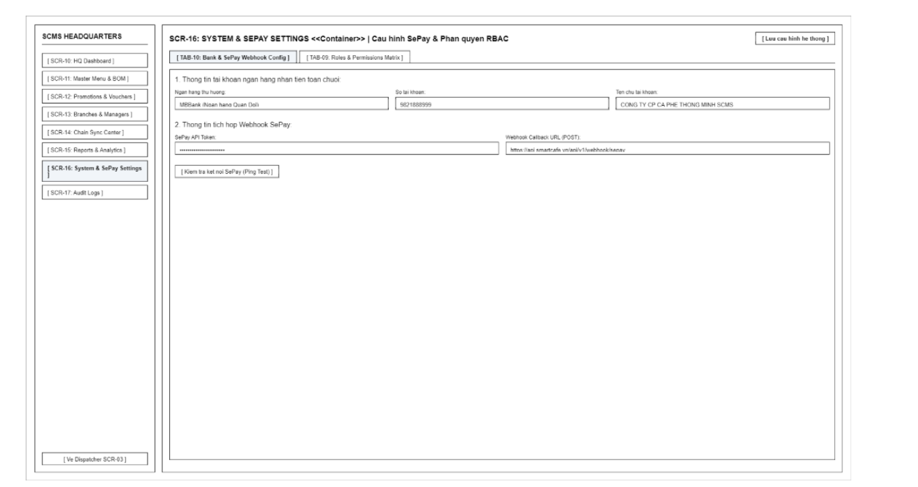
Screen Definition
# | Field Name | Type | Mandatory | Max Length | Description
1 | Save Settings | Button | - | - | Save all configuration changes to the system.
2 | Sub-Tab Switcher | Tabs | - | - | Switch between TAB-10 (SePay Configuration) and TAB-09 (RBAC Authorization Matrix).
3 | (TAB-10) Bank Name | Text | Yes | 50 | Beneficiary bank name receiving money for the entire chain (e.g., MBBank).
4 | (TAB-10) Account Number | Text | Yes | 20 | Beneficiary bank account number.
5 | (TAB-10) Account Holder | Text | Yes | 50 | Beneficiary bank account holder name.
6 | (TAB-10) SePay API Token | Password | Yes | 60 | API Token security key from the SePay account.
7 | (TAB-10) Webhook URL | Text | Yes | 120 | API Endpoint URL to receive IPN data from the SePay gateway.
8 | (TAB-10) Ping Test | Button | - | - | Send a mock packet to test the connection with the SePay Webhook.
9 | (TAB-09) RBAC Matrix Table | Table | - | - | View/Create/Edit/Delete/Approve authorization matrix table for 4 roles (Staff, Cashier, Manager, Owner).

3.8.1.2 Use Case Description
UC02 – Manage Roles & Permissions
Use Case ID |  | UC02 | Use Case Name |  | Manage Roles & Permissions
Author |  | TamDHM | Version | 1.0 | Date | 04/10/2026
Actor |  | COO
Description |  | The COO views the list of system roles and configures detailed functional permissions (e.g., read, create, update, delete) for each role. The system validates and saves the updated access control configuration across the system.
Precondition |  | PRE-01: The COO has successfully logged into the SCMS (UC01).  PRE-02: The COO has navigated to the "Role & Permission Management" screen (SCR-02).
Trigger |  | TRG-01: The COO requests to view, create, or update permissions associated with specific system roles.
Post-Condition |  | POS-01: Permission matrices for the specified roles are updated in the system database.  POS-02: Access control rules take effect immediately for all user sessions bound to the modified roles.
Main flows
Step | Actor | Action
1 | COO | Review the list of existing roles and select a specific role to manage permissions.
2 | SCMS | Display the permission matrix associated with the selected role across all system modules.
3 | COO | Modify functional permission checkboxes (e.g., Grant/Revoke access to specific features/modules).
4 | COO | Click the "Save Permissions" button.
5 | SCMS | Validate the permission changes against system security constraints.
6 | SCMS | Save the updated permission configuration to the database and display a success notification.

Alternative flows
AT1 | Permission configuration conflict or validation failure (At step 5 in the main flows)
Sub step | Actor | Action
2.1 | SCMS | Detect an invalid permission combination (e.g., revoking dependent system admin capabilities).
2.2 | SCMS | Display an error message explaining the permission policy restriction.
2.3 | SCMS | Revert unapplied permission changes and allow the COO to adjust options.

UC15 – Configure SePay Payment
Use Case ID |  | UC15 | Use Case Name |  | Configure SePay Payment
Author |  | VuNL | Version | 1.0 | Date | 04/10/2026
Actor |  | COO
Description |  | The COO configures the receiving account, Payment Reference, and Webhook. The system validates the information and saves the connection configuration.
Precondition |  | PRE-01: The COO has logged into SCMS (UC01) and accessed "System & SePay Settings" (SCR-16 - TAB-10: Bank & SePay Webhook Config).
Trigger |  | TRG-01: The COO sets up or updates the chain's central receiving bank account and SePay gateway credentials.
Post-Condition |  | POS-01: Beneficiary bank details and SePay Webhook credentials are encrypted and saved in the system configuration (BR-24, BR-28).
Main flows
Step | Actor | Action
1 | COO | Open TAB-10 (Bank & SePay Webhook Config) on screen SCR-16.
2 | COO | Enter Beneficiary Bank Name, Account Number, Account Holder Name, Payment Reference prefix (CAFE), SePay API Token, and Webhook Callback URL.
3 | COO | Click "Ping Test" to verify webhook connectivity, then click "Save Settings".
4 | SCMS | Validate mandatory fields and test authentication against the SePay gateway.
5 | SCMS | Save the payment configuration, record the change in the Audit Log (BR-51), and display a success notification.
Alternative flows
AT1 | Webhook Ping Test fails or invalid API Token (At step 4)
Sub step | Actor | Action
4.1 | SCMS | Display a connection error alert notifying the COO to verify the SePay API Token or Webhook URL before saving.

UC44 – Send Payment Webhook via SePay
Use Case ID |  | UC44 | Use Case Name |  | Send Payment Webhook via SePay
Author |  | VuNL | Version | 1.0 | Date | 04/10/2026
Actor |  | SePay
Description |  | The SePay system records a successful customer bank transfer transaction, generates a webhook, and sends the transaction code, amount, and status to the software. SCMS authenticates and automatically confirms the order as paid.
Precondition |  | PRE-01: An order with a pending QR payment exists and the QR code has been generated (UC43).  PRE-02: SePay has been configured with the webhook receiving endpoint and SCMS authentication key.
Trigger |  | TRG-01: SePay records a balance fluctuation due to a successful customer bank transfer.
Post-Condition |  | POS-01: The payment status changes to completed and the order status changes to paid.  POS-02: The webhook is logged, even if rejected.
Main flows
Step | Actor | Action
1 | SePay | Records the transaction and sends a webhook (HTTP POST) containing the transaction ID, amount, transfer description, and status to SCMS.
2 | SCMS | Authenticates the webhook signature.
3 | SCMS | Checks that the transaction ID has not been processed previously.
4 | SCMS | Extracts the order code from the transfer description and finds the corresponding pending payment.
5 | SCMS | Reconciles the received amount with the required payment amount.
6 | SCMS | Changes the payment status to completed, updates the order to paid (maximum 1 second after receiving the webhook), and logs the webhook.
7 | SCMS | Responds to SePay with a success acknowledgment and updates the Cashier screen.
Alternative flows
AT1 | At step 2, if the signature is invalid
Sub step | Actor | Action
2.1 | SCMS | Rejects the webhook, logs the event, and does not change the order status.
AT2 | At step 3, if the transaction ID has already been processed
Sub step | Actor | Action
3.1 | SCMS | Skips processing, logs it as a duplicate transaction, and responds to SePay with an acknowledgment.
AT3 | At step 4, if no corresponding order is found or the order is already paid/cancelled:
Sub step | Actor | Action
4.1 | SCMS | Logs the event for manual handling and alerts the Branch Manager (*).
AT4 | At step 5, if the amount does not match
Sub step | Actor | Action
5.1 | SCMS | Keeps the order in pending status and does not change it to paid.
5.2 | SCMS | Logs the amount discrepancy and sends an alert to the Cashier and Branch Manager.
Business Rules
# | Rule Description
BR-01 | Only automatically confirm payment when the order code, amount, and authentication signature from SePay all match (BR-29).
BR-02 | Each SePay transaction ID can only be processed once (BR-26).
BR-03 | A paid order is frozen and cannot be edited (BR-30).
BR-04 | All received webhooks must be logged, including rejected or duplicate webhooks (BR-31).

3.8.2 Audit Logs

3.8.2.1 Screen Mock-up
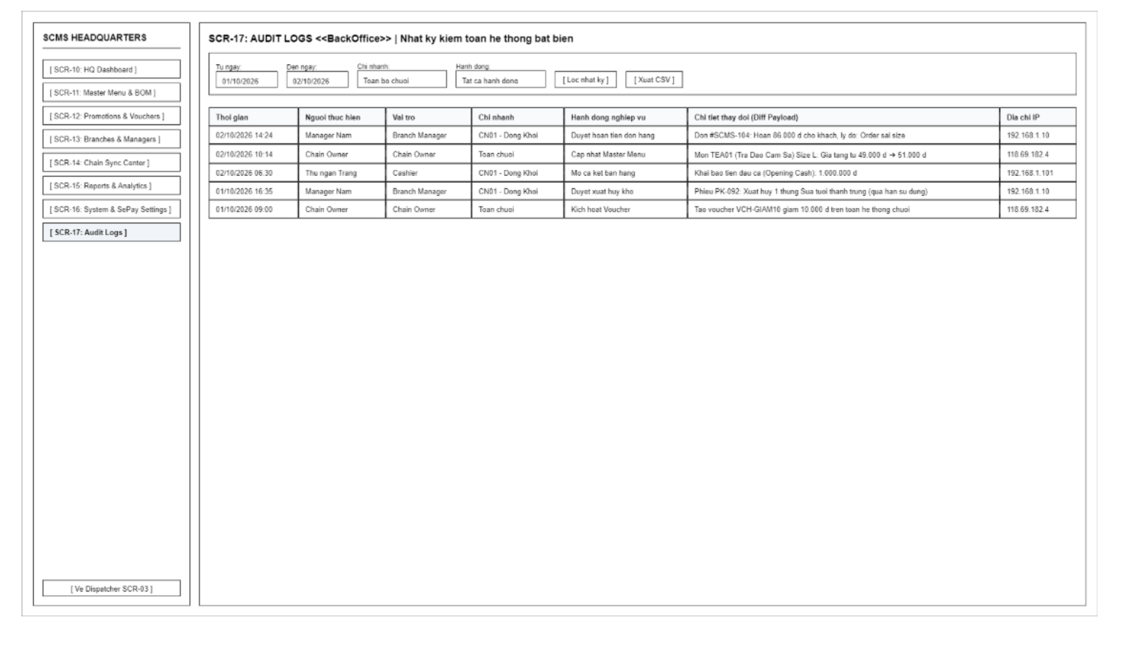
Screen Definition
# | Field Name | Type | Mandatory | Max Length | Description
1 | Date Filter | Text / Date | No | 25 | Filter audit logs by the time range the action occurred.
2 | Branch Filter | Dropdown | No | - | Filter logs by the executing branch or the entire chain.
3 | Action Type Filter | Dropdown | No | - | Filter by sensitive action type (Price adjustment, Refund approval, Order cancellation, Inventory disposal).
4 | Filter Action | Button | - | - | Apply filters to search for log records.
5 | Export CSV | Button | - | - | Export all audit log data to a CSV file.
6 | Audit Logs Table | Table | - | - | Immutable log table (Time, Actor, Role, Branch, Action, Diff Payload, IP).

4. Non-Functional Requirements
4.1 External Interfaces
This section defines the communication requirements between the Smart Cafe Management System and external hardware or service platforms.
- SePay Integration: The system must connect to the SePay Payment Gateway to receive automated payment notifications via a Payment Webhook.
- Payment Reconciliation: The system must receive and store Payment Reference Information from SePay to enable automated transaction matching.
- VietQR Integration: The system must connect to the VietQR platform to send a QR Generation Request for individual billing.
- QR Code Display: The system must successfully receive the Generated QR Code from VietQR and display it on the customer-facing screen for payment.
- Hardware Printer Communication: The system must connect to and transmit Preparation Slips directly to the Bar Thermal Printer immediately after an order is confirmed by the cashier.
4.2 Quality Attributes
4.2.1 Usability
- Cashier Interface Efficiency: The interface designed for the Cashier must be optimized for rapid operations, ensuring that the processing of Order Information, Voucher Information, and Payment Information can be completed in under 5 clicks or taps.
- Training Time: The system must be highly intuitive, ensuring that the training time for a new Staff member or Cashier to understand Login Credentials and basic operations does not exceed 2 hours.
- Management Dashboard: The interfaces for the COO and Branch Manager must present the Sales Report and Operational & Financial Reports in highly visual, easily interpretable charts.
4.2.2 Reliability
- Availability: The system must maintain a 99.5% uptime guarantee during all active shifts (Shift Information) across all cafe locations.
- NFR-REL-02 Offline operation is out of scope for v1.0. When the internet connection or the SCMS server is unavailable, the POS cannot create or pay orders. Branches follow a manual fallback procedure (using paper order slips and cash only); the Branch Manager enters the manual sales records after service is restored.
4.2.3 Performance
- Business Response Time: Core functions that calculate Price Information and retrieve Product Information on the Cashier's screen must respond in under 1 second to prevent customer service delays.
- Integration Latency: The round-trip time for a QR Generation Request sent to VietQR and its subsequent display on the screen must be completed within a maximum of 3 seconds. The internal processing within SCMS before sending the request must be under 300ms.
- Concurrent Processing Capability: The system must handle the simultaneous load of multiple Branch Managers querying the Inventory Report or Attendance Report at the end of the day without degrading the performance of active cashier counters.
4.2.4 Security & Authorization
- Transmission Security: All sensitive data flows—especially Login Credentials, Payment Information, and Operational & Financial Reports—must be strictly encrypted over the network.
- Role-Based Access Control: The system must strictly enforce information access rights through configured Permission Information.
- Chain-Level Data Restrictions: Only the designated COO is authorized to view or modify the Branch Configuration and access aggregate data across all branches.
- Internal Branch Authority: The Branch Manager is restricted to managing Cash In / Out Information and viewing Employee Information strictly within their assigned branch.

5. Requirement Appendix

5.1 Business Rules

ID | Rule Definition
BR-01 | Users must be authenticated with valid credentials before accessing the system; sessions must be strictly limited based on the assigned role and data scope.
BR-02 | The COO is the only role authorized to set up the role matrix and configure functional permissions across the entire system.
BR-03 | Branch Managers are strictly prohibited from self-approving their own attendance data, working hours adjustments, bonuses/deductions, or payrolls (All such approvals must be performed by the COO).
BR-04 | Operational data must be strictly isolated by branch: Branch Managers and Cashiers are only allowed to access data belonging to their assigned branch. Cross-branch data access is exclusively reserved for the COO role.
BR-05 | Each RFID/NFC card can only be linked to one active employee at a time; the system strictly prohibits assigning the same card to multiple employees.
BR-06 | A valid card swipe at the reader must automatically record a Check-in if it is the first attendance of the shift/day, or automatically record a Check-out if a Check-in already exists for that shift.
BR-07 | The time interval between a valid Check-in and Check-out for the same employee must be at least 15 minutes to prevent accidental duplicate card swipes.
BR-08 | In case of a forgotten/lost card or a broken reader, employees are allowed a fallback attendance method by selecting their name and entering a 4-digit personal PIN on the Kiosk screen.
BR-09 | If an employee has Checked-in but fails to Check-out after 14 hours, the system automatically flags a 'Forgot Check-out' warning and suspends payroll calculation for that shift. To include the shift in payroll, the Branch Manager must access Attendance Logs (SCR-09 TAB-04), enter the verified departure time with mandatory justification notes, and unlock the record to ADJUSTED status prior to payroll period finalization.
BR-10 | Only Branch Managers have the authority to adjust the Check-in/Check-out times of their subordinate employees, and a reason must be recorded for every adjustment.
BR-11 | The COO is the only role authorized to create, edit information, or deactivate branches within the chain.
BR-12 | A Branch Manager account belongs to one branch. Only the COO can reassign it; the change is written to the Audit Log and historical data stays with the original branch.
BR-13 | Hard deleting employee profiles is strictly prohibited. Accounts of terminated employees must only be switched to an Inactive state to preserve attendance, order, and payroll history.
BR-14 | When a Branch Manager updates the hourly wage rate, the new rate will only take effect for work shifts occurring after the modification time.
BR-15 | The system must prevent the assignment of overlapping work schedules or duplicate shifts for the same employee on the same day.
BR-16 | The menu categories and product information across the entire system must be centrally managed by the COO; branches are not allowed to arbitrarily add or remove menu items.
BR-17 | Any product with an Unavailable status must be automatically disabled on the POS interface and cannot be added to new orders.
BR-18 | Selling prices based on specifications (size, toppings) must be centrally managed by the COO; branches are not allowed to arbitrarily change selling prices.
BR-19 | The standard bill of materials (BOM/Recipe) for each item must be centrally issued by the COO to serve as a basis for calculating Cost of Goods Sold (COGS) and reconciling loss.
BR-20 | Promotion policies and vouchers (duration, minimum order value, applicable categories) must be centrally managed by the COO.
BR-21 | A maximum of one discount program/voucher can be applied per order. The final total payment amount of the order must not be less than 0 VND.
BR-22 | Cashiers are only allowed to apply discounts/vouchers to an order when the order fully satisfies all constraint conditions of the program.
BR-23 | Changes to the master menu, selling prices, standard recipes and promotions take effect at branches only after the COO publishes them (UC14). Each publish creates a numbered version and a publish record per target branch. Orders created before the effective time keep the prices stored on the order.
BR-24 | All bank transfer payments must be routed directly to the official chain bank account configured by the COO (not to personal accounts).
BR-25 | Cashiers creating orders at the counter must record all attributes: product, quantity, size, toppings, sugar/ice levels, and preparation notes.
BR-26 | Once an order has transitioned to the PAID status, the system strictly prohibits any operations to edit items, change size/toppings, apply promotions, or directly cancel the order (Order data freeze). Any cancellation of a PAID order must follow the official Refund process (UC23) with Branch Manager PIN authorization (BR-32).
BR-26b | Cancellation of Unpaid (Pending) Orders: Cashiers are authorized to cancel orders in PENDING status directly from the POS screen (SCR-04) or Order Details (SCR-06) if the customer changes their mind or payment times out. The Cashier must select a mandatory cancellation reason (Customer mind change, Order error, Payment timeout). The system updates order status to CANCELLED and logs the action to Audit Log (BR-51). No cash drawer transaction is created.
BR-27 | All cash collected from customers at the counter must be instantly recorded in the sales revenue of the current Cashier's shift.
BR-28 | The generated dynamic VietQR code must contain the exact chain bank account number, the order amount, and the payment description formatted as CAFE.
BR-29 | The system will only automatically transition an order to the PAID status upon receiving a SePay Webhook that exactly matches all of the following: Order ID, Transaction Amount, and Authentication Signature.
BR-30 | If the amount transferred by the customer via SePay does not match the total order amount, the system must retain the Pending Payment status and issue a reconciliation alert.
BR-31 | Bar preparation slips and customer payment receipts are only allowed to print automatically after the order has successfully transitioned to the PAID status.
BR-32 | Sensitive counter operations (refund, cash-in, cash-out, shift-close variance above tolerance) follow a two-person rule: the Cashier initiates the request with a mandatory reason, and a Branch Manager approves it by entering their own PIN on the counter terminal (POP-03 or SCR-06 TAB-02). If the amount exceeds the threshold configured for the Branch Manager (BR-35), the request also requires COO approval via system management (SCR-16).
BR-33 | All refunds are always paid in cash from the drawer (even if the customer originally paid via QR code/bank transfer).
BR-34 | The refund amount to the customer must be automatically deducted from the cash drawer balance during the current work shift.
BR-35 | Refund amounts exceeding the Branch Manager's approval threshold limit must be approved by the COO.
BR-36 | A sales shift is only allowed to start after a Cashier or Branch Manager has performed the Open Shift operation and declared the starting cash amount in the drawer.
BR-37 | Cash-in and cash-out transactions during a shift are initiated by the Cashier, require a business reason, and are approved by the Branch Manager (BR-32). A transaction initiated by a Branch Manager is recorded immediately, flagged "self-initiated", and listed for COO review.
BR-38 | During Close Shift, the responsible personnel must enter the physically counted cash amount. If there is a discrepancy with the theoretical balance, an explanatory reason must be provided.
BR-39 | The theoretical end-of-shift cash balance must be calculated using the formula: Starting Cash + Cash Revenue from PAID orders + Cash In - Cash Out - Customer Refunds.
BR-40 | Goods received at the branch must be managed by large packaging units (cartons, bags, boxes, kg) and fully record the quantity and import cost to increase inventory.
BR-41 | Raw materials are only deducted from branch inventory when issued to the Bar counter in intact large packaging units. The system does not deduct branch inventory in fractional amounts per cup sold.
BR-42 | The quantity of raw materials issued to the bar or declared for disposal must not exceed the currently available inventory quantity in the branch warehouse.
BR-43 | All disposal transactions for damaged, expired, or broken raw materials must include a specific disposal reason.
BR-44 | After completing a periodic inventory count, the system must automatically update the book inventory balance according to the physical count and log the inventory discrepancy record.
BR-45 | When the inventory quantity of a raw material drops to or below the Safety Stock level, the system must automatically issue an out-of-stock alert to the Branch Manager.
BR-46 | The system must provide a Dashboard and detailed Sales Reports over time for the Branch Manager to track revenue and order volumes.
BR-47 | The system must provide in-depth branch-level reports: Cash Drawer Flow Report (over/short reconciliation), Inventory In-Out-Balance Report, and Employee Working Hours Report.
BR-48 | Revenue data, Cost of Goods Sold (COGS), and gross profit must be automatically consolidated from all branches to provide real-time chain-wide Financial Reports for the COO.
BR-49 | The system must analyze sales data to provide the COO with a list of Best-sellers and order density during Peak hours.
BR-50 | All financial and operational report forms must allow export to Excel format for independent storage and reconciliation.
BR-51 | All sensitive business operations (price edits, order cancellations, refunds, cash in/out, working hours adjustments, inventory adjustments) must be automatically recorded in the Audit Log and cannot be modified or deleted.
BR-52 | Ingredient shrinkage for a period = Quantity issued to bar (base units) - Theoretical consumption (SUM of BOM quantity x quantity sold of PAID orders, excluding fully refunded orders). A positive result is reported as shrinkage.
BR-53 | Branch Payroll Period & Approval Lifecycle: Branch Managers organize payroll by defined Pay Periods (start_date to end_date). Net salary is computed: Net = (Total Valid Hours x Hourly Wage Rate) + Bonuses - Deductions. All shifts must have valid check-out (or unlocked via BR-09). Branch Managers submit the finalized payroll period to the COO (status SUBMITTED). The COO reviews timesheets, bonuses, and penalties to Approve (status APPROVED) or Reject with notes. Exporting the approved payroll generates official disbursement reports and marks the period as PAID.

5.2 Common Requirements
5.2.1 General User Interface (UI/UX) Requirements
- UI Consistency:
  - All screens must adhere to the system's color palette and standard Design System:
    - Navigation Bar (Sidebar/Header): Dark Primary theme containing user profile, current branch information, and logout button.
    - Primary Action Buttons: Coffee Orange/Brown (Accent Color) used for confirmation, payment, and data saving actions.
    - Status Indicators: Red (Danger/Cancel/Out of Stock/Failed), Green (Success/Paid/In Stock), Yellow/Orange (Warning/Pending).
  - Standard Font: Clear, sans-serif font with full support for Vietnamese diacritics.
- Device & Role-Specific Layouts:
  - POS & Kiosk Interfaces (SCR-01, SCR-02, SCR-04): Optimized for 10-inch to 15.6-inch touchscreens. Item selection buttons, size/sugar/ice options, and the numeric keypad (Numpad) must have large touch targets (minimum 44x44 px) for fast manual operation.
  - Admin Interface (Dashboard & Portal): Optimized for desktop web browsers (Desktop Screen Resolution 1920x1080 or higher) with detailed tables, charts, and permission matrices.
- Quick Operations & Shortcuts at POS:
  - Support physical keyboard shortcuts for Cashiers at the sales counter (SCR-04):
    - F1: Quick search for items/beverages.
    - F8: Apply Discount Code / Voucher.
    - F9: Open payment window (POP-01).
    - F10: Confirm cash payment.
    - Esc: Close/Cancel currently open Pop-ups/Modals.
5.2.2 Data Formatting & Localization Standards
- Currency Formatting:
  - Default currency is Vietnamese Dong (VND).
  - Monetary amounts must use a dot (.) as thousands separators and include the currency symbol (e.g., 45.000 VNĐ).
  - No decimal places are used for VND amounts.
- Date & Time Formatting:
  - Date: DD/MM/YYYY (e.g., 04/10/2026).
  - Time: HH:mm:ss (24-hour format) (e.g., 14:30:00).
  - Combined Date & Time: DD/MM/YYYY HH:mm:ss (e.g., 04/10/2026 14:30:00).
- Quantity & Unit Formatting:
  - Retail item quantity/orders: Positive integers (e.g., 1, 2, 5).
  - Raw materials/Inventory (BOM): Up to 2–3 decimal places allowed using a comma (,) or dot (.) consistently (e.g., 0.02 kg Arabica, 0.03 Liters milk).
5.2.3 Common Validation & Error Handling
- Mandatory Fields:
  - All data fields marked as Mandatory: Yes in the Screen Definition table must display a red asterisk (*).
  - If left blank upon submission, the system must focus on the first missing field and immediately display an error message below it: [Field Name] cannot be left blank.
- Input Validation:
  - Phone Number: Only numeric digits allowed, 10–11 characters long, starting with 0.
  - Timekeeping PIN: exactly 4 digits, unique within the branch, stored hashed. After 5 consecutive wrong PIN entries for the same employee the kiosk blocks that employee for 5 minutes.
  - Amount / Price / Inventory: Only positive integers/floats allowed ($≥0$). Negative numbers are not permitted except for valid inventory write-off/adjustment cases.
- Confirmation Modals for Critical Actions:
  - Actions involving cancellations or sensitive data modifications (Order Cancellation, Refunds, Employee Deletion, Inventory Write-offs, Price/BOM Updates) must trigger a Confirmation Pop-up with a "Cancel" button and a red "Confirm" button.
5.2.4 Table, Pagination & Search Requirements
- Grid/Table View:
  - Support fixed table headers (Fixed Table Header) when scrolling through long lists.
  - Display a clean "Empty State" with an appropriate placeholder image when a list is empty or search filters yield no results.
- Pagination:
  - Apply pagination across all list screens (Order History, Timekeeping Logs, Inventory, Audit Logs).
  - Default items per page: 10, 25, 50, or 100 rows.
  - Display total record count and current page position (e.g., Showing 1-10 of 245 records).
- Filter & Search Behavior:
  - Live Search: Automatically filter results in real-time (with a 300ms debounce delay) as the user types into the search box.
  - Filter Persistence: Retain selected filter parameters (Time range, Status, Branch) when users navigate away and return to the previous screen.
5.2.5 Audit Logging & Security Baseline
- Automatic Audit Trail:
  - Every Create, Edit, Delete, Cancel, Refund, Approval, Configuration Sync, and Login/Logout action must be automatically logged into the system's Audit Log table (SCR-17).
  - Required captured details: Timestamp, User ID, Role, IP Address, Branch, Action, and Data Before/After Change (Diff payload).
- Session Control & RBAC Baseline:
  - Automatic session timeout after 30 minutes of inactivity on Manager/COO screens.
  - If a user attempts to access a URL or function outside their role permissions, the system blocks access and redirects to the Role Dispatcher screen (SCR-03) with the message: You do not have permission to access this function.

5.3 Application Messages List
# | Message code | Message Type | Context | Content
1 | MSG01 | In line | There is not any search result | No search results.
2 | MSG02 | In red, under the text box | Input-required fields are empty | The * field is required.
3 | MSG03 | Toast message | Updating asset(s) information successfully | Update asset(s) successfully.
4 | MSG04 | Toast message | Adding new asset successfully | Add asset successfully.
5 | MSG05 | Toast message | Confirming email of asset hand-over is sent successfully | A confirmation email has been sent to {email_address}.
6 | MSG06 | Toast message | Resetting asset information successfully | Return asset(s) successfully.
7 | MSG07 | Toast message | Deleting asset information successfully | Delete asset(s) successfully.
8 | MSG08 | In red, under the text box | Input value length > max length | Exceed max length of {max_length}.
9 | MSG09 | In line | Username or password is not correct when clicking sign-in | Incorrrect user name or password. Please check again.

6. Business Process

6.1. Order process
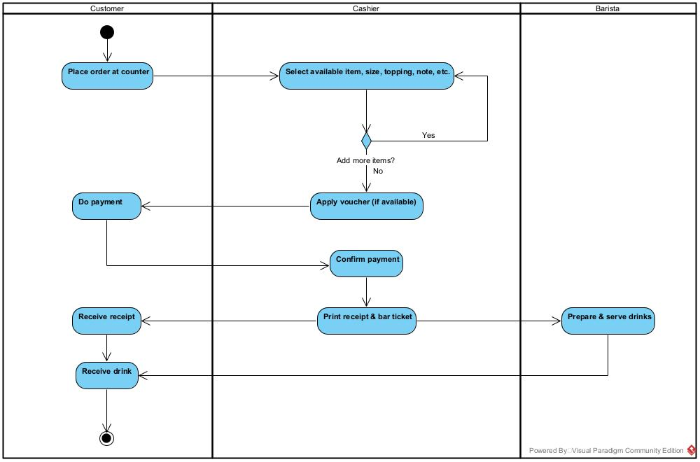

6.2. Chain set up process

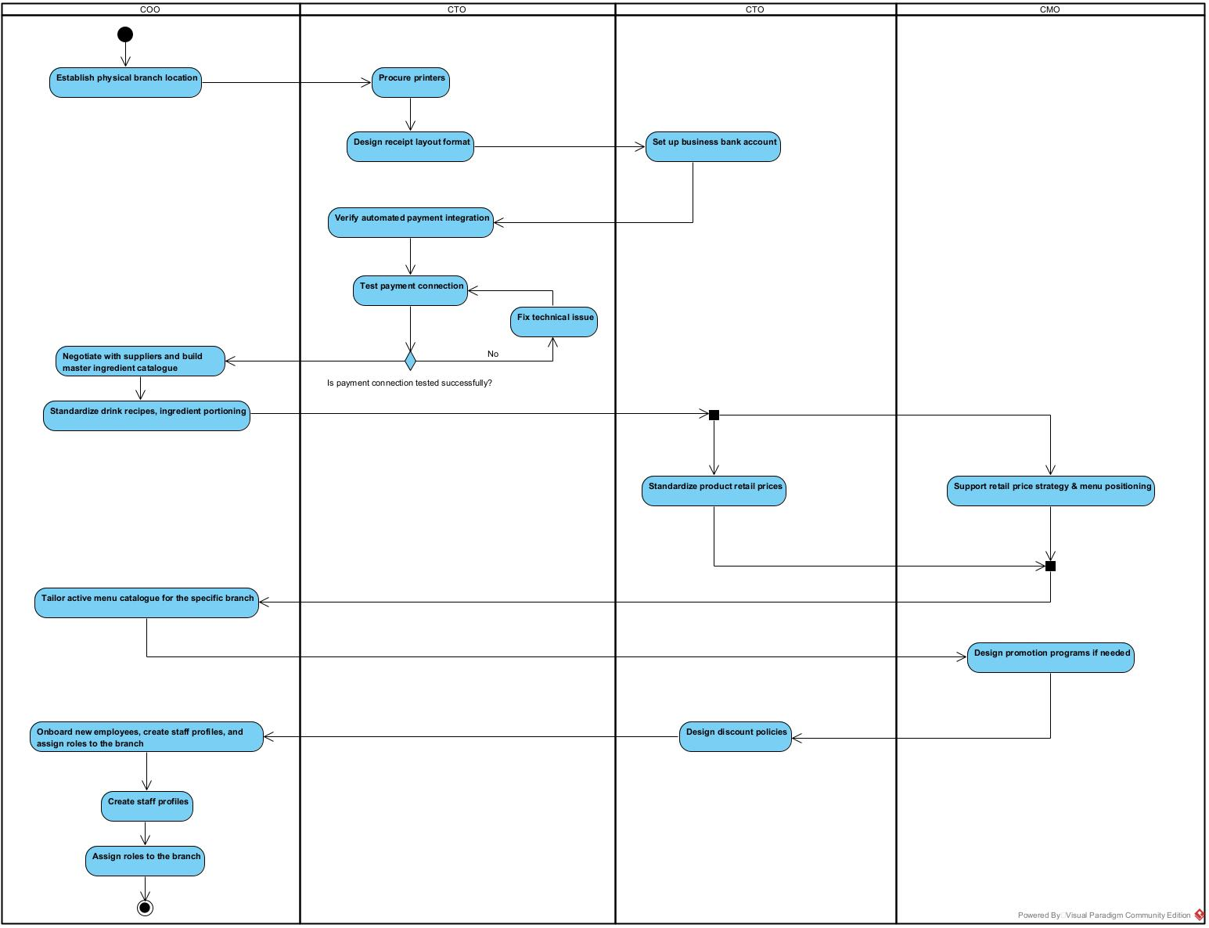

6.3. Cash shift handover
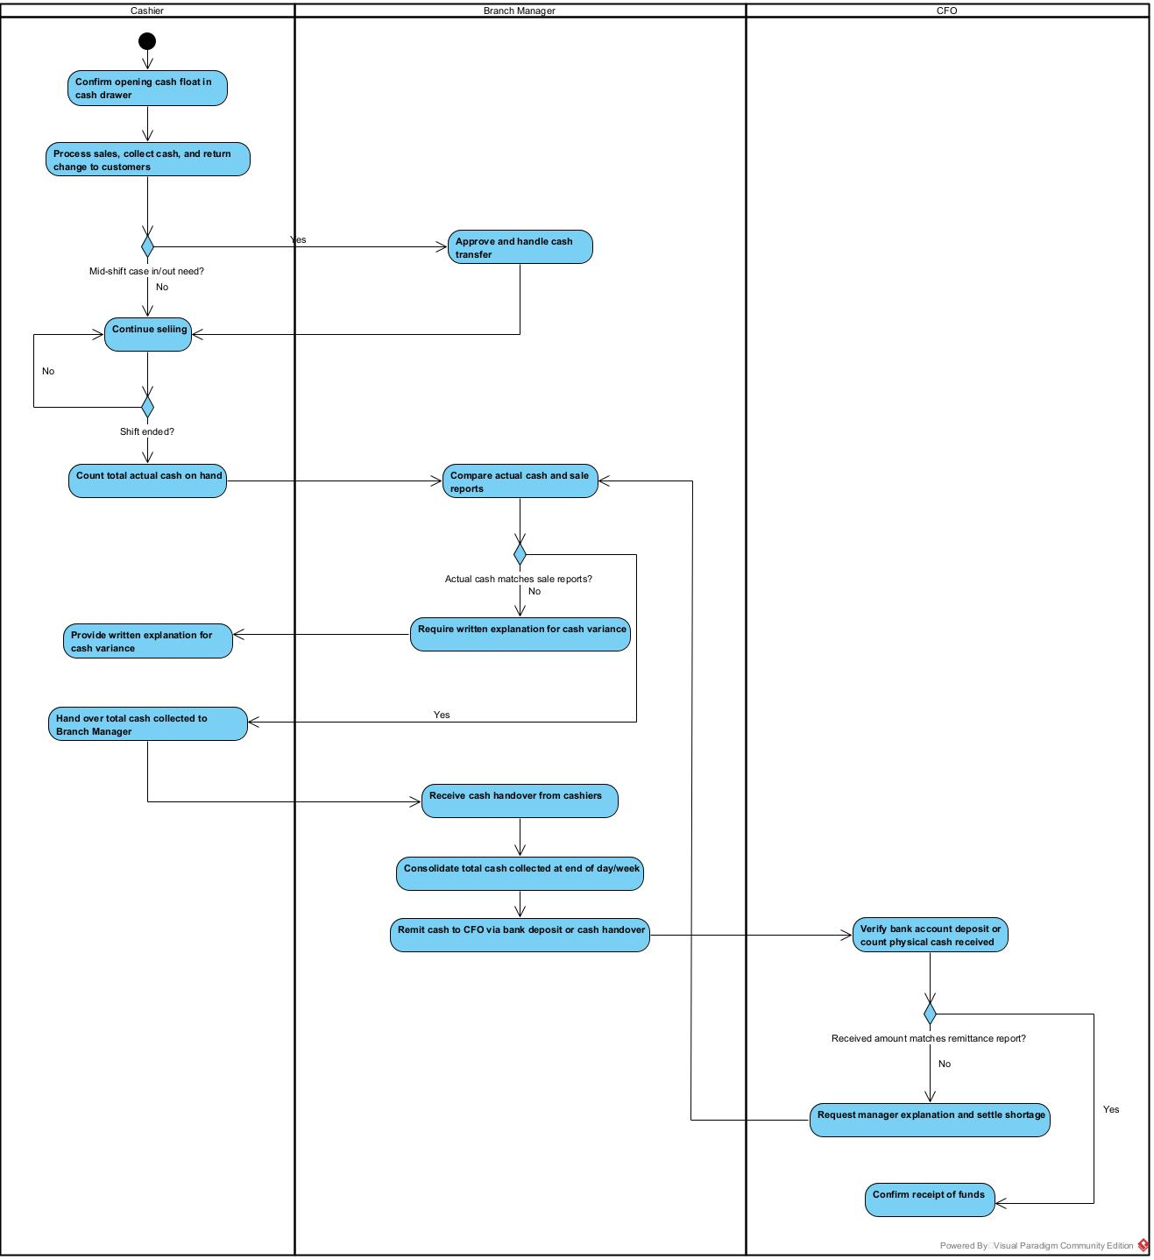

6.4. Attendance to payroll


