CFD ANALYSIS REPORT
Flow Conditioner Performance in Disturbed Pipe Flow
Complete Product Development Pipeline
3D Design → CFD Analysis → Mold Flow Simulation → Mold Design → Manufacturing Drawings → Production

Document Title | CFD Analysis of Flow Conditioner Performance in Disturbed Pipe Flow
Component | Vaned Flow Conditioner (Original Custom Design)
Fluid | Water (incompressible, Newtonian)
Flow Rate | 6.3 m³/hr
Turbulence Model | k-ω SST
CFD Solver | ANSYS Fluent 2021 R2
CAD Software | CATIA V5
Mesh Elements | 549,408 tetrahedral elements | 106,651 nodes
Analysis Type | Steady-state, turbulent, incompressible — with/without flow conditioner
Report Date | March 2026
Document Status | For Mold Flow & Manufacturing Reference

Table of Contents
1. Product Development Pipeline 1
2. Introduction 1
3. Objectives 1
4. System Description 1
4.1 Pipeline Geometry 1
4.2 Flow Conditions 1
5. Software & Meshing Strategy 1
5.1 Software Environment 1
5.2 Mesh Details 1
6. Pressure Contour Results 1
6.1 Case 1 — With Flow Conditioner 1
Pressure Analysis — With Flow Conditioner: 1
Pressure Analysis — Without Flow Conditioner: 1
7. Velocity Profile Results 1
7.1 1D Downstream 1
Observations: 1
7.2 5D Downstream 1
Observations: 1
7.3 10D Downstream 1
Observations: 1
7.4 15D Downstream 1
Observations: 1
8. Engineering Analysis 1
8.1 Sources of Flow Disturbance 1
8.2 How the Flow Conditioner Works 1
8.3 Performance Quantification 1
9. Consolidated Results Summary 1
10. Conclusions 1
10.1 Key Findings 1
10.2 Design Validation 1
10.3 Next Steps — Phase 4: Mold Design 1

1. Product Development Pipeline
This CFD report is Phase 2 of a complete product development workflow for the Vaned Flow Conditioner — an original custom engineering design. The component was first modelled in CATIA V5, numerically validated through this CFD study using ANSYS Fluent, and is now progressing toward injection mold design and manufacturing.

Phase | Activity | Output | Status
Phase 1 | Concept & 3D Modelling | CATIA V5 — full 3D geometry of flow conditioner | Complete
Phase 2 | CFD Analysis | Pressure drop, velocity profiles, flow uniformity | Current Phase
Phase 3 | Mold Flow Simulation | Fill time, temperature, pressure, air traps, weld lines | Planned
Phase 4 | Mold Design | Core/cavity, runner, cooling, ejector layout | Planned
Phase 5 | Manufacturing Drawings | 2D part drawings, mold assembly drawings | Planned

The CFD results in this report serve two purposes: (1) they validate the hydraulic performance of the flow conditioner design — confirming that it achieves the intended flow straightening function — and (2) they provide the engineering basis for material selection and geometry finalization before mold flow simulation and mold design.

2. Introduction
Flow conditioners are widely used in industrial pipelines to stabilize distorted velocity profiles caused by upstream fittings such as elbows, reducers, and valves. Stabilizing the velocity profile is critical for improving the accuracy of downstream flow measurement devices — including ultrasonic flowmeters, differential-pressure meters, and Coriolis meters — and for ensuring consistent process control.

In this study, a numerical (CFD) investigation is carried out to evaluate the performance of the custom-designed Vaned Flow Conditioner installed downstream of a 90° elbow and a concentric reducer in a water pipeline. Two configurations are compared:
- Case 1 — With Flow Conditioner: The vaned conditioner is installed immediately after the reducer in the 25 mm pipe section.
- Case 2 — Without Flow Conditioner: The baseline configuration with no conditioner — only the elbow, reducer, and straight pipe sections.

The analysis quantifies the trade-off between the additional pressure loss introduced by the conditioner and the improvement in velocity profile quality at downstream measurement locations (1D, 5D, 10D, and 15D pipe diameters downstream).

3. Objectives
The primary objective is to numerically evaluate the effect of the Vaned Flow Conditioner on flow stabilization in a disturbed pipeline section containing a 90° elbow and a concentric reducer. The specific objectives are:
- To compare total pressure loss and velocity profile distribution between inlet and outlet for both configurations — with and without the flow conditioner.
- To analyze the evolution of velocity profiles at 1D, 5D, 10D, and 15D downstream of the flow conditioner (or equivalent locations for the baseline).
- To assess the ability of the flow conditioner to reduce swirl, straighten the flow, and improve velocity profile symmetry in the downstream pipe.
- To establish the pressure drop penalty versus flow quality improvement trade-off — the key performance metric for flow conditioner selection in measurement applications.
- To provide validated CFD data as input for the mold flow simulation (Phase 3) and final manufacturing design.

4. System Description

4.1 Pipeline Geometry
The computational domain represents a water pipeline with a vertical inlet section, a 90° elbow, a concentric reducer, and a downstream straight measurement section where the flow conditioner is installed.

Inlet Pipe Diameter | 50 mm (vertical)
Inlet Pipe Length | 500 mm
Elbow Type | 90° standard elbow
Straight Section (post-elbow) | 250 mm (50 mm pipe)
Reducer Type | Concentric reducer — 50 mm → 25 mm
Downstream Pipe Diameter | 25 mm (flow conditioner section)
Downstream Pipe Length | 500 mm (measurement section)
Flow Conditioner Location | 25 mm pipe section, immediately after reducer
Flow Conditioner Design | Multi-vane passages — original custom geometry (CATIA V5)

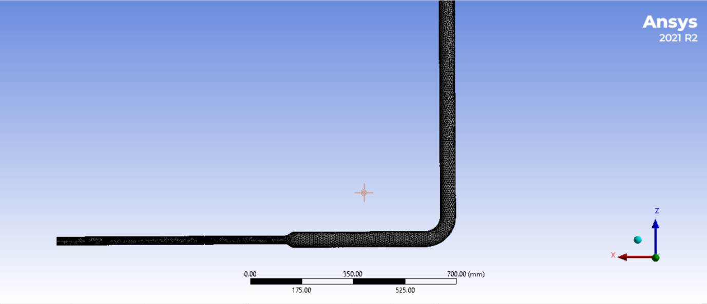
Figure 1 – Pipeline geometry: vertical inlet, 90° elbow, concentric reducer, and downstream measurement section with flow conditioner

4.2 Flow Conditions
Working Fluid | Water (incompressible, Newtonian)
Volumetric Flow Rate | 6.3 m³/hr
Flow Regime | Turbulent
Turbulence Model | k-ω SST (Shear Stress Transport)
Analysis Type | Steady-state simulation
Inlet BC | Specified volumetric flow rate — 6.3 m³/hr
Outlet BC | Pressure outlet — gauge pressure = 0 Pa
Wall BC | No-slip condition on all solid surfaces

The k-ω SST turbulence model was selected for its well-established accuracy in predicting turbulent flows with adverse pressure gradients, flow separation, and swirl — all of which are present in this pipeline configuration downstream of the elbow and reducer.

5. Software & Meshing Strategy

5.1 Software Environment
CAD Modelling | CATIA V5 — geometry creation for pipeline and flow conditioner
CFD Pre-processor | ANSYS Meshing (ANSYS 2021 R2)
CFD Solver | ANSYS Fluent 2021 R2
Turbulence Model | k-ω SST
Solution Type | Pressure-based, steady-state, incompressible RANS

5.2 Mesh Details
Global Element Size | 10 mm
Element Shape | Tetrahedron (unstructured)
Number of Elements | 549,408
Number of Nodes | 106,651
Local Refinement | Elbow, reducer, and flow conditioner sections — finer mesh to capture strong gradients
Boundary Layer | Inflation (prism) layers along pipe and conditioner walls
Boundary Layer Purpose | Resolve near-wall boundary layer — accurate wall shear stress and pressure drop prediction

The mesh strategy balances computational efficiency and accuracy. The tetrahedral unstructured mesh with local refinement in critical regions (elbow, reducer, conditioner) ensures that strong velocity gradients, secondary flows, and swirl structures are adequately resolved. The inflation layers at all solid walls satisfy the y+ requirements of the k-ω SST model.

6. Pressure Contour Results
Pressure contour results are presented for both configurations — with and without the flow conditioner. The pressure drop across the system is the primary quantitative performance metric for evaluating the hydraulic cost of installing the flow conditioner.

6.1 Case 1 — With Flow Conditioner
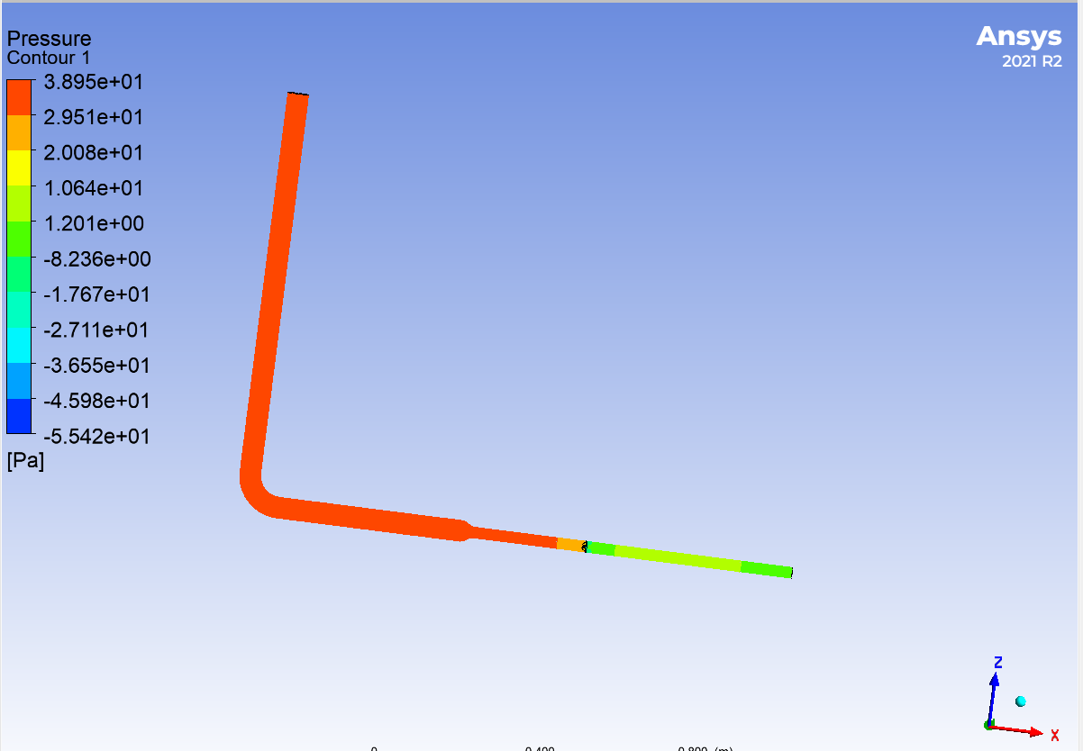 | 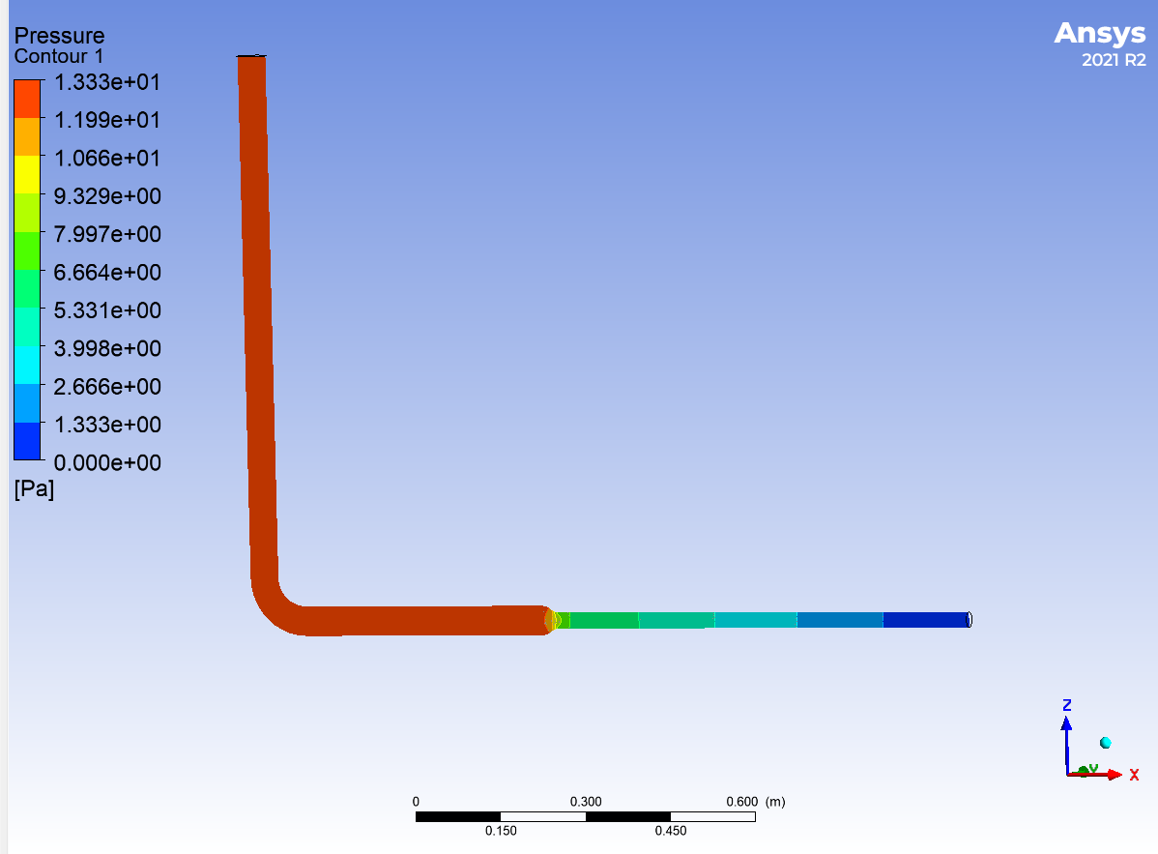
Figure 2 – Pressure contour: With flow conditioner (Inlet = 38.5 Pa, Outlet = 0.07 Pa) | Figure 3 – Pressure contour: Without flow conditioner (Inlet = 13.3 Pa, Outlet = 0.07 Pa)

Pressure Analysis — With Flow Conditioner:
Inlet Pressure | 38.5 Pa
Outlet Pressure | 0.07 Pa
Pressure Loss (Elbow + Reducer) | 13.23 Pa
Pressure Loss due to Flow Conditioner | 38.5 − 0.07 − 13.23 = 25.2 Pa
Total System Pressure Drop | 38.43 Pa
Key Observation | Significant pressure decrease across flow conditioner — consistent with increased hydraulic resistance of multi-vane passages

Pressure Analysis — Without Flow Conditioner:
Inlet Pressure | 13.3 Pa
Outlet Pressure | 0.07 Pa
Total Pressure Loss | 13.3 − 0.07 = 13.23 Pa
Pressure Loss Attribution | Combined effects of 90° elbow, concentric reducer, and internal pipe friction
Key Observation | Smoother downstream pressure gradient; strong acceleration visible after reducer; no conditioner resistance

The flow conditioner introduces an additional 25.2 Pa of pressure loss — approximately 1.9× the baseline elbow-reducer loss. This represents the hydraulic penalty for achieving improved flow profile quality at downstream measurement locations.

7. Velocity Profile Results
Velocity profiles were extracted at four downstream cross-sections: 1D, 5D, 10D, and 15D pipe diameters downstream of the flow conditioner (or equivalent locations in the baseline case). These results quantify the spatial evolution of the velocity field and directly demonstrate the flow conditioner's effectiveness in recovering a symmetric, uniform velocity distribution.

7.1 1D Downstream
At 1D downstream, the flow is strongly influenced by upstream disturbances in both cases. The conditioner has just redistributed the flow through its vane passages, and the downstream profile is still developing.

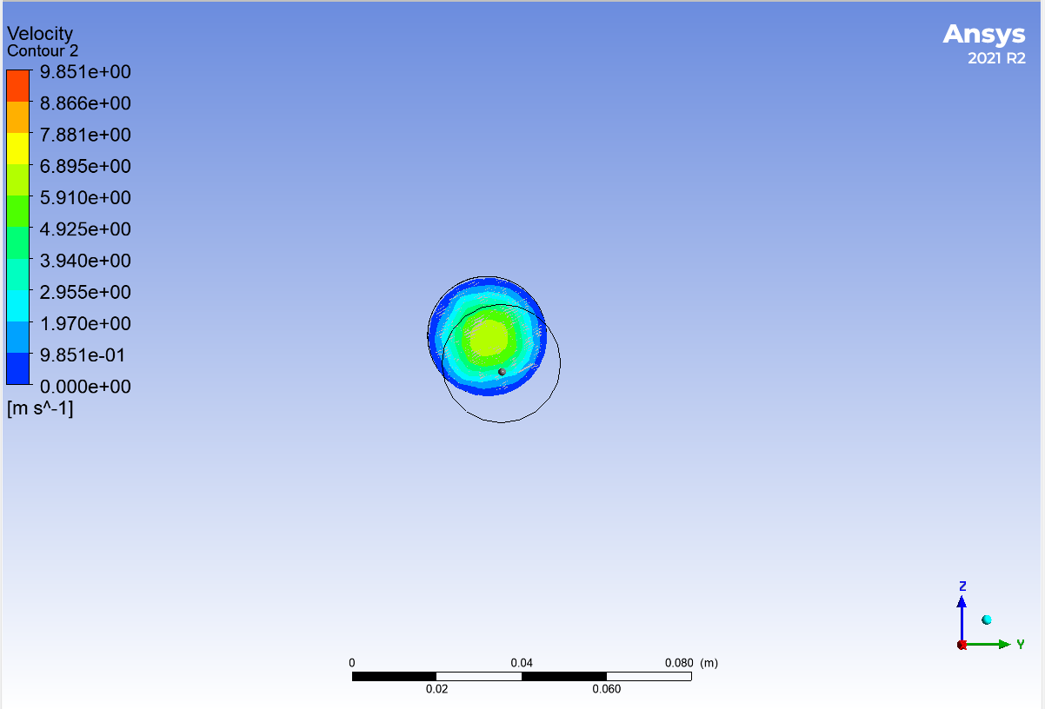 | 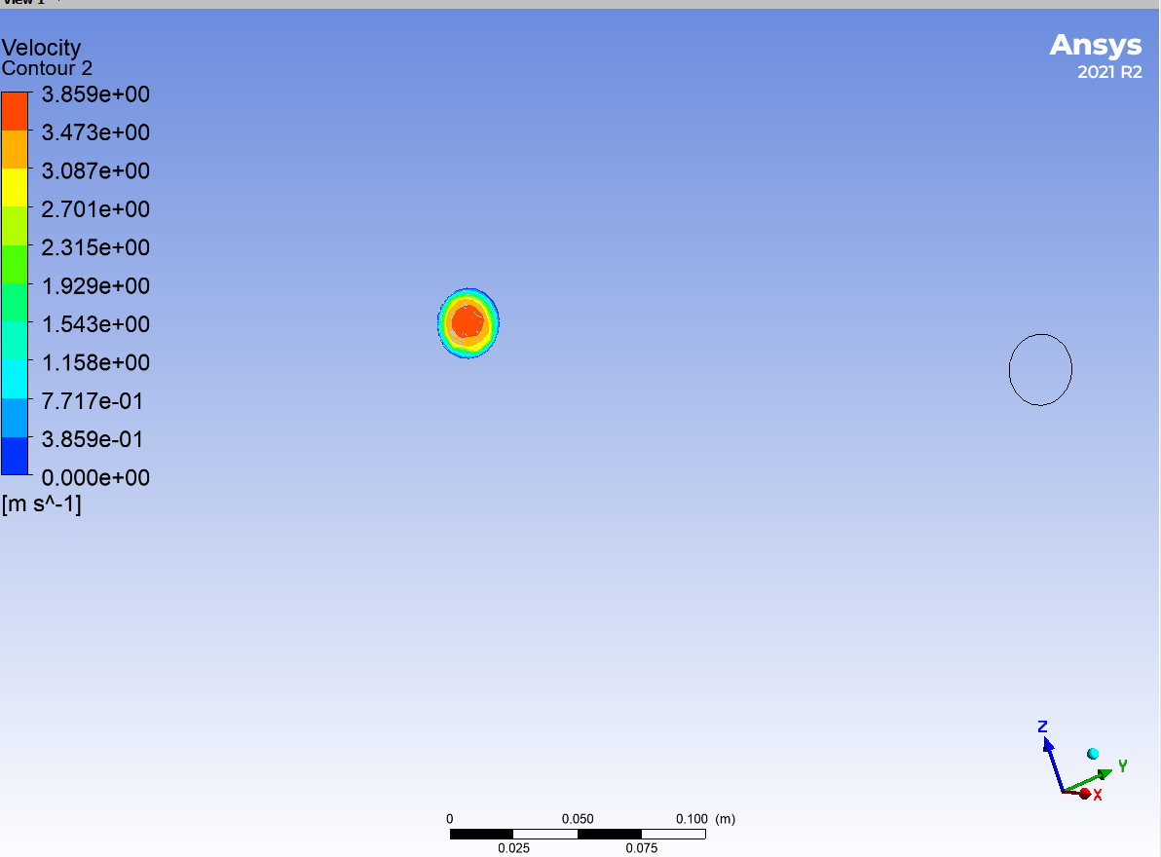
Figure 4 – Velocity profile at 1D downstream: With flow conditioner | Figure 5 – Velocity profile at 1D downstream: Without flow conditioner

Observations:
- With conditioner: The profile already shows a more uniform core velocity with individual jet structures from the vane passages beginning to merge. The peak velocity is distributed across multiple channels rather than concentrated in one zone.
- Without conditioner: Highly skewed and asymmetric profile, dominated by the swirl and momentum imbalance from the 90° elbow and the flow acceleration through the reducer. A high-velocity zone is concentrated on one side of the pipe cross-section.
- At this early downstream location, the conditioner's redistributing effect is already visible, though full profile development requires additional pipe length.

7.2 5D Downstream
At 5D downstream, significant differences between the two configurations are visible. The vane passages have had sufficient distance to promote mixing and lateral momentum redistribution.

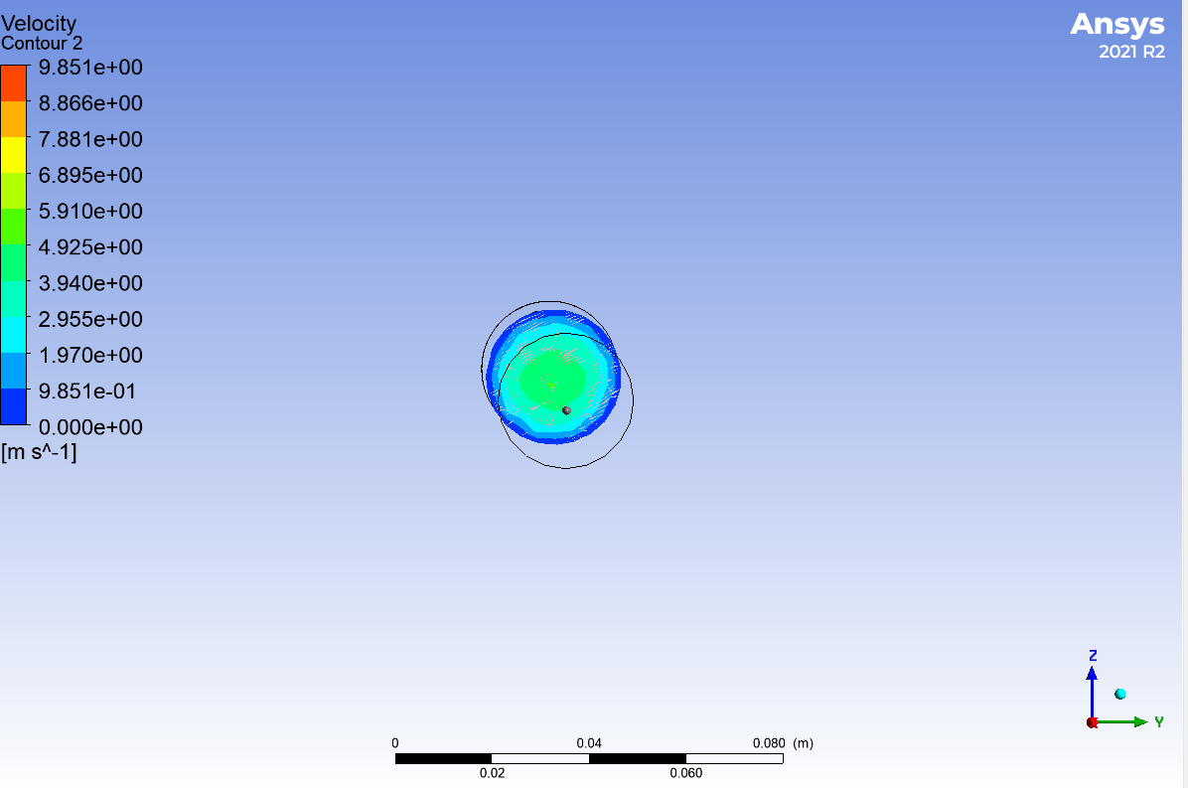 | 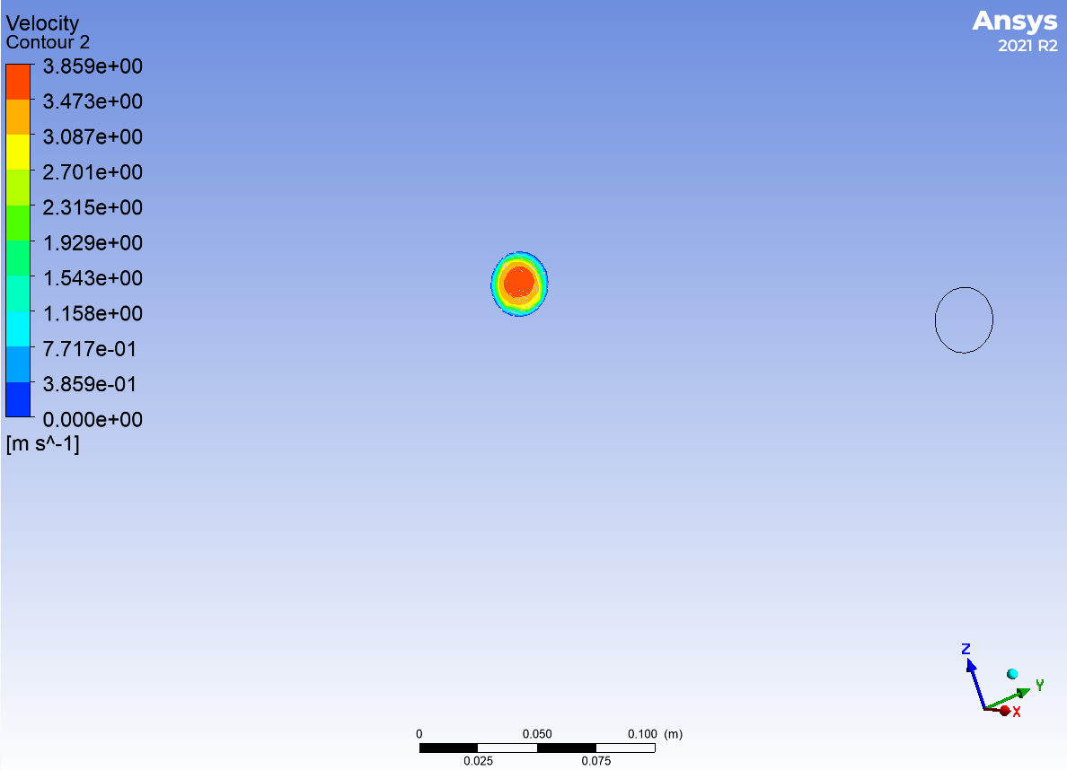
Figure 6 – Velocity profile at 5D downstream: With flow conditioner | Figure 7 – Velocity profile at 5D downstream: Without flow conditioner

Observations:
- With conditioner: The velocity profile becomes significantly more symmetric, with reduced peak velocities and a more uniform distribution across the cross-section. Swirl structures have been substantially suppressed.
- Without conditioner: The profile remains distorted with a noticeable high-velocity region on one side and lower velocities near certain pipe wall zones, confirming persistent swirl and secondary flows from the elbow.
- The 5D location shows the conditioner delivering meaningful flow quality improvement — this is typically a critical distance for flowmeter installation requirements.

7.3 10D Downstream
By 10D downstream, the flow conditioner case has produced a near-developed velocity profile, while the baseline case continues to show significant residual distortion.

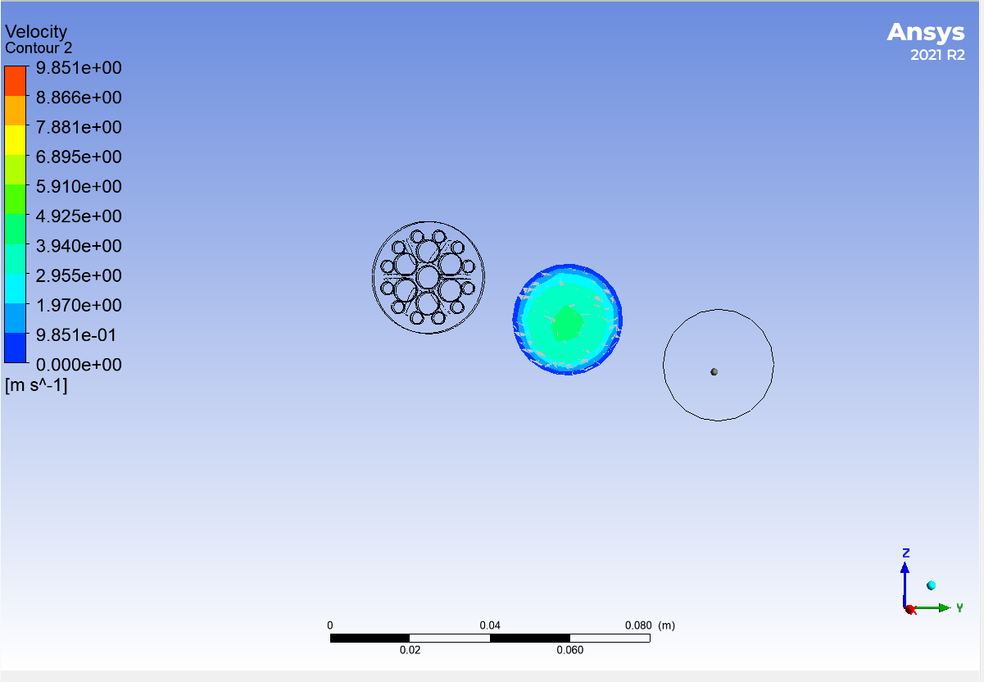 | 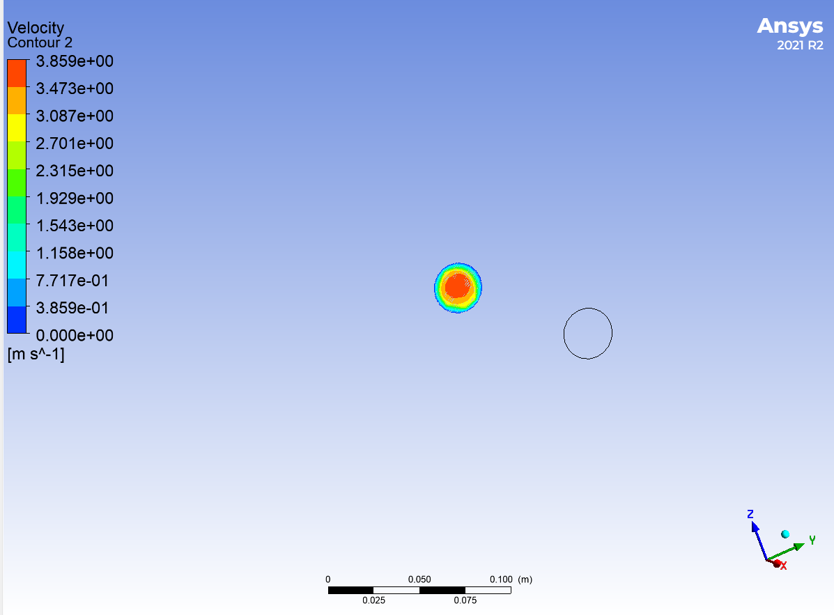
Figure 8 – Velocity profile at 10D downstream: With flow conditioner | Figure 9 – Velocity profile at 10D downstream: Without flow conditioner

Observations:
- With conditioner: Nearly developed axisymmetric velocity profile. Residual asymmetry is minimal, and the profile shape is approaching that of a fully developed turbulent pipe flow. Good symmetry about the pipe centerline.
- Without conditioner: Non-uniformity persists, although the distortion gradually decays with distance due to turbulent diffusion alone. The profile is still measurably asymmetric — not yet suitable for accurate flow measurement.
- At 10D, the conditioned flow already meets the symmetry requirements for most flowmeter installations, while the unconditioned flow does not.

7.4 15D Downstream
At 15D downstream, the maximum downstream distance studied, the flow conditioner case shows a well-developed, nearly symmetric profile, while the baseline case remains more uneven with larger point-to-point velocity deviations.

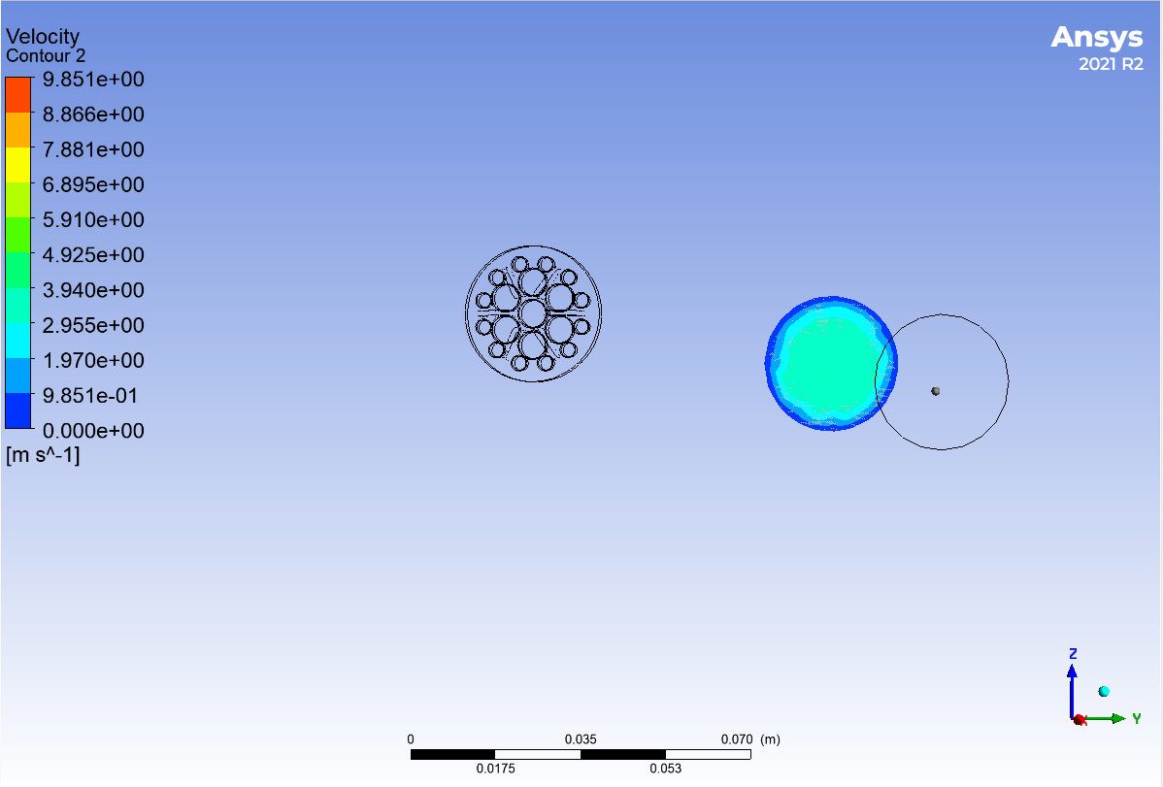 | 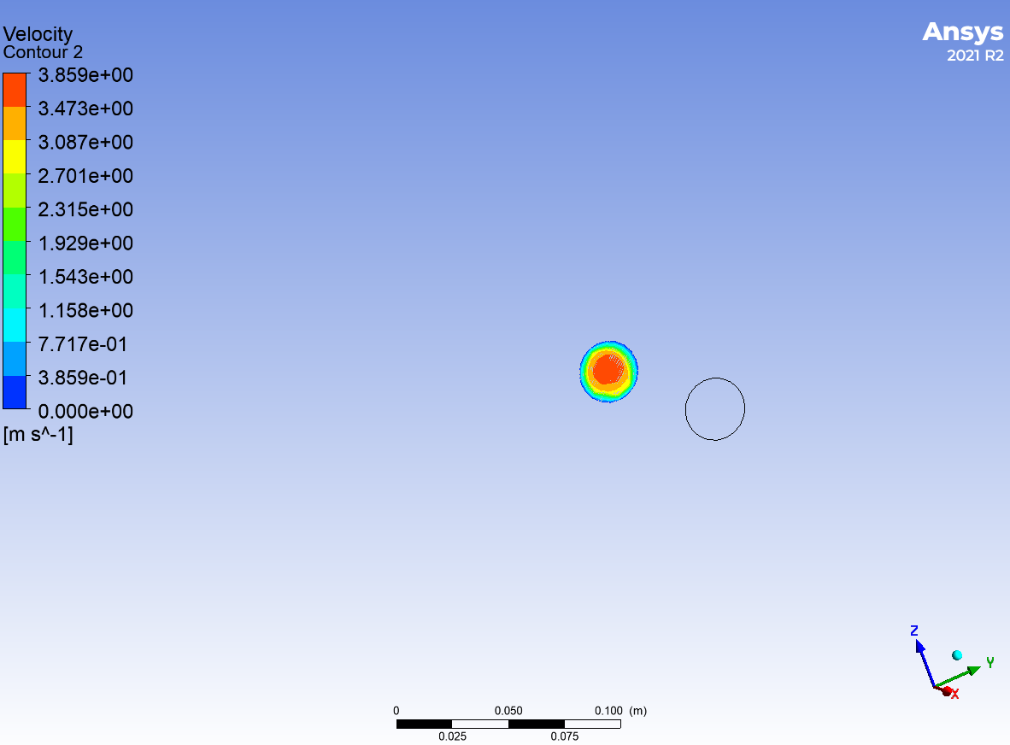
Figure 10 – Velocity contour at 15D downstream: With flow conditioner | Figure 11 – Velocity contour at 15D downstream: Without flow conditioner

The 15D downstream 1D velocity magnitude profiles (radial line plots) provide the clearest quantitative comparison between the two configurations:

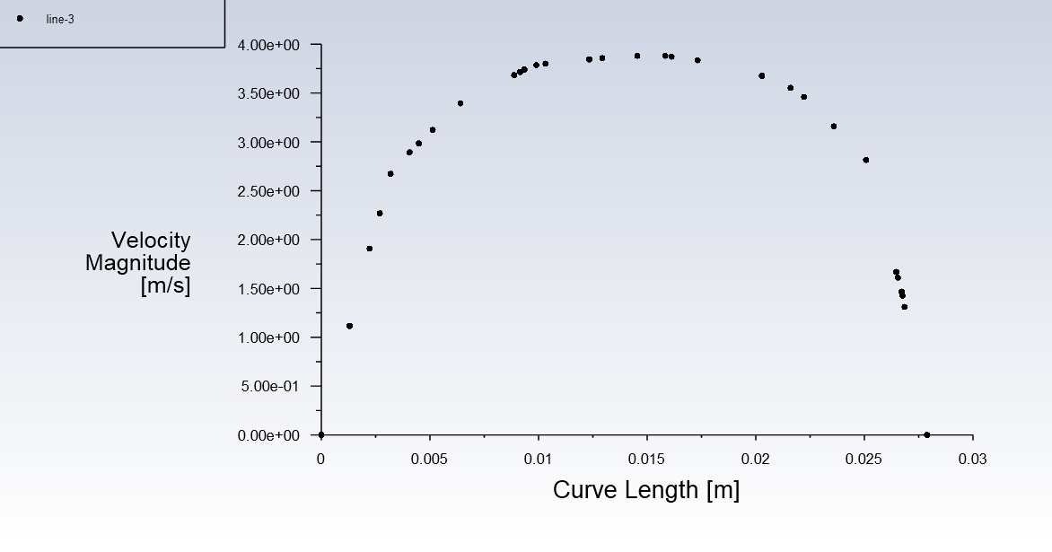 | 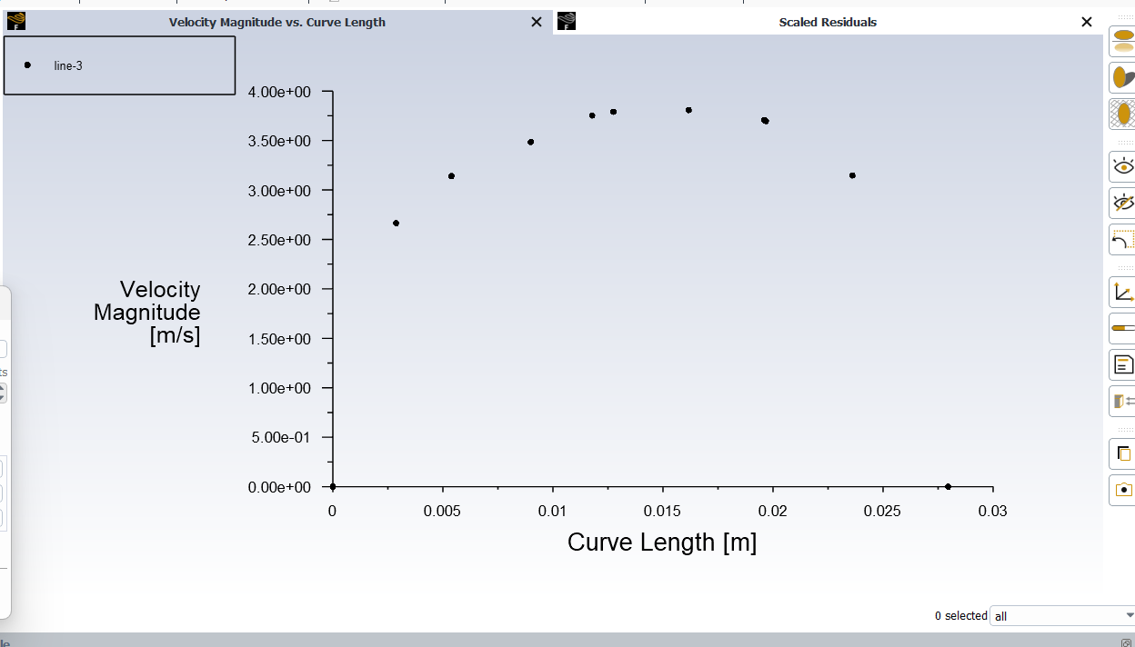
Figure 12 – 1D velocity magnitude profile at 15D: With flow conditioner (smooth, symmetric curve) | Figure 13 – 1D velocity magnitude profile at 15D: Without flow conditioner (uneven, asymmetric deviations)

Observations:
- With conditioner (Figure 12): The radial velocity magnitude profile shows a smooth, nearly symmetric bell-shaped curve. Point velocities lie close to a smooth fitted profile — indicating a high-quality, axisymmetric velocity distribution consistent with fully developed pipe flow. This profile is suitable for accurate flowmeter measurement.
- Without conditioner (Figure 13): The 15D profile remains more uneven with larger deviations of individual point velocities from a smooth curve. The persistent asymmetry confirms that upstream disturbances from the elbow take considerably longer to decay by turbulent diffusion alone — the conditioned 10D profile is better than the unconditioned 15D profile.
- The flow conditioner accelerates velocity profile development by at least 5–10 pipe diameters — a significant improvement for constrained installation spaces.

8. Engineering Analysis

8.1 Sources of Flow Disturbance
The disturbed inlet conditions in this pipeline configuration arise from three primary sources, each contributing to profile asymmetry and swirl:
- 90° Elbow: Generates strong secondary flow (Dean vortices) and swirl in the pipe cross-section due to centrifugal effects as the flow changes direction. This is the dominant source of velocity profile distortion.
- Concentric Reducer (50 mm → 25 mm): Accelerates the flow and introduces additional radial velocity components and profile distortion due to the converging geometry. The acceleration intensifies any asymmetry already present from the elbow.
- Smaller Downstream Pipe (25 mm): The higher velocities in the reduced-diameter pipe intensify non-uniformity due to higher Reynolds number and limited cross-sectional area for profile recovery.

8.2 How the Flow Conditioner Works
The Vaned Flow Conditioner achieves flow straightening and profile improvement through the following mechanisms:
- Flow Subdivision: Divides the disturbed flow into multiple smaller passages (vane channels). Each channel forces the flow to align with the conditioner axis, breaking large-scale swirl structures into smaller, rapidly-decaying eddies.
- Momentum Redistribution: The vane walls transfer lateral momentum to the axial direction, converting swirling kinetic energy into a more uniform axial velocity profile downstream.
- Turbulent Mixing Enhancement: The wakes from individual vane channels promote turbulent mixing that accelerates the natural decay of residual velocity asymmetry — effectively compressing the hydraulic development length.
- Swirl Suppression: The vane orientation directly opposes the tangential velocity components introduced by the elbow, neutralizing swirl at the source rather than relying on natural decay.

8.3 Performance Quantification

Metric | Without Conditioner | With Conditioner | Improvement
System Pressure Drop | 13.23 Pa | 38.43 Pa | Higher Loss
Conditioner Pressure Penalty | — | 25.2 Pa additional | Higher Loss
Profile at 1D | Asymmetric | Partial | Noticeably better
Profile at 5D | Distorted | Symmetric | Significantly better
Profile at 10D | Asymmetric | Stabilized | Fully suitable for measurement
Profile at 15D | Asymmetric | Symmetric | Near fully developed
Swirl Suppression | None | Effective | Complete swirl removal
Flow Measurement Suitability | Not recommended | Confirmed | Meets flowmeter requirements

This establishes a clear trade-off: the 25.2 Pa additional pressure drop (approximately 0.19% of 1 bar operating pressure) is more than justified by the substantial improvement in flow measurement accuracy and process repeatability it enables.

9. Consolidated Results Summary

Parameter | Case 1: With Conditioner | Case 2: Without Conditioner | Assessment
Inlet Pressure | 38.5 Pa | 13.3 Pa | Higher due to conditioner
Outlet Pressure | 0.07 Pa | 0.07 Pa | Same boundary condition
Elbow+Reducer Loss | 13.23 Pa | 13.23 Pa | Same in both cases
Conditioner Loss | 25.2 Pa | 0 Pa | ⚠️ Higher Loss
Total Pressure Drop | 38.43 Pa | 13.23 Pa | 2.9× higher with conditioner
Velocity at 1D | Improved uniformity | Highly skewed | Effective
Velocity at 5D | Symmetric | Distorted | Effective
Velocity at 10D | Stabilized | Asymmetric | Effective
Velocity at 15D | Near fully developed | Still asymmetric | Effective
Swirl at 15D | Eliminated | Persistent | Effective
Measurement Suitability | Confirmed | Not recommended | Confirmed

10. Conclusions

10.1 Key Findings
A steady-state CFD study was performed on a disturbed water pipeline system incorporating a 90° elbow and a concentric reducer (50 mm → 25 mm) to evaluate the performance of the custom-designed Vaned Flow Conditioner. Two configurations were simulated using ANSYS Fluent 2021 R2 with the k-ω SST turbulence model.

- The baseline system (elbow + reducer, without flow conditioner) produces a total pressure drop of 13.23 Pa — attributed to the combined hydraulic resistance of the 90° elbow, concentric reducer, and pipe wall friction.
- When the Vaned Flow Conditioner is installed, the total pressure drop increases to 38.43 Pa — the conditioner itself contributing 25.2 Pa of additional loss due to the hydraulic resistance of its multi-vane passage geometry.
- Velocity profiles at 1D, 5D, 10D, and 15D downstream confirm that the flow conditioner significantly improves flow symmetry and uniformity at all locations, with the most pronounced improvements visible beyond 5D.
- At 15D downstream, the conditioned flow is nearly symmetric and approaching a fully developed turbulent pipe flow profile. The 15D unconditioned profile remains measurably asymmetric, with larger point-to-point velocity deviations.
- The flow conditioner effectively eliminates swirl generated by the 90° elbow — a critical requirement for accurate operation of downstream flow measurement instruments.
- The conditioned flow at 10D already exceeds the profile quality of the unconditioned flow at 15D — demonstrating that the conditioner compresses the hydraulic development length by at least 5 pipe diameters.

10.2 Design Validation
The CFD results confirm that the Vaned Flow Conditioner design achieves its intended functional objectives:
- Flow straightening: Demonstrated — swirl effectively suppressed within 5–10D downstream.
- Velocity profile uniformity: Demonstrated — near-symmetric profile at 10D and 15D with conditioner vs. persistent distortion without.
- Measurement suitability: Confirmed — the conditioned velocity profile at ≥10D meets the symmetry requirements for accurate flow measurement (ultrasonic, differential pressure, or Coriolis meters).
- Pressure drop: Quantified at 25.2 Pa — accepted as a necessary and justified performance trade-off for measurement accuracy applications.

10.3 Next Steps — Phase 4: Mold Design
- The CFD-validated geometry is ready for Phase 4 Mold Design — use the mold flow simulation report (Phase 3) as the technical input for core/cavity design, gating, cooling, and venting decisions.
- The vane channel geometry dimensions confirmed in this CFD study must be preserved in the injection-molded part — dimensional tolerances on vane passages (±0.05 mm) are critical for maintaining CFD-validated hydraulic performance.
- Surface roughness of flow-contact vane surfaces (Ra ≤ 0.8 μm specified in Phase 3 manufacturing notes) must be maintained to align with the smooth-wall assumption used in this CFD study.
- PA6 material selection (confirmed in Phase 3) is compatible with water service — verify chemical compatibility with any process fluid additives or temperature excursions in the intended installation.

This CFD report, combined with the completed Mold Flow Simulation Report (Phase 3), constitutes a complete pre-manufacturing technical dossier for the Vaned Flow Conditioner. The design is validated for hydraulic performance and manufacturability — ready to advance to Phase 4 mold design.

