MOLD FLOW SIMULATION ANALYSIS REPORT
Customized Vaned Flow Conditioner

Document Title | Mold Flow Simulation Analysis Report
Component | Vaned Flow Conditioner (Custom Design)
Material | PA6 — Polyamide 6 (Nylon 6)
Linear Shrinkage | 2.038744 mm/m
CAD Platform | Siemens NX 12
Simulation Module | Easy Fill Advanced (Mold Wizard)
Analysis Stage | Filling Stage — Complete
Report Date | June 2026
Design Origin | Original Design by Engineer (CFD-validated)
Document Status | For Mold Design & Manufacturing Use

Table of Contents
1. Product Development Pipeline 1
2. Component Description & Design Intent 1
2.1 Functional Purpose 1
2.2 Geometry Description 1
3. Simulation Setup & Parameters 1
3.1 Software Environment 1
3.2 Material Properties — PA6 1
3.3 Gate & Runner Configuration 1
4. Mold Flow Analysis Results 1
4.1 Gate Contribution 1
Observations: 1
Implications for Mold Design: 1
4.2 Fill Time (Flow Front Progression) 1
Observations: 1
Implications for Mold Design: 1
4.3 Pressure Drop 1
Observations: 1
Implications for Mold Design: 1
4.4 Melt Front Temperature 1
Observations: 1
Implications for Mold Design: 1
4.5 Maximum Temperature Distribution 1
Observations: 1
Implications for Mold Design: 1
4.6 Average Temperature Distribution 1
Observations: 1
Implications for Mold Design: 1
4.7 Frozen Layer Ratio 1
Observations: 1
Implications for Mold Design: 1
4.8 Air Trap Analysis 1
Observations: 1
Implications for Mold Design — VENTING REQUIREMENTS: 1
5. Consolidated Results Summary 1

1. Product Development Pipeline
This report is part of a structured, end-to-end product development workflow for the customized Vaned Flow Conditioner — an original engineering design. The component has been designed from first principles, validated through Computational Fluid Dynamics (CFD), and is now being analyzed for injection molding feasibility. The complete pipeline is outlined below.

Phase | Activity | Output | Status
Phase 1 | Concept & 3D Modeling | STP model — vaned_flow_conditioner.stp | Complete
Phase 2 | CFD Analysis | Flow field, pressure drop, velocity profiles | Complete
Phase 3 | Mold Flow Simulation | Fill, Temp, Pressure, Weld, Air Trap analysis | Current Phase
Phase 4 | Mold Design | Core/cavity, runner, cooling, ejector layout | Next Step
Phase 5 | Manufacturing Drawings | 2D part drawings, mold assembly drawings | Planned

The mold flow simulation results presented in this document serve as the technical basis for Phase 4 mold design decisions — including gate location confirmation, cooling channel layout, parting line, ejector placement, and venting requirements.

2. Component Description & Design Intent

2.1 Functional Purpose
The Vaned Flow Conditioner is a custom-engineered fluid control component designed to homogenize turbulent or swirling flow profiles upstream of flow measurement instruments (e.g., ultrasonic or Coriolis flowmeters). The vane geometry — developed and optimized by the engineer — straightens and redistributes velocity profiles across the flow cross-section, enabling accurate measurements.

The component was designed from first principles and validated through CFD simulation to confirm the required pressure drop, flow straightening effectiveness, and velocity uniformity index (VUI) before proceeding to physical manufacturing.

2.2 Geometry Description
Overall Shape | Circular disc — designed to fit standard pipe flanges
Central Feature | Multi-vane gate/runner assembly (star pattern)
Peripheral Features | 4 equidistant cylindrical through-holes (bolt pattern / flow ports)
Symmetry | 4-fold rotational symmetry
Material | PA6 (Polyamide 6 / Nylon 6)
Material Class | Semi-crystalline engineering thermoplastic
Mold Type | Injection mold (2-plate or 3-plate, TBD in Phase 4)
Parting Line | Flat parting — disc midplane (confirmed from NX assembly)
Gate Strategy | Central vaned multi-point gate (direct / submarine gates)
CAD File | vaned_flow_conditioner_stp.prt

3. Simulation Setup & Parameters

3.1 Software Environment
CAD / CAM Software | Siemens NX 12
Simulation Module | Mold Wizard — Easy Fill Advanced
Analysis Type | Injection Molding — Filling Stage Simulation
Mesh Type | 3D solid mesh (polyhedral elements)
Result File | vaned_flow_conditioner (PA6, Linear Shrinkage: 2.038744 mm/m)

3.2 Material Properties — PA6
Material Name | PA6 — Polyamide 6 (Nylon 6)
Material Class | Semi-crystalline thermoplastic
Melt Temperature | 260–290 °C (typical processing range)
Mold Temperature | 60–80 °C (recommended for PA6)
Ejection Temperature | ~100–120 °C
Linear Shrinkage | 2.038744 mm/m (simulation-applied value)
Tensile Strength | ~80 MPa (dry as molded)
Flexural Modulus | ~2,800 MPa
Water Absorption | ~3.5% (relevant for flow conditioner in wet service)
Chemical Resistance | Good resistance to hydrocarbons, oils, greases

PA6 is selected for this application due to its balance of mechanical strength, dimensional stability, and chemical resistance. The material's semi-crystalline nature requires careful attention to cooling uniformity to minimize warpage and differential shrinkage — factors directly addressed by the mold flow simulation.

3.3 Gate & Runner Configuration
The gating system employs the component's own vaned central geometry as the primary runner distribution network. The central star-vane structure acts as a balanced runner, distributing melt to four primary sectors of the disc simultaneously. This unique approach leverages the part's functional geometry for molding efficiency, minimizing the need for a conventional runner system.
- Gate type: Central multi-point (vaned runner integrated into part geometry)
- Number of gate points: Multiple (one per vane channel — estimated 4 gates)
- Gate location: Disc quandrant points — optimal for radial fill balance
- Runner system: Naturally balanced by vane symmetry
- Parting surface: Flat (disc midplane — confirmed from NX parting file)

4. Mold Flow Analysis Results
All eight simulation result types from Siemens NX Easy Fill Advanced are presented below. Each result is interpreted in the context of mold design requirements for Phase 4, including implications for gate design, cooling layout, venting, and parting line decisions.

4.1 Gate Contribution
The gate contribution map visualizes the volumetric domain filled by each individual gate point of the central vaned runner system. Each colored wedge sector corresponds to melt originating from one gate point.

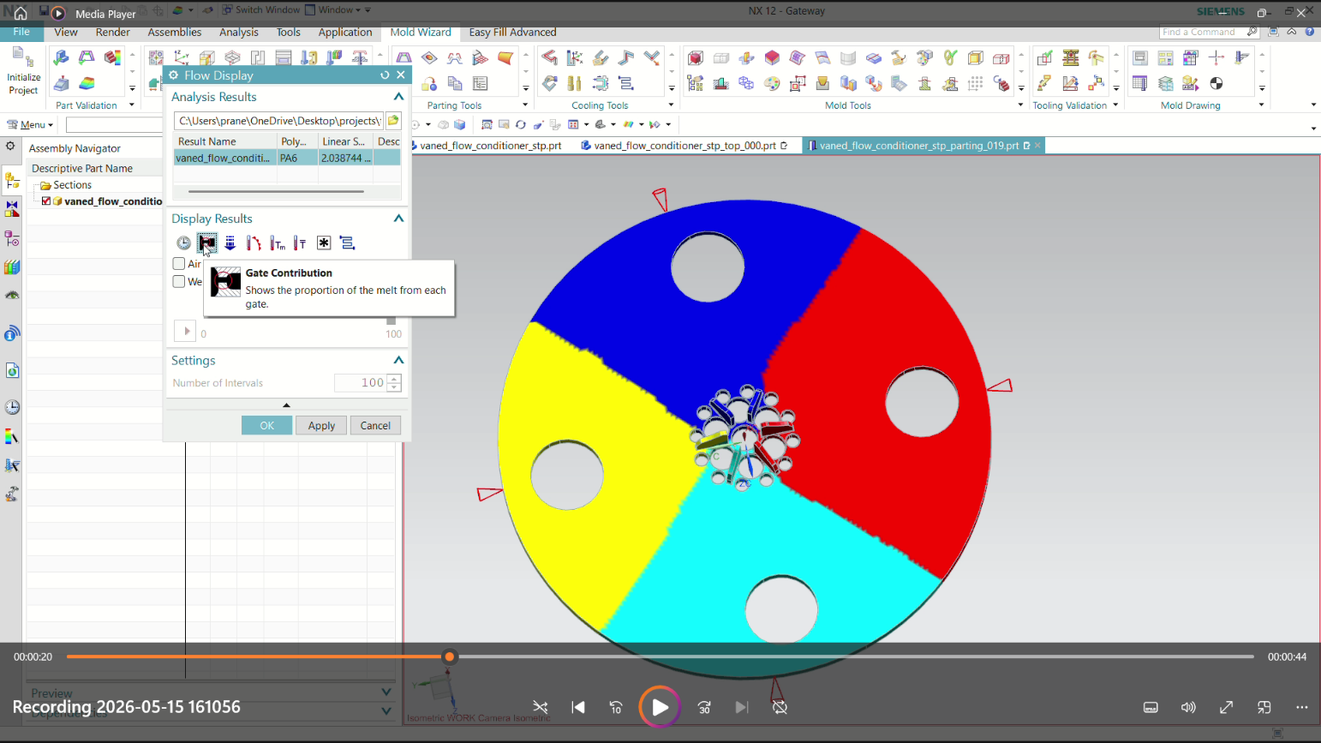
Figure 3 – Gate Contribution: Balanced 4-sector melt distribution from central vaned gate assembly

Observations:
- The disc is divided into 4 roughly equal sectors (blue, red, yellow, cyan) — confirming excellent gate balance.
- Each sector boundary aligns with the vane geometry, validating the design concept of using the vaned runner for balanced distribution.
- No single gate dominates the fill volume — the design is naturally balanced.

Implications for Mold Design:
- Gate location at the center is confirmed — no relocation needed.
- The vaned runner geometry should be machined precisely to maintain equal flow resistance per channel.
- Cold slug well at the end of each vane channel is recommended.

4.2 Fill Time (Flow Front Progression)
The fill time result captures the sequential advance of the polymer melt front from the central gate outward to the disc periphery. The color gradient (cyan = early fill at center → red = last fill at edges) maps the complete filling sequence.

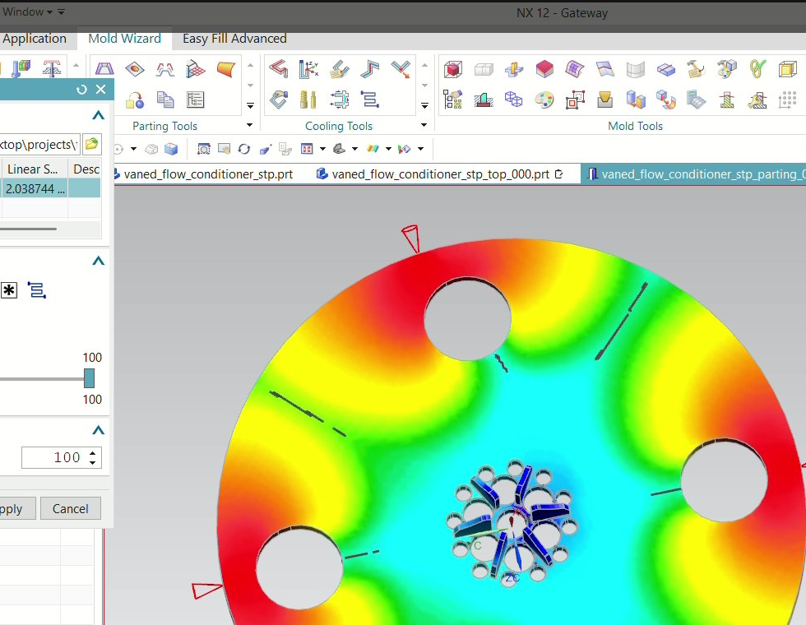
Figure 4 – Fill Time: Radial melt front progression and weld line formation near peripheral holes

Observations:
- Smooth, concentric radial fill pattern — consistent with balanced gate contribution.
- Fill time progression is symmetric across all four quadrants, confirming balanced gating.
- Weld lines (dashed marks) form near all four peripheral holes where opposing flow fronts meet — this is geometrically unavoidable.
- The last-filled zones are located at the outer rim and immediately downstream of each peripheral hole.

Implications for Mold Design:
- Vents must be placed at last-fill locations: outer rim and downstream of peripheral holes.
- Weld line locations should be noted on the part drawing — structural testing at weld lines is recommended.
- Cooling channels should prioritize the outer rim (last fill = highest heat accumulation).

4.3 Pressure Drop
The pressure drop map shows the pressure loss distribution across the mold cavity at the end of the filling stage. It directly informs injection pressure requirements and highlights any flow resistance zones.

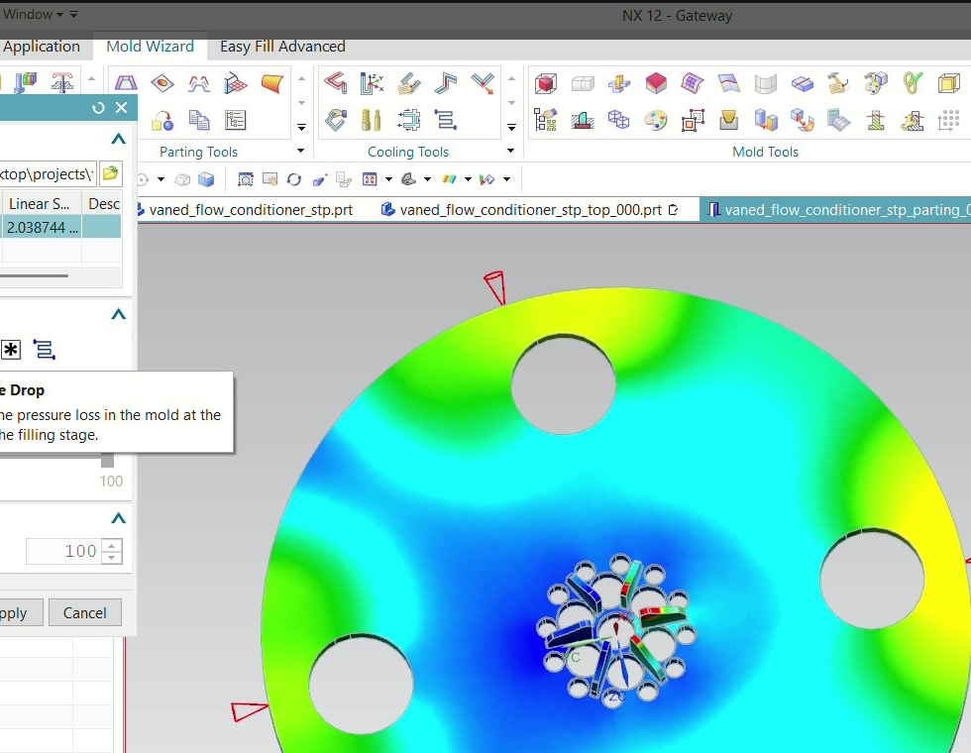
Figure 5 – Pressure Drop: Pressure loss distribution — highest at center gate, lowest at periphery

Observations:
- Maximum pressure is concentrated at the central gate region (green/yellow) — expected for a centrally-gated part.
- Pressure decreases progressively toward the periphery (dark blue zones near outer rim and holes).
- The pressure gradient is smooth and symmetric — no localized high-resistance zones suggesting flow restrictions.
- Low peripheral pressure indicates easy fill of the outer rim — no short-shot risk.

Implications for Mold Design:
- Injection pressure can be set conservatively — the low peripheral resistance means high injection pressure is not required.
- Gate cross-section must be adequate to sustain the central pressure for full pack — recommend gate land length ≤1.0 mm.
- No flow leaders or flow restrictors needed — natural pressure gradient is sufficient.

4.4 Melt Front Temperature
The melt front temperature displays the thermal state of the advancing polymer melt as it progresses through the cavity. This is a dynamic result — it captures temperature at the flow front position, not at a fixed time.

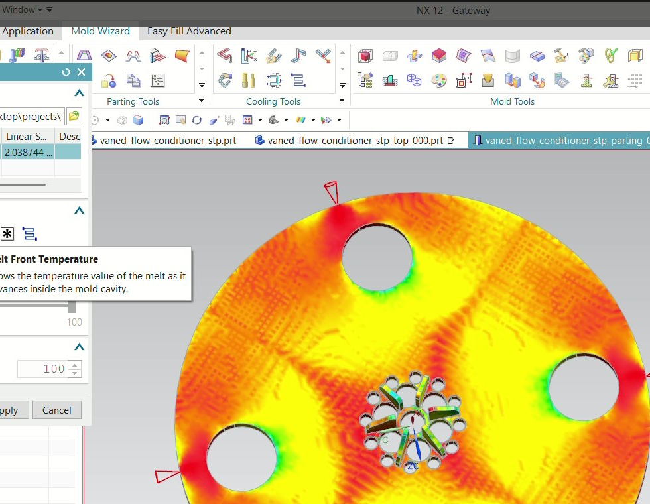
Figure 6 – Melt Front Temperature: Thermal state of advancing melt (highest at center, cooling toward holes)

Observations:
- Central gate region maintains the highest melt temperature (bright yellow/white) — consistent with shortest flow path.
- Temperature decreases toward the peripheral holes (green patches) — acceptable for PA6 fill at these regions.
- No abrupt temperature drop zones detected — no cold slugs or premature freezing during fill.
- Temperature differential across fill path is moderate — within PA6 processing window.

Implications for Mold Design:
- Mold temperature should be maintained at 60–80 °C uniformly to prevent premature freeze-off near peripheral holes.
- Cooling channels near the hole cores must not over-cool — risk of short shot or incomplete fusion at weld lines.
- Hot runner system is not required — cold runner with insulated sprue bush is sufficient.

4.5 Maximum Temperature Distribution
The maximum temperature result shows the highest temperature reached at any through-thickness point of the part wall at the end of filling. Hot spots indicate zones of thermal concentration that may lead to degradation or extended cooling requirements.

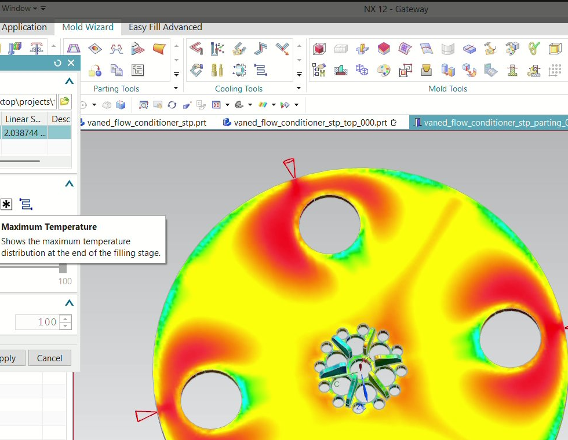
Figure 7 – Maximum Temperature: Peak temperature — hot zones at center runner and disc body

Observations:
- Hot spots (red zones) are concentrated at the central vaned runner assembly and along the diagonal fill paths between holes.
- Cooler zones (green/cyan) are observed near and around peripheral holes — due to thermal dissipation through hole cores.
- The overall maximum temperature appears within PA6 degradation limits — no evidence of thermal overload.
- Star-pattern hot zones correspond to the vane channels — expected due to higher melt velocity in narrow channels.

Implications for Mold Design:
- Conformal or baffle cooling near the central vaned core insert is essential to extract heat from the hot runner region.
- Hole core pins should include internal cooling (bubblers or baffles) to manage the localized cooling at hole boundaries.
- Cooling time should be calculated based on the maximum temperature zone — not average — to ensure full solidification of the center.

4.6 Average Temperature Distribution
The average temperature map shows the mean temperature across the part wall thickness at the end of filling. This is the most relevant result for predicting overall warpage tendency and cooling uniformity requirements.

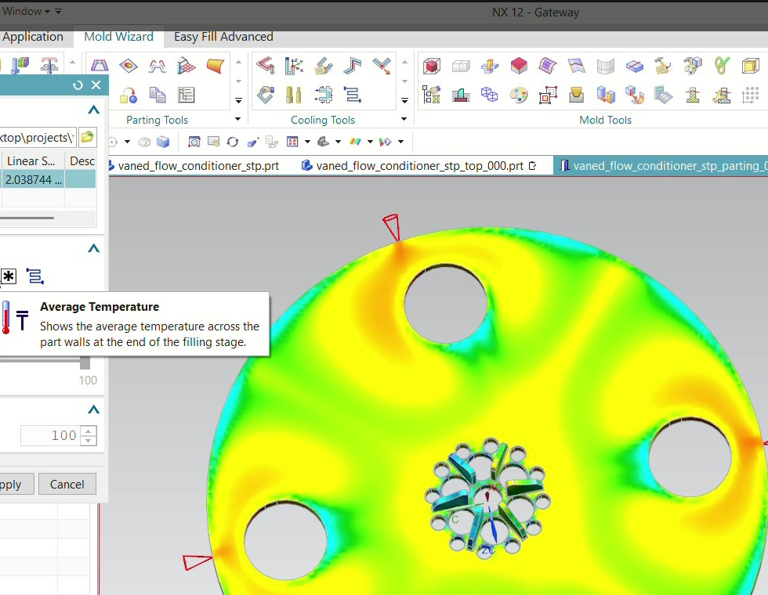
Figure 8 – Average Temperature: Through-thickness average — uniform green-dominated profile

Observations:
- The average temperature distribution is notably more uniform than the maximum temperature — the smooth green-dominated gradient indicates well-distributed thermal state.
- Slight temperature elevation in the disc body (yellow zones) versus the hole regions (cyan/blue) is expected and acceptable.
- No large temperature differentials between opposing zones — warpage risk is moderate to low.
- Symmetric temperature field across all four quadrants — consistent with balanced filling.

Implications for Mold Design:
- Cooling circuit design should target uniform mold temperature within ±5°C across the cavity surface.
- A balanced cooling layout — mirroring the 4-fold symmetry of the part — is recommended (4 symmetrically placed cooling circuits).
- Differential shrinkage between the thicker disc body and thinner zones near holes should be accounted for in the part drawing tolerances.

4.7 Frozen Layer Ratio
The frozen layer ratio quantifies the proportion of the wall thickness that has solidified at the end of filling. A high frozen ratio means that region of the part has already begun to freeze before packing is complete — a potential source of sink marks, voids, or incomplete packing.

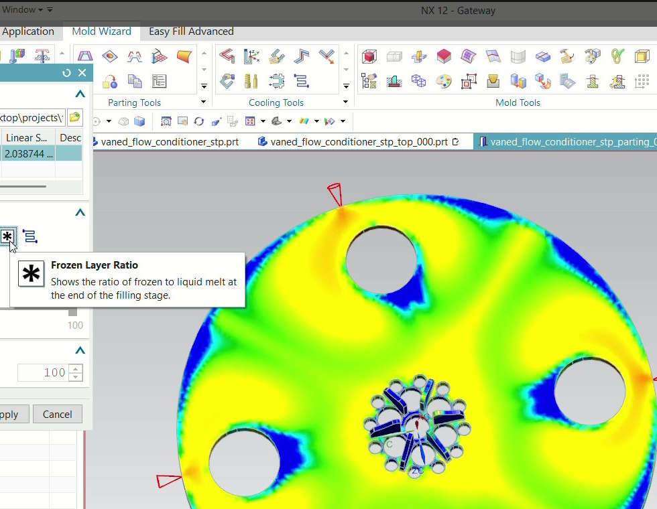
Figure 9 – Frozen Layer Ratio: Blue zones at hole boundaries indicate premature skin freeze

Observations:
- Blue zones at and around peripheral hole boundaries indicate higher frozen layer ratios — these areas are cooling faster due to proximity to the metallic hole core pins.
- The main disc body (yellow/green) shows lower frozen ratios — the melt core is still liquid and able to transmit packing pressure effectively.
- No full-section freeze (ratio = 1.0) detected during filling — packing stage can be effectively applied.
- Corner transitions at hole-to-disc-body intersections show intermediate frozen ratios — potential zone for micro-voids if packing is insufficient.

Implications for Mold Design:
- Packing pressure must be sustained long enough to pack out the disc body before gate freeze-off.
- Gate dimensions must allow adequate packing window — gate freeze should not occur before part body freeze.
- Core pin temperature control is important — if hole core pins are too cold, premature freeze near holes will intensify, creating packing isolation.
- Recommended gate freeze-off time > body freeze time — validate via cooling simulation in Phase 4.

4.8 Air Trap Analysis
Air trap locations indicate zones where the advancing melt fronts converge and trap atmospheric air in the mold cavity. Entrapped air cannot escape and results in burn marks (diesel effect), surface voids, or incomplete fill. This is a critical result for mold venting design.

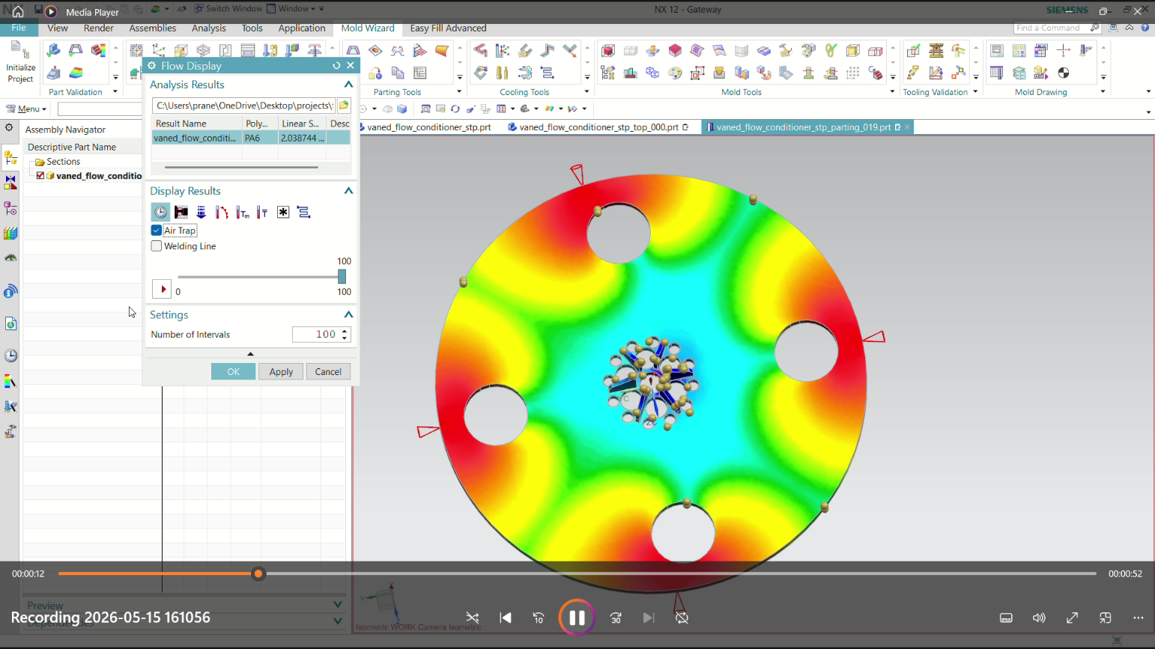
Figure 10 – Air Trap Locations: Gold sphere markers at peripheral hole boundaries and outer rim

Observations:
- Air trap markers (gold spheres) are located at — outer rim of the disc (multiple positions), immediately downstream of each peripheral hole (4 locations), and near the top-center hole boundary.
- These locations correspond precisely to the last-fill zones identified in the fill time analysis — confirming geometrically-driven air entrapment.
- The central gate region is air-trap-free — the melt front advances outward, pushing air ahead of it to the periphery.
- No air traps detected in the disc body or vane channels — the radial fill pattern effectively purges air outward.

Implications for Mold Design — VENTING REQUIREMENTS:
- CRITICAL: Install vents at all identified air trap locations. Recommended vent depth: 0.015–0.025 mm for PA6 (above flash threshold).
- Outer rim vents: Minimum 4 vents at 90° intervals on the parting line. Add 2–4 additional vents if burn marks appear in trials.
- Hole boundary vents: Vent slots or ejector pin clearance venting at each peripheral hole exit.
- Vent land width: 1.0–1.5 mm. Vent channel behind: 0.5–0.8 mm depth to atmosphere.
- Consider vacuum-assisted venting if standard parting line vents are insufficient (likely for PA6 at standard injection speeds).

5. Consolidated Results Summary

Analysis Parameter | Key Finding | Status | Mold Design Action Required
Gate Contribution | 4 balanced sectors from vaned central gate | Balanced | Confirm gate dimensions — no relocation needed
Fill Time | Smooth radial fill; weld lines near holes | Acceptable | Vent at last-fill zones; note weld lines on drawing
Pressure Drop | Low peripheral pressure; smooth gradient | Good | Low injection pressure — conservative settings OK
Melt Front Temperature | Gradual decrease from center; no cold freeze | Good | Mold temp 60–80°C; insulate hole core pins
Maximum Temperature | Hot spots at central vane runner | Monitor | Conformal cooling at central core insert
Average Temperature | Uniform 4-fold symmetric thermal field | Uniform | Balanced 4-circuit cooling layout
Frozen Layer Ratio | Premature skin freeze at hole boundaries | Monitor | Optimize packing pressure & core pin temperature
Air Traps | Traps at outer rim & hole boundaries | Add Vents | Install vents at 8–12 locations on parting line

