Lab 10 report

Cohesion and Coupling

1. **Coupling**

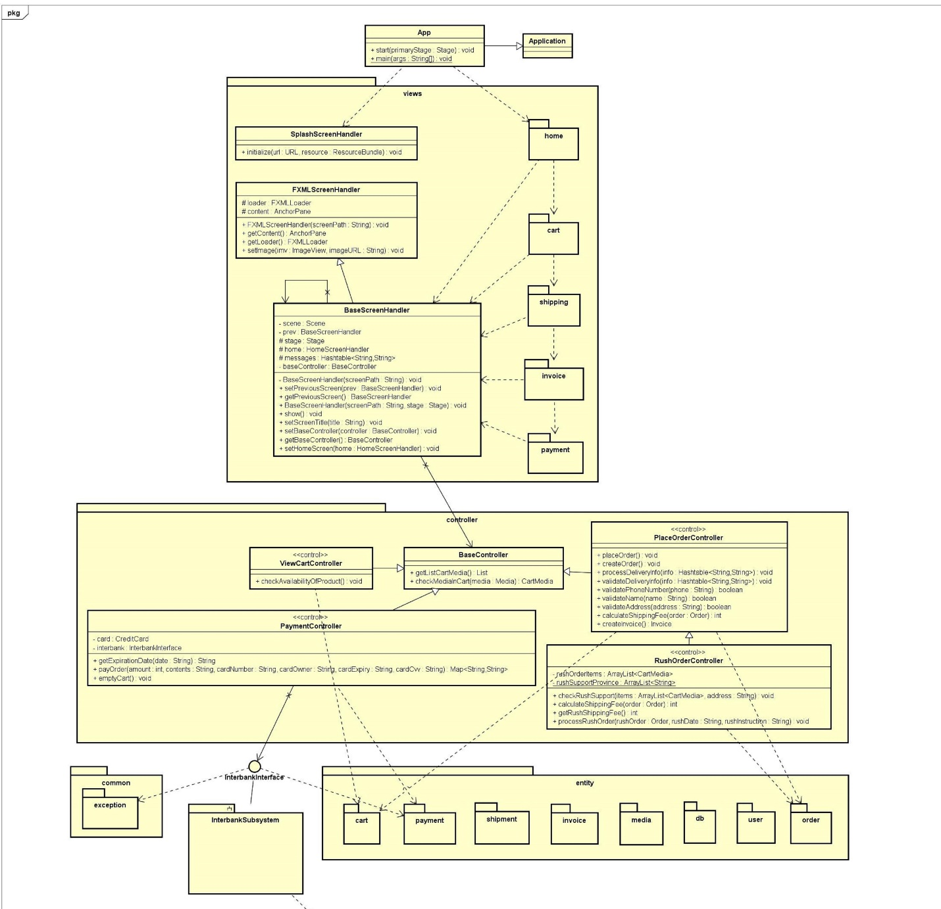

According to the design, AIMS project is modeled by MVC