*Online Digital Photo Printing*

**Project Semaster III Report**



|  |  |
| --- | --- |
| Member | * Binh Pham Van (Leader) * Quyen Do Thu * Chinh Nguyen Thi * Dung Do Thu * Ngoc Pham Thanh |
| Instructor | * Mr.Cuong Nguyen Hung |
| Batch | * C1207i1 – Bachkhoa-Aptech |
| Date | * 10/10/2013 – 11/10/2013 |

Contents

I. Problem Definition 5

II. Customer Requirement Specification 6

III. Architecture and Design of the Project 8

ACKNOWLEDGEMENT

I would like to acknowledge all those who have given moral support and helped me make the project a success.

I wish to express my gratitude to the eProjects Team at Head Office, who guided and helped me. I would also like to express my gratitude to all the staff members of my center for not only providing me with opportunity to work with them on this project, but also for their support and encouragement throughout the process.

And finally, I would like to offer many thanks to all my colleagues for their valuable suggestions and constructive feedback.

Synopsis

The web application is to be developed for Web platform using .Net Framework 3.5, Visual Studio 2010, and SQL Server 2008 as the back-end.

Online Digital Photo Printing (ODPP) allow user to orders for printing digital photo after upload

The application should perform the following functions:

* Store information for managing the processing of selling a vehicle to a customer from the dealer’s showroom
* User
  + Allow login to manager sales, manager car, manager manufactory…
  + Update User information
  + Allow logout
* Customer
  + Add new Customer
  + Search Customer information
  + View Customer information
  + Update Customer information
* Vehicle
  + Add new vehicle
  + Receiving the vehicle from Company
  + Creating vehicle registration data
  + Searching vehicle in showroom
  + Checking vehicle master(available/not available)
  + Checking the Output of Vehicle Data Sheet
  + Update vehicle information
* Manufactory
  + Add new Manufactory
  + View Manufactory information
  + Searching Manufactory information
  + Update Manufactory information
* Employee
  + Add new employee
  + View employee information
  + Seaching employee information
  + Update employee information
* Order
  + Creating Vehicle Sales Order
  + View Order information
  + Searching order information
  + Update order information
  + Creating Purchase Order
  + Creating Service Order
  + Checking the Output of Sales Confirmation
* Billing
  + Creating Billing Document
  + View Billing information
  + Checking the Output of Billing Document

# Problem Definition

After reading the project specifications, the developer tates the scope of the project very briefly. This is referred to as the problem. Queries related to the Vehicle Showroom Management System can be one or mor of the following:

1. How do I become a user for this application? What details do I need to provide to register myself as a user?
2. How can a customer obtain purchase a vehicle from this application?
3. How to create a order and billing for customers?
4. Etc…

# Customer Requirement Specification

**Client:** Dealer cars

**Bussiness/Project Objective:**

Create a database for the Dealer cars. Add table to store information about the Employee, Vehicle, Billing, Order and Manufactory... The application authenticates the existing user(Sales, Manager or Admin) by his username and password based on data in the database. After performing user authentication, for sales staff will perform tasks related to vehicle management, billing management... The manager will be responsible for managing the staff in the showroom, and Admin will manage the user accounts for the application.

**Inputs provided by the Admin/User:**

* Inputs for the application
* Outputs from the application
* Process Involved in the application
* List of Report

**Hardware and OS Requirements:**

* Pentium IV CPU 3.0 GHz
* 1 GB of RAM or higher
* Hard disk requirement: Minimum 2 GB
* Windows XP, Windows Vista or Windows 7

**Software Requirements:**

* NetBeans 6.1 or higher
* JDK 6u20 or higher
* Firefox 4.0 or higher
* SQL Server 2008

**Scope of the Work (in brief):**

Depending on the decision taken by the dealer’s showroom, following are requirements based on which the Windows application needs to be developed:

1. Registration of new Customer and authentication of existing Customer
2. The GUI of application is pretty and friendly
3. The feature of this application should include:
   1. Easy stock inventory updates
   2. Full user management
   3. Photograph uploads
   4. Image optimization
   5. Marketing reports, and
   6. Easy installation
4. Software can also generate reports
   1. Availability of Stock
   2. Customer information
   3. Vehicle master information
   4. Allotment details
   5. Waiting list details

# Architecture and Design of the Project

The application will be of a Windows-based distributed three-tier architecture to support multiple user using at the same time.

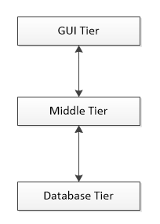

SQL Server 2008

Business Logic

Display Graphic User Interface for User

1. Data Flow Diagram (DFD)

The flow of data in the application is shown by the various data flow diagrams. The most basic data flow diagram is the Context diagram. It shows the basic flow of data in and out of the system.

**Explain symbols used in DFDs:**

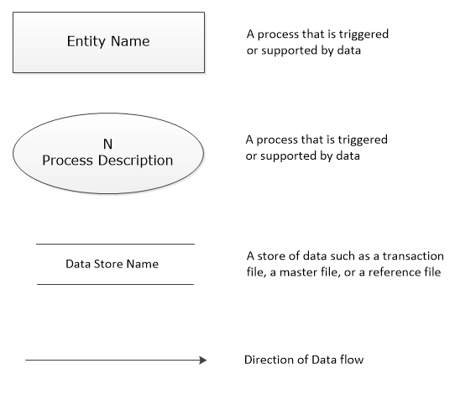

The flow of data in the application is shown by the various data flow diagrams. The most basic data flow diagram is the Context diagram. It shows the basic flow of data in and out of the system.

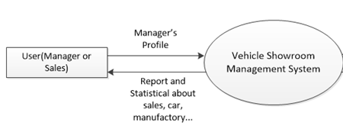

*Context Diagram – Vehicle Showroom Management System*

Sales Process







Car Manager Process



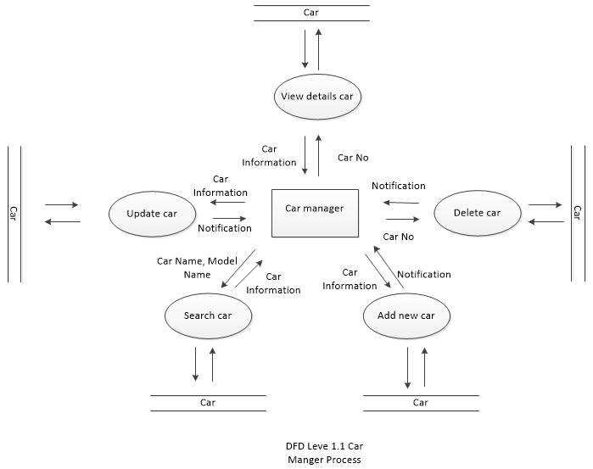

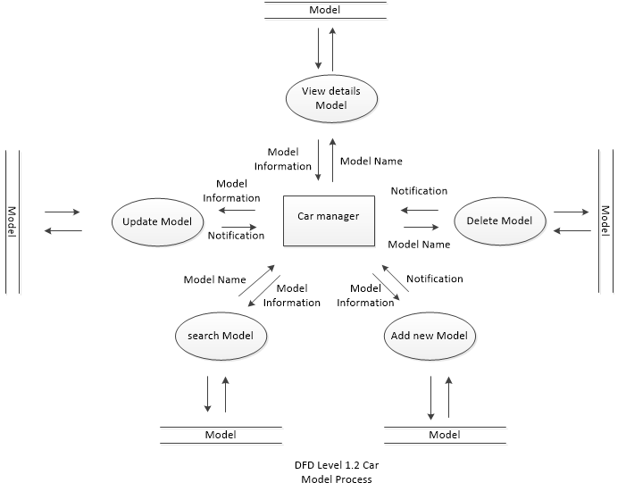

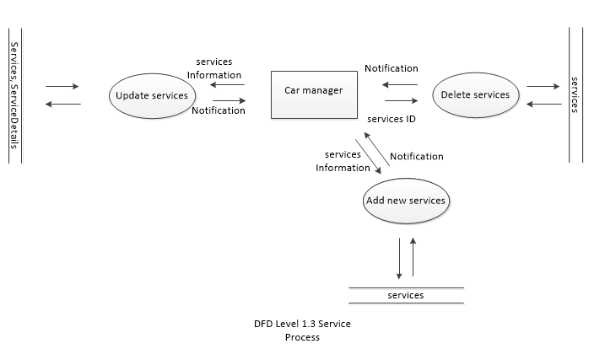

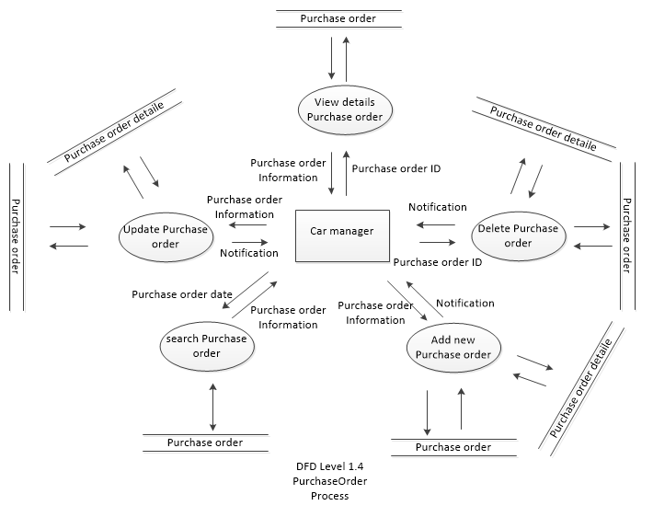

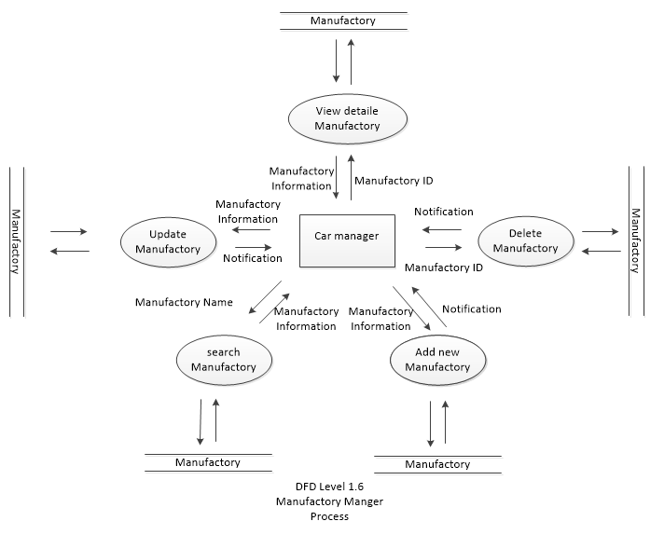

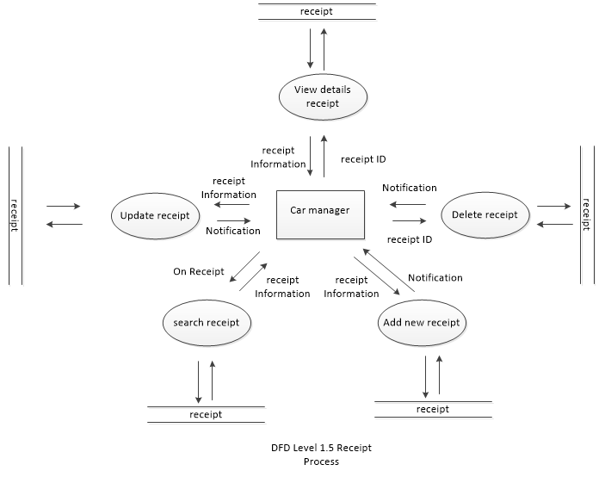

HR Manager Process





Customer Manager Process





1. Entity Relationship (ER) Diagram

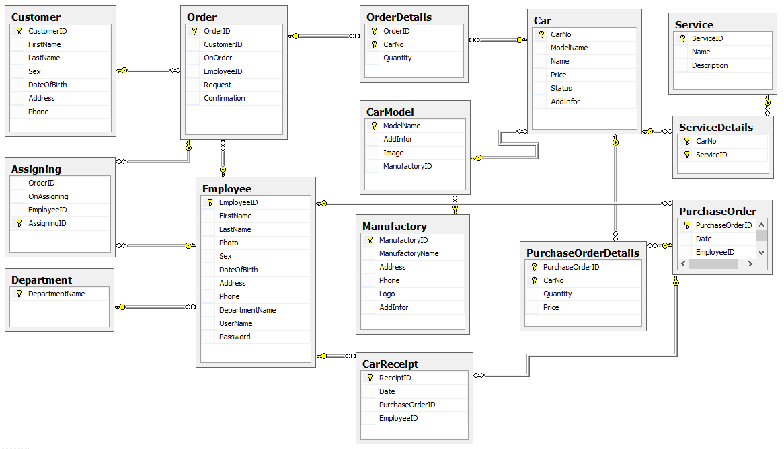

1. Database Design & Structure

Table Design:

* Customer (Store information about Customer)

|  |  |  |  |  |
| --- | --- | --- | --- | --- |
| **Field Name** | **Data Type** | **Null** | **Key** | **Description** |
| CustomerID | Bigint | No | PK | Customer’s ID |
| FirstName | NVarchar(20) | No |  | Customer’s first name |
| LastName | NVarchar(50) | No |  | Customer’s last name |
| Sex | Bit | No |  | Sex |
| DateOfBirth | Date | No |  | Date of birth of Customer |
| Address | Nvarchar(100) | No |  | Customer’s address |
| Phone | Int | No |  | Customer’s phone number |

* Car (Store information about Car)

|  |  |  |  |  |
| --- | --- | --- | --- | --- |
| **Field Name** | **Data Type** | **Null** | **Key** | **Description** |
| CarNo | Bigint | No | PK | number of Car (when receipt from Manufactory) |
| ModelName | Varchar(50) | No | FK | Store the model name |
| Name | NVarchar(50) | No |  | Name of Car |
| Price | Float |  |  | selling prices to customers |
| Status | Bit | No |  | Status of Car (available/not available) |
| AddInfor | NVarchar(100) | Yes |  | Additional information of the Car |

* CarModel (Store information about Car’s model)

|  |  |  |  |  |
| --- | --- | --- | --- | --- |
| **Field Name** | **Data Type** | **Null** | **Key** | **Description** |
| ModelName | Varchar(50) | No | PK | Car’s model name |
| ManufactoryID | int | No | FK | Store the ID of Manufactory |
| AddInfor | NVarchar(100) | Yes |  | Additional information of the Car |
| Image | Varbinay(Max) | No |  | Image of Car’s model |

* Manufactory (Store information about Manufactory)

|  |  |  |  |  |
| --- | --- | --- | --- | --- |
| **Field Name** | **Data Type** | **Null** | **Key** | **Description** |
| ManufactoryID | Bigint | No | PK | Manufactory’s ID |
| Name | Varchar(50) | No |  | Manufactory’s Name |
| Address | Varchar(100) | No |  | Address of Manufactory |
| Phone | Int | No |  | Phone number of Manufactory |
| Logo | Varbinary(max) | No |  | Manufactory’s Logo |
| AddInfor | Varchar(50) | Yes |  | Additional information of the Manufactory |

* Employee (Store information about Employee)

|  |  |  |  |  |
| --- | --- | --- | --- | --- |
| **Field Name** | **Data Type** | **Null** | **Key** | **Description** |
| EmployeeID | Bigint | No | PK | Employee’s ID |
| DepartmentName | Nvarchar(50) | No | FK | Department Name of Employee |
| FirstName | NVarchar(20) | No |  | Employee’s first name |
| LastName | NVarchar(50) | No |  | Employee’s last name |
| Photo | Varbinay(Max) | No |  | Employee’s Photo |
| Sex | Bit | No |  | Sex |
| DateOfBirth | Date | No |  | Date of birth of Employee |
| Address | Varchar(100) | No |  | Address of Employee |
| Phone | Int | No |  | Phone number of Employee |
| UserName | Varchar(20) | Yes |  | Account name |
| Password | Varchar(20) | Yes |  | Password |

* Department (Store information about Department)

|  |  |  |  |  |
| --- | --- | --- | --- | --- |
| **Field Name** | **Data Type** | **Null** | **Key** | **Description** |
| DepartmentName | Nvarchar(50) | No | PK | Store the Department’s name |

* Service (Store information about Service for Customer after purchase Car)

|  |  |  |  |  |
| --- | --- | --- | --- | --- |
| **Field Name** | **Data Type** | **Null** | **Key** | **Description** |
| ServiceID | Bigint | No | PK | Service ID |
| Name | Nvarchar(50) | No |  | Service name |
| Description | NVarchar(200) | Yes |  | Description of Service |

* ServiceDetails

|  |  |  |  |  |
| --- | --- | --- | --- | --- |
| **Field Name** | **Data Type** | **Null** | **Key** | **Description** |
| CarNo | Bigint | No | PK | Car’s number |
| ServiceID | Nvarchar(50) | No | PK | Service ID |

* Order (Store information about sales order)

|  |  |  |  |  |
| --- | --- | --- | --- | --- |
| **Field Name** | **Data Type** | **Null** | **Key** | **Description** |
| OrderID | Bigint | No | PK | Store order’s ID |
| CustomerID | Bigint | No | FK | Customer’s ID |
| OnOrder | Date | No |  | Order’s Date |
| Request | Nvarchar(100) | Yes |  | Customer’s request |
| Confirmation | Bit | No |  | Confirmation of Order |
| EmployeeID | bigint | No | FK | Employee ID (who create order) |

* Assigning (Store information about assigning car to Customer)

|  |  |  |  |  |
| --- | --- | --- | --- | --- |
| **Field Name** | **Data Type** | **Null** | **Key** | **Description** |
| AssigningID | Bigint | No | PK | Assigning ID |
| OrderID | Bigint | No | FK | Sales order ID |
| OnAssigning | Date | No |  | Assigning’s Date |
| EmployeeID | Bigint | No | FK | EmployeeID (who assigning) |

* OrderDetails (Store information about sales order details)

|  |  |  |  |  |
| --- | --- | --- | --- | --- |
| **Field Name** | **Data Type** | **Null** | **Key** | **Description** |
| OrderID | Bigint | No | FK | Store Order’s ID |
| CarNo | Bigint | No | FK | Car’s number |
| Quantity | Int | No |  | Car’s quantity |

* PurchaseOrder (Store information about purchase the vehicles from the Company)

|  |  |  |  |  |
| --- | --- | --- | --- | --- |
| **Field Name** | **Data Type** | **Null** | **Key** | **Description** |
| PurchaseOrderID | Bigint | No | PK | Store the Purchase Order ID |
| EmployeeID | Bigint | No | FK | Employee ID (who create purchase order) |
| Date | Date | No |  | Date of Purchase |

* PurchaseOrderDetails (Store details of information about purchase order)

|  |  |  |  |  |
| --- | --- | --- | --- | --- |
| **Field Name** | **Data Type** | **Null** | **Key** | **Description** |
| PurchaseOrderID | Bigint | No | PK | Store the Purchase Order ID |
| CarNo | Bigint | No | PK | Car’s number |
| Quantity | Int | No |  | Quantity of Car |

* CarReceipt (Store information about good receipt)

|  |  |  |  |  |
| --- | --- | --- | --- | --- |
| **Field Name** | **Data Type** | **Null** | **Key** | **Description** |
| ReceiptID | Bigint | No | PK | The ID of Car receipt |
| PurchaseOrderID | Bigint | No | FK | Purchase Order ID |
| EmployeeID | Bigint | No | FK | EmployeeID (who create the good receipt) |
| Date | Date | No |  | The Delivery Date |

1. Task Sheet

|  |  |  |  |  |  |  |  |
| --- | --- | --- | --- | --- | --- | --- | --- |
| **Project Ref. No.:** | | **Project Title:** | **Activity Plan Prepared By:** | **Date of Preparation of Activity Plan:** | | | |
| **Sr.No.** | **Task** | **Actual Start Date** | **Actual Days** | **Team Member Names** | **Status** |
| 1 | Acknowledgement | VSMS |  | 02/18/2013 | 2 | All member | Completed |
| 2 | Project Definition | VSMS |  | 02/20/2013 | 2 | All member | Completed |
| 3 | Employee Requirement Specification | VSMS |  | 02/22/2013 | 1 | All member | Completed |
| 4 | Architecture & Design of the Project | VSMS |  | 02/23/2013 | 1 | All member | Completed |
| 5 | Data Flow Diagram | VSMS |  | 02/24/2013 | 2 | All member | Completed |
| 6 | Entity Relationship (ER) Diagram | VSMS |  | 02/26/2013 | 1 | All member | Completed |
| 7 | Database Design/Structure | VSMS |  | 02/27/2013 | 1 | All member | Completed |

1. Checklist of Validations

|  |  |
| --- | --- |
| **Option** | **Validated** |
| Can a new user, who gets registered, enter the application after loggin in? | Yes |
| Do all the options present in the application display the correct result? | Yes |
| Does the application’s functionality resolve the user problem, and satisfy their need? | Yes |
| Has the hardware and software been correctly chosen? | Yes |

1. Submission Checklist

|  |  |  |  |  |  |
| --- | --- | --- | --- | --- | --- |
| **Sr.No** | **Particulars** | **Yes** | **No** | **NA** | **Comments** |
| 1. | Are the users able to login to the application after validation is performed on the client name and Password? | Yes |  |  |  |
| 2. | Are the users able to modify the client details after getting registered? | Yes |  |  |  |
| 3. | Are all the screen contents devoid of spelling mistakes? | Yes |  |  |  |
| 4. | Is the application user-friendly? | Yes |  |  |  |