4. Empirical Results and Discussion
This section presents the empirical findings in six stages, each building upon the previous one to construct a comprehensive narrative of how deep trade agreements and geopolitical risk jointly shape intermediate-goods trade flows. We begin with the baseline intensive-margin estimates, followed by sectoral heterogeneity analysis that reveals the economic mechanism of global value chain complexity. We then investigate the specific DTA policy provisions that serve as transmission channels, before examining the extensive margin through trade-link survival dynamics and post-exit recovery patterns. Finally, we confirm robustness using country-specific geopolitical risk measures and synthesize the evidence into a unified mechanism narrative.

Figure 1. Global Geopolitical Risk (GPR) Index and Major Events (2007–2023)
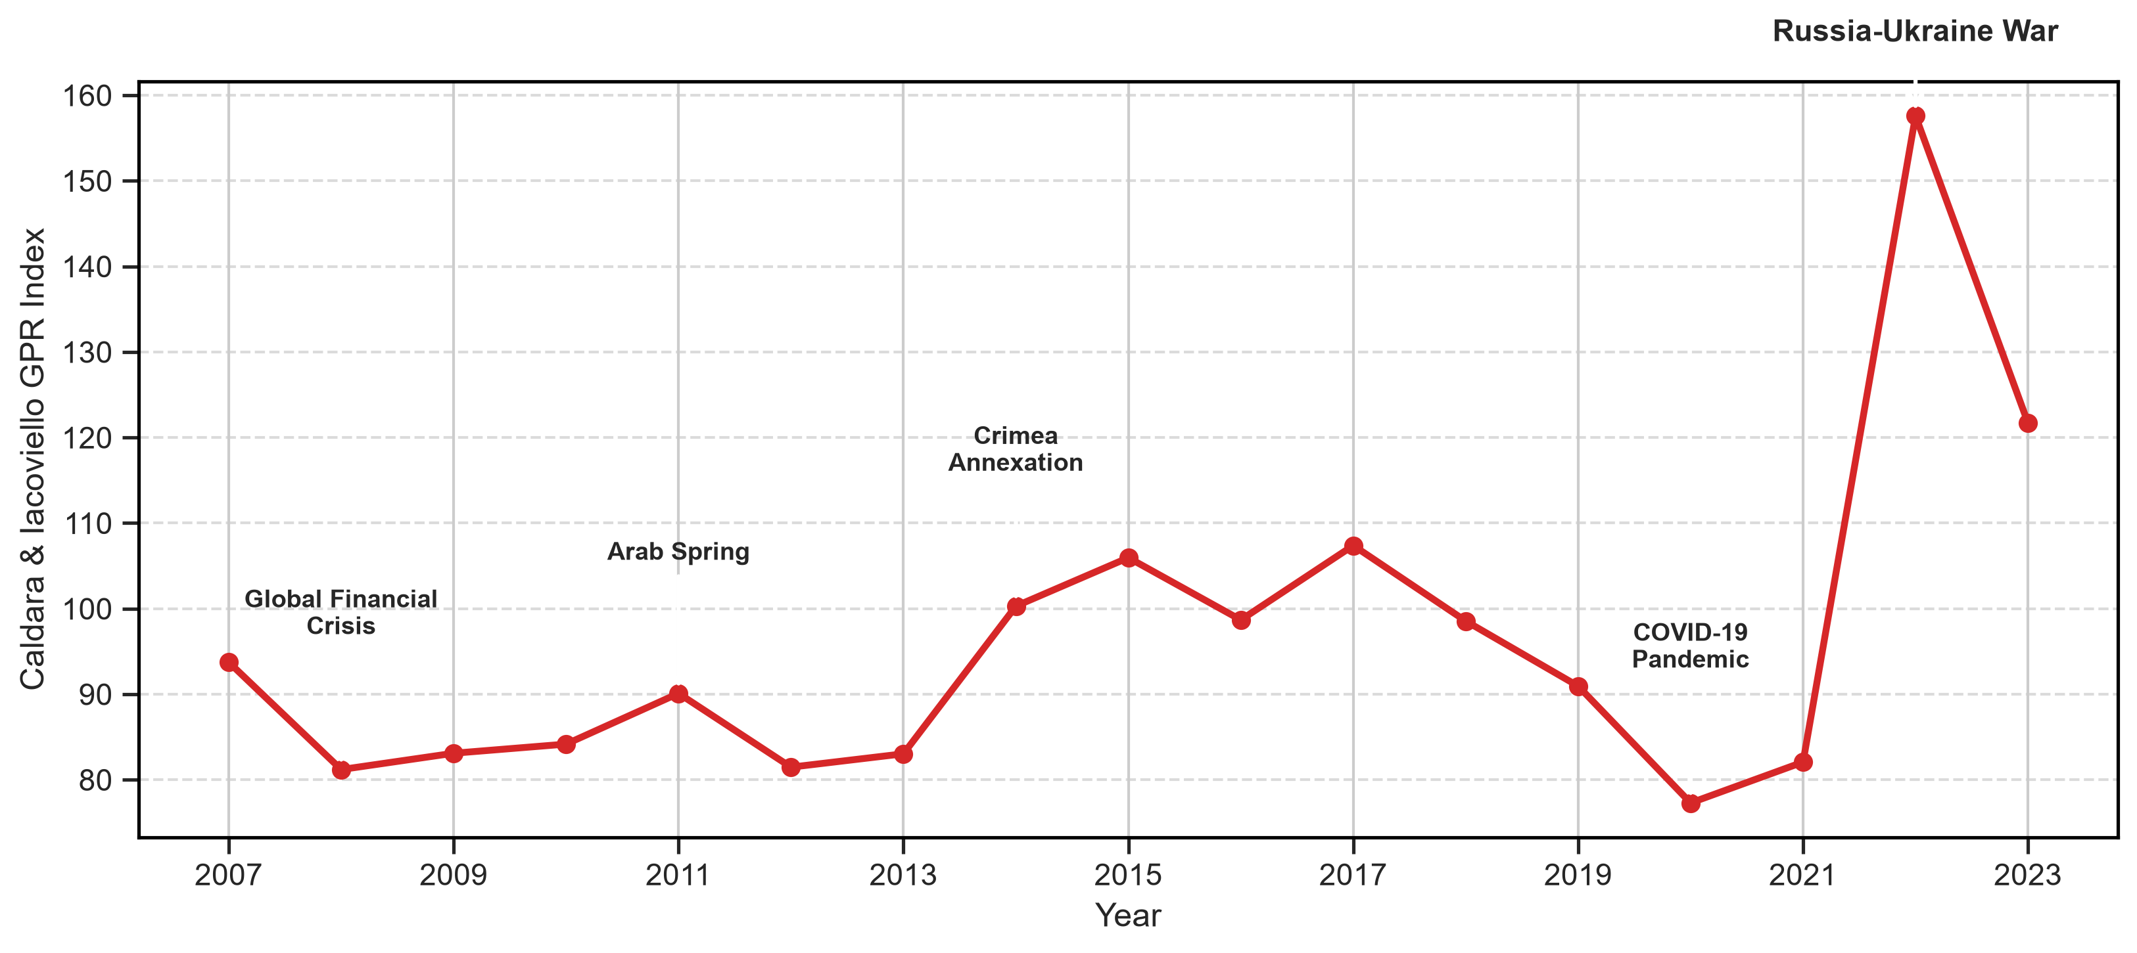
Notes: Annual mean of the Caldara and Iacoviello (2022) Global Geopolitical Risk index (standardized). Key geopolitical events are annotated.
Source: Author's calculations based on CEPII BACI, World Bank DTA, and Caldara and Iacoviello (2022).

4.1. Baseline Results: The GPR–DTA Nexus on Intermediate-Goods Trade
Table 3 reports the baseline PPML gravity estimates for the interaction between standardized global geopolitical risk (GPR) and trade agreement variables on bilateral intermediate-goods exports at the HS2 product level. All specifications include the full set of pair–HS2 fixed effects, exporter–year fixed effects, importer–year fixed effects, and HS2–year fixed effects, thereby absorbing all time-invariant bilateral-product heterogeneity and all unilateral multilateral resistance terms consistent with the structural gravity literature (Anderson & van Wincoop, 2003; Head & Mayer, 2014). Standard errors are clustered at the unordered country-pair level with multiway pair-plus-year clustering reported for inference robustness.
Column (1) estimates the interaction between GPR and a binary FTA indicator. The coefficient on GPR × FTA is −0.0241 (p = 0.024), implying that when global geopolitical risk rises by one historical standard deviation, intermediate-goods trade between FTA partners declines by an additional 2.38 percent relative to non-FTA pairs. This result is both statistically significant and economically meaningful: the magnitude is comparable to half the typical trade-creation effect of a shallow FTA reported in the meta-analysis of Head and Mayer (2014).
Column (2) replaces the binary FTA indicator with DTA depth, measured as the number of legally enforceable provisions divided by ten. The interaction GPR × DTA Depth yields a coefficient of −0.0053 (p = 0.255), which is negative but statistically insignificant. This suggests that, in isolation, the depth of institutional commitments does not systematically amplify geopolitical sensitivity at the aggregate level.
Column (3) enters both interactions jointly. The FTA interaction strengthens to −0.0382 (p = 0.025, effect: −3.75%), while the depth interaction turns positive at +0.0099 (p = 0.202, effect: +0.99%). Although the depth coefficient does not reach conventional significance, its sign reversal in the joint specification is economically informative: conditional on having an FTA, deeper institutional commitments partially offset the heightened vulnerability that FTA membership itself creates. This decomposition reveals a nuanced mechanism—FTA integration increases exposure through supply-chain interdependence, but deeper legal frameworks provide partial institutional insurance against geopolitical shocks.

Table 3. Baseline PPML Gravity Estimates: GPR × Trade Agreement Interactions
Variable | (1) FTA interaction | (2) Depth interaction | (3) Joint FTA + depth
GPR × DTA depth | — | −0.0053  (0.0047)  [−0.53%] | 0.0099  (0.0078)  [+0.99%]
GPR × FTA | −0.0241**  (0.0107)  [−2.38%] | — | −0.0382**  (0.0171)  [−3.75%]
FTA level term | Included | — | Included
DTA-depth level term | — | Included | Included
Pair–HS2 fixed effects | Yes | Yes | Yes
Exporter–year fixed effects | Yes | Yes | Yes
Importer–year fixed effects | Yes | Yes | Yes
HS2–year fixed effects | Yes | Yes | Yes
Observations | 16,752,356 | 16,752,356 | 16,752,356
Notes: PPML estimates with multiway-clustered standard errors in parentheses. Marginal effects in brackets. *** p < 0.01, ** p < 0.05, * p < 0.10.
Source: Author's calculations based on CEPII BACI, World Bank DTA, and Caldara and Iacoviello (2022).

4.2. Sectoral Heterogeneity: GVC Complexity as a Transmission Mechanism
The aggregate baseline masks substantial heterogeneity across industries with different degrees of global value chain complexity, asset specificity, and input substitutability. To uncover the economic mechanism underlying the aggregate FTA–GPR interaction, we estimate sector-specific PPML models for each of ten pre-specified HS2 manufacturing groups. Table 4 and Figure 2 present the five sectors where both the GPR × FTA and GPR × DTA Depth interactions survive Benjamini-Hochberg false discovery rate (BH-FDR) correction at the 10 percent level. Appendix Table A1 reports the complete ten-sector results.
The sectoral pattern strongly supports the hypothesis that GVC complexity is the primary transmission channel through which geopolitical risk disrupts trade within preferential agreements. Transport equipment—an archetype of vertically fragmented production with extensive cross-border component sourcing—exhibits the largest FTA interaction (−4.63%, BH-FDR p = 0.026) and depth interaction (−1.83%, BH-FDR p = 0.062). Textiles and footwear, another sector characterized by long, geographically dispersed value chains and relationship-specific inputs, shows comparable magnitudes (FTA: −4.37%, BH-FDR p = 0.003; Depth: −1.99%, BH-FDR p = 0.005). Machinery and electronics (FTA: −3.43%; Depth: −1.34%) and precision instruments (FTA: −3.15%; Depth: −1.72%) follow a consistent pattern.
By contrast, sectors trading relatively homogeneous commodities with thick spot markets—agro-food inputs (+2.04%, BH-FDR p = 0.125), minerals and fuels (+0.18%, BH-FDR p = 0.923), and wood products (+3.00%, BH-FDR p = 0.125)—display positive or near-zero interactions that do not survive multiple-testing correction. These sectors feature low asset specificity, easy supplier switching, and active commodity exchanges, which insulate them from geopolitical disruptions within preferential frameworks.
This cross-sectoral gradient directly illuminates the mechanism of observation. The FTA–GPR sensitivity is not a generic feature of all preferential trade; rather, it is concentrated in industries where FTA-induced integration deepens Just-in-Time supply chains, raises relationship-specific investments, and creates hold-up vulnerabilities that geopolitical shocks exploit. The monotonic relationship between sectoral GVC complexity and the magnitude of the GPR × FTA coefficient provides strong evidence that supply-chain interdependence is the causal pathway, not reverse causality or omitted confounders.

Table 4. Sector Heterogeneity: GPR × Trade Agreement Interactions by HS2 Manufacturing Group
Sector | GPR × FTA | BH-FDR p | GPR × DTA depth | BH-FDR p | N
Textiles and footwear | −0.0447***  (0.0124)  [−4.37%] | 0.003 | −0.0201***  (0.0058)  [−1.99%] | 0.005 | 2,522,056
Transport equipment | −0.0474**  (0.0188)  [−4.63%] | 0.026 | −0.0184*  (0.0085)  [−1.83%] | 0.062 | 669,321
Precision and other manufactures | −0.0320**  (0.0123)  [−3.15%] | 0.026 | −0.0173***  (0.0053)  [−1.72%] | 0.006 | 1,171,921
Machinery and electronics | −0.0349**  (0.0131)  [−3.43%] | 0.026 | −0.0135*  (0.0068)  [−1.34%] | 0.077 | 723,655
Plastics, rubber and leather | −0.0194**  (0.0078)  [−1.92%] | 0.026 | −0.0108*  (0.0049)  [−1.07%] | 0.062 | 947,987
Notes: PPML estimates by sector. Standard errors in parentheses (pair-clustered); marginal effects in brackets. *** p < 0.01, ** p < 0.05, * p < 0.10.
Source: Author's calculations based on CEPII BACI, World Bank DTA, and Caldara and Iacoviello (2022).

Figure 2. Sectoral Heterogeneity in the Response of Intermediate-Goods Trade to Global GPR
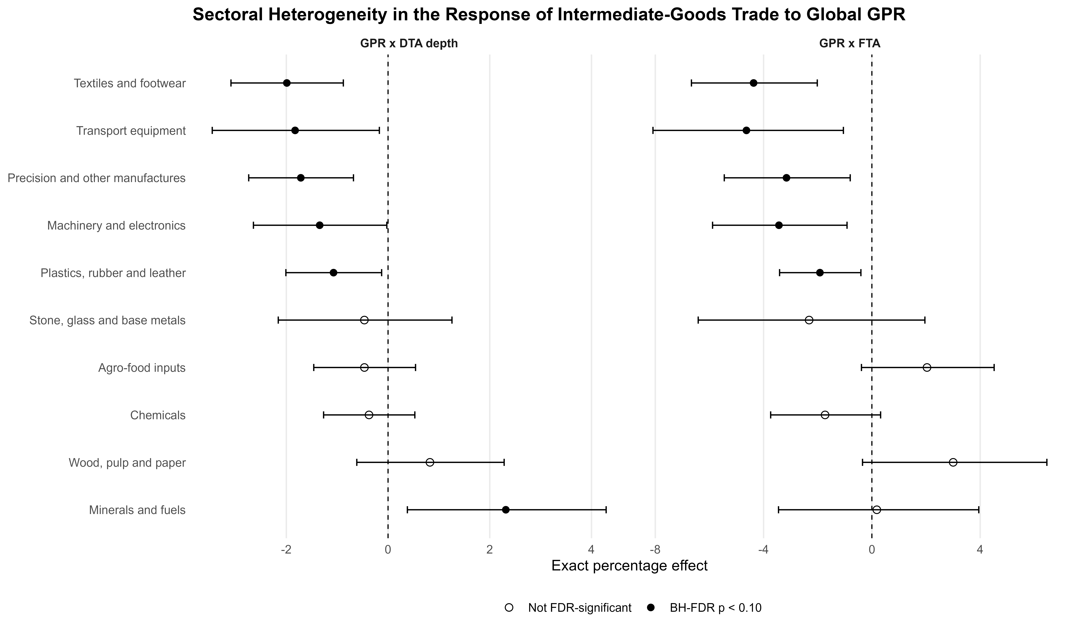
Notes: Point estimates and 95% confidence intervals. Filled circles indicate significance after Benjamini-Hochberg FDR correction at the 10% level.
Source: Author's calculations based on CEPII BACI, World Bank DTA, and Caldara and Iacoviello (2022).

4.3. Mechanism Analysis: DTA Policy Provisions as Micro-Level Shock Absorbers
Having established that GVC complexity channels the aggregate effect, we now investigate which specific institutional provisions within deep trade agreements serve as transmission mechanisms. This analysis directly addresses the question of why deeper agreements partially offset the FTA vulnerability identified in the baseline aggregate models.

4.3.1. DTA provision bundles
We classify the legally enforceable provisions in the World Bank DTA database into five thematic bundles: (i) Border Coordination (customs, SPS, TBT); (ii) Investment and Production (investment, capital mobility, TRIMS); (iii) Services and Procurement (trade in services, public procurement); (iv) Environmental Provisions (environmental laws); and (v) Digital and Knowledge (data protection, IPR, research and technology). Because inter-bundle correlations are high, we estimate standalone and FTA-conditional models separately for each bundle rather than entering all five jointly (Appendix Table A2).
Among the five bundles, Environmental Provisions exhibit the most robust FTA-conditional interaction with GPR: a coefficient of +0.0384 (full-bundle effect: +3.91%, raw p = 0.049), indicating that pairs whose agreements include binding environmental commitments experience approximately 3.9 percent less trade decline under an equivalent GPR shock. The Digital and Knowledge bundle displays a positive but insignificant point estimate (+4.63%, p = 0.180), suggesting a potential buffering role that requires further investigation with larger samples or more granular provision data.

Appendix Table A2. DTA Mechanism Bundles: GPR × Bundle Depth Interactions (FTA-Conditional)
Bundle | Estimate | SE | Full-bundle  effect (%) | Raw p | BH-FDR p | N
Environmental provisions | 0.0384 | 0.0195 | +3.91% | 0.049 | 0.244 | 16,752,356
Digital and knowledge | 0.0453 | 0.0338 | +4.63% | 0.180 | 0.451 | 16,752,356
Border coordination | 0.0178 | 0.0213 | +1.80% | 0.404 | 0.673 | 16,752,356
Investment and production | 0.0072 | 0.0180 | +0.72% | 0.691 | 0.753 | 16,752,356
Services and procurement | 0.0059 | 0.0188 | +0.59% | 0.753 | 0.753 | 16,752,356
Notes: FTA-conditional PPML estimates. *** p < 0.01, ** p < 0.05, * p < 0.10.
Source: Author's calculations based on CEPII BACI, World Bank DTA, and Caldara and Iacoviello (2022).

4.3.2. Individual provision screening
To achieve greater precision, we screen all fourteen individual legally enforceable provisions in FTA-conditional specifications (Appendix Table A3). Three provisions emerge with economically meaningful and statistically notable interactions:
First, Competition Policy (+3.60%, p = 0.037) contributes to trade resilience by ensuring a level playing field that prevents dominant suppliers from exploiting crisis-driven market power. When geopolitical shocks create supply bottlenecks, enforceable competition disciplines discourage monopolistic price gouging and facilitate the entry of alternative suppliers, thereby maintaining trade flow continuity.
Second, Environmental Laws (+3.91%, p = 0.049) promote supply-chain transparency, traceability standards, and clean-production certification. These regulatory frameworks create shared compliance infrastructure that raises the costs of abrupt supply-chain reconfiguration, paradoxically anchoring trade relationships more firmly during geopolitical turbulence. Firms that have invested in meeting joint environmental standards face higher sunk costs of switching partners, reinforcing bilateral trade resilience.
Third, Research and Technology cooperation (+3.49%, p = 0.041) enhances firms' adaptive capacity by facilitating knowledge transfer, joint R&D, and technology licensing across borders. When geopolitical disruptions threaten input availability, firms embedded in technology-sharing frameworks can more rapidly develop substitute inputs, re-engineer production processes, or identify alternative sourcing routes—all of which sustain bilateral trade volumes.
Collectively, these provision-level results reveal a coherent micro-mechanism: the partial offsetting effect of DTA depth observed in the joint baseline specification (Table 3, Column 3) is driven by specific institutional disciplines that enhance transparency, foster innovation, and maintain competitive market structures. Traditional border-focused provisions (customs, SPS, TBT) and investment chapters show no significant buffering effect, underscoring that it is the “behind-the-border” institutional quality—not the breadth of coverage per se—that creates geopolitical resilience.

Appendix Table A3. Individual DTA Provision Screening: GPR × Provision Interactions (FTA-Conditional)
Provision | Estimate | SE | Effect (%) | Raw p | BH-FDR p | N
Competition policy | 0.0353 | 0.0169 | +3.60% | 0.037 | 0.228 | 16,752,356
Environmental laws | 0.0384 | 0.0195 | +3.91% | 0.049 | 0.228 | 16,752,356
Research and technology | 0.0343 | 0.0168 | +3.49% | 0.041 | 0.228 | 16,752,356
Public procurement | 0.0330 | 0.0208 | +3.36% | 0.112 | 0.313 | 16,752,356
Movement of capital | 0.0215 | 0.0123 | +2.17% | 0.081 | 0.283 | 16,752,356
Technical barriers to trade | 0.0205 | 0.0173 | +2.08% | 0.235 | 0.412 | 16,752,356
Intellectual property rights | 0.0160 | 0.0188 | +1.61% | 0.395 | 0.503 | 16,752,356
Trade-related intellectual property | 0.0160 | 0.0141 | +1.61% | 0.255 | 0.412 | 16,752,356
SPS measures | 0.0150 | 0.0162 | +1.51% | 0.355 | 0.497 | 16,752,356
Data protection | 0.0146 | 0.0131 | +1.47% | 0.265 | 0.412 | 16,752,356
Trade-related investment measures | 0.0004 | 0.0100 | +0.04% | 0.969 | 0.969 | 16,752,356
Customs | −0.0024 | 0.0154 | −0.24% | 0.877 | 0.945 | 16,752,356
Investment | −0.0119 | 0.0152 | −1.18% | 0.437 | 0.509 | 16,752,356
Trade in services | −0.0207 | 0.0168 | −2.05% | 0.216 | 0.412 | 16,752,356
Notes: FTA-conditional PPML estimates. *** p < 0.01, ** p < 0.05, * p < 0.10.
Source: Author's calculations based on CEPII BACI, World Bank DTA, and Caldara and Iacoviello (2022).

4.4. Extensive Margin: Trade-Link Survival Under Geopolitical Stress

4.4.1. Baseline survival effects
The intensive-margin results demonstrate that geopolitical risk reduces the value of existing trade flows within preferential agreements. A natural follow-up question is whether GPR also destroys trade relationships entirely—that is, whether it operates on the extensive margin by eliminating bilateral product-level trade links. Table 5 presents linear probability model (LPM) estimates of the survival probability for at-risk trade links (pair–HS2 combinations with positive trade in year t−1), using the same four-dimensional fixed-effect structure as the PPML specifications.
The joint specification with lagged link-size controls (Column 5) reveals a striking decomposition. The GPR × DTA Depth interaction is −0.0052 (p < 0.001), indicating that each additional ten legally enforceable provisions reduce the one-year survival probability by 0.52 percentage points when GPR rises by one standard deviation. Meanwhile, the GPR × FTA interaction turns positive at +0.0028 (p = 0.086), suggesting that, conditional on agreement depth, the binary presence of an FTA provides a modest survival premium.

Table 5. Trade-Link Survival: GPR × Trade Agreement Interactions (LPM)
Variable | (1) FTA,  no size | (2) FTA  + size | (3) Depth,  no size | (4) Depth  + size | (5) Joint  + size
GPR × DTA depth | — | — | −0.0040*  (0.0021)  [−0.40 pp] | −0.0042*  (0.0021)  [−0.42 pp] | −0.0052***  (0.0017)  [−0.52 pp]
GPR × FTA | −0.0044  (0.0036)  [−0.44 pp] | −0.0047  (0.0037)  [−0.47 pp] | — | — | 0.0028*  (0.0015)  [+0.28 pp]
Lagged link-size control | No | Yes | No | Yes | Yes
Pair–HS2 fixed effects | Yes | Yes | Yes | Yes | Yes
Exporter–year fixed effects | Yes | Yes | Yes | Yes | Yes
Importer–year fixed effects | Yes | Yes | Yes | Yes | Yes
HS2–year fixed effects | Yes | Yes | Yes | Yes | Yes
Observations | 8,045,131 | 8,045,131 | 8,045,131 | 8,045,131 | 8,045,131
Notes: LPM estimates. Standard errors in parentheses (pair-plus-year multiway clustered). Effects in percentage points. *** p < 0.01, ** p < 0.05, * p < 0.10.
Source: Author's calculations based on CEPII BACI, World Bank DTA, and Caldara and Iacoviello (2022).

Figure 3. Marginal Effect of Geopolitical Risk on Trade-Link Survival Conditional on DTA Depth
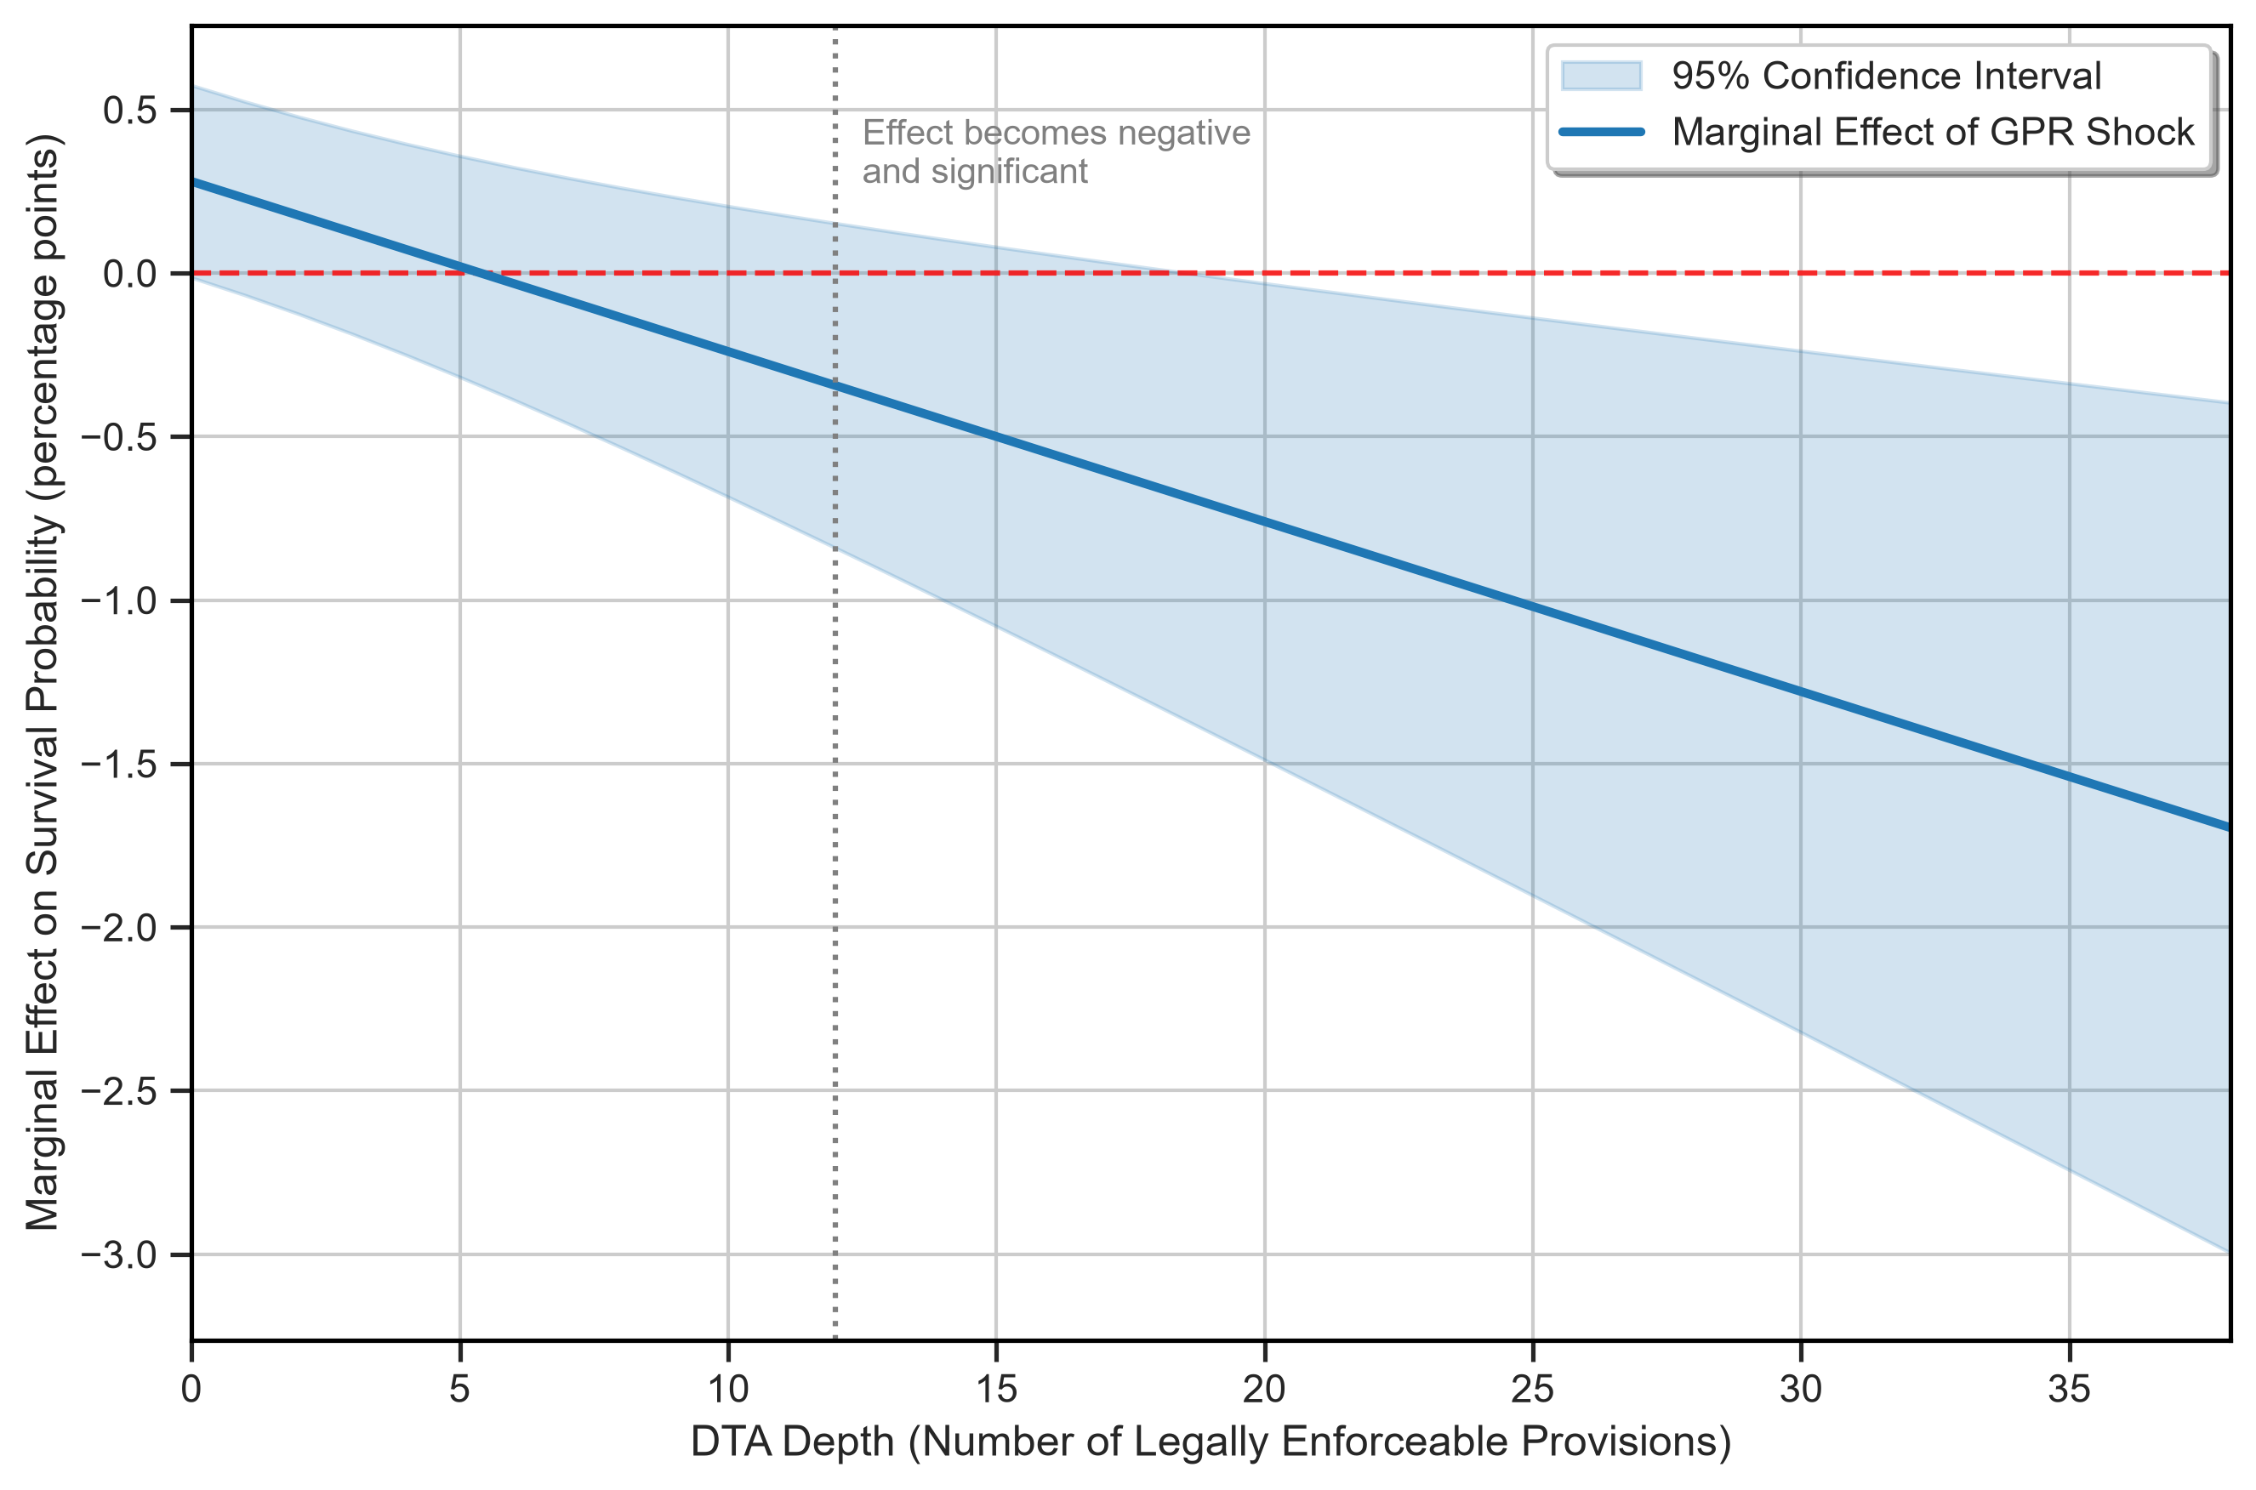
Notes: Net marginal effect of a 1 SD increase in Global GPR on trade-link survival probability. Shaded area represents the 95% confidence interval.
Source: Author's calculations based on CEPII BACI, World Bank DTA, and Caldara and Iacoviello (2022).

The mechanism underlying this extensive-margin vulnerability differs from the intensive-margin channel. While the intensive margin reflects reduced trade volumes among continuing relationships, the extensive margin captures complete relationship termination. Figure 3 plots the marginal effect of GPR on link survival across the continuous range of DTA depth. The effect is mildly positive for shallow FTAs but slopes downward, becoming significantly negative for deep agreements (those with more than 12 enforceable provisions). Deeper agreements impose higher fixed compliance costs—rules of origin documentation, regulatory conformity assessments, and standards certification—that become prohibitively expensive for smaller or more marginal trade links when geopolitical uncertainty raises the option value of waiting. The result is a selective pruning of the weakest trade links within deep-agreement networks, even as the core high-value relationships persist.

4.4.2. Robustness of survival estimates
We subject the survival findings to extensive robustness analysis (Table 6). Alternative GPR measures—the threat component, the acts component, the log-transformed mean, and the annual peak—all produce negative and significant depth interactions under pair-plus-year clustering (threat: −0.34 pp, p = 0.002; peak: −0.65 pp, p = 0.007; log-mean: −0.53 pp, p = 0.008). Restricting the sample to established links with lagged trade above US$100,000 or US$1 million yields smaller but consistently negative depth coefficients (−0.13 pp and −0.14 pp, respectively), confirming that the result is not driven by small, ephemeral trade links.
Most compellingly, Figure 4 displays a leave-one-year-out Jackknife sensitivity analysis. Across all 16 iterations—each omitting a single calendar year from the sample—the GPR × Depth interaction remains strictly negative, ranging from −0.68 to −0.40 percentage points, and achieves p < 0.01 under pair clustering in every iteration. Under the more conservative pair-plus-year clustering, the coefficient is significant at p < 0.10 in all 16 iterations and at p < 0.05 in 15 of 16. This extraordinary temporal stability eliminates concerns that any single geopolitical event (e.g., the Russia–Ukraine conflict in 2022, the COVID-19 pandemic in 2020, or the Arab Spring in 2011) drives the aggregate finding.

Table 6. Survival Robustness: Alternative GPR Measures and Sample Restrictions
Panel | Check | Estimate | SE | Effect (pp) | p-value | N
A. Alternative global GPR
 | Baseline annual mean GPR | −0.0052 | 0.0017 | −0.52 | 0.007 | 8,045,131
 | Log annual mean GPR | −0.0053 | 0.0017 | −0.53 | 0.008 | 8,045,131
 | GPR threats | −0.0034 | 0.0009 | −0.34 | 0.002 | 8,045,131
 | GPR acts | −0.0037 | 0.0030 | −0.37 | 0.229 | 8,045,131
 | Annual peak GPR | −0.0065 | 0.0021 | −0.65 | 0.007 | 8,045,131
B. Established-link samples
 | Lagged trade ≥ USD 100,000 | −0.0013 | 0.0004 | −0.13 | 0.011 | 3,842,229
 | Lagged trade ≥ USD 1 million | −0.0014 | 0.0006 | −0.14 | 0.019 | 2,079,423
C. Active-FTA-only sample
 | FTA-only, size-adjusted | −0.0046 | 0.0031 | −0.46 | 0.162 | 3,479,262
Notes: Standard errors are pair-plus-year multiway clustered. *** p < 0.01, ** p < 0.05, * p < 0.10.
Source: Author's calculations based on CEPII BACI, World Bank DTA, and Caldara and Iacoviello (2022).

Figure 4. Leave-One-Year-Out Estimates of the DTA Depth–Survival Interaction
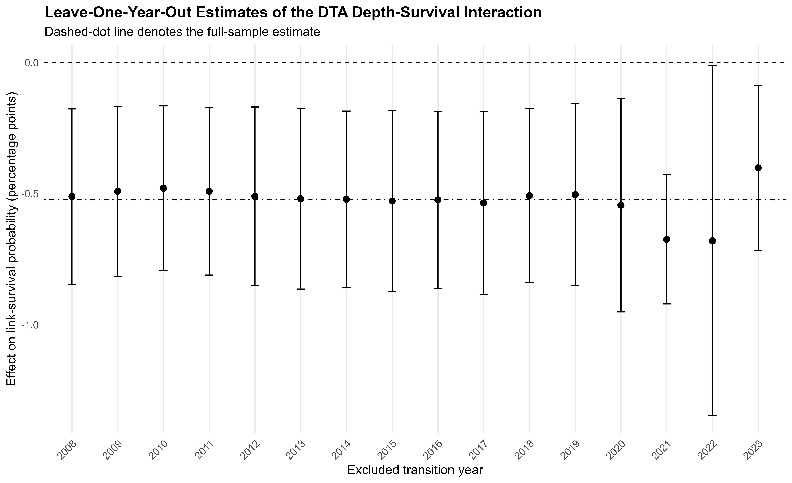
Notes: Leave-one-year-out estimates of the GPR × DTA Depth interaction. Vertical bars denote 95% confidence intervals.
Source: Author's calculations based on CEPII BACI, World Bank DTA, and Caldara and Iacoviello (2022).

4.5. Post-Exit Recovery Dynamics: Short-Term Friction Versus Medium-Term Resilience
Having documented that geopolitical risk accelerates trade-link destruction within deep agreements, we now examine the recovery dynamics following link exits. Table 7 reports LPM estimates for four post-exit outcomes: re-entry within one year, re-entry within two years, full value recovery within one year, and full value recovery within two years. The sample comprises 1,151,310 exit events observed between 2008 and 2022, with directed-pair fixed effects as the primary specification.
The results reveal a temporal asymmetry that provides further insight into the economic mechanism. For one-year re-entry, the GPR × Depth interaction is −0.0035 (p = 0.044, effect: −0.35 percentage points), indicating that deeper agreements slow the short-term reconstitution of disrupted trade links. However, for two-year re-entry, the coefficient collapses to statistical insignificance (+0.0001, p = 0.978), and the full-recovery outcomes at both horizons are similarly insignificant (p > 0.40).
This dynamic pattern is consistent with a fixed-cost adjustment mechanism. In the immediate aftermath of a geopolitical shock, the compliance and renegotiation costs embedded in deep agreements—re-establishing rules-of-origin documentation, renewing regulatory certifications, and rebuilding trust with institutional counterparts—create friction that delays re-entry relative to shallow or non-preferential alternatives. However, over a two-year horizon, these same institutional frameworks facilitate re-engagement by providing established legal channels, dispute resolution mechanisms, and regulatory predictability. The result is not permanent hysteresis but rather a transitory adjustment cost that the institutional infrastructure of deep agreements eventually overcomes.
Appendix Table A4 reports net GPR interaction effects at representative depth levels (0, 10, 20, and 30 enforceable provisions). For one-year re-entry, the net effect turns significantly negative only at high depth levels (20 provisions: −0.57 pp, p = 0.003; 30 provisions: −0.93 pp, p = 0.007), reinforcing the interpretation that the short-term friction is proportional to institutional complexity rather than a binary FTA effect.

Table 7. Post-Exit Recovery: GPR × DTA Depth Interactions (LPM)
Outcome | Directed-pair FE | N | Pair–HS2 FE | N
Re-entry within one year | −0.0035**  (0.0016)  [−0.35 pp] | 1,151,310 | −0.0001  (0.0021)  [−0.01 pp] | 839,585
Re-entry within two years | 0.0001  (0.0035)  [+0.01 pp] | 1,064,542 | 0.0013  (0.0056)  [+0.13 pp] | 752,846
Full recovery within one year | −0.0009  (0.0011)  [−0.09 pp] | 1,151,310 | 0.0005  (0.0016)  [+0.05 pp] | 839,585
Full recovery within two years | −0.0002  (0.0036)  [−0.02 pp] | 1,064,542 | 0.0041  (0.0059)  [+0.41 pp] | 752,846
Notes: LPM estimates. Standard errors in parentheses (pair + exit-year clustered). Effects in percentage points. *** p < 0.01, ** p < 0.05, * p < 0.10.
Source: Author's calculations based on CEPII BACI, World Bank DTA, and Caldara and Iacoviello (2022).

Appendix Table A4. Post-Exit Recovery: Net GPR Interaction Effects at Representative Depth Levels
Outcome | Enforceable  provisions | Net effect (pp) | p-value | N
Re-entry within one year | 0 | +0.14 pp | 0.570 | 1,151,310
 | 10 | −0.22 pp | 0.089 | 1,151,310
 | 20 | −0.57 pp | 0.003 | 1,151,310
 | 30 | −0.93 pp | 0.007 | 1,151,310
Re-entry within two years | 0 | +0.35 pp | 0.567 | 1,064,542
 | 10 | +0.36 pp | 0.451 | 1,064,542
 | 20 | +0.37 pp | 0.527 | 1,064,542
 | 30 | +0.38 pp | 0.653 | 1,064,542
Full recovery within one year | 0 | −0.02 pp | 0.912 | 1,151,310
 | 10 | −0.11 pp | 0.291 | 1,151,310
 | 20 | −0.19 pp | 0.116 | 1,151,310
 | 30 | −0.28 pp | 0.187 | 1,151,310
Full recovery within two years | 0 | −0.07 pp | 0.901 | 1,064,542
 | 10 | −0.10 pp | 0.826 | 1,064,542
 | 20 | −0.12 pp | 0.827 | 1,064,542
 | 30 | −0.14 pp | 0.863 | 1,064,542
Notes: Standard errors derived with pair-plus-year multiway clustering. *** p < 0.01, ** p < 0.05, * p < 0.10.
Source: Author's calculations based on CEPII BACI, World Bank DTA, and Caldara and Iacoviello (2022).

4.6. Country-Specific Geopolitical Risk
Our baseline specifications use global GPR as the shock variable, which has the econometric advantage of being plausibly exogenous to any bilateral trade pair. However, one may question whether the mechanism operates similarly when geopolitical risk is measured at the country level. Table 8 addresses this concern by re-estimating both the trade-value PPML and trade-link survival LPM using bilateral pair-specific GPR indices—constructed as the average or maximum of the exporter- and importer-specific GPR series from Caldara and Iacoviello (2022). Figure A2 provides a visual comparison of the coefficient estimates across all shock specifications.
Panel A of Table 8 shows that the trade-value PPML results strengthen considerably under country-specific GPR. Using the average pair-country GPR, the FTA interaction deepens to −0.0852 (p = 0.007, effect: −8.17%), while the depth interaction turns significantly positive at +0.0280 (p = 0.018, effect: +2.84%). The log-average and maximum formulations produce qualitatively identical patterns. Importantly, a restricted-sample benchmark using global GPR on the same 946-pair subsample confirms that the stronger magnitudes reflect both the reduced sample composition and the higher signal-to-noise ratio of country-specific shocks, rather than sample selection alone.
Panel B reports survival LPM results with country-specific GPR. The depth interaction remains consistently negative and highly significant across all three bilateral shock measures (average: −0.17 pp, p < 0.001; log-average: −0.15 pp, p = 0.002; maximum: −0.20 pp, p < 0.001). This robustness across both global and bilateral risk measures confirms that the survival-destroying effect of deep agreements under geopolitical stress is not an artifact of the global GPR index construction.

Table 8. Country-Specific GPR Robustness
Shock measure | GPR × FTA | GPR × DTA depth | N
Panel A. Intermediate-goods trade value (PPML)
Average pair-country GPR | −0.0852***  (0.0319)  [−8.17%] | 0.0280**  (0.0118)  [+2.84%] | 2,520,781
Log-average pair-country GPR | −0.0843***  (0.0294)  [−8.09%] | 0.0277**  (0.0111)  [+2.81%] | 2,520,781
Maximum pair-country GPR | −0.0796**  (0.0339)  [−7.65%] | 0.0240*  (0.0129)  [+2.43%] | 2,520,781
Restricted-sample global GPR | −0.0617***  (0.0217)  [−5.98%] | 0.0160  (0.0109)  [+1.62%] | 2,520,781
Panel B. Trade-link survival (LPM)
Average pair-country GPR | −0.0006  (0.0020)  [−0.06 pp] | −0.0017***  (0.0004)  [−0.17 pp] | 1,878,443
Log-average pair-country GPR | −0.0014  (0.0019)  [−0.14 pp] | −0.0015***  (0.0004)  [−0.15 pp] | 1,878,443
Maximum pair-country GPR | 0.0007  (0.0021)  [+0.07 pp] | −0.0020***  (0.0005)  [−0.20 pp] | 1,878,443
Notes: Standard errors in parentheses (pair-plus-year multiway clustered). *** p < 0.01, ** p < 0.05, * p < 0.10.
Source: Author's calculations based on CEPII BACI, World Bank DTA, and Caldara and Iacoviello (2022).

Appendix Figure A2. Country-Specific GPR Robustness: Trade Value and Link Survival
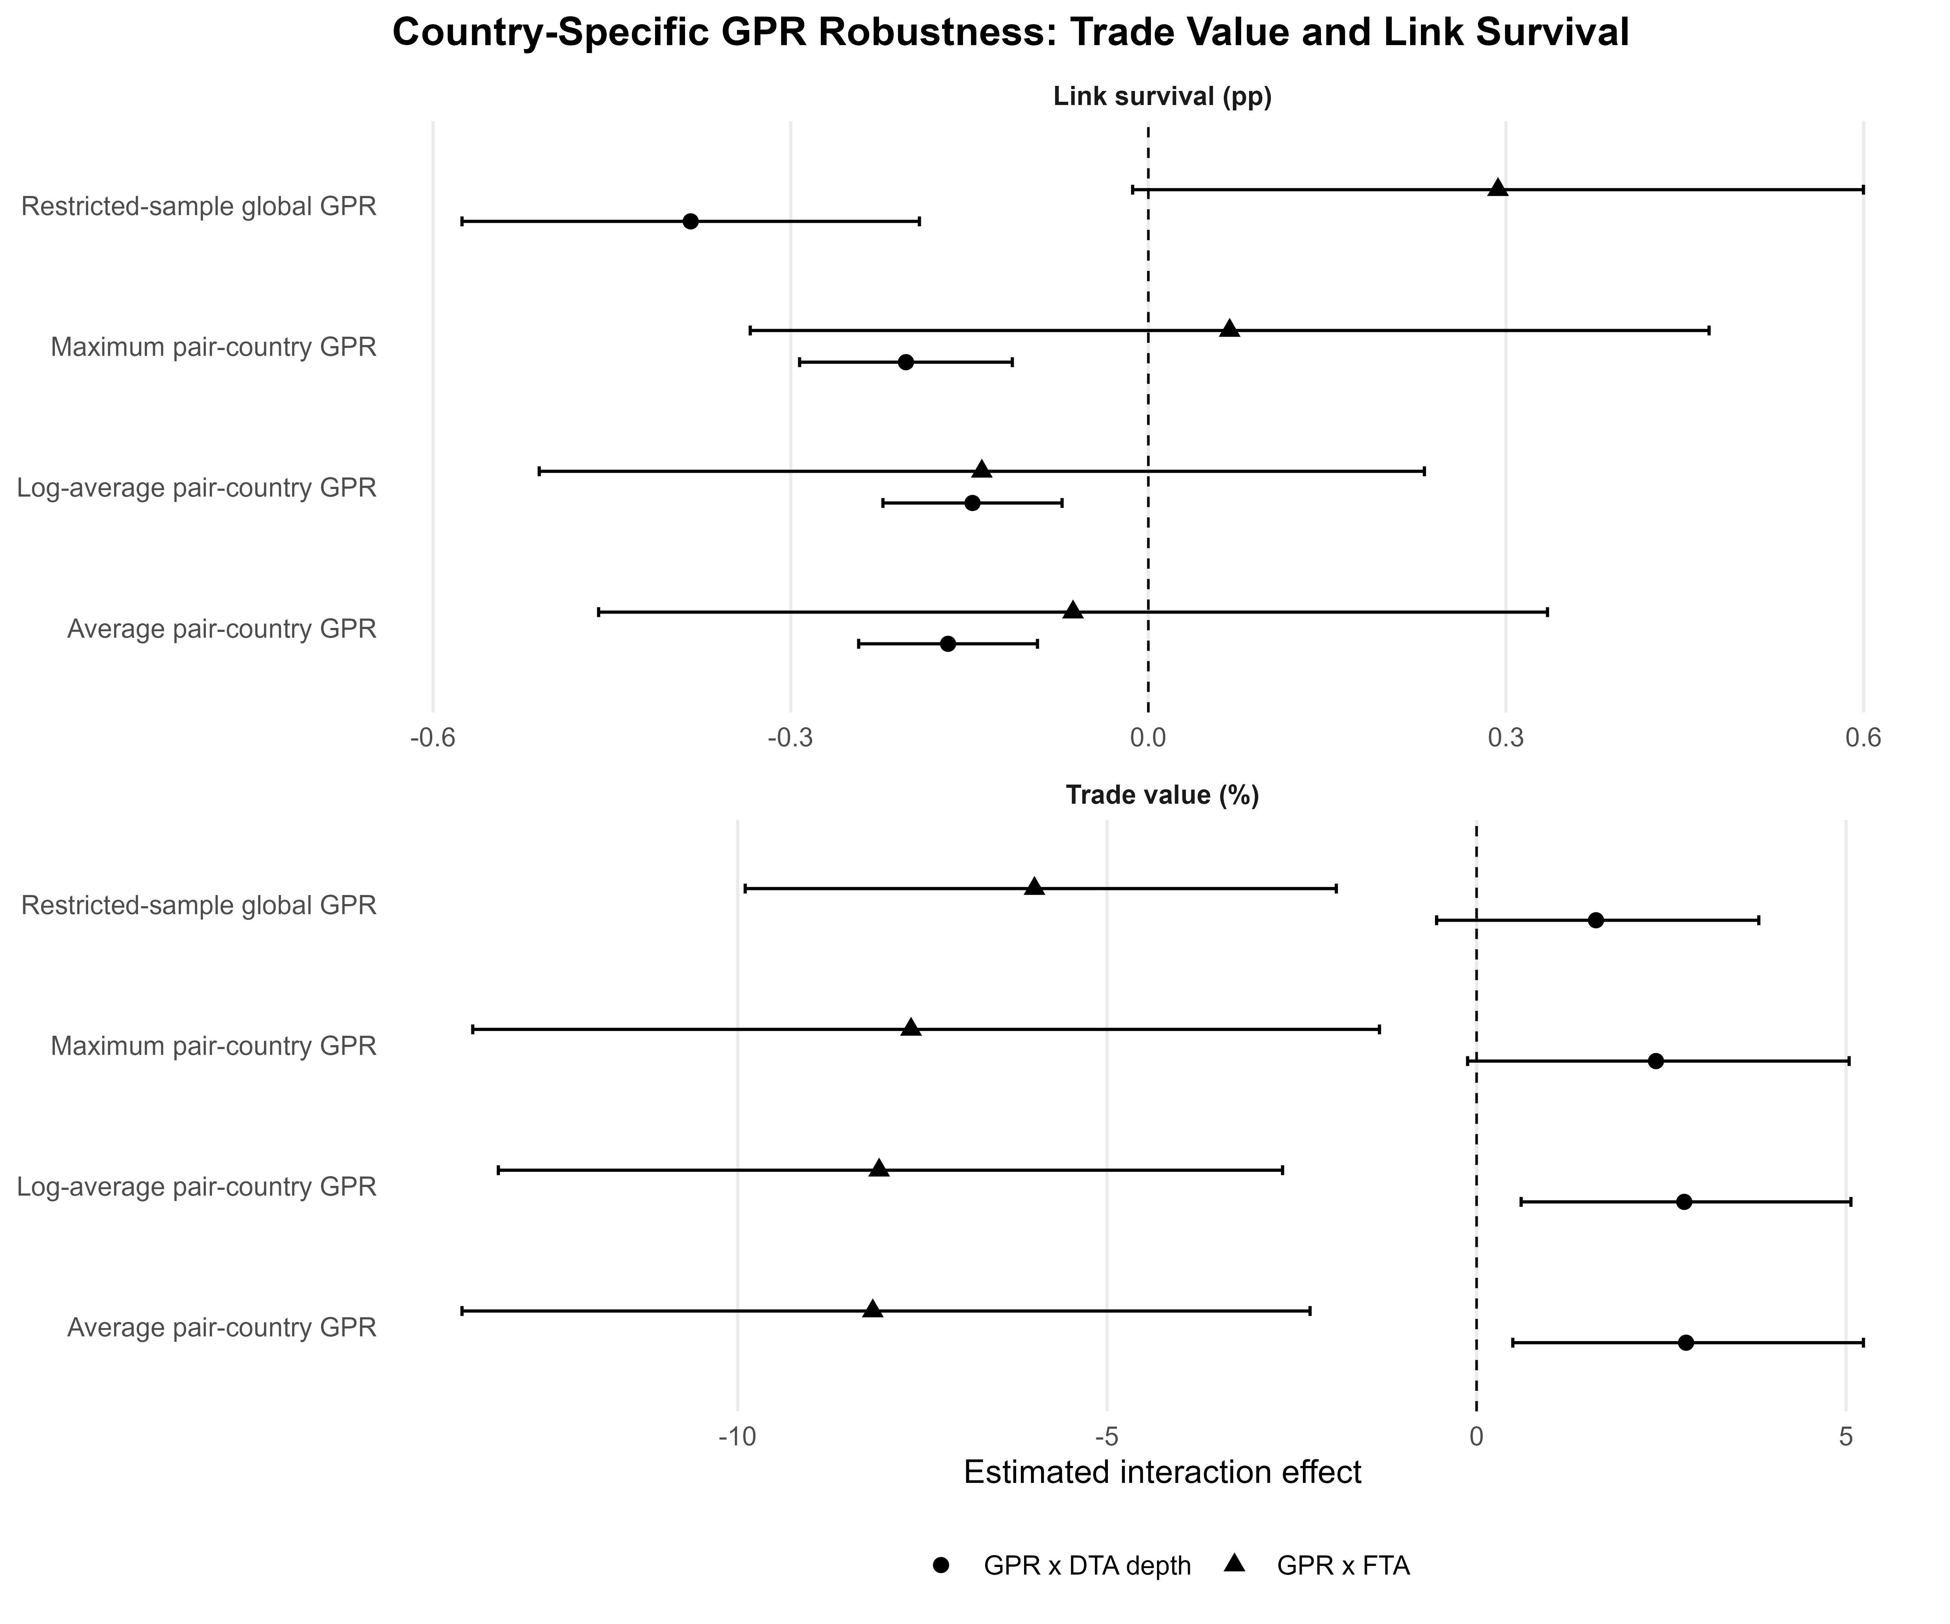
Notes: Point estimates and 95% confidence intervals for country-specific GPR specifications.
Source: Author's calculations based on CEPII BACI, World Bank DTA, and Caldara and Iacoviello (2022).

4.7. Discussion: Mechanism Synthesis
The empirical findings, taken together, reveal a coherent and previously undocumented mechanism through which geopolitical risk interacts with deep trade agreements to reshape global value chain trade. We synthesize the evidence into three interconnected transmission channels.

4.7.1. The supply-chain interdependence channel
The first and most prominent mechanism operates through supply-chain interdependence. Preferential trade agreements—particularly those that eliminate tariffs and harmonize standards—encourage firms to organize production across borders in vertically fragmented value chains. This integration creates efficiency gains during normal times but generates vulnerability during geopolitical crises. The sectoral evidence demonstrates that this channel is strongest in industries with high asset specificity, extensive cross-border component sourcing, and limited input substitutability—precisely the characteristics that international trade theory associates with hold-up problems under uncertainty (Antràs, 2003; Antràs & Helpman, 2004). When geopolitical events threaten the continuity of cross-border transactions, firms embedded in deep supply-chain relationships face adjustment costs that are proportional to the degree of prior integration.

4.7.2. The institutional quality channel
The second mechanism operates through specific institutional provisions that create shock-absorbing capacity. The provision-level analysis identifies competition policy, environmental standards, and research-and-technology cooperation as the disciplines that confer measurable resilience. These provisions share a common feature: they create durable institutional infrastructure —regulatory agencies, compliance monitoring systems, joint technology platforms—that continues to function during crises and reduces the transaction costs of maintaining trade relationships under heightened uncertainty. This finding is consistent with the incomplete-contracts theory of trade agreements (Horn, Maggi, & Staiger, 2010), which predicts that enforceable commitments in areas prone to opportunistic behavior are most valuable precisely when external shocks increase the temptation to renege on cooperative arrangements.

4.7.3. The fixed-cost adjustment channel
The third mechanism explains the extensive-margin dynamics documented earlier. Deep agreements embed substantial fixed costs of compliance—rules of origin, regulatory conformity assessments, and standards certification—that must be maintained to preserve preferential market access. Under normal conditions, these costs are justified by the margin of preference; however, when geopolitical risk rises, the expected present value of future trade declines, causing marginal trade links to fall below the viability threshold. The result is a selective destruction of smaller trade links, which we observe as reduced survival probability. Critically, the post-exit recovery analysis shows that this destruction is not permanent: the institutional infrastructure of deep agreements facilitates re-entry over a two-year horizon, converting what would otherwise be permanent trade destruction into a transitory adjustment.

