4. Empirical Results and Discussion

4.1. Baseline Results
Table 3 reports the baseline PPML gravity estimates. All specifications include pair–HS2, exporter–year, importer–year, and HS2–year fixed effects. Standard errors are multiway-clustered by pair and year.
In Column (1), the GPR × FTA interaction is −0.0241 (p = 0.024), indicating that a one-standard-deviation increase in global geopolitical risk is associated with a 2.38 percent more negative trade response among FTA partners relative to non-FTA pairs. Column (2) enters DTA depth alone; the interaction is negative but statistically insignificant (−0.0053, p = 0.255).
The joint specification in Column (3) is more informative. The FTA interaction strengthens to −0.0382 (p = 0.025, −3.75%), while the depth interaction turns positive at +0.0099 (p = 0.202). Although the depth coefficient does not reach conventional significance, its sign reversal suggests a conditional pattern: FTA membership increases geopolitical sensitivity through supply-chain interdependence, but deeper institutional commitments partially offset this vulnerability. This decomposition motivates the subsequent analyses, which examine whether the pattern varies across sectors, agreement provisions, and trade margins.

Table 3. Baseline PPML Gravity Estimates: GPR × Trade Agreement Interactions
Variable | (1) FTA interaction | (2) Depth interaction | (3) Joint FTA + depth
GPR × DTA depth | — | −0.0053  (0.0047)  [−0.53%] | 0.0099  (0.0078)  [+0.99%]
GPR × FTA | −0.0241**  (0.0107)  [−2.38%] | — | −0.0382**  (0.0171)  [−3.75%]
FTA level term | Included | — | Included
DTA-depth level term | — | Included | Included
Pair–HS2 fixed effects | Yes | Yes | Yes
Exporter–year fixed effects | Yes | Yes | Yes
Importer–year fixed effects | Yes | Yes | Yes
HS2–year fixed effects | Yes | Yes | Yes
Observations | 16,752,356 | 16,752,356 | 16,752,356
Notes: Dependent variable is bilateral intermediate-goods exports at the HS2 level in current USD. Estimated by PPML (fepois). Standard errors in parentheses are clustered at the unordered pair level with pair-plus-year multiway clustering. Marginal effects in brackets. DTA depth is measured as the number of legally enforceable provisions divided by ten. GPR is standardized using 1985–2019 mean and SD. *** p < 0.01, ** p < 0.05, * p < 0.10.

4.2. Sectoral Heterogeneity
Table 4 presents sector-specific PPML estimates for the five manufacturing groups (out of ten) where at least one interaction survives Benjamini-Hochberg FDR correction at the 10 percent level. Transport equipment exhibits the largest FTA interaction (−4.63%, BH-FDR p = 0.026), followed by textiles and footwear (−4.37%, p = 0.003), machinery and electronics (−3.43%, p = 0.026), precision manufactures (−3.15%, p = 0.026), and plastics (−1.92%, p = 0.026). The depth interactions follow a consistent negative pattern across these sectors (Figure 3).
The sectoral gradient is informative about the underlying mechanism. The affected sectors share common characteristics: vertically fragmented production, extensive cross-border component sourcing, relationship-specific investments, and limited short-run input substitutability. By contrast, sectors trading relatively homogeneous commodities with thick spot markets—such as agro-food inputs, minerals and fuels, and wood products—display positive or insignificant interactions that do not survive multiple-testing correction (Appendix Table A1). This pattern is consistent with the interpretation that FTA-induced supply-chain interdependence, rather than trade integration per se, is the primary channel through which geopolitical risk affects intermediate-goods trade within preferential agreements.

Table 4. Sector Heterogeneity: GPR × Trade Agreement Interactions by HS2 Manufacturing Group
Sector | GPR × FTA | BH-FDR p | GPR × DTA depth | BH-FDR p | N
Textiles and footwear | −0.0447***  (0.0124)  [−4.37%] | 0.003 | −0.0201***  (0.0058)  [−1.99%] | 0.005 | 2,522,056
Transport equipment | −0.0474**  (0.0188)  [−4.63%] | 0.026 | −0.0184*  (0.0085)  [−1.83%] | 0.062 | 669,321
Precision and other manufactures | −0.0320**  (0.0123)  [−3.15%] | 0.026 | −0.0173***  (0.0053)  [−1.72%] | 0.006 | 1,171,921
Machinery and electronics | −0.0349**  (0.0131)  [−3.43%] | 0.026 | −0.0135*  (0.0068)  [−1.34%] | 0.077 | 723,655
Plastics, rubber and leather | −0.0194**  (0.0078)  [−1.92%] | 0.026 | −0.0108*  (0.0049)  [−1.07%] | 0.062 | 947,987
Notes: Table reports the five sectors (out of ten) where at least one interaction survives Benjamini-Hochberg FDR correction at the 10% level. Full ten-sector results are in Appendix Table A1. Each sector is estimated as a separate PPML model with the same four-dimensional FE structure as Table 3. Standard errors in parentheses (pair-clustered); marginal effects in brackets. *** p < 0.01, ** p < 0.05, * p < 0.10.

Figure 3. Sectoral Heterogeneity in GPR × Trade Agreement Interactions
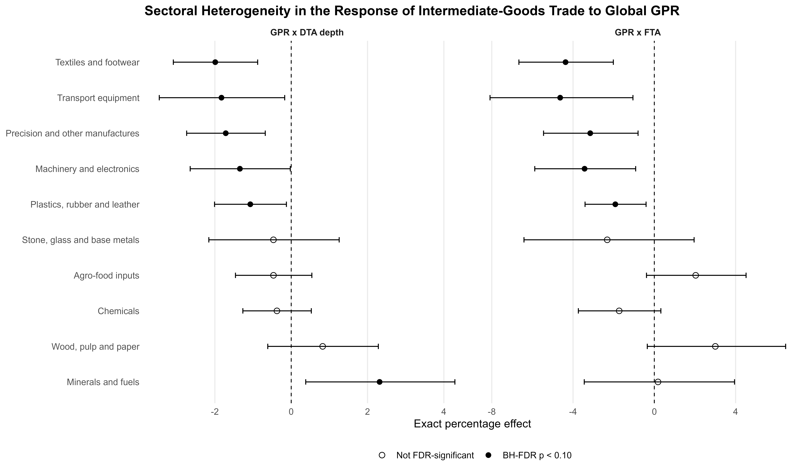
Notes: Forest plot displaying estimated GPR × DTA Depth and GPR × FTA interactions for ten HS2 manufacturing groups. Horizontal bars denote 95% confidence intervals. Filled markers indicate coefficients surviving BH-FDR correction at 10%.

4.3. Mechanism: DTA Policy Provisions
To investigate which institutional provisions within deep agreements contribute to the partial offsetting effect observed in Column (3) of Table 3, we screen five thematic provision bundles and fourteen individual legally enforceable provisions in FTA-conditional PPML specifications (Appendix Tables A2–A3).
Among bundles, Environmental Provisions display the most notable FTA-conditional interaction (+3.91%, raw p = 0.049). At the individual provision level, three disciplines exhibit economically meaningful positive interactions: Competition Policy (+3.60%, p = 0.037), Environmental Laws (+3.91%, p = 0.049), and Research and Technology (+3.49%, p = 0.041). None of these survives BH-FDR correction across all fourteen simultaneous tests (adjusted p = 0.228), which limits the strength of the individual-provision evidence. Nevertheless, their positive signs and consistent magnitudes suggest that “behind-the-border” institutional disciplines—particularly those promoting transparency, competitive market structures, and technology cooperation—may contribute to trade resilience under geopolitical stress, whereas traditional border-focused provisions (customs, SPS, TBT) show no such pattern.

Appendix Table A2. DTA Mechanism Bundles: GPR × Bundle Depth Interactions (FTA-Conditional)
Bundle | Estimate | SE | Full-bundle  effect (%) | Raw p | BH-FDR p | N
Environmental provisions | 0.0384 | 0.0195 | +3.91% | 0.049 | 0.244 | 16,752,356
Digital and knowledge | 0.0453 | 0.0338 | +4.63% | 0.180 | 0.451 | 16,752,356
Border coordination | 0.0178 | 0.0213 | +1.80% | 0.404 | 0.673 | 16,752,356
Investment and production | 0.0072 | 0.0180 | +0.72% | 0.691 | 0.753 | 16,752,356
Services and procurement | 0.0059 | 0.0188 | +0.59% | 0.753 | 0.753 | 16,752,356
Notes: Each row reports a separate FTA-conditional PPML model. The bundle coefficient measures the incremental GPR interaction of the bundle depth, conditional on FTA membership and its GPR interaction. BH-FDR p-values adjust for five simultaneous tests. *** p < 0.01, ** p < 0.05, * p < 0.10.

Appendix Table A3. Individual DTA Provision Screening: GPR × Provision Interactions (FTA-Conditional)
Provision | Estimate | SE | Effect (%) | Raw p | BH-FDR p | N
Competition policy | 0.0353 | 0.0169 | +3.60% | 0.037 | 0.228 | 16,752,356
Environmental laws | 0.0384 | 0.0195 | +3.91% | 0.049 | 0.228 | 16,752,356
Research and technology | 0.0343 | 0.0168 | +3.49% | 0.041 | 0.228 | 16,752,356
Public procurement | 0.0330 | 0.0208 | +3.36% | 0.112 | 0.313 | 16,752,356
Movement of capital | 0.0215 | 0.0123 | +2.17% | 0.081 | 0.283 | 16,752,356
Technical barriers to trade | 0.0205 | 0.0173 | +2.08% | 0.235 | 0.412 | 16,752,356
Intellectual property rights | 0.0160 | 0.0188 | +1.61% | 0.395 | 0.503 | 16,752,356
Trade-related intellectual property | 0.0160 | 0.0141 | +1.61% | 0.255 | 0.412 | 16,752,356
SPS measures | 0.0150 | 0.0162 | +1.51% | 0.355 | 0.497 | 16,752,356
Data protection | 0.0146 | 0.0131 | +1.47% | 0.265 | 0.412 | 16,752,356
Trade-related investment measures | 0.0004 | 0.0100 | +0.04% | 0.969 | 0.969 | 16,752,356
Customs | −0.0024 | 0.0154 | −0.24% | 0.877 | 0.945 | 16,752,356
Investment | −0.0119 | 0.0152 | −1.18% | 0.437 | 0.509 | 16,752,356
Trade in services | −0.0207 | 0.0168 | −2.05% | 0.216 | 0.412 | 16,752,356
Notes: Each row reports a separate FTA-conditional PPML model with a single provision indicator interacted with GPR. BH-FDR p-values adjust for fourteen simultaneous tests. Provisions sorted by effect size descending. *** p < 0.01, ** p < 0.05, * p < 0.10.

4.4. Trade-Link Survival
Table 5 reports LPM estimates for the probability that an existing pair–HS2 trade link (positive trade in t−1) survives into year t. The joint specification with lagged link-size controls (Column 5) yields a GPR × DTA Depth interaction of −0.0052 (p < 0.01), indicating that each additional ten legally enforceable provisions reduce the one-year survival probability by 0.52 percentage points per standard deviation of GPR. The GPR × FTA interaction is positive but only marginally significant (+0.28 pp, p = 0.086).
This extensive-margin result is the most robust finding in the study. Table 6 demonstrates that the negative depth interaction persists under alternative GPR measures (threat component: −0.34 pp, p = 0.002; annual peak: −0.65 pp, p = 0.007), established-link subsamples (trade ≥ USD 100,000: −0.13 pp, p = 0.011), and all sixteen leave-one-year-out iterations (Figure 4). The coefficient ranges from −0.68 to −0.40 pp across Jackknife iterations, indicating that no single year drives the aggregate result.
The mechanism differs from the intensive margin. While the intensive margin captures reduced trade volumes among continuing relationships, the extensive margin reflects complete link termination. Deeper agreements impose higher fixed compliance costs—rules of origin, regulatory conformity assessments, standards certification—that become prohibitively expensive for marginal links when geopolitical uncertainty raises the option value of waiting. The result is selective pruning of the weakest links within deep-agreement networks.

Table 5. Trade-Link Survival: GPR × Trade Agreement Interactions (LPM)
Variable | (1) FTA,  no size | (2) FTA  + size | (3) Depth,  no size | (4) Depth  + size | (5) Joint  + size
GPR × DTA depth | — | — | −0.0040*  (0.0021)  [−0.40 pp] | −0.0042*  (0.0021)  [−0.42 pp] | −0.0052***  (0.0017)  [−0.52 pp]
GPR × FTA | −0.0044  (0.0036)  [−0.44 pp] | −0.0047  (0.0037)  [−0.47 pp] | — | — | 0.0028*  (0.0015)  [+0.28 pp]
Lagged link-size control | No | Yes | No | Yes | Yes
Pair–HS2 fixed effects | Yes | Yes | Yes | Yes | Yes
Exporter–year fixed effects | Yes | Yes | Yes | Yes | Yes
Importer–year fixed effects | Yes | Yes | Yes | Yes | Yes
HS2–year fixed effects | Yes | Yes | Yes | Yes | Yes
Observations | 8,045,131 | 8,045,131 | 8,045,131 | 8,045,131 | 8,045,131
Notes: Dependent variable is a binary indicator equal to one if a pair–HS2 link with positive trade in t−1 remains positive in t. Estimated by LPM with four-dimensional FE. Standard errors in parentheses (pair-plus-year multiway clustering). Effects in percentage points. *** p < 0.01, ** p < 0.05, * p < 0.10.

Table 6. Survival Robustness: Alternative GPR Measures and Sample Restrictions
Panel | Check | Estimate | SE | Effect (pp) | p-value | N
A. Alternative global GPR
 | Baseline annual mean GPR | −0.0052 | 0.0017 | −0.52 | 0.007 | 8,045,131
 | Log annual mean GPR | −0.0053 | 0.0017 | −0.53 | 0.008 | 8,045,131
 | GPR threats | −0.0034 | 0.0009 | −0.34 | 0.002 | 8,045,131
 | GPR acts | −0.0037 | 0.0030 | −0.37 | 0.229 | 8,045,131
 | Annual peak GPR | −0.0065 | 0.0021 | −0.65 | 0.007 | 8,045,131
B. Established-link samples
 | Lagged trade ≥ USD 100,000 | −0.0013 | 0.0004 | −0.13 | 0.011 | 3,842,229
 | Lagged trade ≥ USD 1 million | −0.0014 | 0.0006 | −0.14 | 0.019 | 2,079,423
C. Active-FTA-only sample
 | FTA-only, size-adjusted | −0.0046 | 0.0031 | −0.46 | 0.162 | 3,479,262
Notes: All specifications use the joint FTA + Depth LPM (Column 5 of Table 5) with lagged link-size control. Reported coefficient is GPR × DTA Depth. Standard errors are pair-plus-year multiway clustered. *** p < 0.01, ** p < 0.05, * p < 0.10.

Figure 4. Leave-One-Year-Out Estimates of the DTA Depth–Survival Interaction
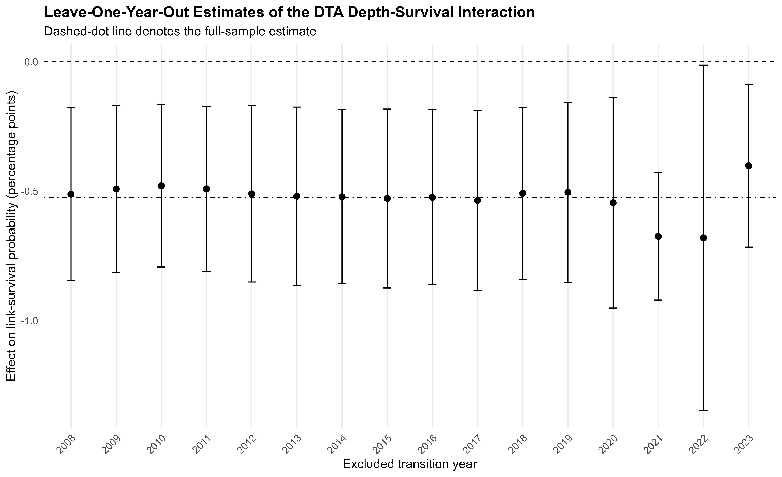
Notes: Each point reports the GPR × DTA Depth coefficient from a separate joint LPM excluding one transition year. Vertical bars denote 95% confidence intervals (pair-plus-year clustering). The dashed-dot line marks the full-sample estimate.

4.5. Post-Exit Recovery
Table 7 examines recovery dynamics following link exits. For one-year re-entry, the GPR × Depth interaction is −0.0035 (p = 0.044, −0.35 pp), indicating that deeper agreements slow short-term reconstitution of disrupted links. However, for two-year re-entry and both full-recovery outcomes, the coefficients are statistically indistinguishable from zero (p > 0.40). The pattern is consistent with a transitory adjustment-cost mechanism: the compliance infrastructure of deep agreements creates friction in the immediate aftermath of disruption but does not prevent medium-term recovery.
Appendix Table A4 reports net effects at representative depth levels. The net one-year re-entry effect turns significantly negative only at high depth (20 provisions: −0.57 pp, p = 0.003; 30 provisions: −0.93 pp, p = 0.007), confirming that the short-term friction is proportional to institutional complexity.

Table 7. Post-Exit Recovery: GPR × DTA Depth Interactions (LPM)
Outcome | Directed-pair FE | N | Pair–HS2 FE | N
Re-entry within one year | −0.0035**  (0.0016)  [−0.35 pp] | 1,151,310 | −0.0001  (0.0021)  [−0.01 pp] | 839,585
Re-entry within two years | 0.0001  (0.0035)  [+0.01 pp] | 1,064,542 | 0.0013  (0.0056)  [+0.13 pp] | 752,846
Full recovery within one year | −0.0009  (0.0011)  [−0.09 pp] | 1,151,310 | 0.0005  (0.0016)  [+0.05 pp] | 839,585
Full recovery within two years | −0.0002  (0.0036)  [−0.02 pp] | 1,064,542 | 0.0041  (0.0059)  [+0.41 pp] | 752,846
Notes: Each cell reports the GPR × DTA Depth interaction from a separate LPM regression. Directed-pair FE is the primary specification; Pair–HS2 FE is a stringent robustness check. Standard errors in parentheses (pair + exit-year clustered). Effects in percentage points. *** p < 0.01, ** p < 0.05, * p < 0.10.

Appendix Table A4. Post-Exit Recovery: Net GPR Interaction Effects at Representative Depth Levels
Outcome | Enforceable  provisions | Net effect (pp) | p-value | N
Re-entry within one year | 0 | +0.14 pp | 0.570 | 1,151,310
 | 10 | −0.22 pp | 0.089 | 1,151,310
 | 20 | −0.57 pp | 0.003 | 1,151,310
 | 30 | −0.93 pp | 0.007 | 1,151,310
Re-entry within two years | 0 | +0.35 pp | 0.567 | 1,064,542
 | 10 | +0.36 pp | 0.451 | 1,064,542
 | 20 | +0.37 pp | 0.527 | 1,064,542
 | 30 | +0.38 pp | 0.653 | 1,064,542
Full recovery within one year | 0 | −0.02 pp | 0.912 | 1,151,310
 | 10 | −0.11 pp | 0.291 | 1,151,310
 | 20 | −0.19 pp | 0.116 | 1,151,310
 | 30 | −0.28 pp | 0.187 | 1,151,310
Full recovery within two years | 0 | −0.07 pp | 0.901 | 1,064,542
 | 10 | −0.10 pp | 0.826 | 1,064,542
 | 20 | −0.12 pp | 0.827 | 1,064,542
 | 30 | −0.14 pp | 0.863 | 1,064,542
Notes: Net effect = β_FTA + D × β_Depth, where D is the number of enforceable provisions. Primary directed-pair FE specification with pair + exit-year multiway clustering. *** p < 0.01, ** p < 0.05, * p < 0.10.

4.6. Country-Specific Geopolitical Risk
The baseline uses global GPR, which is plausibly exogenous to any bilateral pair but may understate bilateral variation. Table 8 re-estimates both models using pair-specific GPR indices constructed from Caldara and Iacoviello (2022) national series (Figure A2).
Panel A shows that the PPML results strengthen under country-specific GPR. Using average pair-country GPR, the FTA interaction deepens to −0.0852 (p = 0.007, −8.17%), while the depth interaction becomes significantly positive (+0.0280, p = 0.018, +2.84%). Panel B confirms that the survival-destroying effect of depth persists across all bilateral shock measures (average: −0.17 pp, p < 0.001; maximum: −0.20 pp, p < 0.001). These results indicate that the documented patterns are not artifacts of the global GPR index construction.

Table 8. Country-Specific GPR Robustness
Shock measure | GPR × FTA | GPR × DTA depth | N
Panel A. Intermediate-goods trade value (PPML)
Average pair-country GPR | −0.0852***  (0.0319)  [−8.17%] | 0.0280**  (0.0118)  [+2.84%] | 2,520,781
Log-average pair-country GPR | −0.0843***  (0.0294)  [−8.09%] | 0.0277**  (0.0111)  [+2.81%] | 2,520,781
Maximum pair-country GPR | −0.0796**  (0.0339)  [−7.65%] | 0.0240*  (0.0129)  [+2.43%] | 2,520,781
Restricted-sample global GPR | −0.0617***  (0.0217)  [−5.98%] | 0.0160  (0.0109)  [+1.62%] | 2,520,781
Panel B. Trade-link survival (LPM)
Average pair-country GPR | −0.0006  (0.0020)  [−0.06 pp] | −0.0017***  (0.0004)  [−0.17 pp] | 1,878,443
Log-average pair-country GPR | −0.0014  (0.0019)  [−0.14 pp] | −0.0015***  (0.0004)  [−0.15 pp] | 1,878,443
Maximum pair-country GPR | 0.0007  (0.0021)  [+0.07 pp] | −0.0020***  (0.0005)  [−0.20 pp] | 1,878,443
Notes: Panel A reports PPML estimates; Panel B reports LPM survival estimates. Both use four-dimensional FE (pair–HS2, exporter–year, importer–year, HS2–year). Standard errors in parentheses (pair-plus-year multiway clustered). Country-specific GPR from Caldara and Iacoviello (2022) national series. *** p < 0.01, ** p < 0.05, * p < 0.10.

Figure A2. Country-Specific GPR Robustness: Trade Value and Link Survival
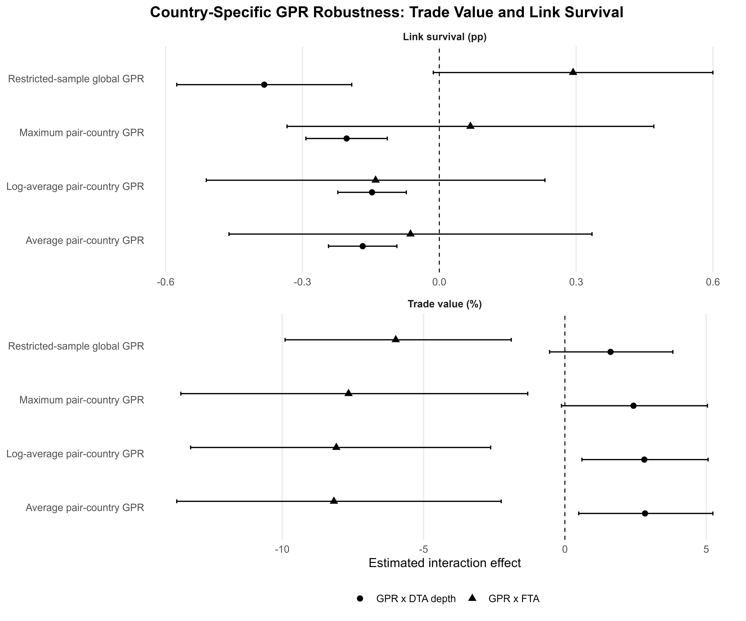
Notes: Forest plot comparing interaction effects across four shock specifications. Horizontal bars denote 95% confidence intervals (pair-plus-year clustering).

4.7. Discussion
The empirical results reveal a nuanced relationship between deep trade agreements and geopolitical risk that does not conform to a simple institutional-buffering narrative. Three interconnected mechanisms emerge from the evidence.
First, a supply-chain interdependence channel operates primarily on the intensive margin. FTA membership increases intermediate-goods trade sensitivity to geopolitical shocks, and this effect is concentrated in sectors with vertically fragmented production, relationship-specific investments, and limited input substitutability (Section 4.2). This pattern is consistent with the prediction that preferential integration deepens cross-border supply-chain linkages that become vulnerable when geopolitical events threaten transaction continuity (Antràs, 2003; Antràs & Helpman, 2004).
Second, an institutional quality channel conditions the intensive-margin effect. Specific provisions—particularly competition policy, environmental standards, and research-and-technology cooperation—are associated with a more favorable GPR–trade relationship (Section 4.3). These disciplines share a common feature: they create durable institutional infrastructure that reduces transaction costs under uncertainty, consistent with the incomplete-contracts theory of trade agreements (Horn, Maggi, & Staiger, 2010).
Third, a fixed-cost adjustment channel operates on the extensive margin. Deeper agreements impose higher compliance costs that cause marginal trade links to fall below the viability threshold when geopolitical uncertainty rises (Section 4.4). The resulting link destruction is transitory rather than permanent: recovery evidence suggests that the institutional infrastructure facilitates re-entry over a two-year horizon (Section 4.5). This asymmetry implies that deep agreements function as “slow stabilizers”—imposing short-term adjustment costs but providing medium-term reconstitution capacity.
These findings carry implications for trade policy design. The tension between efficiency and resilience suggests that the trade-creation benefits of preferential agreements should be weighed against amplified geopolitical vulnerability, particularly in complex manufacturing sectors. Moreover, the composition of provisions matters more than the number of covered policy areas: targeted inclusion of competition, environmental, and technology disciplines may provide more resilience than comprehensive but shallow coverage. Finally, policymakers should complement deep agreement provisions with faster-acting crisis response mechanisms—expedited customs procedures, temporary mutual recognition, emergency supplier coordination—to reduce short-term adjustment friction.

