|  |  |
| --- | --- |
| *school-learn-study-hat-graduate-512.png* | ***Study*** |

Read Chapter 5, section 5.1, 5.3, 5.5, 5.6, 5.7 and 5.10 of “How to Think Like a Computer Scientist: Learning with Python 3”:

<https://drive.google.com/open?id=1S1f_krK63QLamUvte2CmYeMoPylgwW7B>

And then answer the following questions:

1. What is Boolean? Boolean is a form of data that only has two types, true or false.

Write down 3 different expression that results a Boolean type

a == 0; b <= 2; 6 >= 5

1. What is a flow chart? Draw flow chart for the following code snippet: (you can draw on a paper, take a picture of it)

A flowchart is the visualization of a control flow.

if name == “Huy be":

print(“Hand some")

elif name == “Huy big":

even\_more\_handsome = True

else:

webbrowser.open(“<https://www.youtube.com/watch?v=04854XqcfCY>”)

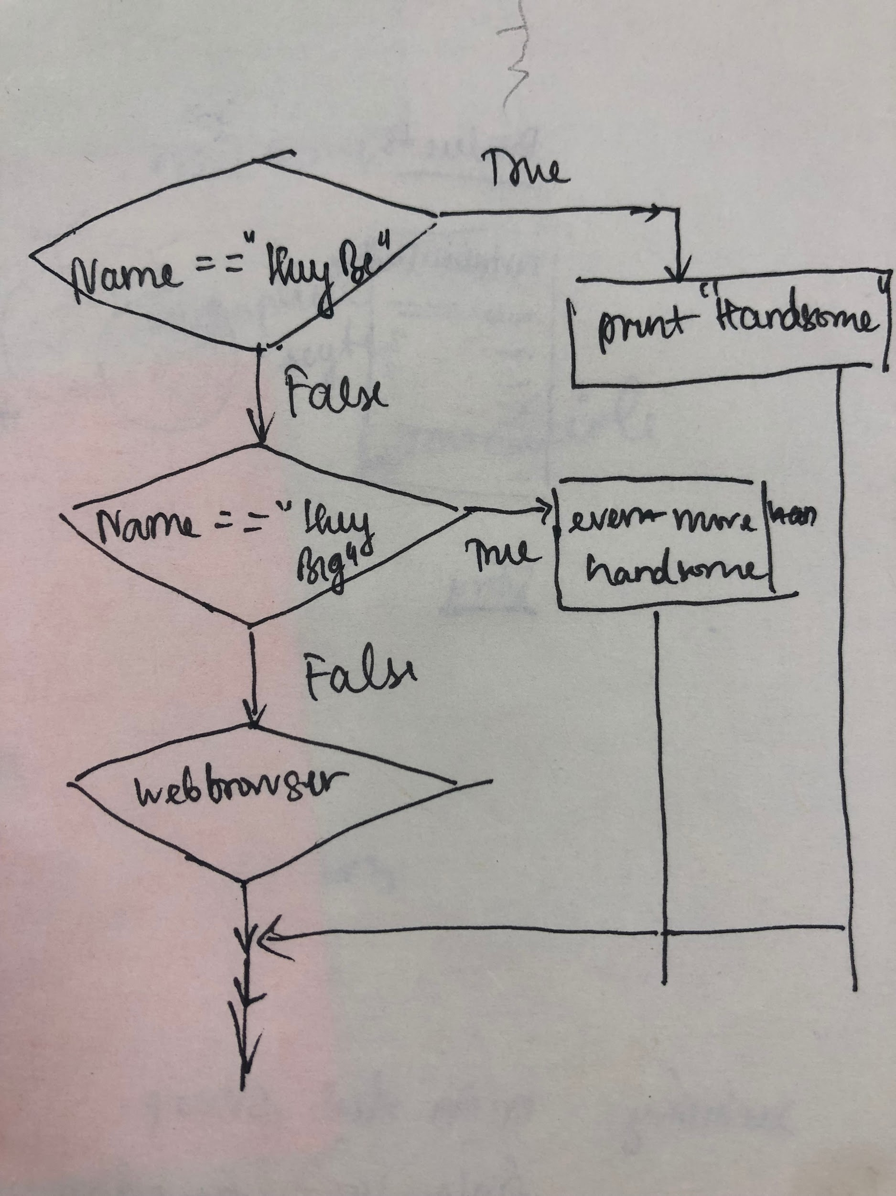

1. What is nested conditionals? Write a piece of code that uses nested conditionals

One conditional can be nested with another conditional.

|  |  |
| --- | --- |
| *http://www.bestappsforkids.com/wp-content/uploads/2012/04/save-turtle.png* | ***Turtle exercises*** |

Using turtle to draw the following shapes:

|  |  |
| --- | --- |
| Screen Shot 2015-12-25 at 04.41.55.png | 2.  Hi-CBUEkYGb-DOPBqc1p-_os3fG83P3OxHLgEhilkO4 |
|  |  |

|  |  |
| --- | --- |
| *6iporAnbT.jpg* | ***Serious exercises*** |

1. Write a program that asks user their height (cm) and weight (kg), and then calculate their BMI (Body Mass Index):

BMI = mass (kg) / (height(m) x height(m) )

Note: you must do the conversion from cm to m before calculation

Then based on the BMI, tell them that they are:

* Severely underweight if BMI < 16
* Underweight if BMI is between 16 and 18.5
* Normal if BMI is between 18.5 and 25
* Overweight if BMI is between 25 and 30
* Obese if BMI is more than 30

1. Write a program that
   1. Asks users enter a number and then calculates factorial of n: (1 \* 2 \* 3 \*... \*n)
2. Study how to print without moving to a new line

Each time we call print(...) to print out something, python will automatically move to a new line, for example, the following snippet:

print("Hello")

print(",my name")

print("is B-max")

will result:

Hello

,my name

is B-max

Your task: Try to search and learn how to print without moving to new line,:

print("Hello", ...)

print(",my name", ...)

print("is B-max", ...)

# "..." is the piece of code you would add

so that the result would be

Hello,my name is B-max

1. Print out the following patterns, remember that the number of columns and rows can be changed later, so try to write programs that can scale
   1. 20 x 1 stars:

\* \* \* \* \* \* \* \* \* \* \* \* \* \* \* \* \* \* \* \*

* 1. n stars (n is entered by users)

Enter a number: 17

\* \* \* \* \* \* \* \* \* \* \* \* \* \* \* \* \*

* 1. 9 stars and xs **in total**

x \* x \* x \* x \* x

* 1. n stars and xs **in total** (n is entered by users)

Enter a number: 13

x \* x \* x \* x \* x \* x \* x

* 1. You can use **print()**, (yes, print with **nothing inside the parentheses ()**) to move to a new line, try it
  2. 7 x 3 stars

\* \* \* \* \* \* \*

\* \* \* \* \* \* \*

\* \* \* \* \* \* \*

* 1. n x m stars (n, m are entered by users)

Enter n: 5

Enter m: 3

\* \* \* \* \*

\* \* \* \* \*

\* \* \* \* \*

|  |  |
| --- | --- |
| system_config_boot.png | ***Tools preparation*** |

Watch the homework submission tutorial