## SE130196 – Vũ Hoàng

**Discussion 2**

**Part 1: Explain in your words: How are password stored in Linux?**

Answer: Shadow utils is a package in Linux that's installed by default in most of the distributions, used for separating passwords from /etc/passwd. After implementing shadow-utils, passwords are now saved in /etc/shadow file in Linux

**Part 2: Chapter 12 Assessment**

Answer:

Q1.

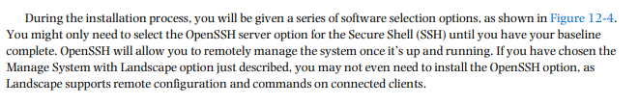

Q2.

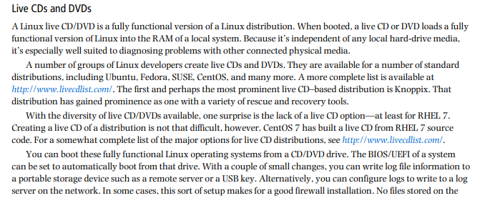

Q3.

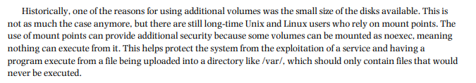

Q4.

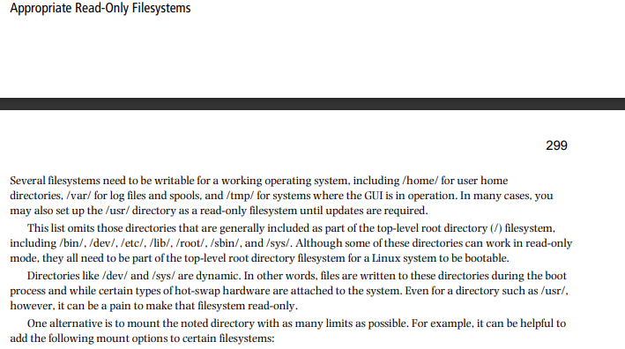

**Q5.**

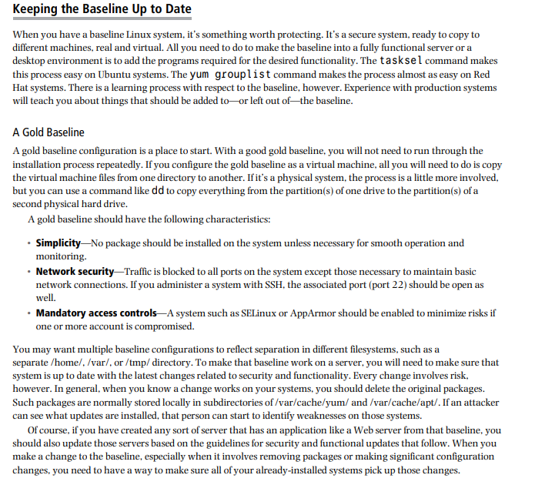

**Q6.**

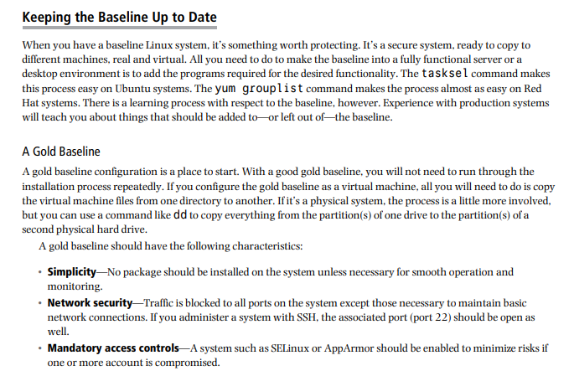

**Q7.**

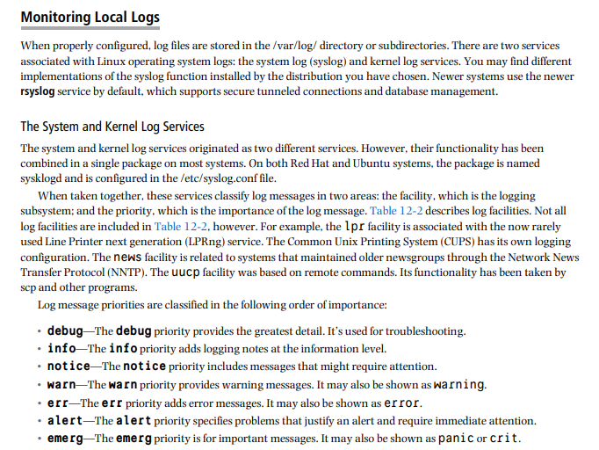

**Q8.**

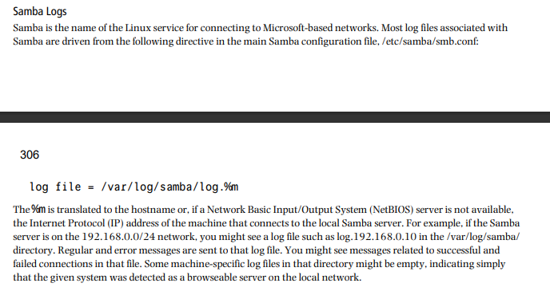

**Q9.**

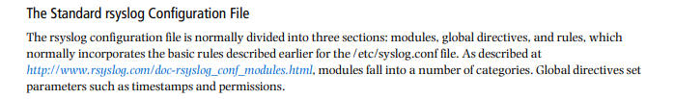

**Q10.**

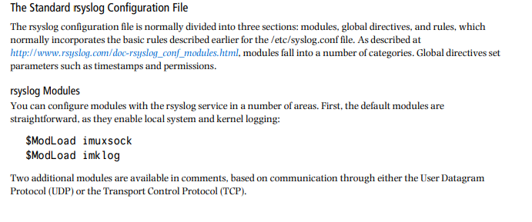

**Q11.**

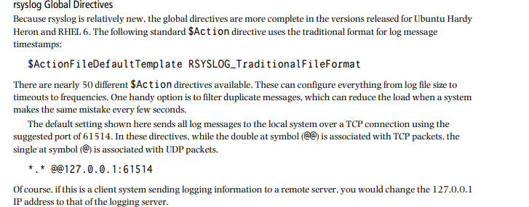

**Q12.**

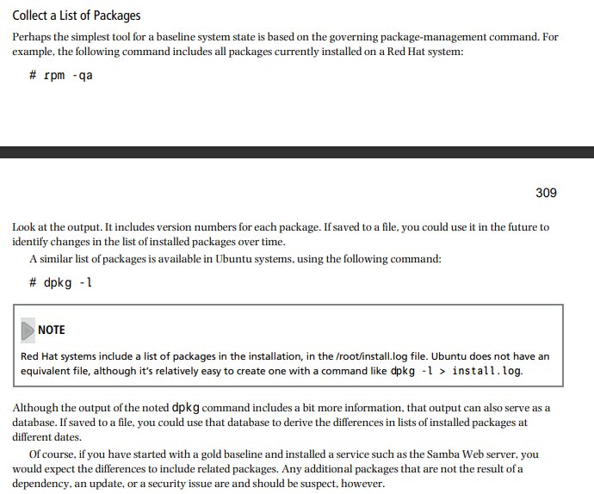

**Q13.**

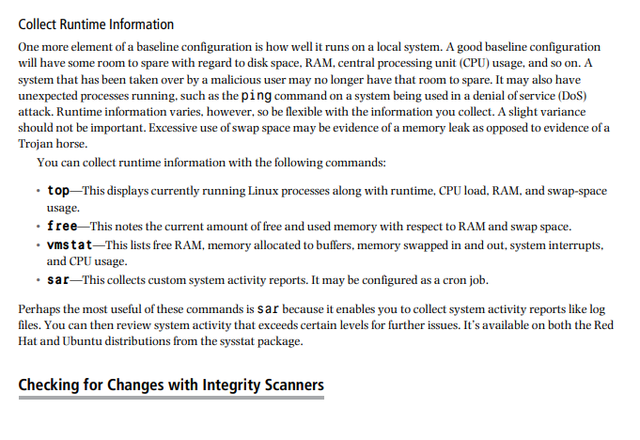

**Q14.**

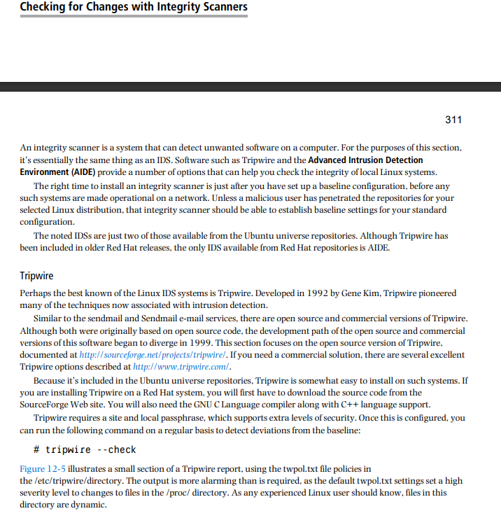

**Q15.**

