HOMEWORK Introduction to Programming using Python

TUT-01: Problem Set 01

Instructor: Dr. Hung Ta

Release Date: September 16, 2020

Semester: Fall 2020

HANU-Faculty of Information Technology Introduction to Programming using Python

Problem 1

1. What is the difference between an Algorithm and a Program?

(a) An algorithm is a conceptual idea, a program is a concrete instantiation of an algorithm.

(b) An algorithm is limited to mathematical operation, a program can specify all kinds of operations.

(c) An algorithm makes a slow program run fast.

(d) An algorithm deals with computer hardware, a program deals with computer software.

2. True or False? A computational mode of thinking means that everything can be viewed as a math

problem involving numbers and formulas.

(a) True

(b) False

3. True or False? Computer Science is the study of how to build efficient machines that run programs.

(a) True

(b) False

4. The two things every computer can do are:

(a) Perform calculations

(b) Convert electricity to numbers

(c) Display results to a screen

(d) Remember the results

5. In the following numeric expression, what is evaluated first?

4 ∗ a + 7/(x − y)+(n ∗ ∗3)

(a) (x − y)

(b) (n ∗ ∗3)

(c) 4 ∗ a

(d) a + 7

Problem 2

1. A sequence of instructions is called a(n) .

(a) program

(b) high-level language

(c) interpreter

(d) flowchart

2. Writing Python statements is called .

(a) coding

(b) compiling

(c) interpreting

TUT-01: Problem Set 01 Page 1 of 3

HANU-Faculty of Information Technology Introduction to Programming using Python

(d) processing

3. Which programming tool graphically depicts the logical steps to carry out a task and show how the

steps relate to each other?

(a) flowchart

(b) hierarchy chart

(c) algorithm

(d) pseudocode

4. Which programming tool uses English-like phrases with some Python terms to outline the task?

(a) algorithm

(b) hierarchy chart

(c) flowchart

(d) pseudocode

5. Integer division is accomplished using the operator.

(a) //

(b) %

(c) /

(d) /=

Problem 3

You are given the following pseudocode to determine if a number is even or odd. Create a flowchart for this program.

• get number

• If the number is divisible by 2 without a remainder

• display the number is even

• else

• display the number is odd

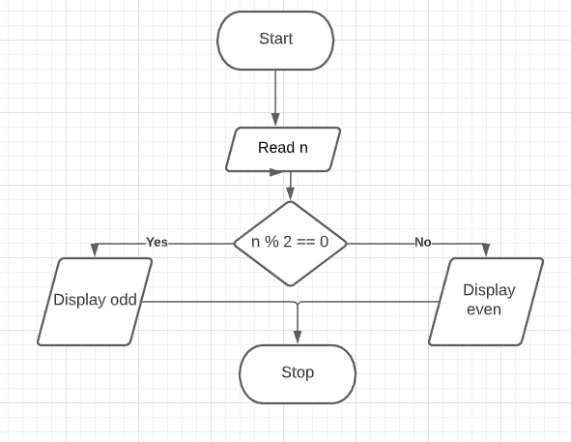

Problem 4 (Sales Prediction)

A company has determined that its annual profit is typically 23 percent of total sales. Write a program that asks the user to enter the projected amount of total sales, and then displays the profit that will be made from that amount.

Problem 5 (Land Calculation)

One acre of land is equivalent to 43,560 square feet. Write a program that asks the user to enter the total square feet in a tract of land and calculates the number of acres in the tract.

TUT-01: Problem Set 01 Page 2 of 3

HANU-Faculty of Information Technology Introduction to Programming using Python

Problem 6 (Distance traveled)

Assuming there are no accidents or delays, the distance that a car travels down the inter- state can be calculated with the following formula:

Distance = Speed × T ime

A car is traveling at 70 miles per hour. Write a program that displays the following:

1. The distance the car will travel in 6 hours

2. The distance the car will travel in 10 hours

3. The distance the car will travel in 15 hours

Problem 7 (Sales tax)

Write a program that will ask the user to enter the amount of a purchase. The program should then compute the state and county sales tax. Assume the state sales tax is 5 percent and the county sales tax is 2.5 percent. The program should display the amount of the purchase, the state sales tax, the county sales tax, the total sales tax, and the total of the sale (which is the sum of the amount of purchase plus the total sales tax).

Problem 8 (Miles-per-Gallon)

A cars miles-per-gallon (MPG) can be calculated with the following formula:

MPG = Miles driven Gallons of gas used

Write a program that asks the user for the number of miles driven and the gallons of gas used. It should calculate the cars MPG and display the result.

Problem 9 (Celsius to Fahrenheit temperature Converter )

Write a program that converts Celsius temperatures to Fahrenheit temperatures. The formula is as follows:

F = 95 × C + 32

The program should ask the user to enter a temperature in Celsius, and then display the temperature converted to Fahrenheit.

References

[1] K. H. Rosen, Discrete Mathematics and Its Applications, McGraw-Hill, 7th edition, 2011.

[2] S. S. Epp, Discrete Mathematics with Applications, Cengage-Learning, 4th edition, 2010.

[3] T. W. Judson and R. A. Beezer, Abstract Algebra: Theory and Applications, Free Software Foundation,

2017, [Online; accessed 08-September-2017].

TUT-01: Problem Set 01 Page 3 of 3