Cau 1:



Cau 2:



Cau 3:



CAU4:

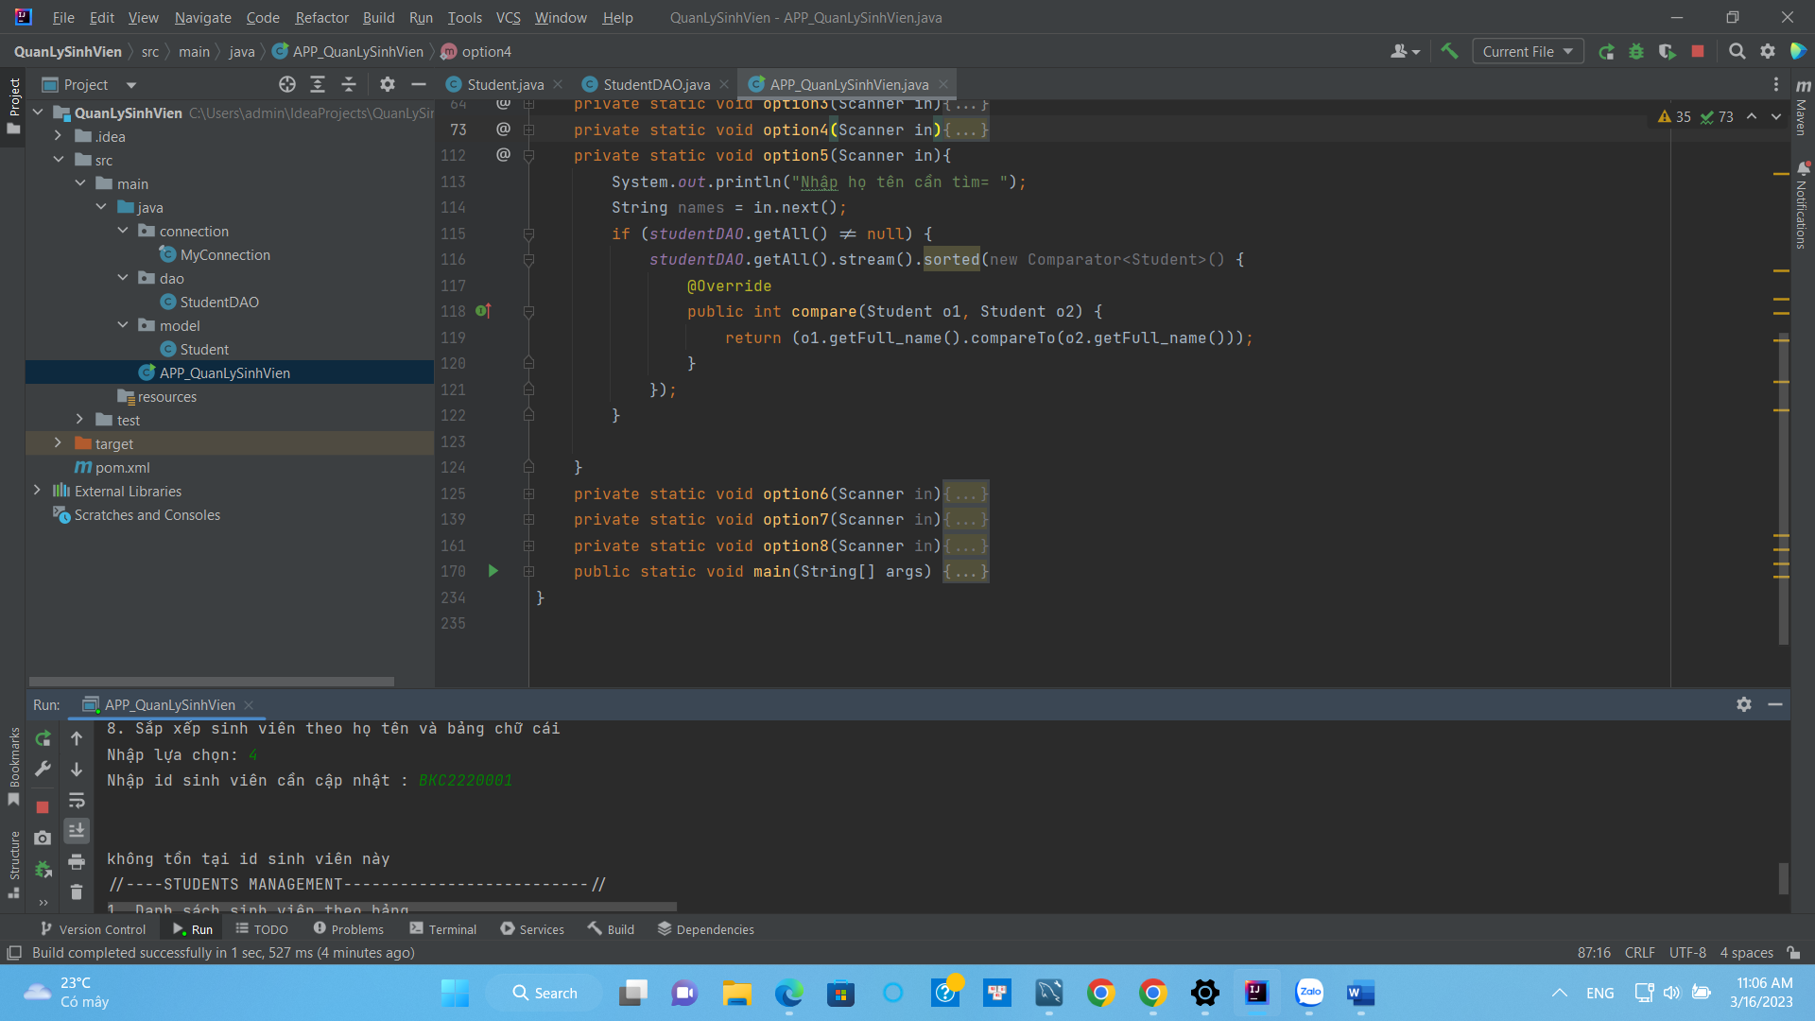

CAU 6:



Cau7:



Cau 8



// DATA SQL

create database bkacad;

use bkacad;

drop table students;

create table students(

id varchar(10) primary key not null,

full_name varchar(30) not null,

gender TINYINT(1) not null,

birhdate varchar(100)not null,

address varchar(200) not null,

phone varchar(10) not null,

email varchar(200) not null,

GPA int not null

);