**Bài 1:**

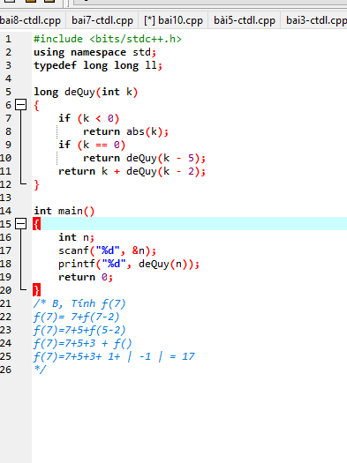

**Bài 2:**

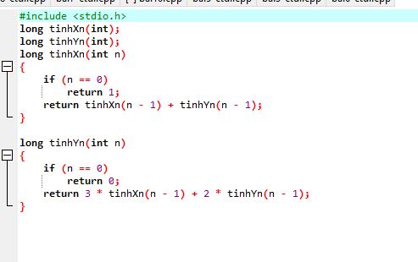

**Bài 3:**

**Mô tả:**

|  |  |  |  |  |  |  |  |  |  |  |
| --- | --- | --- | --- | --- | --- | --- | --- | --- | --- | --- |
| i=1 | **5** | **12** | **3** | **2** | **4** | **0** | **-4** | **-5** | **20** | **15** |
| I=2 | **3** | **5** | **12** | **2** | **4** | **0** | **-4** | **-5** | **20** | **15** |
| I=3 | **2** | **3** | **5** | **12** | **4** | **0** | **-4** | **-5** | **20** | **15** |
| I=4 | **2** | **3** | **4** | **5** | **12** | **0** | **-4** | **-5** | **20** | **15** |
| I=5 | **0** | **2** | **3** | **4** | **5** | **12** | **-4** | **-5** | **20** | **15** |
| I=6 | **-4** | **0** | **2** | **3** | **4** | **5** | **12** | **-5** | **20** | **15** |
| I=7 | **-5** | **-4** | **0** | **2** | **3** | **4** | **5** | **12** | **20** | **15** |
| I=8 | **-5** | **-4** | **0** | **2** | **3** | **4** | **5** | **12** | **20** | **15** |
| I=9 | **-5** | **-4** | **0** | **2** | **3** | **4** | **5** | **12** | **15** | **20** |

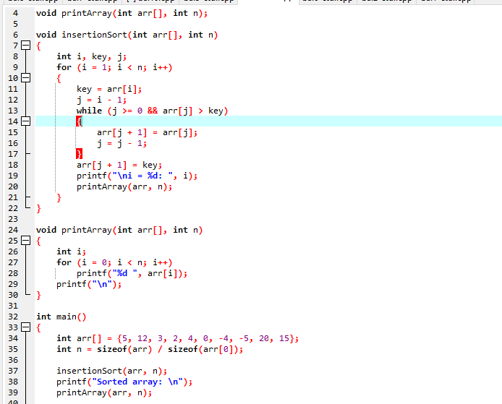

**Bài 4:**

**Mô tả:**

|  |  |  |  |  |  |  |  |  |  |  |
| --- | --- | --- | --- | --- | --- | --- | --- | --- | --- | --- |
| i=1 | **12** | **5** | **3** | **2** | **4** | **0** | **-4** | **-5** | **20** | **15** |
| I=2 | **12** | **5** | **3** | **2** | **4** | **0** | **-4** | **-5** | **20** | **15** |
| I=3 | **12** | **5** | **3** | **2** | **4** | **0** | **-4** | **-5** | **20** | **15** |
| I=4 | **12** | **5** | **4** | **3** | **2** | **0** | **-4** | **-5** | **20** | **15** |
| I=5 | **12** | **5** | **4** | **3** | **2** | **0** | **-4** | **-5** | **20** | **15** |
| I=6 | **12** | **5** | **4** | **3** | **2** | **0** | **-4** | **-5** | **20** | **15** |
| I=7 | **12** | **5** | **4** | **3** | **2** | **0** | **-4** | **-5** | **20** | **15** |
| I=8 | **20** | **12** | **5** | **4** | **3** | **2** | **0** | **-4** | **-5** | **15** |
| I=9 | **20** | **15** | **12** | **5** | **4** | **3** | **2** | **0** | **-4** | **-5** |

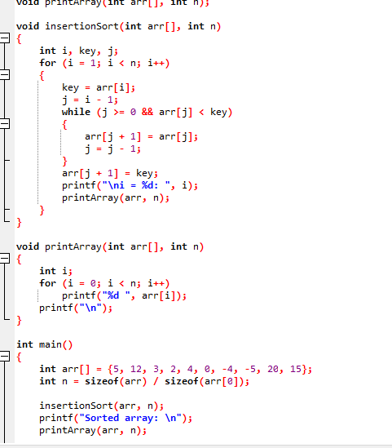

**Bài 5:**

**Mô tả:**

|  |  |  |  |  |  |  |  |  |  |  |
| --- | --- | --- | --- | --- | --- | --- | --- | --- | --- | --- |
| i=1 | **5** | **12** | **3** | **2** | **4** | **0** | **-4** | **-5** | **20** | **15** |
| I=2 | **12** | **5** | **3** | **4** | **2** | **0** | **-4** | **20** | **15** | **-5** |
| I=3 | **12** | **5** | **4** | **3** | **4** | **0** | **20** | **15** | **-4** | **-5** |
| I=4 | **12** | **5** | **4** | **3** | **2** | **20** | **15** | **0** | **-4** | **-5** |
| I=5 | **12** | **5** | **4** | **3** | **20** | **15** | **2** | **0** | **-4** | **-5** |
| I=6 | **12** | **5** | **4** | **20** | **15** | **3** | **2** | **0** | **-4** | **-5** |
| I=7 | **12** | **5** | **20** | **15** | **4** | **3** | **2** | **0** | **-4** | **-5** |
| I=8 | **12** | **20** | **15** | **5** | **4** | **3** | **2** | **0** | **-4** | **-5** |
| I=9 | **20** | **15** | **12** | **5** | **4** | **3** | **2** | **0** | **-4** | **-5** |

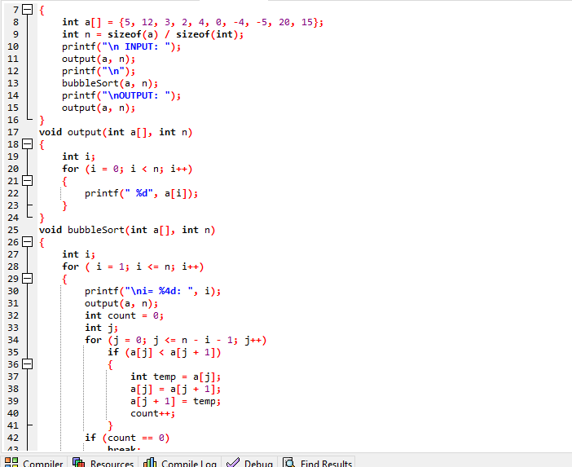

**Bài 6:**

**Mô tả:**

|  |  |  |  |  |  |  |  |  |  |  |
| --- | --- | --- | --- | --- | --- | --- | --- | --- | --- | --- |
| i=1 | **5** | **12** | **3** | **2** | **4** | **0** | **-4** | **-5** | **20** | **15** |
| I=2 | **5** | **3** | **2** | **4** | **0** | **-4** | **-5** | **12** | **15** | **20** |
| I=3 | **3** | **2** | **4** | **0** | **-4** | **-5** | **5** | **12** | **15** | **20** |
| I=4 | **2** | **3** | **0** | **-4** | **-5** | **4** | **5** | **12** | **15** | **20** |
| I=5 | **2** | **0** | **-4** | **-5** | **3** | **4** | **5** | **12** | **15** | **20** |
| I=6 | **0** | **-4** | **-5** | **2** | **3** | **4** | **5** | **12** | **15** | **20** |
| I=7 | **-4** | **-5** | **0** | **2** | **3** | **4** | **5** | **12** | **15** | **20** |
| I=8 | **-5** | **-4** | **0** | **2** | **3** | **4** | **5** | **12** | **15** | **20** |

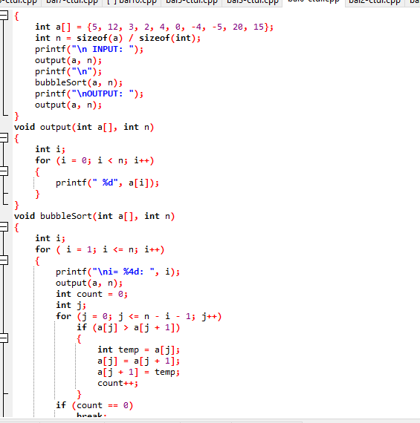

**Bài 7:**

**Mô tả:**

|  |  |  |  |  |  |  |  |  |  |  |
| --- | --- | --- | --- | --- | --- | --- | --- | --- | --- | --- |
| i=0 | **-5** | **12** | **3** | **2** | **4** | **0** | **-4** | **5** | **20** | **15** |
| I=1 | **-5** | **-4** | **3** | **2** | **4** | **0** | **12** | **5** | **20** | **15** |
| I=2 | **-5** | **-4** | **0** | **2** | **4** | **3** | **12** | **5** | **20** | **15** |
| I=3 | **-5** | **-4** | **0** | **2** | **4** | **3** | **12** | **5** | **20** | **15** |
| I=4 | **-5** | **-4** | **0** | **2** | **3** | **4** | **12** | **5** | **20** | **15** |
| I=5 | **-5** | **-4** | **0** | **2** | **3** | **4** | **12** | **5** | **20** | **15** |
| I=6 | **-5** | **-4** | **0** | **2** | **3** | **4** | **5** | **12** | **20** | **15** |
| I=7 | **-5** | **-4** | **0** | **2** | **3** | **4** | **5** | **12** | **20** | **15** |
| I=8 | **-5** | **-4** | **0** | **2** | **3** | **4** | **5** | **12** | **15** | **20** |

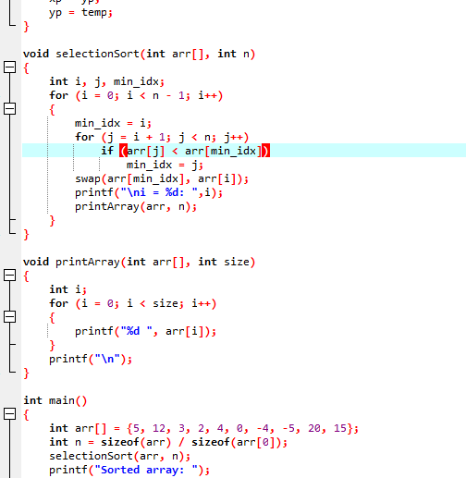

**Bài 8:  
Mô tả:**

|  |  |  |  |  |  |  |  |  |  |  |
| --- | --- | --- | --- | --- | --- | --- | --- | --- | --- | --- |
| i=0 | **20** | **12** | **3** | **2** | **4** | **0** | **-4** | **-5** | **5** | **15** |
| I=1 | **20** | **15** | **3** | **2** | **4** | **0** | **-4** | **-5** | **5** | **12** |
| I=2 | **20** | **15** | **12** | **2** | **4** | **0** | **-4** | **-5** | **5** | **3** |
| I=3 | **20** | **15** | **12** | **5** | **4** | **0** | **-4** | **-5** | **2** | **3** |
| I=4 | **20** | **15** | **12** | **5** | **4** | **0** | **-4** | **-5** | **2** | **3** |
| I=5 | **20** | **15** | **12** | **5** | **4** | **0** | **-4** | **-5** | **2** | **0** |
| I=6 | **20** | **15** | **12** | **5** | **4** | **3** | **2** | **-5** | **-4** | **0** |
| I=7 | **20** | **15** | **12** | **5** | **4** | **3** | **2** | **0** | **-4** | **-5** |
| I=8 | **20** | **15** | **12** | **5** | **4** | **3** | **2** | **0** | **-4** | **-5** |

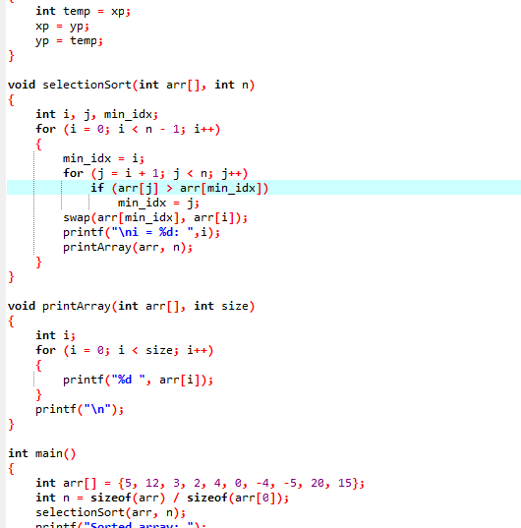

**Bài 9:**

**S= (a+b) / c - (d-e) / b +a / b**

Cây nhị phân:

b) Tiền tố, Hậu tố.

-Tiền tố: gốc, trái, phải.

+ - / + a b c / - d e b / a b.

-Hậu tố: trái, phải , gốc.

a b + c / d e - b / - a b / +.

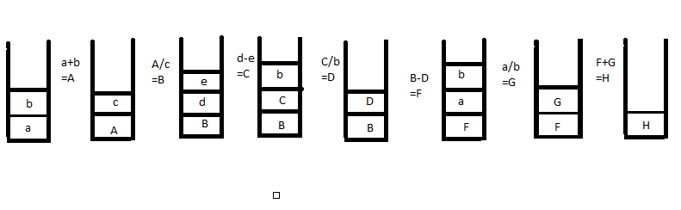

**Bài 10:**

