**Topic: Applying computer vision to develop facial recognition system**

**Mentor:** Dr. Vinh Dinh Nguyen

**Group 3:**

**CE180384_Nguyễn Vũ Huy (Leader)**

CE182226_Nguyễn Khánh Trình

CE180342_Đặng Hoàng Kiệt

CE180756_Đinh Văn Anh Khôi

Chapter 1: Overview

**1.1 Introduction**

Amid the Industry 4.0 revolution, technologies such as Artificial Intelligence (AI), Deep Learning, and Computer Vision have become key drivers for automation and increased efficiency across various fields. Notably, **facial recognition** has emerged as one of the most important applications of computer vision. Facial recognition has been applied in fields like security, surveillance, healthcare, and especially education, where automated attendance systems offer significant advantages over traditional methods.

A facial recognition attendance system enables automated monitoring of student or employee attendance. Instead of traditional methods such as signing, scanning QR codes, or fingerprint scanning, this system leverages unique biometric features of each individual, enhancing accuracy and reducing fraud. For educational settings, automated attendance via facial recognition saves time, reduces management efforts for instructors, and facilitates the accurate collection of data on student attendance.

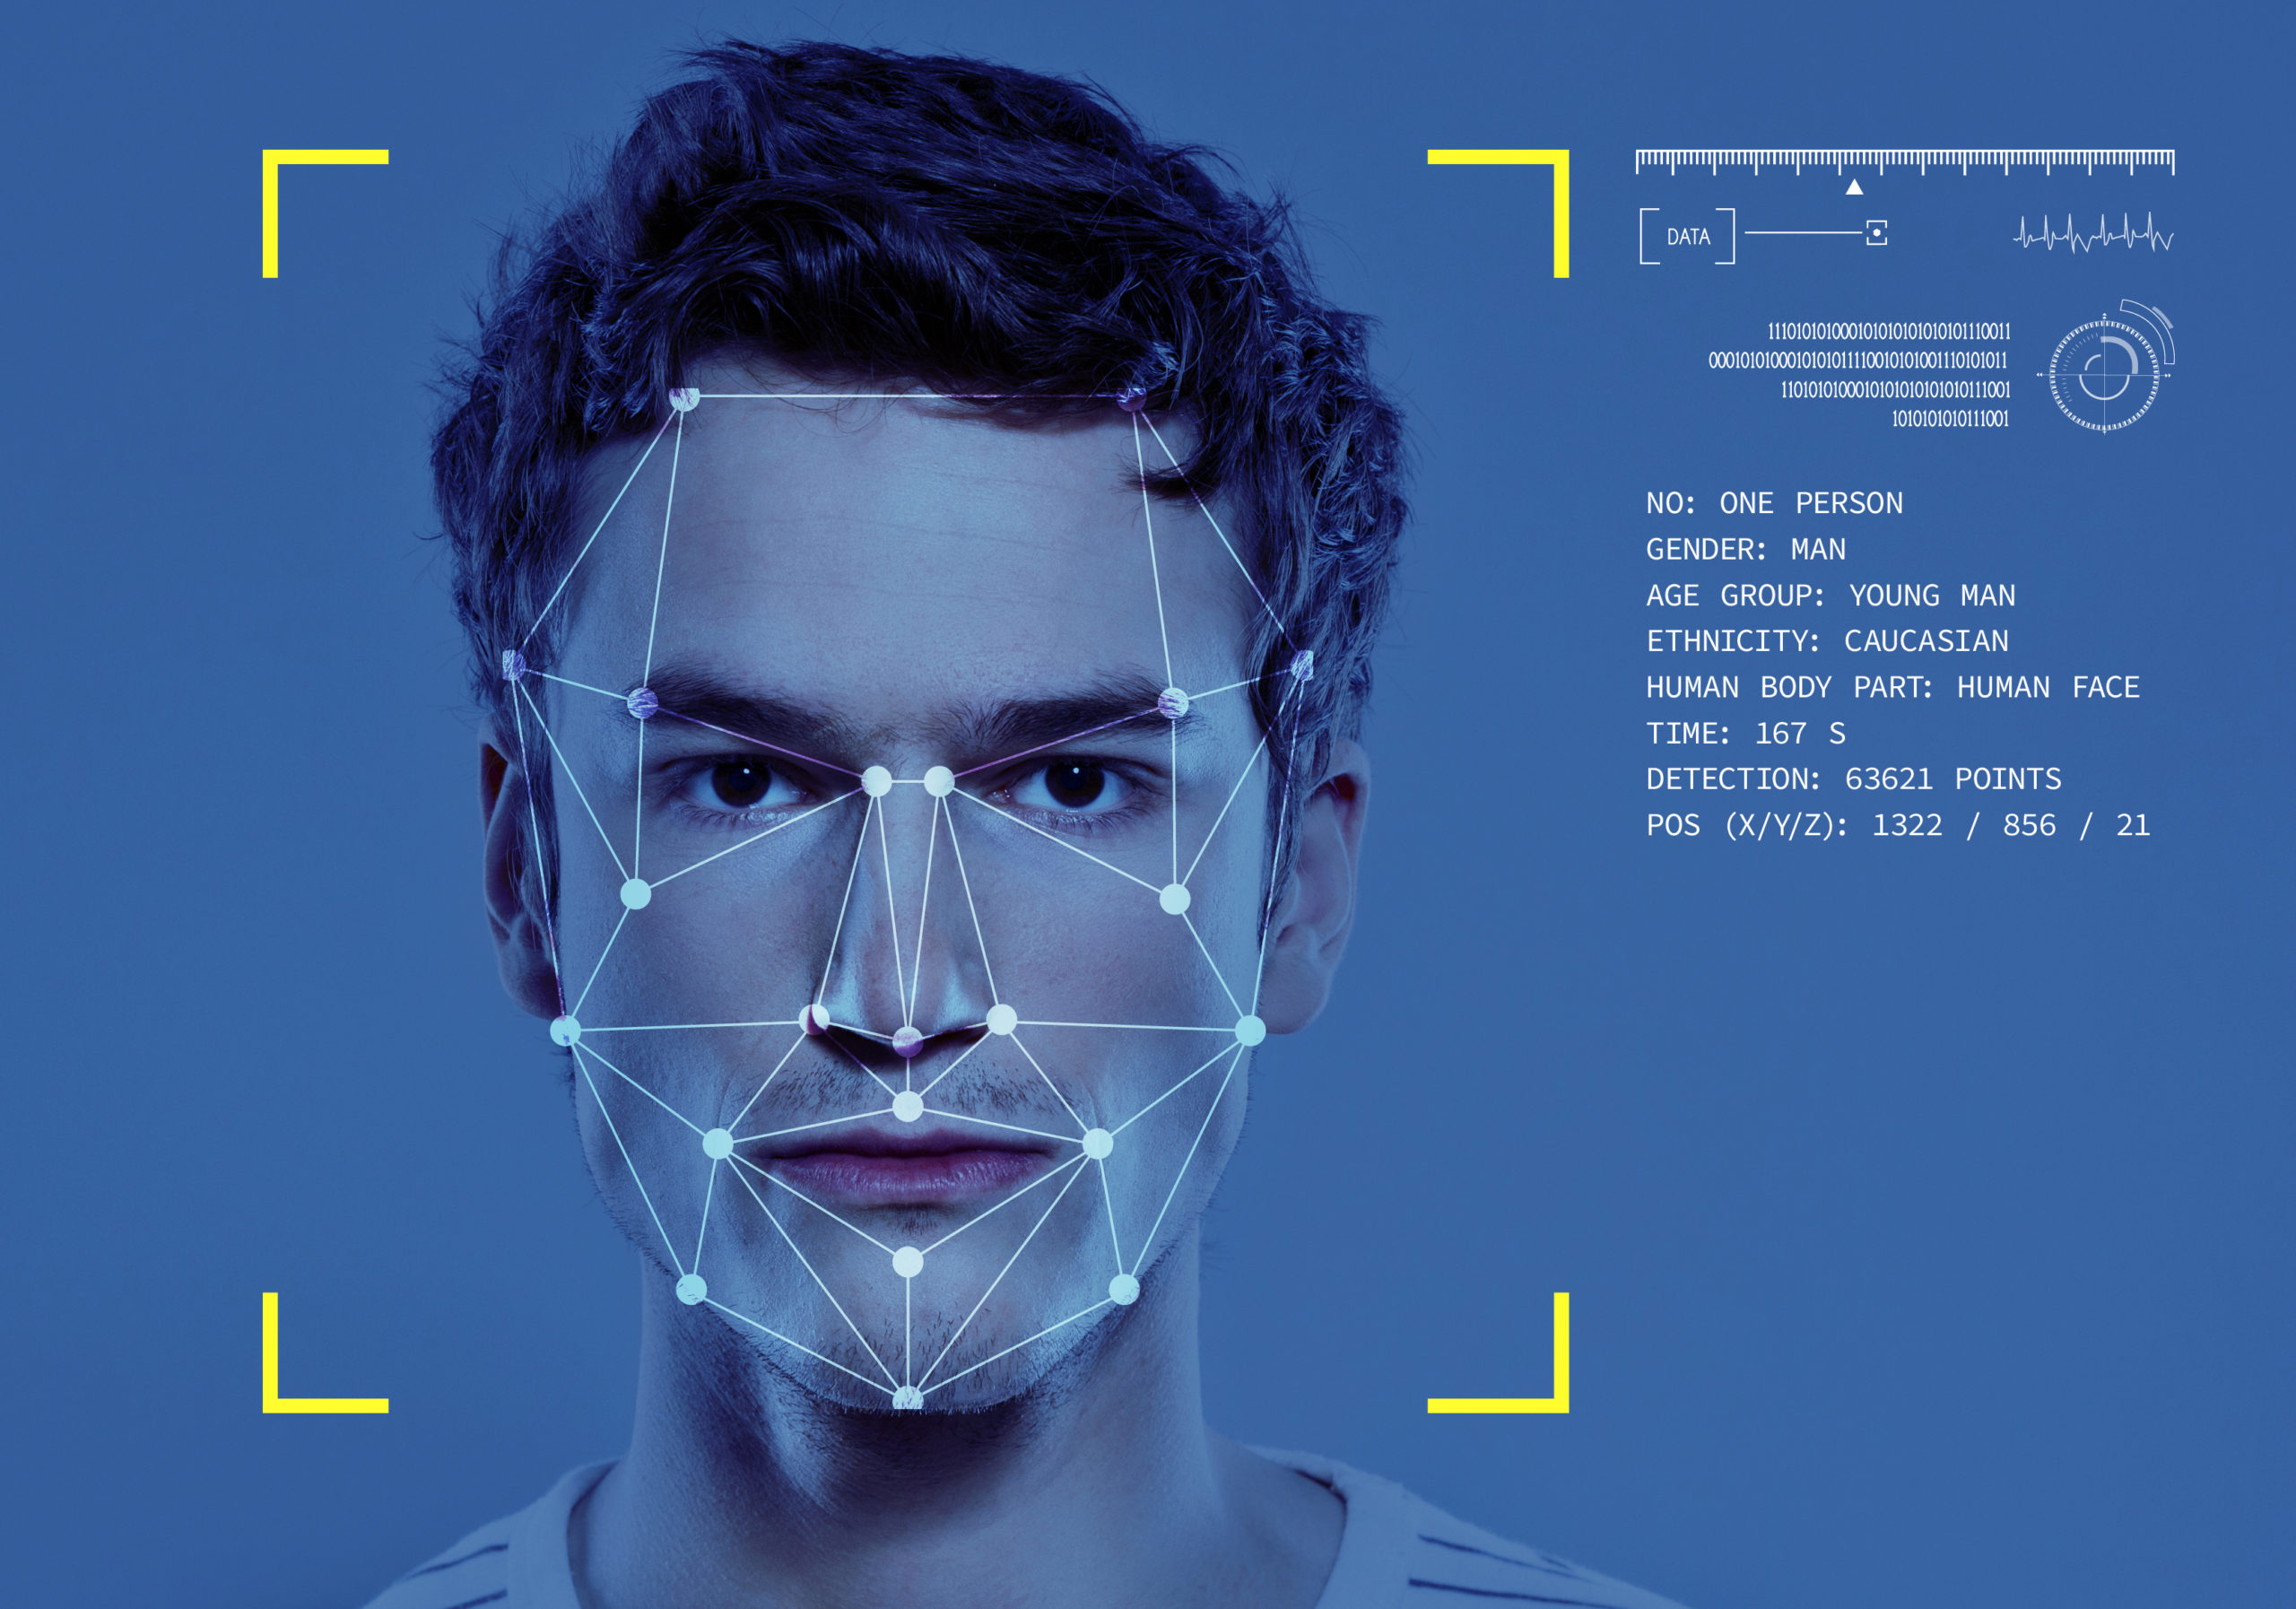

**1.2 Related Studies**

In recent years, researchers have developed and refined facial recognition methods to improve the accuracy, stability, and performance of these systems in various environmental conditions. Below are some notable studies on facial recognition systems, focusing on accuracy, real-time processing, and functionality in diverse conditions:

* **Zhang et al. (2020)** applied **Convolutional Neural Networks (CNN)** to extract facial features and classify identities, aiming to improve accuracy in environments with different lighting and viewing angles. By adjusting CNN parameters, the research group achieved up to 95% accuracy in recognition tests under low-light and varied angle conditions. This method demonstrates CNN's potential for handling complex environmental challenges.
* **Wang et al. (2019)** employed **Deep Metric Learning** in facial recognition systems. This approach helps increase the ability to differentiate between different faces, especially when facial features show high similarity. They implemented this model in large classrooms and achieved higher accuracy than traditional machine learning methods due to its ability to compare facial features based on data-learned distances.
* **Chen et al. (2021)** developed a facial recognition system using the **YOLO (You Only Look Once)** algorithm, combined with facial recognition models to increase processing speed. YOLO enables real-time facial recognition with lower latency, meeting the demands of large classrooms. This approach reduced processing time by 30% while maintaining accuracy, effectively meeting attendance needs in crowded educational environments.
* **Li et al. (2022)** developed a method combining **CNN and Recurrent Neural Networks (RNN)** to improve accuracy when users wear masks—a practical demand arising from the COVID-19 pandemic. This technique enhanced partial facial recognition, showcasing the system's flexibility when facing changing environmental conditions.
* **Smith et al. (2018)** conducted research in educational settings, focusing on the challenges and benefits of applying facial recognition for attendance. This study emphasized the importance of data diversity (including age, gender, and lighting conditions) to ensure system accuracy. The results show that a successful facial recognition system relies not only on the model but also on data quality and representativeness.

**1.3 Research Directions of the Report**

Based on previous research and practical needs, this study will focus on developing a facial recognition attendance system for educational environments. The system's goal is to achieve high accuracy, short processing time, and stable operation in different lighting conditions and environments. Additionally, the system will be tested to assess its performance when dealing with partially obscured faces, such as those wearing masks or glasses.

**Specific Objectives of the Report**:

**I. Build a facial recognition model using the Local Binary Patterns Histogram (LBPH) Face Recognizer. Unlike deep learning-based CNNs, LBPH relies solely on traditional computer vision techniques. This approach is beneficial for smaller datasets and is computationally efficient, making it well-suited for real-time classroom applications where resources may be limited.**

**II. Enhance speed and efficiency by optimizing model parameters and utilizing image pre-processing techniques. LBPH's simplicity makes it faster to train and execute, reducing processing time to meet real-time requirements without the computational overhead associated with deep learning models.**

**III. Evaluate and compare effectiveness by testing the LBPH model’s performance across diverse datasets, including scenarios with low lighting and partially obscured faces. LBPH is particularly effective in controlled environments and requires fewer resources, demonstrating superior performance under constrained conditions compared to more resource-intensive deep learning models.**

**IV. Practical application in classrooms We will implement the system in real classroom settings, assessing its feasibility and advantages for attendance automation.**

Chapter 2: Theoretical Basis of the LBPHFaceRecognizer Algorithm

**1 Introduction**

The LBPH (Local Binary Patterns Histograms) algorithm is a prominent face recognition technique that leverages the geometric features of faces. This chapter provides a comprehensive overview of the steps involved in the LBPH algorithm, including relevant formulas and key concepts.

**2 Local Binary Patterns (LBP)**

**2.1 Concept**

Local Binary Patterns (LBP) is a feature extraction method used to describe images by encoding the intensity information of their pixels.

**2.2 LBP Calculation Formula**

The LBP value for a central pixel with intensity \( C \) and its surrounding neighbor pixels is calculated using the following process:

* Construct a binary pattern B:
* Convert the binary pattern B into a decimal value LBP :

**3. Creating the LBP Image**

The algorithm computes the LBP value for each pixel (excluding border pixels) in the image and stores these values in a new image designated as

**4.** **Dividing the Image into Regions**

Once the LBP image is generated, it is divided into smaller regions, such as 8x8 or 16x16, for further analysis

**5 Computing the Histogram**

**5.1 Histogram Calculation for Each Region**

For each region, the histogram H is computed to represent the frequency of LBP values. The formula for the histogram is as follows:

where δ is the indicator function, returning 1 if the condition is met and

0 otherwise.

**5.2 Histogram Size**

Typically, the histogram size is set to 256, corresponding to LBP values ranging from 0 to 255.

**6 Combining the Histograms**

After computing the histograms for all regions, they are combined into a

single feature vector that represents the entire face:

where denotes the histogram of the i-th region.

**7 Training the Model**

The combined feature vectors from various faces are utilized to train the

face recognition model. The vectors are organized into a matrix, with each

row corresponding to a distinct face.

**8 Recognizing New Faces**

When a new face is introduced, it undergoes the same LBP processing to

generate its feature vector. This vector is then compared with the stored

feature vectors in the model.

Chapter 3: Solution

**1 Introduction**

In the context of modern education, traditional attendance management meth-ods are no longer efficient or convenient. A face recognition attendance system, utilizing computer vision technology and the Local Binary Patterns Histograms (LBPH) algorithm, has been proposed as a feasible solution to optimize this process. This solution not only saves time but also enhances the accuracy and security of the system.

**2 System Architecture**

The face recognition attendance system is designed with the following main

**components:**

**2.1 Data Collection Phase**

• Utilizing a camera to collect real-time images of students’ faces.

• Allowing users to upload images to be added to the database.

**2.2 Processing and Recognition Phase**

• Processing images by detecting and extracting faces from the video or uploaded images.

• Using the LBPH algorithm to train a face recognition model based on the

collected data.

**2.3 Attendance Phase**

• Using the trained model to identify individuals in the camera feed and

store their attendance status.

• Updating attendance data in real time and allowing administrators to

access reports.

**3 Technical Solutions**

**3.1 Data Collection**

• Using Cameras: The system will use cameras to collect face data. These images will be stored and processed to serve the recognition phase.

• Image Upload: Users can upload face images to be stored in the system, enhancing the database for the model.

**3.2 Face Processing and Recognition**

• Face Detection: The Haar Cascade algorithm will be used to detect

faces in the video feed.

• Feature Extraction: The LBPH algorithm will be applied to extract

features from the faces, improving recognition accuracy.

• Model Training: The model will be trained using the collected face data,

enhancing accuracy and recognition ability under varying conditions.

**3.3 Attendance and Data Storage**

• Automatic Attendance: Upon detecting a face, the system will auto-

matically update the attendance status

• Data Storage and Management: Attendance data will be stored in a

table or CSV file for easy access and management by administrators.

**4 Conclusion**

The solution utilizing computer vision and the LBPH algorithm for the face recognition attendance system not only addresses the challenges of traditional attendance management but also paves the way for new applications in education. This system will create a more efficient learning environment, saving time and effort while providing accurate and reliable data for administrators.

Chapter 4: Experiment and Evaluation

**Experiment**

**Compare with the results of previous studies.**

In the context of developing a facial recognition-based attendance system for educational environments, we have chosen the **Local Binary Patterns Histogram (LBPH) Face Recognizer**. Unlike more recent algorithms, such as **Convolutional Neural Networks (CNN)**, **YOLO (You Only Look Once)**, or **Deep Metric Learning** models, LBPH relies on traditional computer vision techniques rather than deep learning. This design choice is particularly advantageous for environments with limited computational resources, such as classroom settings.

**Advantages of LBPH Face Recognizer:**

1. **Efficiency and Real-Time Processing:** LBPH operates with low computational requirements, making it suitable for real-time applications even on devices with limited processing power. This efficiency is crucial for classrooms where quick processing is needed to avoid delays in attendance.
2. **Performance on Small Datasets:** LBPH is particularly effective when the dataset size is limited. Unlike deep learning models, which require vast amounts of data for training, LBPH performs well on smaller datasets, making it ideal for controlled environments.
3. **Robustness in Controlled Settings:** LBPH is known for its robustness in scenarios with consistent lighting and minimal changes in facial features. This attribute makes it a reliable choice for environments with controlled conditions.

**Minor Limitations of LBPH Face Recognizer:**

1. **Sensitivity to Environmental Variations:** LBPH may struggle with accuracy in highly variable conditions, such as changes in lighting, viewing angles, or facial obstructions (like masks), compared to CNNs or YOLO-based systems. This limitation makes LBPH more suited for settings with stable conditions.
2. **Limited Adaptability:** Unlike deep learning models, which can learn complex features and improve over time with larger datasets, LBPH’s traditional approach means it lacks the adaptability of neural networks. As a result, its performance may not scale well with increasing diversity in the dataset.

Chapter 5: Conclusion

In summary, the LBPH Face Recognizer offers a practical solution for developing a facial recognition attendance system in educational environments. Its low computational requirements and effectiveness on small datasets align with the needs of real-time classroom applications, where high speed and efficiency are paramount. While LBPH may not match the flexibility of modern deep learning algorithms under varying environmental conditions, its simplicity and efficiency provide significant advantages. Thus, LBPH stands as a suitable choice for the project's goal: delivering a reliable, resource-efficient, and real-time facial recognition system for classroom attendance tracking.

**References**

1. Analytics Vidhya. (2021). *Understanding Face Recognition Using LBPH Algorithm*. Retrieved from <https://www.analyticsvidhya.com/blog/2021/07/understanding-face-recognition-using-lbph-algorithm/>
2. OpenGenus IQ. *LBPH Algorithm for Face Recognition*. Retrieved from <https://iq.opengenus.org/lbph-algorithm-for-face-recognition/>
3. Pallets Projects. *Flask Documentation*. Retrieved from <https://flask.palletsprojects.com/en/stable/>
4. OpenCV. *OpenCV Library*. Retrieved from <https://opencv.org/>
5. OpenAI. *ChatGPT*. Retrieved from <https://openai.com/index/chatgpt/>