**New York Science Technology Engineering and Math Fund**

**(NYSTEM)**

**Author: Vuk Vujcic**

**Abstract**

The goal of the NYSTEM fund is to bolster the top industries of the state of New York by establishing a scholarship fund for students studying in STEM related fields. The industries driving growth in New York are education, government, financial services, healthcare, information, and professional services. All of these fields are directly related to STEM degree programs, and will benefit from having an influx of skilled and well educated labor. This project seeks to encourage economic development in New York in a diversified manner by not focusing investment on just one specific industry, but providing the skilled work force needed to grow across the board.

New York’s top five industries account for 73% of the state’s total GDP. The clear leader is the financial services industry accounting for 32% of the total GDP. This is largely attributed to New York City playing host to the New York Stock Exchange. Professional services such as accounting, lawyers, information technology, and consulting services command 13% of New York’s GDP. Healthcare, educational services, government, and information industries make up the remaining 26% of the major industries that contribute towards New York’s GDP. These industries are what drives New York’s economy and are the key targets for investment to bolster New York’s economy.

Looking specifically at New York State it was discovered that there is a somewhat low correlation between growth in the state’s GDP, and the amount of scholarship money awarded to public schools. We looked at the yearly total of scholarships awarded to public New York state schools and the yearly GDP of New York state and found a correlation coefficient of 0.65. While this was disappointing, looking at the correlation of yearly scholarships awarded to GDP by individual schools it was discovered that some of the largest public schools did in fact have a strong correlation closer to 0.9. These finding still give us confidence that our investment plan of creating a scholarship fund will create sustained growth.

**Introduction**

The NYSTEM fund seeks to spur sustained economic development in the state of New York. When tasked with developing an investment plan to spur a state’s economy I immediately thought of New York because it is my home state, and the 3rd largest economy in the country. With the size of New York’s economy, growth will not only benefit New York but the economy of country as a whole. To achieve sustained growth, the NYSTEM fund is relying on a tried and true economic principle of diversification.

NYSTEM will establish a scholarship fund for students entering science, technology, engineering, and math related fields at schools in the SUNY system. The theory behind the investment plan is that by increasing the number of STEM educated workers entering the labor force it will create a highly skilled and educated work force for all of the major industries in the state. By focusing the investment fund across various fields of study we are encouraging growth in all the major industries of New York. Diversifying the investment fund into all the major industries reduces the risk of failing to stimulate growth by reducing exposure to any one particular industry having a slump.

**Summary of Analyst’s Workflow**

To gain perspective on the economy of New York state we turned to the US Bureau of Economic Analysis. From bea.gov we were able to gather that the top industries of New York state are education, government, financial services, healthcare, information, and professional services. Bea.gov was also a great source to find the yearly GDP of New York state. This gave us the perspective on New York’s economy to be able to draw a correlation between economic growth and scholarship funds to public schools.

Next we needed to ingest data on scholarships given to New York state public schools. This was available through data.ny.gov. We were able to pull down a CSV file that included award year, school name, school classification, count of scholarships awarded, and total dollar amount of scholarships awarded. This data was left in CSV format to be used in Excel for analysis. There was additional data included in the original data ingested that was filtered out in order to only focus on public schools, and eliminate data that was irrelevant. We also left out schools that did not have complete scholarship data for all years we have GDP data for.

With all the data ingested and cleaned up we first looked at the yearly total of scholarship money awarded to all public schools. By taking the totals of all scholarships awarded for a calendar year over 4 years we were able to create a correlation coefficient by comparing those totals to the yearly GDP of the respective years. This gave us a low positive correlation coefficient of 0.65. To further investigate the relationship, we then arranged the data by individual school and created a correlation coefficient for each school independently. This allowed us to see that some of the biggest public schools have a very strong correlation coefficient. Finally, we excluded any schools that had a correlation coefficient lower than 0.9 which signifies a strong positive correlation to give us the schools eligible for the NYSTEM scholarship fund.

**Conclusion**

We can conclude that overall in the public school system there is a low positive correlation between scholarship funding for public schools, and economic growth based on GDP. However, when looking at the schools that have a strong positive correlation it does include some of the largest in the public school system. This makes us confident in going forward with our investment strategy of creating the NYSTEM fund to give scholarships for STEM related majors in public schools. Producing a highly skilled labor force to go into all of the major industries of New York will help drive sustained growth in the state’s economy. The influx of scholarship funding will immediately bolster one of New York’s top industries, education, and create growth opportunities for the rest of the state’s industries. Diversifying our investment across all the major industries of New York will help to reduce the risk of our investment failing to bolster the economy. With all industries becoming ever more dependent on technology the NYSTEM fund will provide New York state the opportunity for economic growth in not just the immediate future, but years to come.

**Documentation**

**Data Ingest:**

New York State GDP data: <https://bea.gov/scb/pdf/2015/07%20July/0715_gross_domestic_product_by_state.pdf>

New York State top industries by GDP data:

<http://www.bea.gov/regional/bearfacts/pdf.cfm?fips=36000&areatype=STATE&geotype=3>

New York State scholarship data:

<https://data.ny.gov/Education/Scholarship-Recipients-And-Dollars-By-College-Code/ww7t-w8k9>

* Retrieve New York State GDP data from Table 7 in the link referenced above
* Download New York State scholarship data in CSV format from link referenced above

**Clean Data:**

* Open Scholarship data in Excel and sort by TAP Sector group. Remove all rows from table that do not have “1-CUNY SR”, “2-CUNY CC”, “3-SUNY SO”, or “4-SUNY CC” as the TAP sector group. This will give us data from only public schools.
* Sort the table by Academic Year. Remove rows that are not from 2011-2014 because we only have GDP data for those years.
* Save this data set as this will be the base for two different data sets

**Analyze Data:**

* To get the correlation for yearly combined scholarship total to GDP of all schools start with the base data set.
* Get yearly totals for scholarships awarded.
* To get the correlation for yearly scholarship total to GDP by individual school. Start with the base set of data.
* Sort by school name and separate each school and remove any years of data not between 2011-2014
* Calculate the correlation coefficient between yearly scholarship total for each school and the respective years GDP

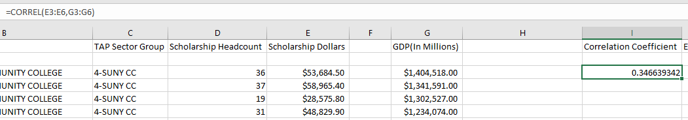

* Check if correlation coefficient is within our acceptable range for scholarship

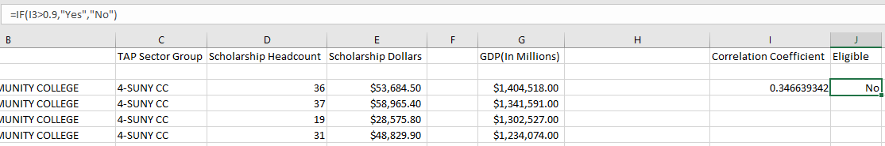

* Compose list of schools eligible for NYSTEM Scholarship