1. **UML**
2. Activity diagram

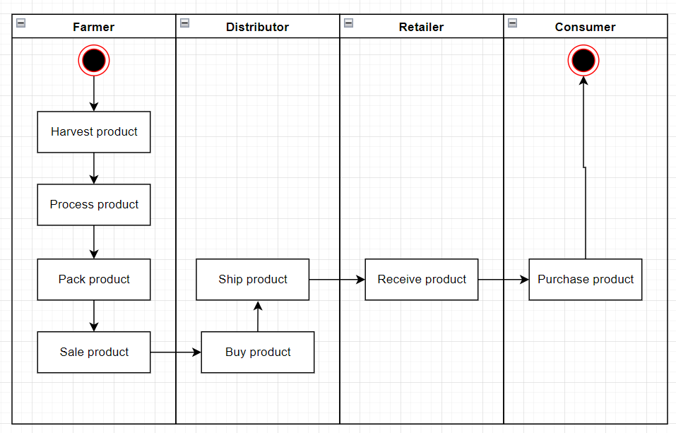

1. Sequence diagram

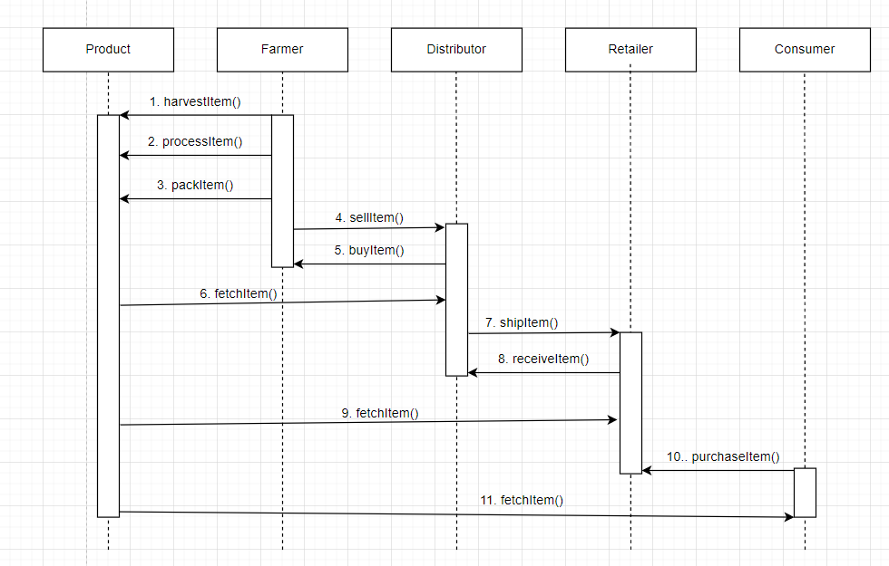

1. State diagram

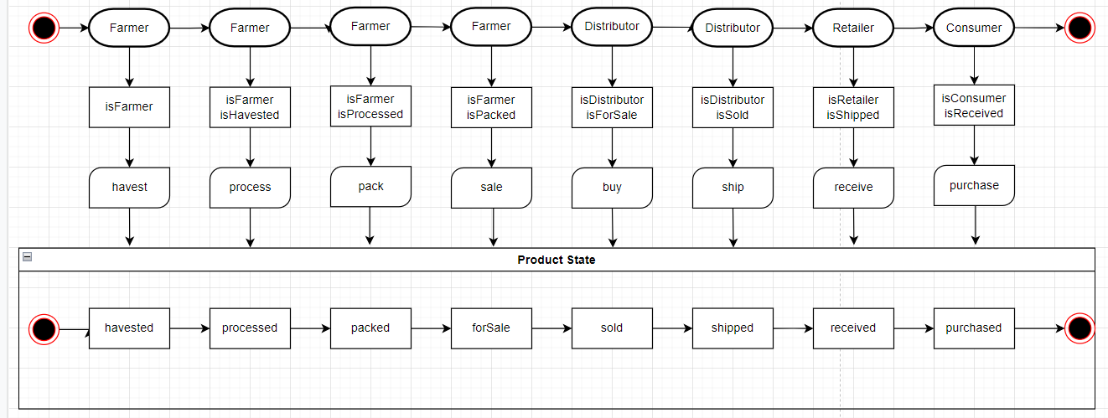

1. Class diagram

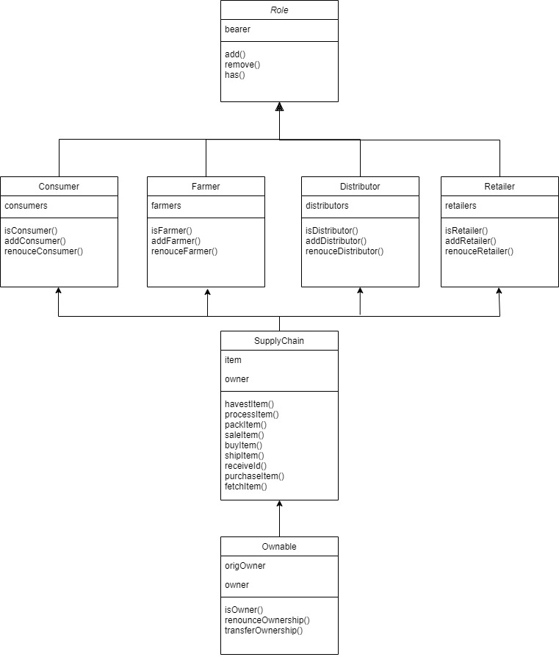

1. **LIBRARY**

|  |  |  |
| --- | --- | --- |
| No | Library |  |
| 1 | Web3 | Used to call smart contract from web application |
| 2 | truffle-hdwallet-provider | Used to deploy smart contract to testnet |

1. **INFURA**

* URL: <https://rinkeby.infura.io/v3/3bc0da104e35493bb779e24ea2da361e>

1. **ENVINROMENT**

* NodeJS: 10.18.0
* Truffle: v4.1.14
* Solidity: v0.4.24
* Web3: ^1.3.5