2. 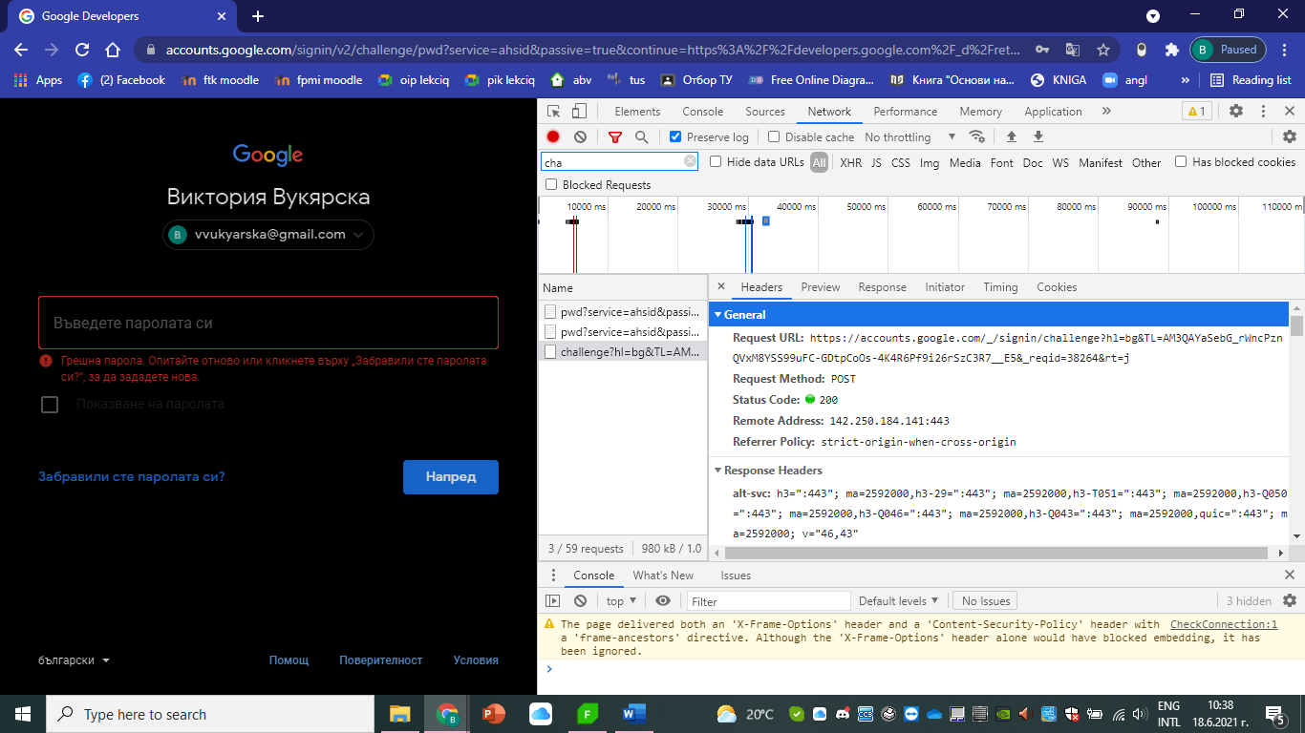

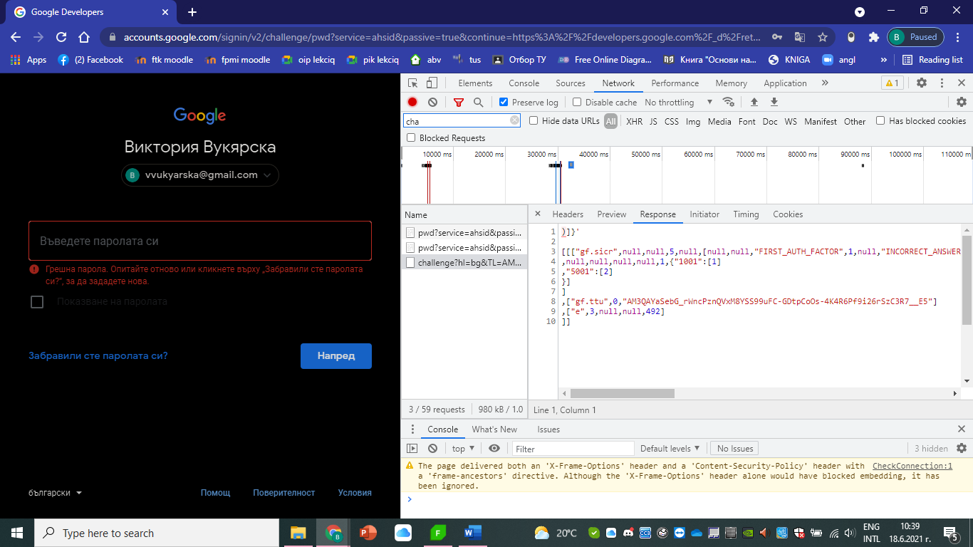

It shows that the login is not successful and everything in the request is as it has to be. The method that is used is POST ( takes care for associating the new resource with the parent), because we insert our credentials. The expected answer from the website is not allowing us to sign in in our profile, ,because we insert incorrect data, and an error message, too.

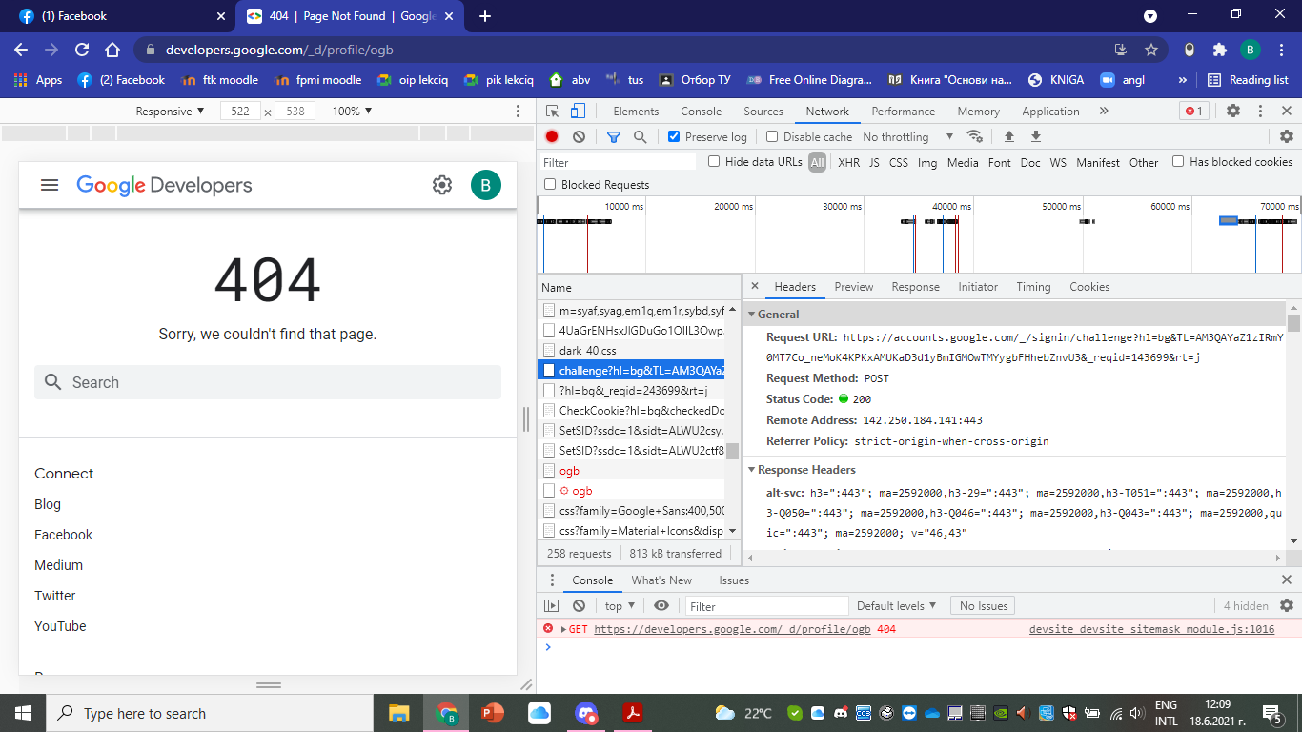

This is the data that appears in the request tab when I insert correct credentials. I tried everything, including restarting my pc restarting my profile, deleting it and etc. but nothing helped and it shows this error page. The request shows that everything with my login is ok, I am in my profile because my credentials are correct, POST is used again because we insert our login info.

1. 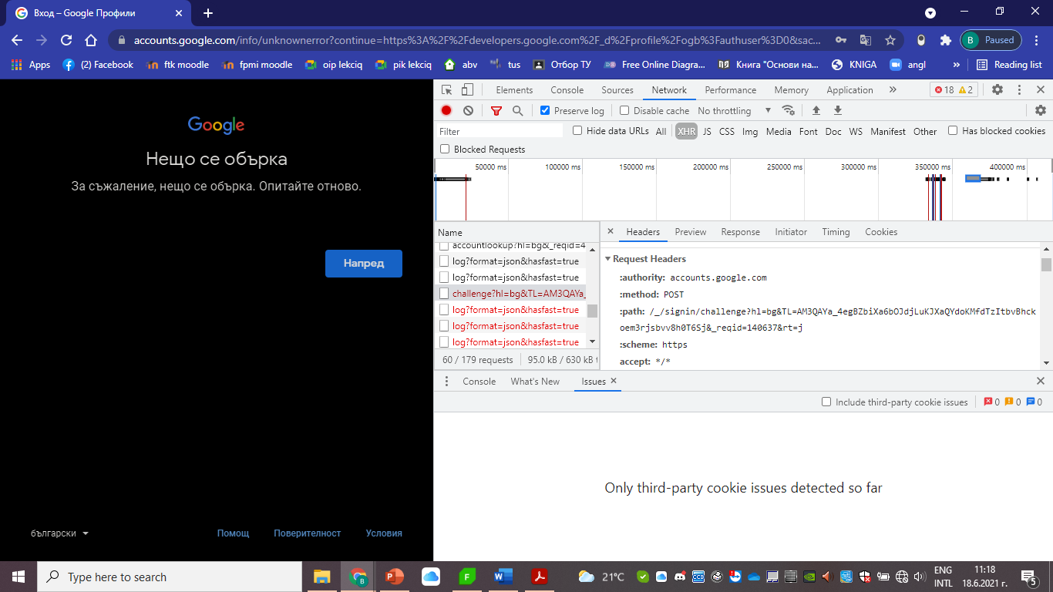

I can see an error message that says ‘Something went wrong’. It allows us to refresh and check whether it is a one-moment (ex: server) error, or something bigger is happening with the website.

On the network tab the request shows us that our action is not completed and there is an error. HTTPS is used.

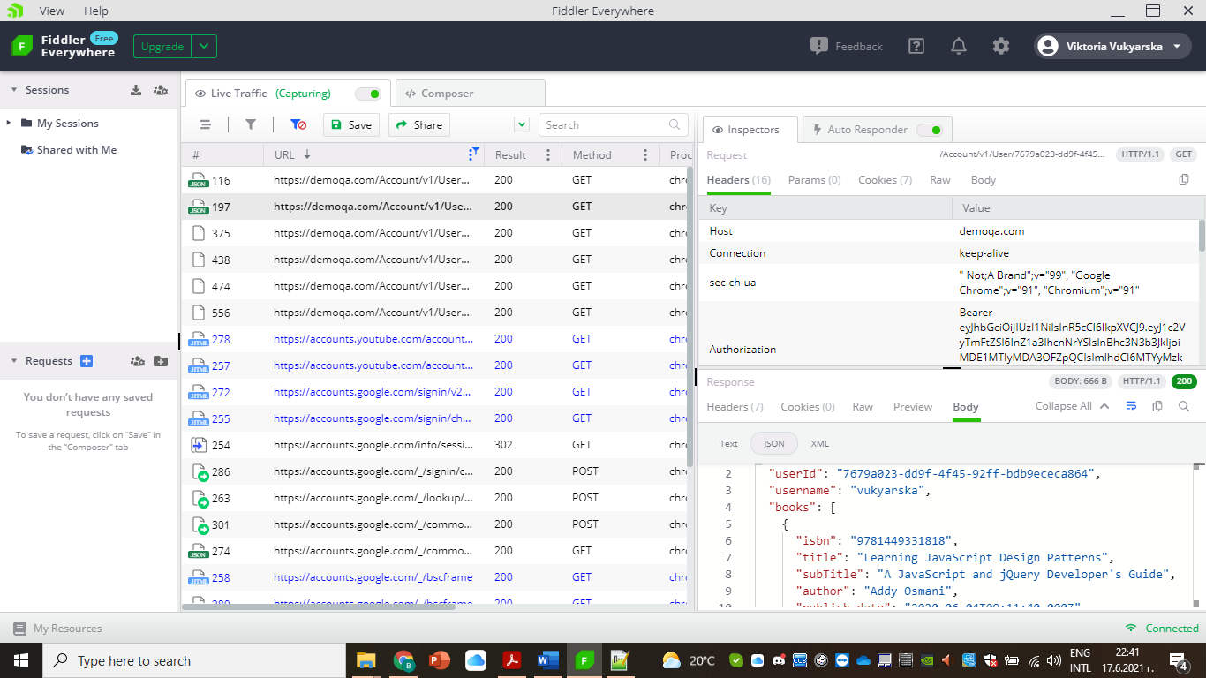

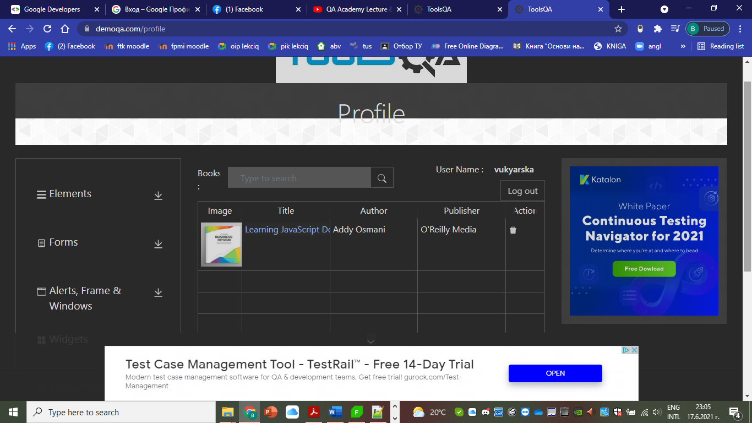

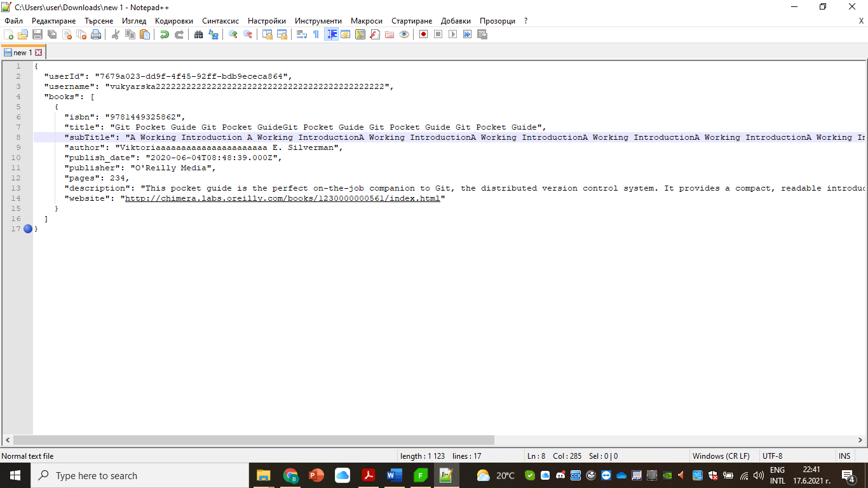

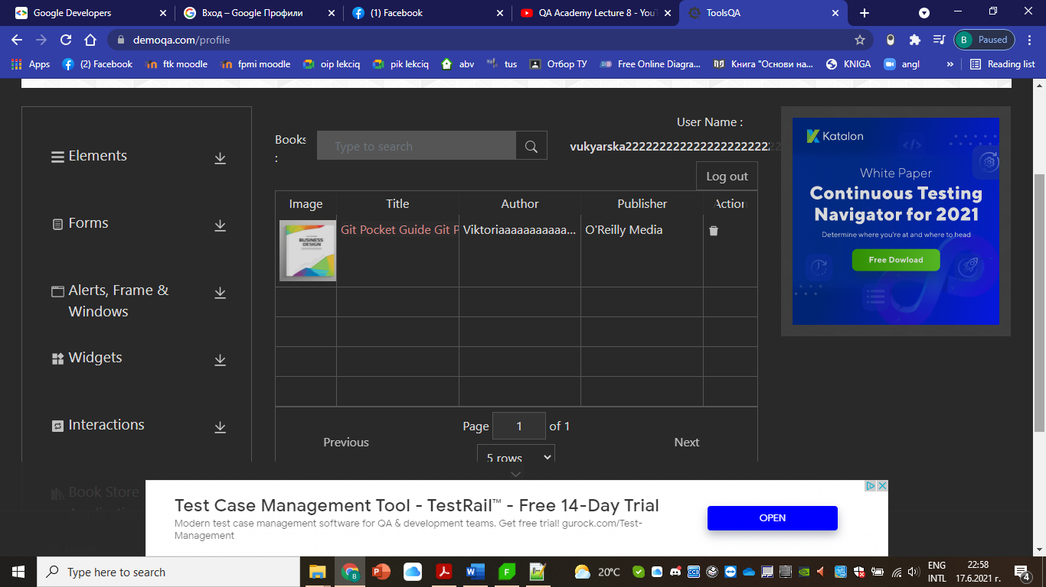

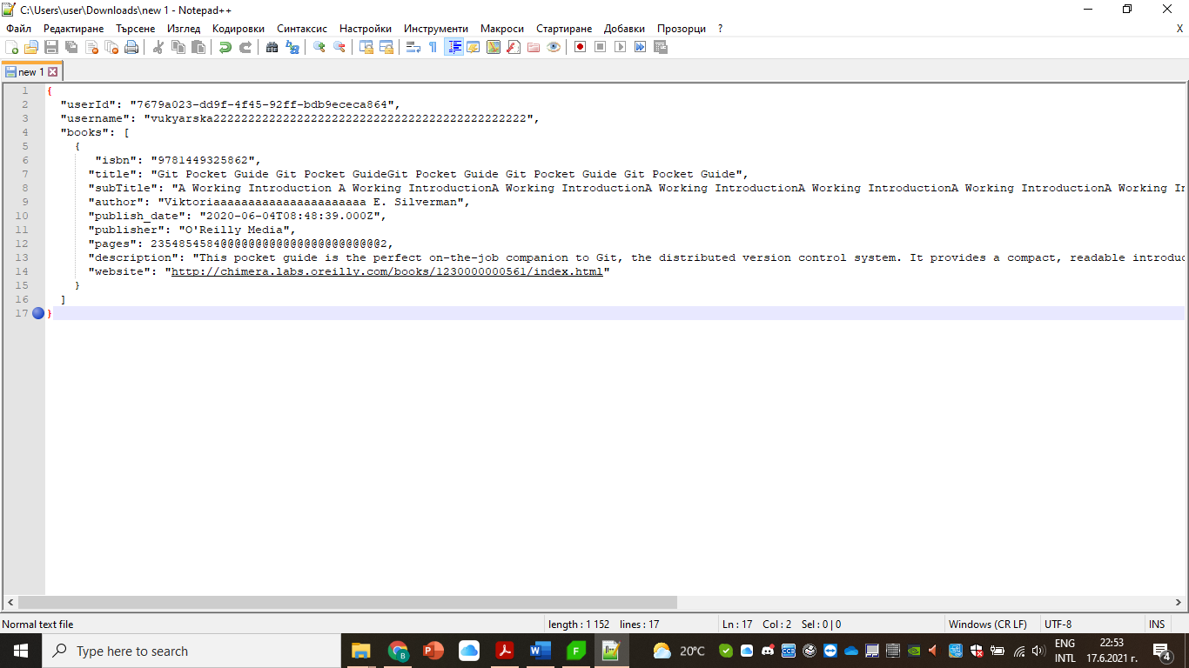

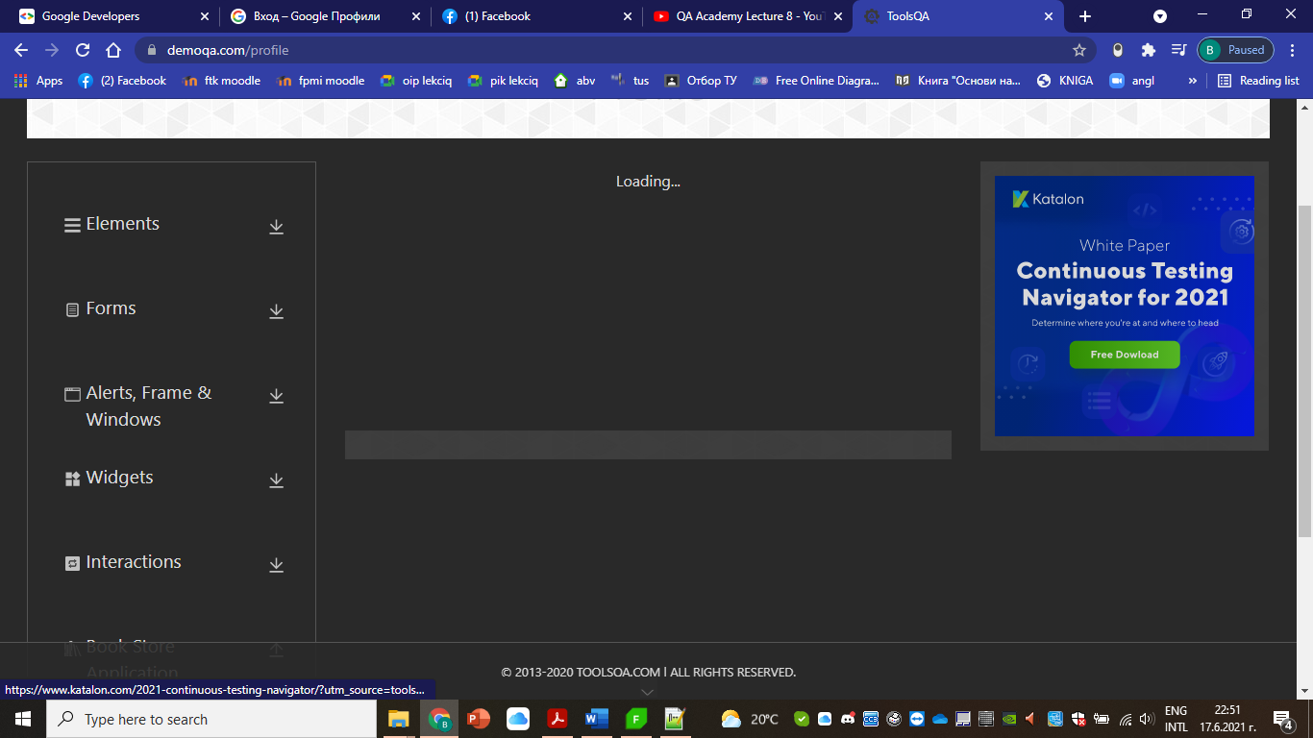

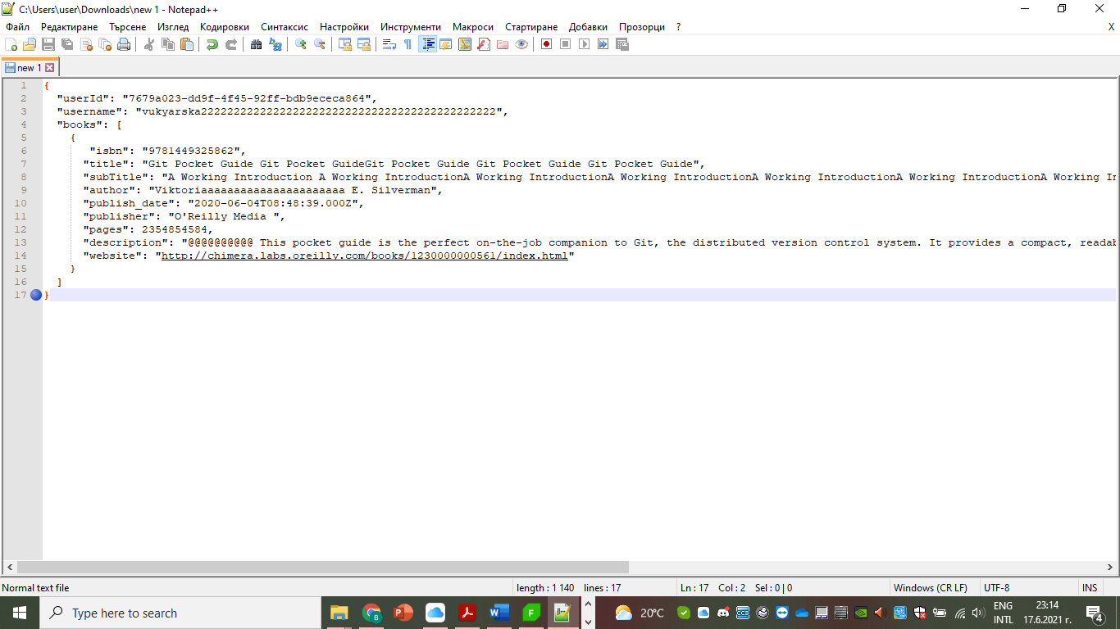

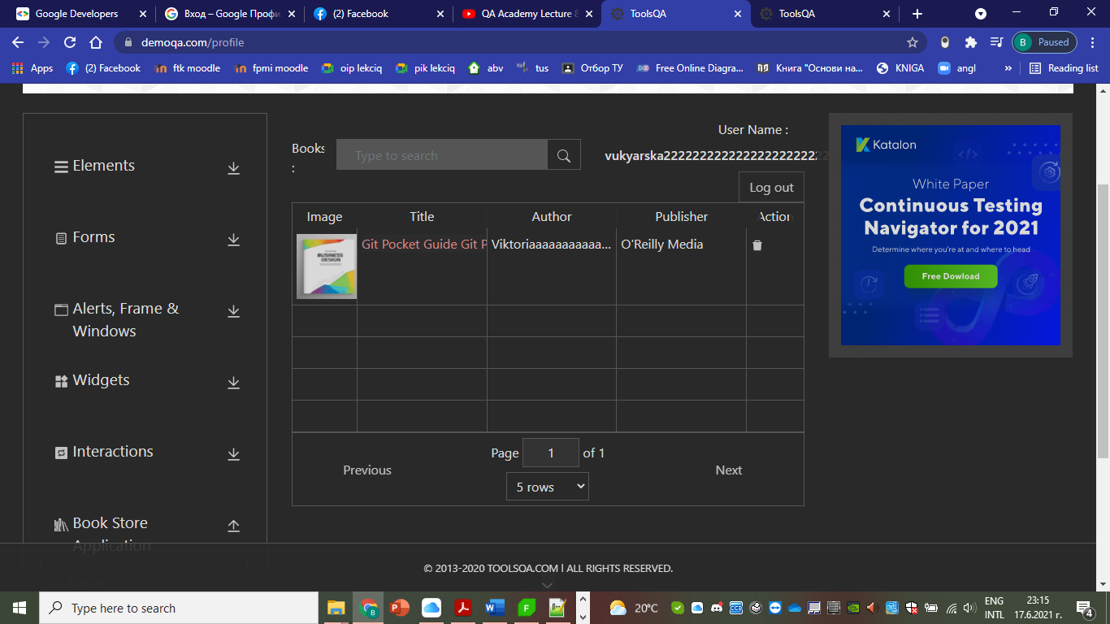

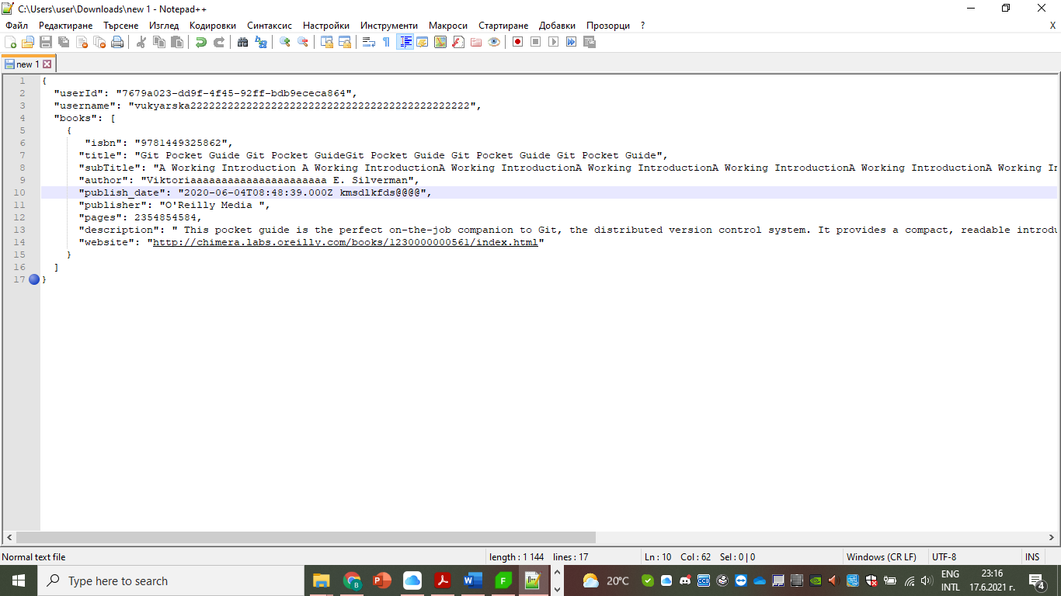

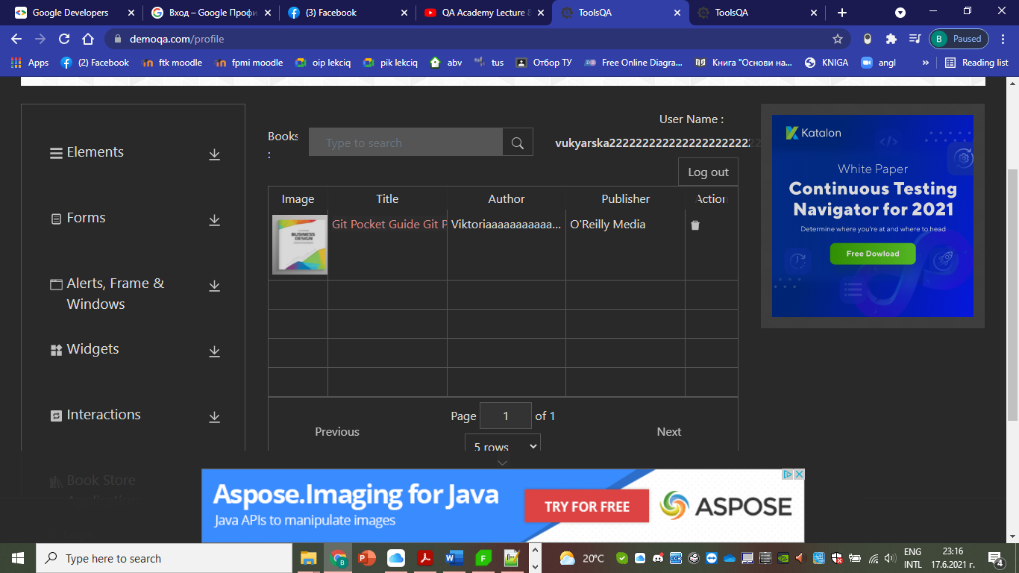

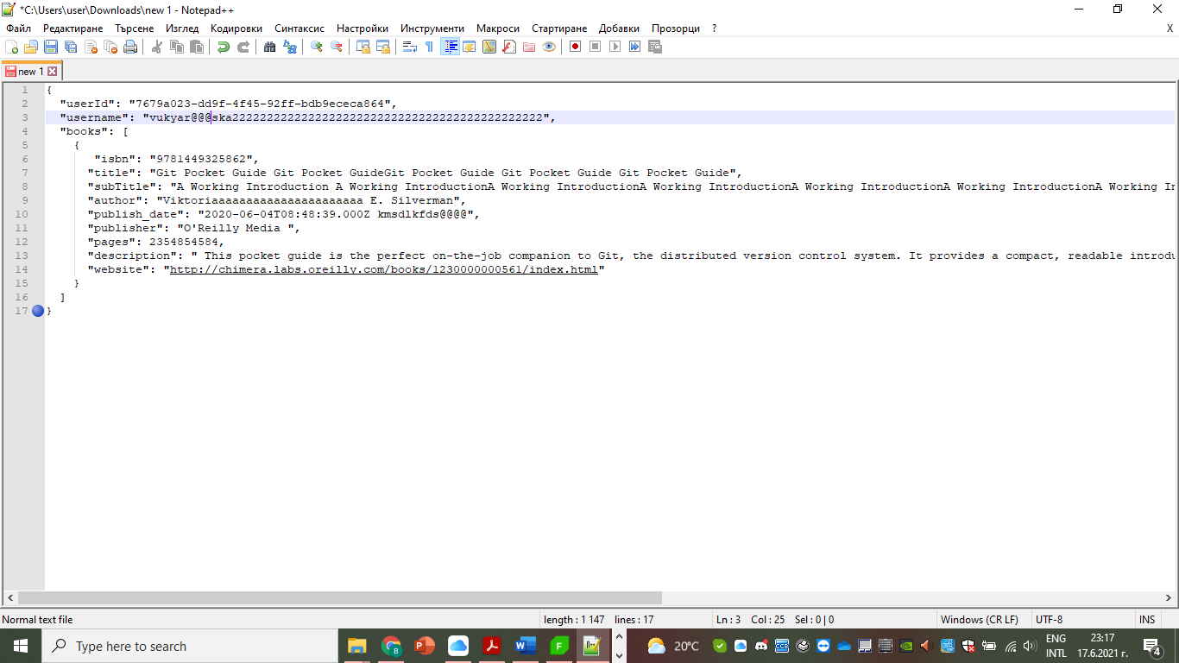

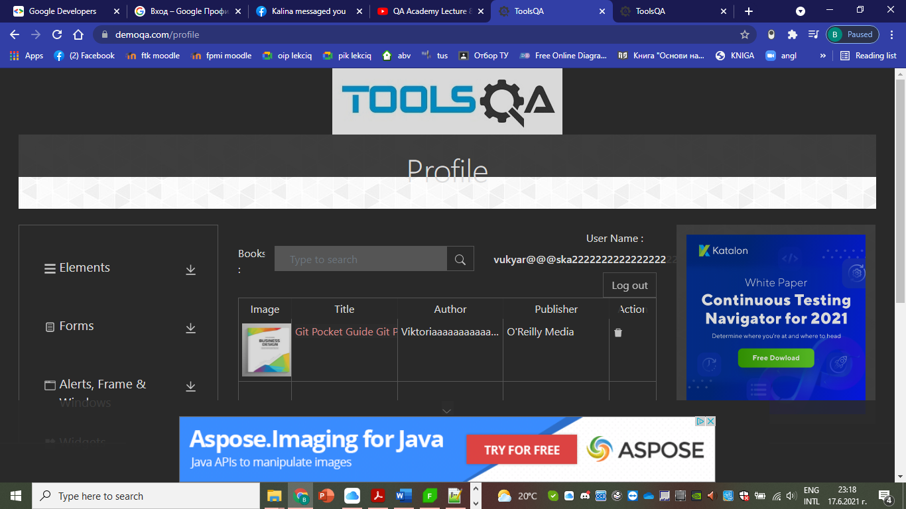

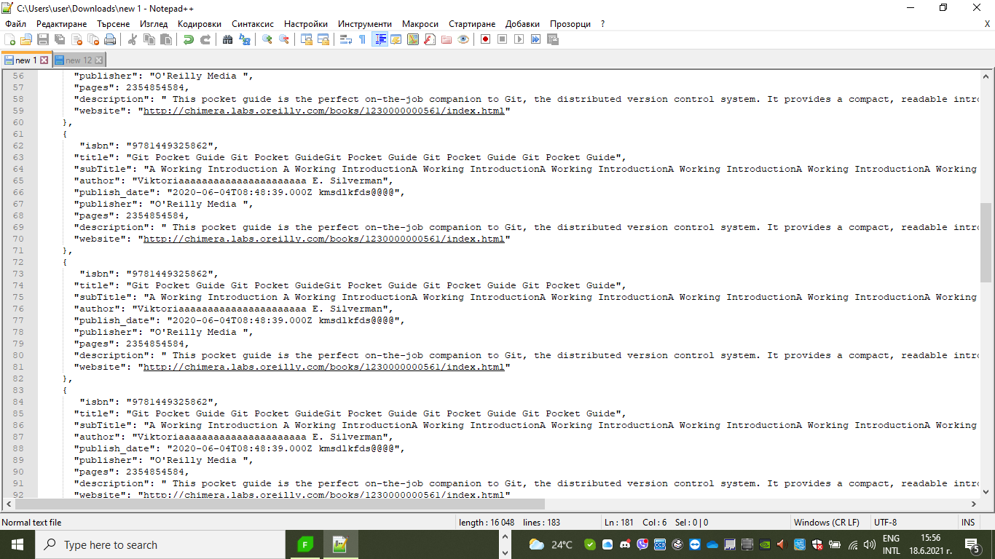

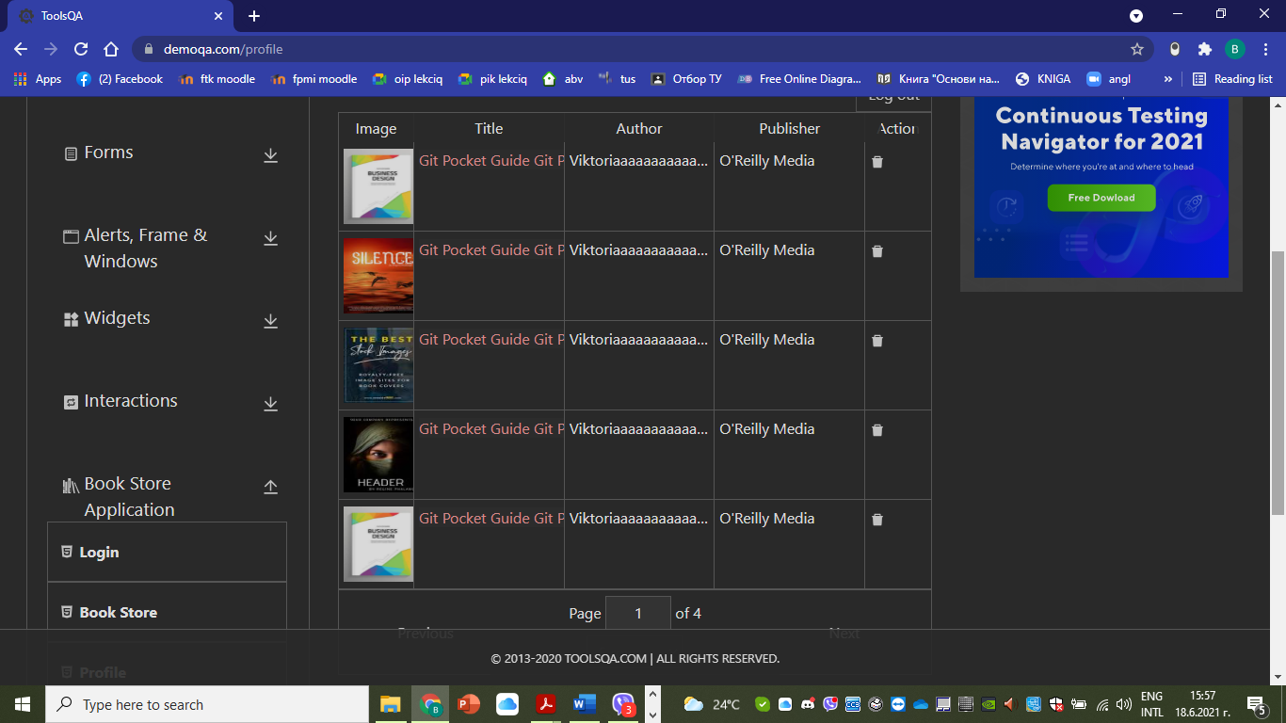

Summary:

**In the first case** I tried to expand the title, the subtitle, the username and the author but nothing happened. The site was working, but the whole extensions weren’t visible.

**In the second case**, including the extensions from the first, I added special symbols for the pages field and the site stopped working, which means that for ‘pages’ field special symbols are not allowed.

**In the third case**, I added some special symbols in the description field and everything was ok.

**In the fourth case**, I deleted the special symbols from the third case and added some special symbols and some letters in the publish date field and nothing happened which means that this field is not for numbers only.

**In the fifth case**, I copied the same code from the fourth case 15 more times and the site added more books with the same parameters, but with the images of the first four books from the book store. And it continued taking only these 4 books for the rest of the cycle. Which means that the site takes the next book not by your choice but by default from the book store by repeating only 4 of them.

{

  "userId": "7679a023-dd9f-4f45-92ff-bdb9ececa864",

  "username": "vukyarska",

  "books": [

    {

      "isbn": "9781449325862",

      "title": "Git Pocket Guide",

      "subTitle": "A Working Introduction",

      "author": "Richard E. Silverman",

      "publish_date": "2020-06-04T08:48:39.000Z",

      "publisher": "O'Reilly Media",

      "pages": 234,

      "description": "This pocket guide is the perfect on-the-job companion to Git, the distributed version control system. It provides a compact, readable introduction to Git for new users, as well as a reference to common commands and procedures for those of you with Git exp",

      "website": "http://chimera.labs.oreilly.com/books/1230000000561/index.html"

    }

  ]

}

|  |  |  |  |  |  |  |  |
| --- | --- | --- | --- | --- | --- | --- | --- |
|  |  | Safari | | Opera | |  |  |
| device | platform | Landscape | Portairt | Landscape | Portairt | Screen size (inches) | Priority |
| iPhone 12 | ios 14.6 | ✓ | ✓ | ✓ | ✓ | 6.1 | High |
| iPhone 12 Pro | ✓ | ✓ | ✓ | ✓ | 6.1 | High |
| iPhone 12 Pro Max | ✓ | ✓ | ✓ | ✓ | 6.7 | High |
| iPhone 12 mini | ✓ | ✓ | ✓ | ✓ | 5.4 | High |
| Samsung Galaxy S21 | Android 11.0 | x | ✓ | ✓ | ✓ | 6.2 | High |
| Samsung Galaxy S21+ | x | ✓ | ✓ | ✓ | 6.7 | High |
| Samsung Galaxy S21 Ultra | x | ✓ | ✓ | ✓ | 6.8 | High |
| Nexus | Android 5.1.1 | x | ✓ | ✓ | ✓ | 7 | High |
| Desktop | Windows 10, Mac, Linux | ✓ | X | ✓ | X | 15.6 | High |
|  |  |  |  |  |  |  |  |
|  |  |  |  |  |  |  |  |
| ✓ | fully tested and supported |  |  |  |  |  |  |
| X | not supported |  |  |  |  |  |  |