SIR MODEL FOR COVD (MAHARASHTRA MAY 2020)

IWEM_111

*Khojasteh Mirza, Btech Mechatronics 2nd year*

An SIR model is an epidemiological model that computes the theoretical number of people infected with a contagious illness in a closed population over time.

The model consists of 3 compartments:

S is the number of susceptible individuals

I is the number of infected individuals

R is the number of recovered individuals

An SIR model is the easiest to compute and can provide fairly accurate results. However it is a closed cycle approach, where the rate of change of parameters are not accounted for, which means that the population will not be affected by births. And the model only accounts for death due to the infection and not any other kind of death.

R

I

S

For this case study it is assumed that the whole population of Maharashtra is capable of contracting the infection hence S(t) = total population = 12.9 Cr.

Because we are conducting this study only for the month of May, we need to assume that the Infected people I(t) were already 11506 on the 1st of May 2020, and that the recoveries r(t) for day 1 is 0 because we are not considering people infected in the previous months. We also assume that the patient cannot recover in a single day i,e, infected and recovered on May1st itself.

S0 = 124900000

I0 = 11506

r0 = 0

The equations used for the model were:

$$S_{n}=S_{n-1}-\left(\frac{S_{n-1}}{S}\right)*β*I_{O}$$

$$I_{O}=I_{0}+\left(\left(\frac{S_{n-1}}{S}\right)*β*I_{O}\right)-(I_{O}*γ)$$

$$r=r_{O}+I_{O}*γ$$

Also, the basic reproduction rate,

$$R_{0}=\frac{β}{γ}=2.5$$

The peak according to this model would be close to 80,000 cases during early June and then decline. Compared to the real world, the data on 25th of May for the model was 52,134 and the actual number recorded was 52,667. Thus it can be seen that the model is fairly accurate with an error of 1.012%. Due to the lockdown being lifted and shops being opened since June, the cases are still rising well beyond the projected 80,000 for Early June.

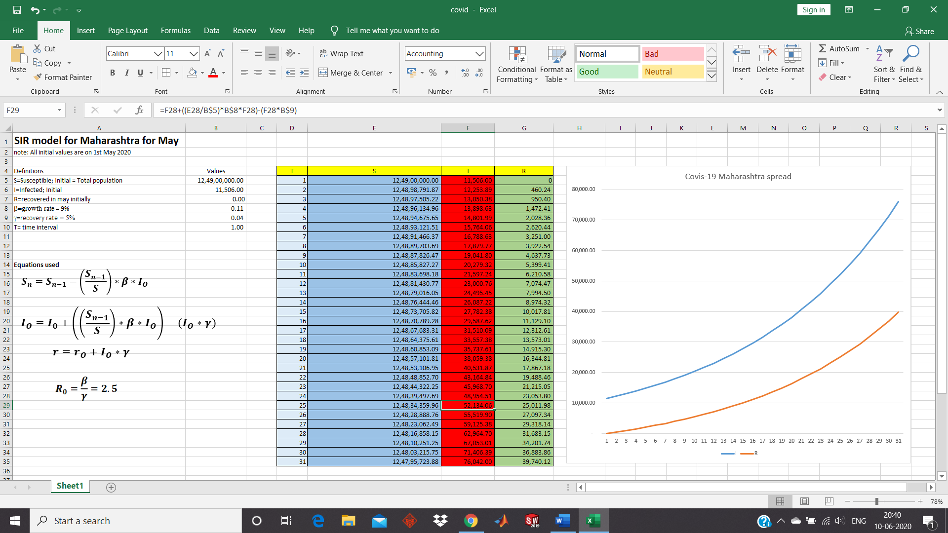

Mathematical model

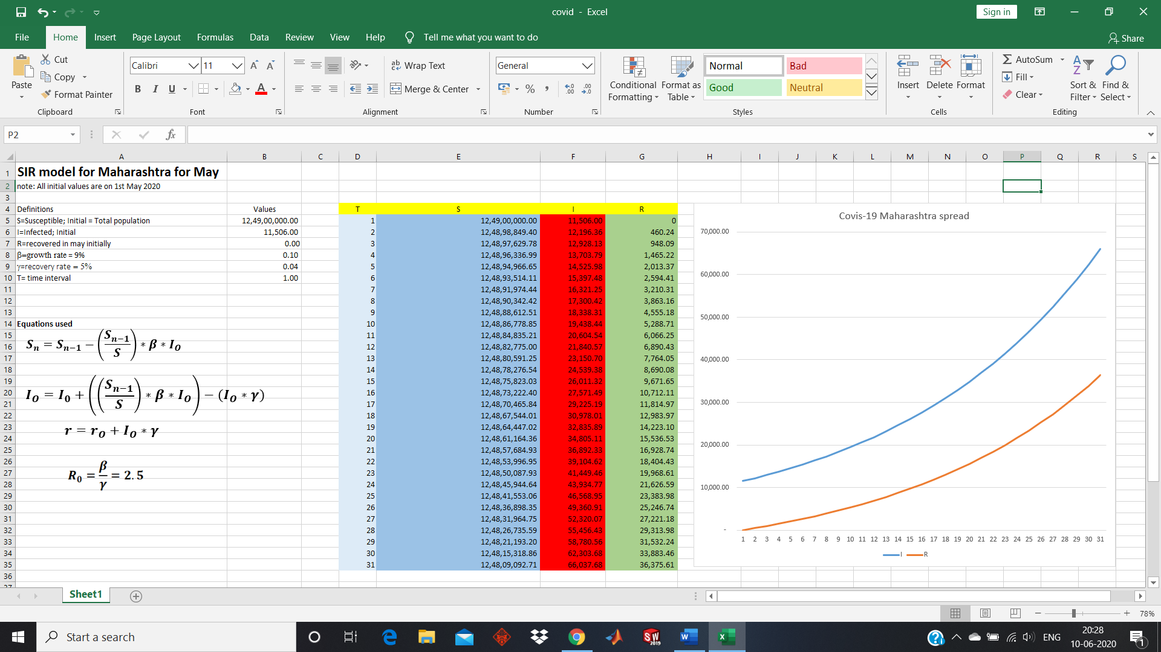

Model predicted graph

I=infected

R=recovered

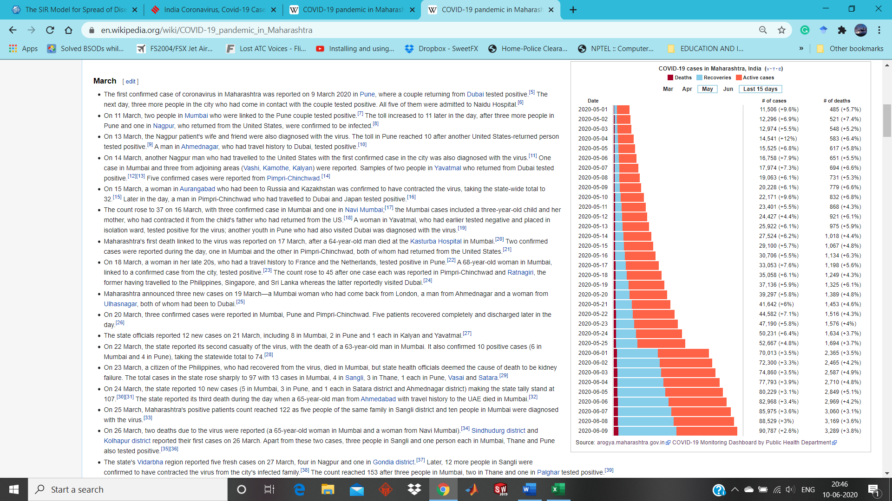

The actual cases, a very sharp rise is seen between 25th May and 6th June 2020, possibly due to lifting of the lockdown restrictions.

References

<https://www.worldometers.info/coronavirus/#countries>

<https://www.maa.org/press/periodicals/loci/joma/the-sir-model-for-spread-of-disease-the-differential-equation-model>

<https://indianexpress.com/article/explained/coronavirus-numbers-explained-india-cases-growth-rate/>

<https://en.wikipedia.org/wiki/COVID-19_pandemic_in_Maharashtra>

<https://www.youtube.com/watch?v=bc0UsckwRYY&list=LLsyK1GECVmUxgVvf3xIX8dQ&index=2&t=0s>

<http://www.pandemsim.com/data/index.php/make-your-own-sir-model/>