Submissions template for Electronics Letters: title should be no more than 15 words

J. Smith, A. Author, B. C. Author and D. Author

This document gives you guidelines on preparing manuscripts for submission to Electronics Letters, and also provides the rough format of finished articles in order to estimate the length of your Letter. Letters should not exceed four columns in length. Manuscripts can also be submitted in LaTex (please see the LaTex template), along with a PDF. The first word of the title should be capitalised, with all other words lowercase. Please avoid using the words ‘new’ and ‘novel’, as well as function words such as ‘the’, ‘a’ and ‘an’. A full list of author names should be placed under the title, using the following style: initials (separated by full stops) and family name. Chinese-style names can be printed in full; therefore they should be typed as the author wishes his/her name to appear. Author names should be separated by a comma apart from the final name, which should, instead, be preceded by ‘and’ (see the example above). The Abstract should follow, and must be: indented 1 cm; Times New Roman; font size 7.5; one paragraph; and should not exceed approximately 200 words. It must not cite any references, and any acronyms used in the Abstract must be expanded.

Introduction: The main text should be set in a two-column format, with a column width of 8.7cm and a central space of 1.06cm. Please use
8.5 pt. Times New Roman font with a line spacing of 1.1, and please number all pages. Each submission should have clearly headed Sections in the style shown, especially an Introduction, Conclusion, and References Section. New sections should be separated by a blank line, and paragraphs within the Sections indented by 0.3cm.
The first instance of all acronyms within the main text should be expanded, with the acronym defined after it in brackets, as follows: ‘electromagnetic interference (EMI)’. The expansion should not be capitalised, unless it contains a word that is normally capitalised, i.e. ‘fibre Bragg grating (FBG)’. Once the acronym has been expanded in the main text, all future instances can be shortened to the defined acronym; i.e. ‘EMI’.
All of the References present in the References Section must be cited in the main text, in numerical order and in square brackets – i.e. ‘[1]’. Multiple references can be bracketed together, for example ‘[1, 2]’ or ‘[3–5]’. Figures and Tables must be embedded within the main text, and must also be cited in numerical order. Tables should be labelled ‘Table 1’, ‘Table 2’ etc. and Figures should be labelled, for instance, ‘Fig. 1’ and ‘Fig. 2’, with any sub-Figures labelled as follows: ‘Fig. 3a’, ‘Fig. 4c’ and so on. Figures that contain sub-Figures can be cited as a whole
(e.g. ‘Fig. 1 shows…’), or separately (e.g. ‘Fig. 1a shows…’) – if citing sub-Figures separately, please ensure that all parts are cited.

Presentation of Figures and Tables: As stated above, Figures and Tables must be embedded within the main text. They cannot be set across two columns, and must be clearly readable when viewing the manuscript at 100% zoom, or when printed. Figures and Tables must also be separated from the main text with a blank line.
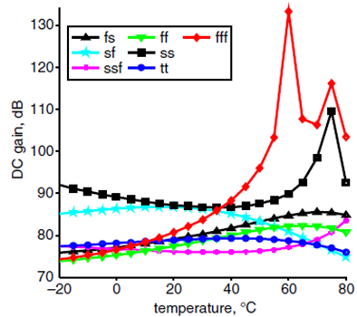

a b
Fig. 1 To ensure traces are distinguishable in black and white, please use a variety of shapes and/or dashed lines.
a Sub-captions should be placed below the main caption, in upright
b Label axes in the format: angle, deg (what axis shows, comma, units)
Please ensure that Figures are clearly labelled, as discussed above, placed near to where they are cited and that they are of good quality; i.e. clear to understand and not blurry. Electronics Letters is available in colour online, but please ensure that Figures are understandable when viewed in black and white. Also note that algorithms should be treated standalone, i.e. not treated as a Figure.
All Figures are relettered, so inclusion of unlettered originals (at the end of the manuscript or as separate files) is welcomed. Note: if possible, please try to avoid setting line-drawings and photographs in the same Figure since photographs require different processing in order to maintain quality.

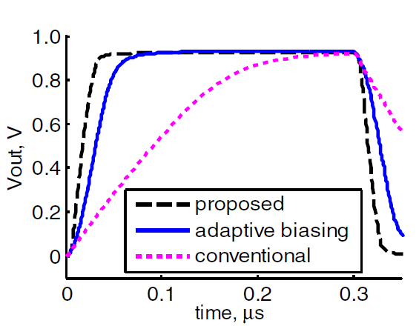

a
b

Fig. 2 All text in Figures should be lowercase, unless the word would normally be capitalised (i.e. ‘LED’, or ‘Butler matrix’)
a Sub-Figures can be placed adjacent to each other or on new lines
b Figures such as the above do not need to be placed in a border.

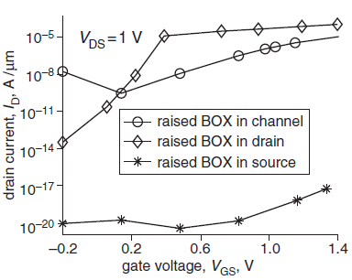

Fig. 3 Zero should always be written ‘0’ – do not include decimal places after zero (i.e. not ‘0.0’); set all legends in boxes within the Figure.

Please see Table 1 as an example of their presentation. Please ensure all Tables are cited in numerical order, as with the Figures and References. Unlike Figure captions, Table captions are placed above the corresponding Table, and are not italicised. If all values in a column use the same units, include this in the column heading in brackets rather than after each value.

Table 1: The font size within the Table should match that of the main text, to ensure that it is clearly readable when printed.

Name | Proportion (%) | Frequency (GHz) | Area  (mm²)
One | 45 | 64 | 12.3
Two | 55 | 18 | 3.4

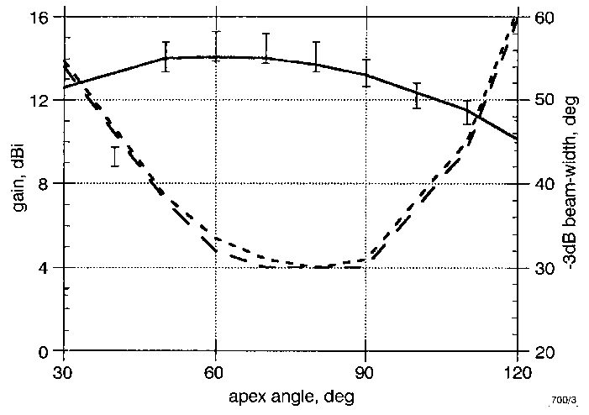

Fig. 4 Insert caption below figure; avoid using function words such as ‘the’, ‘an’ and ‘a’

Information on equations: All numbered equations such as (1), below, should be referred to in the main text using the bracketed number only. For example, ‘I in (1) signifies the area’. Numbered equations or substantial maths should be set on a separate line from the text, as follows:

D_{H} = [2π I(90,φ)] / [ ∫₀ ^{2π} I(90,φ)dφ] (1)

Equation editors can be used, as long as they are in English. All variables must be defined, e.g. ‘the apex angles φ’. If an equation is too long to fit on a single line, then split it over two lines, as follows:

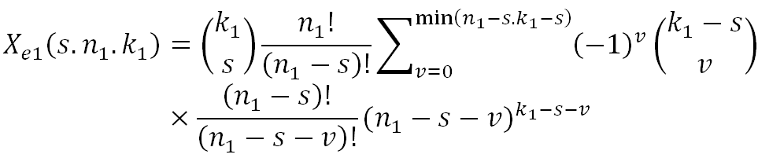
(2)

Please pay attention to the use of italics and upright font: it is important that variables are set in italics, with non-variables and labels in upright. For example, R denotes resistor while R denotes resistance.

Information on References: References should be numbered and cited in numerical order, and should have no line spaces between them (as illustrated in the References section).
A numerical reference system is used in Electronics Letters. If referencing a journal article, please set it as follows: author names, ‘title’, name of journal, year of publication, volume, issue, page numbers and, the DOI (for example, see [1]).
Conferences require the above information, as well as a little more: please include the conference venue and the month that it was held (e.g. see [2]).
Book references must include the publisher’s information in rounded brackets, such as the name of the publisher and their main location. Second and third edition information can also be supplied in the brackets, after the year of publication (e.g. [3]). For an illustration of referencing a chapter from an edited book, please see [4].
To reference a website please include the author/institution/company name, the title of the page, the URL, and the month and year that it was first accessed (see [5]).
Please Note that References to submitted works cannot be included unless they have been accepted for publication. In the case of PhD theses, please provide as much information as possible, especially the relevant university.

Information on Author affiliations: Affiliations appear after the Conclusion and Acknowledgments Section (please see below). Please give the full affiliations of all authors. It must also be indicated which author is the corresponding author by including their e-mail address with their affiliation. Only one e-mail address can be published at the end of a manuscript. This e-mail will be published in the journal, as well as used for editorial work. If authors wish to change the e-mail address, or the author’s order of appearance, we will require email verification from all co-authors.

Conclusion: The Conclusion must be clearly marked as shown. When referring to other Sections in the Letter, please use the Section heading, or describe the relevant Section as the ‘following’ or ‘preceding’ Section in relation to the current Section in the text.

Acknowledgments: This Section is optional but can be used to recognise the support from certain funds or organisations, for example: ‘This work was supported by *insert organisation here* (grant ABCD-1234X)’. Please try to avoid personal acknowledgments, such as individuals, and please do not include any thanks to the Editorial staff.

J. Smith, B. C. Author and D. Author (*insert address of affiliation here*)

E-mail: j.smith@1234.com - please only include one e-mail address, and place it next to the affiliation of the corresponding author

A. Author (*has a different affiliation, insert address here*)

J. Smith: also with *insert second affiliation here* if author has more than one affiliation

References
1. Hoshuyama, O., Sugiyama, A., Hirano, A.: ‘A robust adaptive beamformer for microphone arrays with a blocking matrix using constrained adaptive filters’, IEEE Trans. Signal Process., 1999, 47, (10), pp. 2677–2688, doi: 10.1109/78.790650
2 Lin, D.B., Pan, J.L.: ‘Analysis and improvement on propagation efficiency of high-speed asymmetric differential transmission system’, Asia-Pacific Conf. Circuits Syst., Tainan, Taiwan, December 2004, pp. 329–332, doi 10.1109/APCCAS.2004.1412761
3 Taflove, A.: ‘Computational electrodynamics’ (Artech House, Norwood, MA, USA, 1995, second edition)
4. DeVito, L.M.: ‘A versatile clock recovery architecture and monolithic implementation’ in Razavi, B. (Ed.): ‘Monolithic phase-locked loops clock recovery circuits’ (Wiley-IEEE Press, New York, 1996)
5 CVX Research: ‘CVX: Matlab software for disciplined convex programming, version 2.0 beta’, http://cvxr.com/cvx, accessed August 2013

The below line is approximately the maximum length of a manuscript allowed (if it were to fill all four columns).

This document is intended as a guide for format and length; your manuscript will be copyedited and formatted further at proof stage.

