HealthRules Payer Documentation Intelligence Pipeline
From raw multi-version release-note PDFs to a taxonomy-aware,
self-evaluating, dynamically-gated RAG chatbot

Knowledge Transfer Document
Covers: Stage 1 (ingestion → taxonomy pipeline) + retrieval_layer (retrieval, eval, caching)
Generated: 2026-07-06

Contents
1. Executive Summary
2. Problem Statement & Approach
3. System Architecture — Two-Phase Pipeline
4. Environment & Dependencies
5. Stage 1 — Ingestion & Taxonomy Pipeline (main.py)
6. Stage 1 Tail — Cross-Version Intelligence & Indexing (run_tail.py)
7. Retrieval Layer Architecture
8. Evaluation Framework & Results
9. Hackathon Demo — Dynamic Gating + Redis Cache
10. Design History — Key Decisions & Course Corrections
11. How To Run It — Step by Step
12. Known Limitations & Open Items
13. File Reference Index

1. Executive Summary
This system turns a folder of multi-version enterprise release-note PDFs (HealthRules Payer v25.2 and v26.1) into a retrieval-augmented chatbot that is measurably better than both a naive vector-search baseline and a traditional sliding-window RAG baseline — and self-evaluates against both on every change. It is built in two phases: an offline ingestion/taxonomy pipeline ("Stage 1") that turns raw PDFs into a structured, cross-version aware knowledge base, and a retrieval layer that serves that knowledge base through smart routing, confidence-gated escalation, version-conflict detection, and a Redis-backed response cache for instant demo answers.

Headline results (53-query golden eval set)
Metric | Naive RAG | Traditional RAG | Pipeline | Merged (Pipeline + Naive) | Merged-All (Pipeline + Naive + Traditional)
Mean top rerank score | -0.582 | -0.793 | 1.985 | 2.418 | 2.696
Keyword hit rate | 39/41 (95%) | 41/41 (100%) | 41/41 (100%) | 40/41 (97%) | 41/41 (100%)
Mean latency | 160 ms | 54 ms | 322 ms | 206 ms | 269 ms

Source: retrieval_layer/eval_report.md, generated 2026-07-05 from the 53-query golden set. "Pipeline" is the taxonomy-routed system; "Naive" is flat vector search over the same curated chunks; "Traditional" is a sliding-window RAG baseline over raw markdown, with no taxonomy at all — the closest analogue to an off-the-shelf RAG system.

What makes this more than "a RAG demo"
- Self-comparing, not just self-serving. Every retrieval path (pipeline, naive, traditional, and two pooled ensembles) is measurable head-to-head on the same 53-query set, with both retrieval-quality metrics (eval.py) and generation-quality metrics (deep_eval.py, using DeepEval's Faithfulness/Correctness/Completeness/Conciseness) — not just "it works on my test query".
- Dynamic confidence gating, not a static router. The production entry point (redis_cache.gate_and_retrieve) runs the cheap path first, measures its own live retrieval confidence, and only escalates to a more expensive, pooled retrieval method when that specific query actually needs it — it generalizes to unseen queries instead of only knowing how to route what it was tuned on.
- Version-aware by construction. The pipeline detects when retrieved chunks come from more than one document version, auto-injects the relevant delta (change) analysis, and instructs the LLM to present version differences explicitly instead of silently blending contradictory facts from two releases into one answer.
- A real caching layer for live demos. A Redis-backed cache (seeded via build_cache_preset.py) gives sub-millisecond, zero-token answers for a curated set of demo questions, while leaving an uncached half available to show the real, live retrieval + generation path — both hit the exact same code path, so the demo isn't faking anything.

2. Problem Statement & Approach
Enterprise release-note PDFs are long, multi-version, and full of interdependent features described inconsistently across releases (tables, bullet notes, ticket references, version-specific caveats). A plain RAG pipeline over these documents runs into three structural problems this project set out to solve:
- Fragmentation. A single logical feature is often split across a title paragraph, a sub-section, a table, and a closing ticket reference — naive fixed-size chunking cuts straight through these boundaries.
- Version blindness. Two releases can describe the same section differently (or contradictorily); a flat retriever has no notion that it just returned facts from two different points in time as if they were one fact.
- Breadth vs. depth query mismatch. Some queries want a specific fact ("what property controls X"); others want a breadth answer ("list all the domains this covers") that no single chunk — however well written — can structurally satisfy.

Model strategy: prove cheap, then scale
The whole pipeline was first validated end-to-end on a small local model (gemma-3-1b-it) before any investment in a larger model or paid API. The reasoning: if a 1B model can drive the full pipeline (extraction → labeling → grouping → delta analysis) without architectural changes, a larger model only improves output quality, not design correctness. Once validated, the LLM backend was upgraded to a locally-hosted Qwen3.5-9B (Q4_K_M, via llama.cpp — see Section 4) with zero pipeline code changes; only config.py's model pointer changed. This is why the pipeline exposes a single llm_client.py abstraction everywhere instead of hardcoding a provider.

3. System Architecture — Two-Phase Pipeline
The codebase is split into two top-level folders that share one Python virtual environment but run as separate processes:
- Stage 1/ — offline, run-once-per-corpus-update. Turns PDFs into structured JSON/CSV artifacts: chunked+labeled text, a topic registry, a nested taxonomy, cross-version delta findings, relationship clusters, and rolled-up summaries.
- retrieval_layer/ — the serving layer. Reads Stage 1's output artifacts, builds a ChromaDB vector store + HNSW index, and exposes retrieval, evaluation, and a Redis-cached chatbot CLI on top of them.

End-to-end data flow
PDFs (data/pdfs/*.pdf)
│
▼ main.py (Stage 1, steps 1-7)
Chunked → Rectified tables → Enriched → Quality-filtered → Grouped
→ Master-labeled → Normalized → QnA-generated
│
▼ registry.py + nested.py
topic_registry.csv + enterprise_nested_topics.json (parent/sub taxonomy)
│
▼ run_tail.py (Stage 1, steps 1-11 — see Section 6)
cross-version filter → grandparent clusters → cross-corpus clusters (no-op today)
→ delta analysis → topic summaries → hierarchy roll-ups → delta_reports/
→ HNSW index → ChromaDB collections → eval → Redis cache preset
│
▼ retrieval_layer/ (see Section 7)
router.py (HNSW routing) → reranker.py (cross-encoder)
→ retriever.py (intent classification, confidence ladder, version-conflict
detection, delta/evolution injection, merged ensembles)
→ chroma_store.py (corpus / intelligence / delta / corpus_overlap collections)
→ redis_cache.py (dynamic gate: cheap-first, escalate on low confidence)
│
▼
cli.py / graph.py (LangGraph session mode) — chat-facing entry points
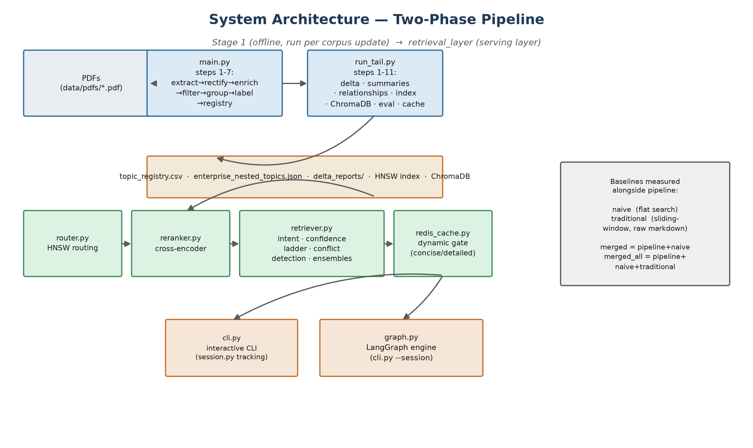
Figure 1 — Two-phase architecture, drawn directly from the code paths described above (main.py/run_tail.py stages, router→reranker→retriever→redis_cache chain, and the baseline definitions used throughout this document).

The four retrieval baselines, side by side
A recurring theme in this project is that every new idea gets measured against three existing baselines before being trusted, not just architected and assumed to help:
Method | What it does | Purpose
Naive RAG | Flat vector search over the same curated (taxonomy) chunks — no routing. | Isolates the value of hierarchical routing/taxonomy, same underlying data.
Traditional RAG | Sliding-window chunks over raw markdown, no taxonomy at all. | Closest analogue to an off-the-shelf RAG system — isolates the value of the whole Stage 1 pipeline, not just routing.
Pipeline | Taxonomy-routed HNSW search + cross-encoder rerank + confidence ladder. | The system's own primary retrieval path.
Merged (pipeline + naive) / Merged-All (pipeline + naive + traditional) | Pools multiple methods' candidates and reranks once. | An ensemble that empirically beats all three individual methods on every query (see Section 8) — the strongest single retrieval method found.

Conceptual pitch version of the same architecture
The figure below is the project's own pitch-deck framing of this architecture — useful for explaining the idea quickly, but it uses different names for the same things and idealizes a couple of details relative to the code as it stands today. Read it alongside the crosswalk note underneath, not as a literal 1:1 diagram of the current implementation.
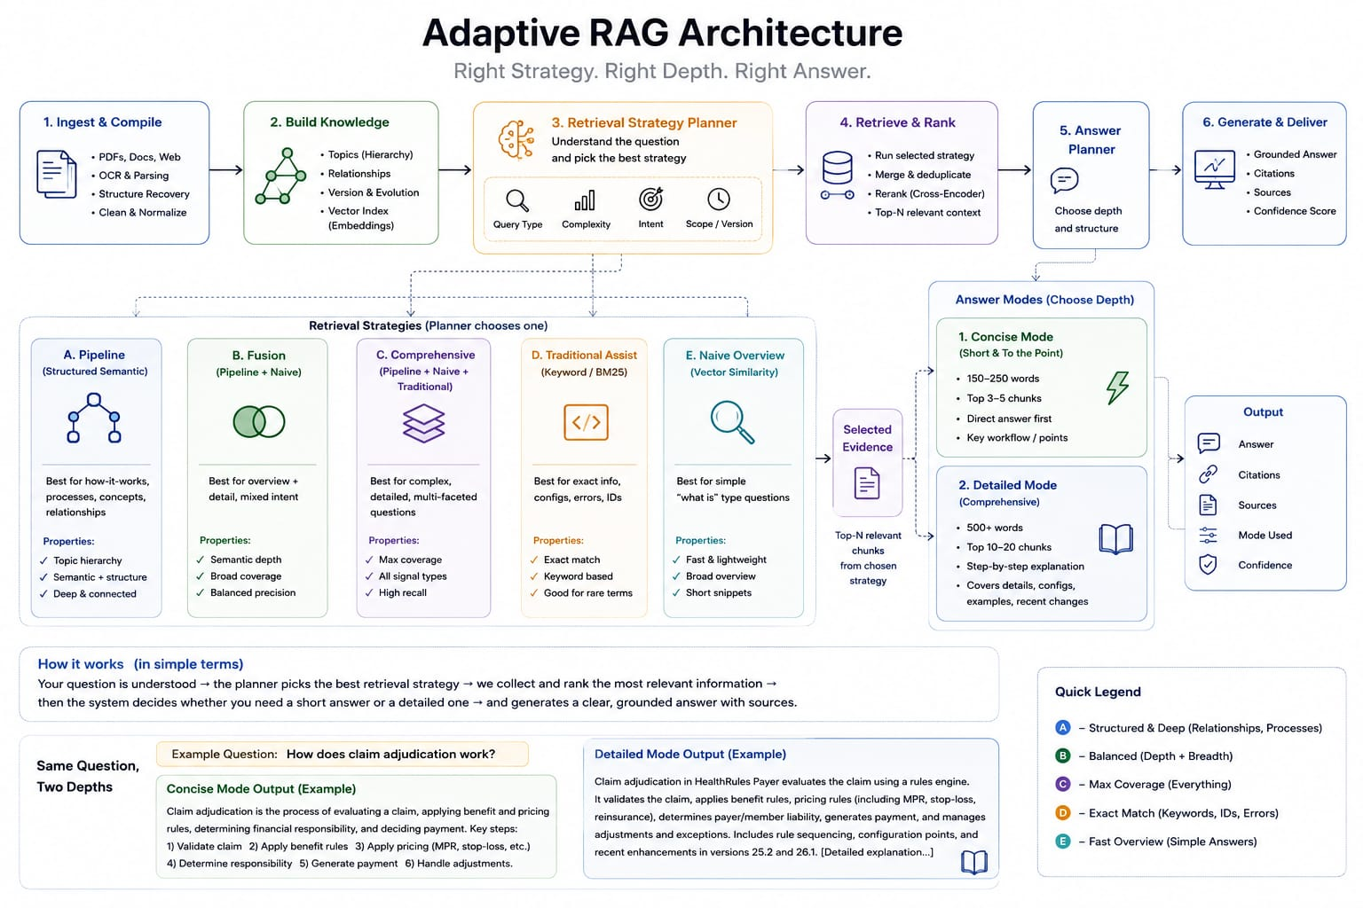
Figure 2 — Conceptual pitch diagram (provided).
- Naming crosswalk: "A. Pipeline" = pipeline. "B. Fusion (Pipeline+Naive)" = merged. "C. Comprehensive (Pipeline+Naive+Traditional)" = merged_all. "E. Naive Overview" = naive.
- "D. Traditional Assist (Keyword/BM25)" is a naming mismatch worth flagging: the actual traditional/overlap baseline (retrieve_overlap, corpus_overlap collection) is a semantic vector search over sliding-window markdown chunks using the SAME embedding model and cross-encoder reranker as every other method — it is not a keyword/BM25 exact-match search. There is no BM25/keyword-search code in this project today.
- The 5-way "Retrieval Strategy Planner" choosing among all 5 named strategies per query is the pitch framing; the actual retriever.py only ever auto-selects between specific/factual/intelligence/delta intents, and the merged/merged_all ensembles are only reached via the confidence-gate decision tree in Section 9 (gate_and_retrieve), not a single unified planner weighing query type/complexity/intent/scope simultaneously across all 5 named strategies.
- Concise/Detailed word-count targets (150–250 / 500+ words) are illustrative in this figure; the actual code does not enforce an explicit word-count instruction — both modes generate with the same max_tokens=900 cap (redis_cache._generate_answer), and what differs between modes is which retrieval pool feeds the answer, not a length instruction to the LLM. See Section 9 for the exact, code-accurate decision tree.

4. Environment & Dependencies
One Python venv (Stage 1/venv) serves both folders. requirements.txt (in Stage 1/) was audited against actual imports across every .py file in both folders — five packages that are no longer imported anywhere (bertopic, hdbscan, umap-learn, nltk, pdfplumber — topic clustering now runs on plain sentence-transformers + scikit-learn, and PDF extraction now uses docling/pypdf instead of pdfplumber) were removed, and the packages actually driving the retrieval layer and Stage 1 tail were added.

Two external services the pipeline depends on (not pip-installable)
Service | Role | Start command
llama.cpp server | Local Qwen3.5-9B (Q4_K_M) LLM, OpenAI-compatible API at 127.0.0.1:8080 — no external API, no rate limits. | bash start_server.sh (from Stage 1/)
Redis | Response cache for the hackathon demo (redis_cache.py). | systemd service, e.g. sudo systemctl start redis-server

Verified during this KT pass: Redis was already running as an active systemd service (PONG on redis-cli ping); the llama.cpp server needs a manual start via start_server.sh before running any pipeline step or CLI query that calls the LLM.

Real bug found and fixed during this KT pass
cli.py crashed on startup with ModuleNotFoundError: No module named 'langgraph'. graph.py (imported unconditionally at the top of cli.py, not lazily inside --session handling) needs langgraph + langchain-core for its LangGraph-based conversational session mode. langgraph was missing from both the venv and requirements.txt — it has now been installed into the venv and added to requirements.txt, and cli.py --help was re-verified to run cleanly.

requirements.txt (current)
# Core ML / embeddings
torch, transformers, sentence-transformers, scikit-learn, numpy, pandas
# Stage 1: PDF extraction, keyword/taxonomy clustering
docling, pypdf, keybert, networkx, python-louvain, duckduckgo-search (optional)
# LLM client (local llama.cpp server, OpenAI-compatible endpoint)
openai, httpx, pydantic, langchain-core
# retrieval_layer: vector store, ANN index, reranking, session graph
chromadb, hnswlib, langgraph, redis
# retrieval_layer: eval harness + hackathon demo doc
deepeval, python-docx, tqdm

5. Stage 1 — Ingestion & Taxonomy Pipeline (main.py)
main.py orchestrates 7 stages (plus two sub-stages) over every PDF in data/pdfs/. Each stage checkpoints its output to data/output/ so the pipeline can resume from cache instead of re-running expensive LLM/embedding work.
Before the step-by-step breakdown, the figure below shows the big picture: how one real feature travels all the way from raw atomic PDF chunks up to its enterprise-wide grandparent group, using an actual traced example from this corpus (chunks 1502/1503/1505, verified against parent_relationship_clusters.json) rather than an illustrative one. Each level is built purely by merging or clustering the level directly below it — nothing above the atomic-chunk level is hand-labeled from scratch.
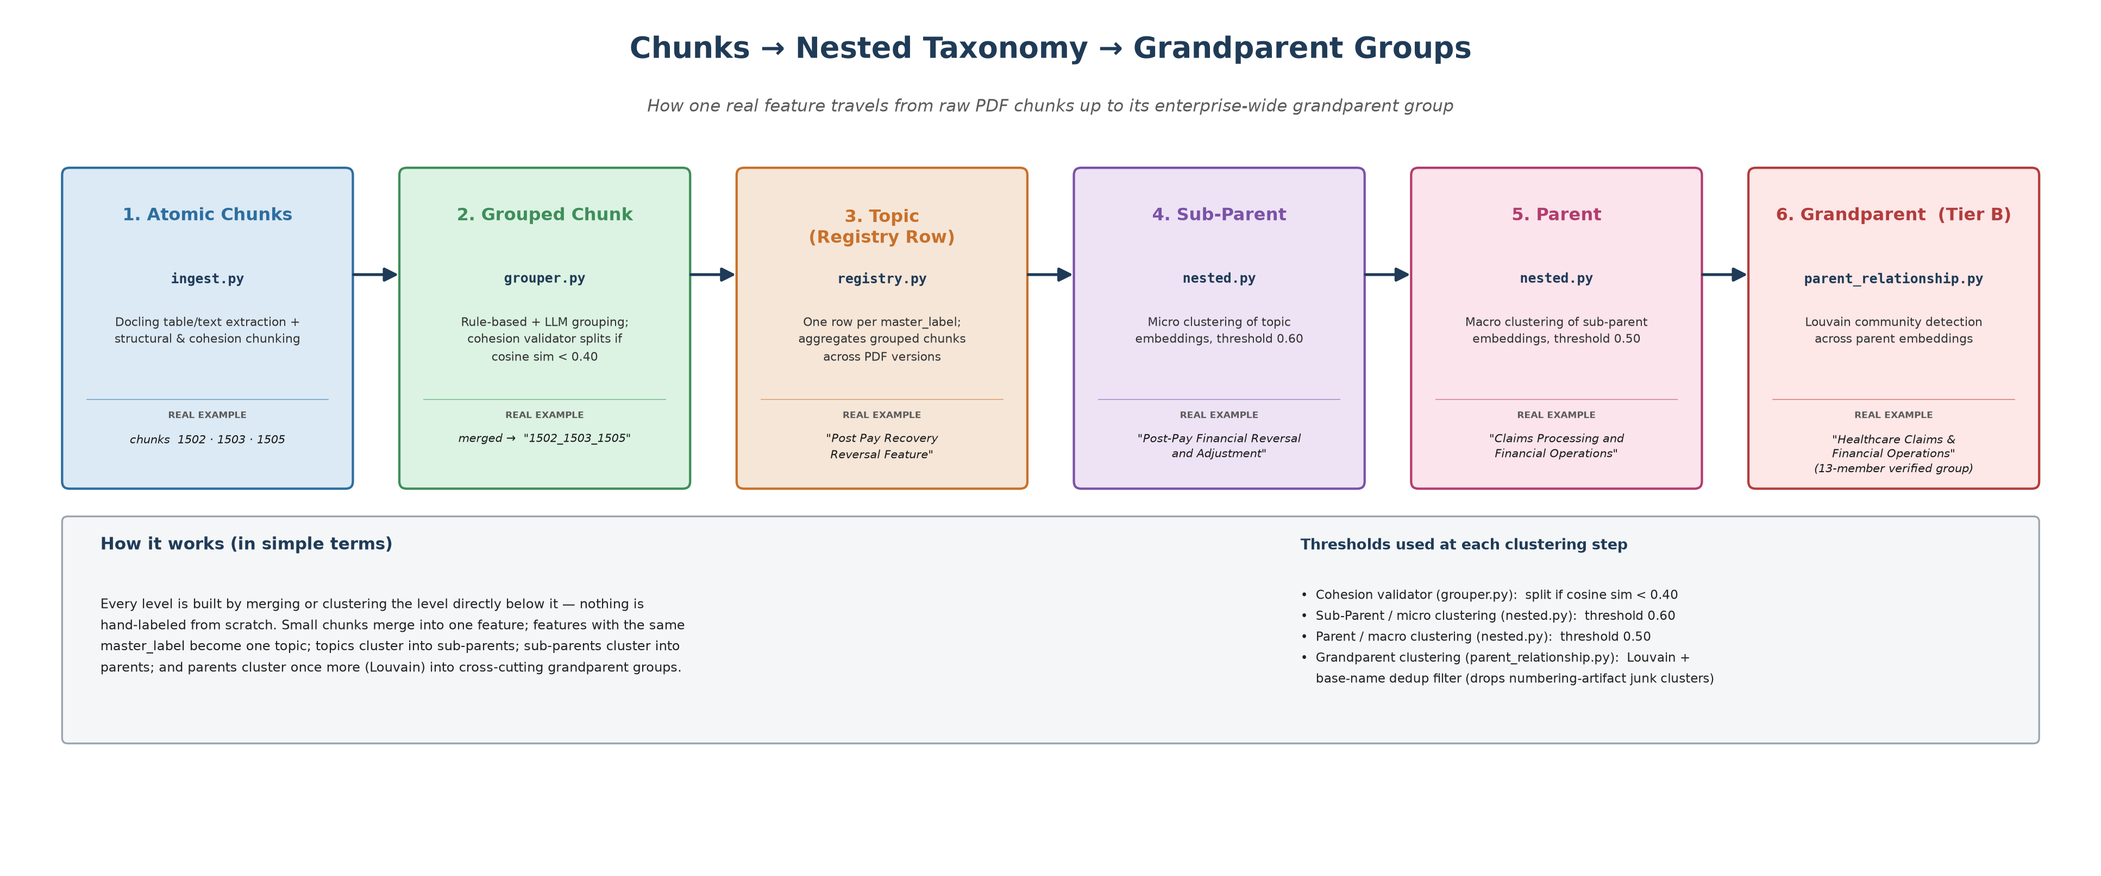
Figure 5 — Real, verified example: chunks 1502/1503/1505 → "Post Pay Recovery Reversal Feature" → "Post-Pay Financial Reversal and Adjustment" → "Claims Processing and Financial Operations" → "Healthcare Claims & Financial Operations" (the 13-member Tier B grandparent group described in Section 10).

1. Extract → Rectify → Re-Rectify (ingest.py, rectifier.py, re_rectifier.py)
ingest.py uses Docling's TableFormer to extract each PDF (parallelized across CPU workers for large PDFs), formats tables to JSONL, and runs structural + LLM cohesion chunking plus KeyBERT keyword extraction. rectifier.py is a fast heuristic pass that repairs obviously-broken JSONL tables. re_rectifier.py sends still-broken tables to the local LLM with the original markdown table as ground truth, with explicit anti-hallucination rules (don't invent values for blank cells, don't copy category names into empty cells, infer sensible headers when the source table had none).

2. Enrichment (enricher.py)
An LLM "quality judge" flags chunks whose description would otherwise be hollow (short legal-citation fragments, transitional paragraphs). Route 1 pulls in similar chunks from the same source document as context; Route 2 falls back to a DuckDuckGo web search for case names/concepts if internal context isn't enough (soft-disabled via config.USE_WEB_ENRICHMENT if offline).

2.5 Context Profiling (context_profiler.py)
Builds one domain profile per unique document family (e.g. both 25.2 and 26.1 release notes share the 'HR_Payer_Release_Notes' type_key) from captured TOC text, section-header distribution, top keywords, and sample chunks — a single LLM call producing domain, specialist_role, key_terminology, and few-shot examples that every downstream prompt (labeling, delta analysis, summarization) reuses instead of a one-size-fits-all prompt.

3. Quality Filter (quality_filter.py)
Drops any chunk whose text_quality_score falls below 70% before it can pollute the taxonomy — a simple, deliberately dumb filter (missing scores default to keep, not drop).

3.5 Semantic Grouper (grouper.py)
A two-stage (plus a 2.5 validator) grouping system that merges a release note's title + sub-sections + tables + closing ticket reference into one logical "feature block" chunk. Stage 1 is zero-LLM-call rule matching on header patterns ((Table)/(Cont.) suffixes, known sub-section names). Stage 2 is a sliding-window LLM pass for anything the rules didn't catch. Stage 2.5 is the cohesion validator (added after auditing real merge failures): embeds each group's constituent chunk texts and splits the group wherever consecutive cosine similarity drops below GROUP_COHESION_THRESHOLD (0.40) — this catches both runaway (Cont.) chains and cross-window stitching artifacts from Stage 2's overlap-based dedup.

4. Master Labeling (topic_model.py → labeler.py)
Per-chunk labeling via the local LLM, with topic_model.py adding cross-version fuzzy matching (embedding similarity) so the same feature in v25.2 and v26.1 gets the same label even if the LLM's wording drifted slightly between the two labeling passes.

4.5 Label Normalization (label_normalizer.py)
Clusters near-duplicate labels by embedding similarity and assigns one canonical label per cluster — collapsing symbol variants ("&" vs "and"), plural/singular drift, typos, raw DB-table-name labels, and single-word garbage labels.

4.7 QnA Generation (grouper.generate_group_qna)
Generates synthetic Q&A pairs per grouped chunk — this QnA bank is what feeds both the retrieval layer's QnA vector type and, later, the hackathon cache-preset's sample questions (build_cache_preset.py samples real questions from here, not invented ones).

5. Topic Registry (registry.py)
One row per unique master_label; concatenates per-PDF chunk descriptions in a bracketed format ([desc_1 | desc_2] | [desc_3]) that preserves which PDF each description came from, and tracks chunk IDs the same way for traceability back to source.

6. Nested Taxonomy (nested.py)
Clusters the registry into a two-level enterprise taxonomy — macro categories (parents, MACRO_THRESHOLD=0.50) and micro categories (sub-parents, MICRO_THRESHOLD=0.60) — using embeddings of each topic's label+summary+keywords, with LLM-assisted naming that reuses context_profiler's domain roles. Output: enterprise_nested_topics.json, the taxonomy every downstream Stage 1 tail script and the retrieval router are built from.
recover_qna.py is a narrow recovery script, not part of the normal path — it re-runs only steps 4.7 → 5 → 6 against an already-existing filtered_chunks.json, for the specific case where QnA generation produced empty results and a full main.py re-run isn't needed.

6. Stage 1 Tail — Cross-Version Intelligence & Indexing (run_tail.py)
run_tail.py runs everything after the nested taxonomy exists — 11 steps, each checkpointed, each independently re-runnable. This is where the taxonomy becomes retrieval-ready.

1. Cross-version filter (filter.py)
Keeps only topics that appear in 2+ source documents — the lightweight input delta_analyzer needs to compare versions, instead of feeding it every single-version topic too.

2. Parent relationship clustering (parent_relationship.py)
Louvain community detection over parent-category embeddings (grounded in each parent's own sub-category name+description list, matching nested.py's own methodology) to find "grandparent" families of related parents that the two-level taxonomy alone can't express — e.g. a verified 13-member "Healthcare Claims & Financial Operations" group. A base-name dedup filter removes junk mega-clusters caused by nested.py's own numeric-suffix disambiguator (e.g. two unrelated groups both named "General IT Operations (N)").

3. Cross-corpus relationship linking (cross_corpus_relationship.py)
Generalizes step 2's mechanism to link parents across two SEPARATE document-type taxonomies (e.g. Payer docs <-> a future Connector/security doc corpus), restricting graph edges to cross-source pairs only. Currently a structural no-op — only "payer" is registered in its SOURCES list, since no second corpus exists yet. Mechanism-tested via a synthetic split of the existing corpus, but not quality-validated (see Section 12).

4. Delta analysis (delta_analyzer.py)
Compares each cross-version topic pair, classifying the change (Direct Contradiction, Minor Enhancement, New Requirement, Workflow Automation, Bug Fix, Deprecation, No Change Detected) and extracting Key Differences bullets. Output feeds both the human-readable delta report and delta_jobs_cache.json, which every later step reuses instead of re-extracting.

5. Topic summarizer (topic_summarizer.py)
Leaf-level, chunk-grounded summaries (reuses delta_analyzer's two-pass BehavioralProfile extraction, generalized to run per single-version bracket too, not just cross-version pairs). Feeds the router's topic vector and the ChromaDB 'intelligence' collection.

6. Hierarchy summarizer (hierarchy_summarizer.py)
Rolls topic summaries up into sub-category and parent-level GroupProfile objects (overview + key_features[] + notable_details[]) — this is what answers breadth queries like "list all the domains covered" that no single topic summary is shaped to answer. Uses an embed/store split: a short overview is embedded for retrieval matching, but the full structured profile is what's actually stored and shown.

7. Convert delta cache → delta_reports/
Transforms delta_jobs_cache.json into one JSON file per parent domain, in the exact shape chroma_store.py's delta ingestion expects.

8. Build HNSW index (build_index.py)
Builds the ANN index the router queries at retrieval time, from the nested taxonomy.

9. Populate ChromaDB (chroma_store.py)
Builds all vector collections — see Section 7 for the full collection breakdown.

10. Eval comparison (eval.py --compare)
Runs the full pipeline-vs-naive-vs-traditional comparison over the golden query set and writes eval_report.md.

11. Seed Redis cache preset (build_cache_preset.py)
Samples real questions from the existing QnA bank (not invented ones), runs both gate modes for half of them to seed Redis, leaves the other half live for a demo latency comparison, and writes the demo manifest + Word/Markdown scripts.

Conceptual pitch version of the intelligence layer
The figure below is the project's pitch framing of the steps above — a good one-glance summary of intent, with a couple of details idealized relative to the code as it stands today. Crosswalk notes follow.
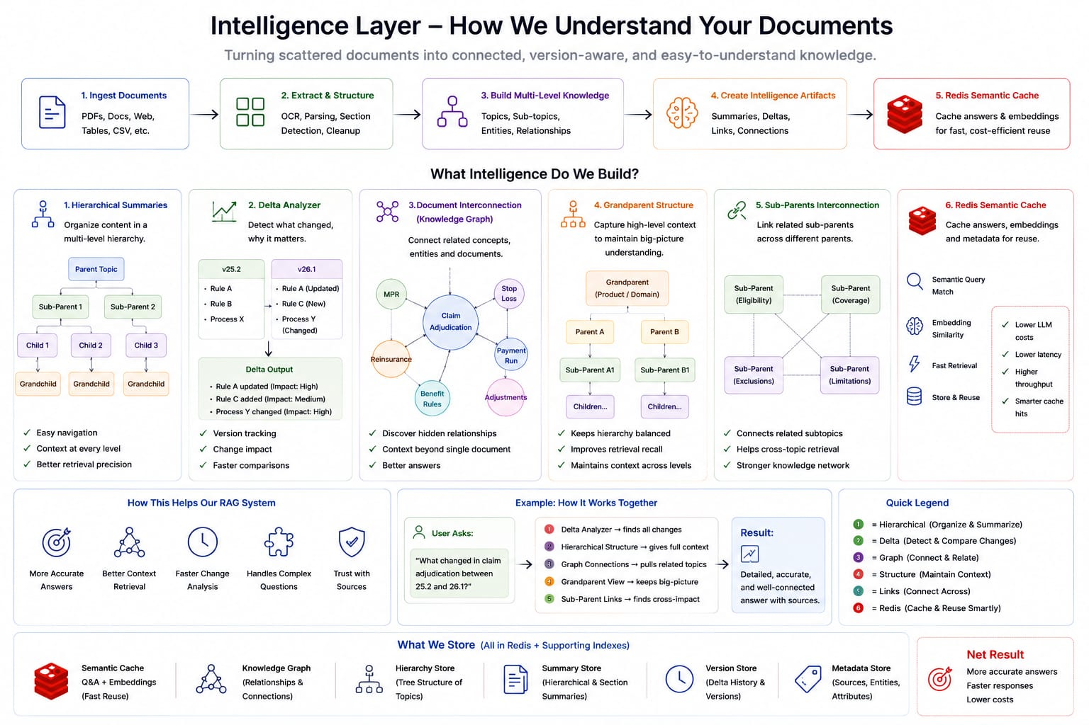
Figure 3 — Conceptual pitch diagram (provided).
- "1. Hierarchical Summaries" (Parent → Sub-Parent → Child → Grandchild): maps to nested.py + hierarchy_summarizer.py, but the current taxonomy is two levels deep (parent, sub-parent), with topic_summarizer.py's leaf-level topic summaries sitting under each sub-parent — there is no separate "Child"/"Grandchild" split below that in the code today.
- "2. Delta Analyzer" and "4. Grandparent Structure": accurate — these map directly to delta_analyzer.py and parent_relationship.py (Tier B) respectively, including the "keeps hierarchy balanced / improves retrieval recall" framing.
- "3. Document Interconnection (Knowledge Graph)" and "5. Sub-Parents Interconnection": conceptually match parent_relationship.py / cross_corpus_relationship.py's Louvain clustering, though the code does not build or expose an explicit queryable graph structure — clusters are precomputed once and retrieved as flat synthesized documents through the confidence-ladder rungs described in Section 7, not traversed as a live graph at query time.
- "6. Redis Semantic Cache" with "Semantic Query Match" / "Embedding Similarity": the most important gap to flag. The actual redis_cache.py cache is an EXACT-match cache — cache_key() normalizes (lowercase, whitespace-collapsed) and SHA256-hashes the literal query string per mode; there is no embedding-similarity lookup, so a paraphrased question will not hit an existing cache entry today. Semantic/embedding-based cache matching is a reasonable future extension, not a currently-built capability — don't present it as already working.

7. Retrieval Layer Architecture

ChromaDB collections
Collection | Contents | Used by intent
corpus | Raw chunk texts — what things ARE. | specific (widen), factual
intelligence | Topic summaries, hierarchy roll-ups, the flat parent-name enumeration doc (for breadth/list queries). | intelligence
delta | Delta analysis findings + evolution/value-add cards merged in. | delta
corpus_overlap | Sliding-window chunks from raw markdown — the Traditional RAG baseline's own index, no taxonomy. | overlap / traditional baseline only

Parent-relationship (Tier B), cross-corpus, and evolution-card rows also live inside the 'intelligence' collection but are excluded from general query_intelligence() calls — reachable only through their dedicated confidence-ladder rungs — to avoid diluting ordinary intelligence-intent queries with content most queries don't need.

router.py — HNSW hierarchical routing
Routes a query to the right (parent, sub) taxonomy branch using content-first scoring across four vector types (topic, QnA, description, chunk — 6432 vectors total at last count) rather than only topic-name/summary embeddings — the earlier topic-name-only router was the single biggest source of losses to naive RAG (queries where the right content existed, but the topic summary never used the query's actual words). Includes expand_siblings() and expand_cross_parent() for the confidence ladder's Tier A.

reranker.py — cross-encoder rerank
Cross-encoder (ms-marco-MiniLM-L-6-v2, 512-token window) reranks whatever candidate pool it's handed. Because it scores the text actually stored in ChromaDB — independent of what was embedded — the embed/store split used by hierarchy_summarizer relies on this: a short text can be embedded for bi-encoder matching while a much richer structured document is what the cross-encoder (and the LLM) actually sees.

retriever.py — the single entry point
retrieve(query) does five things, in order:
- 1. Intent classification. classify() returns delta / intelligence / specific by keyword-set + version-token matching (any 'v25.2'-shaped token routes straight to delta).
- 2. Primary retrieval + confidence ladder. For 'specific' intent, if the top rerank score is below CONFIDENCE_THRESHOLD (0.30) AND the ladder is enabled for this query, it escalates through up to five rungs in order: sibling sub-parents → cross-parent bridge → precomputed parent-relationship doc (Tier B) → cross-corpus relationship doc → evolution/value-add card — stopping at the first rung that raises confidence.
- 3. Version-conflict detection. If retrieved chunks span the same section_header across more than one version token, it's flagged as a conflict.
- 4. Delta injection. On conflict, queries the delta collection using the conflicting section name (more targeted than the original query) and auto-attaches the relevant delta finding.
- 5. Context + prompt selection. Conflict → versioned context layout + a system prompt that explicitly forbids blending two versions' facts into one statement; otherwise → standard layout + standard prompt.
The confidence ladder itself is gated two ways: config.ENABLE_CONFIDENCE_LADDER is a global off-switch (False by default — measured 4x latency cost with zero benefit on ordinary factual queries), but four query-shape classifiers (_is_relationship_query, _is_evolution_query, _is_cross_corpus_query, plus delta-intent's own merge path) auto-enable it specifically for queries shaped like a cross-domain relationship or evolution question — the only shapes it was ever shown to help.

Ensemble methods — retrieve_merged() / retrieve_merged_all()
Rather than picking one winning method, these pool multiple methods' candidate chunks into one set and rerank once — reusing the exact pattern already proven by the confidence ladder's rungs. retrieve_merged() = merged (pipeline + naive); retrieve_merged_all() = merged_all (pipeline + naive + traditional). Both dedup via _dedup_key(), which falls back to a text prefix (not chunk_id) for traditional/overlap chunks, since those never carry a chunk_id in ChromaDB metadata and would otherwise collapse onto one empty-string key. See Section 8 for measured results — merged_all is a provable upper bound (0 wins / 53 ties / 0 losses against the best of the three individual baselines, i.e. its top score exactly equals max(pipeline, naive, traditional) on every query, confirmed by direct measurement).
Terminology note: this "best of 3 methods" comparison sense is unrelated to retrieve_best_of_n()'s "best-of-N query reformulations" (Section 7/9) — same phrase, two different meanings in this codebase. Watch for which one a given passage means.

graph.py — LangGraph engine (cli.py --session)
A fully separate, LangGraph-based stateful chat ENGINE (named nodes: rewrite_query → classify → retrieve → widen → detect_conflict → inject_delta → format) — tracks conversation history, pinned version, and active topic via LangGraph's own MemorySaver, and rewrites follow-up questions before retrieval. It is a swap of the retrieval engine itself, not something layered on top of the other modes below — cli.py --session routes to this instead of retriever.retrieve(), it doesn't add session tracking to --compare/--naive/etc.

session.py — mode-agnostic session tracking (used by every OTHER CLI mode)
Was dead code until this pass — cli.py's old --session flag routed exclusively through graph.py above, and nothing ever imported ConversationSession. Refactored into two building blocks any retrieval mode can wrap around: prepare_turn(message) (extract version pins, rewrite an ambiguous follow-up) and record_turn(message, result) (update active_topic, store history) — chat() is kept as a plain-pipeline convenience wrapper around both. cli.py now calls prepare_turn()/record_turn() around every mode (default, --compare, --naive, --overlap, --best-of, --raw) — this is what "session everywhere" actually means, as distinct from graph.py's separate engine swap.
- Short memory vs. full summary — two different logs, on purpose. self.history is a TRIMMED sliding window (default 6 turns) that feeds the query-rewrite prompt — kept short deliberately so an ambiguous follow-up doesn't balloon the rewrite prompt as a conversation grows. self.full_log is never trimmed and backs summary() (turn count, every question asked, topics/versions touched, plus a one-paragraph LLM recap) — nothing is lost just because the rewrite window is short.
- pin_version() / clear() are now real, not stubs. The REPL's old 'pin <version>' command used to just print a tip telling the user to mention the version in their next message — it didn't actually pin anything. Now it calls session.pin_version() directly.

cli.py — interactive testing tool
Default behavior changed: every query now goes through the gated/cached path (redis_cache.answer_query, mode="concise", best-of-3 baked in) — what used to be the explicit --cached flag. --raw opts out, back to the old plain-retrieve() debug view (routing/chunks/context, no generated answer, no caching, no reformulation).
python cli.py # NEW DEFAULT: gated + cached, best-of-3, sessioned
python cli.py --raw # OLD DEFAULT: plain retrieve(), routing/chunk debug view
python cli.py --verbose # + routing/debug info
python cli.py --version 26.1 # scope retrieval to one document version
python cli.py --intent delta # force an intent
python cli.py --compare # pipeline vs naive vs traditional, side by side
python cli.py --detailed # shorthand for --mode detailed (always merged_all)
python cli.py --raw --best-of 5 # diagnostic view: show all 5 reformulations + scores
python cli.py --session # swap engine to graph.py's LangGraph pipeline
Any flag above can ALSO be typed inline, mixed into the question itself, in both the REPL and single-shot mode — combined freely, applying for that one turn only:
Chat > --detailed what changed in claim editing between versions?
Chat > --raw --best-of 5 how does prior authorization work?
Chat > summary # full-conversation recap (session.py's summary())
Chat > pin 25.2 # now actually pins — see session.py above
See Section 9 for the exact rule governing how --best-of composes with the gated default vs. --raw — it's not simply additive.

8. Evaluation Framework & Results

eval.py — retrieval-quality comparison
A 53-query golden set (GOLDEN_QUERIES), each with expected keywords, grown organically over the project as new capabilities needed dedicated test coverage (28 original → +6 evolution queries → +19 benefit-probe queries, zero duplicates). Scores every method by top/mean rerank score, keyword hit rate, version-conflict detection, and latency; --compare, --merged, --merged-all, and --best-of flags can all run together and export to eval_report.md.

deep_eval.py — answer-quality harness (DeepEval)
Judges actual generated answers (not just retrieved chunks) using DeepEval's Faithfulness metric plus three hand-written GEval metrics (Correctness, Completeness, Conciseness) — all reference-free, judged by the same local Qwen model via LocalModel (no external API key, no exfiltration risk). Also computes keyword-based MRR/Precision@5/Recall. Full 53-query × 6-method run (318 judged jobs, ~2.5 hours):
Method | Faithfulness | Correctness | Completeness | Conciseness | Recall | Top score
pipeline | 0.932 | 0.955 | 0.975 | 0.808 | 0.963 | 1.985
naive | 0.912 | 0.968 | 0.921 | 0.708 | 0.878 | -0.582
traditional | 0.928 | 0.975 | 0.953 | 0.732 | 0.927 | -0.788
merged (pipeline + naive) | 0.941 | 0.991 | 0.979 | 0.768 | 0.939 | 2.418
merged_all (pipeline + naive + traditional) | 0.895 | 0.998 | 0.975 | 0.826 | 0.976 | 2.696
gated (dynamic concise mode — see Section 9) | 0.934 | 0.958 | 0.955 | 0.823 | 0.963 | 2.461

Key finding: merged_all (pipeline + naive + traditional pooled) is the strongest single method almost everywhere at full scale — best Correctness, Recall, top score, even Conciseness. Its one consistent weakness is Faithfulness (worst of all six methods) — pooling occasionally drags in a superficially similar but irrelevant chunk and states it as fact. Concrete case: the query "What are the rules for claim editing?" — merged_all scored 0.059 Faithfulness (worst of the whole run) because it pooled in an unrelated "Provider Data Mapping to CES" chunk; pipeline/gated both scored 1.000 on the same query by staying on the plain high-confidence pipeline path. This single case is the empirical justification for the dynamic gate in Section 9 — it isn't concise-vs-verbose, it's safety-vs-coverage.

9. Hackathon Demo — Dynamic Gating + Redis Cache
redis_cache.py is the production-facing entry point built directly from the deep-eval findings above. It replaced an earlier static keyword/category lookup table (select_method(), still kept as an offline reporting label only) after the observation that a fixed table only knows how to route the query shapes it was tuned on, and has nothing to fall back on once real traffic drifts outside the calibration set.
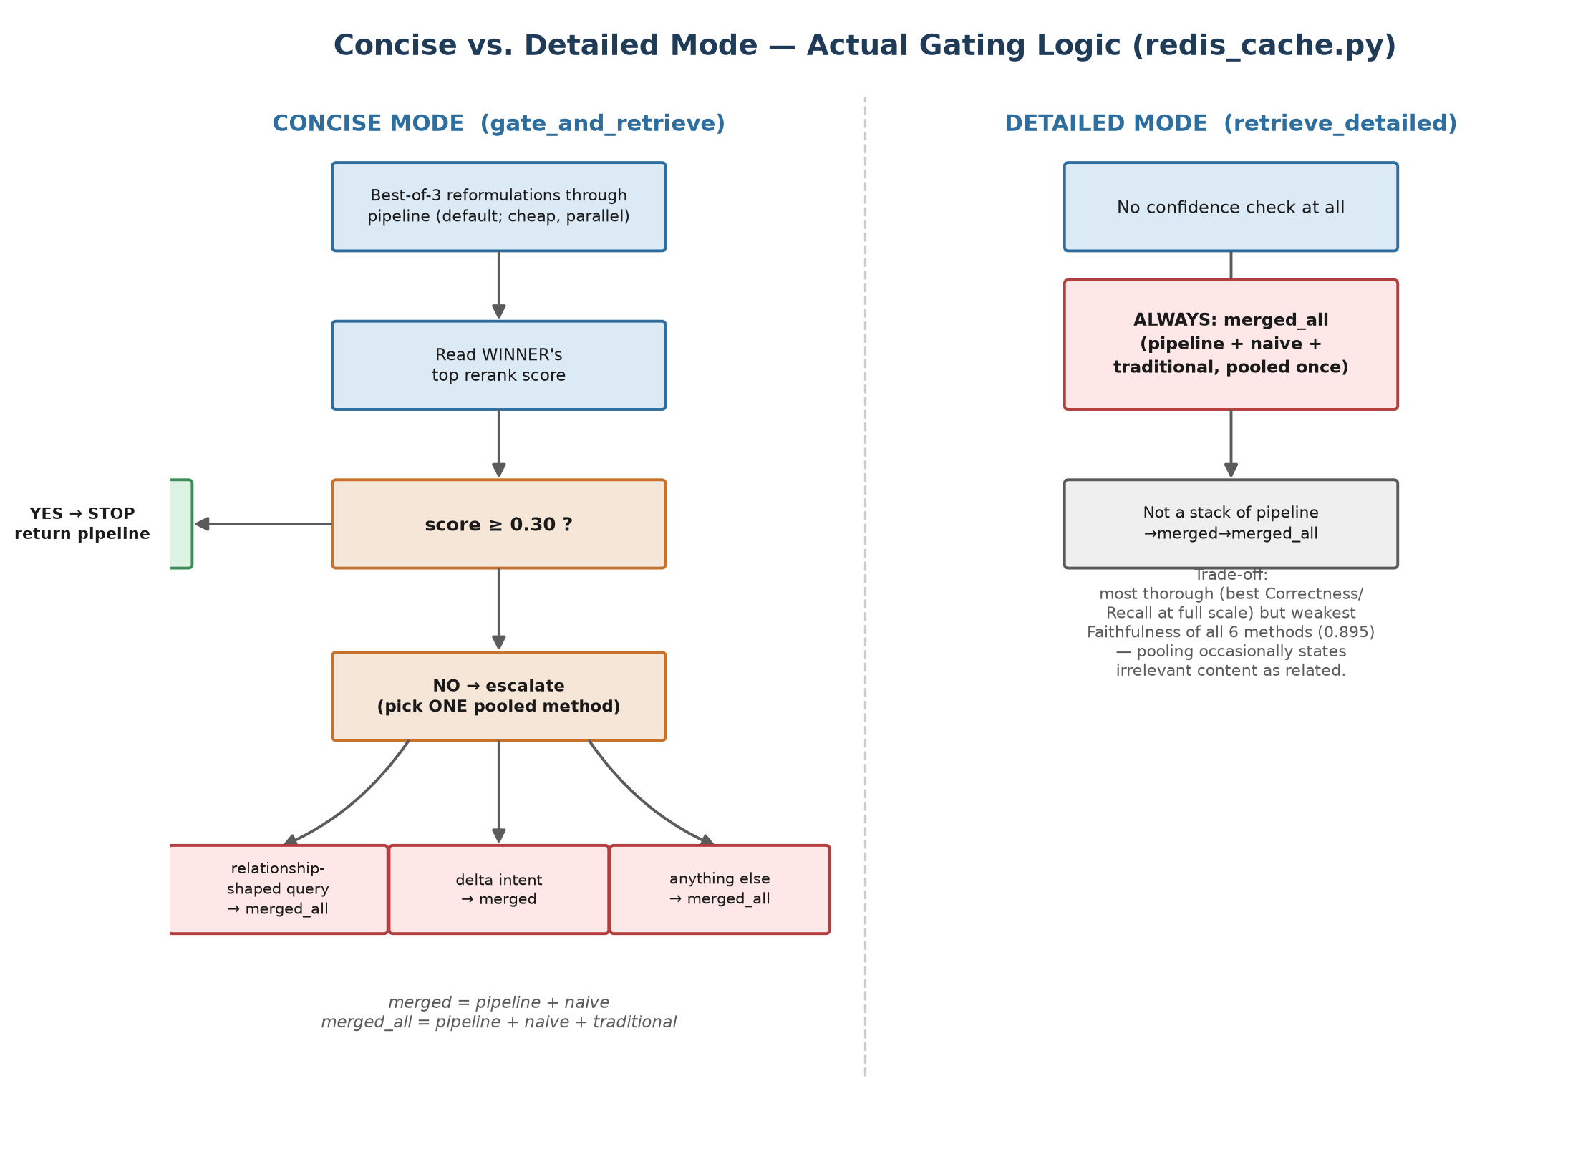
Figure 4 — Exact gating logic for both modes, drawn directly from redis_cache.py (gate_and_retrieve / retrieve_detailed) — not the pitch-deck version. Updated to show best-of-3 as the default cheap-first-pass (see below).

Concise mode (gate_and_retrieve) — a decision tree, not a pool of five
A common misreading is that "concise" pools all five retrieval methods together. It does not — it is a decision tree that runs exactly ONE method per query, chosen dynamically:
1. Run best-of-3 reformulations through `pipeline` (taxonomy-routed HNSW +
rerank) — 3 parallel reformulations of the query, keep whichever scores
highest. Default; pass best_of=0 or 1 to fall back to a single plain
retrieve() call instead. Still the "cheap" path relative to pooling.
2. Read the WINNING reformulation's top rerank score (the same confidence
signal retriever.py's ladder uses).
3. score >= CONFIDENCE_THRESHOLD (0.30)?
YES -> STOP. Return that pipeline result. No pooling at all.
NO -> escalate to exactly ONE pooled method, chosen by query shape:
- relationship-shaped query -> merged_all (pipeline+naive+traditional)
- delta-intent query (not relationship) -> merged (pipeline+naive)
- anything else -> merged_all (pipeline+naive+traditional)
So on a typical, well-covered query, concise mode costs exactly 3 parallel reformulated pipeline calls and nothing else — it only reaches for a bigger pool on the specific queries that actually need it, which is the entire point of measuring confidence live instead of guessing upfront (see Section 10, "Dynamic gating over static lookup tables"). Best-of-3 becoming the default (Section 10, "Best-of-3 becomes the gate's default") is a later, separate addition layered on top of this same decision tree — the escalation logic above is unchanged, it just now operates on the winning reformulation's result instead of a single shot's.

Detailed mode (retrieve_detailed) — always merged_all, not a stack of three
Detailed mode is also a common misreading — it is NOT "pipeline, then merged, then merged_all" layered as three separate fallback attempts. It is a single, unconditional call to retrieve_merged_all(), with no confidence check at all. merged_all itself is already the full 3-way pool: it runs pipeline + naive + traditional once each, merges their candidate chunks into one set (deduplicated), and reranks that combined pool a single time. merged (the 2-way pipeline+naive pool) is never used in detailed mode — merged_all supersedes it. Deliberately does NOT get best-of-N reformulation either, even though answer_query()/gate_and_retrieve() accept a best_of parameter — detailed already pools 3 methods per call; stacking 3 reformulations on top would be 9 retrieval calls for a mode that already trades cost for coverage. cli.py prints a note and silently ignores --best-of if it's combined with --detailed, rather than pretending to honor it.

Exactly what each mode can end up using
Mode | Trigger | Method actually run | What's pooled inside that method
concise | confidence >= 0.30 (typical case) | pipeline | nothing pooled — single taxonomy-routed retrieval
concise | confidence < 0.30, relationship-shaped query | merged_all | pipeline + naive + traditional candidates, reranked once
concise | confidence < 0.30, delta intent | merged | pipeline + naive candidates, reranked once
concise | confidence < 0.30, other | merged_all | pipeline + naive + traditional candidates, reranked once
detailed | always, unconditionally | merged_all | pipeline + naive + traditional candidates, reranked once

naive and traditional are never used as the SOLE method by either gate mode — only as ingredients inside merged/merged_all. See below for why.

Real examples, pulled from the actual demo cache preset
These are real questions from hackathon_cache_preset.json (sampled from the project's own QnA bank, not invented) together with the method each mode actually picked when the preset was seeded — concrete proof of the decision tree above, not a hypothetical.
Question | Concise mode picked | Detailed mode picked
"Why did the system fail to retain checkbox selections in the Prompt Options tab, and what does fixing the 'missing value bindings' imply for data integrity?" | pipeline (confident on the first try — no escalation needed) | merged_all
"Why was the INCLUDES_BINDER_CHARGES flag added to both the Bill Fact and Section Fact tables, and what does this imply for data granularity?" | merged (escalated — pipeline's own confidence was too low) | merged_all
"Why was the interface split into separate 'Add Contract' and 'Add Selection' flows rather than one combined flow?" | merged_all (escalated — pipeline's confidence too low, escalation went to the fuller pool, not just merged) | merged_all
"What are the real-world implications for a member whose only available provider is exactly at the network boundary?" | merged (escalated) | merged_all

Pattern visible across the full 24-question cached sample: the large majority of ordinary "why does X work this way" factual questions stay on plain pipeline in concise mode — escalation to merged or merged_all was the exception, not the rule, which is exactly the cost profile the gate was designed for. Detailed mode shows merged_all for every single question in the sample with no exceptions, confirming it really is unconditional. Notably, no query in this particular sample triggered the delta-intent -> merged branch specifically (the sample skews toward single-document "why" questions rather than cross-version "what changed" questions) — so that branch is real code but wasn't exercised by this batch of examples.
Snapshot caveat: this table was captured when gate_and_retrieve's cheap-first-pass was a single retrieve() call, before best-of-3 became the default (see below). Re-seeding build_cache_preset.py now will pick up best-of-3 automatically — the winning reformulation occasionally clears CONFIDENCE_THRESHOLD when a single-shot call wouldn't have, so a few questions could shift from 'escalated' to 'stayed on pipeline' compared to this table. The decision-tree logic itself is unchanged, only the confidence signal feeding step 2 improved.

Why escalation always targets a pooled method, never naive or traditional alone
This is a confirmed, numbers-backed choice, not a guess. From the 53-query eval (eval_report.md, also Section 8):
Method | Mean top rerank score
pipeline | 1.985
naive | -0.582
traditional | -0.793
merged (pipeline+naive) | 2.418
merged_all (pipeline+naive+traditional) | 2.696

Escalating a low-confidence pipeline result to plain naive or plain traditional would make the answer worse on average, not better — both score below pipeline itself. Only the pooled ensembles are provably at least as good as pipeline: merged_all is a measured upper bound (its top score ties max(pipeline, naive, traditional) on all 53 queries, zero losses — see Section 10). That is why every escalation path in both modes lands on merged or merged_all, never on a single alternate method.

Open question — why delta intent escalates to merged, not merged_all
One branch is inherited, not freshly derived: delta-intent queries escalate to the 2-way merged pool while every other escalation case uses the fuller merged_all. This split comes from the older select_method() static category table (built from a 13-query pilot's per-category composite scores) and no code comment documents the specific reason for this one branch — it should be treated as inherited convention, not a verified result on the current 53-query set.
Best available explanation (an inference, not a confirmed fact — worth validating before relying on it): merged_all pools in traditional's raw sliding-window chunks, which carry no version tag and no awareness of the delta/evolution collections at all. A delta-intent query already gets version-aware findings injected directly via _retrieve_delta() (which merges in query_evolution() results on top of the delta collection itself); adding undated, taxonomy-free raw-markdown chunks into that pool risks reintroducing the kind of generic, version-blind boilerplate the Q12 "No Change Detected" bug fix (Section 10) was built to filter out. Restricting delta escalation to merged — pipeline+naive only, both drawn from the curated, cross-version-aware corpus — sidesteps that risk. If this matters for future tuning, it would be worth a dedicated eval slice (delta-intent queries only, merged vs. merged_all) rather than trusting the inherited default.

CLI convenience — inline flags, and how --best-of composes with the gate
cli.py lets ANY flag be typed inline as part of the question itself, in both the REPL and single-shot mode, combined freely — e.g. "--detailed --best-of 5 what changed in claim editing?". These are one-turn overrides layered on top of the persistent REPL defaults; they don't permanently change the session. The one non-obvious composition rule:
- --best-of N alone (or with --detailed/--concise), no --raw: tunes the GATED path's own internal reformulation count (redis_cache.answer_query(..., best_of=N)) — one generated, cached-eligible answer comes back, same as the default, just with a different N. This is what lets --detailed and --best-of combine into one call instead of best-of hijacking into a separate view.
- --raw --best-of N together: the OLD standalone diagnostic behavior — reformulate N ways via plain retrieve() (no caching, no generation), print every reformulation with its score, show the winner's routing/chunk debug info. For inspecting reformulation behavior directly, not the production answer path.
- --detailed --best-of N together: N is silently ignored (with a printed note) — detailed mode never reformulates regardless of N, by design (see above).

Demo mechanics
- build_cache_preset.py samples real questions from the existing chunk-grounded QnA bank (2,725 pairs across 1,391/1,499 chunks — no new generation needed), splits the sample in half.
- The cached half runs both gate modes for real and seeds Redis — asking one of these questions returns instantly with zero LLM tokens.
- The uncached half is left untouched, so asking one of those live shows the full retrieval + generation path for latency/token comparison.
- Measured numbers (pre-best-of-3 snapshot — see caveat above): cache hit ≈ 0.0018s, 0 tokens. Cache miss (merged_all-routed) ≈ 20s, 992 tokens. Roughly a 13,000x latency ratio — a strong, honest "why caching matters" visual for a live demo. Re-seeding now will show a higher cache-miss latency on the concise-mode half specifically, since its cheap-first-pass is now 3 parallel reformulated retrievals instead of 1 — the cache-HIT number is unaffected either way (a cache hit never touches retrieval or generation at all).
- Outputs: data/output/hackathon_cache_preset.json (manifest), hackathon_cache_demo.docx and .md (both formats, ready to present from).

10. Design History — Key Decisions & Course Corrections
These are the decisions that shaped the current architecture, including ones that were tried, measured, and reverted. They matter because the reasoning isn't visible just from reading the final code.

Dynamic gating over static lookup tables
The first version of both redis_cache.select_method() and an earlier gating draft used a fixed if/else table built from a one-time offline category analysis (e.g. "relationship queries → merged_all"). This was deliberately replaced with a live-confidence-measurement gate (gate_and_retrieve()) mirroring retriever.py's own confidence ladder — a static table "only knows how to route what it was tuned on" and has nothing to fall back on for queries outside its calibration set. This is now the standing design rule for any future routing/gating decision in this codebase.

Router rewrite: content-first, not topic-name-first
The original router selected candidate topics using only topic-name/summary embeddings, never raw chunk text — this was the single biggest source of losses to naive RAG early in the project (queries where the right content existed, but the topic summary never said the query's actual words). Rewriting to content-first routing, plus adding QnA and per-source description vector types, drove the pipeline from 14/19 losses to a first-ever win over naive RAG.

Length bias is a real, repeatable failure mode
Twice in this project, making a shared vector-space document "better" (more content, richer detail) caused unrelated queries to regress, because longer/richer text wins unfairly on cosine similarity regardless of relevance: once in topic_summarizer.py (fixed via a character budget that greedily prioritizes diagnostic content), and again when a grandparent-summary-merge experiment was tried, measured to make retrieval worse in 3/4 cases, and fully reverted. Any future change to what gets embedded should be sanity-checked against the corpus-average field length for that vector type.

Breadth queries need a structurally list-shaped document, not better prose
"List all the domains covered" (Q9) stayed unmoved through multiple rounds of summary-quality improvements, because no single-category description — however well written — can structurally answer a list-shaped query. The fix (ingest_enumeration_doc(), a flat numbered list of parent names, no LLM call) flipped Q9 decisively and was the first point the pipeline beat naive RAG on the aggregate tally. The same fix tried one level down (sub-categories) measured zero effect and was cleanly reverted, since no golden query asks at that granularity — a reminder that this class of fix only pays off at the exact granularity a real query asks for.

The cohesion validator, and its known blind spot
grouper.py's Stage 2.5 cohesion validator splits merged chunk groups when embedded similarity between consecutive chunks drops below 0.40 — catching runaway (Cont.) chains and cross-window stitching artifacts. Its known blind spot: JSONL-table-shaped bug-fix report rows share near-identical stylistic language ("Previously, X was broken... Resolution: this has been fixed...") that keeps cosine similarity above threshold even across topically unrelated rows. A targeted fix (stripping JSON key names/shared headers before embedding) was tried and measured to have zero effect — the real driver is register/style similarity, not scaffold text — and was reverted rather than shipped as a non-fix.

Merged (pipeline + naive) / merged-all (pipeline + naive + traditional) ensembles — a clean, measured win
Rather than picking pipeline OR naive per query, pooling both methods' candidates and reranking once (retrieve_merged, i.e. merged = pipeline + naive) raised mean top score 1.985 → 2.418 with zero regressions across 53 queries. Extending to a 3-way pool including traditional RAG (retrieve_merged_all, i.e. merged_all = pipeline + naive + traditional) required first fixing a real dedup bug (traditional/overlap chunks never carry a chunk_id, so naive chunk_id-based dedup would silently collapse all but one onto an empty-string key) before it could be trusted — after the fix, merged_all reached 2.696 mean top score and was verified to be a true upper bound (ties max(pipeline, naive, traditional) on all 53 queries, zero losses).

Cross-corpus linking: built and mechanism-tested, not quality-validated
cross_corpus_relationship.py generalizes the within-corpus grandparent-clustering mechanism to bridge two separate document-type taxonomies, restricted to cross-source edges only. Since only one real corpus ("payer") exists today, it was validated only via a synthetic test (an arbitrary split of the existing corpus into two fake sources) that confirms the mechanism is correct — cross-source-only edges, correct composite-key lookups, correct rejection of single-source clusters — but this cannot and does not validate real quality. The threshold (0.60, inherited from the within-corpus case) is explicitly flagged as unproven for cross-corpus vocabulary and should be recalibrated once a second real document type is ingested.

External LLM APIs are a hard block, not a soft preference
Two separate attempts to use a third-party API (OpenRouter, then Groq) as a stronger judge model for cross-checking eval scores were both hard-blocked by Claude Code's data-exfiltration classifier — sending retrieved corpus content to any third-party LLM API is blocked regardless of user consent or a provided API key. This is a hard wall requiring a permission change outside the session, not something retryable by switching providers — the local judge model (via the same llama.cpp server) remained the trusted baseline for every reported eval number in this document.

Session tracking was dead code — revived and made mode-agnostic
cli.py's --session flag routed exclusively through graph.py's separate LangGraph engine; session.py's ConversationSession (history, version pinning, query rewriting) was never imported by anything. Refactored chat() into two building blocks — prepare_turn(message) (pin extraction + ambiguous-follow-up rewriting) and record_turn(message, result) (active_topic + history bookkeeping) — decoupled from any specific retrieval function, so cli.py could wrap them around every mode (default, --compare, --naive, --overlap, --best-of, --raw), not just a separate --session silo. Also added a real distinction between the TRIMMED sliding window that feeds the rewrite prompt (kept short deliberately — "short conversational memory") and a never-trimmed full_log backing a new summary() method ("full session summary": turn count, every question asked, topics/versions touched, plus a one-paragraph LLM recap) — nothing is lost just because the rewrite window is short. graph.py's LangGraph engine is untouched and still reachable via --session; it's a genuinely separate engine (its own node graph, its own MemorySaver-backed state), not something the session.py refactor tries to replace.

Best-of-3 becomes the gate's default — which exposed a real thread-safety bug
redis_cache.gate_and_retrieve()'s cheap-first-pass changed from a single retrieve() call to retriever.retrieve_best_of_n(query, n=3) by default (pass best_of=0 or 1 to opt back out) — reformulate 3 ways, run all 3 through the pipeline in parallel, keep whichever scores highest, then run the existing confidence check/escalation on that winner. detailed mode deliberately does NOT get this — it already pools 3 methods per call; stacking 3 reformulations on top would be 9 retrieval calls for a mode that already trades cost for coverage.
This made retrieve_best_of_n's ThreadPoolExecutor part of the DEFAULT CLI path instead of an opt-in debug flag, which surfaced a genuine, previously-latent thread-safety bug: router.py, reranker.py, and chroma_store.py each used an unlocked check-then-act lazy-singleton pattern (`if _x is None: _x = load(); return _x`). Two threads racing to lazy-load the SAME SentenceTransformer/CrossEncoder for the first time crashed with a torch "Cannot copy out of meta tensor; no data!" error — reproduced live via cli.py's new default on a fresh process. Fixed two ways, both needed: (1) double-checked locking (threading.Lock()) around all three lazy singletons, preventing two threads from loading the same model twice; (2) retrieve_best_of_n() now pre-warms all three singletons on the MAIN thread before spinning up its ThreadPoolExecutor — the lock alone wasn't sufficient, since loading a model for the very first time from a worker thread (rather than racing on an already-started load) was independently unreliable in this environment. Verified fixed via a real multi-turn conversation through the LLM server after the fix, with no crashes.

Inline CLI flags — and the composition rule for --best-of
Any cli.py flag can now be typed inline as part of the question itself (in both the REPL and single-shot mode), combined freely, as a ONE-TURN override — e.g. "--detailed --best-of 5 what changed in claim editing?". The one non-obvious design decision: --best-of N alone (or with --detailed/--concise) tunes the GATED default's own internal reformulation count and still returns one generated, cached-eligible answer — it does NOT divert into a separate standalone view. That older standalone "show me every reformulation and its score, no generation" behavior is still there, just reached by combining --raw --best-of N instead. This composition (rather than --best-of always meaning "show the diagnostic view") is what lets --detailed and --best-of combine into one coherent call, per explicit ask, instead of one flag silently overriding the other.

11. How To Run It — Step by Step

A. First-time setup
cd "Stage 1"
python -m venv venv # if venv/ doesn't already exist
source venv/bin/activate
pip install -r requirements.txt

B. Start external services
bash start_server.sh # llama.cpp server, Qwen3.5-9B, port 8080
sudo systemctl start redis-server # if not already running as a service
redis-cli ping # should print PONG

C. Run Stage 1 (only needed when PDFs change)
cd "Stage 1"
python main.py # steps 1-7: ingest -> ... -> nested taxonomy
# resumable — checkpoints to data/output/*.json
# If QnA generation came back empty without needing a full re-run:
python recover_qna.py

D. Run the Stage 1 tail (builds the retrieval-ready index)
cd "Stage 1"
python run_tail.py # steps 1-11: cross-version filter -> ... ->
# HNSW index -> ChromaDB -> eval -> Redis cache preset

E. Query it
cd retrieval_layer
python cli.py # interactive REPL — gated+cached, best-of-3, sessioned (NEW default)
python cli.py "What changed in claim editing between versions?"
python cli.py --raw --compare "..." # pipeline vs naive vs traditional, debug view
python cli.py "--detailed how does claim adjudication work?" # inline flag, one turn only
Any flag works typed inline within the question itself too (REPL or single-shot), combined freely — see Section 7/9 for the full inline-flag list and the --best-of composition rule.

F. Re-run evaluation only (after any retrieval-layer change)
cd retrieval_layer
python eval.py --compare --merged --merged-all --export-md
python deep_eval.py --pilot # fast 13-query answer-quality check
python deep_eval.py --all # full 53-query x 6-method run (~2.5h)

12. Known Limitations & Open Items
- Cross-corpus linking is unvalidated. No second real document corpus exists yet — cross_corpus_relationship.py is mechanism-tested only (see Section 10). Don't present cross-corpus results as quality-proven until a second corpus is ingested and hand-validated.
- Naive/traditional RAG are never selected by either gate mode. Despite being competitive on some individual metrics at full scale, gate_and_retrieve() and retrieve_detailed() only ever route to pipeline, merged (pipeline + naive), or merged_all (pipeline + naive + traditional) today — exposing a 3rd/4th mode using naive or traditional alone would need deliberate design, not yet built.
- One residual, root-caused coverage gap (Q5, "How are remittance advices generated?"). Traced to a genuine corpus gap (no ingested chunk substantively covers remittance-advice generation), not a retrieval bug — merged_all's ensemble approach papers over it (+5.50) by pulling in a Traditional RAG chunk that at least mentions the topic in passing, but the underlying content gap remains.
- redis_cache.select_method()'s offline category table is stale. It reports labels derived from an early 13-query pilot, not the final 53-query/6-method results — low priority since it's reporting-only now, not used for routing.
- Q19's small residual regression is unexplained. A leftover, unexplained regression from the topic_summarizer length-bias episode (Section 10) that survived the length fix; not investigated further.
- eval_report.md / deep_eval_full_6method.md's latency numbers predate best-of-3 becoming the gate's default. Both were measured against a single-shot pipeline() cheap-first-pass (Section 10, "Best-of-3 becomes the gate's default"). Retrieval-quality numbers (rerank scores, keyword hits) are unaffected — those measure the pipeline/naive/traditional/merged/merged_all methods directly, not the gate. But any latency figure attributed to "gated"/"concise mode" specifically is now an underestimate; re-running deep_eval.py would give current numbers if that matters for a demo.

13. File Reference Index

Stage 1/
File | Role
main.py | Orchestrates steps 1-7 (ingest → nested taxonomy)
run_tail.py | Orchestrates steps 1-11 (cross-version intel → Redis cache preset)
recover_qna.py | Recovery path: re-runs QnA→registry→taxonomy only
config.py | All Stage 1 tunables — paths, model names, thresholds
ingest.py / rectifier.py / re_rectifier.py | PDF extraction + table repair
enricher.py | Content-poor chunk enrichment (internal RAG + web fallback)
context_profiler.py | Domain-aware prompt profiles per document family
quality_filter.py | Drops low text_quality_score chunks
grouper.py | 3-stage feature-block grouping + cohesion validator + QnA generation
topic_model.py / labeler.py | Per-chunk master labeling + cross-version matching
label_normalizer.py | Near-duplicate label clustering/dedup
registry.py | Builds topic_registry.csv
nested.py | Builds enterprise_nested_topics.json (parent/sub taxonomy)
filter.py | Cross-version-only topic filter
parent_relationship.py | Grandparent clustering within one taxonomy (Tier B)
cross_corpus_relationship.py | Grandparent clustering across two taxonomies
delta_analyzer.py | Cross-version change classification + Key Differences
topic_summarizer.py | Leaf-level chunk-grounded summaries
hierarchy_summarizer.py | Sub-category/parent GroupProfile roll-ups
evolution_analyzer.py | Value-add / evolution cards from delta cache
build_cache_preset.py | Seeds Redis hackathon demo + writes demo docs
llm_client.py | Single OpenAI-compatible client for the local llama.cpp server
start_server.sh | Starts the local llama.cpp server

retrieval_layer/
File | Role
config.py | All retrieval-layer tunables — thresholds, collection names, Redis config
router.py | HNSW hierarchical routing + sibling/cross-parent expansion (thread-safe lazy singleton — Section 10)
reranker.py | Cross-encoder reranking (thread-safe lazy singleton — Section 10)
retriever.py | Main entry point — intent, confidence ladder, conflict detection, ensembles, retrieve_best_of_n() pre-warming (Section 10)
chroma_store.py | ChromaDB collection build/ingest/query (thread-safe lazy singleton — Section 10)
build_index.py | Builds the HNSW index
graph.py | Separate LangGraph engine (cli.py --session) — own node graph, own MemorySaver state
session.py | Mode-agnostic session tracking (short memory + full summary + pins + rewriting) used by every OTHER cli.py mode — revived from dead code this pass
cli.py | Interactive CLI / demo entry point — gated+cached by default, --raw opt-out, inline flags
redis_cache.py | Dynamic confidence gate + Redis-backed answer cache, best-of-3 default (Section 10)
eval.py | Retrieval-quality golden-query evaluation harness
deep_eval.py | DeepEval-based answer-quality + retrieval-quality harness

