MVP Data Model — Entity Relationship Diagram
AI-Powered Privacy & Compliance Management Platform · Phase 1 (F1–F8) · v1.0 July 2026 · Confidential
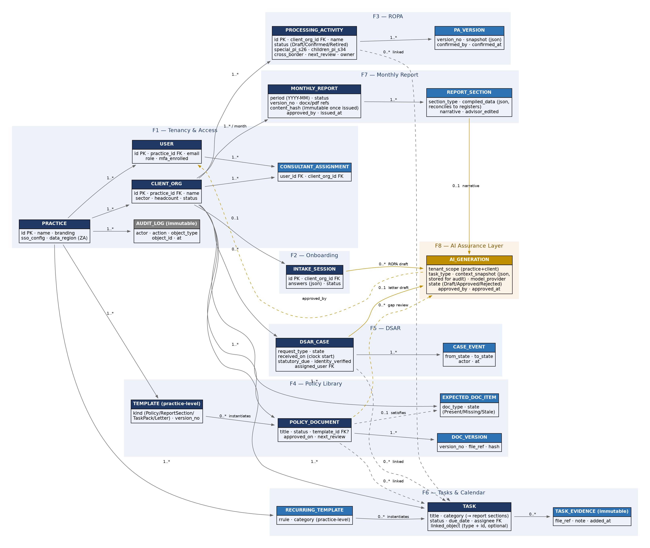
Dark-blue entities are aggregate roots; mid-blue are dependent/child entities; amber is the cross-cutting AI assurance layer. Dashed edges are optional links.

Entity Dictionary
Key design decisions are noted per entity. All entities carry created_at / updated_at and are tenant-scoped; every state change writes to AUDIT_LOG.

F1 — Tenancy and Access
Entity | Purpose and key decisions
PRACTICE | The advisor tenant and top-level isolation boundary. Holds branding (applied to issued reports), SSO configuration, and the data-region flag (ZA for MVP). Nothing is shared across practices.
USER | One identity per person per practice, carrying one of the five fixed MVP roles. MFA enrolment is tracked here and enforced practice-side.
CONSULTANT_ASSIGNMENT | Join table scoping a consultant to specific clients within their practice — the mechanism behind “consultants see only assigned clients”.
CLIENT_ORG | The client workspace. All compliance content hangs off this entity; a Client Admin’s visibility is bounded here.
AUDIT_LOG | Append-only. References actor, action, object type and id. No application path can update or delete entries; export to CSV only.

F2 — Onboarding
Entity | Purpose and key decisions
INTAKE_SESSION | Stores the structured intake answers (JSON) with save-and-resume. It is the grounding context for AI-drafted candidate ROPA entries and the onboarding gap summary, and is retained so any AI draft can be traced to the answers that produced it.

F3 — ROPA
Entity | Purpose and key decisions
PROCESSING_ACTIVITY | The register of record. POPIA-native flags (s.26 special PI, s.34 children’s PI, cross-border) are first-class columns so reporting and future framework mapping can query them directly. Status lifecycle: Draft → Confirmed → Retired.
PA_VERSION | Full-field JSON snapshot per confirmed change, with confirmer identity. Month-over-month register diffs for the report are computed between snapshots — cheap, exact, and immune to schema drift.

F4 — Policy Library
Entity | Purpose and key decisions
TEMPLATE | Practice-level masters for policies, report sections, task packs, and letters. Instantiation records provenance (template id + version), enabling “which clients are on an outdated template” queries.
POLICY_DOCUMENT | Per-client governance document with status and review dates. Overdue next_review raises tasks automatically.
DOC_VERSION | File reference plus content hash per version — the hash supports evidence integrity claims.
EXPECTED_DOC_ITEM | The per-client checklist of documents that should exist (Present / Missing / Stale). Drives the report’s document-status table; a POLICY_DOCUMENT optionally satisfies an item.

F5 — DSAR
Entity | Purpose and key decisions
DSAR_CASE | received_on starts the statutory clock and supports backdating for requests received outside the form. statutory_due is stored, not derived at read time, so deadline history survives configuration changes.
CASE_EVENT | Event-sourced state transitions with actor and timestamp. The full lifecycle is reconstructable for regulator or court scrutiny — the defensibility requirement expressed as schema.

F6 — Tasks and Calendar
Entity | Purpose and key decisions
TASK | The operational unit. category aligns 1:1 with monthly report sections so the actions section is a pure query. Polymorphic link (linked_object_type + id) attaches a task to a ROPA activity, document, or DSAR case.
TASK_EVIDENCE | Immutable attachments and completion notes — citable from issued reports.
RECURRING_TEMPLATE | Practice-level recurrence rules (RRULE) that instantiate the per-client annual compliance calendar at onboarding.

F7 — Monthly Report
Entity | Purpose and key decisions
MONTHLY_REPORT | One row per client per period per version. On issue: DOCX/PDF artefacts stored, content_hash computed, row becomes immutable. Corrections create a new version with a visible note — never an edit.
REPORT_SECTION | Carries both the compiled_data (the structured figures, reconcilable to the registers by automated test) and the narrative, with an advisor_edited flag distinguishing AI draft from human-edited text.

F8 — AI Assurance Layer
Entity | Purpose and key decisions
AI_GENERATION | One row per model call, from any feature. Stores the full context_snapshot (audit and grounding verification), provider, and the Draft → Approved / Rejected state with approver identity. This single entity is what makes the platform’s governed-AI claims demonstrable: every AI output in the system has a traceable context and a named human approver, and nothing in Draft state is ever client-visible or issuable.

Cross-Cutting Schema Rules
Rule | Rationale
Tenant isolation at the data layer | Every table carries the tenancy chain (practice_id, and client_org_id where applicable) with row-level security or per-tenant schema enforcement — isolation is not left to application code (spec F1.1).
Immutability where evidence matters | AUDIT_LOG, TASK_EVIDENCE, issued MONTHLY_REPORT versions, and AI_GENERATION context snapshots are append-only.
Soft lifecycle, never hard delete | Register entries retire; documents supersede; cases close. Hard deletion exists only as an administrative data-erasure procedure, itself logged.
Reconciliation by construction | Report figures are stored as compiled_data snapshots whose derivation queries are re-runnable — the automated reconciliation test in spec F7 acceptance criteria.
GDPR readiness without schema change | POPIA-native fields map to GDPR Article 30 concepts; the UK localisation in Phase 4 is a presentation view over the same model, not a migration.

