**Deployment Preparation and Important Steps**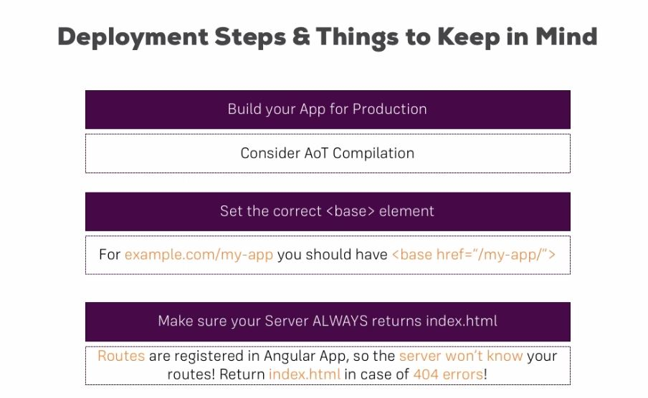

**Example: Deploying to AWS S3**

https://www.udemy.com/the-complete-guide-to-angular-2/learn/v4/t/lecture/6656752?start=0