1. **What is Docker?**

* Docker is a standard for Linux containers
* A container is an isolated runtime inside of Linux
* A container provides a private machine like space under Linux
* Container will run under any modern Linux Kernel

1. **Container can:**

* Have their own process space
* Their own network interface
* ‘Run’ processes as root
* Have their own disk space

1. **Docker Terminology**

* Docker Image: The representation of Docker container. Kind of like a JAR or WAR file in Java
* Docker Container: the Standard runtime of Docker. Effectively a deployed and running Docker Image. Like a Spring boot executable JAR
* Docker Engine: The code which manages Docker stuff. Create and runs Docker Container

1. **Virtual Machine**

host operating system: là hệ điều hành chạy trên máy chủ.

Hypervisor is runtime environment that it’s running on physical hardware, they call it virtual machine because it is machine that’s written in software

Container is not operating system

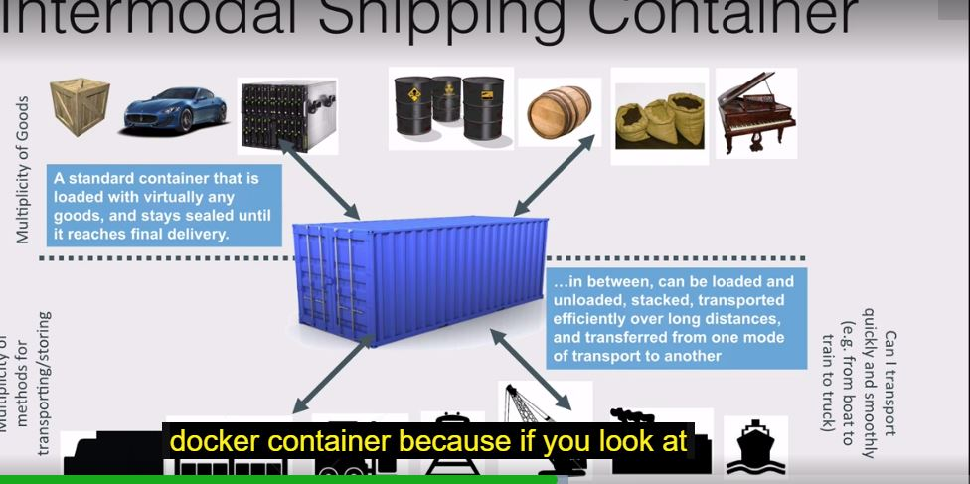

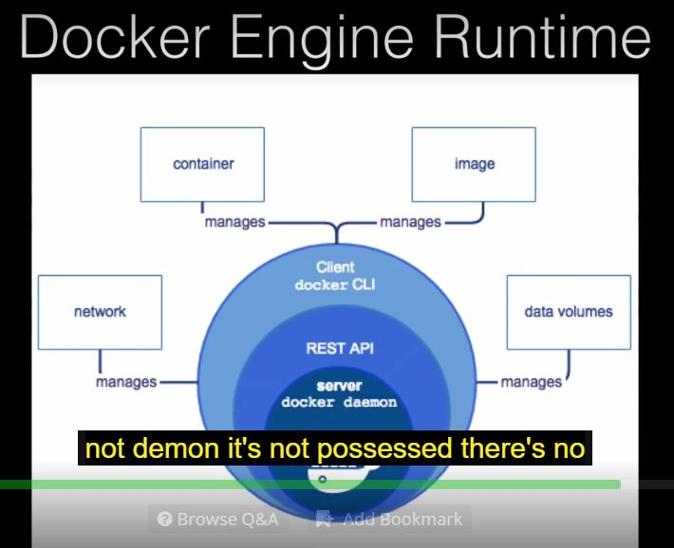

1. **Docker Editions**

Docker have enterprise Edition and Community Edition

With Community Edition:

Monthly “edge” release with latest features for developers

Quarterly releases for operations

Docker version numbering: Docker version 1.13.1 was last Docker pre-edition Docker realease

<https://jobs.evolable.asia/eva-topics/huong-dan-su-dung-docker-co-ban/>

192.168.99.100 must remember

<https://springframework.guru/docker-cheat-sheet-for-spring-devlopers/>

1. **Hello World With Docker**

Clear to clear all command

Docker run hello-world

Docker images : docker images –a : list all docker images

Docker ps –a: list all docker container

Docker ps: list all running docker container

Docker start <container name>: start a docker container

Docker stop <container name>: stop a docker container

1. **Docker Hub**

Docker Hub is a public docker registry and What it is lot like Maven where centralizing public repository

Docker Hub is a docker registry that’s publicly available and what this has lot of docker images that we can pull down to our local system

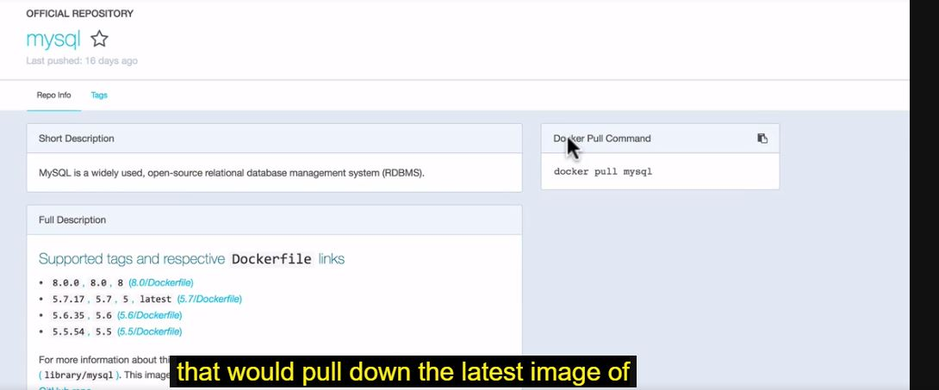

1. **Running MongoDB Docker Container**

Go to public and download Docker for MongoDB

Docker repository for MongoDB in Docker Hub

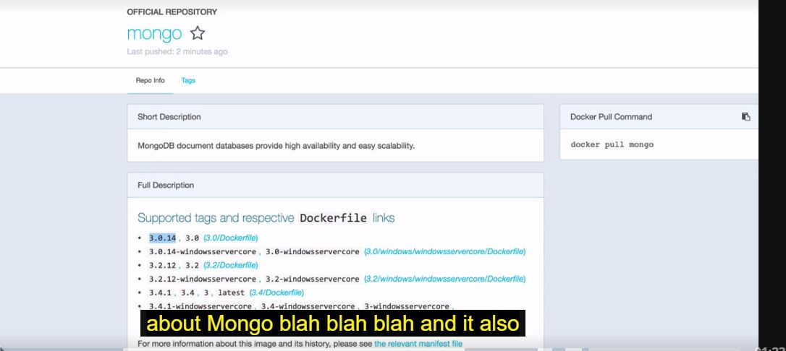

start a mongo instance

$ docker run --name some-mongo -d mongo

Docker run mongo: download latest mongo image

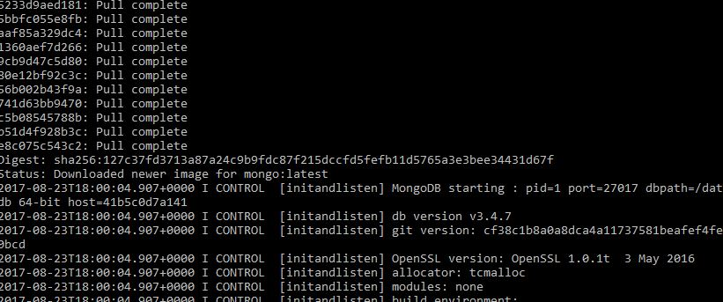

Stop all docker are running

**docker stop $(docker ps -a -q) or docker stop container_ID**

**docker run –d name:** -d turn on back-ground running mode

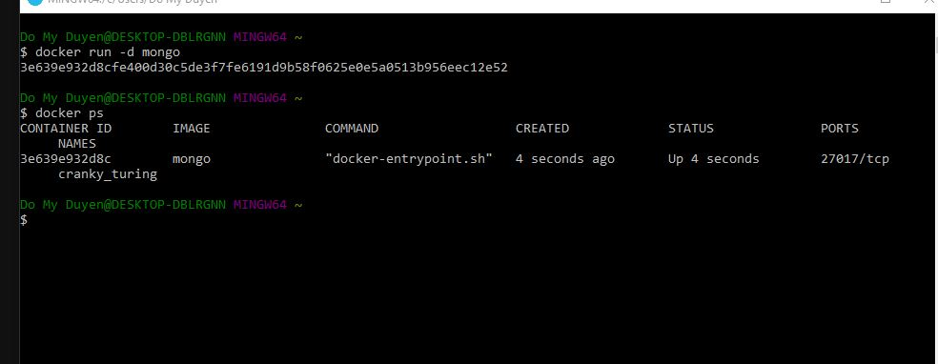

Docker run –p –d mongo

-p mở port container ra ngoài IP public

Docker logs –f container_ID

https://stackoverflow.com/questions/38906058/unable-to-connect-to-mongodb-container-using-mongojavadriver

Connect to MongoDB

<https://stackoverflow.com/questions/29403638/mongo-waiting-on-27017-even-after-reinstall>

"C:\Program Files\MongoDB\Server\3.4.7\bin\mongod.exe" --dbpath d:\test\mongodb\data

<https://docs.mongodb.com/manual/tutorial/install-mongodb-on-windows>

<http://dev-pages.info/how-to-run-spring-boot-and-mongodb-in-docker-container/>

**Docker Image**

An image defines a Docker Container, similar in concept to a snapshot of a VM or a class vs an instance of the class.

Image are immutable