Remove Windows spying and take control of your PC.

Name: WDP

URL: https://wpd.app/

Description:
A small but powerful portable tool working via Windows API. WPD is the most convenient and proper way to customize privacy related settings in Windows.
Screenshot:
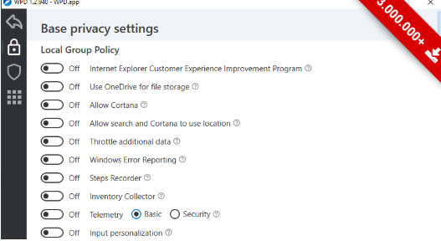
Status: Clean
https://www.virustotal.com/#/file/f8be6cbdc9f17a0c972b2deb94d26b396653c261499b35ec7471cdc7087ce058/detection

Name: TinyWall

URL:
https://tinywall.pados.hu/

Description:
Good firewall with capability of blocking all traffic and allowing only some applications to run.

Screenshot:
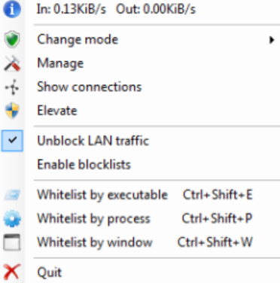
Status: Clean
https://www.virustotal.com/#/file/05d348d18f99fed60e4ed82370ec3690655d0170f9034e1d06094f563190d64a/detection

Name: Anvir Task manager
URL:
https://www.anvir.com/

Description: Advanced task manager with capability of blocking services, checking risk rate, remove auto runs and scheduled tasks. Very useful.

Screenshot:
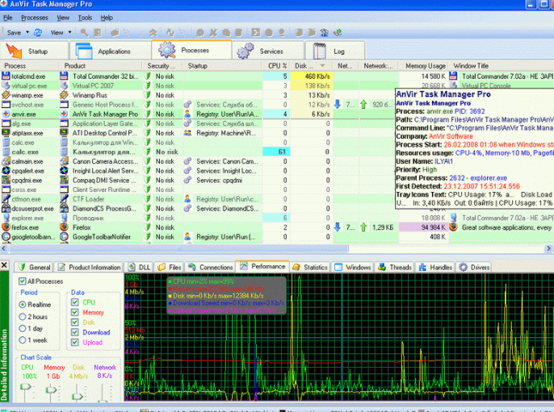

Status: 2/69 ( Most likely 99% not malicious)

https://www.virustotal.com/#/url/8999cdac09a2b05980cf54ce722ef985b3af7eea72f375088ade1c1d1582b191/detection

Name: Privacy Repairer
URL:https://www.securilla.com/privacy-repairer

Description: User friendly software to remove all telemetry, sample send, print and voice recognitions as well as to make one click to use recommended.

Screenshot:
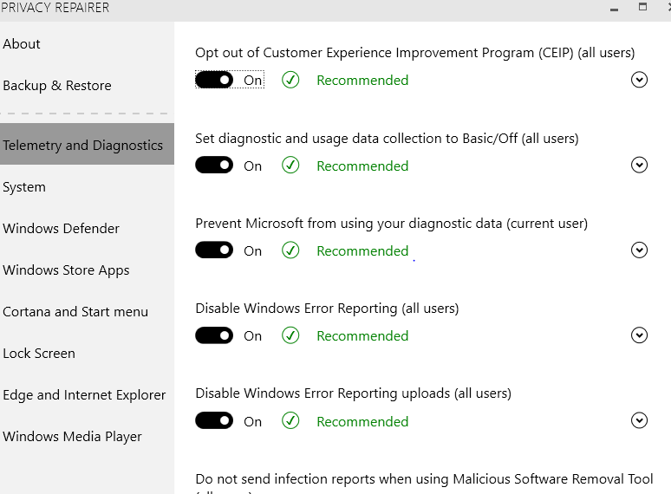

Status: Clean
https://www.virustotal.com/#/file/83bfa4f91e88a47d46e542a72967c914f739d0a98323148c4715ae3c0692ccb2/detection

Name: Disable Windows 10 tracking
URL:https://github.com/10se1ucgo/DisableWinTracking
Description:Software to block hosts and IP adresses of potential telemetry servers. Updates weekly.
Screenshot:
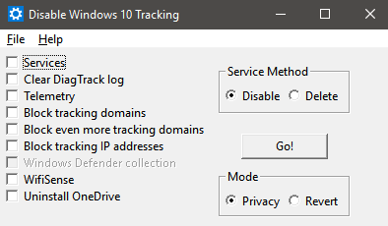
Status: Clean
https://www.virustotal.com/#/url/e9c999035342de978869620178438632536405281f196a46b0835ff619f9637d/detection

Name:AntiOsGUI

URL: https://github.com/vektort13/AntiOS (source)
https://mega.nz/#!kUdEFYpS!TLpJJ4-0ldKoHKBSWcHiqFICqXObPosTiJ9zzdeptCk Binary

Description: Tool to Change all Fingerprints in order to erase your identity detection for advertising and make sure

Screenshot:
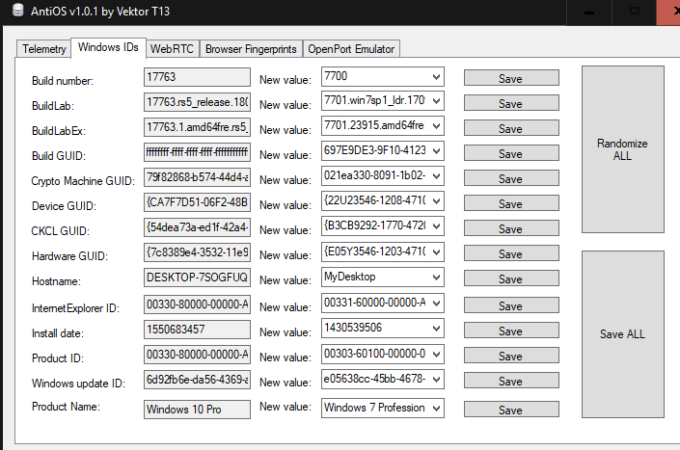

Status:
https://www.virustotal.com/#/file/57582bb89de51debe71d68b17b97de34f2afcde9307e389dd475cc21156e23c0/detection

Name: ShupUp10
URL:https://www.oo-software.com/en/shutup10
Description: Windows telemetry and Edge telemetry disabler.
Screenshot:
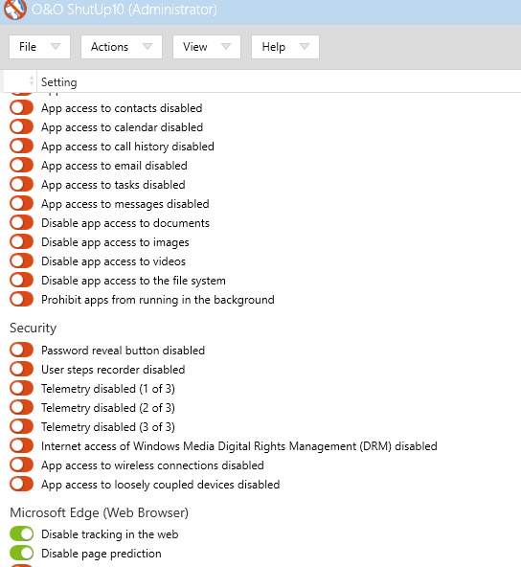

Status: 1/72 Most likely not a malware
https://www.virustotal.com/#/file/a282cbfc6cc70ee131d112bbb0ae70097546ac7d1749fed1396ffc3b300f15aa/detection
Name: Blackbird

URL:https://www.getblackbird.net/

Description:Blocks Telemetry Completely, Removes Windows Ads, Restores Privacy. Usefull tool. Very professional as long as it works based on situation and software it finds.
Screenshot:
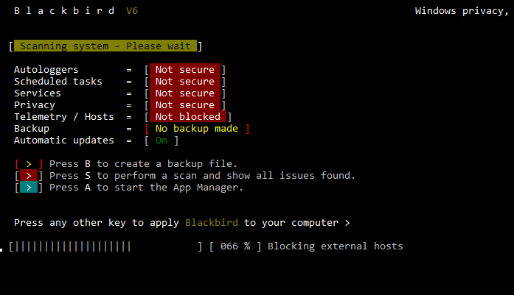

Status: Suspicious ( Most likely detected like a hackingtool)
https://www.virustotal.com/#/file/80582c9ff3dca385445792aab0daa40086e853af5fedbf5e70cbf513bf8c5aa9/detection

After applying all Software by default – Windows 10 booted successfully.

