Assignment 3

Project documentation

Student(s):

* Vulpe Valentin

**Group: 30444**

**Contents**

I Project specification **3**

1.1 Domain Model Diagram 3

II Use-Case model **3**

2.1 Users and stakeholders 4

2.2 Use-Case identification 4

2.3 UML Use-Case diagram 4

III Architectural design **5**

3.1 Conceptual architecture 5

3.2 Package diagram 5

3.3 Class diagram 5

3.4 Database (E-R/Data model) diagram 6

3.5 Sequence diagram 6

3.6 Activity diagram 6

IV Supplementary specifications **6**

4.1 Non-functional requirements 6

4.2 Design constraints 6

V Testing **7**

5.1 Testing methods/frameworks 7

5.2 Future improvements 7

VI Bibliography **7**

# II Use-Case model

## 2.3 UML Use-Case diagram

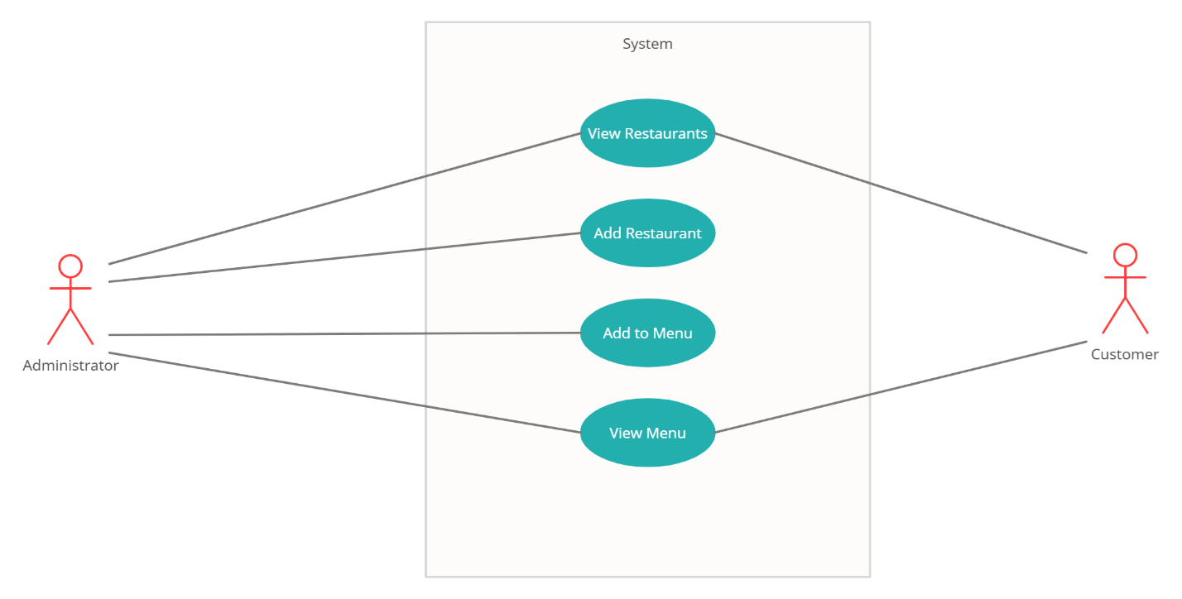

# III Architectural design

## 3.2 Package diagram

## 3.3 Class diagram

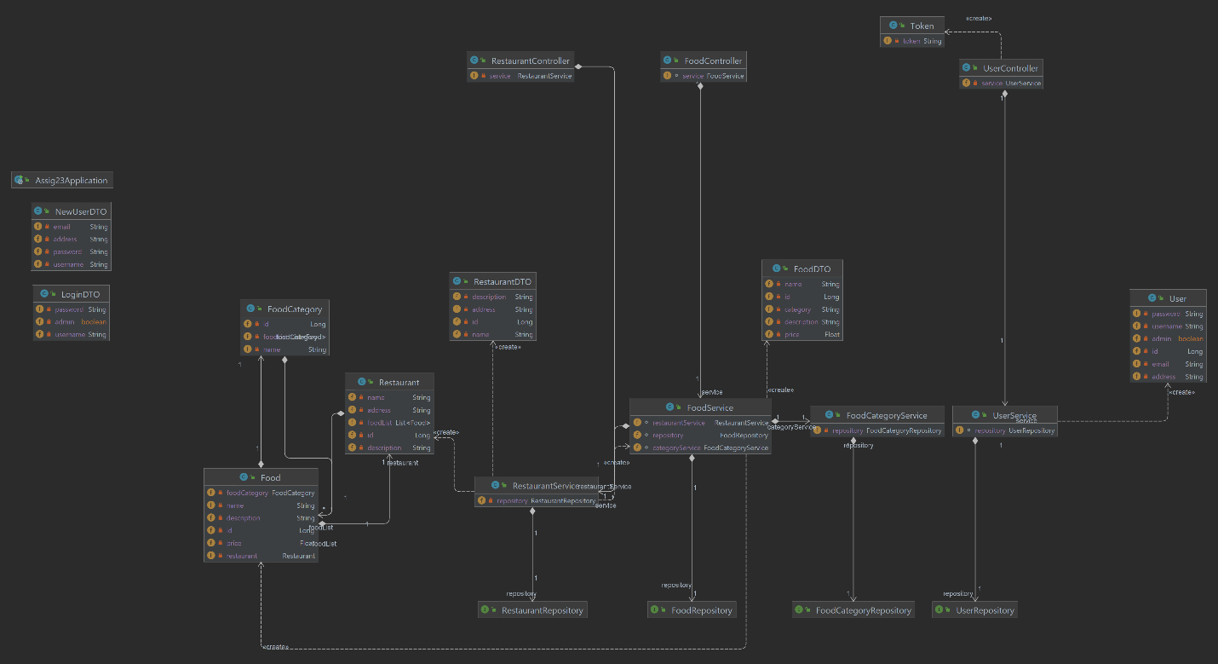

## 3.4 Database (E-R/Data model) diagram

