WEDE5020
Vumo Mdhluli
ST10521534
Propsal2
Rosebank College
DATE: August 2026

TABLE OF CONTENTS

Contents
WEDE5020 1
List of figures 3
Organisation Overview 4
Brief History: 4
Mission: 4
Vision: 4
Target Audience: 4
Website Goals and Objectives 5
Key Performance Indicators (KPIs): 5
4. Proposed Website Features and Functionality 6
Design and User Experience 6
7. Budget 7
8. References 7

List of figures
Figure 1: colour scheme 6
Figure 2: welcome page 7
Figure 3: About page 7
Figure 4: services page 8
Figure 5: request for qoaut page 8
Figure 6: Contact page 9

Organisation Overview

CSL Technologies (Pty) Ltd

Brief History:
CSL Technologies (Pty) Ltd was formally established in 2014. Building up a reputation for being competitive and professional within the systems integration industry, CSL Technologies has become recognised as a specialist in the installation and maintenance of integrated security systems nationally.

Mission:
To offer and deliver high-quality, cost-effective technological solutions to our customers' specific needs.

Vision:
To expand and become a leading player and provider within our market, preferred by customers due to the value we offer through our range of professional security solutions.

Target Audience:
CSL Technologies serves both residential and commercial clients across South Africa:
- Homeowners, including those specifically concerned with fire and smoke risk who need integrated detection alongside traditional security measures.
- Hotels, which require coordinated access control, CCTV and monitoring across guest rooms, staff areas and public spaces.
- Shopping malls, which need large-scale CCTV, access control and fire/smoke safety integration for high-footfall public environments.
- Shop and retail owners, who need cost-effective alarm, CCTV and access control solutions to protect stock, staff and premises.

Website Goals and Objectives
1. Generate qualified leads — make it fast and simple for homeowners, hotel managers, mall facility teams and shop owners to request a free security assessment or quote.
2. Build trust and credibility — present CSL Technologies' history, completed projects and client base clearly, so new visitors can verify the company's experience before making contact.
3. Educate the target audience — provide clear, jargon-free information on each service line (CCTV, fire/smoke detection, fire extinguishers ) so visitors understand what they need before they enquire.
4. Support every audience segment — give hotels, malls and shop owners a way to see solutions relevant to their sector, rather than a single generic homeowner-focused page.

Key Performance Indicators (KPIs):

Quote/contact form submissions: 15–20 per month within 3 months of launch
Organic website traffic growth: +25% within 6 months of launch
Visitor-to-enquiry conversion rate: 3–5%
Average page load time: Under 3 seconds on mobile
Bounce rate on service pages: Below 55%
Mobile traffic share: Tracked to confirm mobile-first design is justified (SA mobile browsing is typically 60%+)

3. Current Website Analysis
Company/ business has no website. They have operating on a word of mouth basses and good client relationships

4. Proposed Website Features and Functionality

Homepage; First impression, route visitors to the right section fast, Hero with core value proposition, service overview grid, client trust bar, stats band, testimonials, primary CTA
About Us; Build trust through history, mission and vision, Company history, mission/vision (finally given real visual space), team, values
Services; Explain each offering clearly, Individual entries for CCTV, Access Control, Alarm Systems, Electric Fencing, Fire & Smoke Detection, Solar Security, with a short description and "Learn more" per service
Sectors We Serve; Speak directly to each audience segment, dedicated content blocks for Residential, Hospitality, Retail & Malls, and Commercial clients
Projects / Case Studies; Prove capability with real examples, short write-ups of completed projects (with client permission), photos, sector tags
Resources / Safety Tips; Capture early-stage search traffic, support the "provide valuable information" goal | Short articles on topics like home fire-safety basics and choosing the right CCTV coverage
Get a Quote; Primary lead-generation tool, Short multi-step form (property/business type → service needed → contact details) that emails and WhatsApps the enquiry to CSL Technologies
Contact Us; Give every audience a direct channel, contact form, click-to-call, WhatsApp button, embedded map, office hours, social links

Design and User Experience
Colour scheme:
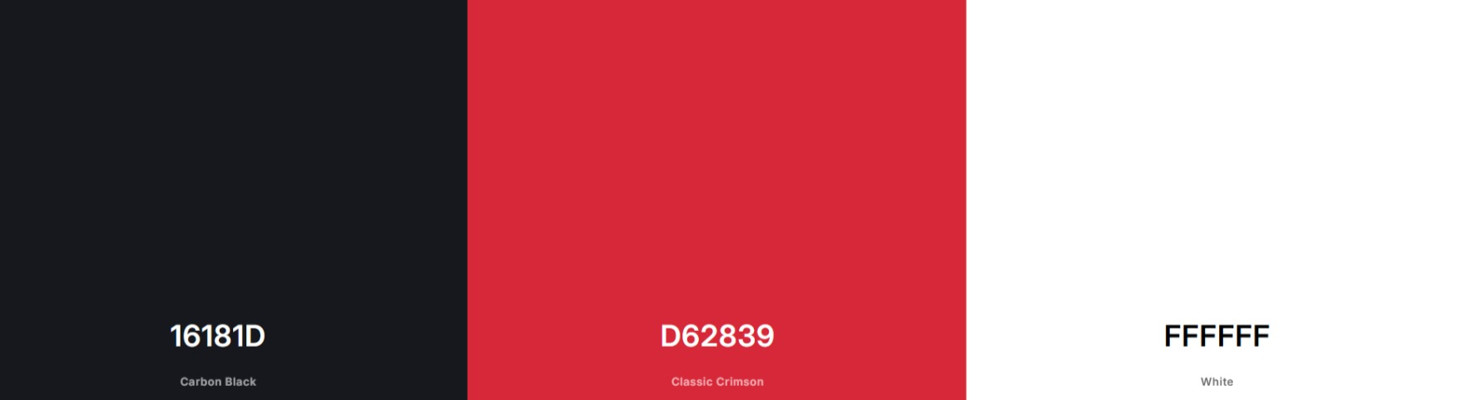
Figure 1: colour scheme
Wireframe:
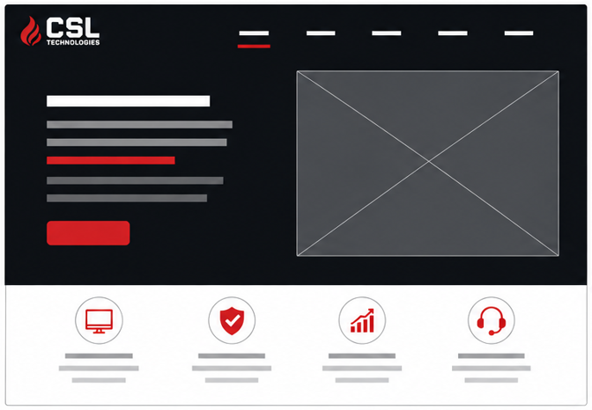
Figure 2: welcome page

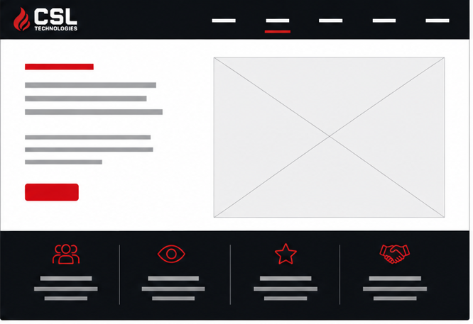
Figure 3: About page

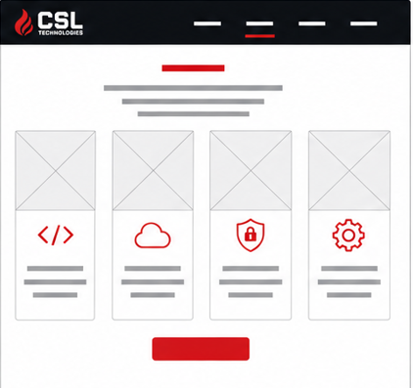
Figure 4: services page

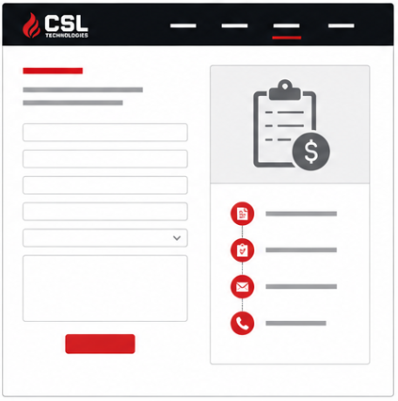
Figure 5: request for qoaut page

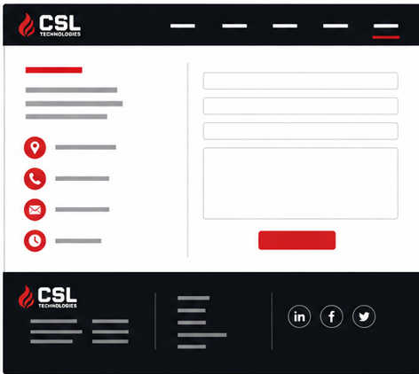
Figure 6: Contact page

7. Budget

Domain registration (`.co.za`, 1 year): R85 – R150, Annual renewal; standard client-side running cost regardless of who builds the site
Web hosting (12 months): R3,600 – R6,000 (R300–R500/month) SSD hosting, SSL included, South African host recommended
Website design & development (once-off); R18,000 – R28,000, Market rate
Ongoing maintenance & support (annual), R6,000 – R12,000 (R500–R1,000/month), Updates, backups, security monitoring, minor content edits
Estimated first-year market value = R27,700 – R46,150, See References for pricing sources
But all of these will be at no cost to you due to this website being a school project

8. References

- CSL Security Technologies. (2026). *Home.* Retrieved from https://cslsecurity.co.za/
- CSL Security Technologies. (2023). *About Us.* Retrieved from https://cslsecurity.co.za/about/
- New Perspective Studio. (2026). *Website Design Cost in South Africa: 2026 Price Guide.* Retrieved from https://www.newperspectivestudio.co.za/wp/what-is-the-cost-of-creating-a-website-in-south-africa/
- Naveck Technologies. (2026). *Web Development Companies Cost in South Africa (2026).* Retrieved from https://www.naveck.com/blog/web-development-cost-south-africa/
- Dotdigital. (2026). *How Much Does a Website Cost in South Africa? 2026 Guide.* Retrieved from https://dotdigital.co.za/website-cost-south-africa/
- Truehost. (2026). *How Much Does a Domain Cost in South Africa?* Retrieved from https://truehost.co.za/cost-of-domain-name-south-africa/

WEDE5020
Vumo Mdhluli
ST10521534
Propsal1
Rosebank College
DATE: August 2026

Dear Falcon Security Team,

My name is Vumo Mdhluli, and I'm a student currently developing my web design and development skills through a program at my school. I'm reaching out to propose something simple: I would like to design and build a brand new website for Falcon Security, completely free of charge.

Through my school, I have access to a full suite of professional design and development tools, which means I can take on real projects like this one without needing to charge for my time or software. In return, I'd gain genuine hands-on client experience and a strong portfolio piece, the kind of practical work a classroom assignment alone can't provide.

I also want to share why Falcon Security specifically caught my attention. My uncle spent years working for a company in the security industry, doing work much like what you do. I never got to see that world up close growing up, but it always stuck with me, listening to him talk about it at family dinners, and getting the chance to work with a company like Falcon Security feels like living out a childhood dream I've held onto since watching him.

As for what I can offer: a clean, modern, mobile-friendly website that reflects Falcon Security's professionalism, clearly explains your security services, and makes it simple for potential customers to reach out to you. I'd work closely with you at every stage, so the final result reflects how your business actually runs, not just how I imagine it from the outside, and so you're never left guessing about the process.

There's no obligation beyond your time and honest feedback along the way, and no pressure if it turns out not to be the right fit. If this sounds interesting, I'd love to set up a short call to learn more about Falcon Security and share a few early ideas for what the site could look like.

Thank you for taking the time to consider this. I hope to hear from you soon.

Warm regards,
Vumo Mdhluli
0796017113
vumomdhluli@gmail.com
Rosebank college

