LIST AND OPERATION

DATE : 17/11/2020

ACTIVITY 1:

Read values from users and create a list of cars (say list_of_cars).

a. Print the list_of_cars without sorting (as given by the users)

b. Print the list_of_cars in ascending order.

c. Print the list_of_cars in descending order.

PROGRAM:

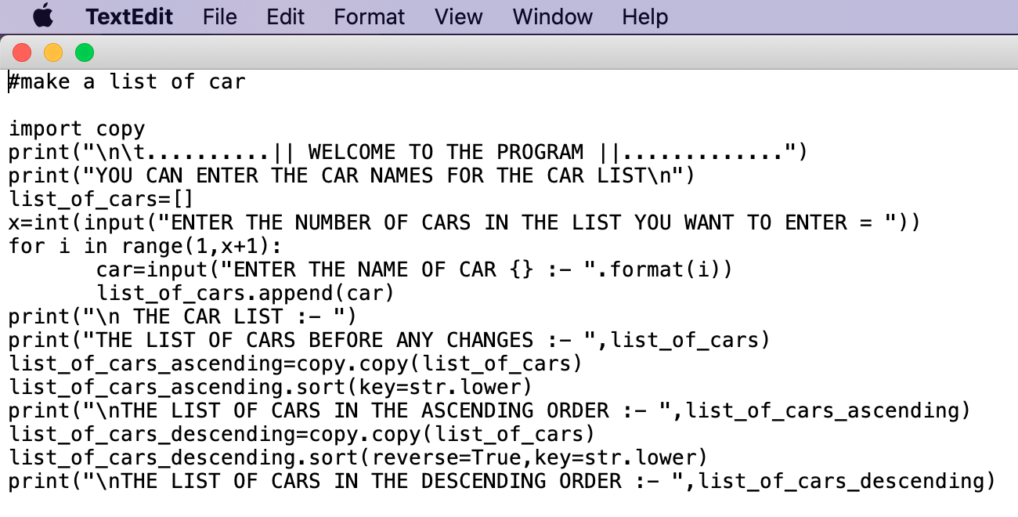

Link for code :

OUTPUT:

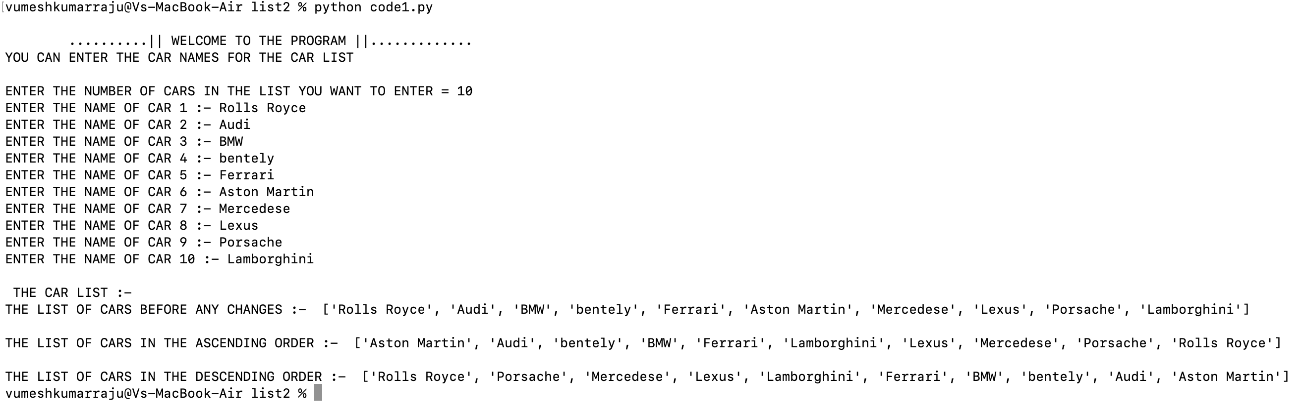

ACTIVITY 2:

Read a list of numbers from users and add them to a list (say number_list).

* Print the number_list.
* Print the number_list in ascending order.
* Print the number_list in descending order.
* Create a new list (say even_number_list) from  number_list. This even_number_list must contain only  even numbers.
* Create a new list (say postive_number_list) from  number_list. This postive _number_list must contain only non-negative numbers.

PROGRAM:

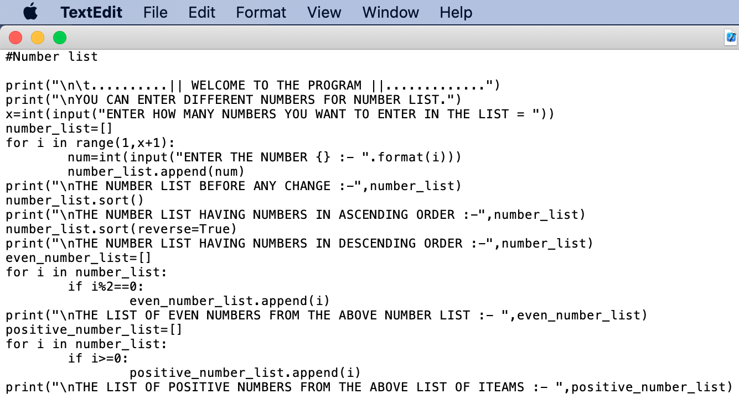

Link for code :

OUTPUT:

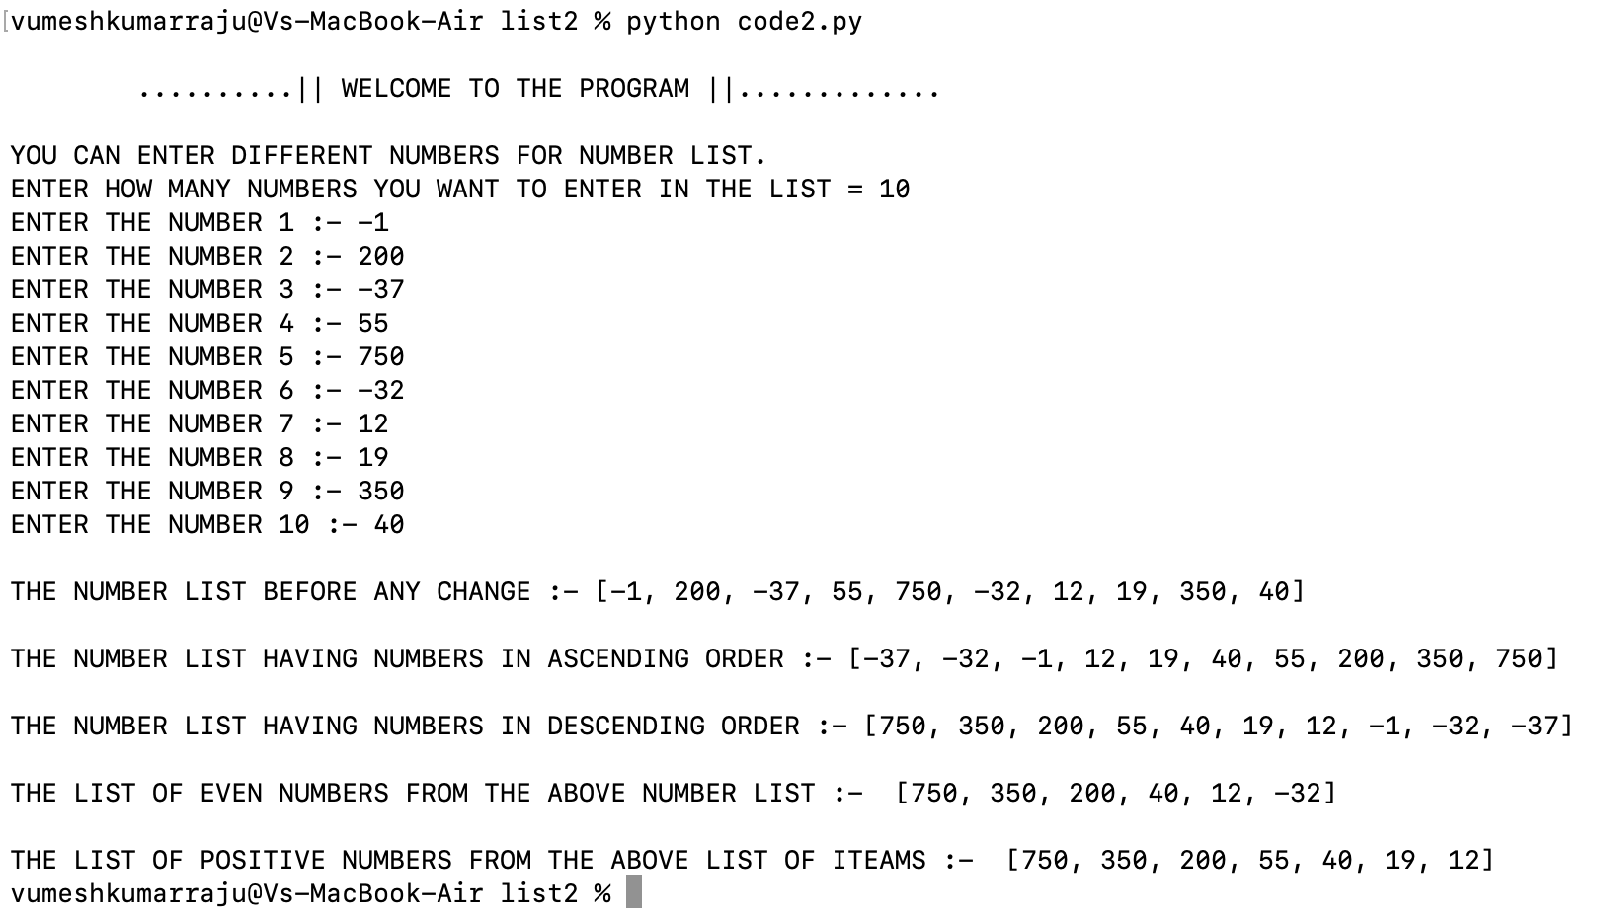

ACTIVITY 3:

Read a list of numbers/Strings from users and add them to a list (say string_number_list) by strictly following the following constraints.

a) Strings starting only with vowel character are permitted.

b) Only positive numbers are permitted.

c) Only even numbers are permitted.

d) Numbers between 100 – 800 only should be permitted.

PROGRAM:

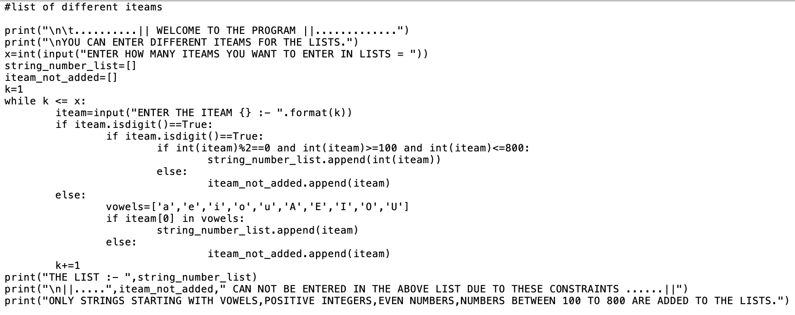

Link for code :

OUTPUT:

