TABLE OF CONTENT

I. DATABASE SCHEMA.......................................................................................

II. QUERIES.........................................................................................................

1. **DATABASE SCHEMA**

We created a database to manage a small bookstore.

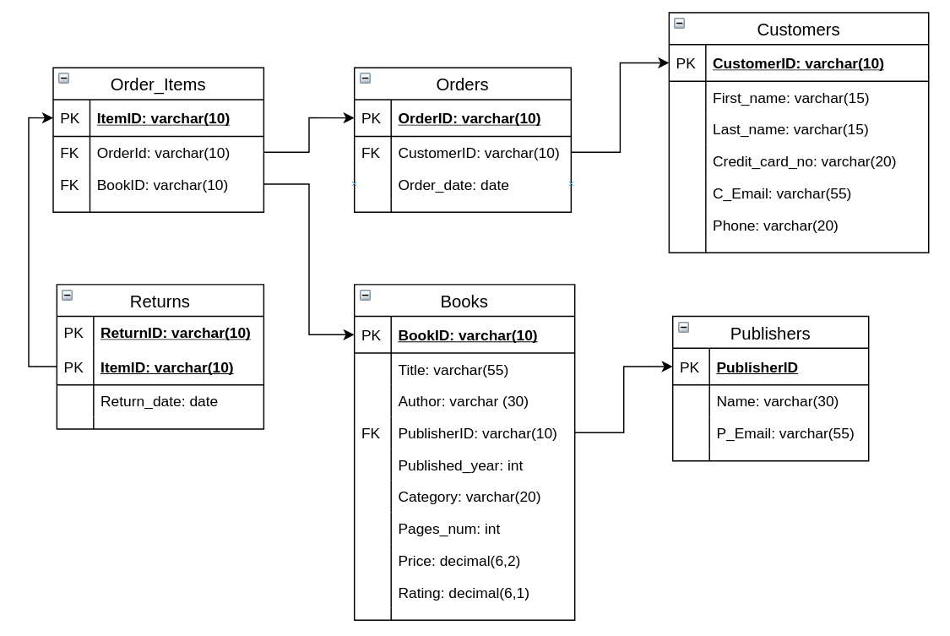

1. Books: information about books that the bookstore sells
   * BookID: ID of each book
   * Title: Name of the title
   * Author: Name of book’s author
   * PublisherID: Foreign key references the ID of book’s publisher
   * Category: Genre of book (Horror, Fiction, etc...)
   * Pages_num: Number of pages that book contains
   * Price: Book price in dollars
   * Rating: Rating over 5 of book
2. Publishers: infomation about publishers that provide books to the bookstore
   * PublisherID: ID of each publisher
   * Name: Publisher name
   * P_Email: Email of publisher
3. Customers: information about customer that buys from the bookstore
   * CustomerID: ID of each
   * First_name: first name of customer
   * Last_name: last name of customer
   * Credit_card_no: The credit card number of each customer
   * C_Email: Customer’s email
   * Phone: Phone number of each customer
4. Orders: Record of the order made in the bookstore
   * OrderID: ID of each order
   * CustomerID: Id of the customer who makes the purchase
   * Order_date: date of the order
5. Order_items: Record of book items in each order
   * ItemID: id of the item purchased
   * OrderID: id of the order
   * BookID: id of the book purchased
6. Returns: Information about book items returned after purchased (the customer’s not satisfy with the quality)
   * ReturnID: id of the returnment
   * ItemID: id of the item returned
   * Return_date: date of the returnment
7. QUERIES

-- 1. Get the top 10 best sellers and the number of copies that they sold

select Title, count(ItemID) No_books

from Books natural join Order_Items

where ItemID not in (select ItemID from Returns)

group by BookID

order by No_books desc

limit 10;

-- 2. Find the cheapest among the top 10 best selling books

select *

from (select Books.*

from Order_Items natural join Books

where ItemID not in (select ItemID from Returns)

group by BookID

order by count(ItemID) desc

limit 10) best_sellers

order by Price

limit 1;

-- 3. Find books for give away events - cheapest among 10 most returned books

-- 1 title with lowest price

select Title, Price

from (select BookID, count(ItemID) No_of_returns

from Returns natural join Order_Items natural join Books

group by BookID

order by No_of_returns desc

limit 10) most_returned natural join Books

order by Price

limit 1;

-- titles with lowest price

delimiter //

create temporary table most_returned (

BookID varchar(10),

No_of_returns int

);

insert into most_returned

(select BookID, count(ItemID) No_of_returns

from Returns natural join Order_Items

group by BookID

order by No_of_returns desc

limit 10);

select Title, price

from Books natural join most_returned

where price = (select min(price) from most_returned natural join Books)//

-- 4. Find the difference between the rating of the highest rated publisher (average book rating) and the lowest rated publisher

select max(avg_rating) - min(avg_rating)

from (select Name, avg(rating) avg_rating

from Publishers natural join Books

group by PublisherID) p;

-- 5. Get Publishers who sold the most copies (excluding returns)

select Name

from Publishers natural join Books natural join Order_Items

where ItemID not in (select ItemID from Returns)

group by PublisherID

having count(ItemID) >= all (select count(ItemID)

from Publishers natural join Books natural join Order_Items

where ItemID not in (select ItemID from Returns)

group by PublisherID);

-- 6. Find the publishers that have the most books rated 4.0 or above

select Name

from Publishers natural join Books

where rating > 4.0

group by PublisherID

having count(BookID) >= all (select count(BookID)

from Books

where rating > 4.0

group by PublisherID);

-- 7. Return the percentage of titles with rating > 4.0 of each publisher

select Name, round((select count(b2.BookID)

from Books b2

where b2.PublisherID = b1.PublisherID

and b2.rating > 4)

/

(select count(BookID))

* 100, 1) Percentage

from Books b1 natural join Publishers

group by PublisherID

order by Percentage desc;

-- 8. Find the differences between the number of books released after and before the year 2010

select abs(b1.no_books - b2.no_books)

from (select count(BookId) no_books

from Books

where Published_year >= 2010) b1,

(select count(BookID) no_books

from Books

where Published_year < 2010) b2;

-- 9. Find the difference in the number of books published each year to the number of books published in the busiest year

delimiter //

set @SoB = (select count(BookID) SoB

from Books

group by Published_year

order by SoB desc

limit 1);

select Published_year, @SoB - count(BookID) 'Difference'

from Books

group by Published_year//

-- 10. Return the size of books (<200, 200-300, 300-400, >400) and their corresponding popularity (successful orders)

delimiter //

set @under_200 = (select count(ItemID)

from Order_Items natural join Books

where ItemID not in (select ItemID from Returns)

and pages_num < 200);

set @200_300 = (select count(ItemID)

from Order_Items natural join Books

where ItemID not in (select ItemID from Returns)

and pages_num between 200 and 300);

set @300_400 = (select count(ItemID)

from Order_Items natural join Books

where ItemID not in (select ItemID from Returns)

and pages_num between 301 and 400);

set @over_400 = (select count(ItemID)

from Order_Items natural join Books

where ItemID not in (select ItemID from Returns)

and pages_num > 400);

create temporary table size_popularity(Size varchar(10),

No_of_orders int);

insert into size_popularity values('under 200', @under_200), ('200 to 300', @200_300), ('300 to 400', @300_400), ('over 400', @over_400);

select * from size_popularity//

-- 11. Find books that get returned the quickest

select Title, datediff(return_date, order_date) days

from Books natural join Order_Items natural join Orders natural join Returns

group by BookID

having days <= all (select datediff(return_date, order_date)

from Orders natural join Order_Items natural join Returns

group by BookID);

-- 12. Get info of customers who return their books within the a month after they bought them

select c.*

from Customers c natural join Orders natural join Order_Items natural join Returns

where datediff(return_date, order_date) <= 31;

-- 13. Find the success percentage (number of successful purchases / total titles) of each category

select category, round((select count(ItemID)

from Order_Items natural join Books b2

where ItemID not in (select ItemID from Returns)

and b2.category = b1.category)

/

(select count(ItemID)

from Order_Items natural join Books b3

where b3.category = b1.category) * 100, 1) success_percentage

from Books b1

group by category

order by success_percentage desc;

-- 14. Find average value (Dollars per number of pages) of each publisher

select Name, (select avg(round(price / pages_num, 2))

from Books b2

where b2.PublisherID = b1.PublisherID) average_value

from Publishers natural join Books b1

group by PublisherID

order by average_value desc;

-- 15. Customers who make the most orders in the most recent year

select Customers.*

from Customers natural join Orders o1

where year(order_date) = (select max(year(order_date))

from Orders)

group by CustomerID

having count(OrderID) >= all (select count(OrderID)

from Orders

where year(order_date) = (select max(year(order_date))

from Orders)

group by CustomerID);

-- 16. Get customers who bought the most copies of book

select concat(first_name, ' ', last_name) Name

from Customers natural join Orders natural join Order_Items

where ItemID not in (select ItemID from Returns)

group by CustomerID

having count(ItemID) >= all (select count(ItemID)

from Orders natural join Order_Items natural join Customers

where ItemID not in (select ItemID from Returns)

group by CustomerID);

-- 17. Get the favourite publisher of each customer

select concat(first_name, ' ', last_name) Name, p.Name "Favourite publisher"

from Customers c1 natural join Orders natural join Order_Items natural join Books natural join Publishers p

where PublisherID = (select PublisherID

from Books natural join Order_Items natural join Orders natural join Customers c2

where c1.CustomerID = c2.CustomerID

group by PublisherID

order by count(ItemID) desc

limit 1)

-- group by CustomerID;

-- 18. Get the favourite genre/category of each customer

select concat(first_name, ' ', last_name) Name, category "Favourite category"

from Customers c1 natural join Orders natural join Order_Items natural join Books

where category = (select category

from Books natural join Order_Items natural join Orders natural join Customers c2

where c1.CustomerID = c2.CustomerID

group by category

order by count(ItemID) desc

limit 1)

group by CustomerID;

-- 19. Get info of customers who bought more than 2 copies of any book

select c1.*

from Customers c1 natural join Orders natural join Order_Items b1

where (select count(distinct ItemID)

from Order_Items b2 natural join Orders natural join Customers c2

where c1.CustomerID = c2.CustomerID

and b1.BookID = b2.BookID

and ItemID not in (select ItemID from Returns)) > 2

group by CustomerID;

-- 20. Return the customers with valid credit card numbers according to Luhn’s algorithm:

-- 1. Multiply every other digit by 2, starting with the number’s second-to-last digit, and then add those products’ digits together.

-- 2. Add the sum to the sum of the digits that weren’t multiplied by 2.

-- 3. If the total’s last digit is 0 (or, put more formally, if the total modulo 10 is congruent to 0), the number is valid!

delimiter //

create function check_validity(Credit_card_no varchar(20)) returns boolean

begin

set @card_no = trim(replace(Credit_card_no, '-', ''));

set @total = 0;

set @len = 16;

set @ptr = 0;

while @ptr < @len do

set @add_value = convert(substr(@card_no, @ptr + 1, 1), int);

if mod(@ptr, 2) = 0 then

set @add_value = @add_value * 2;

end if;

set @total = @total + @add_value;

set @ptr = @ptr + 1;

end while;

if mod(@total, 10) = 0 then

return true;

else

return false;

end if;

end;

select concat(first_name, ' ', last_name) Customer, Credit_card_no, check_validity(Credit_card_no) as validity

from Customers

order by validity desc//

-- BONUS

-- 21. Find the publishers who got the most copies returned

select Name

from Publishers natural join Books natural join Order_Items natural join Returns

group by PublisherID

having count(ItemID) >= all (select count(ItemID)

from Publishers natural join Books natural join Order_Items natural join Returns

group by PublisherID);

-- 22. Return the percentage of orders that get returned within a month of each genre/category

select category, round((select count(ItemID)

from Orders natural join Order_Items natural join Returns natural join Books b2

where b2.category = b1.category

and datediff(return_date, order_date) <= 31)

/

(select count(ItemID)

from Order_Items natural join Books b3

where b3.category = b1.category) * 100, 1) Percentage

from Books b1

group by category;

-- 23. Find the ID and price of the most expensive order

select OrderID, sum(Price) Gia_Tien

from Order_Items natural join Books

group by OrderID

having Gia_Tien >= all (select sum(Price)

from Order_Items natural join Books

group by OrderID);

-- 24. Find the average rating of each year

select Published_year, round(avg(rating), 1) 'Average rating'

from Books

group by Published_year ;

-- 25. Find the publishers whose all books are rated 3.0 or above

select Name

from Publishers

where PublisherID not in (select PublisherID

from Books

where rating < 3.0);