**MINI PROJECT REPORT**

**Group II**

**Group members:**

|  |  |
| --- | --- |
| Phạm Vũ Minh | 20176818 |
| Trần Công Minh | 20176825 |
| Đào Hồng Quân | 20176850 |

**Projects Assigned:**

1. **Project 21.** (Phạm Vũ Minh)

Let's define the digit degree of some positive integer as the number of times we need to replace this number with the sum of its digits until we get to a one-digit number. Given an integer, find its digit degree.

Example

● For n = 5, the output should be digitDegree(n) = 0;

● For n = 100, the output should be digitDegree(n) = 1. 1 + 0 + 0 = 1.

● For n = 91, the output should be digitDegree(n) = 2. 9 + 1 = 10 -> 1 + 0 = 1.

**2. Project 23.** (Trần Công Minh)

Surpassing words are English words for which the gap between each adjacent pair of letters strictly increases. These gaps are computed without "wrapping around" from Z to A.

For example:

Write a function to determine whether a word passed into a function is a surpassing word. You can assume the word is made of only alphabetic characters and are separated by whitespace. We will consider the empty string and a 1-character string to be a valid surpassing word.

is_surpassing_word("superb") # => True

is_surpassing_word("excellent") # => False

**3. Project 24** (Đào Hồng Quân)

Cyclone Word (challenge)

Cyclone words are English words that have a sequence of characters in alphabetical order when following a cyclic pattern.

Example:

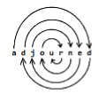

Write a function to determine whether a word passed into a function is a cyclone word. You can assume that the word is made of only alphabetic characters and is separated by whitespace.

is_cyclone_phrase("adjourned") # => True

is_cyclone_phrase("settled") # => False

**Details**

1. Project 21:
   1. Pseudo Code

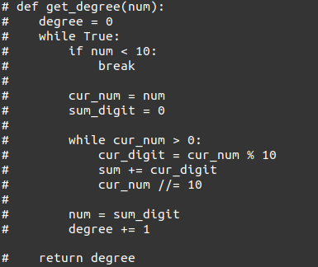

* 1. Assembly Code

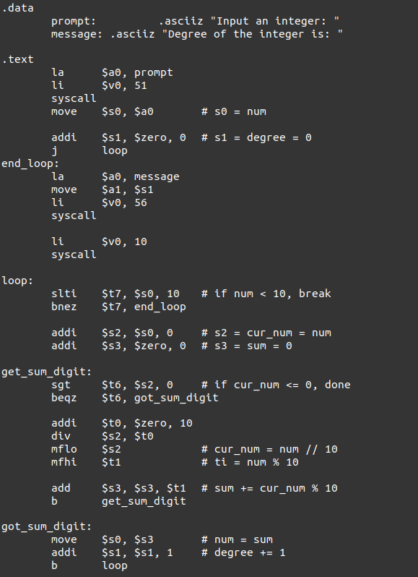

* 1. Test Result

Input:

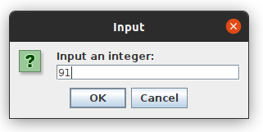

Output:

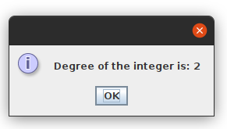

1. Project 23
   1. Pseudo Code

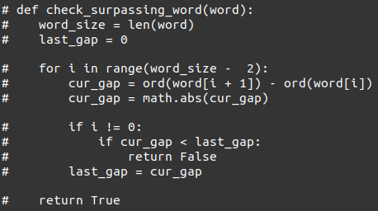

* 1. Assembly Code

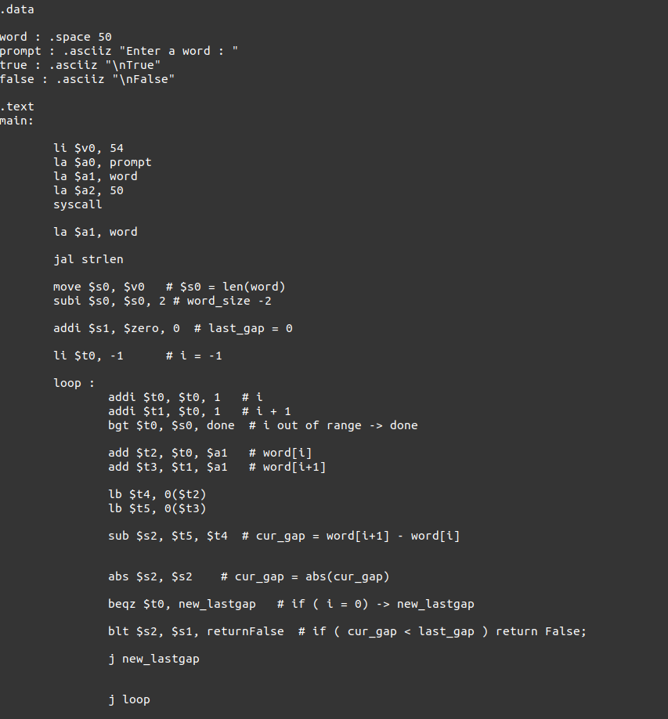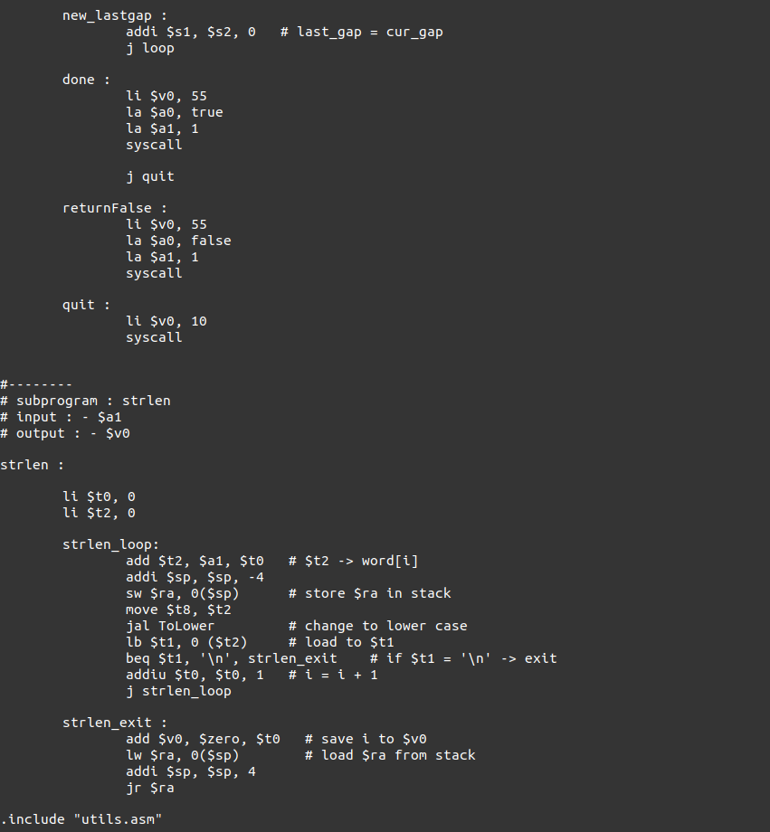

* 1. Test Result

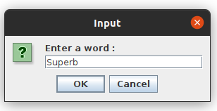

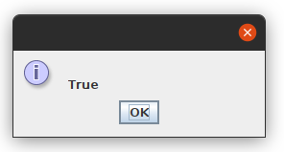

1. Project 24
   1. Pseudo Code

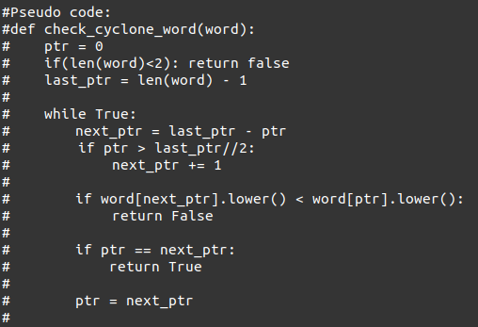

* 1. Assembly Code

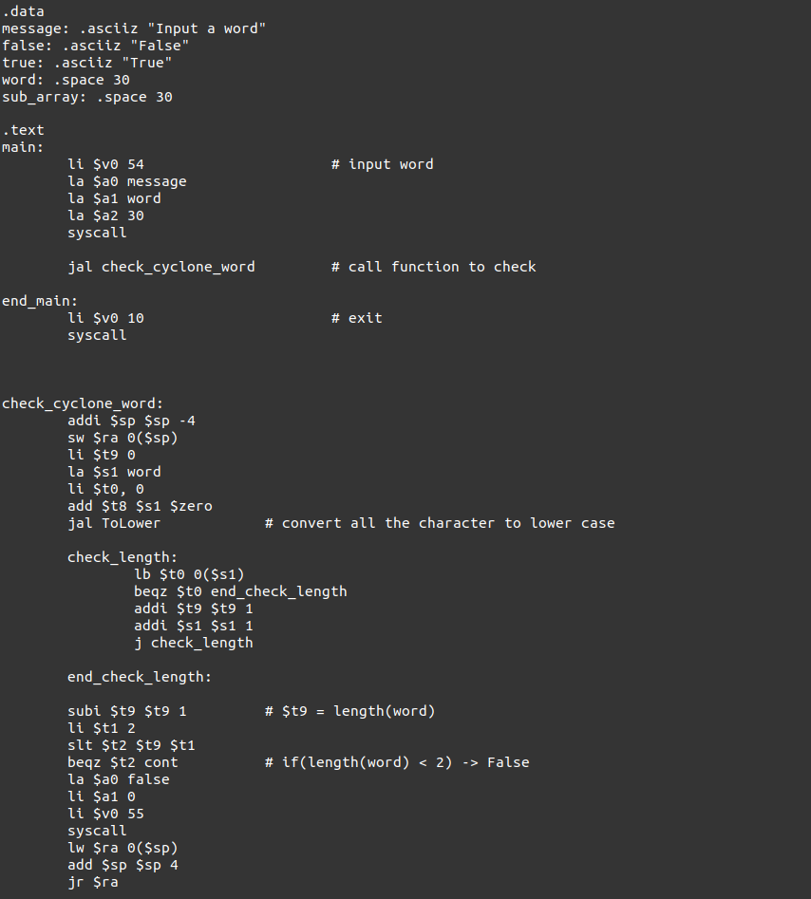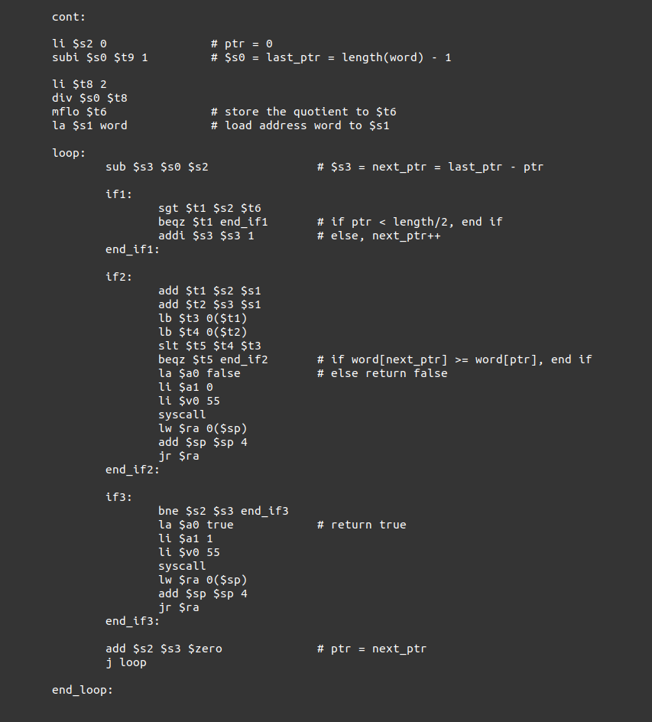

* 1. Test Result

