**Shoe Store App**

Presented by Group 3 - PRM392

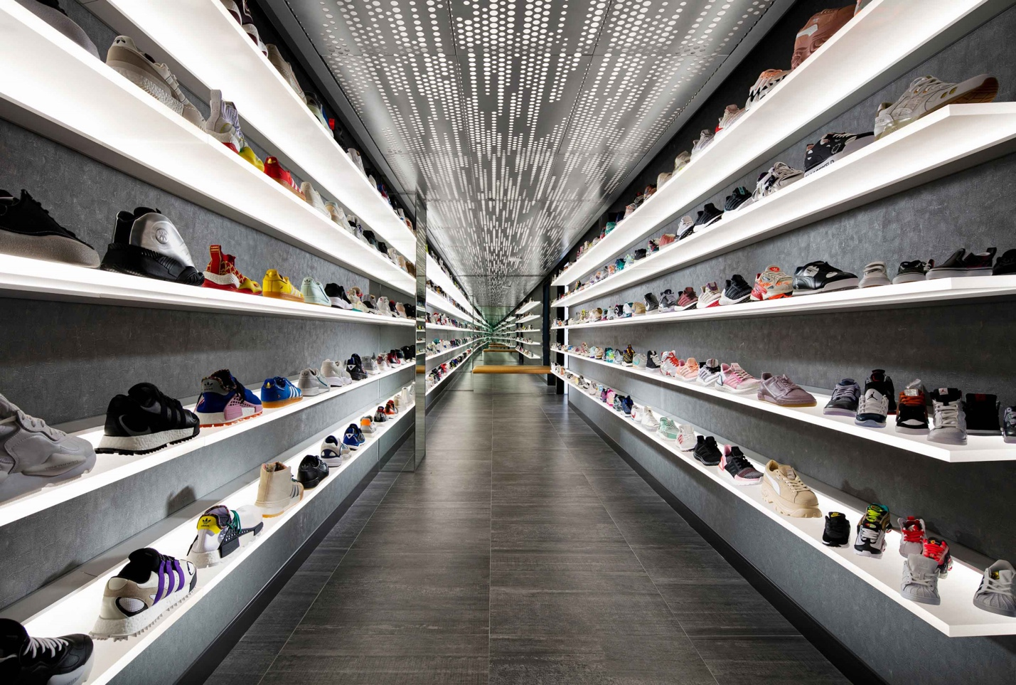

**Members:**

Nguyễn Công Vũ – SE151184

Đào Anh Tú – SE151149

Nguyễn Thanh Tân – SE140017

Lê Hiếu Nghĩa – SE150939

Admin Login Account:

Username: admin

Password: 1

© 2023 Group 3 of PRM392 - All Rights Reserved.

1. **Login**

* 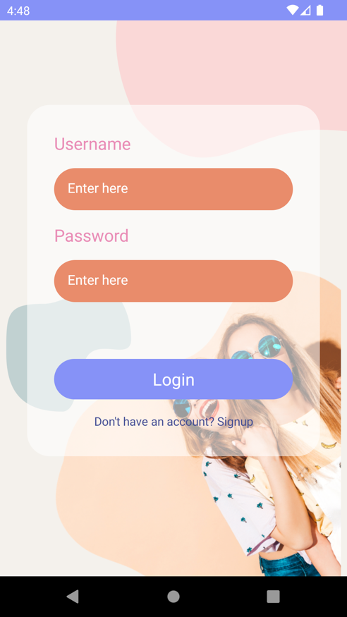Function name: Login.
* Function trigger: After opening the application.
* Function description: The system allows users to use their username and password to log in to the system as administrator or user.

1. **Sign Up**

* 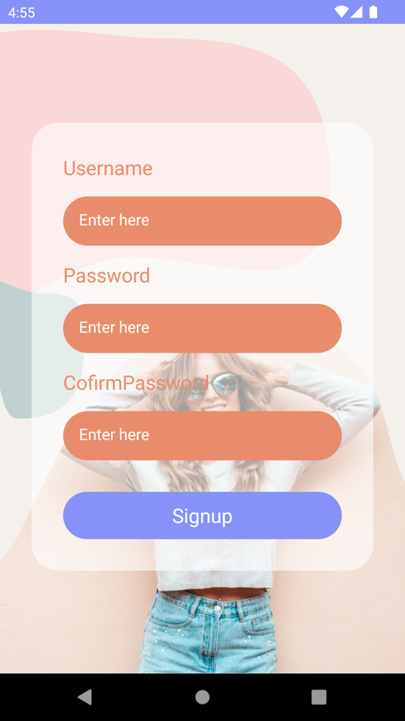Function name: Sign Up.
* Function trigger: After clicking “Signup” button.
* Function description: The system allows users to create a new user account.

1. **Admin**

* 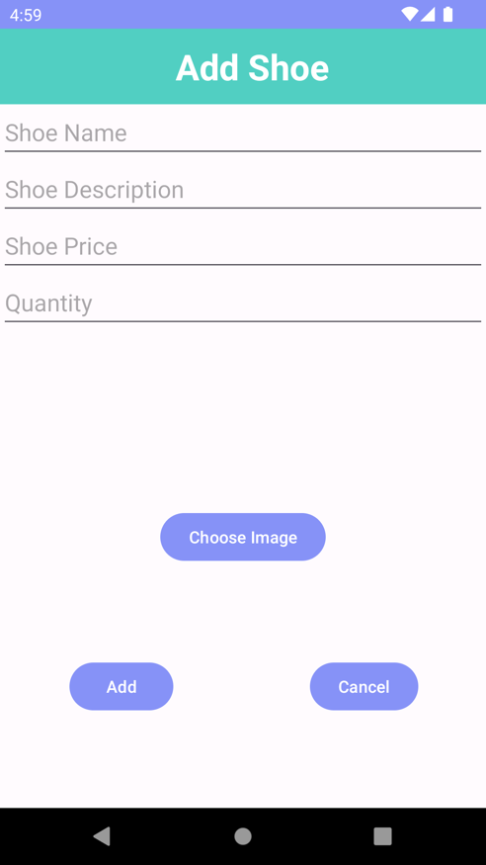Function name: Add shoe.
* Function trigger: After logged in as admin and click on “Add New Shoes” button on the top right corner menu.
* Function description: The system allows administrator to add new shoe product into database. Shoe information include: Name, Description, Price, Quantity and Image.
* 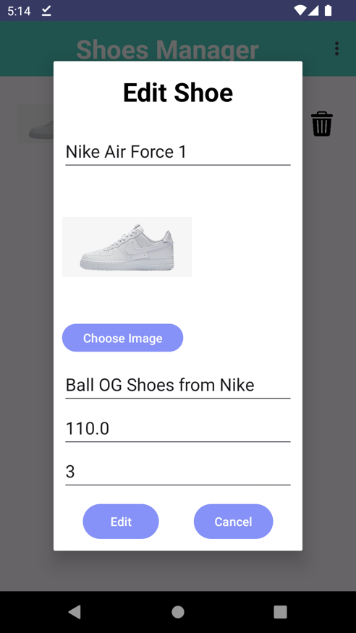Function name: Edit shoe.
* Function trigger: After logged in as admin and click on the Pencil icon in specific item.
* Function description: The system allows administrator update product information.
* 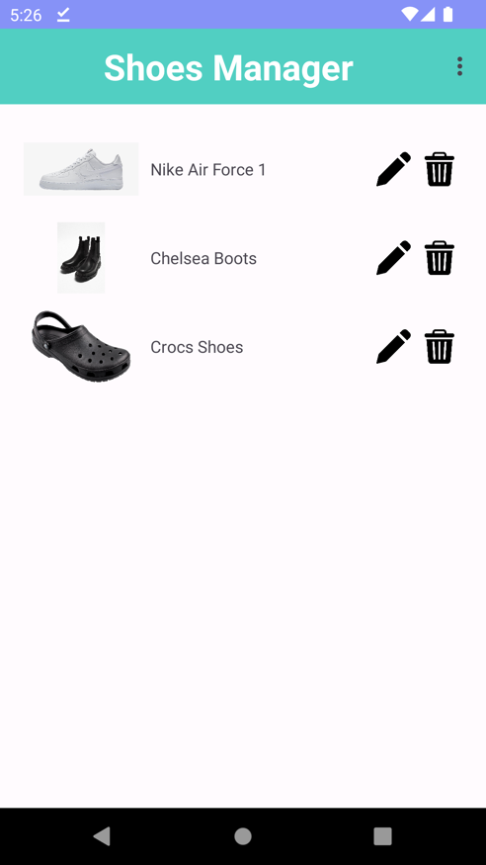Function name: Manage shoes.
* Function trigger: After logged in as admin or click on “Manage shoes” button on the top right corner menu.
* Function description: The system allows administrator to manage shoes list.
* 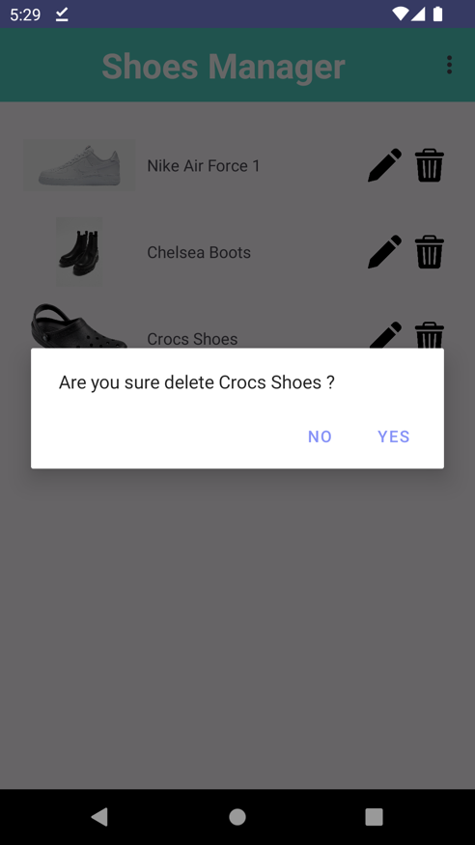Function name: Delete shoe.
* Function trigger: After logged in as admin and click on the Bin icon in specific item.
* Function description: The system allows administrator to delete an item.

* 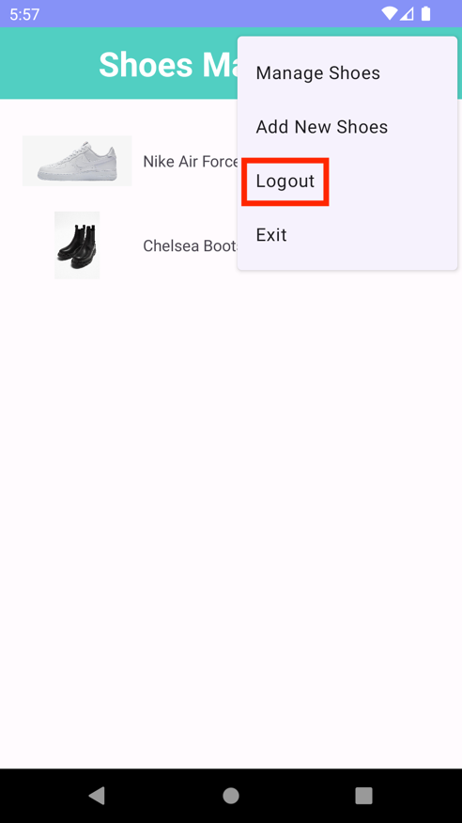Function name: Logout
* Function trigger: After logged in as admin.
* Function description: The system allows administrator to log out their account.
* 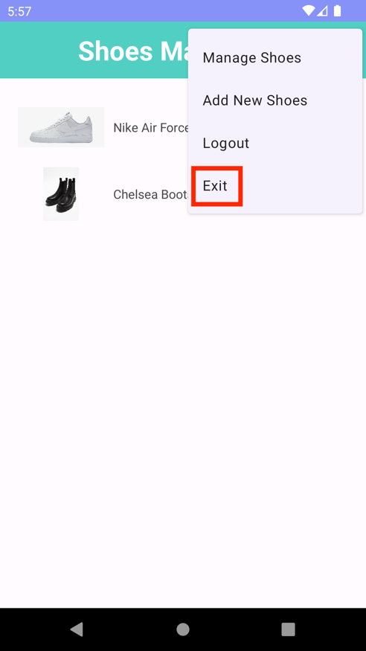Function name: Exit.
* Function trigger: After logged in as admin.
* Function description: The system allow administrator to exit the application.

1. **User**

* 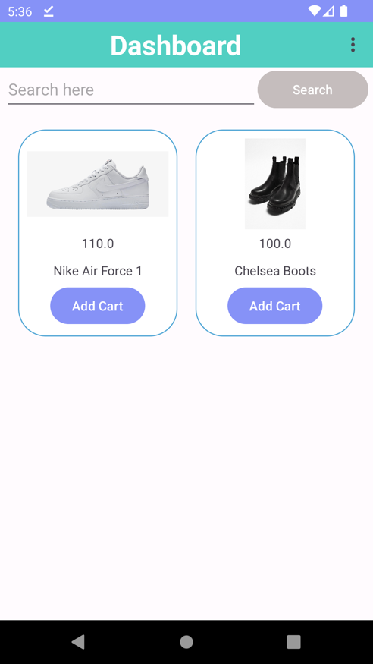Function name: Dashboard.
* Function trigger: After logged in as user or click on “Dashboard” button on the top right corner menu.
* Function description: The system allow user to see shoes list.
* 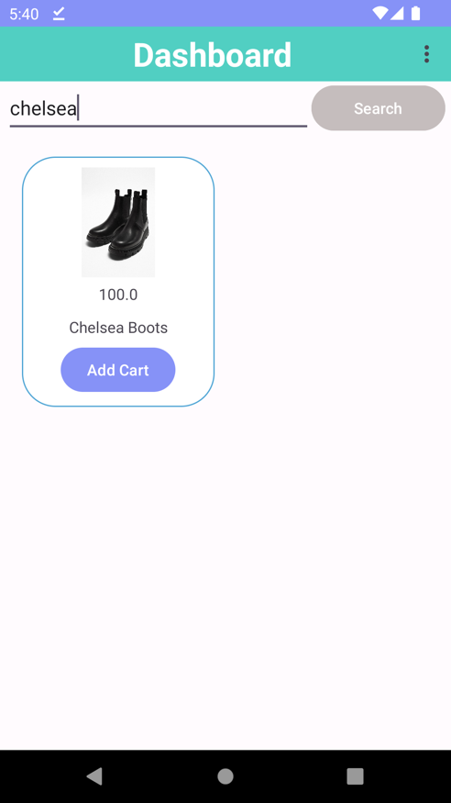Function name: Search item.
* Function trigger: After logged in as user and search name of the product.
* Function description: The system allows user to search for specific shoe.

* 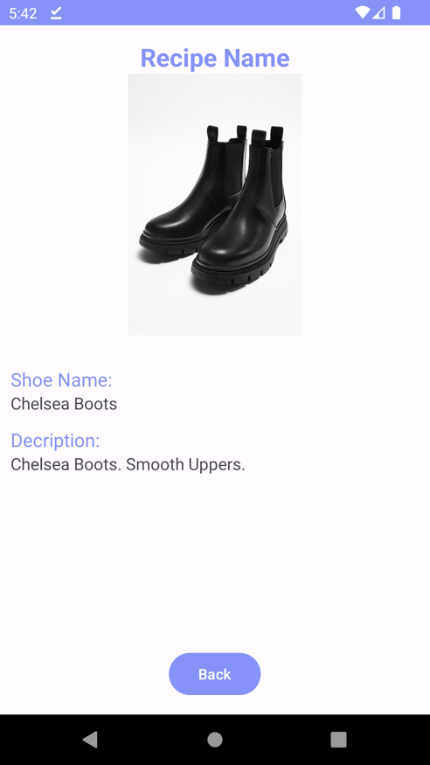Function name: See item details.
* Function trigger: After logged in as user and click on the item.
* Function description: The system allows user to see the item’s further details such as name and description.

* 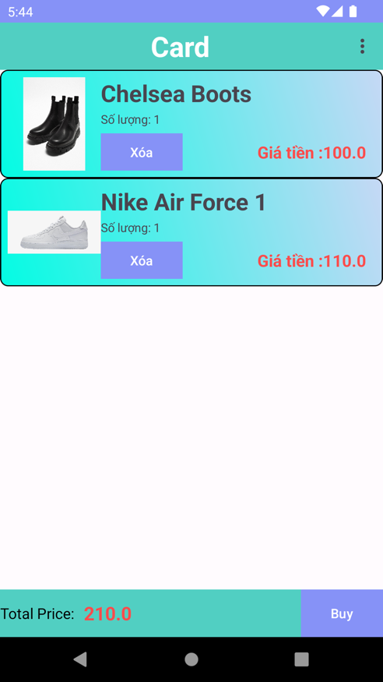Function name: Shopping Cart.
* Function trigger: After logged in as user and click on “Add Cart” button.
* Function description: The system allows user to add to cart and proceed to check out.
* 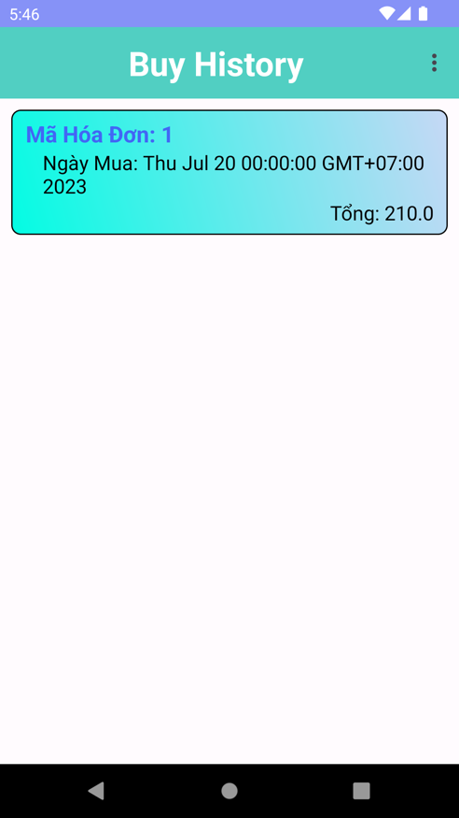Function name: Buy history.
* Function trigger: After logged in as user and click on the “Buy” button in cart menu or click on the “Buy History” ion the top right corner menu.
* Function description: The system allows user to see buy history after purchased successful.
* 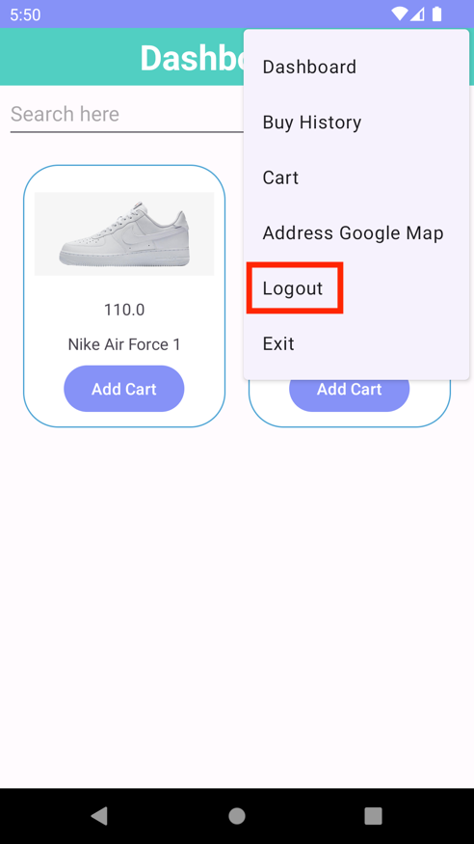Function name: Logout.
* Function trigger: After logged in as user.
* Function description: The system allows user to log out their account.
* 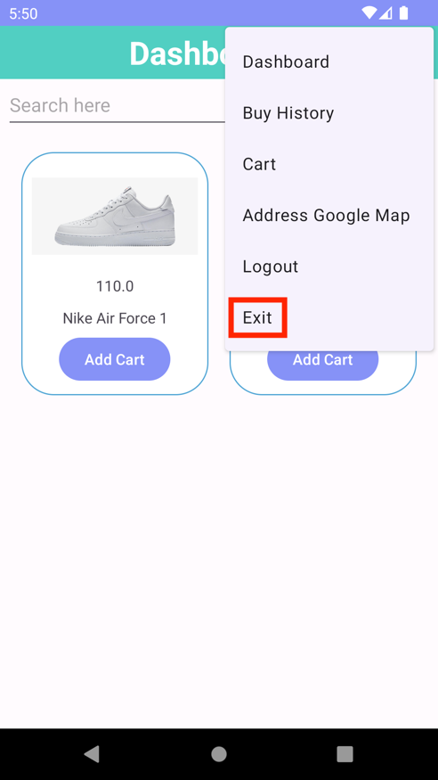Function name: Exit.
* Function trigger: After logged in as user.
* Function description: The system allows user to exit the application.

**<<<THE END>>>**