

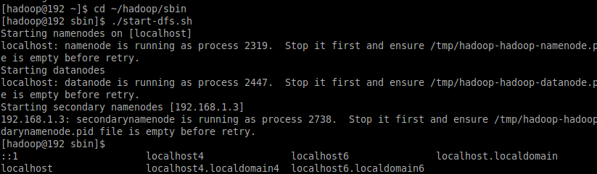

1.4. Execute the start-yarn.sh script to start YARN services.

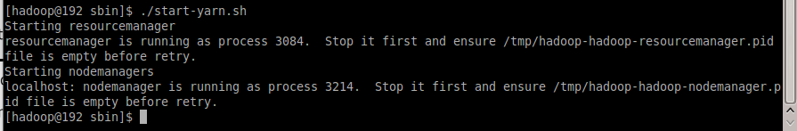

2.1. From a terminal as user student, enter the following command:

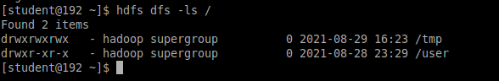

2.2. Explore further, the user home directories in HDFS.

hdfs dfs -ls /user

hdfs dfs -ls /user/student

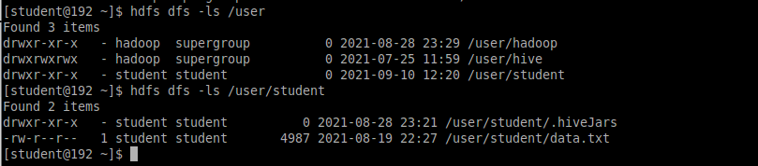

2.3. Explore user home directories for Linux.

cd /home

ls -l

cd /home/student

ls -l

cd /home/

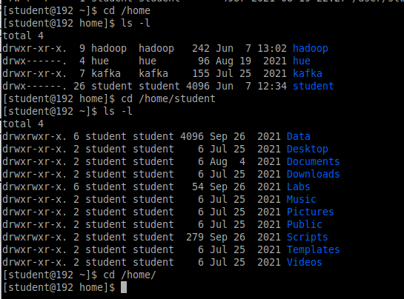

2.4. Create a new Linux user. Create HDFS and Linux home directories for the user.

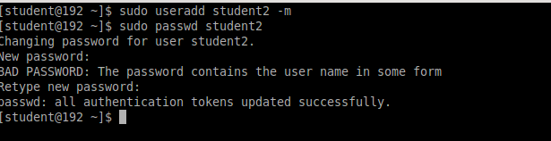

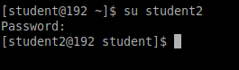

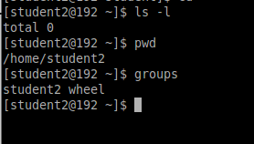

2.4.2. Create HDFS home directory for user student2

su – hadoop

hdfs dfs -mkdir /user/student2

hdfs dfs -chown student2 /user/student2

hdfs dfs -ls /user/student2

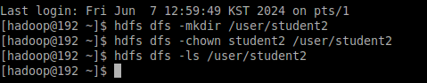

3. Exploring and working with HDFS directories.

3.1. Create a subdirectory in the student HDFS home directory and name is “MRtest”

hdfs dfs -mkdir MRtest

hdfs dfs -ls /user/student

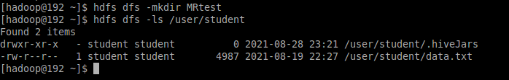

3.2. Explore a book located in a subdirectory under your home directory.

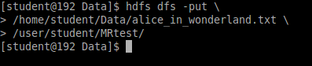

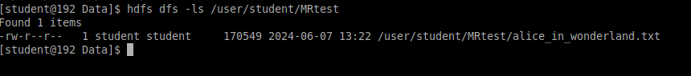

Lab 3:Working with YARN/MapReduce

cd $HADOOP_HOME/sbin

mr-jobhistory-daemon.sh start historyserver

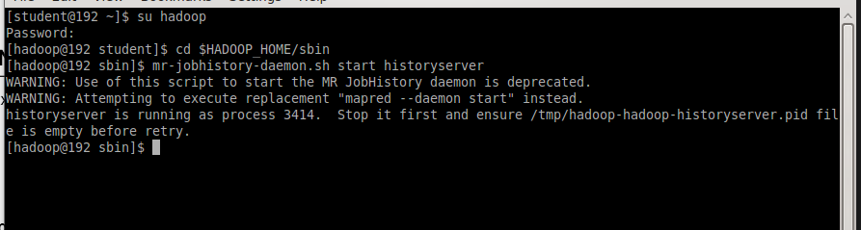

2. Run the wordcount program from the MapReduce examples jar

2.1. Open a new terminal as student.

2.2. Navigate to the following directory.

2.3. Execute the hadoop-mapreduce-examples-3.3.1.jar with the wordcount option

cd $HADOOP_HOME/share/hadoop/mapreduce

hadoop jar ./hadoop-mapreduce-examples-3.3.1.jar wordcount \

MRtest WC_Output