Lab 3: Data Access with Hbase

1. Start with HBase Shell

1.1 Run the HBase shell. And execute the help command and view the basic usage

information for HBase Shell.

$hbase shell

hbase(main):001:0> help

1.2 Display the version and status for basic usage

hbase(main):001:0> version

hbase(main):001:0> status

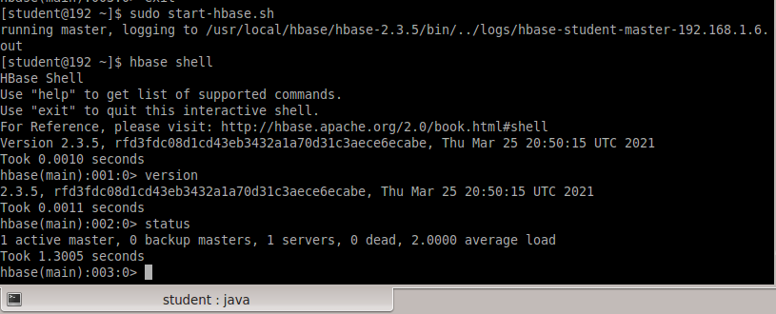

1.3 Use the create command to create a new table. You must specify the table name

and the column family name.

Table name: tbl_authors, Column Family: cf1

hbase(main):001:0> create ‘tbl_authors’, ‘cf1’

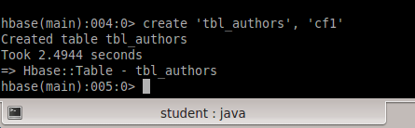

1.4 List table to verify table tbl_authors was created using list. You can either give the

List command alone or give the table name along with List .

hbase(main):002:0> list

hbase(main):003:0> list ‘tbl_authors’

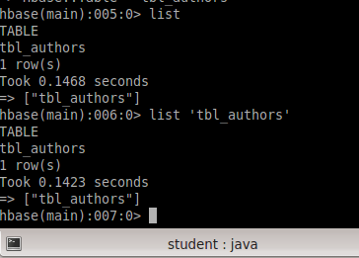

1.5 Use the describe command to see details, including configuration defaults.

hbase(main):001:0> describe ‘tbl_authors’

hbase(main):002:0> describe

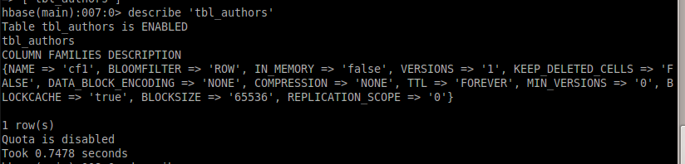

1.6 Delete the table you just created. And list all tables to verify table was successfully

deleted

hbase(main):001:0> drop ‘tbl_authors

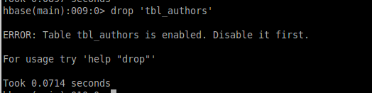

1.7

Disable the tbl_authors table for drop.

hbase(main):003:0> disable ‘tbl_authors’

hbase(main):004:0> drop ‘tbl_authors’

hbase(main):005:0> list

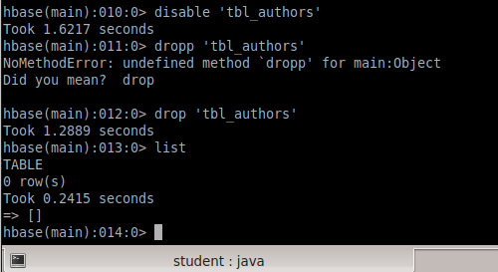

1.8 Create a test table, and use the put command. Here, we insert three values, one at

a time.

The input data is in the following format

