*Message Queue
- Chạy rabbit
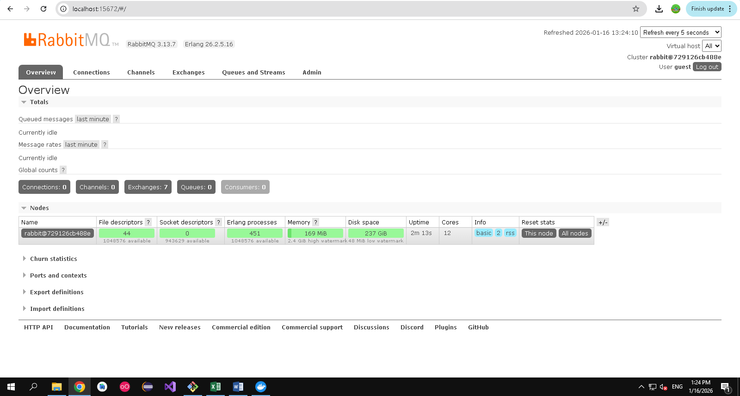
- code
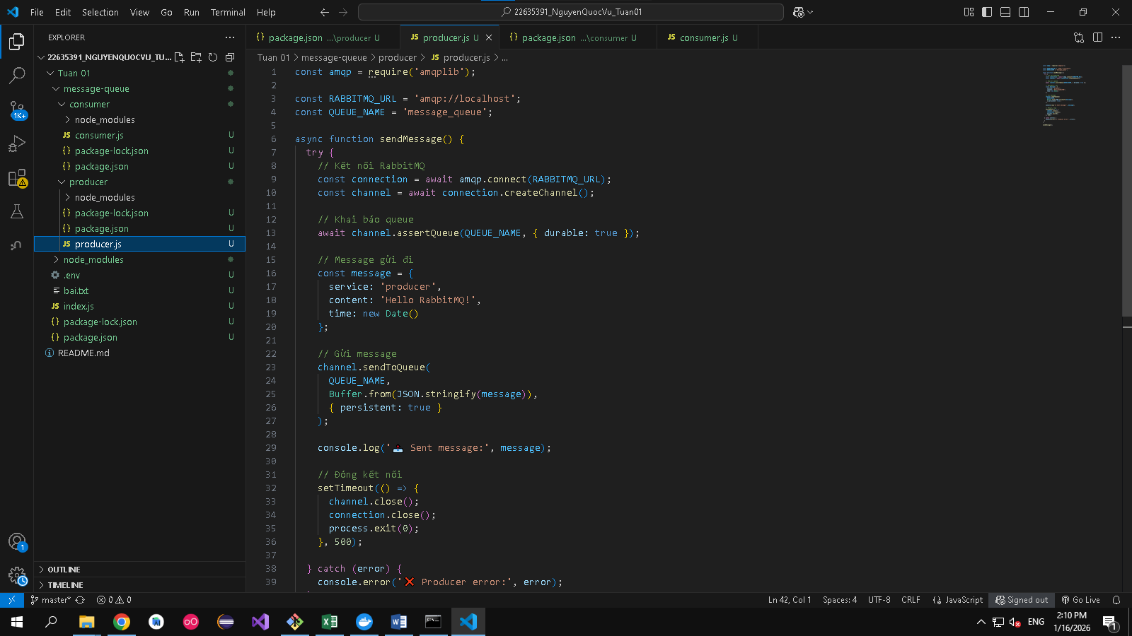
- Kết quả
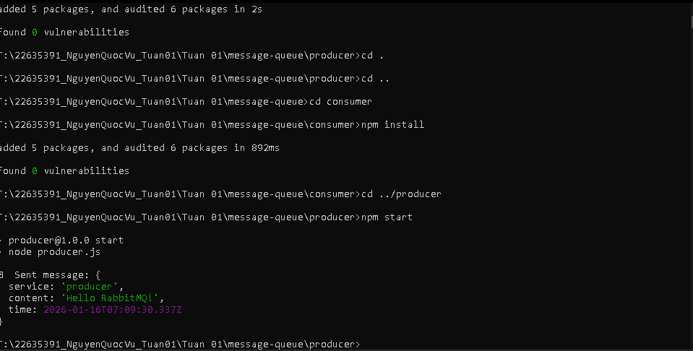

*JWT
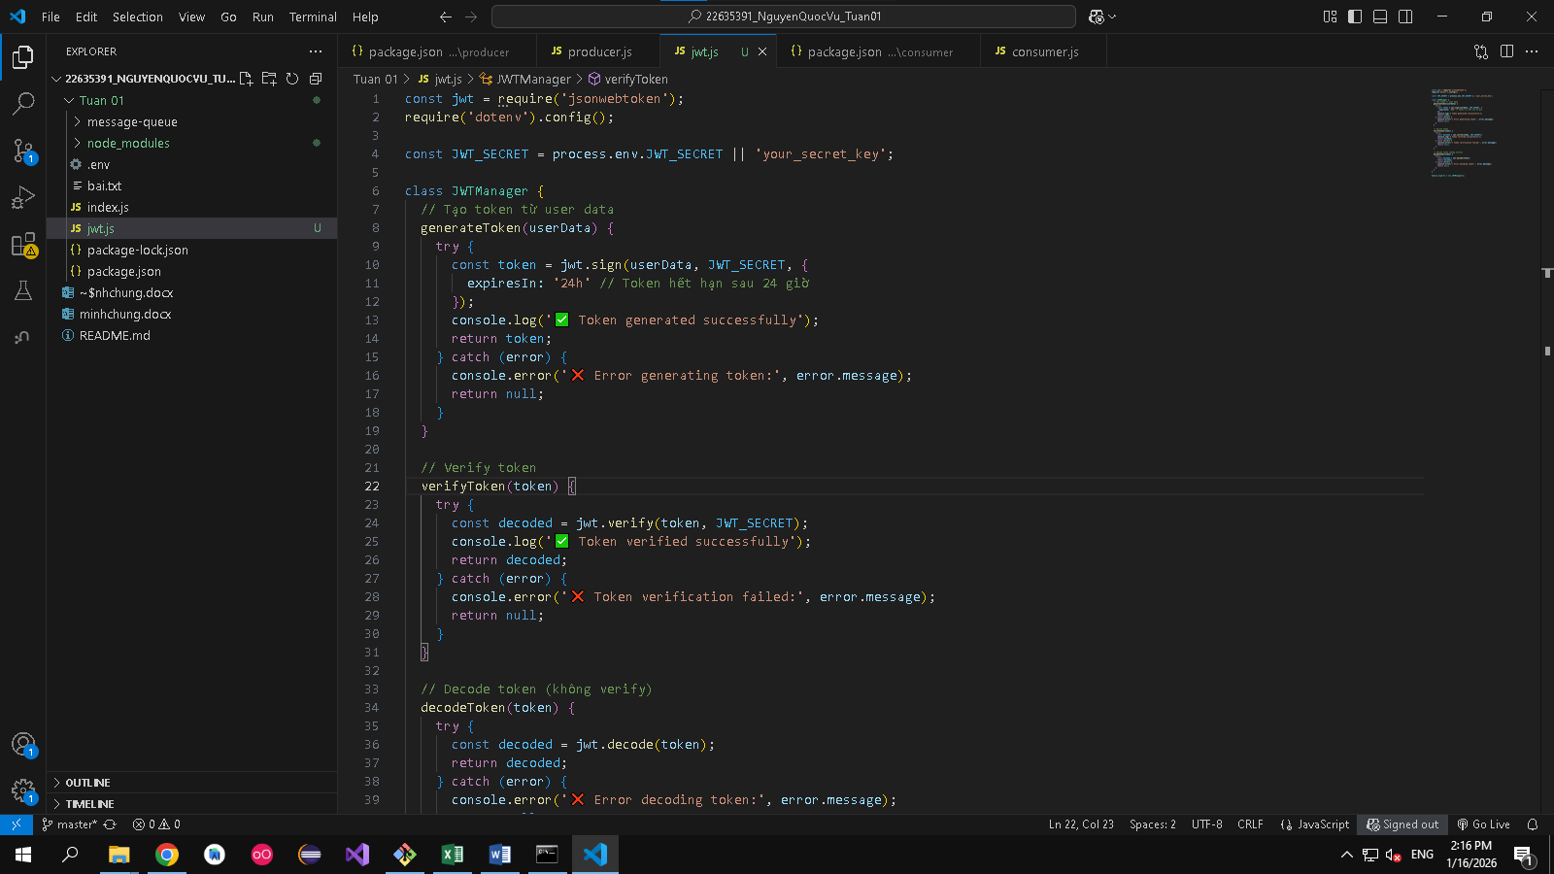
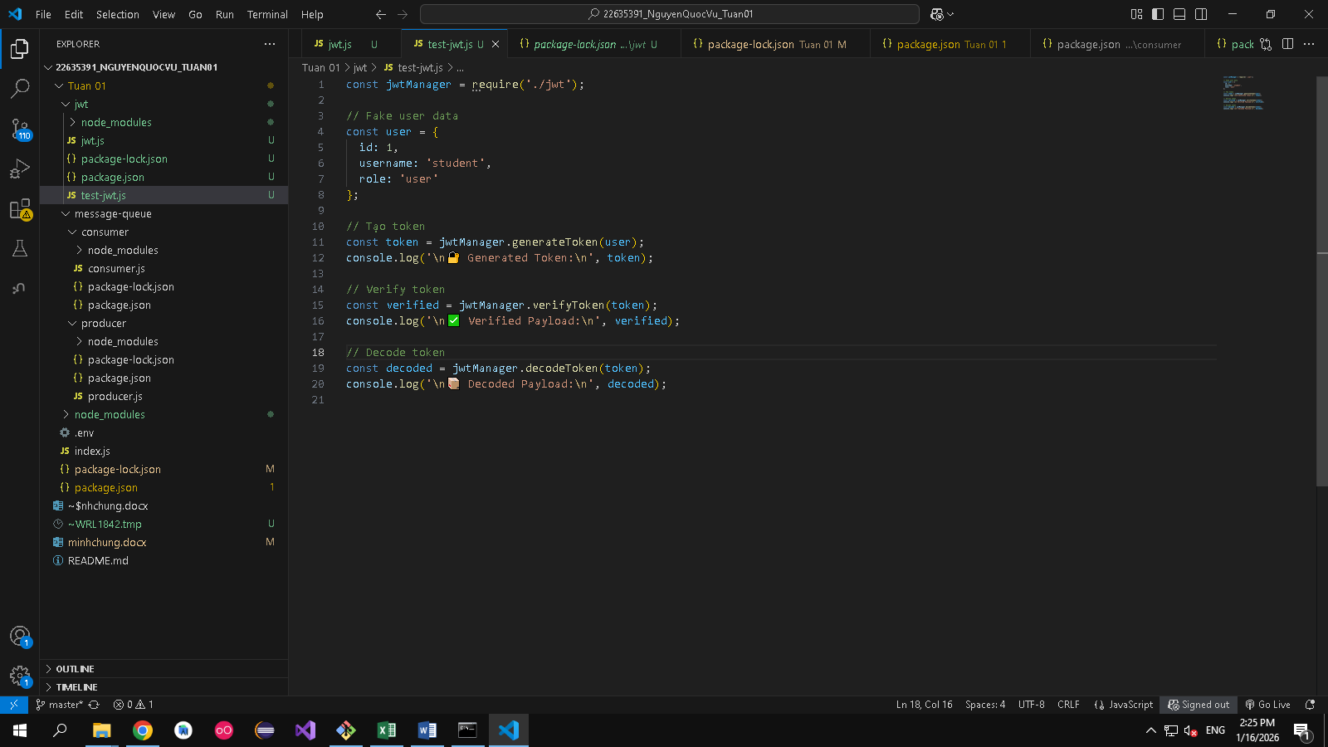
Kết quả
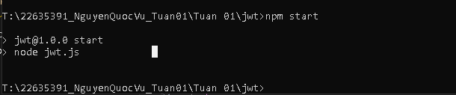
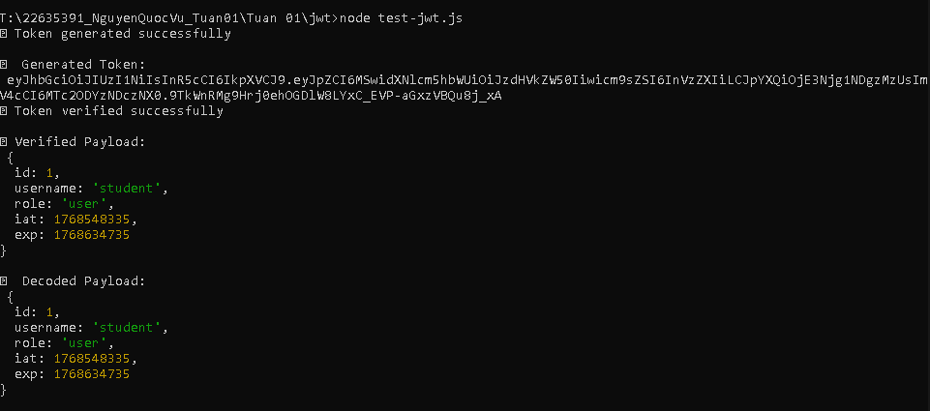

═══════════════════════════════════════════════════════════════════════════════
BUỔI 1: ARCHITECTURAL THINKING & TRADE-OFFS
Hệ thống: E-commerce Mini
Sinh viên: Nguyen QUoc Vu - 22635391
═══════════════════════════════════════════════════════════════════════════════

## PHẦN 1: XÁC ĐỊNH 10 ARCHITECTURAL CHARACTERISTICS

Sau khi phân tích hệ thống E-commerce mini (bao gồm: product catalog, shopping cart,
payment, order management, user authentication), tôi xác định các đặc tính kiến trúc:

1. **AVAILABILITY (Tính khả dụng)**
- Hệ thống phải accessible 99.5% thời gian (có downtime < 3.6 giờ/tháng)
- Khách hàng cần mua sản phẩm bất kỳ lúc nào (không thể downtime)
- Độ ưu tiên: CAO (9/10)

2. **PERFORMANCE (Hiệu năng)**
- Response time < 200ms cho product listing
- Response time < 500ms cho checkout (critical path)
- Handle concurrent users tối thiểu 1000 concurrent
- Độ ưu tiên: CAO (9/10)

3. **SCALABILITY (Tính mở rộng)**
- Có thể scale horizontally (thêm server) cho traffic peaks
- Support từ 100 lên 10,000 users/giây trong sale event
- Database có thể grow từ GB lên TB
- Độ ưu tiên: CAO (8/10)

4. **RELIABILITY (Độ tin cậy)**
- Không được mất data (transaction failure < 0.01%)
- Payment system phải 100% reliable (no double charge)
- Order data ACID compliant
- Độ ưu tiên: VÔ CÙNG CAO (10/10) ⭐

5. **SECURITY (Bảo mật)**
- Encrypt payment data (PCI DSS compliant)
- Authentication & Authorization (JWT/OAuth)
- Prevent SQL injection, XSS attacks
- GDPR compliant (data privacy)
- Độ ưu tiên: VÔ CÙNG CAO (10/10) ⭐

6. **MODIFIABILITY (Tính dễ sửa đổi)**
- Thêm feature mới (promo, loyalty program) trong 2 sprint
- Maintain và update code dễ dàng
- Low coupling, High cohesion
- Độ ưu tiên: TRUNG (7/10)

7. **ELASTICITY (Tính co giãn)**
- Auto-scale khi traffic tăng (scale up)
- Scale down khi traffic giảm (tiết kiệm cost)
- Handle traffic spike 10x trong 5 phút
- Độ ưu tiên: CAO (8/10)

8. **TESTABILITY (Tính kiểm tra được)**
- Unit test coverage > 80%
- Easy to mock dependencies
- Integration test & E2E test
- Độ ưu tiên: TRUNG (6/10)

9. **USABILITY (Tính dễ sử dụng)**
- UI/UX responsive & intuitive
- Mobile-first design
- Fast checkout flow (< 3 clicks)
- Độ ưu tiên: CAO (8/10)

10. **COST (Chi phí)**
- Infrastructure cost < 30% revenue
- Database licensing reasonable
- No unnecessary 3rd-party services
- Độ ưu tiên: TRUNG (7/10)

═══════════════════════════════════════════════════════════════════════════════

## PHẦN 2: UTILITY TREE - SẮPXẾP ƯU TIÊN ĐẶCTÍNH

📊 UTILITY TREE (Cây tiện ích):

┌─── SYSTEM GOALS
│
├─── CRITICAL (Phải có để hệ thống hoạt động)
│ ├── Reliability ⭐⭐⭐⭐⭐ (10/10)
│ │ └─ Payment ACID compliant
│ │ └─ Zero data loss
│ │ └─ Transaction consistency
│ │
│ ├── Security ⭐⭐⭐⭐⭐ (10/10)
│ │ └─ Encrypt sensitive data
│ │ └─ PCI DSS compliant
│ │ └─ No unauthorized access
│ │
│ ├── Availability ⭐⭐⭐⭐ (9/10)
│ │ └─ 99.5% uptime
│ │ └─ Failover mechanism
│ │ └─ Health check monitoring
│ │
│ └── Performance ⭐⭐⭐⭐ (9/10)
│ └─ Response < 200ms (listing)
│ └─ Response < 500ms (checkout)
│ └─ Handle 1000 concurrent users
│
├─── IMPORTANT (Quan trọng nhưng không critical)
│ ├── Scalability ⭐⭐⭐ (8/10)
│ │ └─ Horizontal scale
│ │ └─ Handle 10x traffic spike
│ │ └─ Database sharding ready
│ │
│ ├── Elasticity ⭐⭐⭐ (8/10)
│ │ └─ Auto-scale infrastructure
│ │ └─ Cost optimization
│ │ └─ Dynamic resource allocation
│ │
│ ├── Usability ⭐⭐⭐ (8/10)
│ │ └─ Mobile responsive
│ │ └─ Fast checkout
│ │ └─ Intuitive UI
│ │
│ └── Cost ⭐⭐ (7/10)
│ └─ Infrastructure cost < 30% revenue
│ └─ Optimize licensing
│ └─ Minimize 3rd-party dependencies
│
└─── NICE-TO-HAVE (Có tốt, nhưng có thể defer)
├── Modifiability ⭐⭐ (7/10)
│ └─ Easy feature addition
│ └─ Clean architecture
│ └─ Low coupling
│
└── Testability ⭐⭐ (6/10)
└─ Unit test coverage > 80%
└─ Mockable dependencies
└─ E2E tests

═══════════════════════════════════════════════════════════════════════════════

## PHẦN 3: 5 QUYẾT ĐỊNH KIẾN TRÚC VỚI TRADE-OFF ANALYSIS

───────────────────────────────────────────────────────────────────────────────
QUYẾT ĐỊNH 1: SQL vs NoSQL DATABASE
───────────────────────────────────────────────────────────────────────────────

✅ CHỌN: PostgreSQL (SQL Database)

TRADE-OFF ANALYSIS:

SQL (PostgreSQL) vs NoSQL (MongoDB)
─────────────────────────────────────────────────────────────────────────────
✅ PROS: ✅ PROS:
• ACID transactions • Horizontal scaling (sharding)
• Data consistency guaranteed • Flexible schema (document-based)
• Complex JOIN queries • High write throughput
• Foreign keys & constraints • Good for unstructured data
• Better for relational data • Better for real-time analytics

❌ CONS: ❌ CONS:
• Vertical scaling limit • Eventual consistency (risky for payment)
• Schema migration complex • No ACID by default (MongoDB 4.0+ added)
• Less flexible schema • Complex JOIN-like queries
• More storage needed (denormalization)

🎯 DECISION: PostgreSQL (SQL)

JUSTIFICATION:
1. RELIABILITY (10/10) - Hệ thống ecommerce cần ACID transactions cho payment
→ SQL đảm bảo không có double charge, lost transactions
→ NoSQL eventual consistency không chấp nhận được cho payment

2. CONSISTENCY - Order data phải absolute consistent
→ Payment, inventory, order status phải sync
→ SQL foreign keys enforce data integrity

3. COMPLEX QUERIES - Join multiple tables (orders, users, products, payments)
→ SQL optimal cho relational data
→ NoSQL require denormalization (data duplication, sync issues)

4. Cost - PostgreSQL open-source, MongoDB Enterprise $$

TRADE-OFF NHÂN ĐẮC:
❌ MẤT: Không scale horizontally as easily
✅ ĐƯỢC: ACID guarantee, data integrity, reliability

RISK & MITIGATION:
Risk: Vertical scaling limit
Mitigation: Database replication (read replicas), query optimization, cache layer (Redis)

───────────────────────────────────────────────────────────────────────────────
QUYẾT ĐỊNH 2: SYNC vs ASYNC COMMUNICATION (Product Catalog & Inventory)
───────────────────────────────────────────────────────────────────────────────

✅ CHỌN: HYBRID - Synchronous cho critical, Asynchronous cho non-critical

ARCHITECTURE:
┌─────────────────────────────────────────────────────────────────┐
│ E-COMMERCE SYSTEM │
├─────────────────────────────────────────────────────────────────┤
│ │
│ CRITICAL PATH (Sync): NON-CRITICAL (Async): │
│ 1. Add to cart → Inventory 1. Email notification │
│ 2. Checkout → Payment 2. Analytics tracking │
│ 3. Create order → Database 3. Recommendation engine │
│ 4. Inventory sync (warehouse) │
│ 5. Audit logs │
└─────────────────────────────────────────────────────────────────┘

SYNC (Synchronous) vs ASYNC (Asynchronous + Message Queue)
─────────────────────────────────────────────────────────────────────────────
✅ PROS: ✅ PROS:
• Immediate response • Decouple services
• Data consistency • Better performance (fast response)
• Simple error handling • High throughput (batch processing)
• Easier debugging • Resilient to failures
• Easy to scale consumer services

❌ CONS: ❌ CONS:
• Slow response (wait for all) • Eventual consistency
• Tight coupling • Complex error handling
• Cascading failures • Harder to debug (distributed)
• Can't handle spikes • Requires message queue (infra cost)
• Retry logic needed

🎯 DECISION: HYBRID

CRITICAL PATH (Synchronous):
├─ Add to cart → Check inventory (must be real-time)
├─ Process payment → Must succeed/fail immediately
└─ Create order → DB transaction (must complete atomically)

NON-CRITICAL (Asynchronous with RabbitMQ/Kafka):
├─ Send confirmation email → RabbitMQ message
├─ Update analytics → Message queue
├─ Notify warehouse → Async message
└─ Generate recommendation → Background job

JUSTIFICATION:
1. PERFORMANCE (9/10) - Critical path sync response < 500ms
Async for non-critical → Fast user experience

2. RELIABILITY (10/10) - Payment MUST be sync (no eventual consistency)
Async for non-critical → Decouple & improve resilience

3. SCALABILITY (8/10) - Async handles traffic spikes better
Can scale consumers independently without blocking users

TRADE-OFF NHÂN ĐẮC:
❌ MẤT: Operational complexity (need RabbitMQ), eventual consistency on non-critical
✅ ĐƯỢC: Fast response + resilient + decoupled

IMPLEMENTATION:
Message Queue: RabbitMQ
├─ Queue: "order.created" → Email service
├─ Queue: "payment.success" → Analytics service
├─ Queue: "inventory.updated" → Warehouse service
└─ Dead Letter Queue: Retry mechanism

───────────────────────────────────────────────────────────────────────────────
QUYẾT ĐỊNH 3: MONOLITHIC vs MICROSERVICES ARCHITECTURE
───────────────────────────────────────────────────────────────────────────────

✅ CHỌN: MODULAR MONOLITH (Best of both worlds)

ARCHITECTURE:
┌──────────────────────────────────────────────────────────┐
│ SINGLE DEPLOYABLE UNIT (Monolith) │
├──────────────────────────────────────────────────────────┤
│ │
│ ┌─────────────────┐ ┌──────────────────┐ │
│ │ User Service │ │ Product Service │ │
│ │ - Register │ │ - Catalog │ │
│ │ - Login │ │ - Search │ │
│ │ - Profile │ │ - Reviews │ │
│ └─────────────────┘ └──────────────────┘ │
│ │
│ ┌─────────────────┐ ┌──────────────────┐ │
│ │ Order Service │ │ Payment Service │ │
│ │ - Cart │ │ - Process │ │
│ │ - Checkout │ │ - Verify │ │
│ │ - History │ │ - Refund │ │
│ └─────────────────┘ └──────────────────┘ │
│ │
│ ┌──────────────────────────────────────────┐ │
│ │ SHARED DATABASE (PostgreSQL) │ │
│ └──────────────────────────────────────────┘ │
│ │
│ ┌──────────────────────────────────────────┐ │
│ │ MESSAGE QUEUE (RabbitMQ) - Optional │ │
│ └──────────────────────────────────────────┘ │
└──────────────────────────────────────────────────────────┘

Monolith vs Microservices
─────────────────────────────────────────────────────────────────────────────
✅ PROS: ✅ PROS:
• Simple deployment • Independent scaling
• Easy debugging • Technology flexibility
• Good performance (no network) • Team autonomy
• ACID transactions easy • Deploy without downtime
• Shared DB consistency • Easier to replace parts

❌ CONS: ❌ CONS:
• Single point of failure • Network latency
• Can't scale individual parts • Distributed transaction nightmare
• Tech stack lock-in • Operational complexity
• Long deployment cycle • Data consistency issues
• Testing is slower • Testing distributed system hard
• 3x infrastructure cost

🎯 DECISION: MODULAR MONOLITH

JUSTIFICATION:
1. SIMPLICITY - Dễ develop, deploy, maintain cho team nhỏ (Junior developer)
Không cần setup Kubernetes, service mesh, distributed tracing

2. RELIABILITY (10/10) - Single database → ACID transactions guaranteed
Avoid distributed transaction complexity (2-phase commit hell)

3. PERFORMANCE (9/10) - No network latency between services
In-process communication vs RPC calls

4. COST - Single deployment, single database, less infrastructure

5. FUTURE-PROOF - Can evolve to microservices later (modular design enables this)

TRADE-OFF NHÂN ĐẮC:
❌ MẤT: Can't scale individual services, potential bottleneck
✅ ĐƯỢC: Simple, reliable, fast, easy to maintain

MIGRATION PATH:
Phase 1 (Now): Modular Monolith
Phase 2 (6 months): Extract to Microservices if needed
Phase 3 (Scale): Full microservices architecture

───────────────────────────────────────────────────────────────────────────────
QUYẾT ĐỊNH 4: CACHING STRATEGY - Where & How
───────────────────────────────────────────────────────────────────────────────

✅ CHỌN: MULTI-LAYER CACHING STRATEGY

CACHING ARCHITECTURE:
┌────────────────────────────────────────────────────────────────┐
│ CLIENT (Browser) │
│ HTTP Cache (Expires header) │
│ Max-Age: 5 minutes (static assets) │
└────────────────────────────────────────────────────────────────┘
↓
┌────────────────────────────────────────────────────────────────┐
│ API GATEWAY / CDN │
│ Response cache (Cloudflare) │
│ Cache product listings (1 hour) │
└────────────────────────────────────────────────────────────────┘
↓
┌────────────────────────────────────────────────────────────────┐
│ APPLICATION LAYER (Node.js) │
│ Redis Cache │
│ ├─ Product cache (TTL: 1 hour) │
│ ├─ Category cache (TTL: 2 hours) │
│ ├─ User session (TTL: 24 hours) │
│ ├─ Cart (TTL: 7 days, persistent) │
│ └─ Search results (TTL: 30 minutes) │
└────────────────────────────────────────────────────────────────┘
↓
┌────────────────────────────────────────────────────────────────┐
│ DATABASE (PostgreSQL) │
│ Source of Truth │
│ Persistent Storage │
└────────────────────────────────────────────────────────────────┘

CACHE INVALIDATION STRATEGY:
1. TTL-based (Time-To-Live) - Auto expire after time
└─ For product listing, category

2. Event-based - Invalidate on change
└─ When product updated → Clear cache
└─ When inventory changed → Clear product cache
└─ When user profile changed → Clear user cache

3. Lazy Loading - Invalidate when accessed
└─ Check DB, if changed → Update cache

Cache-Aside Pattern (Most Common):
┌──────────────────────────────────────────┐
│ Request for product ID 123 │
├──────────────────────────────────────────┤
│ 1. Check Redis cache │
│ ├─ FOUND? → Return cached data (FAST)│
│ └─ NOT FOUND? → Go to DB │
│ 2. Query PostgreSQL │
│ 3. Update Redis cache (TTL: 1 hour) │
│ 4. Return to client │
└──────────────────────────────────────────┘

WITH CACHING vs WITHOUT CACHING
─────────────────────────────────────────────────────────────────────────────
✅ PROS: ✅ PROS:
• Fast response (< 50ms) • Simple (no cache layer)
• Reduce DB load • Always fresh data
• Handle more users • No cache invalidation issues
• Better UX • Less infrastructure

❌ CONS: ❌ CONS:
• Stale data risk • Slow response (> 200ms)
• Cache invalidation • DB bottleneck
• Complexity • Can't handle traffic spikes
• Extra infrastructure • Poor UX

🎯 DECISION: MULTI-LAYER CACHING

JUSTIFICATION:
1. PERFORMANCE (9/10) - Product listing response < 50ms (from Redis)
Without cache → 200ms (DB query) → fails requirement

2. SCALABILITY (8/10) - Handle 1000 concurrent users
Cache reduce DB load by 80-90%

3. COST - Less DB connections needed = less expensive

4. AVAILABILITY (9/10) - If DB slow, cache serve stale data
Better than timing out

TRADE-OFF NHÂN ĐẮC:
❌ MẤT: Stale data (products might be wrong for 1 hour), cache invalidation complexity
✅ ĐƯỢC: Fast response, scalable, handle spikes

CACHE INVALIDATION STRATEGY:
When product updated:
├─ DELETE cache key "product:123"
├─ DELETE cache key "category:electronics" (if related)
├─ Publish "product.updated" event to message queue
└─ Invalidate CDN cache

───────────────────────────────────────────────────────────────────────────────
QUYẾT ĐỊNH 5: PAYMENT PROCESSING - 3RD PARTY vs IN-HOUSE
───────────────────────────────────────────────────────────────────────────────

✅ CHỌN: 3RD PARTY PAYMENT GATEWAY (Stripe/PayPal)

ARCHITECTURE:

┌────────────────────────────────────────────────────────────┐
│ PAYMENT FLOW (3RD PARTY) │
├────────────────────────────────────────────────────────────┤
│ │
│ 1. User fills card info │
│ 2. Call Stripe API (never see card details) │
│ 3. Stripe processes payment │
│ 4. Stripe webhook callback to our server │
│ 5. Our server updates order status │
│ 6. User redirected to success page │
│ │
│ ✅ PCI DSS compliance handled by Stripe │
│ ✅ Encryption & security included │
│ ✅ 99.99% uptime SLA │
│ ✅ Fraud detection built-in │
│ │
└────────────────────────────────────────────────────────────┘

3RD PARTY (Stripe) vs IN-HOUSE PAYMENT SYSTEM
─────────────────────────────────────────────────────────────────────────────
✅ PROS: ✅ PROS:
• PCI DSS compliance • Full control
• 99.99% uptime • No 3rd party dependency
• Fraud detection • Custom logic
• Multiple payment methods • Save on payment fees
• Tokenization • No integration complexity
• Webhook handling • Direct data access
• 24/7 support

❌ CONS: ❌ CONS:
• 2.9% + $0.30 per txn fee • PCI DSS cert required ($$, complex)
• Dependency on 3rd party • Security responsibility (high risk)
• API rate limits • Maintain & update constantly
• Less control • Fraud detection needed
• Build redundancy (failover)
• 24/7 monitoring required
• Hire security experts ($$$)

🎯 DECISION: 3RD PARTY PAYMENT GATEWAY (Stripe)

JUSTIFICATION:
1. SECURITY (10/10) - Payment processing is HIGH RISK
❌ In-house = PCI DSS violation = $5000-$100,000 fine per incident
✅ Stripe = PCI DSS compliant, handles all security

2. RELIABILITY (10/10) - Stripe SLA: 99.99% uptime
❌ In-house = Single point of failure = lost revenue
✅ Stripe = Global redundancy, automatic failover

3. COST - Stripe 2.9% fee vs hiring 1 security engineer ($100K/year)
Payment fees = $290 per $10K transactions
Security engineer = $100K/year for 1 person
Cost-benefit: Pay fees is cheaper

4. TIME-TO-MARKET - Can integrate Stripe in 1 day
In-house payment system = 3 months development + security audit

5. COMPLIANCE - Stripe handles PCI DSS, GDPR, etc.

TRADE-OFF NHÂN ĐẮC:
❌ MẤT: 2.9% transaction fee, dependency on Stripe, less control
✅ ĐƯỢC: Security, compliance, reliability, fast time-to-market

IMPLEMENTATION:
┌─────────────────────────────────────────────────────────┐
│ Stripe Integration │
├─────────────────────────────────────────────────────────┤
│ 1. Client → Stripe (card info) │
│ 2. Stripe → Payment intent │
│ 3. Confirm payment │
│ 4. Stripe → Webhook │
│ 5. Update DB order status │
│ 6. Send confirmation email │
└─────────────────────────────────────────────────────────┘

Fallback: If Stripe down (rare):
├─ Store pending orders in queue
├─ Retry every 5 minutes
├─ Notify admin
└─ Manual processing if needed

═══════════════════════════════════════════════════════════════════════════════

## PHẦN 4: ARCHITECTURAL DECISION RECORD (ADR)

ADR là document ghi lại các quyết định kiến trúc, why, trade-offs.

### ADR-1: Database Selection (SQL vs NoSQL)

Title: Use PostgreSQL as Primary Database

Status: ACCEPTED

Context:
E-commerce systems require strong consistency, especially for payment processing.
We evaluated SQL (PostgreSQL) and NoSQL (MongoDB).

Decision:
Use PostgreSQL as primary database.

Rationale:
1. ACID transactions guarantee payment consistency
2. Foreign keys ensure data integrity
3. Complex queries across multiple entities
4. Simpler to maintain than NoSQL for relational data
5. Open-source (no licensing cost)

Consequences:
✅ Guaranteed ACID consistency
✅ Strong data integrity
❌ Limited horizontal scaling (need read replicas)
❌ Vertical scaling limit

Alternatives Considered:
- MongoDB: Considered, rejected due to eventual consistency risk for payments

Migration Path:
- Phase 1: PostgreSQL monolith
- Phase 2: Add read replicas if needed
- Phase 3: Database sharding for large scale

---

### ADR-2: Synchronous vs Asynchronous Communication

Title: Use Hybrid Approach (Sync for Critical, Async for Non-Critical)

Status: ACCEPTED

Context:
High-volume ecommerce system needs both speed and reliability.
Critical operations (payment, orders) need immediate response.
Non-critical operations (email, analytics) can be asynchronous.

Decision:
- Synchronous: Add-to-cart, Checkout, Payment, Create Order
- Asynchronous: Email notifications, Analytics, Recommendations

Rationale:
1. Critical path must be sync (ACID guarantee)
2. Non-critical can be async (improve performance)
3. Decouple services reduces cascading failures
4. Handle traffic spikes better with async
5. Better user experience (faster response)

Consequences:
✅ Fast response time (< 200ms)
✅ High throughput for non-critical
✅ Better resilience (decouple services)
❌ Eventual consistency on non-critical
❌ Need message queue infrastructure
❌ Harder to debug distributed issues

Implementation:
- Message Queue: RabbitMQ
- Dead Letter Queue: Retry 3x then alert

---

### ADR-3: Monolithic vs Microservices

Title: Use Modular Monolith Architecture

Status: ACCEPTED

Context:
Small team (5 developers), need fast development cycle.
Microservices add operational complexity (Docker, Kubernetes, etc.).
Modular monolith allows future migration to microservices.

Decision:
Deploy as single monolithic application with modular service structure.

Rationale:
1. Simple deployment (1 container, 1 database)
2. Easy ACID transactions (single DB)
3. No network latency between services
4. Easier debugging (single process)
5. Can migrate to microservices later if needed
6. Good for team size and maturity

Consequences:
✅ Simple deployment and operations
✅ ACID transactions guaranteed
✅ Good performance (no RPC)
❌ Can't scale individual services
❌ Tech stack lock-in
❌ May hit limits at extreme scale

Migration Path:
- Phase 1: Modular Monolith (now)
- Phase 2: Extract Payment Service (high value, isolated)
- Phase 3: Extract Order Service
- Phase 4: Full microservices (if needed)

---

### ADR-4: Caching Strategy

Title: Implement Multi-Layer Caching

Status: ACCEPTED

Context:
Database query performance is bottleneck for product listing (200ms vs 50ms target).
Need to handle 1000 concurrent users.

Decision:
Implement 3-layer caching:
1. Browser cache (HTTP headers)
2. Redis cache (in-memory)
3. Database (source of truth)

Rationale:
1. Dramatically improve response time
2. Reduce database load (80-90%)
3. Handle more concurrent users
4. Cost-effective (one Redis instance)
5. Standard industry practice

Consequences:
✅ Response time < 50ms (from cache)
✅ Handle 10x more users
✅ Lower infrastructure cost
❌ Data might be stale (1 hour old)
❌ Cache invalidation complexity
❌ Need to understand TTL & invalidation

Cache Invalidation:
- TTL: Auto-expire (1 hour for products)
- Event-based: Clear on product update
- Manual: Cache.delete() when needed

---

### ADR-5: Payment Processing

Title: Use Stripe as Payment Gateway (3rd Party)

Status: ACCEPTED

Context:
Payment processing is high-risk (security, compliance, reliability).
Options: Build in-house vs use Stripe/PayPal.

Decision:
Use Stripe as primary payment gateway.

Rationale:
1. PCI DSS compliance handled by Stripe
2. 99.99% uptime SLA
3. Fraud detection built-in
4. Security expertise expensive (in-house)
5. Fast integration (1 day vs 3 months)
6. Multiple payment methods (card, Apple Pay, etc.)

Consequences:
✅ Security & compliance guaranteed
✅ High reliability (99.99% uptime)
✅ Fast time-to-market
❌ 2.9% + $0.30 transaction fee
❌ Dependency on 3rd party
❌ Less control over payment flow

Cost Analysis:
- Stripe fee: 2.9% on $100K revenue = $2,900/month
- Security engineer salary: $100K/year = $8,333/month
- Result: Stripe is cheaper, more secure

Fallback:
- If Stripe unavailable (rare): Queue orders, retry every 5 minutes
- Manual processing for critical orders

═══════════════════════════════════════════════════════════════════════════════

## PHẦN 5: TỔNG KẾT TRADE-OFFS

1. SQL vs NoSQL:
❌ Lost: Horizontal scaling ✅ Gained: ACID guarantee, strong consistency

2. Sync vs Async:
❌ Lost: Simplicity ✅ Gained: Performance, scalability, resilience

3. Monolith vs Microservices:
❌ Lost: Service independence ✅ Gained: Simplicity, performance, reliability

4. With vs Without Caching:
❌ Lost: Data freshness ✅ Gained: 10x faster response, scalability

5. 3rd Party vs In-House Payment:
❌ Lost: 2.9% fee ✅ Gained: Security, compliance, reliability

═══════════════════════════════════════════════════════════════════════════════

ARCHITECTURAL THINKING KEY POINTS:

1. "Best Practice" không tồn tại → Chỉ có "Best for this context"
2. Mỗi quyết định có trade-off
3. Phải hiểu cái mình nhân đắc và cái mình mất
4. Trade-off dựa trên business goals & constraints
5. Document lại quyết định (ADR) cho team sau hiểu

DECISION MAKING FRAMEWORK:

Step 1: Xác định priorities (reliability > performance > scalability)
Step 2: List options (SQL/NoSQL, Sync/Async, etc)
Step 3: Analyze trade-off từng option
Step 4: Choose dựa trên priorities
Step 5: Document trong ADR
Step 6: Review & iterate khi context thay đổi

═══════════════════════════════════════════════════════════════════════════════

