
CAPELLA TRAVEL · PRIVATE LUXURY QUOTATION
Anisha's Family Trip
Bespoke Northern Vietnam Exploration
8 Days 7 Nights | 30 Sep – 07 Oct 2026 | 5 Adults | Ref: QT-2026-CAPELLA-8D7N-IND

A Personal Note for Your Journey
Dear Anisha,
A premium, personalized 8-day private journey crafted by Capella Travel for our guests. The itinerary showcases the historic soul of Hanoi, the mystical rivers of Ninh Binh, an overnight cruise through the magical waters of Ha Long Bay, and the breathtaking terraced mountains of Sapa. Every detail, from the double and triple room configurations to the carefully curated vegetarian culinary experiences, has been designed for your group of 5 adults to travel in ultimate comfort.
We have poured our expertise and passion into crafting every detail of this journey, and we cannot wait for you to experience the magic of Vietnam. Please review the itinerary below, and let us know if you would like any refinements.
Warm regards,
Eddie (Pham Trung Hieu) — Lead Travel Designer
Capella Travel | Phone: +84 911 538 738 | Email: sales@capellatravel.com

Trip at a Glance
Duration & Dates | 8 Days / 7 Nights (30 Sep 2026 – 07 Oct 2026)
Curated Route | Sapa – Hanoi – Ninh Binh – Halong Bay – Hanoi
Travel Party | 5 Adults (1 Double Room + 1 Triple Room) · Indian Market
Accommodation Tier | Premium 4★ Luxury Mountain & City Boutique Hotels + 5★ Luxury Halong Cruise
Dietary Preference | Indian Vegetarian (Lacto-Ovo: Eggs allowed, strictly no meat, fish, or seafood)
Travel Style | 100% Private luxury vehicle, dedicated English guide, 2 private 4-berth sleeper train cabins

Behind the Itinerary Curation
Private & Flexible Pacing
Travel in complete exclusivity with your private air-conditioned vehicle and dedicated English-speaking guide. Daily pacing is highly flexible, ensuring your group can explore Sapa, Hanoi, Ninh Binh, and Halong Bay comfortably at your own speed.

Carefully Curated Accommodations & Transport
Enjoy premium accommodations including Sapa Jade Hill, Hanoi Le Jardin Hotel & Spa, and Ambassador Signature Cruise. For the overnight train back to Hanoi, we have pre-arranged 2 private 4-berth cabins on the Chapa Express Train to guarantee absolute privacy and space for your 5 guests.

Dedicated Indian Vegetarian Dietary Care
Your dietary requirements are fully respected. All included meals feature carefully curated Indian vegetarian selections (eggs permitted, strictly no meat/seafood). Restaurants and cruise chefs are briefed to prevent cross-contamination.

Balanced Highlights of Northern Vietnam
A perfect harmony of highland exploration in Sapa, historic culture in Hanoi, scenic rivers in Ninh Binh, and a luxury overnight cruise in Halong Bay, offering a complete northern Vietnam experience in 8 days.

Day-by-Day Journey Program
DAY 1 (2026-09-30) — Sapa
Arrive at Noi Bai International Airport in Hanoi. After a warm welcome and breakfast, board your private luxury vehicle for a scenic drive to the mountainous region of Sapa (approx. 5-6 hours). Arrive at Sapa Jade Hill and check in. Enjoy a relaxed evening and a gourmet Indian vegetarian welcome dinner.  Meals: Breakfast & Indian Vegetarian Welcome Dinner  Overnight: Sapa  Included Services: VIP Airport Fast-track, private airport transfer to Sapa, Indian vegetarian welcome dinner. | 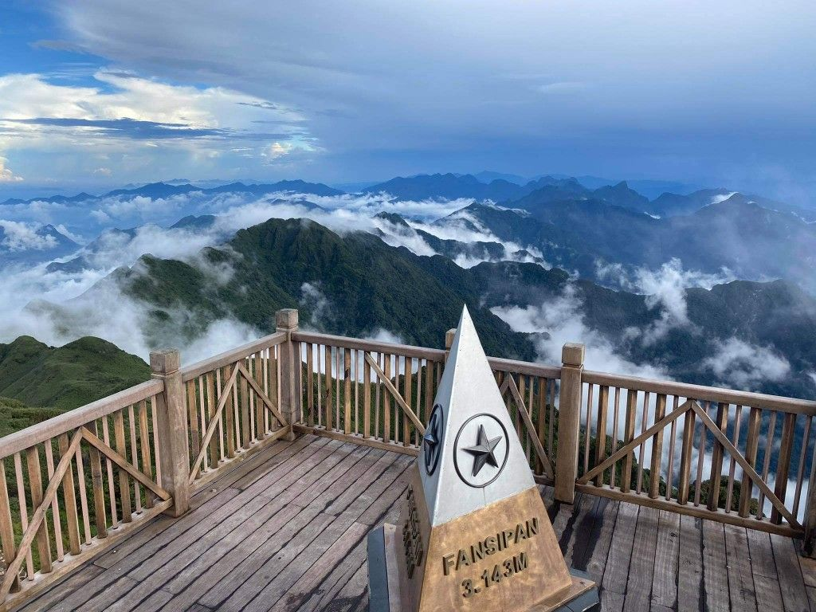

DAY 2 (2026-10-01) — Sapa
Embark on a guided trekking tour to Cat Cat village, learning about the Black Hmong culture and viewing the scenic waterfall. Savor a local vegetarian lunch. Spend a relaxed afternoon exploring Sapa town or enjoying the resort's facilities. Overnight at Sapa Jade Hill.  Meals: Breakfast & Vegetarian Lunch  Overnight: Sapa  Included Services: Sapa tour with guide and entry tickets, vegetarian lunch. | 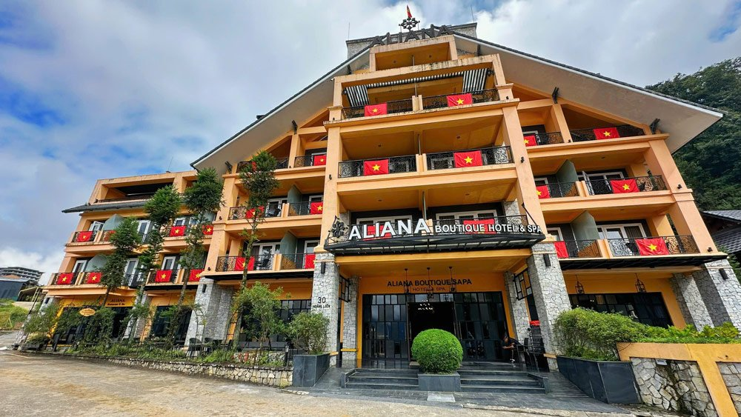

DAY 3 (2026-10-02) — Sapa
A highlights day in Sapa! Take the Fansipan cable car, the longest three-rope cable car system in the world, to ascend the 'Roof of Indochina' at 3,143 meters. Explore the spiritual pagoda complex at the summit. Enjoy a scenic vegetarian lunch. In the afternoon, visit Ta Van village. Overnight at Sapa Jade Hill.  Meals: Breakfast & Vegetarian Lunch  Overnight: Sapa  Included Services: Fansipan cable car roundtrip tickets, guide, Sapa transfers, vegetarian lunch. | 

DAY 4 (2026-10-03) — Hanoi
Enjoy a free day to relax at Sapa Jade Hill, shop for souvenirs in Sapa town, or explore at your own pace. In the late afternoon, transfer to Lao Cai station. Board the Chapa Express Train for your overnight journey back to Hanoi in pre-arranged private 4-berth cabins.  Meals: Breakfast  Overnight: Hanoi  Included Services: Station transfer, Chapa Express Train tickets. | 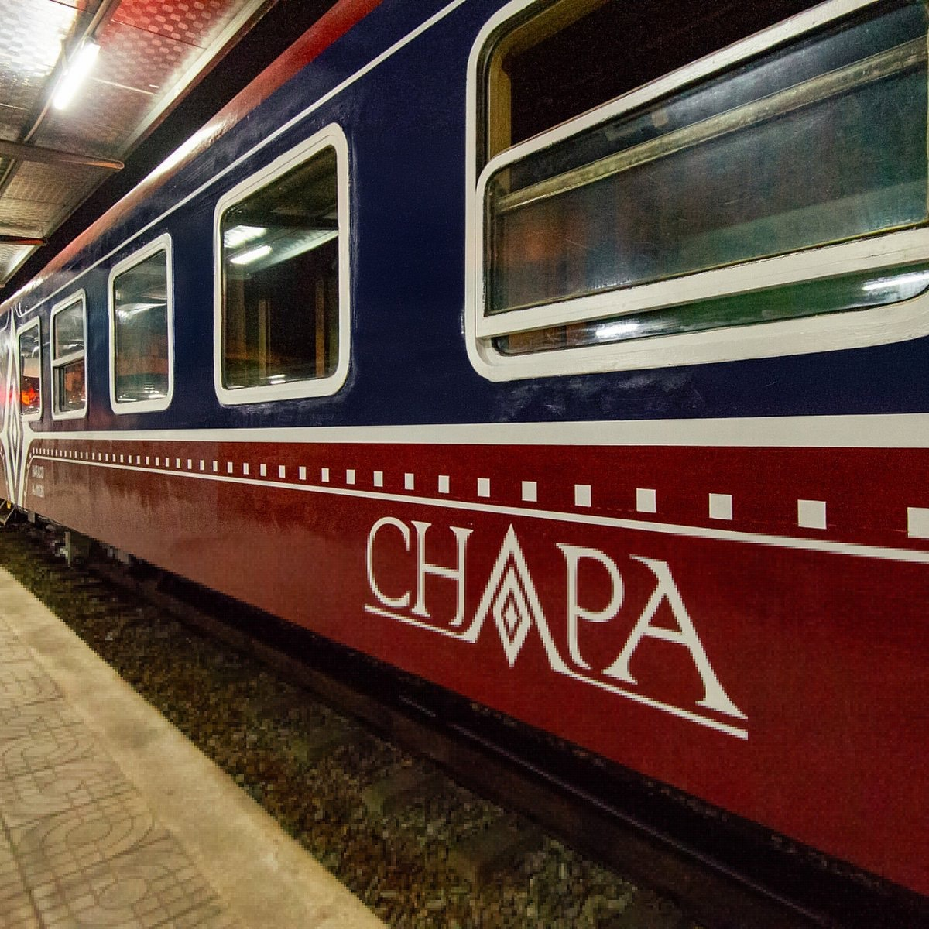

DAY 5 (2026-10-04) — Hanoi
Arrive at Hanoi station early in the morning and transfer to Hanoi Le Jardin Hotel & Spa for a hot breakfast and early check-in (subject to availability). Enjoy a full-day city tour of Hanoi, visiting the historic Temple of Literature, Ho Chi Minh Mausoleum complex, and Hoan Kiem Lake. Savor a vegetarian dinner in the Old Quarter.  Meals: Breakfast, Vegetarian Lunch & Dinner  Overnight: Hanoi  Included Services: Station transfer, Hanoi full-day tour with guide and entry tickets, vegetarian lunch & dinner. | 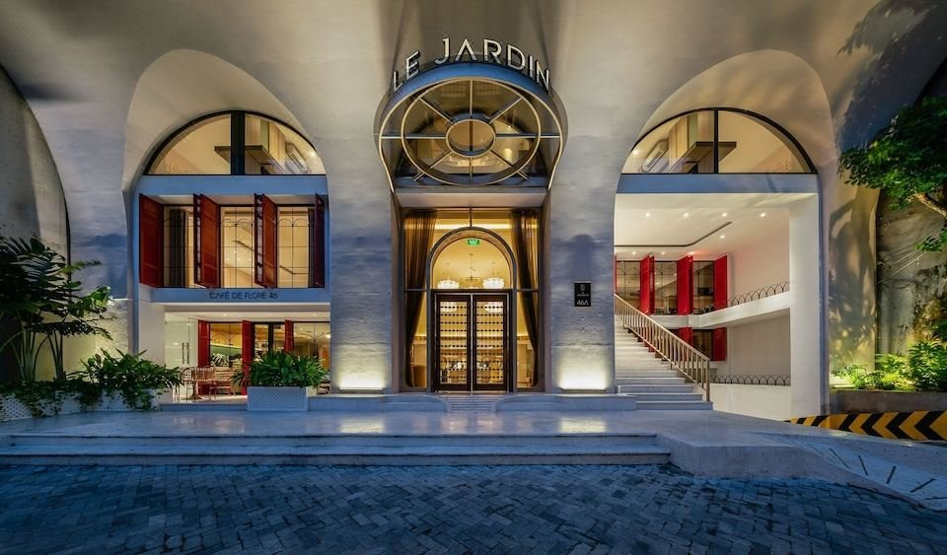

DAY 6 (2026-10-05) — Ninh Binh
Embark on a full-day private excursion to Ninh Binh. Experience the serene beauty of Trang An landscape complex, a UNESCO World Heritage site, during a traditional rowboat tour through limestone caves. Visit the ancient capital of Hoa Lu and climb to the peak of Mua Cave for panoramic views over the rice fields. Return to Hanoi in the late...  Meals: Breakfast & Indian Vegetarian Lunch  Overnight: Ninh Binh  Included Services: Private roundtrip vehicle to Ninh Binh, English guide, Trang An boat tour, Mua Cave entry, vegetarian lunch. | 

DAY 7 (2026-10-06) — Halong Bay
Depart Hanoi by private vehicle to Halong Bay. Board the premium Ambassador Signature Cruise, where your Double and Triple cabins await. Glide past iconic karst formations and enjoy a delicious vegetarian buffet lunch on board. Participate in cruise activities including a bamboo boat ride or kayaking.  Meals: Breakfast, Onboard Vegetarian Lunch & Dinner  Overnight: Halong Bay  Included Services: Private transfer Hanoi - Halong, double & triple cabins on Ambassador Signature Cruise, cruise excursions, onboard vegetarian lunch and... | 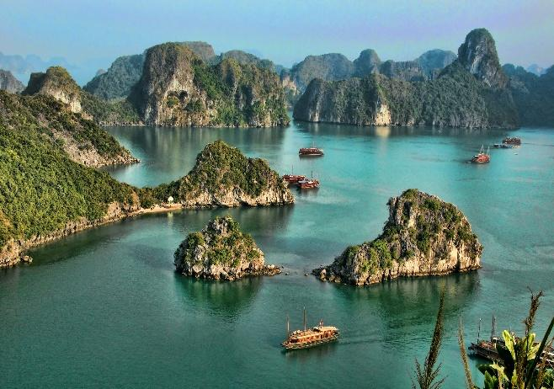

DAY 8 (2026-10-07) — Hanoi
Greet the sunrise with Tai Chi on the sundeck. After a vegetarian brunch, check out and disembark. Transfer back to Noi Bai International Airport by private luxury vehicle for your international departure flight.  Meals: Onboard Vegetarian Brunch  Overnight: Hanoi  Included Services: Onboard vegetarian brunch, private transfer Halong - Hanoi Airport. | 

Selected Luxury Hotel & Overnight Plan
SAPA, VIETNAM · 30 Sep – 03 Oct 2026  Sapa Jade Hill Resort & Spa  Located in the scenic mist-covered hills of Sapa, Sapa Jade Hill Resort & Spa features stunning panoramic views of Fansipan mountain and Muong Hoa valley. Designed with local heritage details, the hotel offers comfortable heated bungalows, an outdoor pool, and local gourmet dining.  Phone: +84 214 381 3888 | 

SAPA, VIETNAM · 03 Oct – 04 Oct 2026  Chapa Express Train  Chapa Express Train offers premium overnight sleeper service between Hanoi and Lao Cai (Sapa). Featuring traditional wooden panels, comfortable air-conditioned cabins, clean amenities, and personalized passenger hospitality.  Phone: +84 24 3999 6868 | 

HANOI, VIETNAM · 04 Oct – 06 Oct 2026  Hanoi Le Jardin Hotel & Spa  Nestled in the historic Ba Dinh district, Hanoi Le Jardin Hotel & Spa blends French colonial charm with modern hospitality. It offers elegant rooms, a rooftop bar with spectacular city views, and a serene spa for a perfect urban retreat.  Phone: +84 24 3927 5888 | 

HALONG BAY, VIETNAM · 06 Oct – 07 Oct 2026  Ambassador Signature Cruise  A premier 5-star overnight cruise sailing through the mystical waters of Halong Bay and Lan Ha Bay. The cruise features elegant cabins with private balconies, upscale dining, an outdoor jacuzzi, and immersive itineraries showcasing natural wonders.  Phone: +84 90 175 8888 | 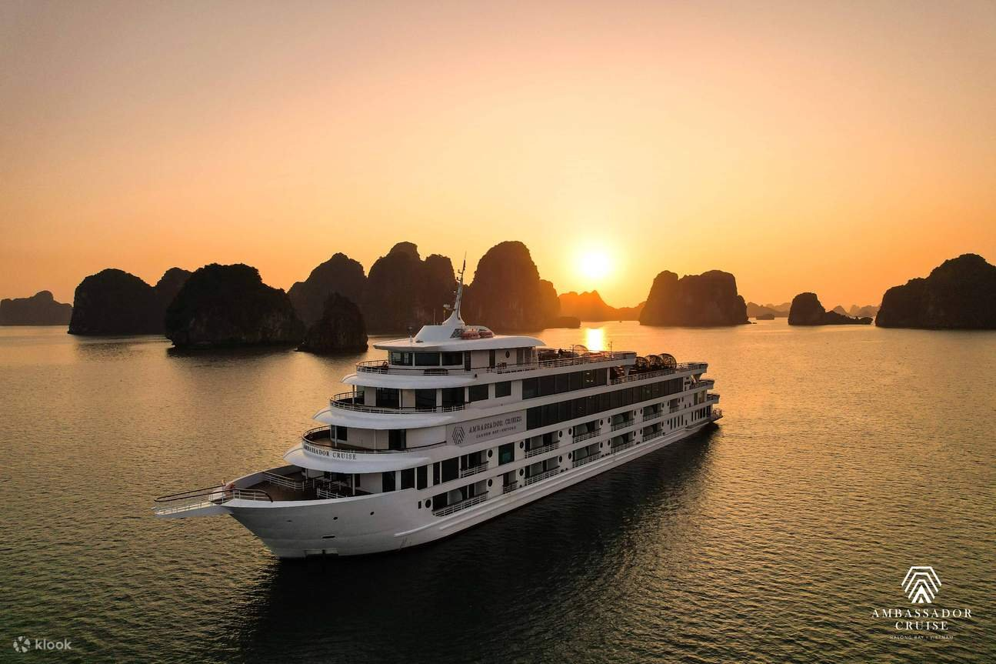

Journey Investment
Package Category | Per Person (USD) | Total Package (USD)
Premium Accommodations & Cruise (5 Adults)  Twin/Double/Triple sharing basis (1 Double Room + 1 Triple Room) | $1,250 | $6,250
* Rates are B2B net indicative and subject to reconfirmation at the time of deposit receipt.
What Your Journey Includes
Included in Your Package | Not Included
✓ VIP Airport Fast-track, private airport transfer to Sapa, Indian vegetarian welcome dinner.  ✓ Sapa tour with guide and entry tickets, vegetarian lunch.  ✓ Fansipan cable car roundtrip tickets, guide, Sapa transfers, vegetarian lunch.  ✓ Station transfer, Chapa Express Train tickets.  ✓ Station transfer, Hanoi full-day tour with guide and entry tickets, vegetarian lunch & dinner.  ✓ Private roundtrip vehicle to Ninh Binh, English guide, Trang An boat tour, Mua Cave entry, vegetarian lunch.  ✓ Private transfer Hanoi - Halong, double & triple cabins on Ambassador Signature Cruise, cruise excursions, onboard...  ✓ Onboard vegetarian brunch, private transfer Halong - Hanoi Airport. | — International flights  — Visa fees and travel documentation  — Travel insurance  — Personal expenses  — Optional experiences not specified in the itinerary  — Tips and gratuities  — Any services not expressly listed as included

Booking & Payment Terms
Deposit | A 30% deposit is required at the time of booking to secure hotels, cruise, and train cabins.
Balance Payment | The remaining 70% balance is due 30 days prior to arrival in Vietnam.
Cancellation Policy | Free cancellation up to 45 days prior to departure. 50% cancellation fee applies between 44 and 15 days.
Confirmation | Subject to room availability. Final confirmations will be sent within 24 hours of deposit receipt.
Thank you for choosing Capella Travel · Crafted with passion for Anisha's Family

