Update bundle (auto update when change file)

Install-Package Microsoft.AspNet.Web.Optimization

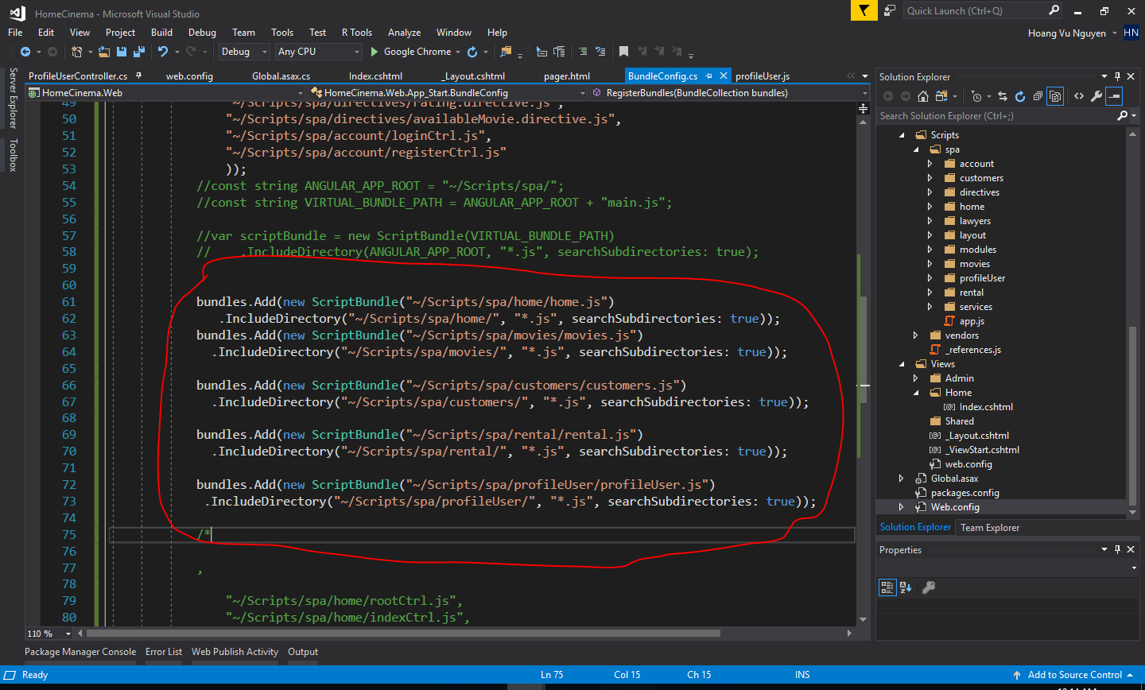

Add more Table data base (ProfileUser)

1. Add script database (ProfileUser)

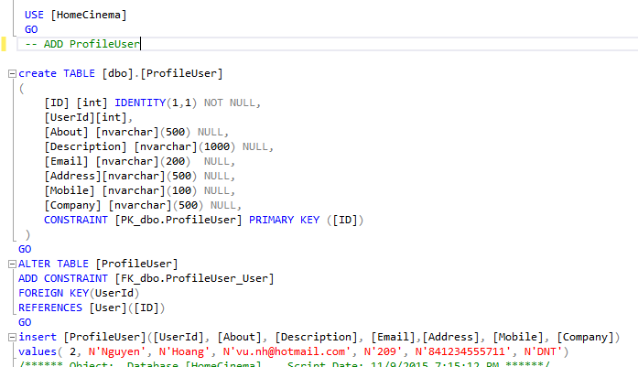

1. Add function in Entity

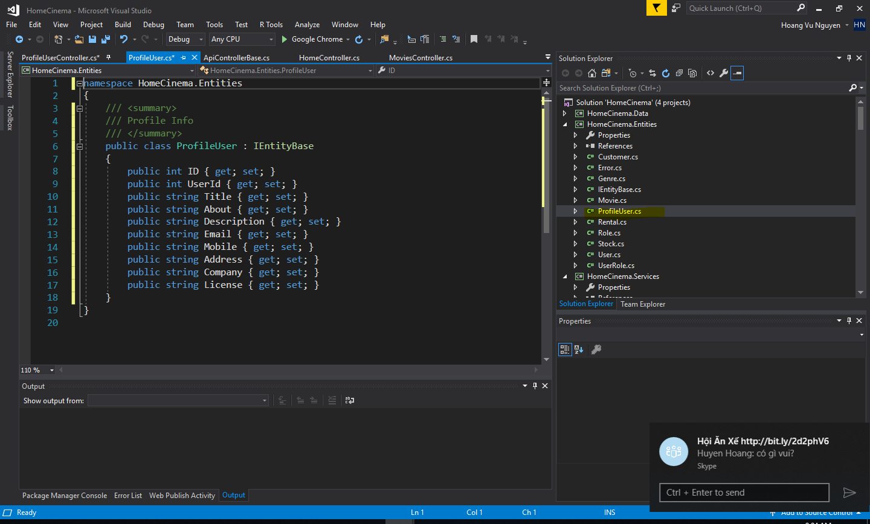

1. Add function in Data

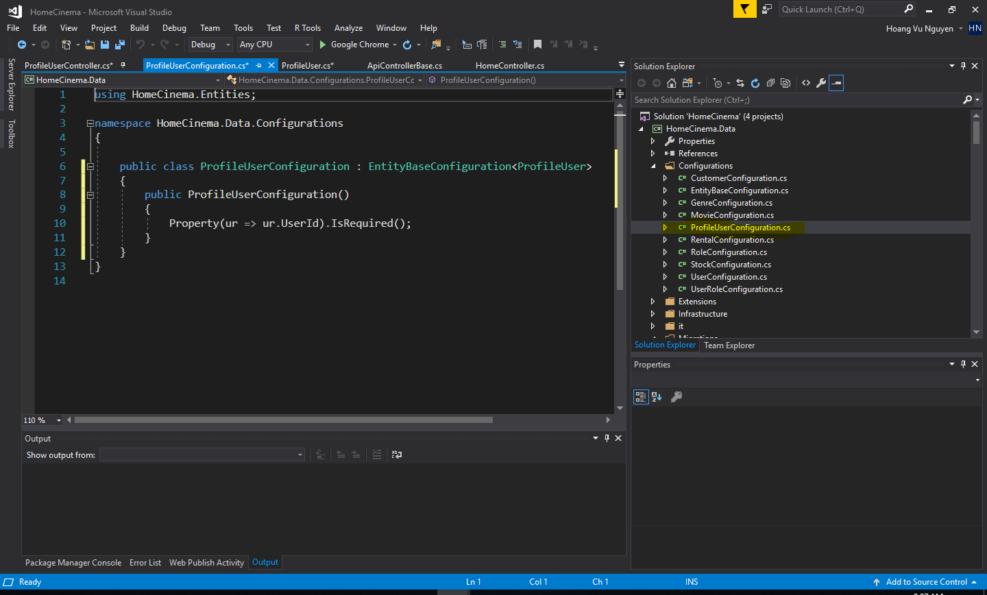

1. Context

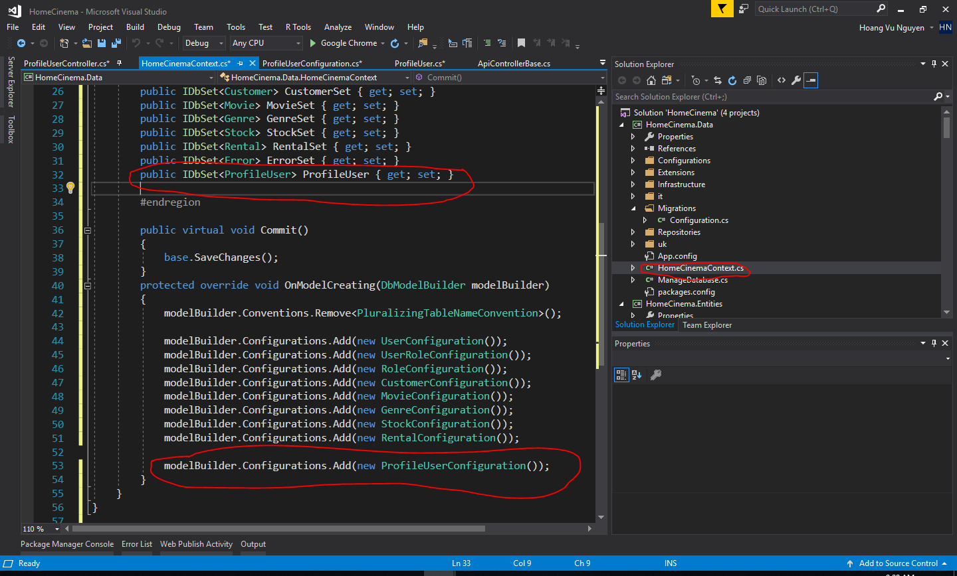

1. Api

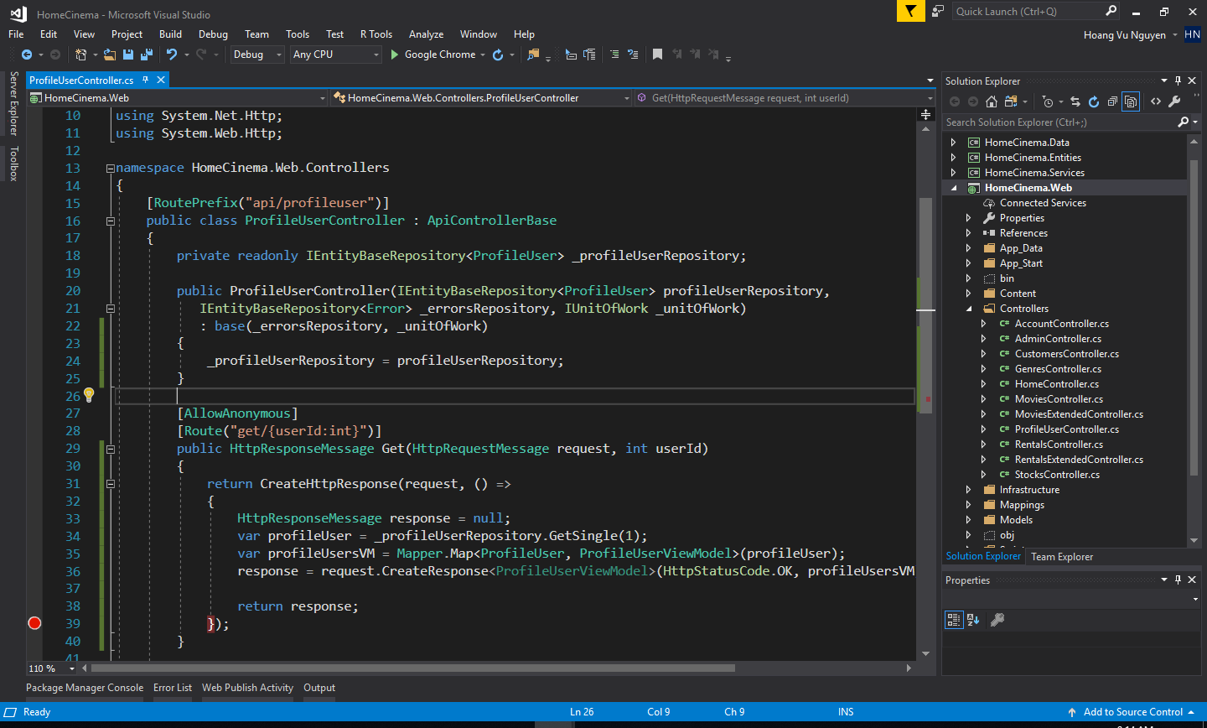

1. App

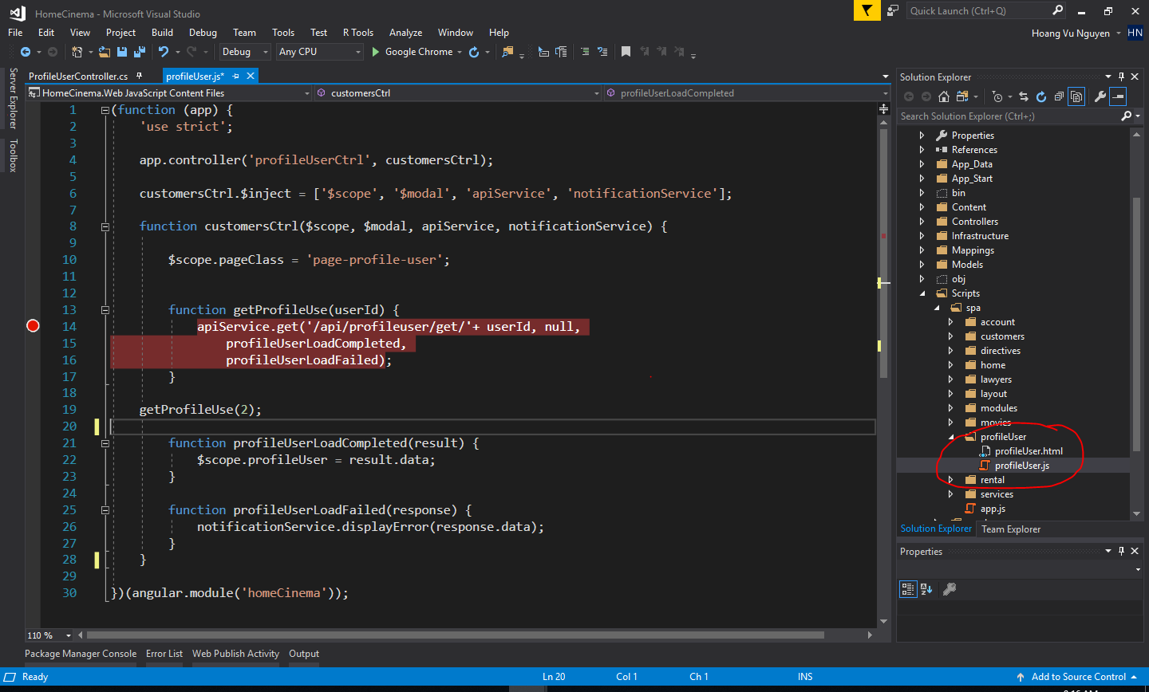

1. Bundle

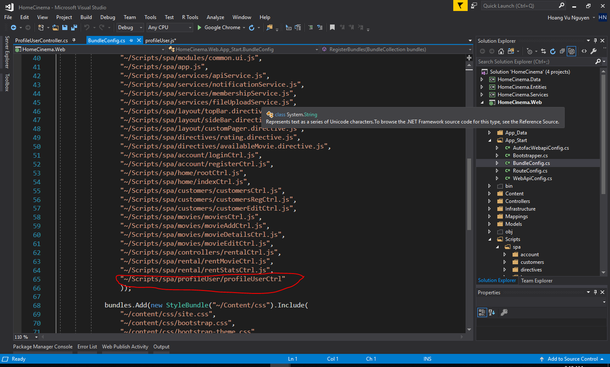

* Note Error (javascript == with ===)

1. Create start database

<add key="ENABLE_CREATE_DATA" value="true" />