TRƯỜNG ĐẠI HỌC **SƯ PHẠM KỸ THUẬT THÀNH PHỐ HỒ CHÍ MINH**

HCMC University of Technology and Education

**KHOA ĐÀO TẠO CHẤT LƯỢNG CAO**

NGÀNH CÔNG NGHỆ THÔNG TIN



**­BÁO CÁO ĐỒ ÁN :** Manage Readable Document

Member’s group:

1/ Đặng Thị Kim Ngân 18110032

2/ Nguyễn Hoàng Vũ 18110398

Lecture: TS. Huỳnh Xuân Phụng

**TP. HỒ CHÍ MINH, THÁNG**

SCORE

|  |  |  |  |
| --- | --- | --- | --- |
| CRITERIA | CONTENT | PRESENT | TOTAL |
| SCORE |  |  |  |

ASSESSMENT OF THE TEACHERS:

……………………………………………………………………………………………………………………………...

……………………………………………………………………………………………………………………………...

……………………………………………………………………………………………………………………………...

……………………………………………………………………………………………………………………………...

……………………………………………………………………………………………………………………………...

……………………………………………………………………………………………………………………………...

……………………………………………………………………………………………………………………………...

……………………………………………………………………………………………………………………………...

……………………………………………………………………………………………………………………………...

……………………………………………………………………………………………………………………………...

……………………………………………………………………………………………………………………………...

……………………………………………………………………………………………………………………………...

***Thanks***

*We would like to sincerely thank the High Quality Training Department, Ho Chi Minh City University of Technical Education for creating favorable conditions for us to study and complete this project.*

*We would like to express our deep gratitude to Huynh Xuan Phung for giving us wholehearted guidance and guidance during the implementation process.*

*We would like to thank the attention and help of friends during the implementation.*

*Although I have tried to complete the project within the scope and ability to allow but certainly inevitable shortcomings.*

*We hope to receive the sympathy, suggestions and devoted guidance of teachers and friends.*

TP.HCM, ngày 16 tháng 06 năm 2019

Nhóm sinh viên thực hiện

Nguyễn Hoàng Vũ-18110398

Đặn g Thị Kim Ngân-18110032

Table of Contents:

# Catalogue of shapes ………………………………………………

# List of tables………………………………………………………

# Chapter 1: Program Overview……………………………………

## General Introduction

## Software specification

# Chapter 2: Plan……………………………………………………

## Subdivision at work:

# Chapter 3: Software Design………………………………………

## Algorithm

## Design Class

# Chapter 4: Install and Test…………………………………………

# Chapter 5: Conclusion and Development…………………………

## Reference MaterialChapter 1 : Program Overview

1. *Genneral Introduction*

Request: Manage readable document (like Kinlde)

* Manage : Information of user (username , password, list of document, note ,…)
* Readable document : include all of document that can read like : word(.doc), pdf (.pdf),…

Analysis : Creat database to save information and use control datagridview on winform to show data for user, use Richtextbox and Itext Sharp to read word and pdf file…

1. *Software Specfication*

* Program help open and read document. In addition, user can manage document through a collection with some features : add, edit, delete, note,..
* Input : File Document (link, ID user, name ,..) , User (ID, name, password..)
* Output : List of information about documents which is opened by user.
* Requested by the proposed project.
* Adopt object Oriented programming and new software technologies.
* Lightweight software, stable running.
* Tool and Technology used:

Entity framework

Visual studio 2019 (.NET framework)

Microsoft SQL server management studio 18

Chapter 2 : Plan

1. *Subdivision at work*

|  |  |  |  |
| --- | --- | --- | --- |
| STT | Tên sinh viên | Desciption work | % Contribute |
| 2 | Đặng Thị Kim Ngân | Desgin Graphic and Report Design database | 40% |
| 1 | Nguyễn Hoàng Vũ | Design Program  Annalysis Interface  Write code  Design 3 layer model  Design and connect to database | 60% |

Chapter 3 : Software Design

**How to do :**

Need to solve 2 importance problem :

*First* : How to show a document on form

Solution : use Open File Dialog to open document and get link, use richtextbox to show the content of that file.

*Second* : Save and change information from form to database and upload data to form.

Solution : use SQL server 2019 to save information of user and document, use entityframework query to load data from database to form and use datagridview to show data.

**Alogrithm:**

### Save Informatuin from Form to database

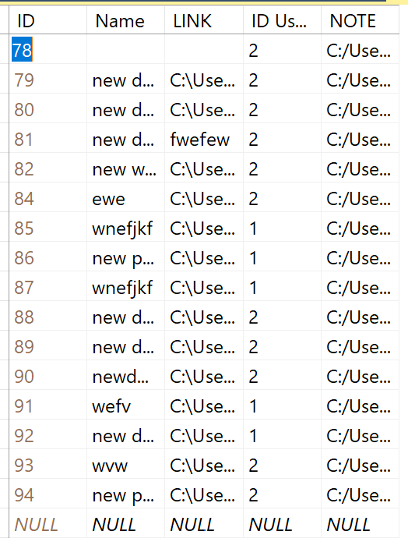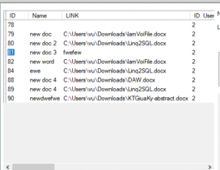

btnAdd

### Algorithm update Note

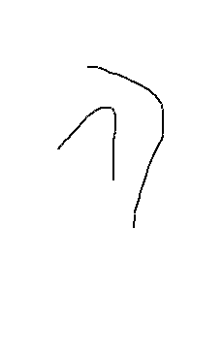

Graphics g = Graphics.FromImage(bmOld); g.DrawImage(bmNew, 0, 0, bmOld.Size.Width, bmOld.Size.Height);

g.Dispose();



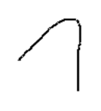

Bitmap New (.jpg)

btnUpdate

Bitmap Old (.jpg)

Bitmap Old (.jpg)

### Algorithm Login

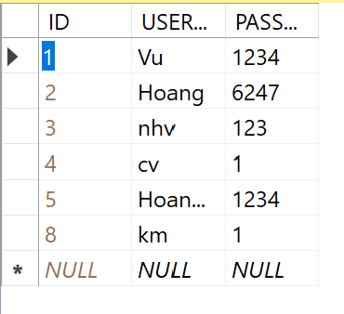

Comparision

if (us.USERNAME == txtTendn.Text && us.PASSWORD.ToString() == txtPass.Text)

new

Table Users in database

If the condition is true, program will show form MDI

**Design :**

|  |  |  |  |
| --- | --- | --- | --- |
| **STT** | **Name** | **Code** | **Function** |
| **1** | **Controllers** | | Connect database to get data and load to datasource of Datagridview |
|  | Load Files | Input : ID user  Output : The list of Document approriate to ID user |  |
|  | Delete Files | Input : Name file  Output : Delete file approriate to name |  |
|  | Add Files | Input : ID , Name, link Note,  Output : The list of Document have added the new file approriate to input. |  |
|  | Edit Files | Input : ID , Name, link Note  Output :the doccument has changed approriate to input. |  |
| **2** | **Models** | | |
|  | Documents | public partial class Document  {  public int ID { get; set; }  public string Name { get; set; }  public string LINK { get; set; }  public int ID_Users { get; set; }  public string NOTE { get; set; }    public virtual User User { get; set; }  }  } | Basic information of a document |
|  | Users | public User()  {  this.Documents = new HashSet<Document>();  }    public int ID { get; set; }  public string USERNAME { get; set; }  public Nullable<int> PASSWORD { get; set; } | Basic information of a user |
| 3 | **Views** | | |
|  | frmLogin |  | To Allow people use program |
|  | btnLogin | Input : Username and Password  Output : Form MDI has been showed on screen | Check the text in both of 2 textbox txtTendn and txtPass, if they are the same then allow to login |
|  | Form1 |  | To Open file and read Document file( word and pdf) |
| 1 | btnOpenfile | Input : the Richtextbox  Output : the richtextbox have content of file which is opened | When user click OK to open file,  A string which name is filename while be saved to field LINK in table Document in database, richtextbox will show on content inside file document |
| 2 | btnCLosefile | Input : the Richtextbox  Output : the richtextbox have no content | This button will clear all content in richtextbox and hide richtextbox |
|  | Form: frmCollection |  | To show and manage list of Document |
| 2 | btnDelete | Input : the Cells(“Name”) in datagridview  Output : the document was deleted approiate to Name | This button will delete the row selected on datagridview |
| 3 | btnLoad | Input : ID user  Output : The list document approriate to ID | This button will load the data from database to dataSource of datagridview and show |
| 4 | btnAdd | Input : Name , Link  Output : The Document was added in database approriate to Name and Link | This button add new doc which information : name, link , note ,…. Add to database |
| 5 | btnUpdate | Input : Name , Link  Output : The Document was changed in database approriate to Name and Link | This button will update name or link or note of selected row in datagridview if user want to change. |
| 7 | btnUpdateNOTE | Input : bitmapOld, bitmapNew  Output : bitmapOld | This button will add both of bitmap together and update to bitmapOld |

|  |  |  |  |
| --- | --- | --- | --- |
| STT | Name | Code | Function |
| 4 | AddDoc | Input : Link (string)  Output : The Document was added in database approriate to Link | This method used to add new document to Document table in database |
| 5 | AddPDF | Input : Link  Output : The Document was added in database approriate to Link | This method used to add new Pdf file to database |

**Method:**

**Design Database:**

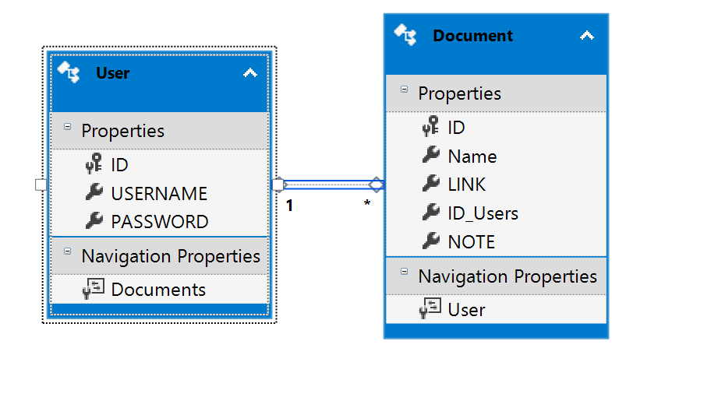

|  |  |  |
| --- | --- | --- |
| **TT** | **Name of Table** | **Purpose** |
| 1 | Document | Save information of file which is opened by user |
| 2 | User | Save username , password and id user to manage collection |

|  |  |  |  |
| --- | --- | --- | --- |
| **TT** | **Field** | **Type** | **Purpose** |
| 1 | Name | Nvarchar(100) | Save name of document |
| 2 | LINK | Nvarchar(200) | Save Link of document |
| 3 | Id_Users | Nvarchar(50) | Save Id user of document |
| 4 | NOTE | Nvarchar(200) | Save link of bitmapnote in picture box |

Document table :

|  |  |  |  |
| --- | --- | --- | --- |
| **TT** | **Field** | **Type** | **Purpose** |
| 1 | Username | Nvarchar(100) | Save username of user to login |
| 2 | Password | Nvarchar(100) | Save Password of user to login |

User table:

**Design Interface:**

*Form LOGIN and Sign-up:*

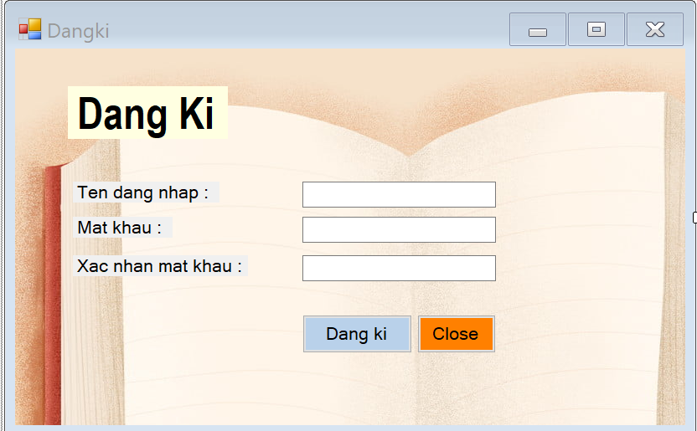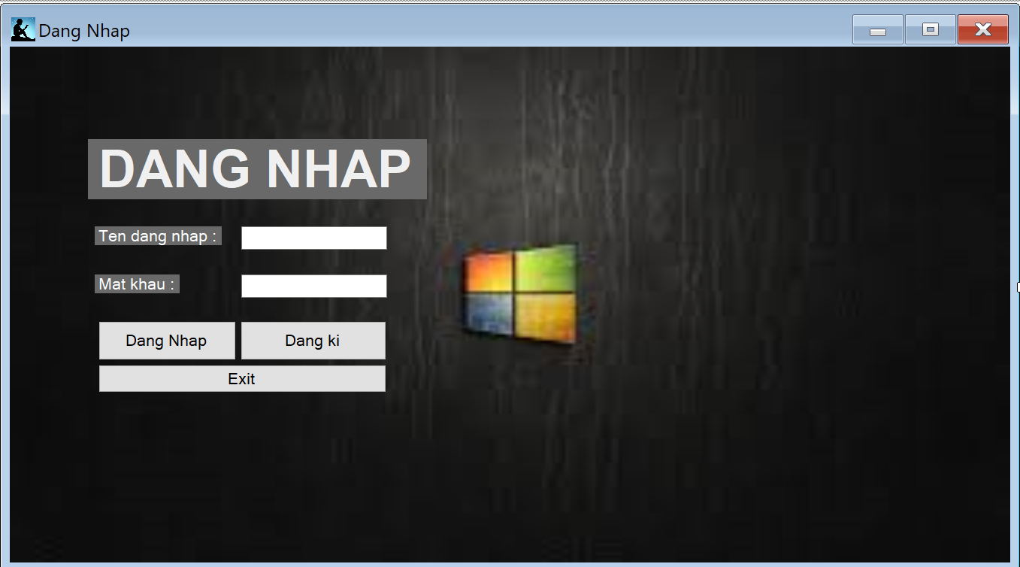

|  |  |  |
| --- | --- | --- |
| *Form Read Document:* | To open and read document | Nguyễn Hoàng Vũ  Button and some control are located on the left because all of the right side of form will be used for richtextbox show the content of file document |
| *Form Your Collection:* | To show and manage document have opened | Kim Ngân  List of document need a large region to show all the information so it must be center and buttons are located in the left side. I don’t put the button update to the left because it must near the text box name and link. This will help user more conveniently |

Chapter 4 : Install and Test

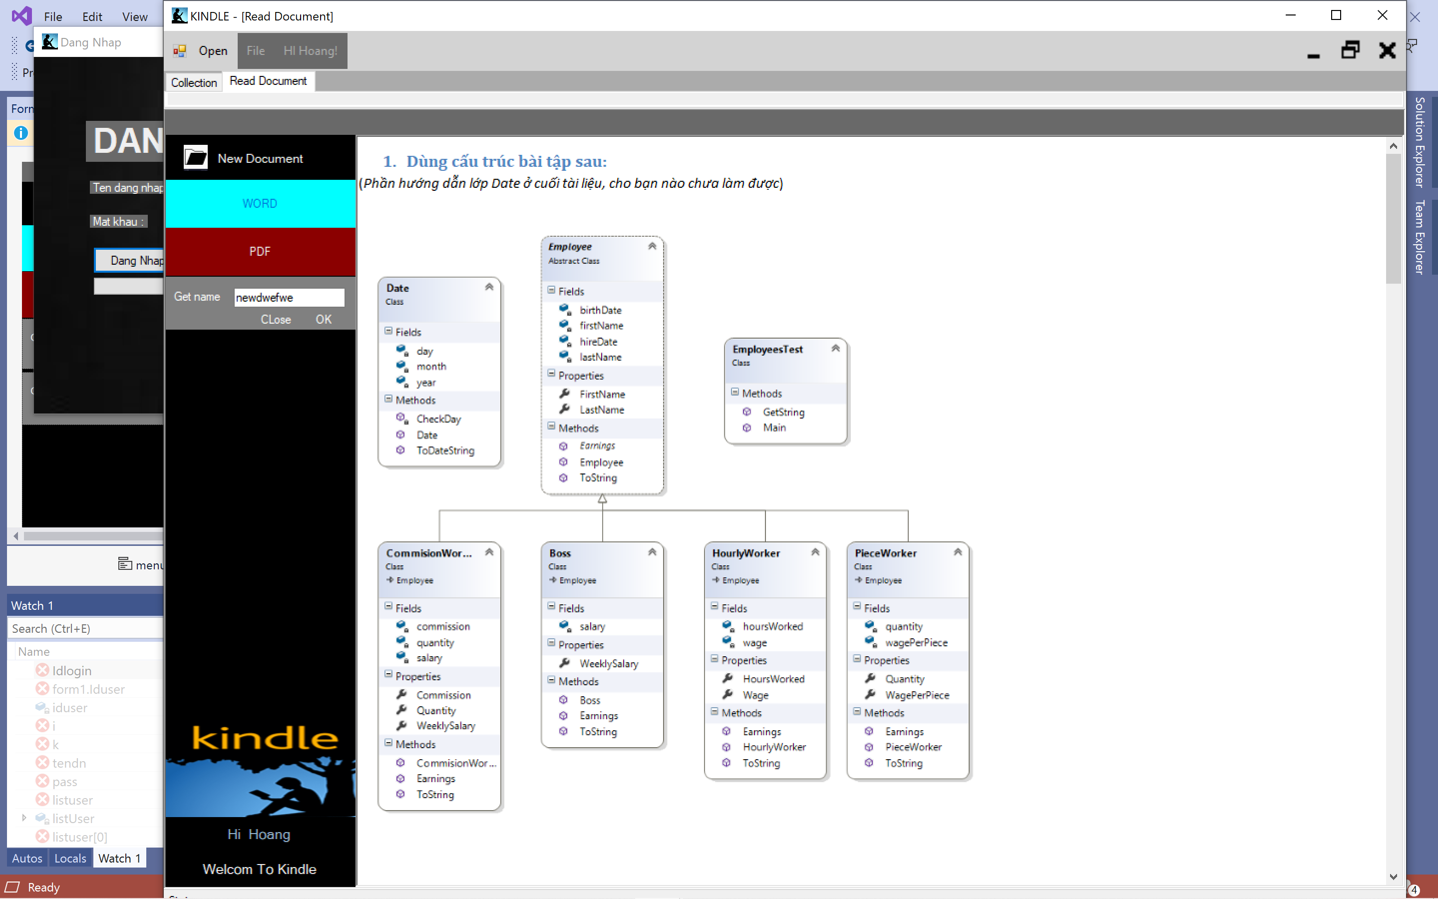

Check user with username is “Hoang”

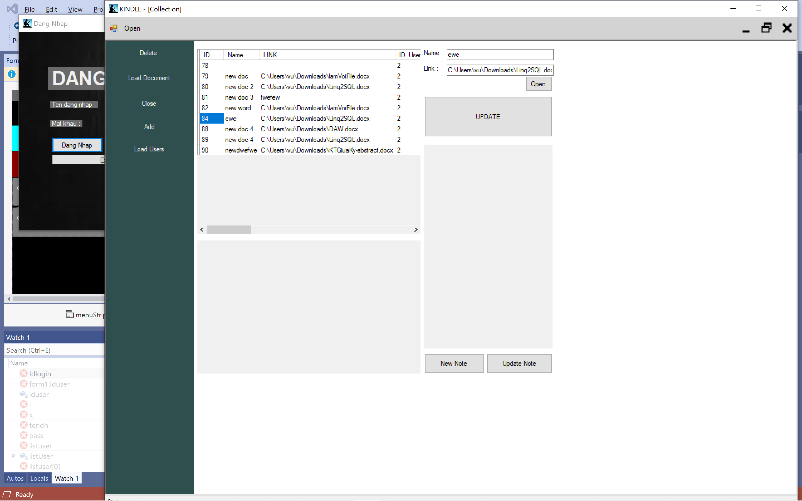

Check list of Documents

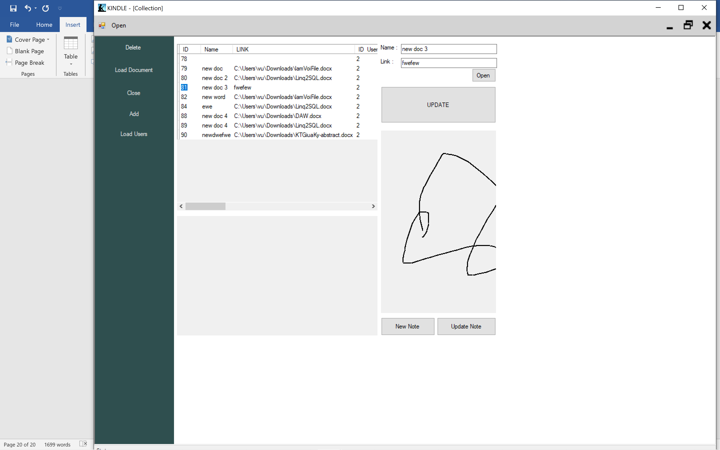

Check feature update Note

Chapter 5 : Development

* Improve the interface
* Personalize the program : Change name, avatar..
* Can open many type of ducument
* Can edit the content of document
* Develop the program similar to the Kindle of Amazon

***Reference:***

[1]Entity Framework (Microsoft) <https://docs.microsoft.com/en-us/ef/>

[2] C#: Learn C# in One Day and Learn It Well. C# for Beginners with Hands-on Project. (Learn Coding Fast with Hands-On Project Book 3) Kindle Edition by Jamin Chan <https://www.amazon.com/Beginners-Hands-Project-Coding-Project-ebook/dp/B016Z18MLG>

[3]C# 8.0 and NET.Core 3.0 – Modern Cross Platform Development Fourth Edition(2019).pdf

[4] Documentation windown forms’ on Website Microsoft <https://docs.microsoft.com/en-us/dotnet/framework/winforms/>