ASSIGNMENT-2
2303a52022
B-38
Task 1: Cleaning Sensor Data
Scenario:
You are cleaning IoT sensor data where negative values are invalid.
Task:
Use Gemini in Colab to generate a function that filters out all negative
numbers from a list.
Expected Output:
Before/after list
Screenshot of Colab execution
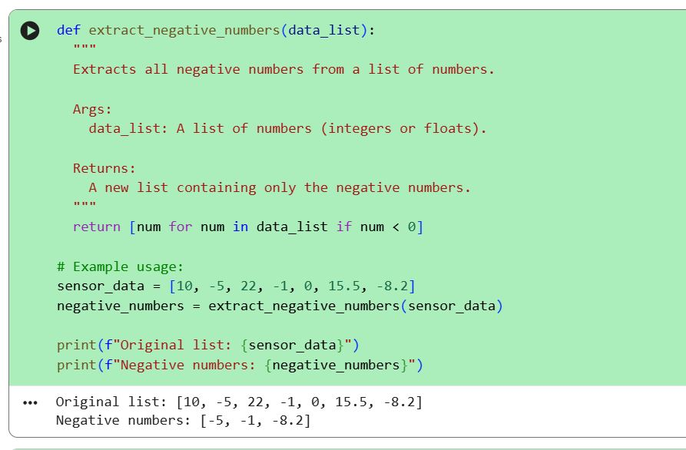
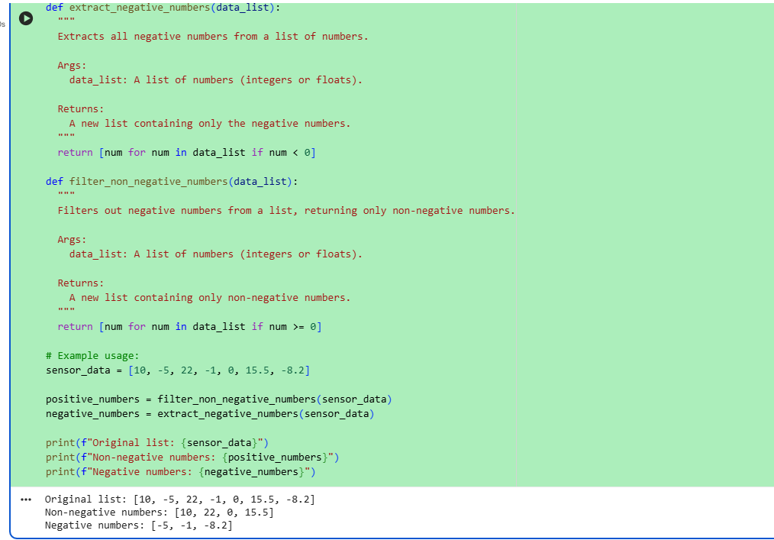

Explanation of code:-
This program starts with a list of numbers.
It goes through each number one by one and checks whether it is negative or not.
If the number is less than zero, it is added to the negative numbers list.
If the number is zero or greater, it is added to the non-negative numbers list.
In the end, the program displays the original list, the list of negative numbers, and the list of non-negative numbers.

Task 2: String Character Analysis
Scenario:
You are building a text-analysis feature.
Task:
Use Gemini to generate a Python function that counts vowels, consonants,
and digits in a string.
Expected Output:
Working function
Sample inputs and outputs
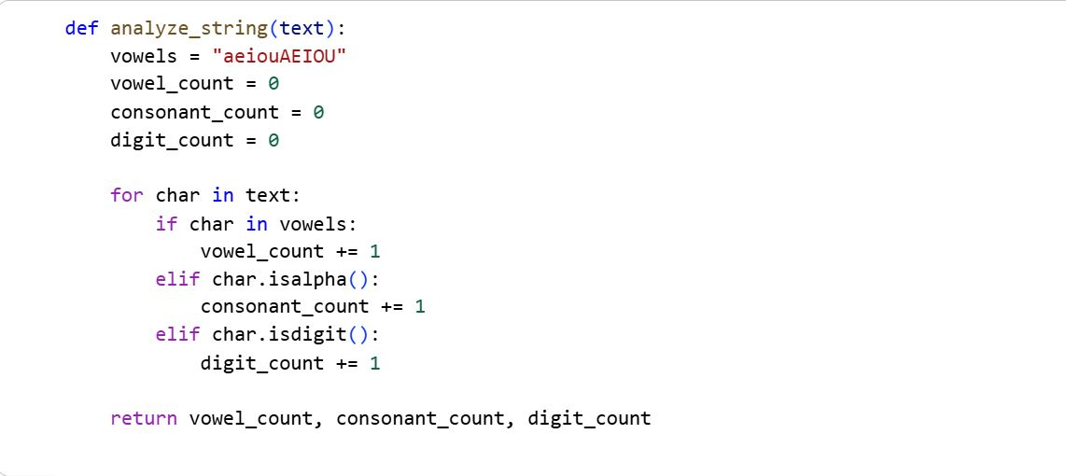

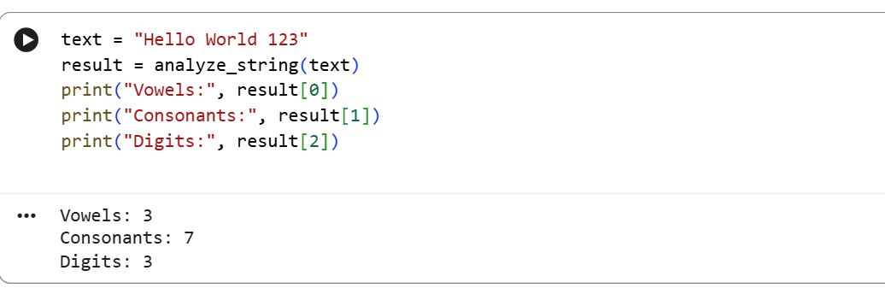
Explanation of code:-
This program has a function named analyze_string that takes a string as input.
It checks each character in the string one by one.
If the character is a vowel, it increases the vowel count.
If it is a consonant, it increases the consonant count.
If it is a digit (number), it increases the digit count.
After checking all characters, the function gives back the total number of vowels, consonants, and digits.
The example shows how the function is used with the text "Hello World! 123 Python" and prints the final counts.
Task 3: Palindrome Check – Tool Comparison
Scenario:
You must decide which AI tool is clearer for string logic.
Task:
Generate a palindrome-checking function using Gemini and Copilot, then
compare the results.
Expected Output:
Side-by-side code comparison
Observations on clarity and structure
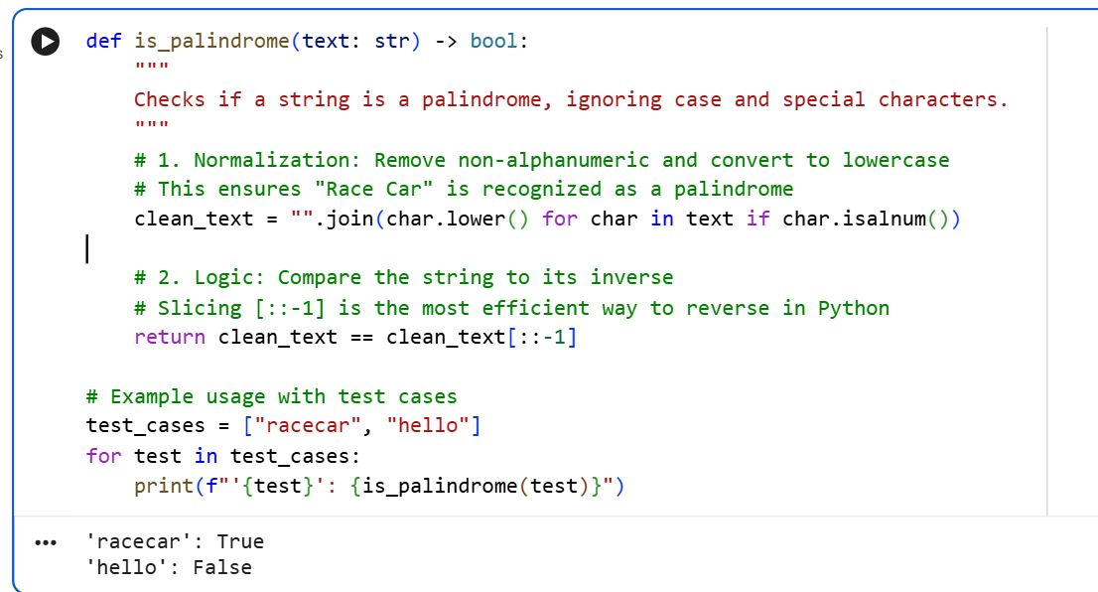
Explanation of Code:-
This program defines a function called is_palindromei that checks whether a given text reads the same forwards and backwards.
It does this by comparing the original text with its reversed version.
The program then asks the user to enter a text.
If the function returns true, it prints that the text is a palindrome; otherwise, it prints that the text is not a palindrome.
Task 4: Code Explanation Using AI
Scenario:
You are reviewing unfamiliar code written by another developer.
Task:
Ask Gemini to explain a Python function (prime check OR palindrome
check) line by line.
Expected Output:
Code snippet
AI explanation
Student comments on under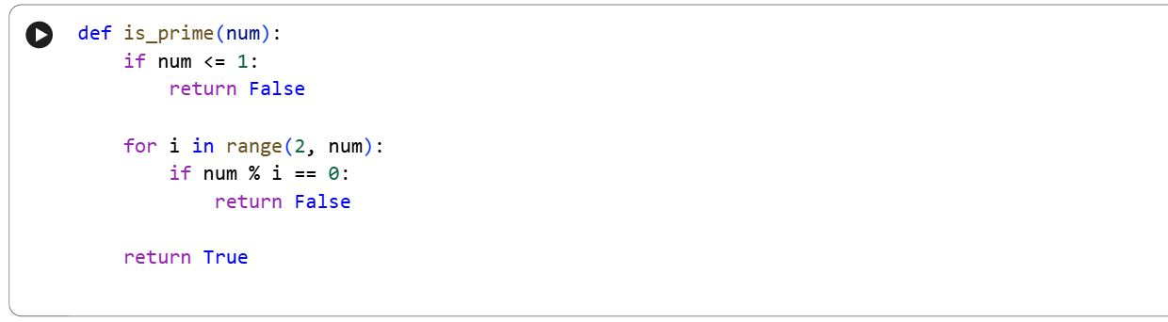standing

def is_prime(num):
Defines a function named is_prime.
It takes one parameter num, which is the number to be checked.
if num <= 1:
Checks if the number is less than or equal to 1.
Numbers 0, 1, and negative numbers are not prime.
return False
Immediately returns False if the number is not prime.
for i in range(2, num):
Starts a loop from 2 to num - 1.
These numbers are possible divisors of num.
if num % i == 0:
Checks if num is divisible by i (no remainder).
If true, num has a factor other than 1 and itself.
return False
Returns False because a prime number must have exactly two factors.
return True
If no divisors are found in the loop, the number is prime.
Returns True.
print(is_prime(7)) #TRUE
print(is_prime(10)) #FALSE
Explanation of Code:-

This code defines a function called is_prime that checks whether a number is prime or not.
It first rules out numbers less than 2, then checks if the number is divisible by any value up to its square root; if it is, the function returns false, otherwise it returns true and the example prints the results for 7 and 10.

