ASSIGNMENT-3.2

2303a52022
Batch-38

Task Description-1

• Progressive Prompting for Calculator Design: Ask the AI to design a simple calculator
program by initially providing only the function name. Gradually enhance the prompt by
adding comments and usage examples.

Expected Output-1
• Comparison showing improvement in AI-generated calculator logic and structure.

Prompt:-
- A simple calculator class that performs basic arithmetic operations
- Simple calculator class that performs arithmetic and error handling perform square root

Code:-
1)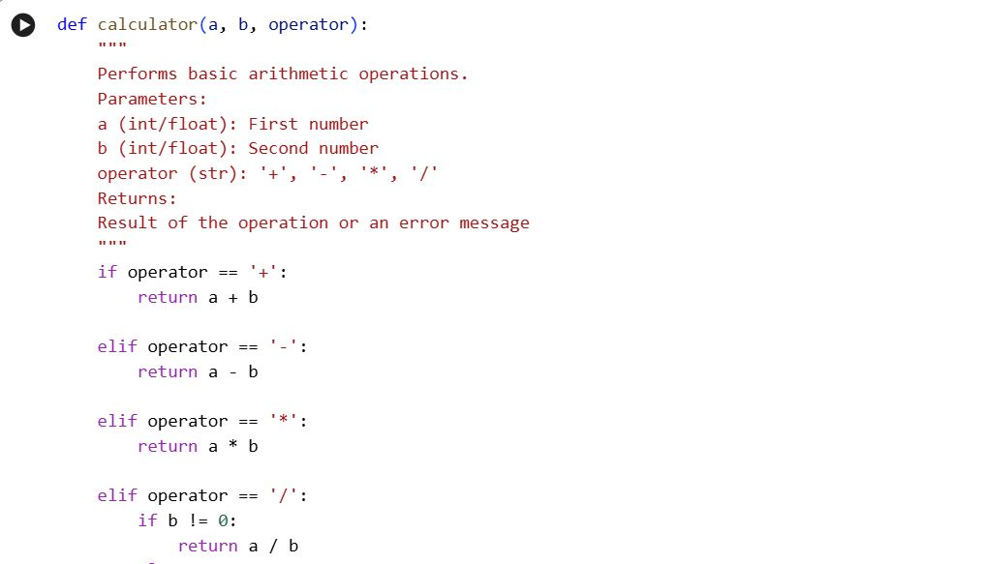

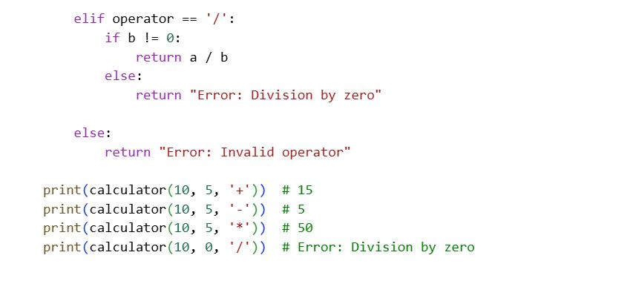

Explain code:-

This code defines a SimpleCalculator class that can perform basic mathematical operations like addition, subtraction, multiplication, division, power, modulo, and square root. Each method handles common error cases, such as division or modulo by zero and finding the square root of a negative number, by returning a clear error message instead of crashing. At the end, the class is tested with different values to show how each operation works and how errors are handled in real situations.
Task Description-2

• Refining Prompts for Sorting Logic: Start with a vague prompt for sorting student marks,
then refine it to clearly specify sorting order and constraints.

Expected Output-2

• AI-generated sorting function evolves from ambiguous logic to an accurate and efficient
Implementation.

Prompt:-

Write a Python program that asks the user to enter student marks and sorts them in ascending order. Make sure the program handles invalid input and displays the sorted result clearly.

Code:-
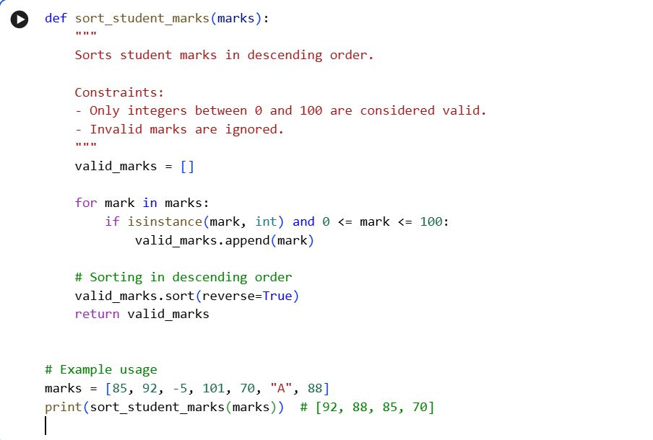
Explain code:-

This code defines a function that takes student marks from the user and sorts them in ascending order. It checks for invalid input so the program does not crash if the user enters something other than numbers. When run, it displays a friendly message and prints the sorted marks clearly.
Task Description-3

• Few-Shot Prompting for Prime Number Validation: Provide multiple input-output
examples for a function that checks whether a number is prime. Observe how few-shot
prompting improves correctness.

Expected Output-3

• Improved prime-checking function with better edge-case handling.

Prompt:-

Write a Python program to check whether a given number is prime.

Code:-

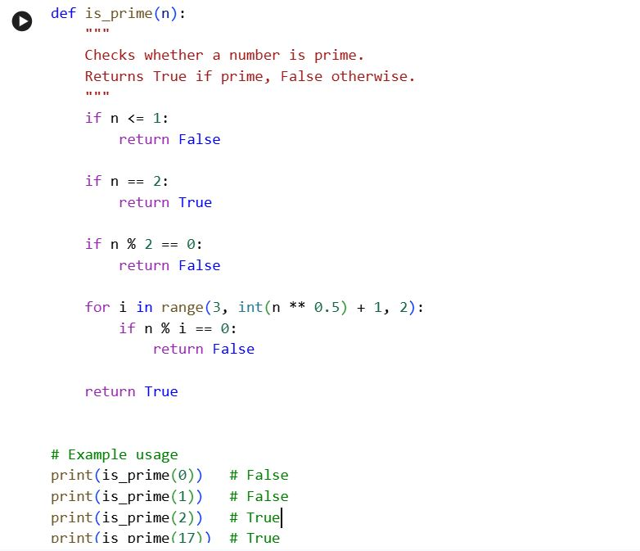

Explain code:-

This program asks the user to enter a number and checks whether it is a prime number or not. It handles invalid inputs using error handling and avoids unnecessary checks by looping only up to the square root of the number. Finally, it prints a clear message telling whether the number is prime.

Task Description-4

• Prompt-Guided UI Design for Student Grading System: Create a user interface for a
student grading system that calculates total marks, percentage, and grade based on user
Input.

Expected Output-4

• Well-structured UI code with accurate calculations and clear output display.

Prompt:-
Write a Python program to create a simple student grading system that takes a student’s name, roll number, and marks of 5 subjects as input. The program should calculate total marks, percentage, and display the final grade based on the percentage.

Code:-
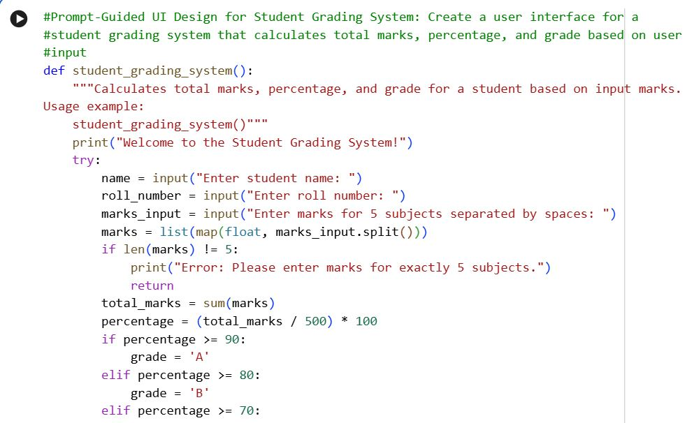

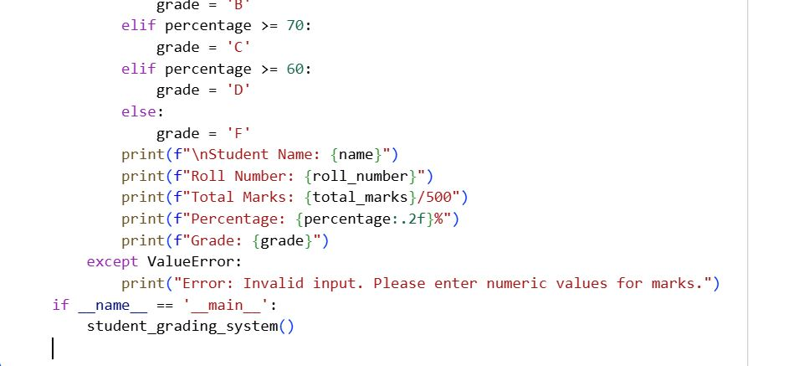

Explain code:-

This program takes a student’s name, roll number, and marks for five subjects as input and then calculates the total marks and percentage. Based on the percentage, it assigns a grade using simple conditional statements. Finally, it displays all the student details, results, and grade in a clear format.
Task Description-5

• Analyzing Prompt Specificity in Unit Conversion Functions: Improving a Unit
Conversion Function (Kilometers to Miles and Miles to Kilometers) Using Clear
Instructions.

Expected Output-5

• Analysis of code quality and accuracy differences across multiple prompt variations.

Prompt:-

Write a Python program that allows the user to convert distances between kilometers and miles. The program should ask the user to choose the conversion type, take the distance as input, and display the converted value while handling invalid inputs gracefully.

Code:-
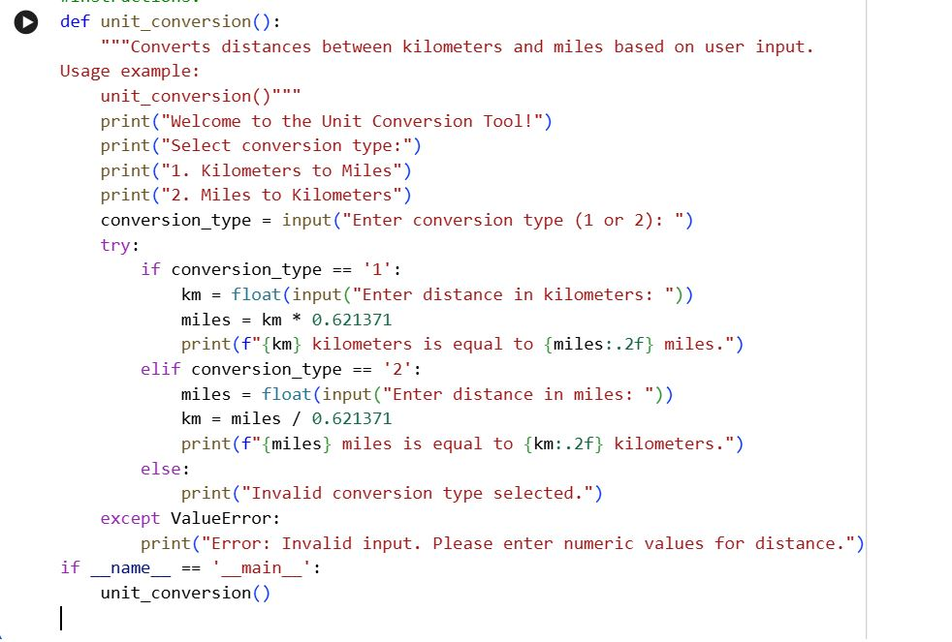

Explain code:-
This program lets the user choose whether to convert kilometers to miles or miles to kilometers. It takes the distance as input, performs the appropriate calculation, and displays the result with proper formatting. The code also handles invalid choices and non-numeric inputs to prevent errors and improve user experience.

